iTee Solutions. Your iTee partner in golf.


Albatros Quick Guide

Step by step instructions on the most common
tools & functions in Albatros

Release: April 2012 - Ver. 8.8.0.0
Table of Contents
1

. Bookings / Reservation 3
1.1 How to add a tee booking 3
1.2 How to Edit / Copy / Cut / Paste / Delete a tee booking 3
1.3 How to add and edit rental items 4
1.4 How to search for a player / booking 4
1.5 How to view cancelled bookings 4
1.6 How to add a group booking / tee closure 5
1.7 How to print a tee sheet / list of rental items / Stats 5

- Bookings / Reservation
  - How to add a tee booking
- The simple way to add a tee booking is to double click on the tee time where you want to make the tee booking.
- You will then see the Simple Add mode Adding screen, here you can simply select the players from the bottom half of the screen by double clicking on them.
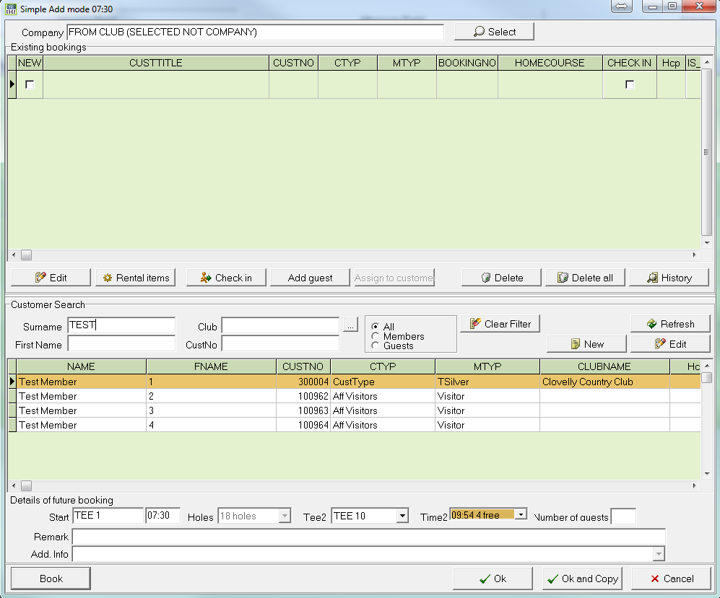
- To search for a player, you simply start typing out his/her name.
- To add a player who is not a member, click on Add guest.
- When you are done, click OK or OK and Copy.
- Your booking will now be displayed on the booking sheet.

  - How to Edit / Copy / Cut / Paste / Delete a tee booking
- Select the function you want to use on the left hand side – Edit, Check in, Cut, Copy, Copy All, Delete or Delete All.
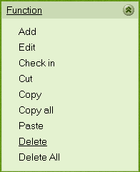
- Then click on the tee booking you want to apply this function to and confirm by answering Yes to the security question.

  - How to add and edit rental items
- Go to AlbAdmin and click on POS Bookings Settings.
- Then click on Rental item settings, on the main screen, click on the Article tab
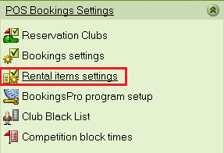
- Click New, then give the article you want to add a name and short name, quantity and delay time (e.g. golf carts might need time in-between players to charge) and click OK.
- On the menu bar click on tools and Reinitialize and your rental item should now reflect in Bookings.

  - How to search for a player / booking
- Click on Info, Search (player / booking), then input surname or CustNo or BookNo and click Search.
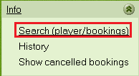
- The specific booking or a list of customers with the same surname will appear, you can double click on the customer to go to their booking.
  - How to view cancelled bookings
- You simply click on Info, Show cancelled bookings, and all cancelled bookings for that date will be displayed in a new window.
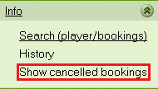
- You can select the a specific date, what course and tee the booking was cancelled from.

  - How to add a group booking / tee closure
- Click on Additional function, Group booking, then click on the time slot you want to make the booking.
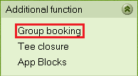
- You then select the group from the list – if the group is not there, click on New and create a new „customer“ with the name of the Group – e.g. „The Sanlam Group“.
- You can then add as many guests as there are participants – please note that there will be a limit on the amount of guests, depending on the individual golf course – and confirm by clicking on OK
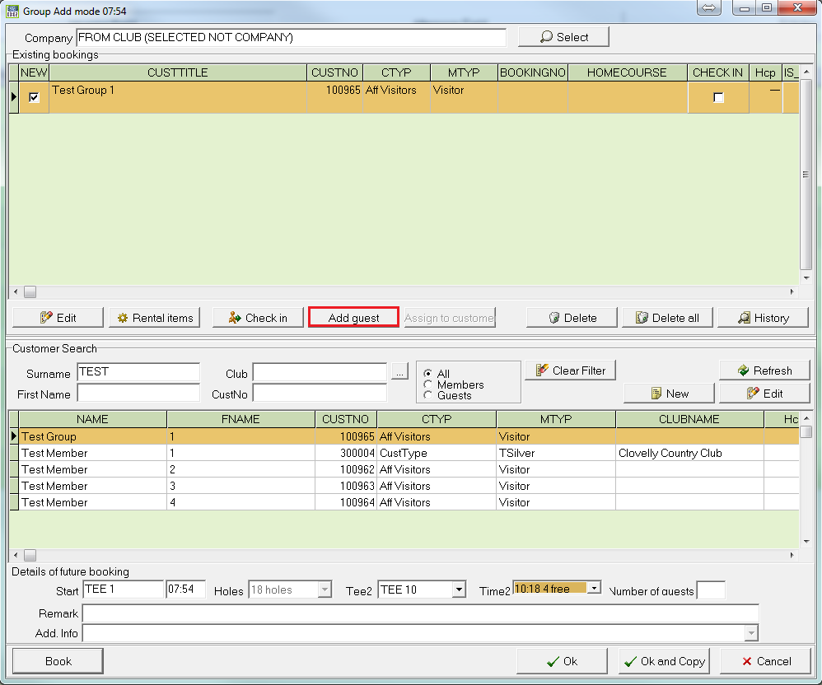

Your group booking will now be displayed on the tee sheet.

  - How to print a tee sheet / list of rental items / Stats
- Click on Printing, Tee sheet OR List of rental items OR Stats.
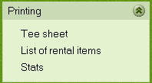
- You will have the option to preview this report before printing it.

