
iTee Solutions. Your iTee partner in golf.

Manual:
Bookings Module
(Offline Tee times)

Updated: 31.01.2011 – Ver.: 5.0.1 - Rev. 1.0.0 FNO
Table of Contents
1. Introduction 5
1.1 Bookings 5
1.2 Evaluation 5
1.3 Administration 5
1.4 Interfaces 5
1.5 Tee sheet 6
1.6 Additional modules 7
1.7 Structure of the system 7
2. Starting the program / Logging in 10
2.1 Example 1: Error free activation 10
2.2 Example 2: No permission to use module for the current user: 10
2.3 Example 3: User name or password entered incorrectly 10
2.4 Example 4: Tip relating to settings on your keyboard 10
3. Tee sheet views 10
3.1 View 1 10
3.2 View 2 10
3.3 Multi Tees 10
3.4 Multi Day View 10
3.5 Multi Courses View 10
3.6 Multi Course Tee View 10
4. Menu 10
4.1 Menu „Function“ 10
4.2 Menu „Rental items“ 10
4.3 Menu „Info“ 10
4.4 Menu „Additional functions“ 10
4.5 Menu „Printing“ 10
5. Booking a tee time 10
5.1 Book / Change 10
5.2 Delete, Delete All 10
5.3 Cut, Copy & Paste 10
5.4 Follow on bookings, Check-In, Remarks 10
5.4.1 Step-by-step procedure to Check-In 10
5.4.2 Use of the ‚Remark‘ field during the ‚Add‘ function 10

6. Group bookings 10
6.1 Creating / Changing 10
6.2 Changing a group booking: 10
6.3 Deleting a single player / Deleting a group 10
6.4 Copying and pasting a group booking 10
6.5 Checking in individual players that are part of a group 10
6.5.1 Step-by-step procedure to Check-In: 10
7. Tee closure 10
7.1 Enter / Change 10
7.2 Recurrence, Frequency 10
7.3 Deleting or changing a closure 10
7.4 Cancellation of a tee closure: 10
7.5 Competition module: tee closures for competitions 10
8. Rental items 10
8.1 Setting up of a new or changing of an existing rental item 10
8.2 Creating a new rental item: 10
8.3 Editing a rental item: 10
8.4 Allocating and deleting booked rental items 10
8.5 Removing an allocated rental item 10
8.6 Configuring the availability of rental items 10
8.7 Editing the availability in a change of quantity: 10
8.8 Deleting a change: 10
8.9 History (Log book of all changes to the rental item quantities) 10
8.10 Statistics of the rental items still in use 10
9. INFO MENU 10
9.1 Search bookings 10
9.2 History 10
9.3 Cancelled bookings 10
10. Printing (Lists: Tee sheet, Rental items and Stats) 10
10.1 Tee sheet 10
10.2 List of rental items 10
10.3 Stats 10
11. Configuration 10

12. Remote access by our support team with Netviewer 10
12.1 Remote access in the Albatros modules 10
12.2 Starting the remote access session 10

© Frank Nordwig (Albatros, Germany) / Translation done by Sonja Bland (iTee Solutions, South Africa)

- Introduction
Albatros is a software solution that has been used successfully for over 16 years in Europe. It is currently being implemented in over 400 golf clubs worldwide. Albatros offers a ‚(w)hole-in-one‘ product range for golf clubs and resorts. This range is compatible with Microsoft Windows. To compliment the offline modules, Albatros offers several online solutions that can further improve the club’s service to its members and guests.

‘Bookings’ offers the following extra features over and above the standard functions of a reservation system:

- Bookings  - Single and multiple bookings  - Group bookings  - Status of check-ins & cancellations  - Lessons | - Evaluation  - Tee Sheets  - List of Bookings  - Occupancy Overview  - Financial Reports
- Administration  - Variable Time Sheet Rosters  - Variable No. of Courses  - Teeing off from Tee 1 und 10  - Calendar with Public Holidays  - Carts, Trolleys und Rental Items  - Notes or Comments to Bookings  - Tee Closures & Group Bookings |  | - Interfaces  - Hotels  - Other Golf Clubs  - Internet  - AOC-Terminal

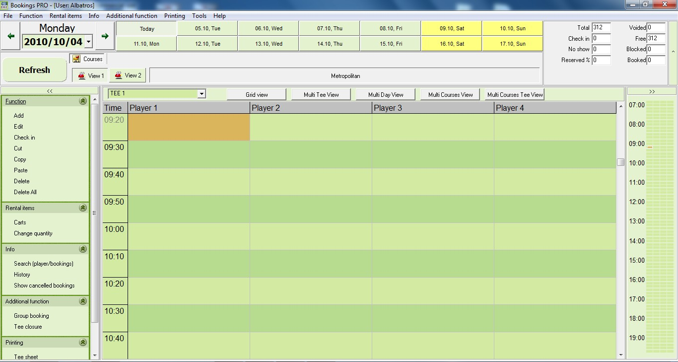

‘Bookings’ is the solution for an efficient organisation of bookings for tee times, lessons with a pro, driving range boxes or club events.

This module can manage the tee times for any number of courses and can be individually configured for the requirements of a golf club or resort. The mutually accessible SQL-Database offers you quick access to all customers in the database. Should you add new clients in this module to the database, this information is immediately accessible from the other modules as well.

  - Tee sheet
The tee sheet can be configured individually for each bookings object (18-hole-course, 9-hole-course, Pros).
The screen is designed to be easily understood with a bright colour design that is both clear and informative.
The ‚cut & paste‘ functions assist in moving a tee time or making a copy of a group booking for another day.

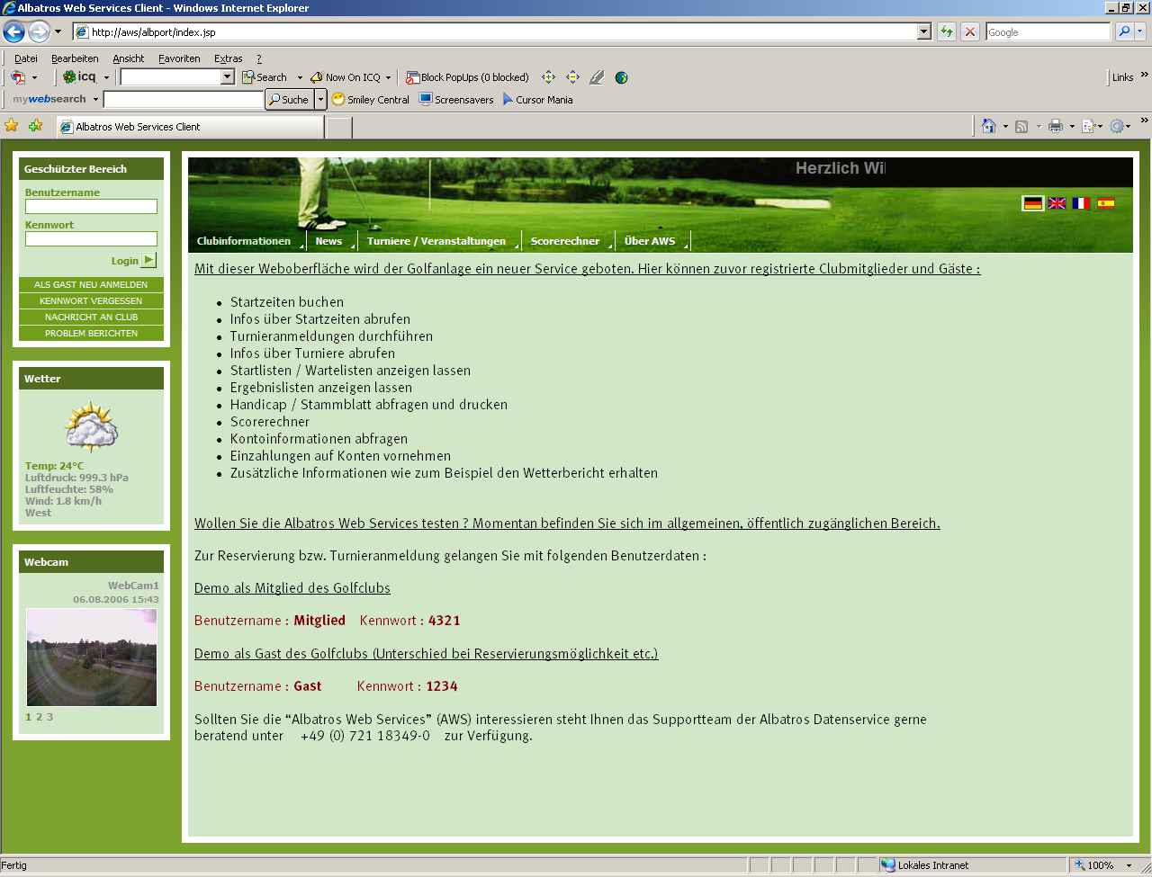

  - Additional modules
The local system can be extended by the online bookings module for the internet.
This technology offers members and guests the opportunity to book tee times via the club’s homepage.
The master system is the club’s local database which manages the online booking requests in real time.

  - Structure of the system
Due to the open structure of the system, other modules such as the ‚Greenfees & Proshop’ as well as ‘AOC Terminal’ can access the Bookings module directly and thereby complete the offer.

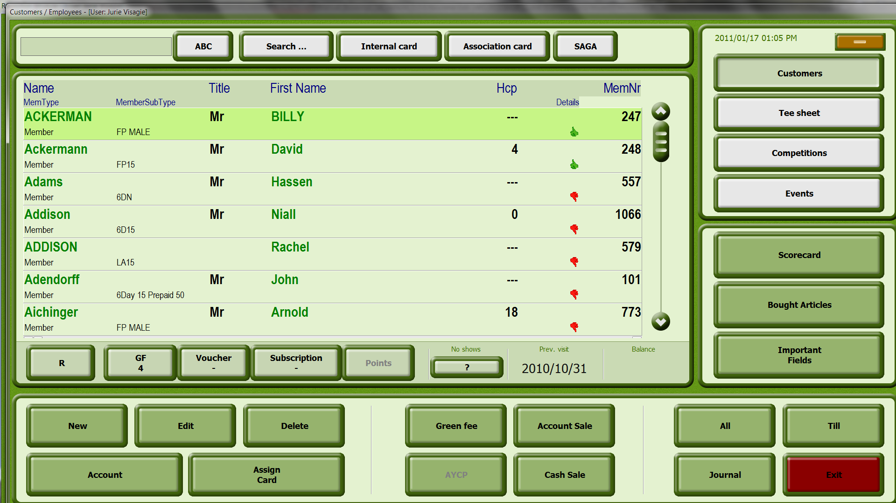

With all these options, members and guests can book a tee time 24/7.

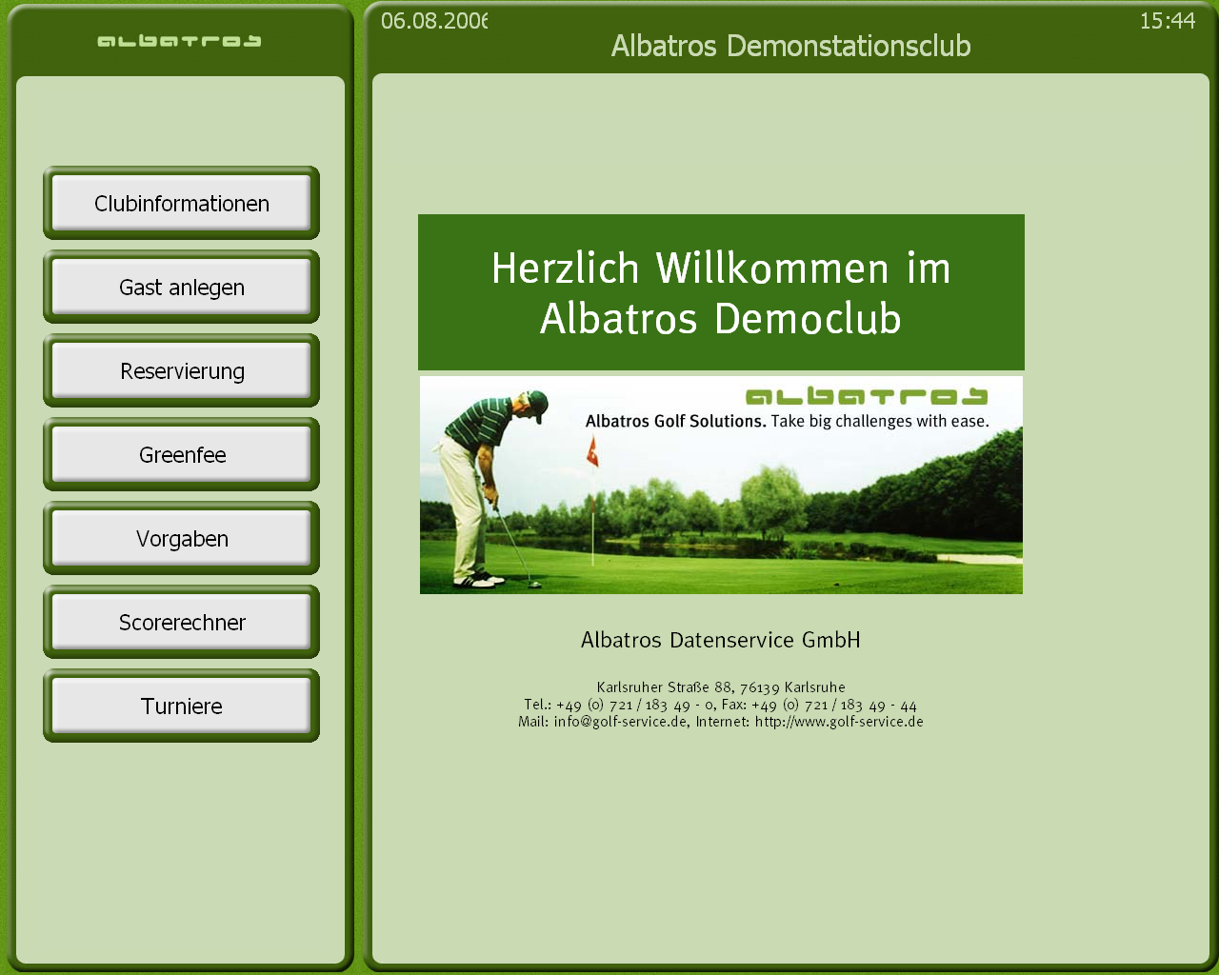

In combination with the Albatros leaderboard module, available tee times can be shown on a screen in the club house, for example, so that members or guests can view the tee sheet to decide on their tee time.
- Starting the program / Logging in
- Example 1: Error free activation  - Activate your ‘Bookings’ module by double clicking on the icon on your screen or via the start menu: Start – All Programs – Albatros – Bookings. | 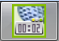

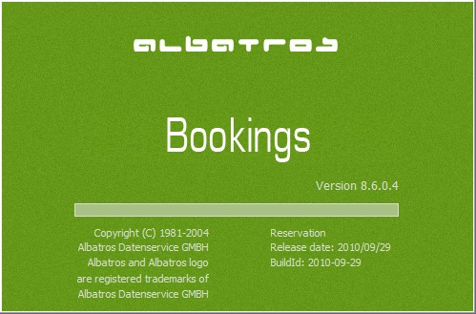 | - Once activated, the initial screen will appear. This gives you info on: Charging Time, Name of the module, Version and Release date. Do not interrupt this process. it can take a couple of seconds.

After successfully activating the program, the log in screen will appear. A user name and password are required to continue. Should the module have been activated before, the last user will appear next to the user name.

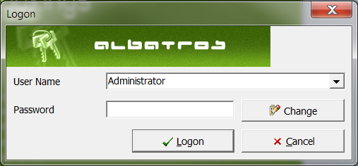
Use the arrow to choose the user

- If you are not the user whose name appears next to the ‘User name’ button activation, please choose your name from the list provided by clicking on the arrow. Next, enter your password where the cursor flashes.

Enter your password and confirm by clicking the logon button

- Enter your password in the allocated space and confirm by clicking on the ‚Logon‘ button. If your entry data was correct, the main part of the Bookings module is activated. Incorrect data entry will result in a message with the reason for the non-activation being displayed.

  - Example 2: No permission to use module for the current user:

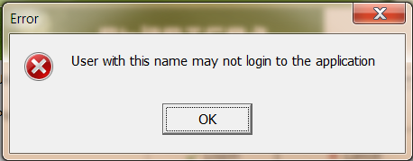

If the user does not have the permission to log into this module, a window will pop up with the following message: „User with this name may not log into the application”. Click on the ‘OK’ button and contact your local Albatros administrator or call the support hot line to resolve the issue.

  - Example 3: User name or password entered incorrectly

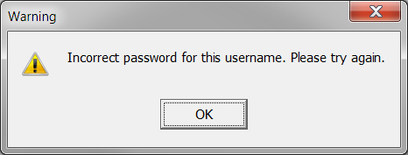

Should you have made a mistake while entering your password; a screen will pop up with the following message: „Incorrect password for this username. Please try again.” Click on the ‚OK‘ button and re-enter your password correctly. Confirm by clicking on the ‘Logon’ button.
  - Example 4: Tip relating to settings on your keyboard
If you are sure that you have entered your password correctly, but are still refused access, check the settings on your keyboard such as Caps lock, NumLock as well as Scrollock.

DELETE – DELETE TEXT IN FRONT OF CURSOR
TAB
BACKSPACE, TO MOVE BACKWARDS
CAPS LOCK –ONLY TYPE IN CAPITALS
END – GO TO END OF LINE
HOME – GO TO BEGIN-NING OF LINE

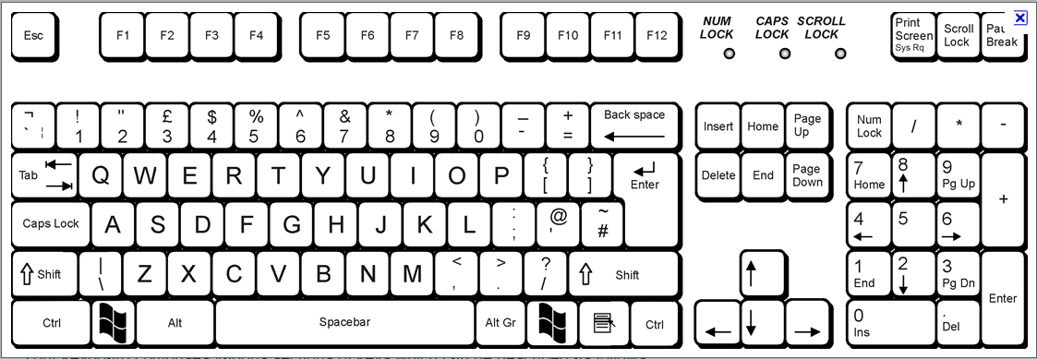
SHIFT
ALT GRAPHIC
RETURN/
ENTER
CURSORS TO MOVE UP/DOWN
NUM LOCK

If your keyboard has a LED-Display, only one light should be illuminated, either on “Num“ or „1“. If the light on the button „A“ is on, please click on the Caps Lock button again to revert to default. The same applies to the button with the symbol ‘Arrow down‘: if this light is on, click on the Scroll button.
- Tee sheet views
The Albatros ‘Bookings’ module offers you the option to adapt the screen view of your course(s) to your preference. This is done by clicking on the buttons ‘View 1’ or ‘View 2’.

Menu – View 1 & 2:

Menu – Grid / Tees / Daily / Course view:

View 1 / Grid | View 1 shows the grid view of a chosen day with a display of the checked in players.
View 2 | View 2 shows the tee sheet of a whole day and also displays the number of players in the pairing. Moving the mouse over the tee time shows the players booked and a window pops up with more detailed info.
Multi Tee View | The ‚Multi Tee View‘ shows both Tee 1 and Tee 10 – if set up accordingly – as well as the daily view. On this screen, all bookings are shown coloured and when moving your mouse over the relevant tee time; a pop-up window shows the pairing. This view gives a good indication of today’s occupancy rate of the course.
Multi Day View | The ‚Multi Day View‘ shows today and the next 6 days. On this screen, all bookings are shown coloured and when moving your mouse over the relevant tee time a pop-up window shows the pairing. This view gives a good indication of the weekly occupancy rate of the course.
Multi Courses View | As the name states, the ‚Multi Courses View‘ shows the tee sheet of several (selected) courses on the Tee 1. On this screen, all bookings are shown coloured and when moving your mouse over the relevant tee time; a pop-up window shows the pairing. This view gives a good indication of the weekly occupancy rate of a tee.
Multi Courses Tees View | The screen ‚Multi Courses Tees View‘ offers you the option of choosing several courses on both Tee 1 and Tee 10. On this screen, all bookings are shown coloured and when moving your mouse over the relevant tee time; a pop-up window shows the pairing. This view gives a good indication of the weekly occupancy rate of both tees.

  - View 1
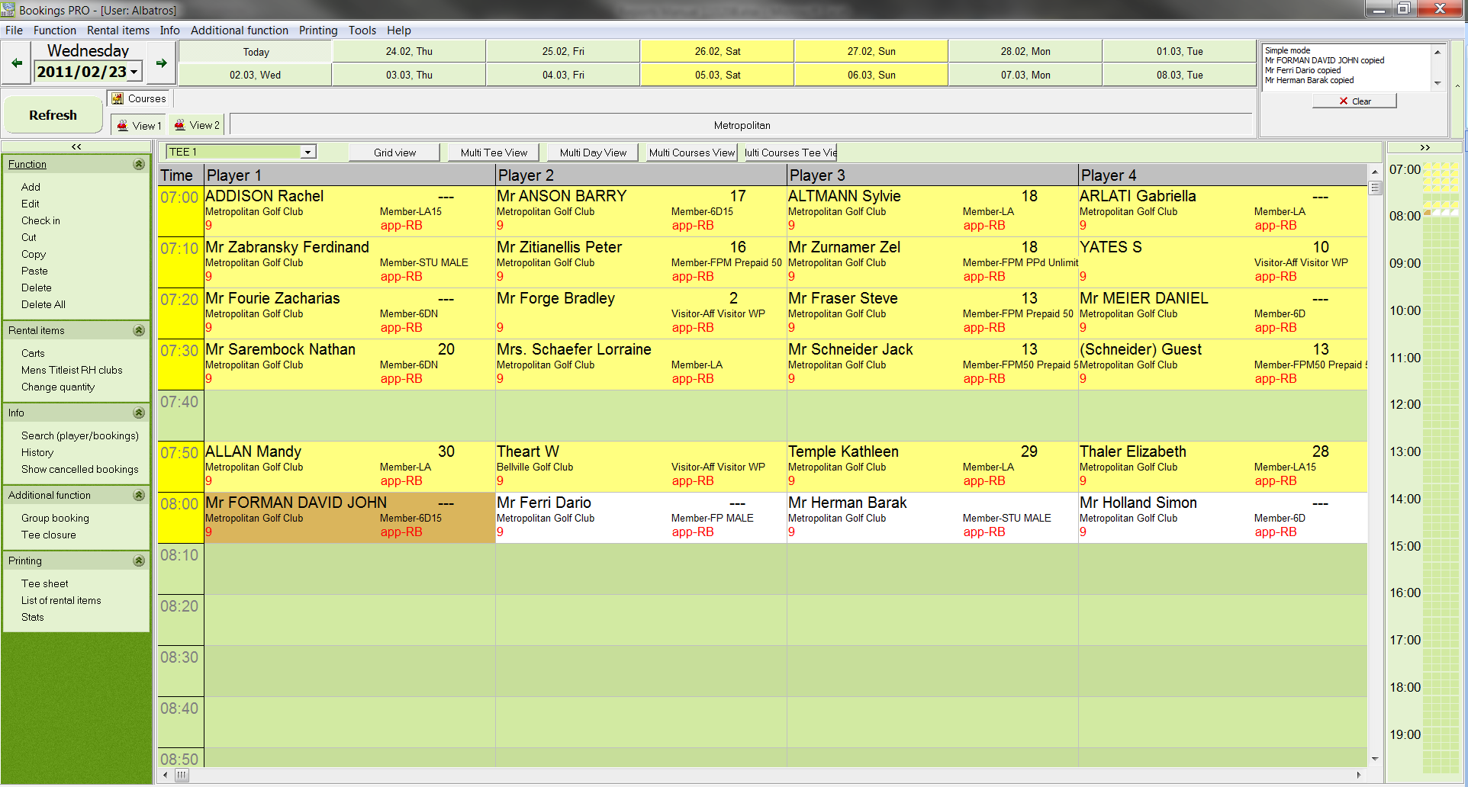

View 1 shows the detailed tee sheet with a display of the booked players, their home club and the respective handicap as well as any rental items, the status of their check-in as well as the booked times.
  - View 2
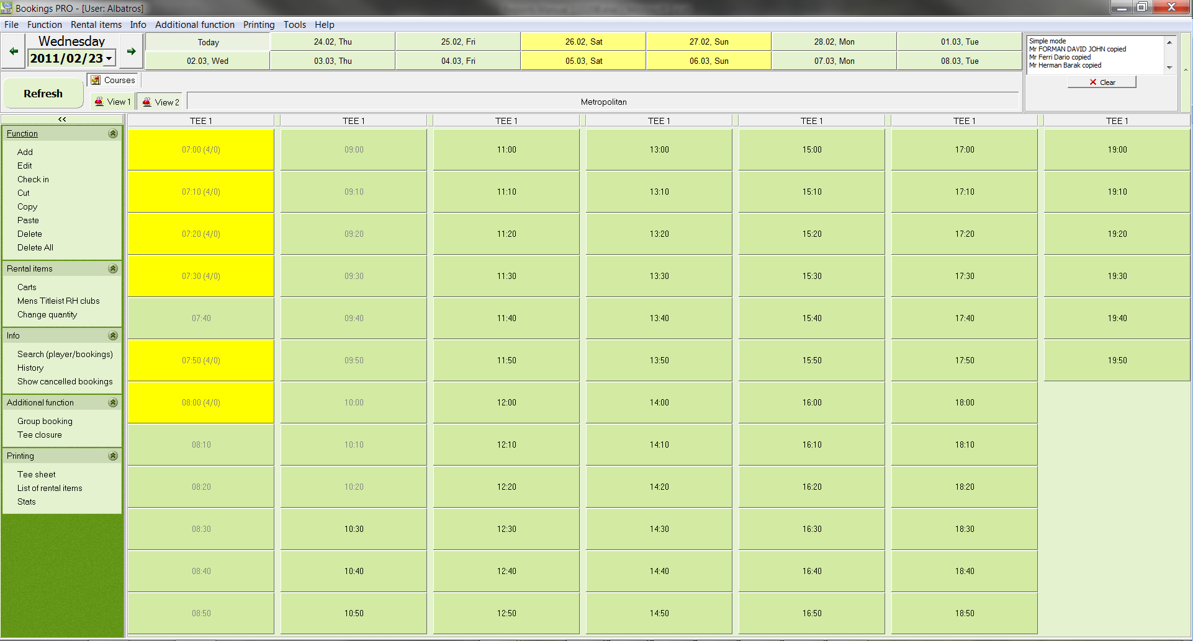

View 2 shows the daily tee sheet with the number of players in a booked pairing. On this screen, all bookings are shown coloured and when moving your mouse over the relevant tee time; a pop-up window shows the pairing.

  - Multi Tees
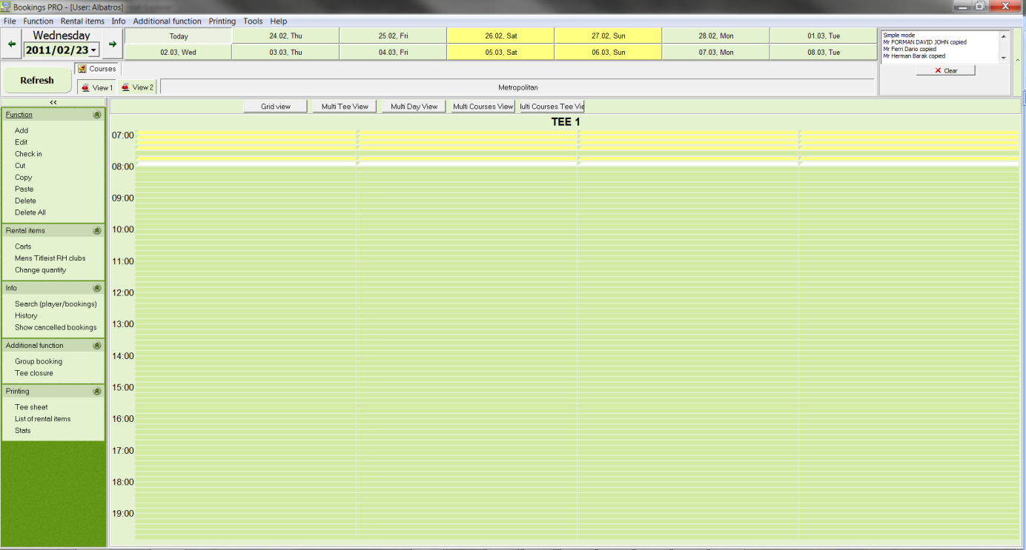

The ‚Multi Tee View‘ shows both Tee 1 and Tee 10 – if setup accordingly – as well as the daily view. On this screen, all bookings are shown coloured and when moving your mouse over the relevant tee time; a pop-up window shows the pairing. This view gives a good indication of the daily occupancy rate of the course.

  - Multi Day View
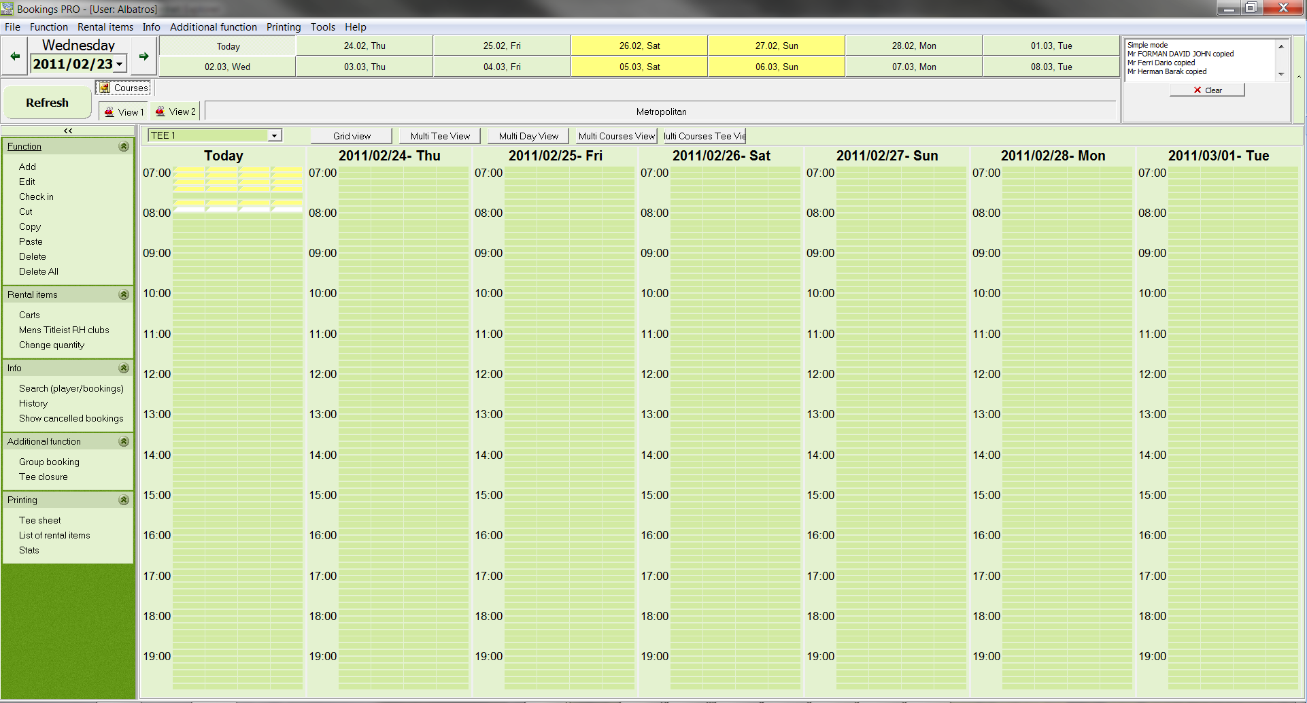

The “Multi Day View” shows today and the next 6 days. On this screen, all bookings are shown coloured and when moving your mouse over the relevant tee time; a pop-up window shows the pairing. This view gives a good indication of the weekly occupancy rate of the course.

  - Multi Courses View
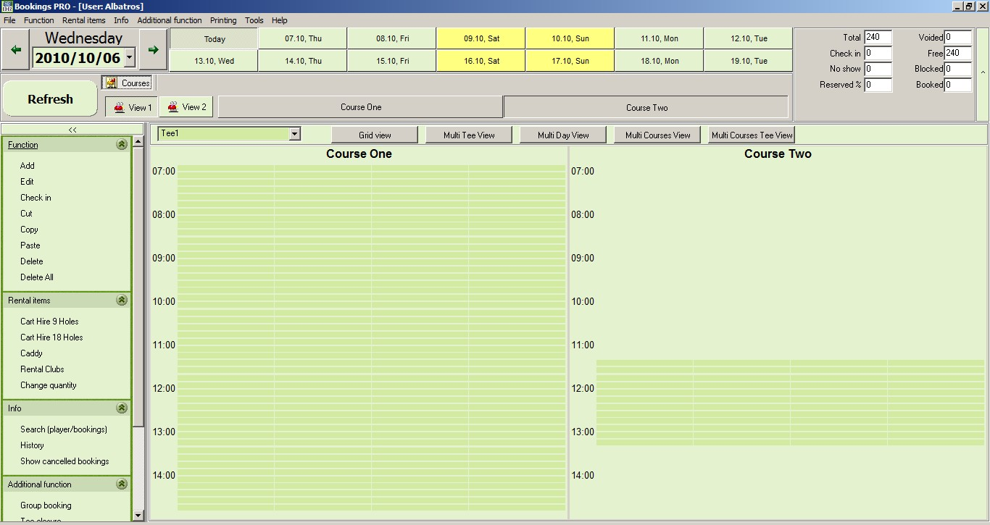

As the name states, the ‚Multi Courses View‘ shows the tee sheet of several (selected) courses on the Tee 1. On this screen, all bookings are shown coloured and when moving your mouse over the relevant tee time; a pop-up window shows the pairing. This view gives a good indication of the weekly occupancy rate of a tee.

  - Multi Course Tee View

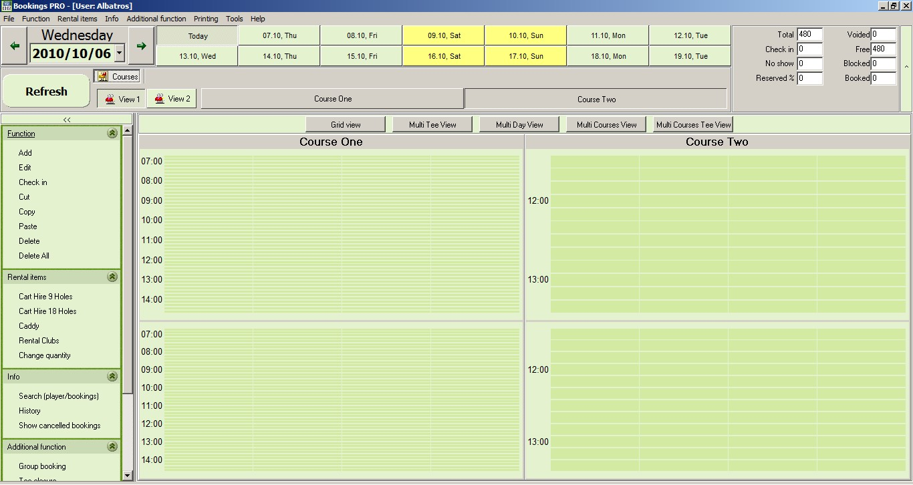

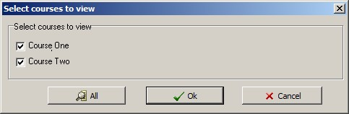

The screen ‚Multi Courses Tees View‘ offers you the option of choosing several courses on both Tee 1 and Tee 10. On this screen, all bookings are shown coloured and when moving your mouse over the relevant tee time; a pop-up window shows the pairing. This view gives a good indication of the weekly occupancy rate of both tees.
- Menu
Albatros ‘Bookings’ is subdivided into 5 standard menus which can be accessed via die menu bar as well as the Explorer bar.

  - Menu „Function“
Add By clicking on the ‚Add‘ button, a dialog window called „Simple Add Mode“ opens. Here you have the option to open a tee time and to add one or more players, with or without adding rental items, process the check-in, determine the details for the booking and perform SAGA matching.
Edit By clicking on the ‚Edit‘ button, a new window called „Simple Edit Mode“ opens in which you can edit bookings, add rental items, process a check-in, add guests, delete individual players or a whole pairing. This function also offers a history of all bookings as well as a search function for a player. This enters the ‘edit’ mode too.
Check-In Clicking on the ’Check-In’ button activates the Check-In-function. If you click on a player with a booked tee time, you can confirm his status. In a similar manner, a player that has been checked in mistakenly can be checked out again.
Cut The ‚Cut‘ function is activated by clicking on the ‚Cut‘ button. This mode allows you to move a player on the times sheet by ‘cutting’ him from a pairing and then entering him into another using the ‘paste’ function. The player will be deleted from his first pairing and added to the requested group.
Copy The ‚Copy‘ function is activated by clicking on the ‚Copy‘ button. This mode allows you to copy a player in a pairing and by changing into the ‚paste‘ mode, entering him in another tee time. The player then remains in both the first pairing and in the new one.Paste The ‚Paste‘ function is activated by clicking on the ‚Paste‘ button. This function assists in entering a cut or copied player or pairing into a new tee time. If you used the ‘cut’ function, the previous tee time will be available once again, or if you used the ,copy’ function, the first time is not deleted.
Delete Clicking on the ‚Delete‘ function activates the single deletion function. This allows for deleting of individual players in a pairing. Click on the player and confirm the process by choosing ‘Yes’. This process cannot be reversed.
Delete All Clicking on the ‚Delete All‘ function activates the deletion function of a whole tee time booking. This allows for deleting of all the players in a pairing. Click on the pairing and confirm the process by choosing ‘Yes’. This process cannot be undone.
  - Menu „Rental items“
Caddies By selecting the hire article you can assign it to as many players as you like at the same time. The function is activated by clicking on the specific article, you then select the player to assign the article to that player, you can then click on as many players as you like to assign the same article. .
Ladies Club Sets By selecting the hire article you can assign it to as many players as you like at the same time. The function is activated by clicking on the specific article, you then select the member to assign the article to that member, you can then click on as many members as you like to assign the same article.
Mens Club Sets By selecting the hire article you can assign it to as many players as you like at the same time. The function is activated by clicking on the specific article, you then select the member to assign the article to that member, you can then click on as many members as you like to assign the same article. .
Change quantity Selecting the button ‘Change quantity‘ opens the administration of the rental items. This section allows you to manage your rental items, e.g. allocating a certain number of rental items such as golf carts, trolleys or rental sets to a block booking. The temporary non-availability of items (e.g. servicing of golf carts; seasonal rental of a cart by a member) can be recorded here as well as the temporary increase in items (e.g. an extra rental set).

  - Menu „Info“
Reservation search Selecting this button opens a new window where you can search for certain items by using one of the following categories: surname, first name, customer no., invoice no., course selection for certain period such as today, this week, this month, this year or a user defined period (custom). The result of the search can also be printed.
History By choosing the ‚History‘ function, one can see the individual steps in the booking process for a player. First select the player and then the ‚history‘ button.
Show cancelled
bookings By choosing the function ‚Show cancelled bookings‘ you can view cancelled bookings according to the date, the course and the tee. The detailed window shows further variables such as the date of cancellation, logged in use etc.

  - Menu „Additional functions“
Group bookings This function assists in booking groups. One can select several players at once and at the end of the booking procedure, they are automatically entered into the chosen time slot. The group booking is marked in a different colour and highlighted by an additional comment. It is then possible to add rental items such as trolleys or golf carts or to check in or delete individual players and add new ones. A bookings history can also be requested.
Tee closure This function allows the user to block tees for certain periods. The blocking can be done for a date, a course or a tee and can be used to inform users about the non-availability for a period, a day or even several weeks. A comment can be added for additional information.

  - Menu „Printing“
Tee sheet By selecting the ‚Tee sheet‘ function, the current day‘s tee sheet is transformed into a printable document. The tee sheet shows the following data: Name, 9/18 holes, customer type, handicap and check-in status.
List of rental items This function aids in printing a list of rental items that have been requested. The list displays the rental period, date and time of rental, the name of the customer and the respective booking details.
Stats The selection of the ‚Stats‘ function displays the monthly data with daily occupancy in a printable format. This monthly stat shows the analysis for the chosen course.

- Booking a tee time
  - Book / Change
- Click on the ‚add‘ button in the ‚Function‘ menu.

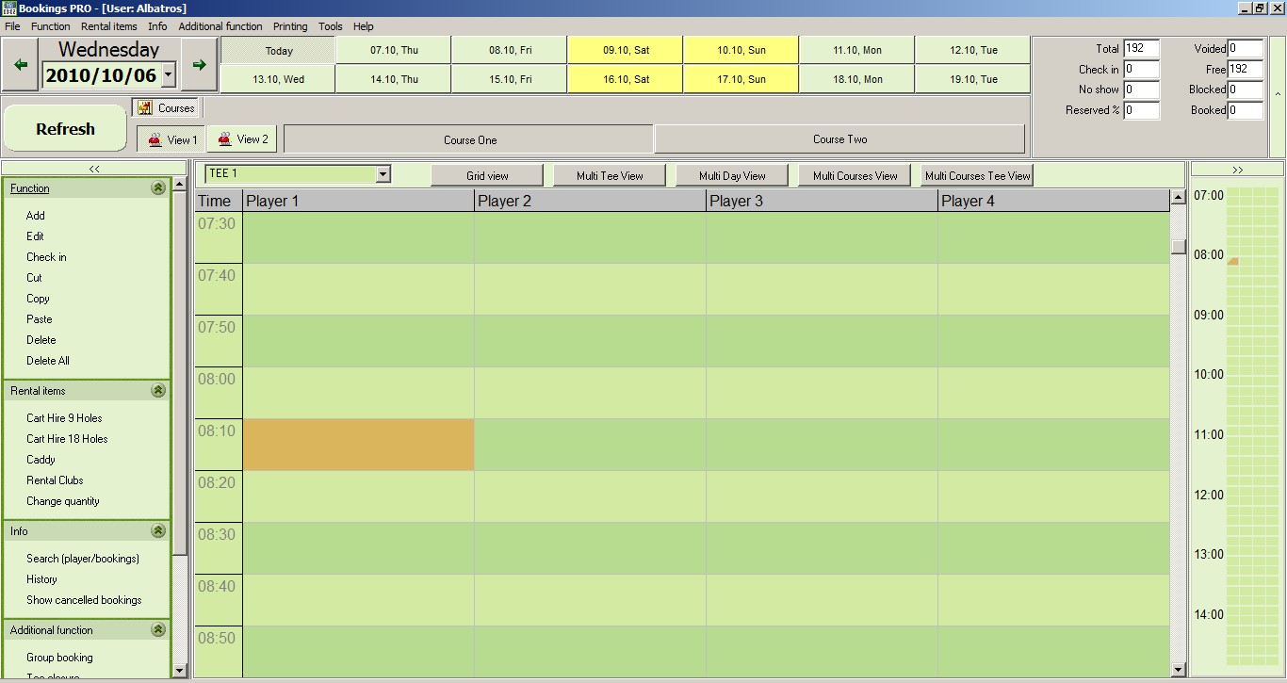
1st step:
Choose ‘Add’ by clicking on it.

2nd step:
Choose the tee time for the booking.

- Choose the requested time slot with your mouse and click on it.

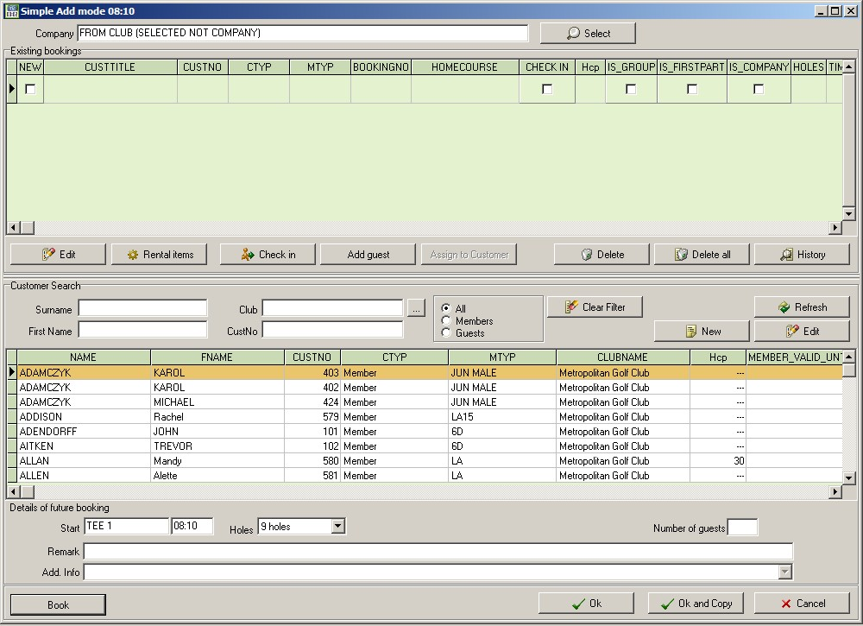
3rd step:
Click on the variable „Surname“, then enter the name. The program automatically begins searching for the customer.
- A dialog window opens up. To enter the customer‘s name, you have several options. You can start the search by either entering the surname, first name, customer number, the home club or by clicking on his name by scrolling in the displayed list.

- Our example describes the search by entering the surname. Click in the ‘surname’ field and enter either parts or the whole surname. After the first 3 letters Albatros will start searching for the customer in its database!

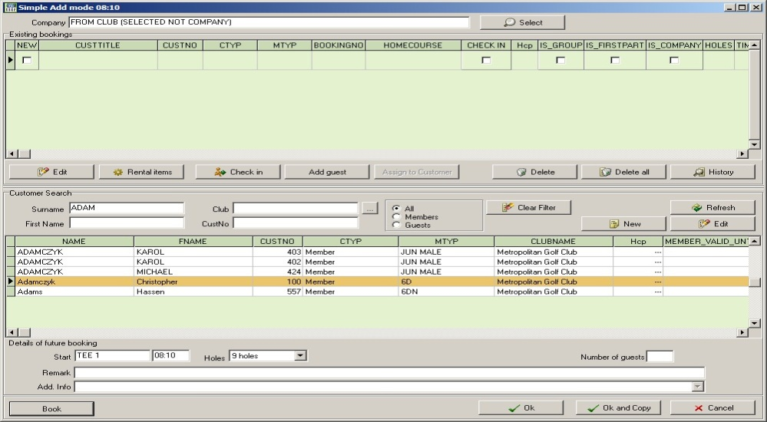
4th step:
Choose the player from the searched list and click on the button ‚Book‘.

- From the results of the search, choose the relevant player by clicking on him, so that he is marked in a different colour, then click ‚Book‘.

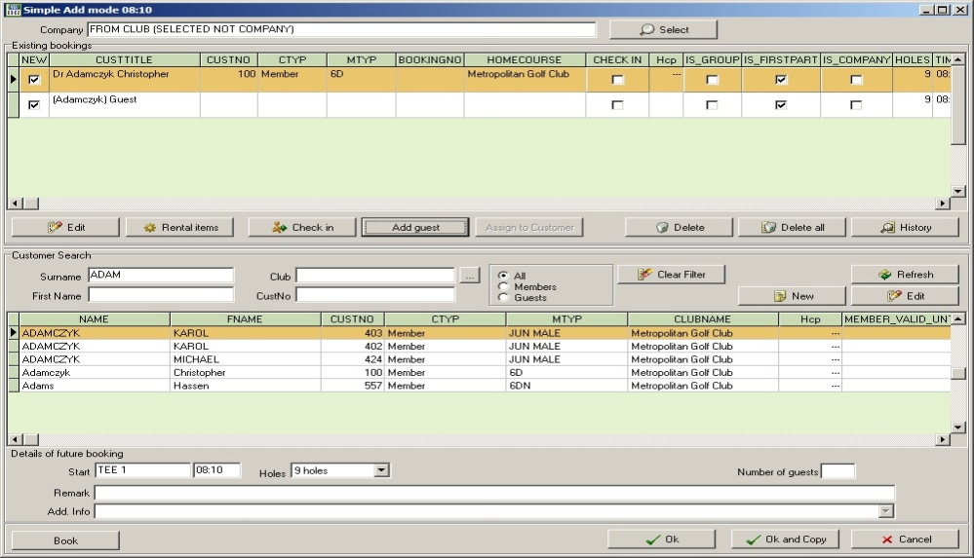
5th step:
Add further players – here in this example, non-listed customers – by clicking the button ‚Add guest‘.

- Should you want to add further members, click ‚Clear filter‘ and repeat the procedure. You can also use the ‘Add guest’ button to add a maximum of 3 players to this pairing without entering the names. In our example the screen will look as follows:

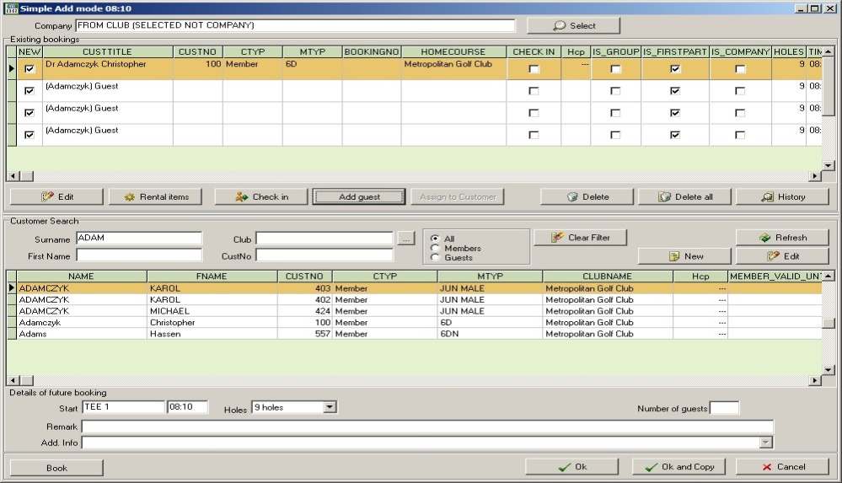
Confirm the booking by clicking on the buttons ‚Book‘ and ‘Ok’.

- To complete the booking process, click on ‚Book‘ and confirm by clicking ‚Ok‘. In our example, the screen shot would look as follows:

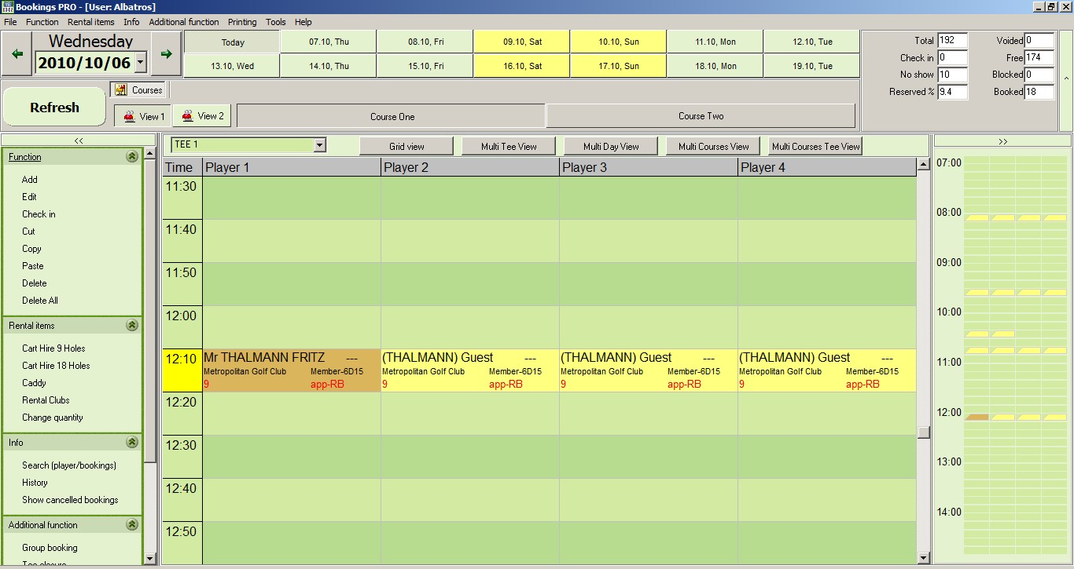
This shows the new pairing with all details in the daily view as well as in the overview display on the right of your screen.
  - Delete, Delete All
The ‚delete’ function is available in several parts of the module, most evidently in the Toolbar menu on the left under ‘Function’ as well as in the pop-up window that appears when you click on a booking. One has the option to delete a single player or the whole pairing (or four ball). Please note that this step cannot be undone.

To delete, proceed as follows:
- In the ‚Function‘ menu, click on ‚Delete‘.
- Now click on the player you wish to delete. Once you have done this, a pop-up window asks, whether you want to delete the specified booking.

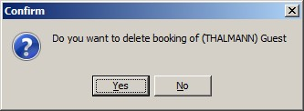
You need to confirm the delete command with ‘Yes’.

- If your selection was the right one, click on ‚Yes‘ to confirm deletion, otherwise click on ‚No‘. After confirmation of the command, the screen reverts back to the former window.

The deleted ‚Name from example Guest‘ has now been removed from the pairing and the screen should look as follows:

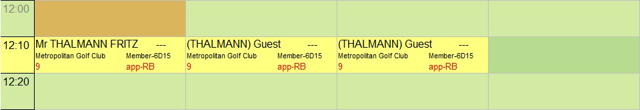
Note the available spot in this fourball after deleting a guest.

To delete a whole pairing, proceed as follows:
- In the ‚Function‘ menu, click on ‚Delete All‘. 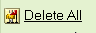
- Now click on the player in the pairing that you wish to delete. Once you have done this, a pop-up window asks, whether you want to delete all customers.

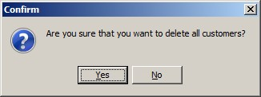
You need to confirm the delete command with ‚Yes‘.

- If your selection was the right one, click on ‚Yes‘ to confirm deletion, otherwise click on ‚No‘. After confirmation of the command, the screen reverts back to the former window.
The deleted pairing or four ball has now been removed from the tee sheet and the screen should look as follows:
Tee time becomes vacant immediately after confirming cancellation of a booking. The tee time is now available again for booking.
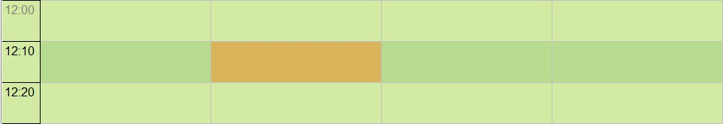

  - Cut, Copy & Paste
The ‚Cut‘ function is activated by clicking on the ‚Cut‘ button. This mode allows you to move a player on the times sheet by ‘cutting’ him from a pairing and then entering him into another using the ‘paste’ function. The player will be deleted from his first pairing and added to the requested group. This mode also allows you to cut a player from one tee time and paste him in another without having to delete him in the first pairing and then re-entering him in the new tee time. Here is how to go about it:

- Click on ‚Cut‘ in the menu bar on the left.

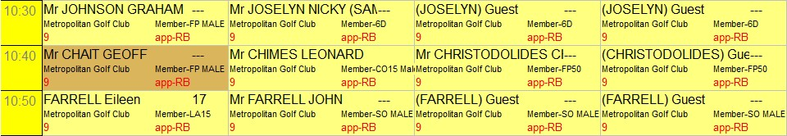
Click on the player that you would like to mark or to move.

- Click on the player which you would like to move. In our example, we are choosing „Chiat Geoff“.
- Now click on ‚Paste‘ in the menu bar on the left and then click on the tee time that the player would prefer to tee off.

A window appears, requesting you to confirm the pasting by clicking on ‚Ok‘:

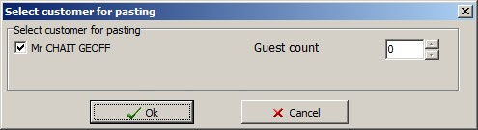
Name of the chosen player appears here. Confirm pasting with ‚Ok‘.

- If you would like to move the player, click on ‚Ok‘ to confirm. The module now automatically switches into the ‚Simple Add Mode‘.

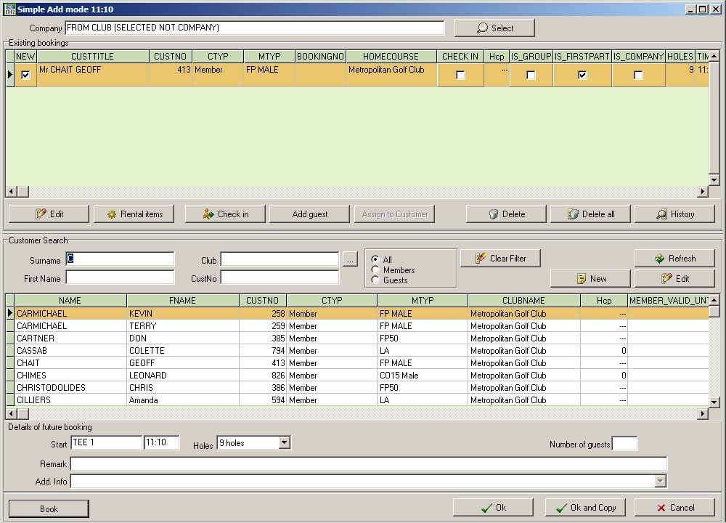
Chosen customer is shown and can be moved by clicking the buttons ‚Book‘ and confirming with ‚Ok‘.

Hint: Make sure that the search fields are empty, otherwise a further customer will be added to the booking.

- If no other customers or guests are to be added, you can confirm the change by first clicking on ‚Book‘ and then confirming with ‚Ok‘. The customer will now be cancelled in the first booking and added to the second. Here is a screen shot for our example:
Customer is cut, the remaining players in the pairing are moved to the left. An available spot for single customer becomes available.

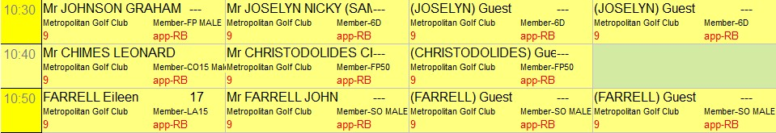

Screenshot of the pairing into which the customer was pasted:

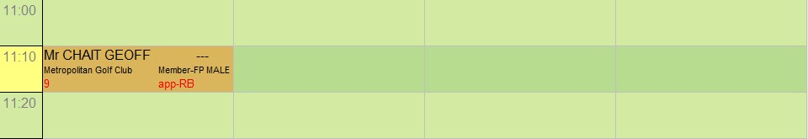
The previously cut customer ,Chait Geoff has now been pasted into the pairing at 17.00 o’clock.

Hint: Making sure that all search fields are empty is vital; otherwise a further customer will be added to the booking.

The function ‚Copy‘ works very similar in conjunction with „Paste“. The only difference is that by copying the customer, his place in the first time slot remains and he is entered into the new spot as well. This saves time as you don’t have to enter the player again.

To copy, proceed as follows:

- Click on ‚Copy‘ in the menu bar on the left.
- Click on the player which you would like to copy. In our example, we would like to copy „Chait Geoff into a later pairing.
By clicking on a customer after activating the function ‚Copy‘, the customer is saved in a temporary memory.
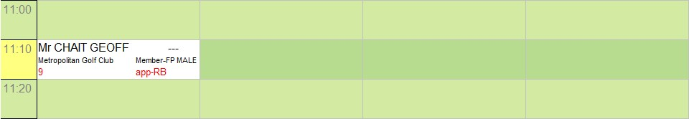

- Now click on ‚Paste‘ in the menu bar on the left and then click on the tee time that the player would also like to tee off.

A window appears with the security question for the ‘Paste’ function:

Chosen customer is listed, confirm by clicking on ‚Ok‘.

- If you would like to ‚copy‘ the player, click on ‚Ok‘ to confirm. If you have mistakenly chosen the wrong tee time to copy the player into, click on ‚Cancel‘. After confirming by the copy function by clicking on ‘Ok’, the module now automatically switches into the ‚Simple Add Mode‘.

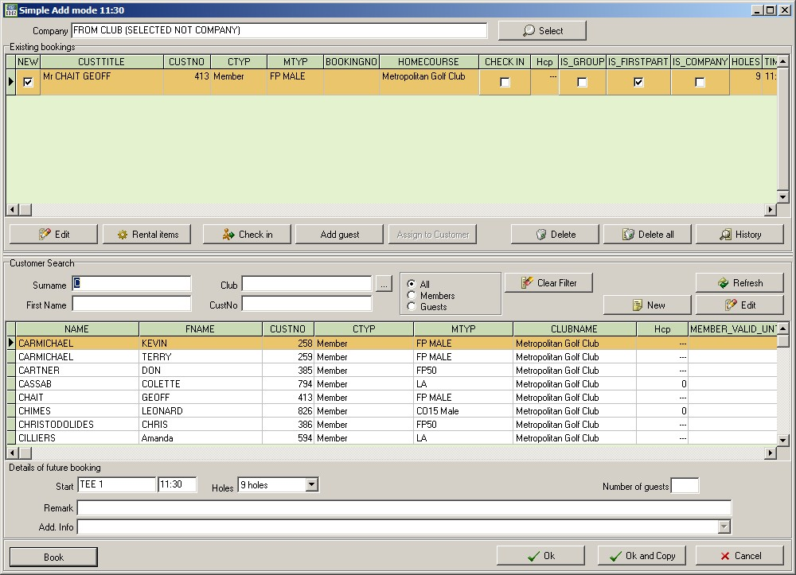
Selected customer is shown and can be copied by clicking on ‚Book‘ and ‚Ok‘.

Hint: Remember to clear all search fields to prevent another customer being added.

Screenshot of the time slot from which the player was copied:

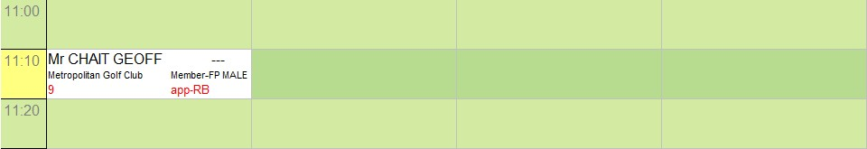
Customer has been copied and therefore also remains in the original pairing.

Screenshot of the new booking for the player:

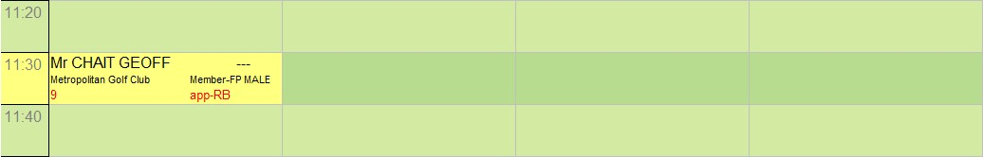
Copied player has now been booked into another tee time.

- To empty the temporary memory, click on ‚Clear‘ in the window in the top right of your screen.

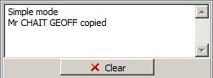
Window explains executed function.
To remove window, click on ‚Clear’.

The default window for this part of the screen reappears, showing the stats for the day.
  - Follow on bookings, Check-In, Remarks
Follow on bookings are done in the same manner as already described in this chapter. The only difference is the date. There are several ways to achieve this goal.

Option 1
The desired date is shown as a button on the top of your screen and can be chosen by clicking on it.

Option 2
If the desired date is just a couple days in the future, you can choose the date on the top left of your screen with the help of the arrow buttons.

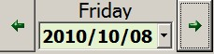
Use the left and right arrows to choose the desired date.

Option 3
If desired date is more than a couple of days away, activate the calendar by clicking on button on the right of today’s date.

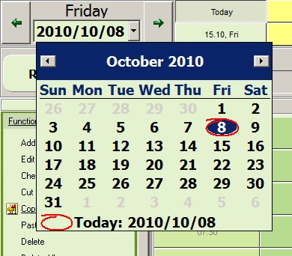
Default calendar with the option of using the arrows to jump to the next month. Choose date by clicking on it.
Today’s date is indicated by the red circle.

- Choose the option which allows you to select the desired date the quickest.

The process of checking in a player can be done either when first entering the player into the booking system or later when he comes to register.

    - Step-by-step procedure to Check-In
- Click on ‚Check-in‘ in the menu bar on the left.
- Click on the player that you would like to ‚check-in‘. A window pops up with the following message:

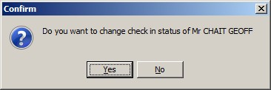
Changing the Check-In status: By clicking on the button ‚Yes‘, the player is checked in. Choose ‘No’ if you don’t want to check the player in.

- Answering the security question with ‚Yes‘, checks the player in. Should you have chosen the wrong player, click on ‚No‘ to revert back to the previous screen.

The flag is the Check-in symbol.
Before Check-In: After Check-In:

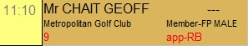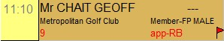

The checked-in status of a player will be indicated on the main screen with a small red flag in the bottom right hand corner.

Hint: If you notice that you have checked-in the wrong player, this status can be reversed by selecting the player again.

    - Use of the ‚Remark‘ field during the ‚Add‘ function
- If you would like to leave a note or remark for a specific four ball, have a look in the section ‚Details of a future booking‘ and use the allocated space next to ‚Remark‘ to enter your comments.

If the field has a remark entered, this is displayed on the main screen in the following way:
Symbol indicating a note was added to this booking

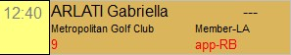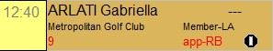

The information can also be allocated to all players in the pairing.

- Group bookings
  - Creating / Changing
- Click on ‚Group bookings‘ in the section ‚Additional function‘ in the menu on the left.
- Choose the tee time when the group is meant to start. Don’t forget to take the number of players and the available free times behind the chosen time into account.

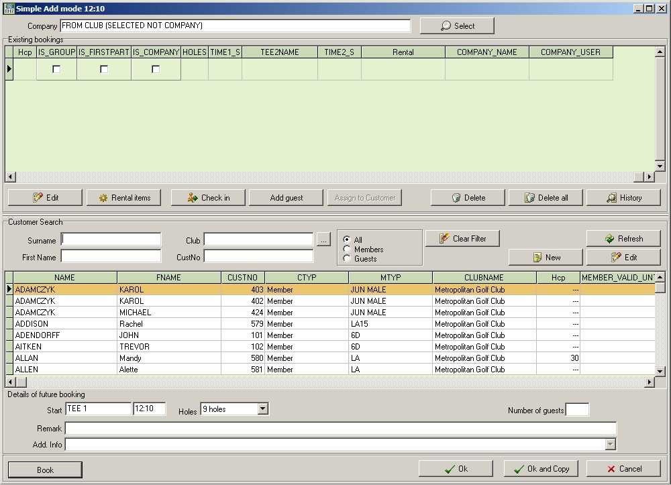
Select the players using the Function ‚Customer search‘, & ‚Book‘. You can also add guests (‚Add guest‘), even if you don’t know all names.

- After clicking on a tee time, the window „Group Add Modus‘ opens. Choose the members and guests from the current list. Be aware of a sensible grouping of the pairings. In this mode, the program doesn’t show whether a tee time is filled and the max. number of players is reached. In our example, we have selected 8 players:

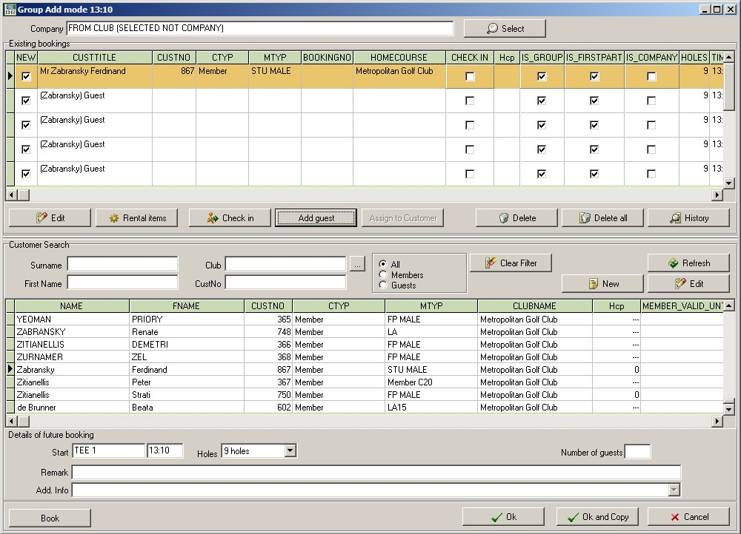
„Book“ and „OK“ complete the group booking and create the desired entry into the tee sheet.

- Click on the buttons ‚Book‘ and then ‚OK‘.

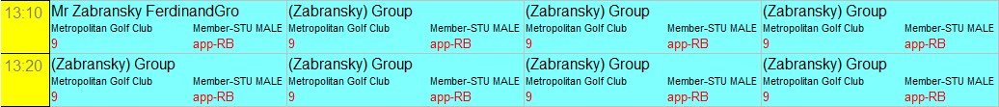
You have now created your group booking.

- Immediately after clicking ‚Ok‘, your group booking will be entered into the times sheet by the program. For easier recognition, your group booking will be highlighted in a different colour and the word ‘Group’ is added after the players names. (Group entry reference)

  - Changing a group booking:
To change a group booking, you can choose any player that is part of the group. Should you only want to change data of a player or even add a remark to his booking, you obviously need to select that player. In our example, we would like to add a remark to the player ”Zabransky Ferdinand”

- Select the player “Zabransky Ferdinand” within the list of players in the group booking. Make sure that the correct player is highlighted.

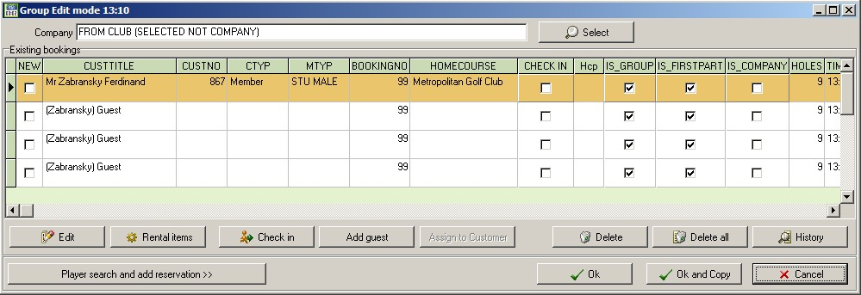
Choose the player you want to edit.
Click on ‚Edit‘ to enter the remark in the pop-up window.
- Then click on ‚Edit‘.

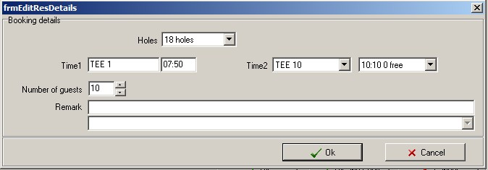
Add your remarks in the available space.

- Enter your comments in the ‚Remark‘ field and confirm by clicking on ‚Ok‘.

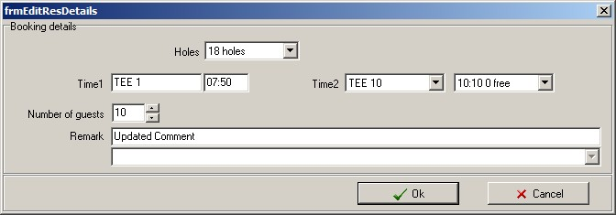
Confirm by clicking on „OK“.

Now the customer Zabransky Ferdinand has a remark attached to his booking. You can add more comments to other customers as well. In this example, you can see that all players, except for Joe Alblas, have been checked in. This function is also applied individually, and not necessarily to the whole group.

The symbol ‚I‘ indicates that a remark is attached to the booking.
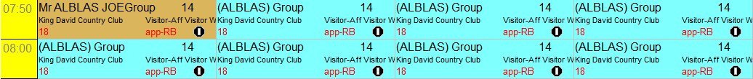

  - Deleting a single player / Deleting a group
Just like with an individual booking, you can delete a player or a whole pairing / group in the group booking. The procedure is the same. Please just remember that this step is not reversible.

The function ‚Delete‘ is available in several parts of the module (as described on page 18), most evidently in the Toolbar menu on the left (Explorer strip) under ‘Function’ as well as in the pop-up window that appears when you click on a booking.

To delete a single player who is part of a group booking, proceed as follows:

- In the ‚Function‘ menu, click on ‚Delete‘. 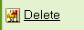
Group booking before deleting a single player

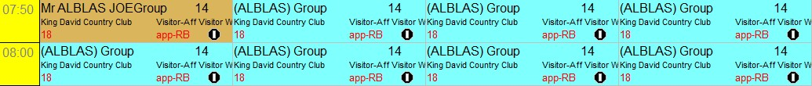

- Now click on the player you wish to delete (in our example Joe Albas). Once you have done this, a pop-up window asks, whether you want to delete the selected booking

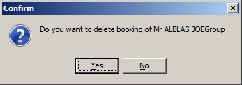
Security question before deleting a single player of a group.

- If your selection was the correct one, click on ‚Yes‘ to confirm deletion, otherwise click on ‚No‘. After confirmation of the command, the screen reverts back to the former window.

The deleted player Beckenbauer, Dolly (Group)“ has been removed from the pairing. In our example the screen shot would be as follows:

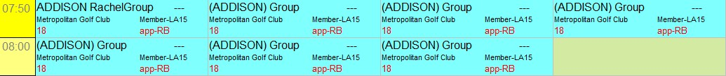
Empty spot after deleting a customer in a group booking.

To Delete a group booking, proceed as follows:

- In the ‚Function‘ menu, click on ‚Delete All‘ .

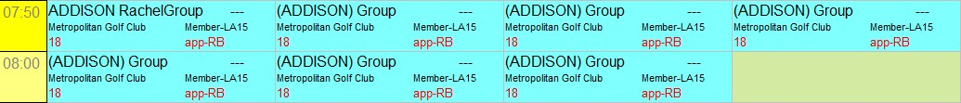
View of the group booking before deletion.

- Now click on any player within the group you wish to delete. Once you have done this, a pop-up window asks, whether you wan to delete all customers within this booking:

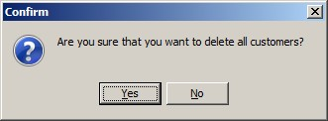
Security question before deleting a whole group.

- If your selection was the correct one, click on ‚Yes‘ to confirm deletion, otherwise click on ‚No‘. After confirmation of the command, the screen reverts back to the former window.
The deleted group booking has been removed from the tee sheet. In our example, this would look as follows:

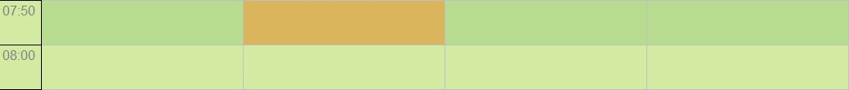
Immediately after confirming deletion, the times are available again.

  - Copying and pasting a group booking
To copy a group booking, proceed as follows:

- Click on ‚Copy‘ in the menu bar on the left or just
- Click on the players of the group that you would like to copy. In our example, we’re copying all players for a new group.

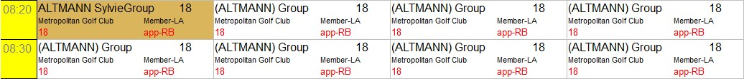
By clicking on a player after activating the function ‚Copy‘, the player is saved in the temporary memory.

- Now click on the function ‚Paste‘ in the menu bar on the left and choose a date and tee time for the group to be copied to.

Once you have done this, a pop-up window appears:

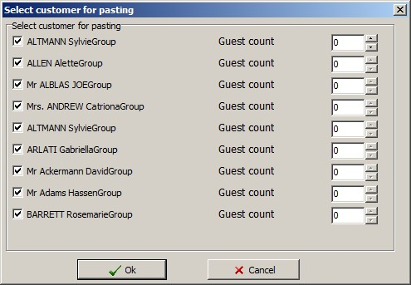
Selected players as well as guests of the selected players are listed individually.
Confirm by clicking on ‚Ok‘ or ‚Cancel‘ if you don’t wish to go ahead with the procedure.

- Confirm the copy process by clicking on ‚Ok. If you don’t wish to go ahead with the procedure, click on ‚Cancel‘. After confirmation of the command, the screen reverts back to the former window.

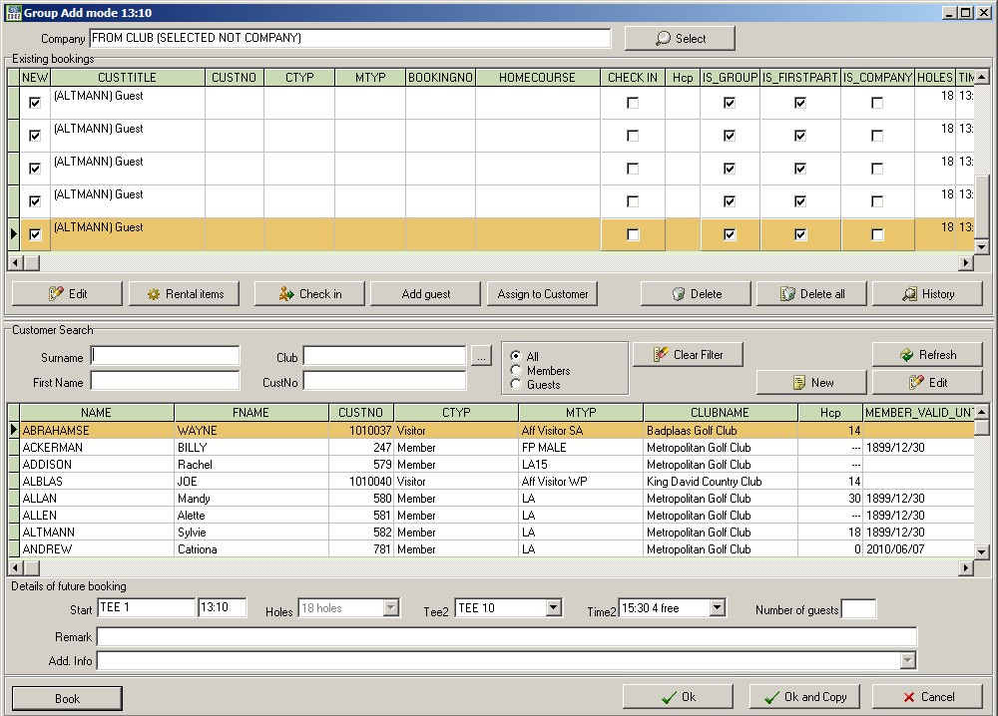
Selected players of the group booking are listed individually and can be copied using the buttons ‚Book‘ and ‚Ok‘.
Hint: Remember to clear all search fields to prevent another customer being added.

Screenshot of the group that was used to copy:
Players have been copied, so their original tee time will remain in place.
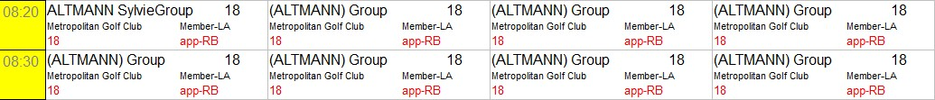

Screenshot of the pairing, where the player was pasted:
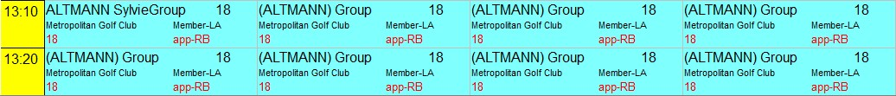
Copied players are now also entered in the second tee time.

To empty the temporary memory (window in the top right hand corner), click on ‚Clear‘

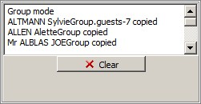
First line indicates the group mode. To empty temporary memory, click on ‘Clear’.

The screen reverts back to the default booking screen and you can view the stats for the day in the top right corner again.

  - Checking in individual players that are part of a group
The process of checking in a player can be done either when first entering the player into the booking system or later when he comes to register.

This program does not offer the function to check in a whole group at the click of one button, as it seldom happens that all players in a party arrive at the same time.

You therefore have to check in each player individually.

    - Step-by-step procedure to Check-In:
- Click on ‚Check-in‘ in the menu bar on the left.
- Click on the player that you would like to ‚check in‘. A window pops up with the following message:
Changing the Check In status: By clicking on the button ‚Yes‘, the player is checked in. Choose ‘No’ if you don’t want to check the player in.

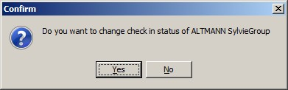

- Answering the security question with ‚Yes‘, checks the player in. Should you have chosen the wrong player, click on ‚No‘ to revert back to the previous screen.

Before Check-In: After Check-In:
The flag is the Check-in symbol.

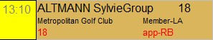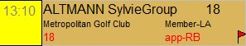

The checked-in status of a player will be indicated on the main screen with a small red flag in the bottom right hand corner.

Hint: If you notice that you have checked in the wrong player, this status can be reversed by selecting the player again.

- Tee closure
  - Enter / Change
- If you would like to close a tee box, this can be done by choosing ‚Tee closure‘ under ‚Additional functions‘ in the menu on the left. Clicking on the button will open the following window:
1st step:
Make sure that you have chosen the correct date, time & tee box that you wish to close.
Should the data be wrong, you can rectify this, by using the sliding button on the side..

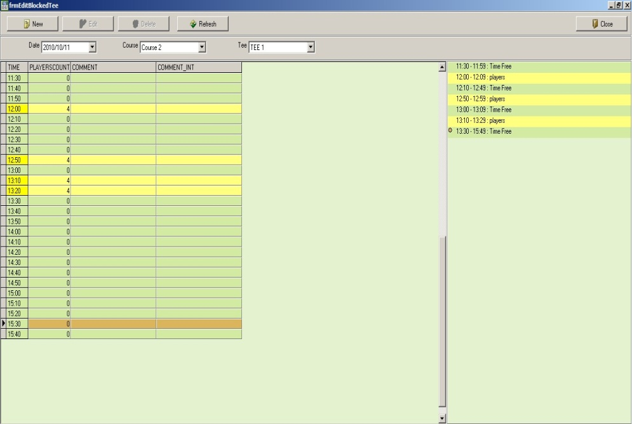
2nd step:
Click on the ‘New‘ button to block off some tee times.

The screen shows the chosen day with all available tee times, the selected course and tee box. On the right side of the screen, you can view the existing bookings for the day.

- To block off (a) tee time(s), click on ‚New‘ on the menu bar at the top. A new window called “Select time” pops up:

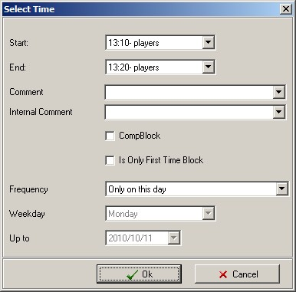
3rd step:
Choose the time you wish the closure to commence and the time that it ends. Clicking on the arrows next to the time, shows the available times for the day.

In our example, we have chosen to block off the tee from 13:10 to 13:20.

- Choose the desired starting and end time for the closure of the tee. The scrolling option to the right of the time assists in this process.

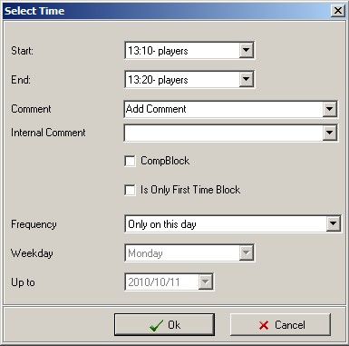
4th step:
Enter a comment to explain the reason for blocking the tee. Should you wish to choose from the options offered, click on the arrow before making your choice. (Text formatting done in the AlbAdmin module).

- To confirm the chosen tee closure, click on “Ok”. Should you for any reason be unsure, you can abort the process by clicking on ‘Cancel’ and no entry is made into the times sheet.

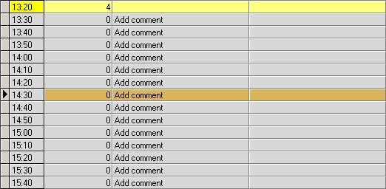
View of the times blocked. The time, number of players and comment are displayed.

The chosen closure with the comment (blank in this instance) is entered from 13:20 to 13.30. Once confirmed, the tee times are blocked for access from any other Albatros module as well. The identical comment is displayed in all programs.

  - Recurrence, Frequency
One can obviously enter recurring closures without having to enter them for each occurrence. The procedure is just like the one for a once-off entry as described above.

- If you would like to enter a recurring closure of a tee box, this can be done by choosing ‚Tee closure‘ under ‚Additional functions‘ in the menu on the left. Clicking on the button will open the following window:

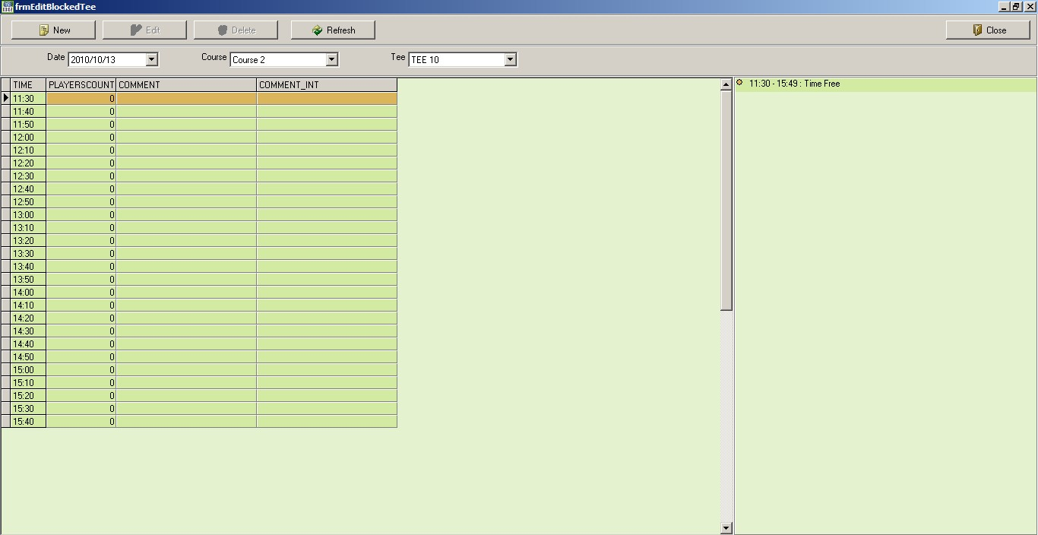
1st step:
Make sure that you have chosen the correct date, time & tee box that you wish to block off.
Should the data be wrong, you can rectify this by using the sliding button on the side of the screen.
2nd step:
Click on the ‘New‘ button to enter a new recurring closure of a tee.

The screen shows the chosen day with all available tee times, the selected course and tee box. On the right side of the screen, you can view the existing bookings for the day.

- To block off (a) tee time(s), click on ‚New‘ on the menu bar at the top. A new window called “Select time” pops up:
3rd step:
Choose the time you wish the blockage to commence and the time that it ends. Clicking on the arrows next to the time, shows the available times for the day.

In our example, we have chosen to enter a recurring blockage of the tee from 11:30 to 15:40, every Wednesday.

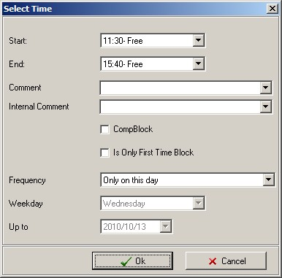

- Choose the desired starting and end time for the blocking off of the tee. The scrolling option to the right of the time assists in this process.

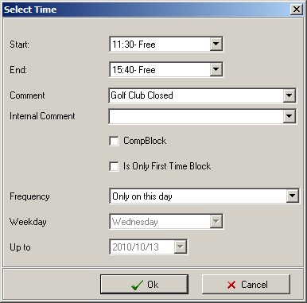
4th step:
Enter a comment to explain the reason for closing the tee. Should you wish to choose from the options offered, click on the arrow before making your choice. (Text formatting done in AlbAdmin module).

- Now choose the frequency – in our example, once a month:

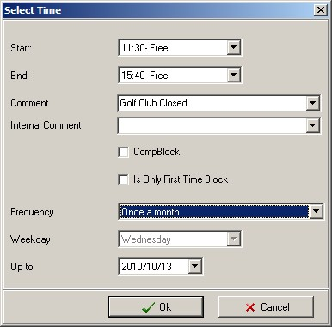
The following frequency options are available:

- Only on this day
- Daily
- Daily on weekdays
- Daily on weekends
- Every 2nd day
- Once a week
- Every 2nd week
- Once a month

Several combinations are possible .depending on the reason for closure.

- You begin on the first closure on the day you are viewing. Now enter the range of the recurrence by entering the „Up to‘ field. Our example ends on 13/10/2010.

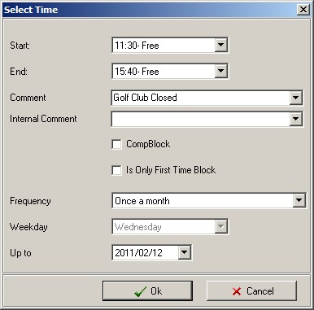
Choose the last date of the recurring closure. A calendar window opens up. Select the end date by clicking on the date.

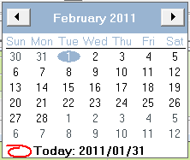

- To confirm the recurring closure, click on ‘Ok’.

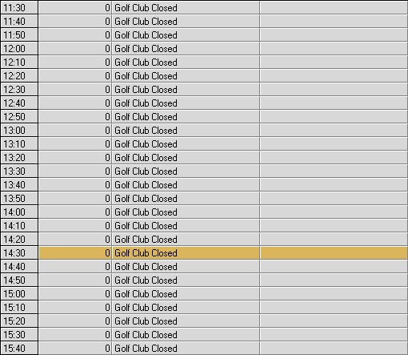

  - Deleting or changing a closure
- To delete or change a closure, click on ‘Tee closure” in the left menu bar. The screen will display a closure as follows:

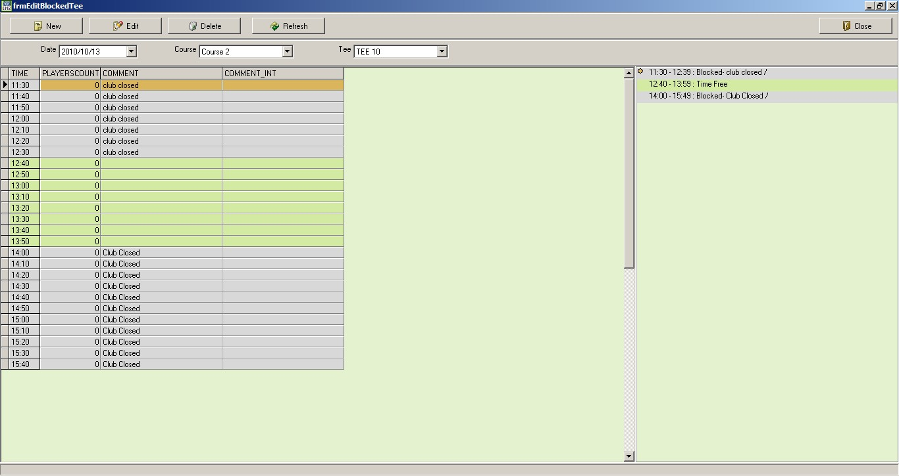
The date we have chosen, shows two periods for which the tee is closed.

11.³⁰-12.30 , duration 1 hour
14.⁰⁰-15.30 , duration 1 hour, 30 minutes

We would like to change the 2nd closure to end an hour earlier.

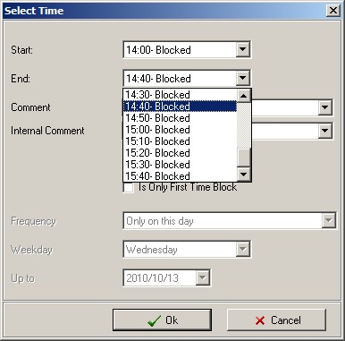 | Select the closure, then click on ‚Edit‘ from the menu at the top.  A new window opens, giving you the opportunity the change the end time of the closure. Chose the correct time by clicking on the scrolling option.

After selection, the window looks as follows:

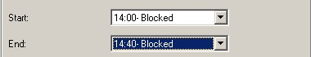
New select the end time

- Confirm the change by clicking on ‘Ok’. The new closure period appears on the main screen.

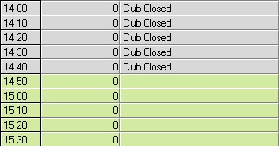
New closure:
Blocked until 14.40, next available time is at 14.50. The closure from 14.00 – 15.30 was changed following the above mentioned procedure and therefore these tee times have become available for bookings again.

As you can see, the tee times between 14.50 and 19.00 are available for bookings again.

  - Cancellation of a tee closure:
In a similar manner, one can obviously cancel a tee closure setting.

- Choose the closure that you wish to cancel.
- Now click on ‚Delete‘ from the menu at the top.

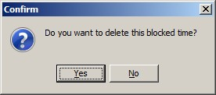
Security question:
Confirm with ‘Yes’ or click ‘No’ if you have mistakenly chosen the wrong tee closure.

- Confirm with ‘Yes’ or click ‘No’ if you have mistakenly chosen the wrong tee closure.
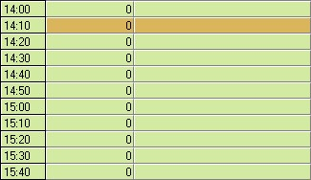
The tee closure was cancelled and the tee times are available for booking again.

Beware: On confirmation of the security question, the tee closure is cancelled. This procedure cannot be undone.

  - Competition module: tee closures for competitions
The Bookings program also offers you the option to reserve the tee for competitions. Die procedure is very similar to a tee closure as discussed, with the only difference being that you tick the option ‘CompBlock’.

- If you would like to close a tee box, this can be done by choosing ‚Tee closure‘ under ‚Additional functions‘ in the menu on the left. Clicking on the button will open the following window:
1st step:
Make sure that you have chosen the correct date, time & tee box that you wish to close.
Should the data be wrong, you can rectify this by using the sliding button on the side. ##Menüreiter seitlich.
Menüreiter seitlich.
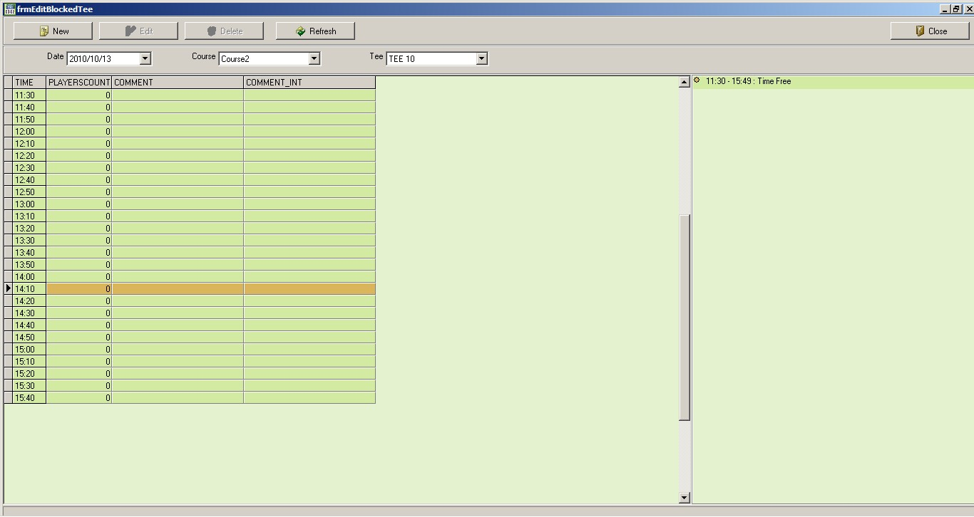
2nd step:
Click on the ‘New‘ button to block off some tee times for the competition.

The screen shows the chosen day with all available tee times, the selected course and tee box. On the right side of the screen, you can view the existing bookings for the day.

- To block off (a) tee time(s), click on ‚New‘ on the menu bar at the top. A new window called “Select time” pops up:

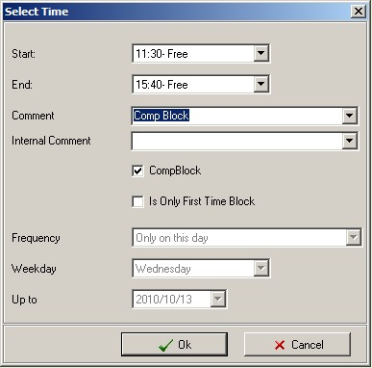
3rd step:
Enter the required variables for the tee closure:

- Start
- End
- Comment

And now click on the field adjacent to ‘CompBlock’ to enter a tick.
All other fields appear grey.

- Choose the start and end of your tee closure for the competition, enter a comment such as the name of the competition and activate the tick in the field next to ‚CompBlock‘ by clicking on it. All further fields appear grey.
Confirm or cancel tee closure.
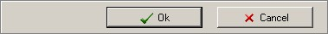

- To confirm the chosen tee closure, click on “Ok”. Should you for any reason be unsure, you can abort the process by clicking on ‘Cancel’ and no entry is made into the times sheet.

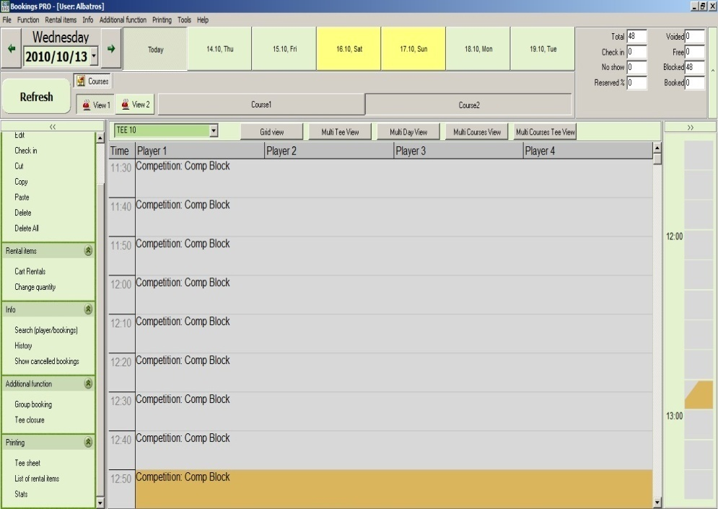
View 1 – Detailed view with readable comment for closure
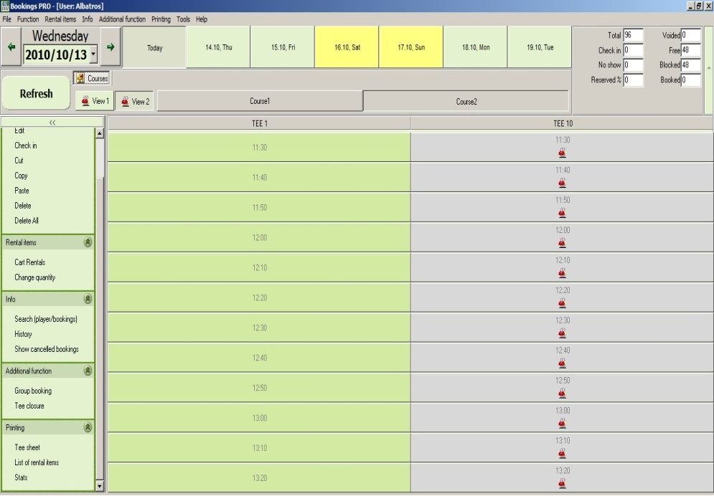
View 2 – Daily view – the reason for the closure pops up when moving the mouse

The tee times for the competition are now blocked off in the Bookings module. No other tee times can be booked in this time slot. The setting of the tee closure has no effect on the Competition module.

- Rental items
  - Setting up of a new or changing of an existing rental item
 | - The setting up and changing of a rental item as well as inventory is done in the module Albatros Admin. Activate this program and log in.
- First select ‘POS Bookings Settings’ from the menu on the left and then choose ‘Rental items settings’.
View of existing rental item choices including info about quantity and delay time.
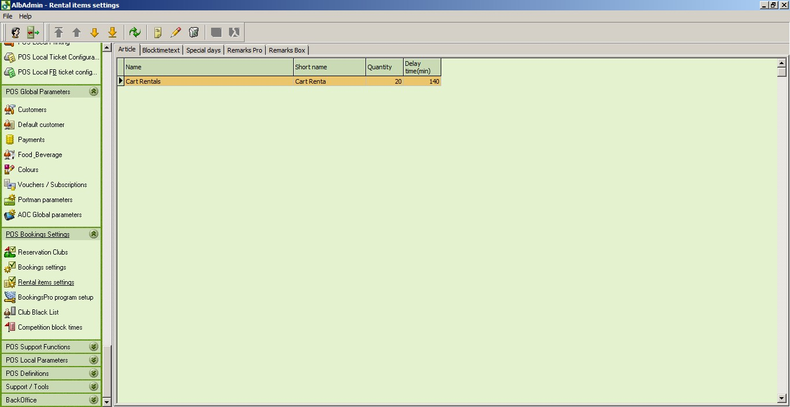
Current menu bar ‘POS Bookings Settings’ and then ‘Rental items settings’.
Optional functions: ‘New’, ‘Edit’ or ‘Delete’

  - Creating a new rental item:
- Click on ‘New’(insert icon) to create a new rental item. The following window appears:

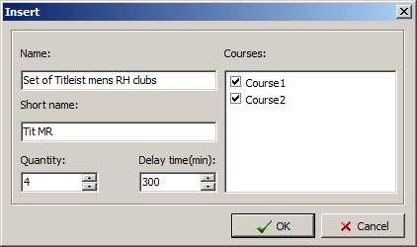

- Enter the name (e.g. Set of Titleist mens RH clubs), shortened version (e.g. Tit MR), the amount available (e.g. 4) and the time delay (e.g. 300 mins – remember to include a battery charge time for Club cars). Should you have several courses, please remember to allocate the items. To confirm, click on ‘OK’.

The newly created rental item has now been added to the list of rental items.

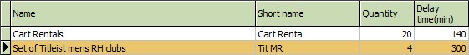

Hint: The new rental item will only be displayed in Bookings if no Bookings programs on the different workstations are activated. You should therefore rather create new rental items outside of business hours.

  - Editing a rental item:
- Highlight the rental item in the list that you wish to edit.
- Then click on the button ‘Edit’ to change into the edit mode.

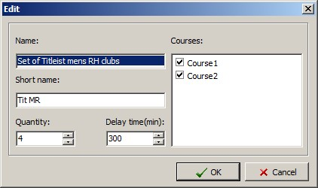

All fields in the ‚Edit‘ mode can be changed. Enter the desired changes as follows:

Name Description of the rental item
Short name Short name for stats and reports
Quantity Available number
Delay time Delay interval until available for next rental
Courses Allocation to certain locations or courses

- Click on ‘OK’ to confirm. The changes come into effect immediately and are visible in Albatros Administration.

Hint: The changes will only be displayed in Bookings if no Bookings programs on the different workstations are activated. You should therefore rather make changes to rental items outside of business hours.

- Close the albadmin module on completion by either clicking on ‚File‘ and then ‚Exit‘; „ALT+F4” or by clicking on the ‘Close’ button top right, so that no-one gains unauthorised access to the administrative section of your software.

  - Allocating and deleting booked rental items
The allocation of a rental item is done in the Bookings module.
Here you have the option to allocate a certain number of rental items to players.

- Click on the requested rental item, e.g.

Then left click on the player who would like to book the item.

The following security question appears:

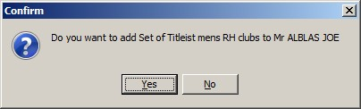
Security question prior to allocating a rental item.

- Click on ‚Yes‘ to book for the player Joe Alblas or on ‚No‘ should you have made an error either in the selection of the rental item or the player.

Once you have confirmed the question with ‚Yes‘, the rental item has been allocated to your customer.

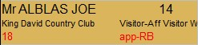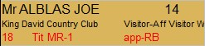

Field before allocation Field after allocation

Hint: Should you have allocated a rental item to the incorrect customer and would now like to remove it, it isn’t sufficient to click on the player again, and to answer the security question again, because the rental item would be allocated a further time. A different solution is necessary.

  - Removing an allocated rental item
- Change into the menu ‚Function‘ and then choose ‘Edit’.
- Click on the player whose allocated rental item you would like to delete. The ‚Simple Edit Mode‘ window opens:

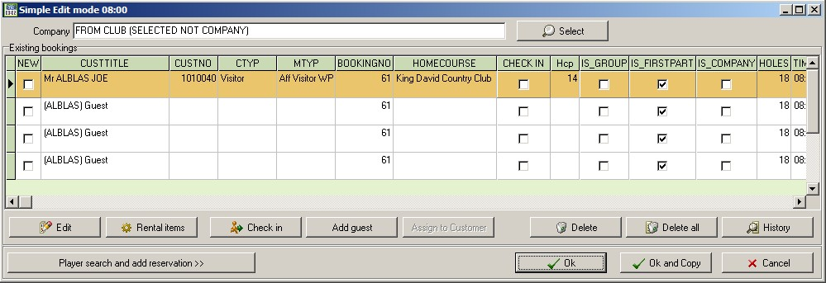
First choose the player and then the rental items button in the Simple Edit Mode.

- In the edit mode, first choose the player and then click on ‚Rental items‘.

The ‚rental items‘ window opens up:

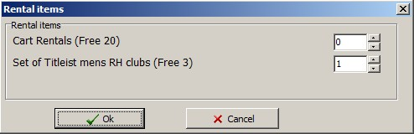
Change the quantity and click on ‘OK’ to confirm otherwise click on ‘Cancel’ to abort edit.

In this window all rental items configured in the program are visible. You can change the quantities of the items by making use of the arrows to change the quantity. Confirm the change by clicking on ‘Ok’. Also confirm with ‘Ok’ in the Simple Edit mode window.

  - Configuring the availability of rental items
- If you need to temporarily change the quantity of rental items for a couple of days, choose the submenu ‘Change quantity’ in the ‘Rental items’ menu. It could e.g. happen that an electric trolley is out of action due to a service.
- Click on the submenu ‘Change quantity‘. A new window opens up; choose the rental article that you would like to change.
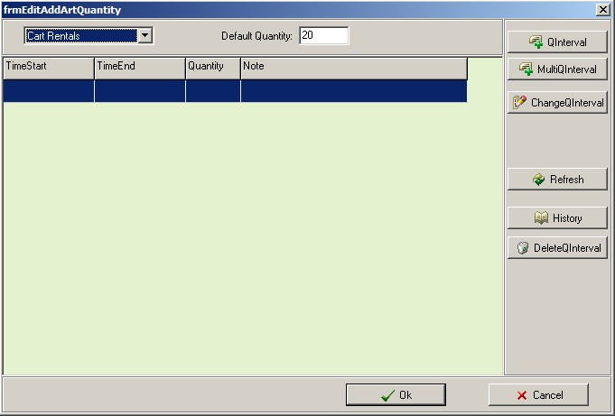
1st step:
Select the rental item.
2nd step:
Click on Qinterval

- Now click on the button „QInterval“.

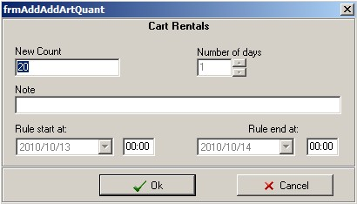
3rd step:
Enter the new amount.

- A new window pops up. It shows the current quantity available for the selected rental item. To change the quantity, enter the new amount available. Click on ‘Ok’ to confirm the changes. These are available on the whole network with immediate effect.

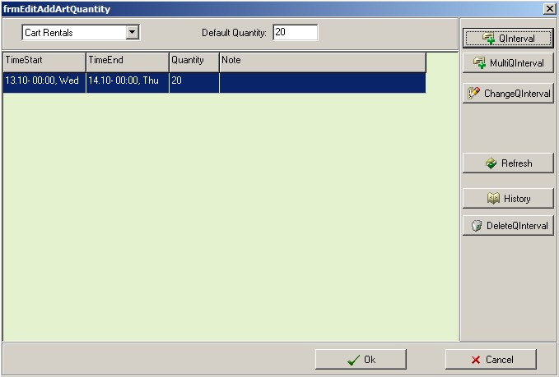
By clicking on DeleteQinterval, these changes are reflected immediately

As you can see from the new entry, the change applies until the end of the day.

  - Editing the availability in a change of quantity:
Should you notice that you have mistakenly entered an incorrect number, you can correct the entry by clicking on the “edit" button again, entering the correct amount and clicking OK.

  - Deleting a change:
Click on ‘DeleteQInterval’ to delete an existing change in the quantity of a rental item. No security question is asked.

  - History (Log book of all changes to the rental item quantities)
By clicking on the button ‚History‘ in the ‚Change quantity‘ window, you can view a history of the changes to the quantity of the different rental items. Think of it as a logbook with entries of all changes.

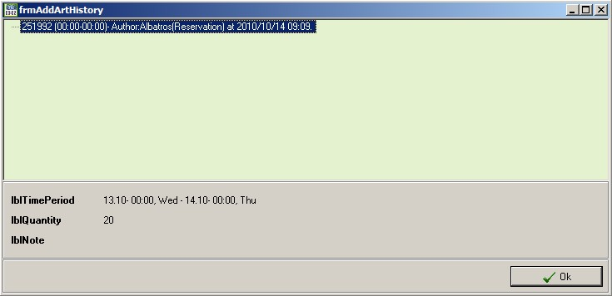
Exit the ‘History’ window by clicking on ‘Ok’.

  - Statistics of the rental items still in use
You have the option to print a list of the rented items and hereby get a summary which items have rented out to which customer and when they will be available again.

- Click on ‘List of rental items’ in the menu ‘Printing’. A reports window pops up with a choice of lists:

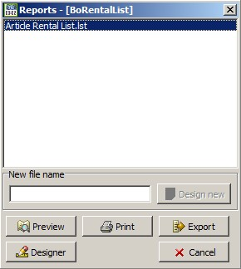
1st step:
List selection. Should only one list be available, an automatic selection is activated.

2nd step:
Click on ‘Preview’ to show the rental items in use.

- The requested list is highlighted in blue. You can preview the list by clicking on ‚Preview‘. The following list appears:

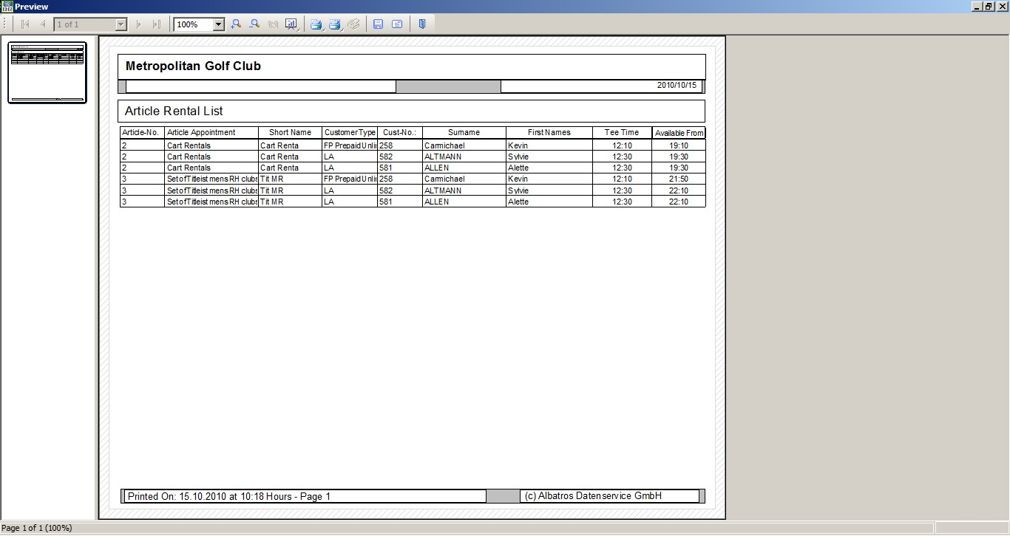

Different functions like e.g. zoom /shrink, 1:1, print, printing settings, save, send by email as a file and exit are available in the menu bar at the top.

The symbols are self explanatory; if you move your cursor over the symbol, a description of that function appears. 9.0 Info menu

- INFO MENU
  - Search bookings
- The search function is a submenu in the ‘Info’ section. If you click on ‘Search (player/bookings)’, a new window called ‘Search’ opens up:

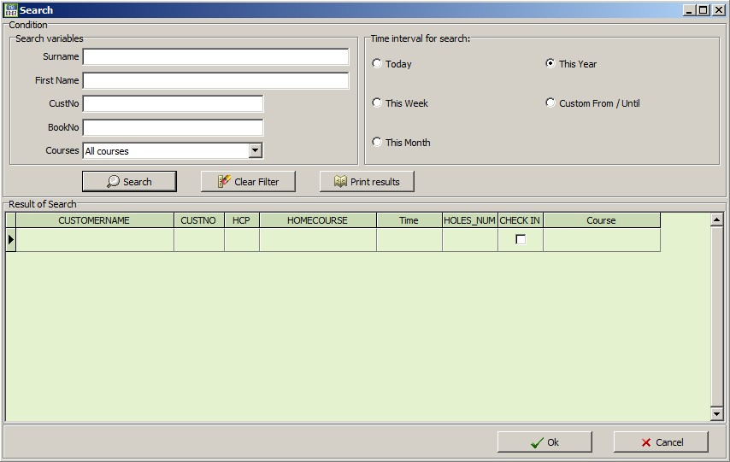
Commence search after entering sufficient criteria
Start a new search by clearing the filter
Show & print results
Time interval
Search criteria

- To initiate a search, you should select your search criteria carefully to increase your chances of finding what you are looking for, but making sure that you don’t restrict the search in such a way that no result is found. The more criteria you enter, the more precise the result will be and the fewer results will be shown.

The following fields can be entered:

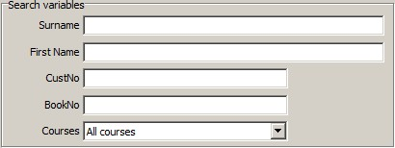
Search window

Surname Surname of the customer; you can also only enter a portion, at least the first three letters
First name First name of the customer; here again, you can also only enter a portion, at least the first three letters
CustNo. Customer no. Please only use this field if you are sure about the customer’s number, otherwise leave this field empty.
BookNo. Bookings number. Please only use this field if you are sure about the customer’s number, otherwise leave this field empty.
Courses Here you can either select all courses or only a specific one. If you are unsure about the course, leave the setting on the default ‚all courses‘.

You can choose from the following time ranges:

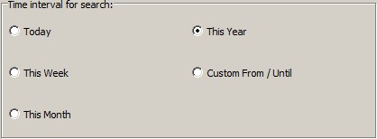
Window for time interval

The selected time intervals can be chosen from the list available: ‘Today’; ‘This week’; ‘This month’; ‘This year’ or a custom date range. If you select ‘Custom’ 2 windows open up with the option to enter the start and end dates.

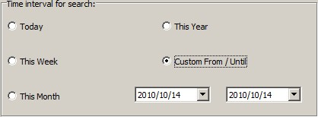
Fields to enter date range

The search function gives you the opportunity to look for specific bookings of certain players and to collect a stat over a period of time for that player.

Example: We are searching for a player with the surname Alblas and would like to know how often this golfer played during the course of the current year.

- Now enter the surname Al… in the relevant field. Click on the time interval and select this year. The window then appears as follows:

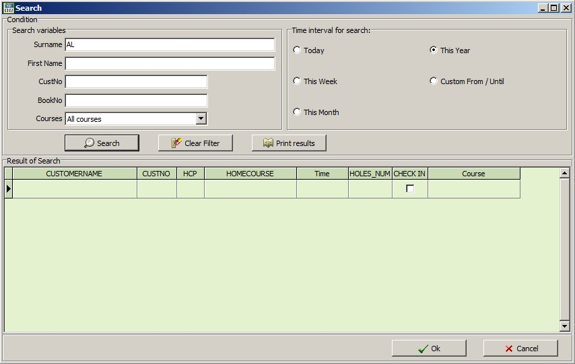

- Now click on ‚Search‘ to commence the task..

- You will notice in ‘Result of search’ that you might have more than one customer with the surname Alblas. To narrow down the results, enter the first name in the field ‘First name’.

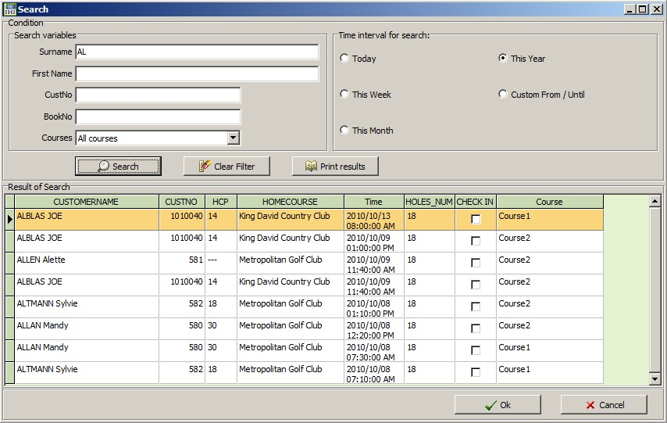

- Select the button ‘Search’ again, the result of the search then looks as follows:

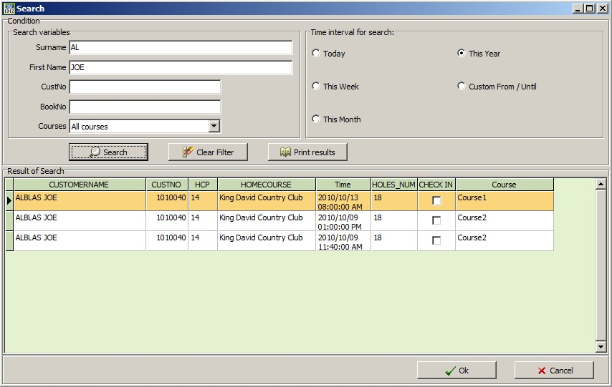

- You now have the option to print the list displayed on the screen. Click on ‘Show Results‘. Your search results are shown in the previous of the List&Label-Generator:

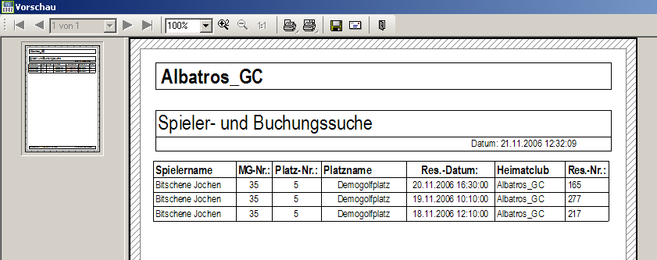

Different functions like e.g. zoom /shrink, 1:1, print, printing settings, save, send by email as a file and exit are available in the menu bar at the top of the List & Label Generator.

The symbols are self explanatory; if you move your cursor over the symbol, a description of that function appears.

- To select a printer and the functions, right click on the first of the 2 printer symbols; a print options window opens.

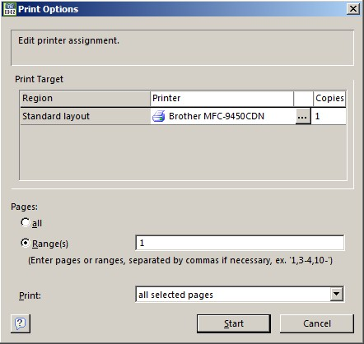

In this window, you have the option to view the current printer, to choose a new printer from the list, and to choose the pages and no. of copies. The settings connected to this document will be saved in a special file on your hard drive.

- In this box you can now select the printer you want to use and click „OK“.

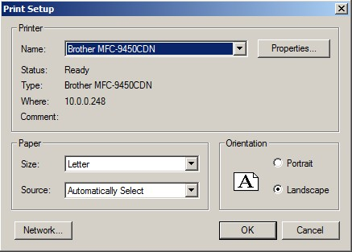

Should you have any further questions, please contact your administrator.

  - History
For every booking or bookings no. a log is created, which one can access if one needs to check on information relating to this booking.

- Click on the booking which you would like to look into. Close any editing windows that may open.

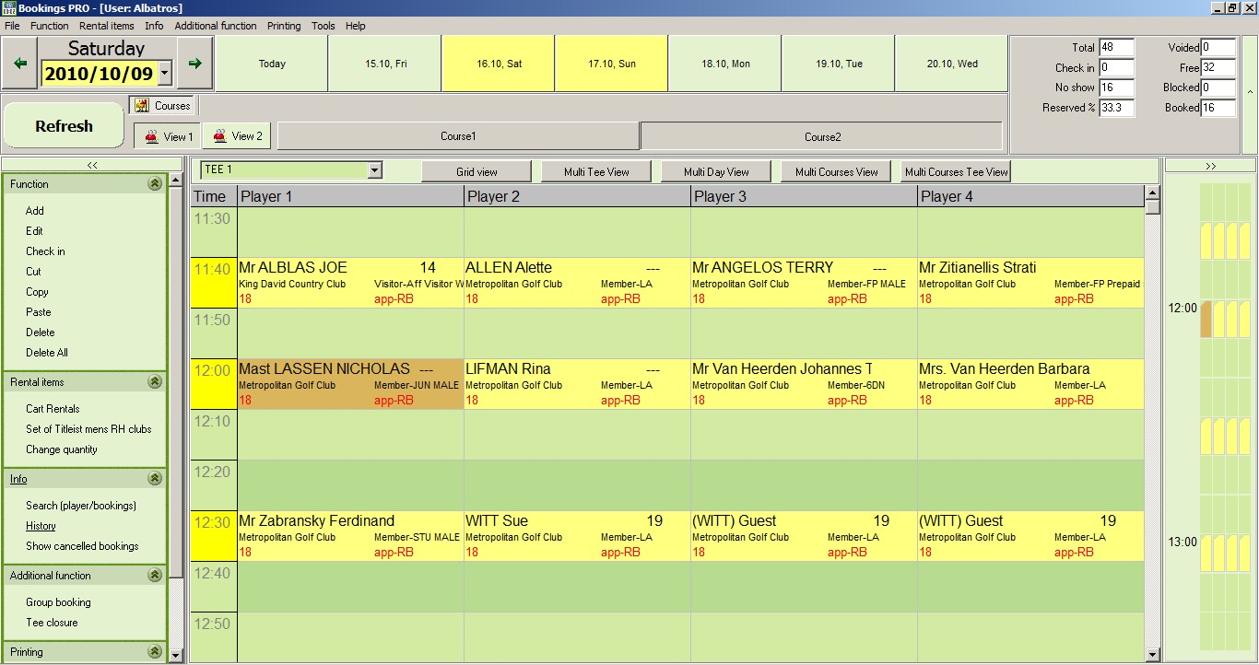
2nd step:
Choose ‘History’ in the section ‚Info‘.
1st step:
Choose the player / booking for which you require more info.

- Now click on the submenu ‚History‘ in the ‚Info‘ section on the left.

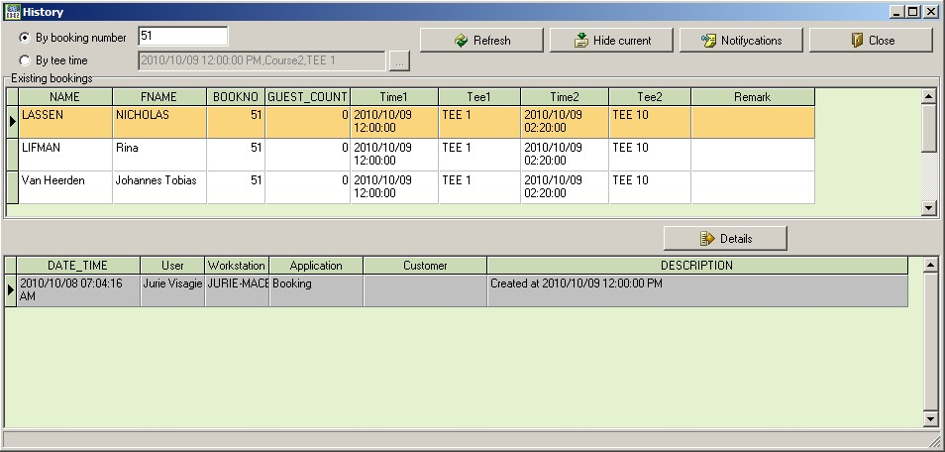

A window pops up, showing a log of transactions done in the booking process of this group and individual players.

- Any booking and any change to this booking is saved here. You also have the option to request further history by entering a tee time. The button “Hide current’ closes the second window. Click on ‘Close’ to close the history.

  - Cancelled bookings
In this submenu, you’ll encounter all cancellations of any tee time or rental item bookings.

- Open the function ‘Show cancelled bookings’ and the following window will appear:

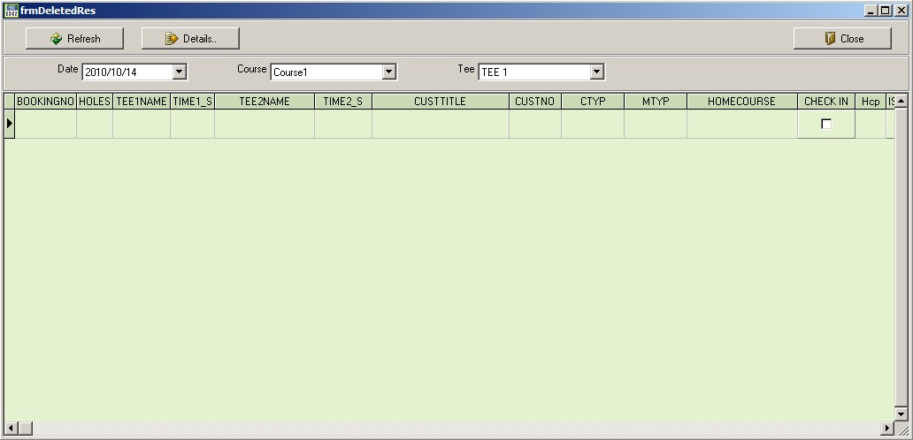

By default, the current date is chosen, but you have the option to change the date, the course and the tee box for which you would like to view cancellations.

- In our example, we’ll use the following date: 01.02.2011. You can either enter the date manually or choose from the calendar by clicking on the arrow. Once you have entered the date, a list of cancellations appears:

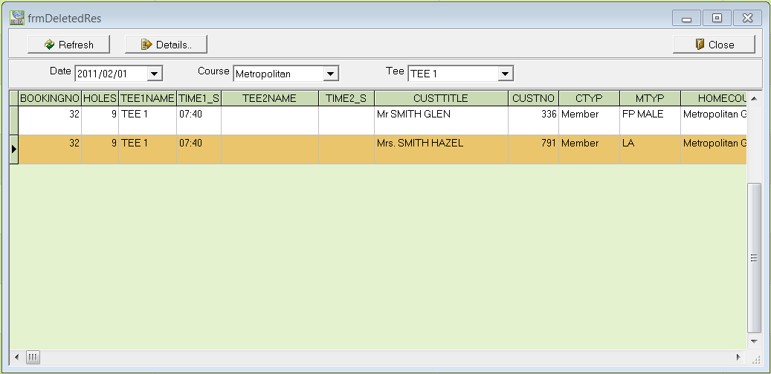

- Now choose one of the cancellations from the list and click on „Details“. A new window opens up with the entire logged history to this cancellation.

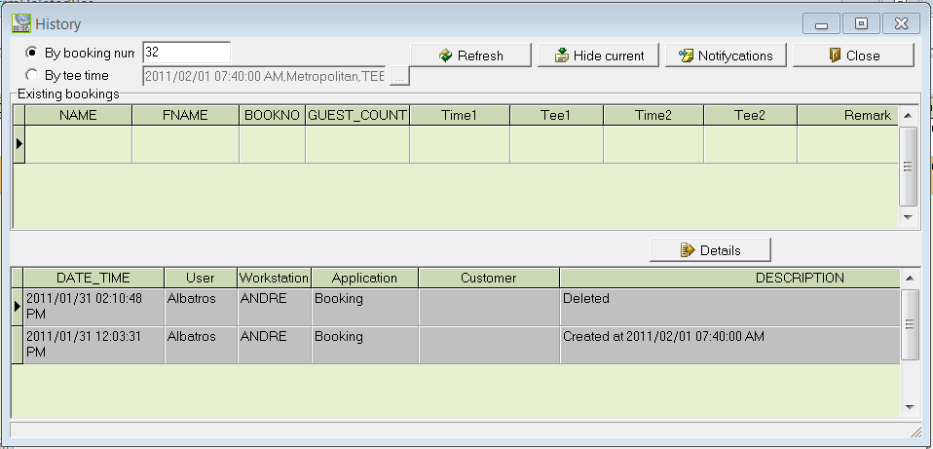

This window shows the following details:

- Date and time of the entry
- Name of the logged in user
- Name of the workstation at which the cancellation was done
- Program/Module which was used to execute the cancellation
- Name of customer if the booking was that customer’s booking
- Description of what was done

- Close the history by clicking on ‚Close‘.

In another example of the previous selection, the screen shows the following:

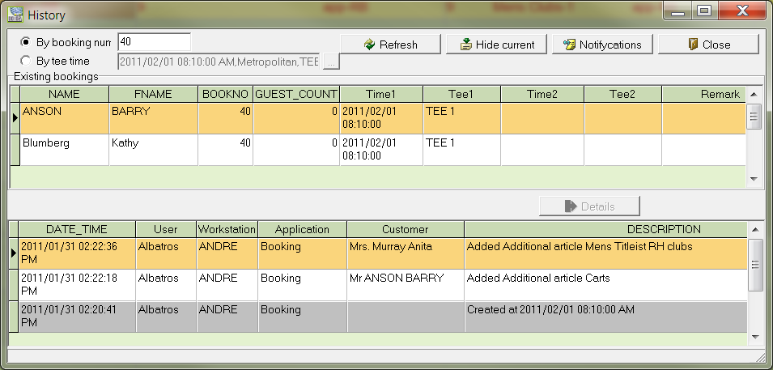

Here you can see that a booking exists for customers Barry Anson and Kathy umberg and a cancellation was done for Sylvie Altmann, this means the booking was voided in a pairing of two golfers, while the booking for Alette and Vic Allen remains.

In a third example from the previous selection:

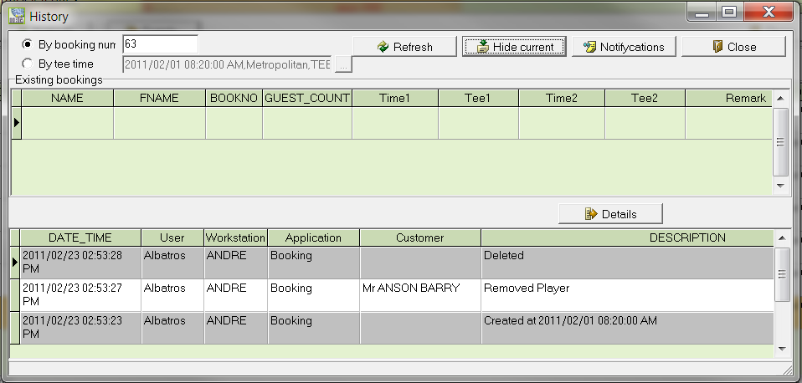

The screen shows that a blocked tee time was cancelled to be able to add a guest to customers’tee time. You can see the date and time of the cancellation of the blocked tee time as well as the addition of new guest.
- Printing (Lists: Tee sheet, Rental items and Stats)
  - Tee sheet
By clicking on ‘Tee sheet’ in the ‘Printing’ menu, you can print the tee sheet for the day.

- Choose the day for which you would like the tee sheet printed.
- Then click on ‘Tee sheet’ in the section ‘printing’. The following window ‘Reports’ pops up:

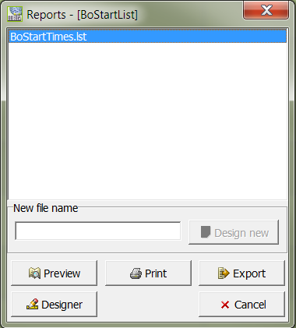

- Choose the entry ‘BoStartTimes.lst’ from the list. Should you only have one list to choose from, this list is highlighted. Now, click on ‘Preview’ to view the tee sheet.

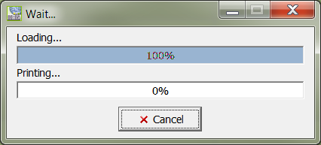

- Please wait until the data has been processed and the screen ‘print’ is complete. If you click on ‘Cancel’ the process will be interrupted and no screen shot of the tee sheet will be shown.

- Should you not want a preview, you can skip this step and choose ‘Print’ immediately. The print job will be sent to the default printer.

Depending on the number of bookings, this list could entail several pages. Should you only need the list for informative purposes, we suggest you use the preview function.

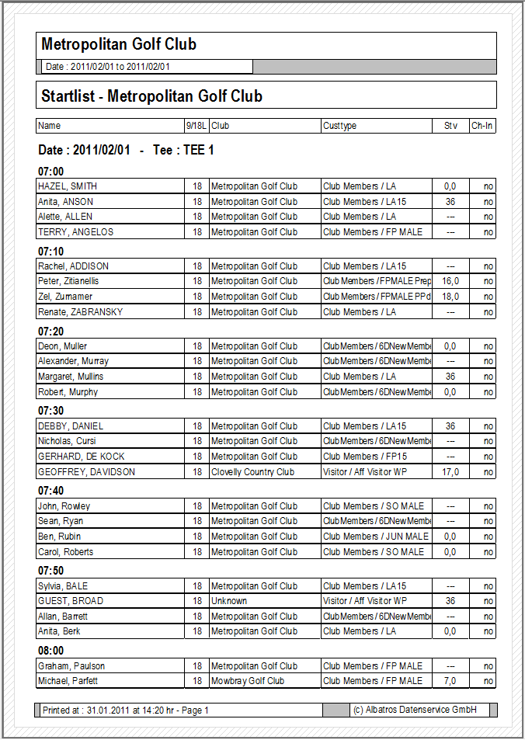

Printout of an example of a ‘Tee sheet’ from Albatros Bookings
  - List of rental items
By clicking on ‘List of rental items’ in the ‘Printing’ menu, you can print the reserved rental items for the day.

- Choose the day for which you would like the list printed.
- Then click on ‘List of rental items’ in the section ‘printing’. The following window ‘Reports’ pops up:

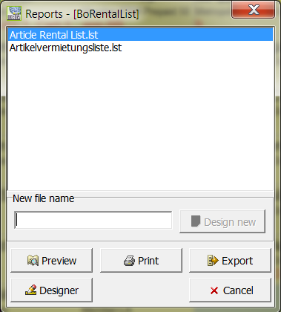

- Choose the entry ‘ArticleRentalList.lst’ from the list. Should you only have one list to choose from, this list is highlighted. Now, click on ‘Preview’ to view the list of rental items.

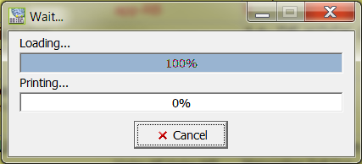

- Please wait until the data has been processed and the screen ‘print’ is complete. If you click on ‘Cancel’ the process will be interrupted and no screen shot of the tee sheet will be shown.

- Should you not want a preview, you can skip this step and choose ‘Print’ immediately. The print job will be sent to the default printer.

Depending on the number of bookings, this list could entail several pages. Should you only need the list for informative purposes, we suggest you use the preview function.

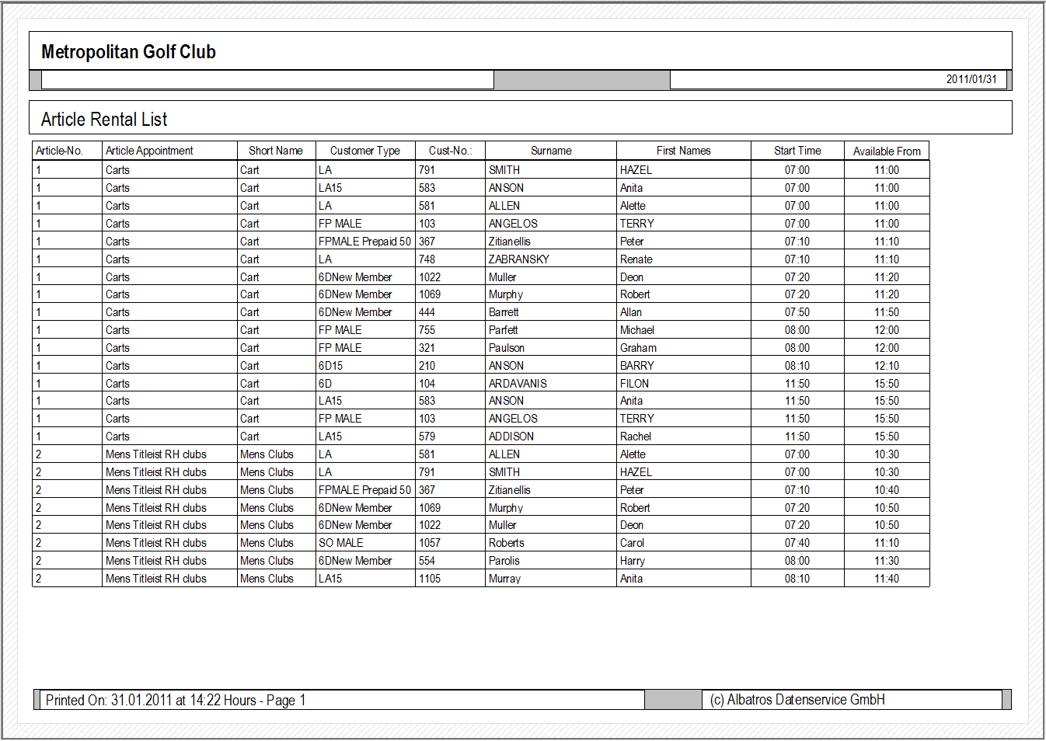

  - Stats
By clicking on ‘Stats’ in the ‘Printing’ menu, you can print the bookings statistic for a month.

- Choose the month for which you would like the list printed. Any day in the month is fine.
- Then click on ‘Stats’ in the section ‘Printing’. The following window ‘Reports’ pops up:

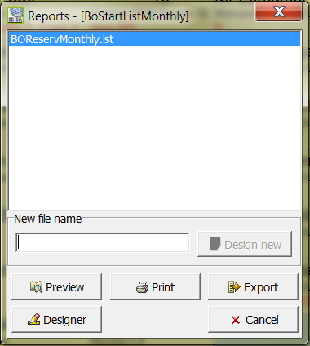

- Choose the entry ‘BOReservMonthly.lst’ from the available list. Should you only have one entry to choose from, this entry is highlighted. Now, click on ‘Preview’ to view the bookings stats for a month.

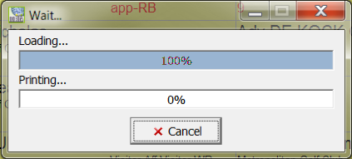

- Please wait until the data has been processed and the screen ‘print’ is complete. If you click on ‘Cancel’ the process will be interrupted and no screen shot of the tee sheet will be shown.
- Should you not want a preview, you can skip this step and choose ‘Print’ immediately. The print job will be sent to the default printer.

Depending on the number of bookings, this list could entail several pages. Should you only need the list for informative purposes, we suggest you use the preview function.

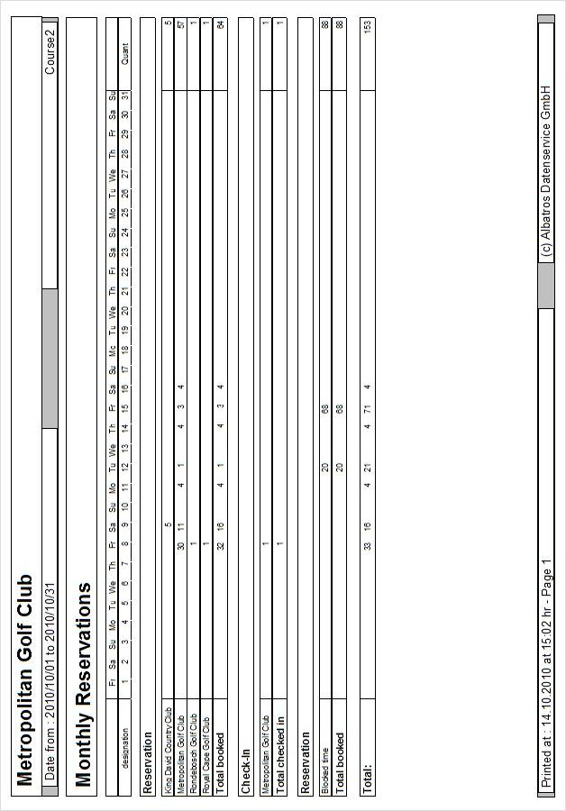

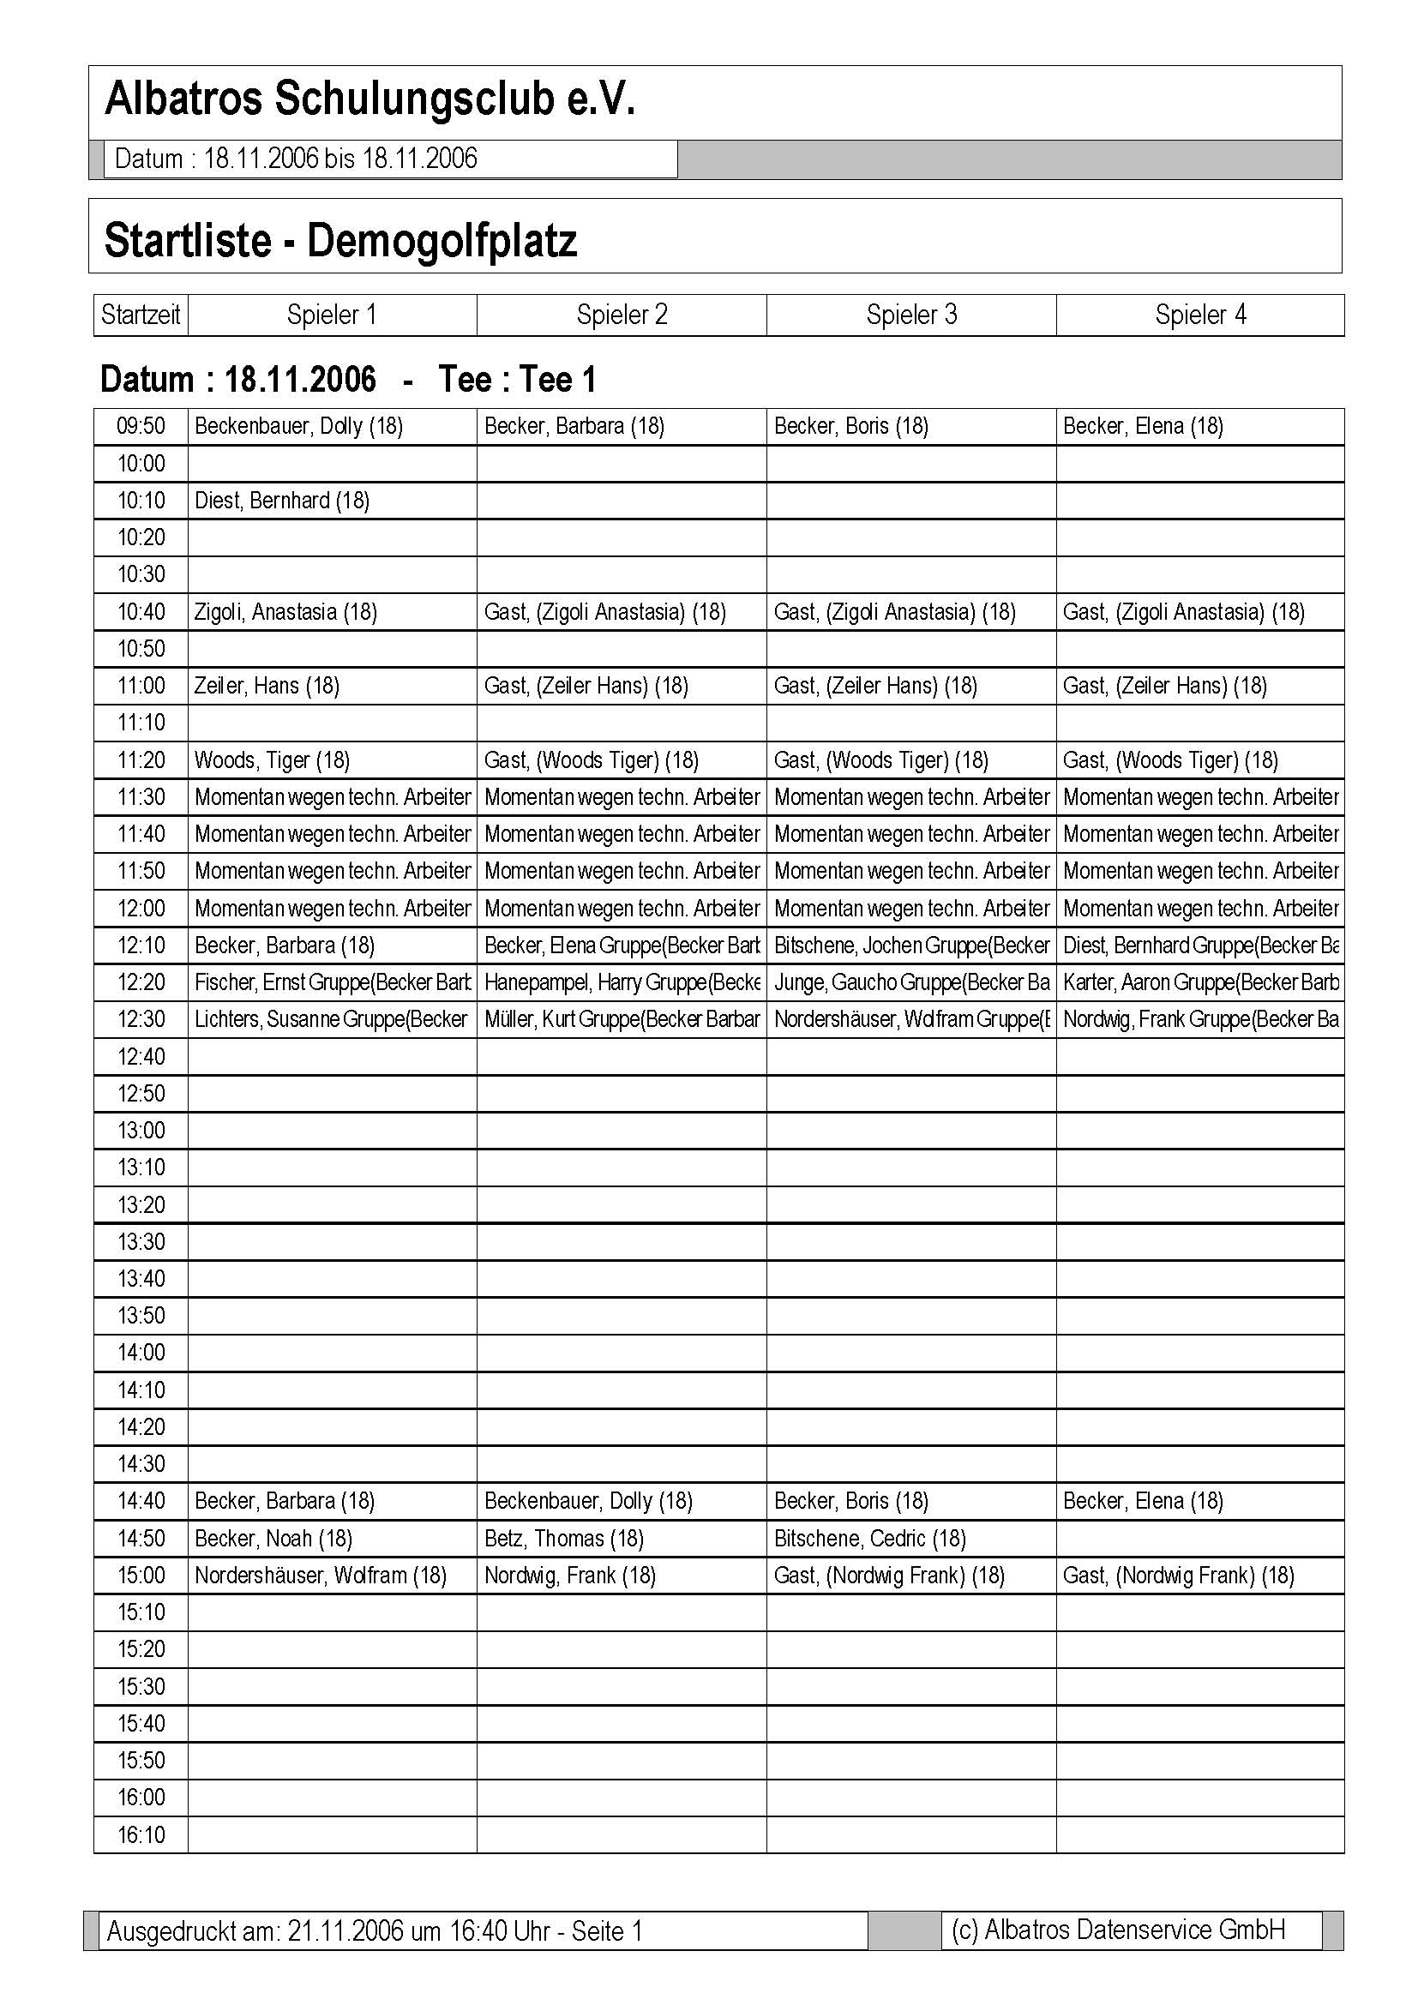

- Configuration
The configuration of the default settings for this module is done in Albatros Administration. This task requires administrative knowledge and an introduction into the Admin module.

Should you want to change settings in this section, please contact our support team on 086-010 9372 / 079-314 9571 for assistance. You can also send us an email to support@iteesolutions.co.za.

- Remote access by our support team with Netviewer
As part of our installations, we include the Netviewer software, which gives our Support team the opportunity to access your workstation remotely.

This software can be activated in the following ways:

Netviewer icon on your desktop:

Click on the Netviewer Icon to start a remote management session.

Quick Launch Bar

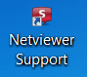

Desktop logo

  - Remote access in the Albatros modules
Click on ‚Help‘ in the top line and then choose ‚Albatros Netviewer Service‘.

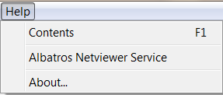

  - Starting the remote access session
- Please call our support number: 086-010 9372 / 079-314 9571. Should our support team member feel that it is necessary to start a Netviewer session, he will ask you to load the software.

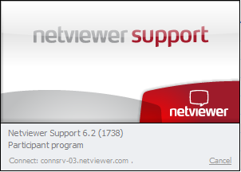

- The session starts with the left screenshot as seen above. The connection is tested and once it has been established successfully, a window pops up, requesting you to enter a code. This code will be given to you by the Support team member and is unique for this session.

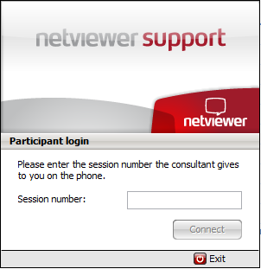

- Once you have entered the number, please click on ‚Connect‘ to confirm and when the secure connection has been established between the two computers, you are requested to allow the transmission of your screen:

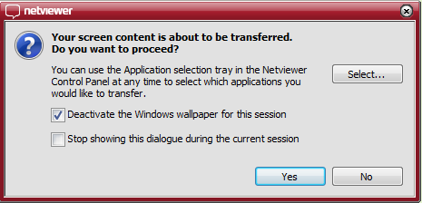

- Click on the button „Yes“, so that the support team member can view your screen. The remote access (Remote control) is now active as shown by the window:

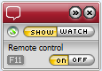

- This menu is visible throughout the whole session. Once the session is completed, a new window opens up to document the end of the remote access. Please click on ‚Close‘ to confirm.

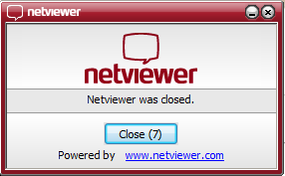

The advantages of Netviewer compare to other remote access software are:

- Quick link via the Internet
- Low costs compared to other softwares on the market
- 128 Bit Encryption
- VeriSign-Certificate
 Support – Hotline

Support inquiry:  Monday – Friday | Operating hours: 08.00 – 17.00
Support-inquiry:  Saturday, Sunday or public holiday | Operating hours: 10.00 -15.00  Included but non-technical only
Remote maintenance  Monday – Friday | Included
Remote maintenance  Saturday, Sunday or public holiday | Included but non-technical only, subject to availability

Publisher of this manual:

iTee Solutions
Old Castle Brewery
Unit 404
6 Beach Road
Woodstock
7925
Office: 086-010 9372
Technical Support: 079-314 9571

Email: info@iteesolutions.co.za
Internet: http://www.iteesolutions.co.za

