iTee Solutions. Your iTee partner in golf.


Albatros Quick Guide

Step by step instructions on the most common
tools & functions in Albatros

Release: April 2012 - Ver. 8.8.0.0
Table of Contents
Error! Bookmark not defined.
Error! Bookmark not defined.
Error! Bookmark not defined.
Error! Bookmark not defined.
Error! Bookmark not defined.
Error! Bookmark not defined.
Error! Bookmark not defined.
Error! Bookmark not defined.
Error! Bookmark not defined.
Error! Bookmark not defined.
Error! Bookmark not defined.
Error! Bookmark not defined.
Error! Bookmark not defined.
Error! Bookmark not defined.
Error! Bookmark not defined.
Error! Bookmark not defined.
Error! Bookmark not defined.
Error! Bookmark not defined.
Error! Bookmark not defined.
Error! Bookmark not defined.
Error! Bookmark not defined.
Error! Bookmark not defined.
Error! Bookmark not defined.
Error! Bookmark not defined.
Error! Bookmark not defined.
Error! Bookmark not defined.
Error! Bookmark not defined.
Error! Bookmark not defined.
Error! Bookmark not defined.
Error! Bookmark not defined.
Error! Bookmark not defined.
Error! Bookmark not defined.
Error! Bookmark not defined.

Error! Bookmark not defined.
Error! Bookmark not defined.
Error! Bookmark not defined.
Error! Bookmark not defined.
Error! Bookmark not defined.
Error! Bookmark not defined.
Error! Bookmark not defined.
Error! Bookmark not defined.
Error! Bookmark not defined.
Error! Bookmark not defined.
Error! Bookmark not defined.
Error! Bookmark not defined.
Error! Bookmark not defined.
Error! Bookmark not defined.
Error! Bookmark not defined.
Error! Bookmark not defined.
Error! Bookmark not defined.
Error! Bookmark not defined.
Error! Bookmark not defined.
Error! Bookmark not defined.
Error! Bookmark not defined.
Error! Bookmark not defined.
Error! Bookmark not defined.
Error! Bookmark not defined.
Error! Bookmark not defined.
Error! Bookmark not defined.
1. Greenfees & Proshop 3
1.1 How to search for a member / customer 3
1.2 How to assign a card to a member 3
1.3 How to deposit money to the member’s account (card) 4
1.4 How to increase a member account limit 4
1.5 How to add a new member 5
1.6 How to edit an existing member 5
1.7 How to delete a member 5
1.8 How to ring up a Green fee 6
1.9 How to ring up an article in the proshop 7
1.10 How to review / print / void old transactions 7
1.11 How to make a tee sheet booking 8

- Greenfees & Proshop
  - How to search for a member / customer
- After you have logged in, click on the Customers button. This will display a list of all the members currently on the system. Alternatively you can click on the „All“ button to bring up a list of all the membership types and select what member type you need to display in the list.
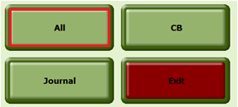

- You can find any member by starting to typing the customer’s name in the search bar at the top left of the page or you can click on the Search button and click on Customer Number to do a search using the customer’s membership number if you have it.

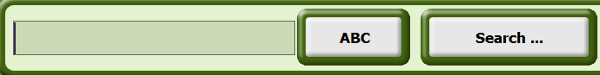

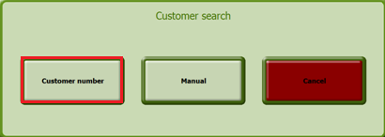

- If the member has an SAGA card and the card is assigned to the member, you can swipe the card to get to the members name.

  - How to assign a card to a member
- After you have logged in, click on the Customers button. Find and select the member you want to assign the card to. Click on the Assign Card button.
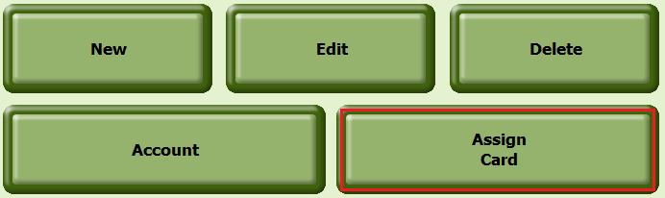

- In the new window click on the New button at the bottom left side of the screen.
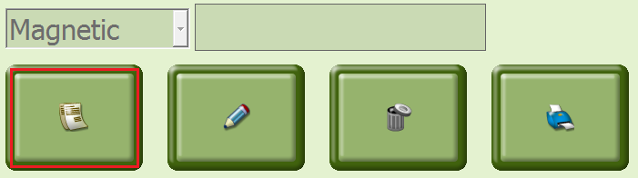
- Swipe the card. The card number will appear in the text box and click on the green tick (also bottom left) to complete the process.

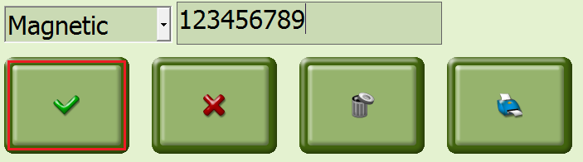
  - How to deposit money to the member’s account (card)
- Select the member and click on the Account button. This will take you to the member account page. Click on the Account Deposit button, input amount and click OK.
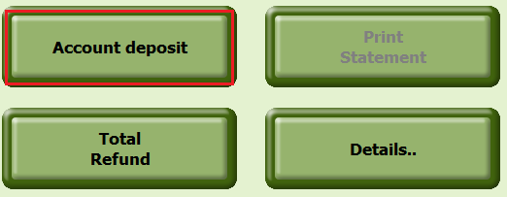
- In the next screen, select the payment method (by clicking on the default payment method which will then display all payment options on the right hand side of the screen) and click on the Print icon.
- The credit amount will now appear on the customer’s Account page.

  - How to increase a member account limit
- After you have logged in, click on the customer button. Find and select the member you want to increase the account limit for. Click on the Assign Card button.

- Enter the value for the account limit and click on the green tick button.
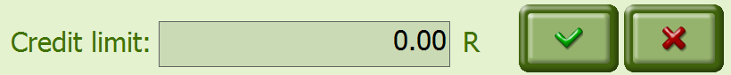
- When done click on exit. This will limit the amount a member can charge to his account. If a transaction exceeds the credit limit, an alternate payment type and the balance will have to be entered to close the transaction.

  - How to add a new member
- Click on Customers and then on the New Button.
- On the next screen, input as much of the new members information as possible, remember to also go to the „Info 2“ tab at the top of the page and complete email address and cell number information.
- Click on Save.

  - How to edit an existing member
- Click on Customers and select the member you want to edit and click on the Edit button.
- Change the relavant information and click on the Update button.

  - How to delete a member
- Click on Customers and select the member you want to delete.
- Click Delete and confirm with a Yes to the security question.
- Remember that you will not be able to delete a customer with any transactions against their profiles.

  - How to ring up a Green fee
- Click on Customers and find and select the member you want to sell a green fee to.
- Click on the Green fee button.
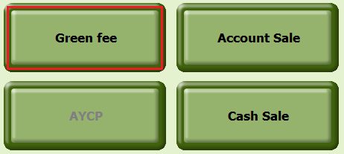
- On the next screen select the date, time, course and 9 or 18 holes and click ok.
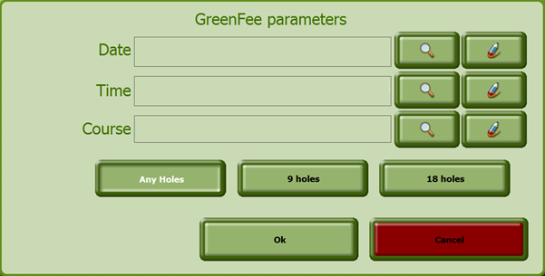
- Complete the transaction and a new window will appear. Click on the Open Round button to open a round in the SAGA for the member.
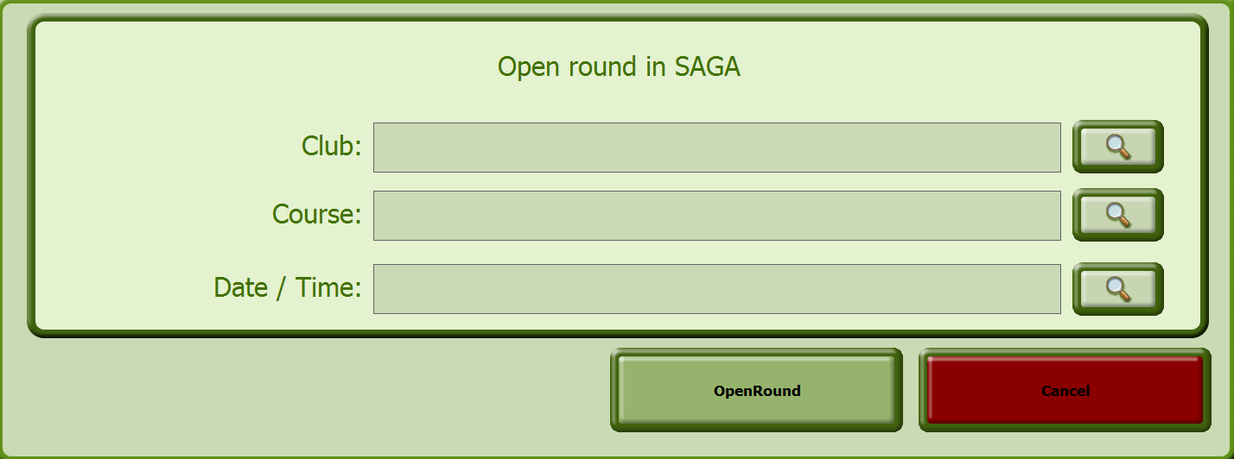

  - How to ring up an article in the proshop
- Click on Customers, then select the correct member (you will generally do this by swiping his / her card)
- Click on either the Account Sale of Cash Sale button depending on the payment from the member.
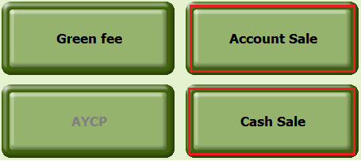
- On the next screen click on the articles button at the top of the screen.
- Select the Search group on the left side and click on the required article. You can increase the quantity by clicking on same article again or add another article.
- When you are done adding all the articles to the transaction, you click on the pay button.
- The total amount will automatically display in the main window next to the default payment method, if this is not the correct payment type click on it and other payment options will appear on the right hand side – select the right payment method and click on the button with the printer on it at the bottom of the screen.
- This will complete the transaction and print a receipt.

  - How to review / print / void old transactions
- On main page, click on Journal and select the correct date at the bottom left of the screen.
- Select the transaction you want to view, reprint, void or edit. Please note that you can only edit n transaction before day end is completed.
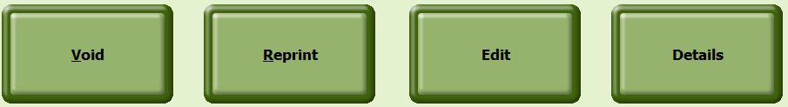

- If you void a transaction you will be taken to a screen where a password is required, after you have done this you will see a list of the articles included in the transaction. Here you can either select all to remove all articles or click on a specific article and click select. Then enter the amount you want to be voided and click on the green tick button.
- On the next screen you confirm the void by clicking on the coin icon at the bottom of the screen and on the next screen click on the button with the printer on it, this completes the process and prints a slip.
- Please note if a password was set up for this procedure and you do not have access rights to void documents you might have to get assistance from a manager or team leader.
- Reprint will print another copy of the invoice.
- Edit will allow you to change the payment type for a transaction but only before day end is completed.
- Details will give you all articles involved in the transaction.

  - How to create a tee sheet booking
- Click on Customers, then click on Tee sheet in the top right corner of the screen.
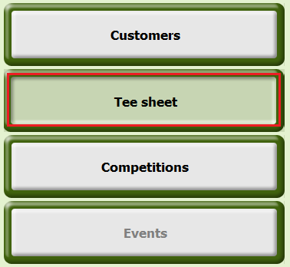
- Now click on New starttime to make a new booking.
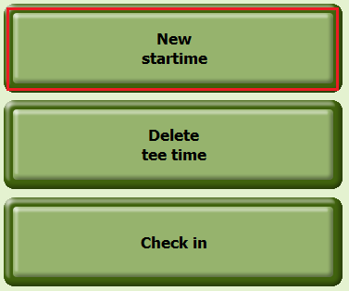
- A new window will appear. Here you can select the date for the booking at the top left of the screen. What field the member want to play in (Morning/Afternoon) and on what tee they will start on.

- Once you have selected a tee, a new screen with all the available times will be displayed.When you select a time slot, the time will change to the turnaround time. Select the time and click on the next button at the bottom of the screen. A list of all the members will appear. From the list select the member that has requested that time. Multiple members can be selected in this list. When done click on the save button.

