
iTee Solutions. Your iTee partner in golf.

Manual: Greenfees & Proshop

Release: February 2011 - Ver. 8.7.0.0 - Rev. 1.0.4 FNO

Table of Contents
1. Introduction to Greenfees & Proshop 4
1.1 Buttons and Icons in Albatros Greenfees & Proshop 5
2. Login 6
2.1 Login procedure 7
3. Program settings and necessary configuration 8
3.1 Adjustment of standard values 8
3.2 Customer status 8
4. Customers 8
4.1 Searching a customer type 8
4.2 Searching a standalone customer 8
4.2.1 Search by name 8
4.2.2 Search by Customer Number 8
4.3 Entering a new customer 8
4.3.1 Putting in a new customer with a SAGA card 8
4.3.2 Entering a new customer manually 8
4.4 Edit customers’ data 8
4.5 Delete a customer's data completely. 8
4.6 Combining with another person (Set Link) 8
4.7 Assign a golf card 8
4.7.1 Processing of a cash transaction 8
4.7.2 Processing of an Account transaction 8
4.8 Journal of a customer 8
4.9 Creating Invoices 8
4.10 Making a tee booking 8
4.11 Booking a new tee time 8
4.12 Greenfees 8
5. Account 8
6. Journal of a customer 8
7. Termination / end of day 8
7.1 Performing end-of-day close 8
8. CashBook 8
8.1 Cashbook 8
8.2 Inserting a new booking 8
8.3 EditAlbatring a booking 8
8.4 Void a booking 8
8.5 Texts / Articles 8
8.6 Inserting a new article 8
8.7 Editing an article 8
8.8 Deleting an article 8
9. Remote access by our support team with Netviewer 8
9.1 Remote access in the Albatros modules 8
9.2 Starting the remote access session 8

- Introduction to Greenfees & Proshop
The Greenfees & Proshop module offers all the functions of an electronic cash register. With the Backoffice module and also the numerous hardware connection options, Greenfees & Proshop is an impressively simple yet multifunctional POS system for the Pro Shop and the reception area.

The main interface is quick and easy to use and its full functionality will be available to you and your employees with only a brief introduction.

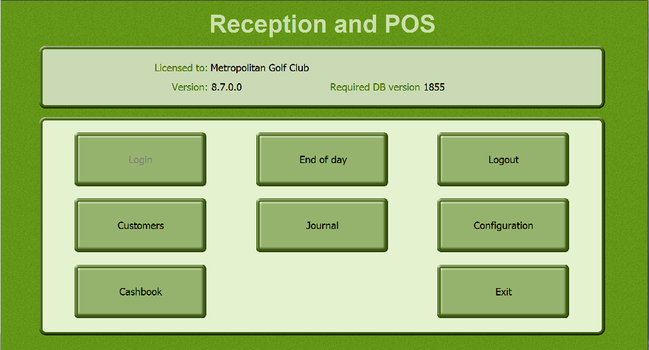

The opening menu of Greenfees & Proshop is divided into the following areas:

End of Day Change to the END OF DAY window. Here you close your daily records and print the desired reports.
Logout Log the user out of the system.
Customers In this window you manage general customer information and perform all transactions.
Journal The JOURNAL lists all sales transaction entries.
Configuration Program settings are defined in CONFIGURATION.
Cashbook Individual bookings are made and articles are entered here
Exit End the program.

1.1 Buttons and Icons in Albatros Greenfees & Proshop

You move from record to record in the Albatros database with simple arrow icons. |  | 
 |  | 
The underscored arrows jump sideways within the Albatros database. |  | 
 |  | 
The "Pencil" icon changes to Edit Mode. The "Magnifying Glass" icon displays available auxiliary tables. |  | 
The "Paper" icon creates a new entry in the current menu pick (for example, assign ID Cards). | 
The "Tick" icon saves changes that have been made.  The "Cross" icon cancels changes that have been made. |  | 
The "SAGA" icon uploads information from the  SAGA Handicap Interface. To identify a given record it is necessary to define the player’s SAGA unique player ID. | 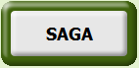
The "Printer" icon sends the displayed information to the printer. | 
The "Exit" icon will exit you from the current menu or from the Greenfees & Proshop program itself. | 

- Login
This is where you log in to the Greenfees & Proshop module.

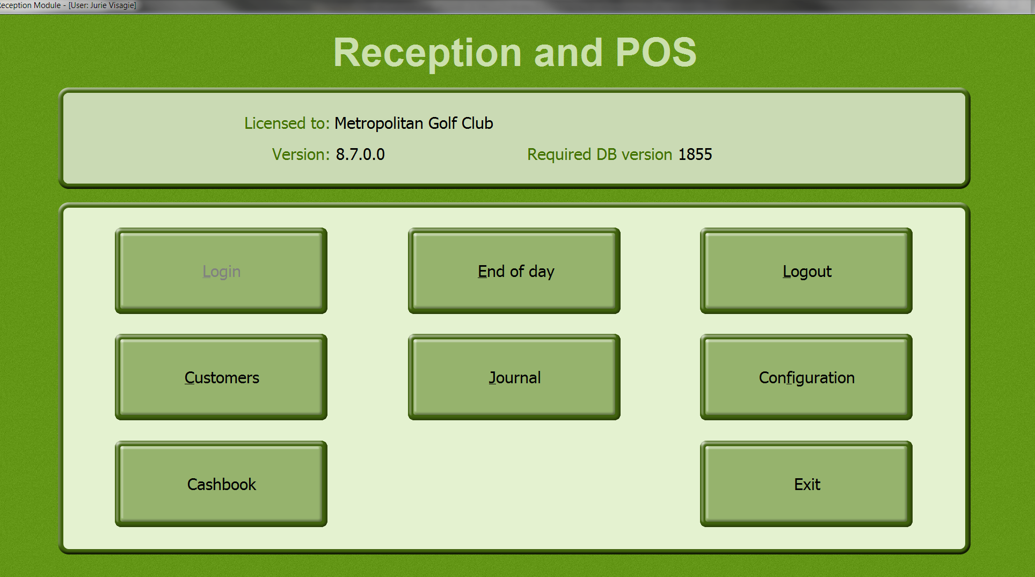 | Active Buttons  Login -  Log a user in to the system  Exit -  Exit the program

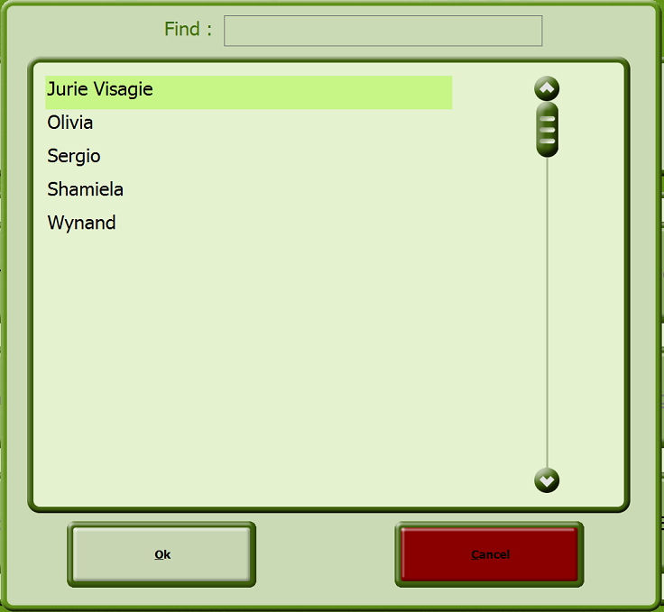

  - Login procedure
- Click the button Login.
- Select the user.
- Click the OK button.
- Enter the user's password.

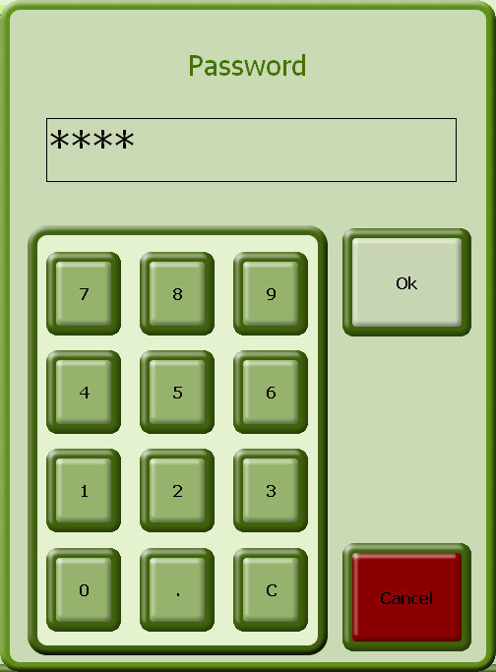 | - Click the OK button to confirm the entries.  The users, passwords and user privileges are defined in Albatros user administration or in Backoffice.

- Program settings and necessary configuration

  - Adjustment of standard values

- After clicking the Configuration button the following selection appears:

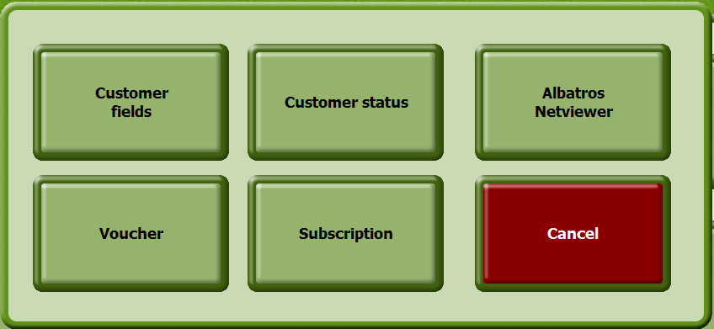

When you select the "Customer Fields" button you have the following possibilities:

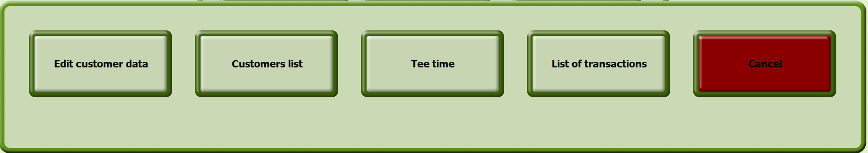

- Click the "Edit customer data" button.

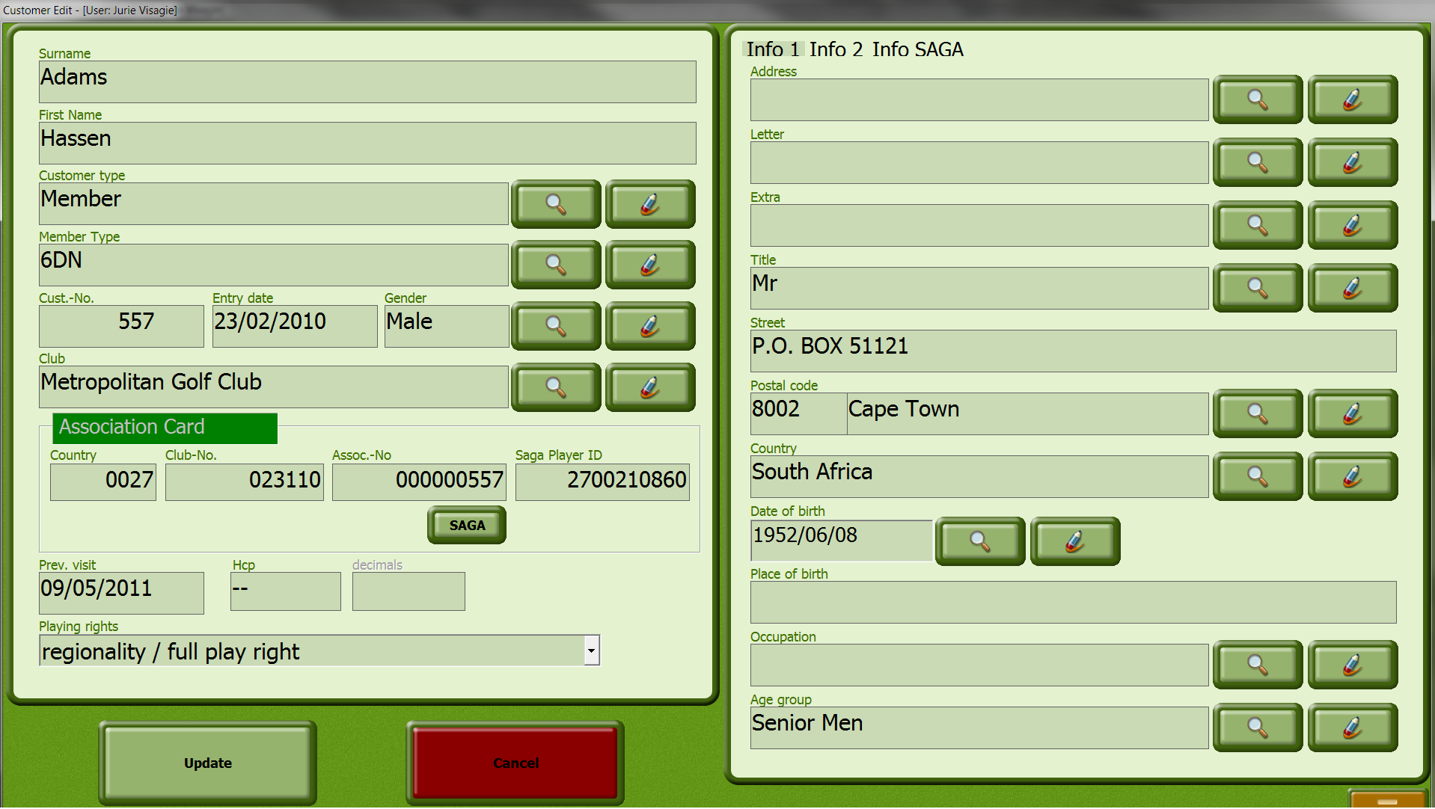

The customer edit window displays the customer information as it will be seen in the Greenfees & Proshop module. On the above screen you select which fields you wish to be displayed. The mandatory fields on the left should not be changed. The pages "Info 1", "Info 2" etc. may be modified as desired.

You may create as many pages as you wish by clicking on one of the pages with the right mouse button and selecting "Add field" from the context menu. | 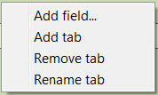

A field is added in the customer dialog definition with the "Insert field" menu item. The fields can be moved and ordered by dragging and dropping. The "OK" button ends the definition and saves your changes. The "Cancel" button aborts the current process.

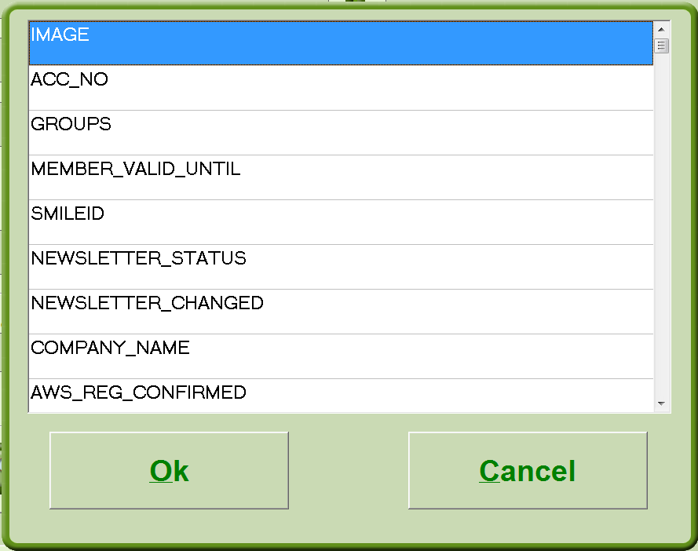 | With the "Customers List" button from the submenu you define which fields will be displayed in the customer list.

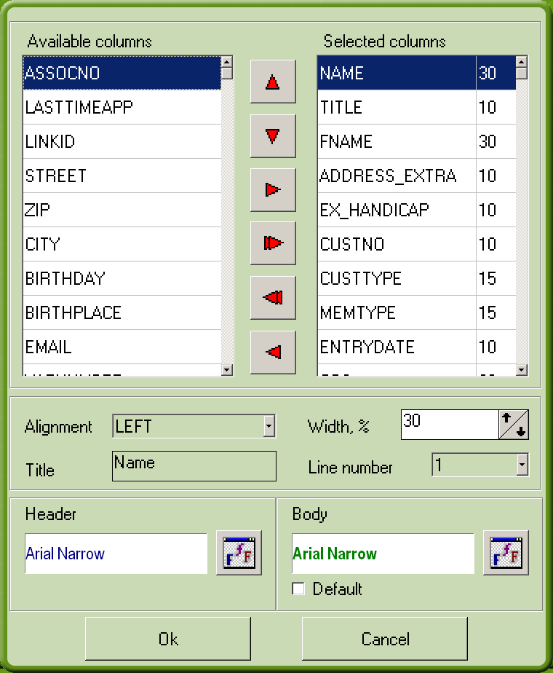 | You can also specify font and size used in the displayed fields.  By using the arrow buttons you move the desired fields from the "Available columns" list to the "Selected columns" list.  The selected field is then highlighted in blue and you can define the orientation, width, title, font and color of the field.  The "OK" button ends the definition and saves your changes.

With the "Tee time" button from the submenu you can specify which criteria will be displayed when the "Customers" button in the main menu is pressed.

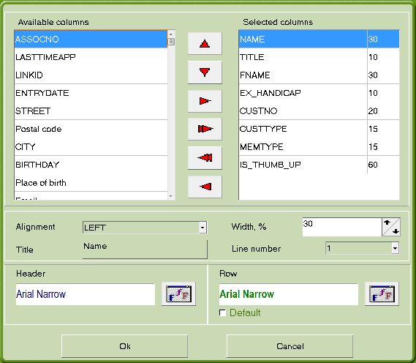 | You can also define font and font size for the displayed fields.  By using the arrow buttons you move the desired fields from the "Available columns" list to the "Selected columns" list.  The selected field is then highlighted in blue and you can define the orientation, width, title, font and color of the field.  The "OK" button ends the definition and saves your changes.

With the "List of transactions" button in the sub menu you can define which criteria will be displayed when the "Customers" button in the main menu is pressed.

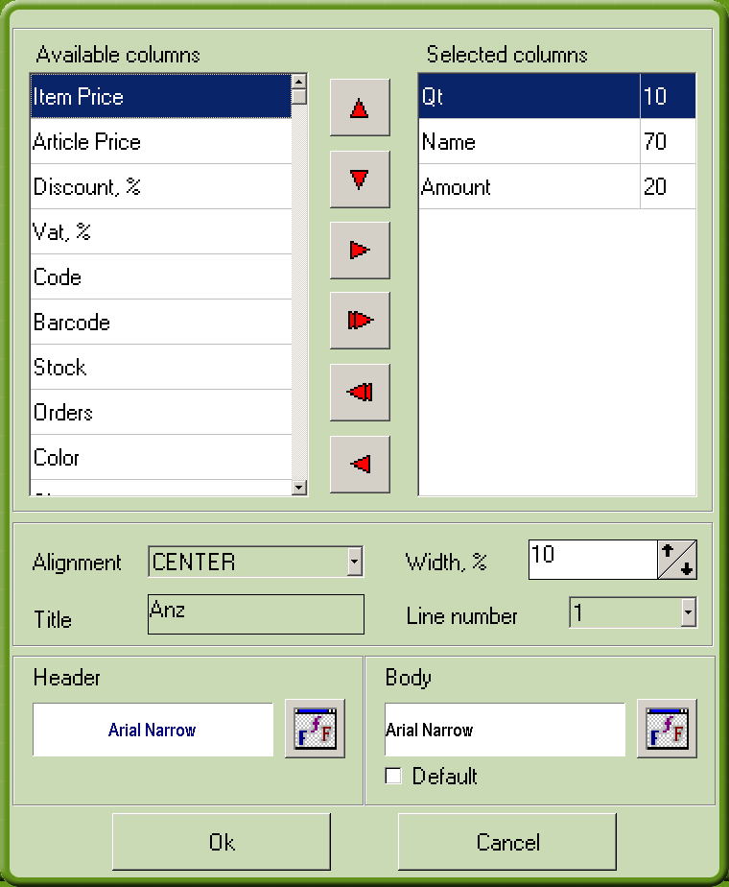 | You can also define font and font size for the displayed fields.  By using the arrow buttons you move the desired fields from the "Available columns" list to the "Selected columns" list.  The selected field is then highlighted in blue and you can define the orientation, width, title, font and color of the field.  The "OK" button ends the definition and saves your changes.

  - Customer status

With the “Customer fields” button, you can specify which fields in the list will be displayed or hidden. Just click on Customer List and the available fields will be there for selection.

With the "Customer Status" button you can display or hide customers as desired.

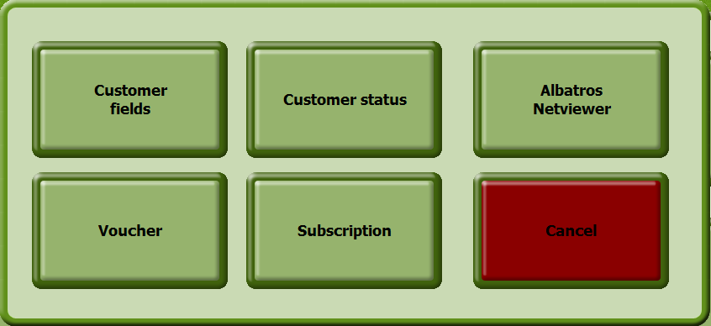

By ticking the "Status" box you make the customer visible. If you remove the tick, the customer will no longer be displayed.

You can select customers with the scroll bar on the side or you can enter a name in the "Name" field and then select.

The "OK" button saves your changes and exits the menu.

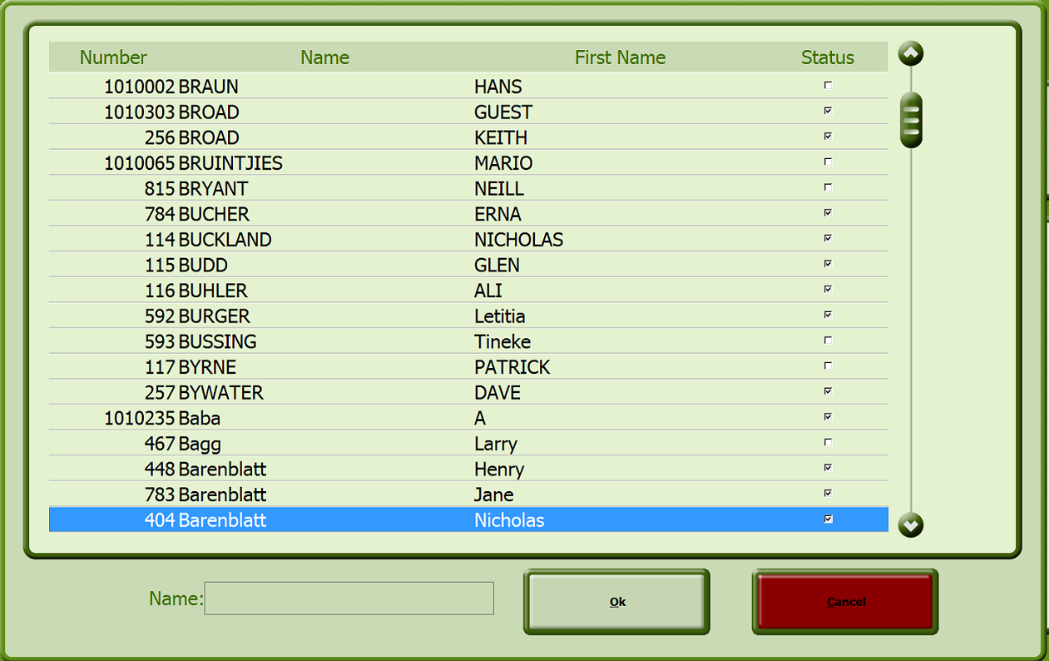

- Customers
By clicking on Customers, you access this screen, which allows you to add, edit and delete customers, take Greenfee payments, book tee times, process cash / account transactions, view and print customers’ journals, assign cards and more.

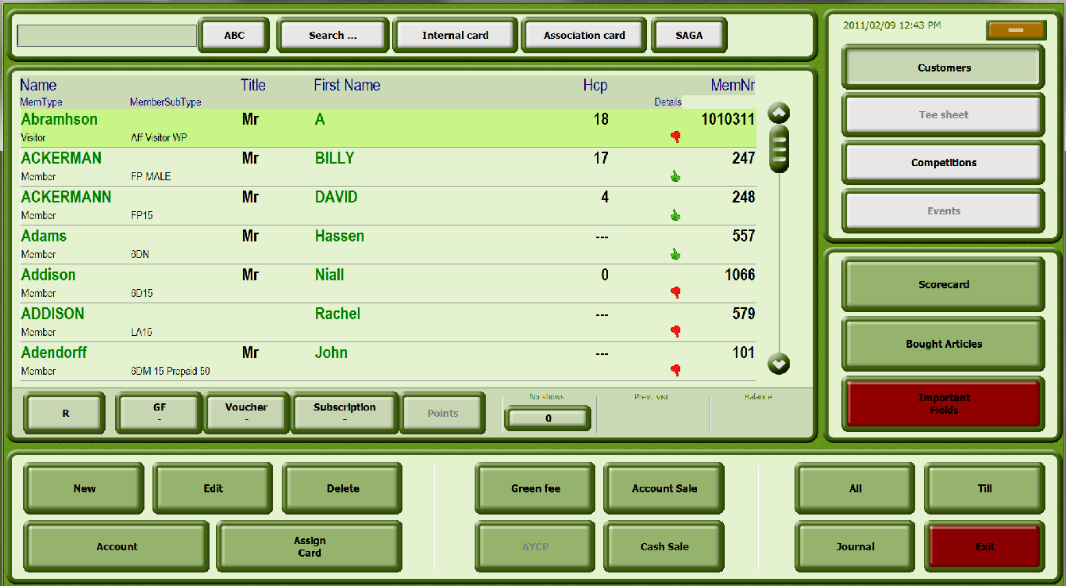

Buttons

Internal Card Clicking the Internal Card button enables you to read data from the internal club card after it has been swiped. If the customer is already in the customer list, he or she will be selected there. If this is a new customer, a window with the customer data will appear. By confirming the data the customer will be transferred to the customer list.

SAGA Clicking the SAGA button allows you to read data from the SAGA Card after it has been swiped. If the customer is already in the customer list, he or she will be selected there. If this is a new customer, a window with the customer data will appear. By confirming the data the customer will be transferred to the customer list.
Search -
Cust Num Find a person in the customer list with the customer number.
Search – Manual Find a person in the customer list by swiping his / her SAGA card

Customers Display the customer list.

Tee sheet With the Tee sheet button a new window will be opened in which the tee sheet for a specific day can be selected. Tee bookings can also be managed here.
Competitions With the Competitions button, you manage entries for competitions – including waiting lists, payments and invoices.

Scorecard With this button the players’ scores are calculated and saved.
Bought Articles With this button, all the articles purchased on a specified day by the customer in current view, is displayed.
Important Fields With this button, all mandatory fields in the customers’ info screen is displayed – Tel personal, cell and email.

Edit Edit the data of the selected customer (see the section Edit Customer Data)

New Add a new customer (see the section Add Customer Data)

Delete Delete the selected customer (see the section Delete Customer Data)

Journal Invoice Journal of the selected customer. You can reprint invoices, cancel invoice items or change the method of payment.

With customer Article sale with customer assignment

Account Account information of the selected customer

Green fee Direct access to the green fee assigned to the customer subtype or the customer

Assign cards Opens the ASSIGNED CARDS window. A card can be assigned to an individual manually at this point, the card can be locked and personal conditions for the customer can be stored. If the customer was created with an SAGA card, the data from the card will be displayed in the window.

  - Searching a customer type

- Click the Selection button (“All”) to select by customer type. The SELECT CUSTOMER TYPE wizard opens.

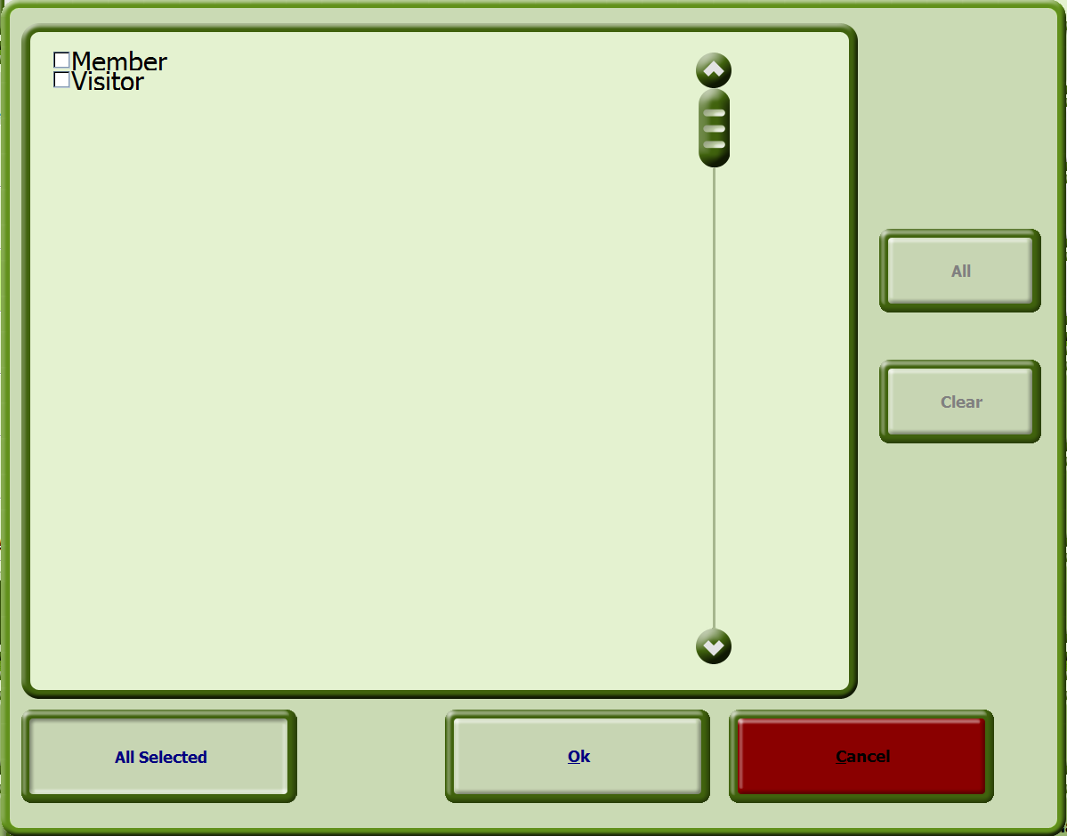

Buttons

All With the All button all customer types will be selected automatically.

Clear By clicking the Clear button the check marks will be removed from all customer types.

OK Return to the CUSTOMERS / EMPLOYEES window.

Cancel Return to the CUSTOMERS / EMPLOYEES window without making a selection.

- Check the boxes for the customer type(s) that you wish to display and click the OK button to confirm the selection and return to the CUSTOMERS window.

  - Searching a standalone customer

You can search for a customer by name or by customer number.

    - Search by name

Enter the name that you are searching for in the blank field next to the "ABC" button. The desired name will be selected in the list.

    - Search by Customer Number

- Click on the Cust Num button.

The following window opens.

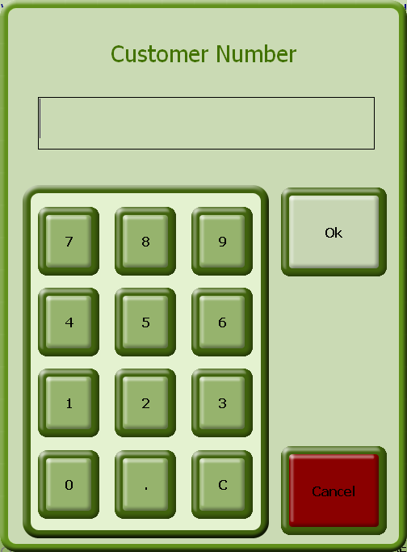

- Enter the customer number with the number buttons and click the OK button to confirm the entry and return to the CUSTOMERS window.

  - Entering a new customer

You can enter a customer in two ways.

- by using his or her SAGA card or
- manually

    - Putting in a new customer with a SAGA card

- Swipe the card through the card reader.

- Answer the confirmation question "Customer from Club No. XYZ with Customer Number XYZ not found. Create New?" by clicking the "Yes" button.

- The CUSTOMER EDIT window opens.

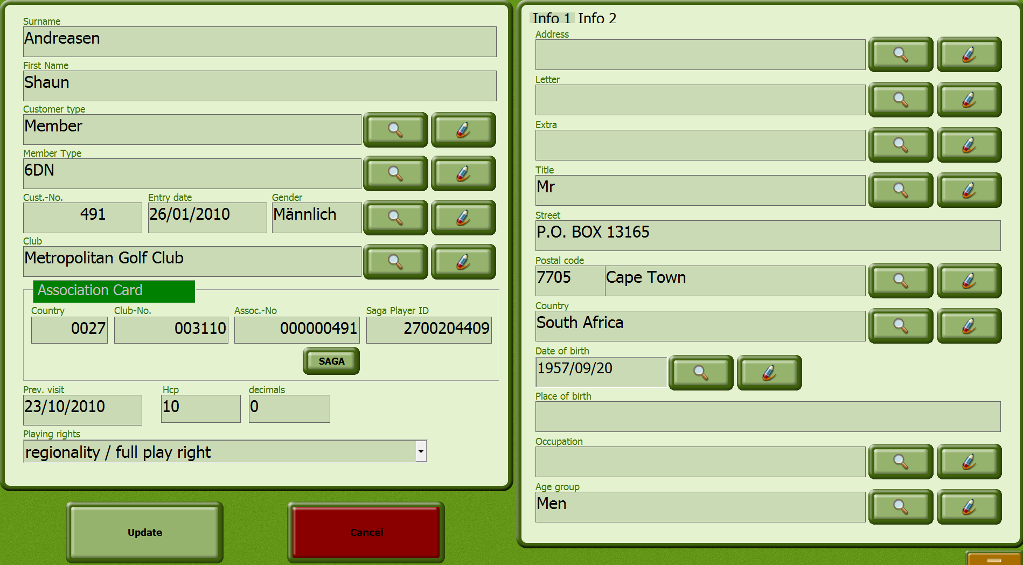

- Enter any desired values in the dialog and confirm your entries with the UPDATE button.

    - Entering a new customer manually

- Click the button New.

The CUSTOMER EDIT window opens.

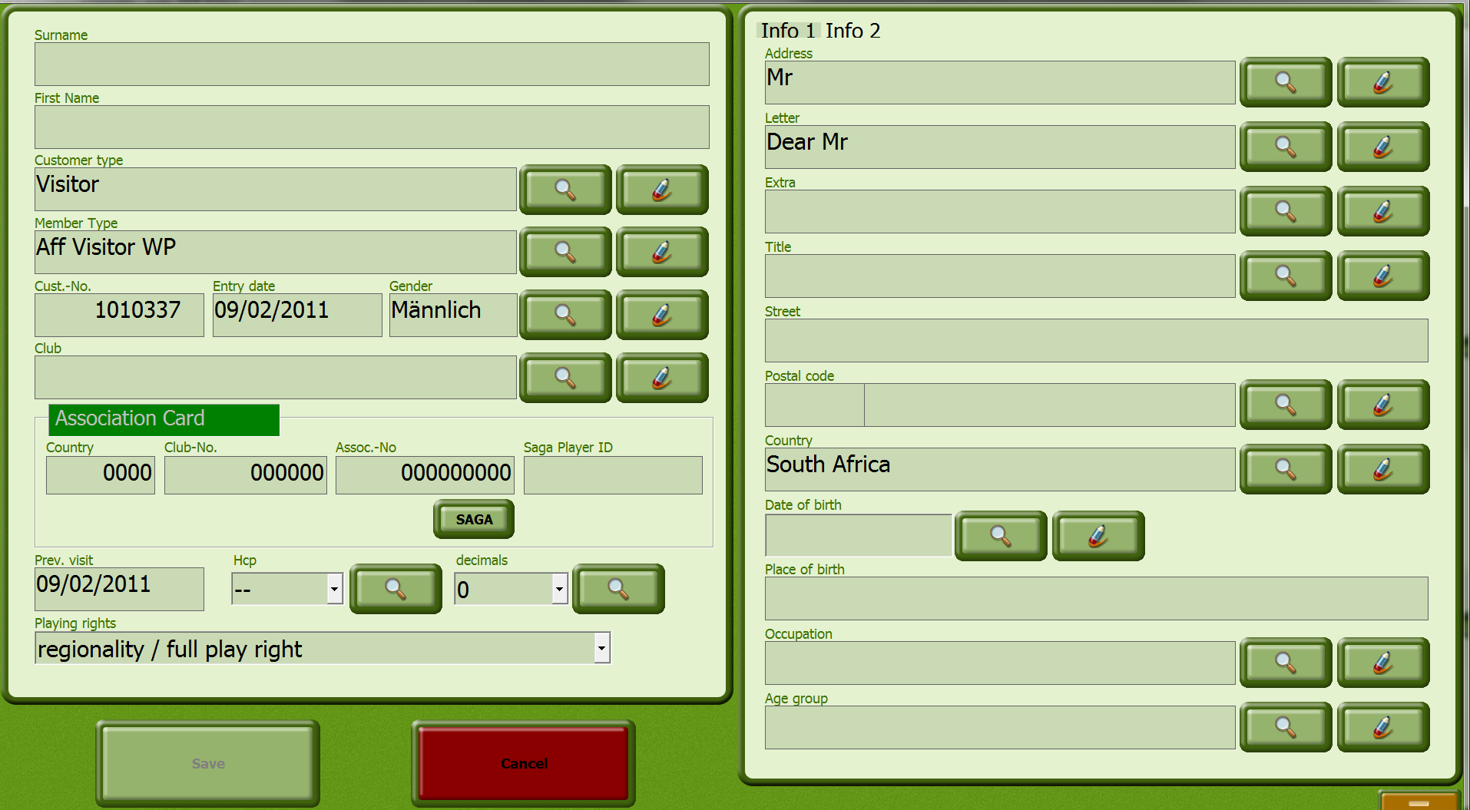

Input Fields

Surname The customer's surname

First Name The customer's first name

Customer Type Selection list for the customer type

Member Type Selection list for the member type

Cust.-No. Customer’s number

Entry Customer's entry date

Gender Selection list for the customer's gender

Club Selection list for the customer's home club

Country Country code

Club No. Club number

Assoc.-No. Customer's member number

Prev visit Customer's last visit

Hcp Selection list for the customer's exact handicap in front of the decimal.

decimals Selection list for the decimal places of the customer's exact handicap.

Info 1

Address Selection list for the personal title of the customer. All titles created in Members are available.

Letter Selection list for the Address Letter of the customer. All salutations created in Members are available.

Extra Selection list for the customer's address extra. All suffixes created in Members are available.

Title Selection list for the customer's courtesy title. All titles created in Members are available.

Street Input field for the street

Postal code Selection list for the customer's city/town

Country Selection list for the customer's country. All countries created in Members are available.

Date of Birth Customer's date of birth. The date can be entered manually or by using the calendar sheet.

Place of Birth Input field for the customer's place of birth

Occupation Selection list for the customer's occupation. All occupations created in Members are available.

Age Group Selection list for the customer's age group. All age groups created in Members are available.

Info 2

Tel. personal Input field for the customer's home telephone number

Fax personal Input field for the customer's private fax

Tel. business Input field for the customer's business telephone number

Fax business Input field for the business fax number

Cell and Provider Customer's cell phone number and his cell provider

SMS If this box is ticked, the customer is an SMS subscriber

Email Customer's e-Mail address

VAT No. Customer's VAT number

Comments Input field for any comments for this customer.

Buttons

Save Save the customer's data

Cancel Return to the CUSTOMERS / EMPLOYEES window without having made any changes

Assign Card By using the Assign Card button you can assign one or more cards to the customer. This button is not active when creating a new customer.

Set Link With the Set Link button you can link a customer to another person. By assigning the customer to a person, debits and credits will be made against that person’s account. This means that if Mrs. Miller is assigned to Mr. Miller, and Mr. Miller loads his card with $100.00, that value is immediately available on Mrs. Miller's card. This button is not active when creating a new customer.

- Make the corresponding entries for the customer.

- Confirm the entries with the OK button and return to the CUSTOMERS / EMPLOYEES window.

  - Edit customers’ data

- In the list, select the customer whose data is to be changed.

The CUSTOMER EDIT window opens.

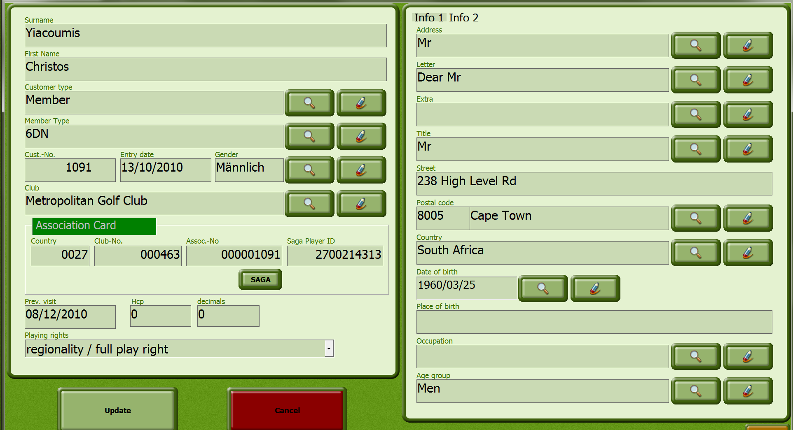

Input Fields -

See p19 - Entering a new customer manually

- Make any desired changes to the data.

- Confirm the entries with the OK button and return to the CUSTOMERS window.

  - Delete a customer's data completely.

- In the list, select the customer to be deleted.

- Click the Delete button and answer the confirmation question.

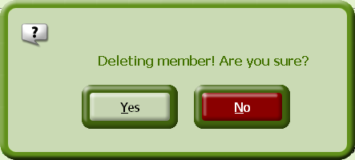

  - Combining with another person (Set Link)

- In the EDIT CUSTOMER window, click the Info 2 page link.

- Use the Set link button and the following wizard opens.

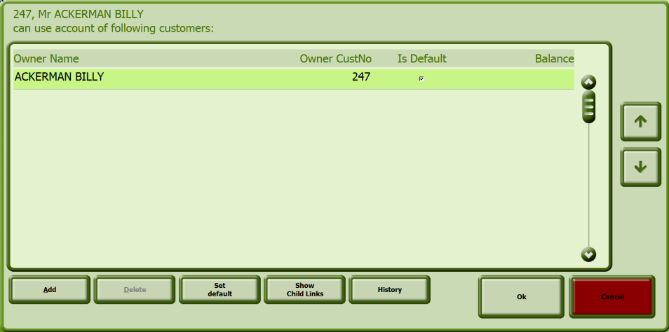

- Then click on Add, and in the list, select the person with whom a link should be created. Click the OK button to confirm the link and return to the CUSTOMER EDIT window.

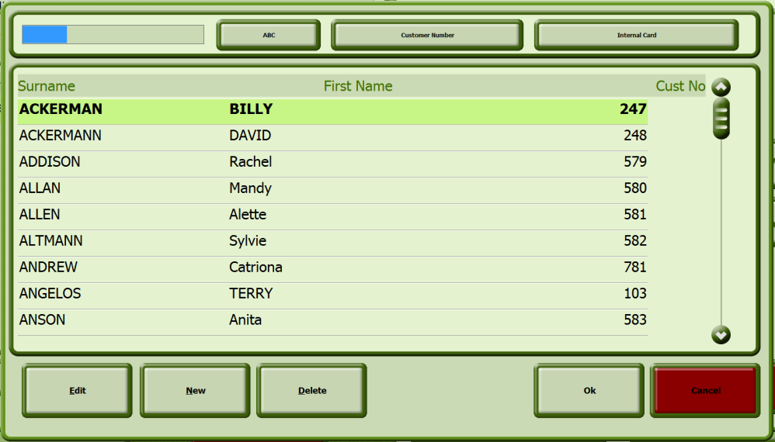

- Then click Update to complete this combining of customers.

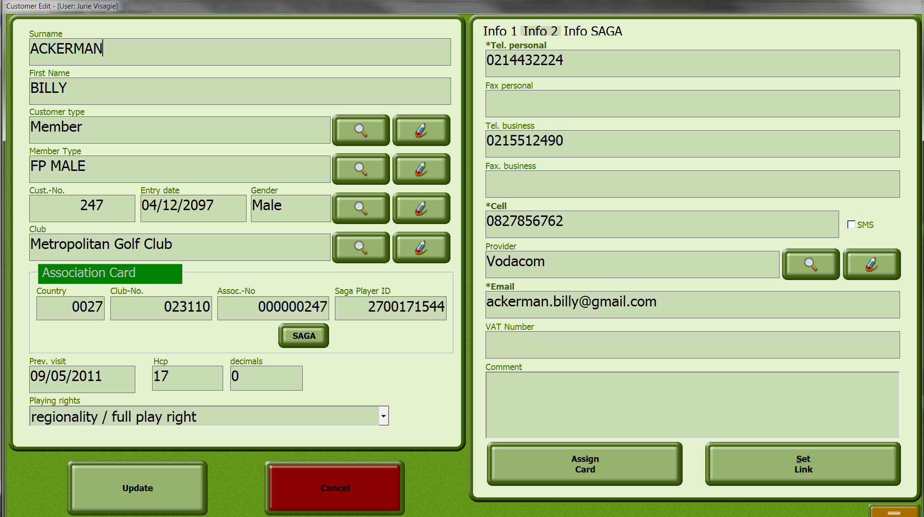

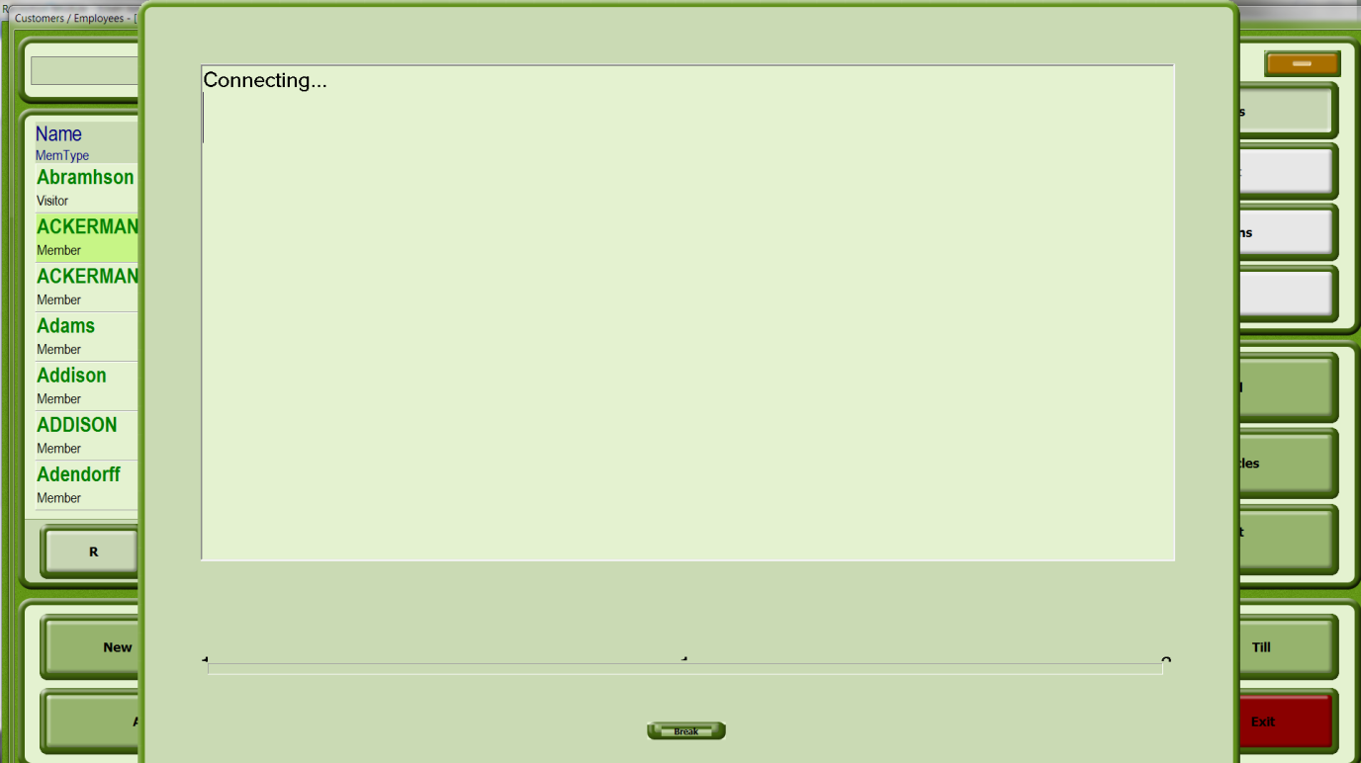

This information will be uploaded toe the SAGA server immediately.

Buttons

Internal Card Clicking the Internal Card button enables you to read data from the internal club card after it has been swiped. If the customer is already in the customer list, he or she will be selected there. If this is a new customer, a window with the customer data will appear. By confirming the data the customer will be transferred to the customer list.

Customer Number Find a person in the customer list with the customer number

Clear link Clear an existing link

OK Confirm the deletion of the link and return to the CUSTOMER EDIT window.

Cancel Return to the CUSTOMER EDIT window without setting a link

  - Assign a golf card

- In the list, select the customer to whom a golf card should be assigned.

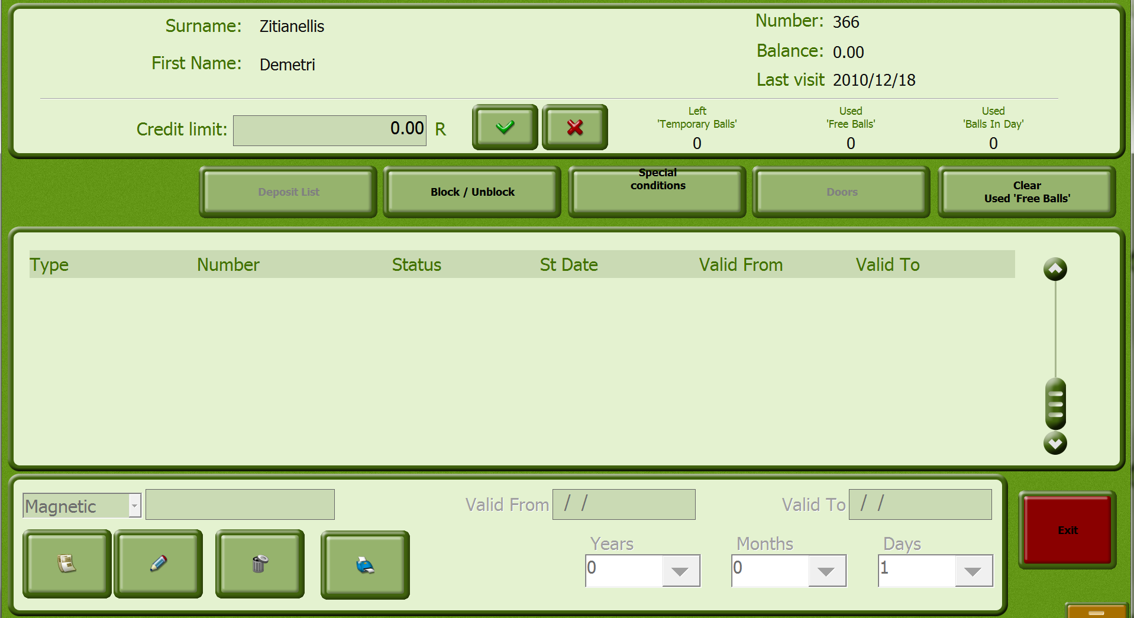

Input Fields

Credit Limit Input field for the customer's credit limit

Left ‘Temporary Balls’
Used ‘Free Balls’ Number of free balls available to the customer

Used ‘Balls in Day’ Number of free balls available to the customer per day

Type Selection list for the card type

Number Input field for the number

Valid From Input field for the date after which the card is valid. The system automatically enters the current date.

Valid To Input field for the date until which the card is valid. If the Absolute Date field is marked, the card is valid exactly for 12 months after the current date. If the Relative Date field is marked, you can select the number of Years / Months / Days that the card is valid for.

Buttons

Deposit List This function is not used in South Africa

Block / Unblock By using the Block / Unblock button the card selected in the list will be immediately blocked regardless of the expiration date.

Special Conditions With the Special Condition button, personal conditions can be assigned to the customer.

Doors With the Doors button you can assign access rights for various doors to a customer. This field is only activated if doors have been set up in the Backoffice module.

Clear Used ‘Free Balls’ With the Clear Free Balls button the count of free balls per day can be changed.

- Click the Assign Card button

- Select the card type and enter the card number in the corresponding field.

- Make the necessary entries and click on the Save button to save your data.

Processing of Transactions
- Processing of a cash transaction
- Processing of an account transaction

    - Processing of a cash transaction
- Click on the Cash Sale button

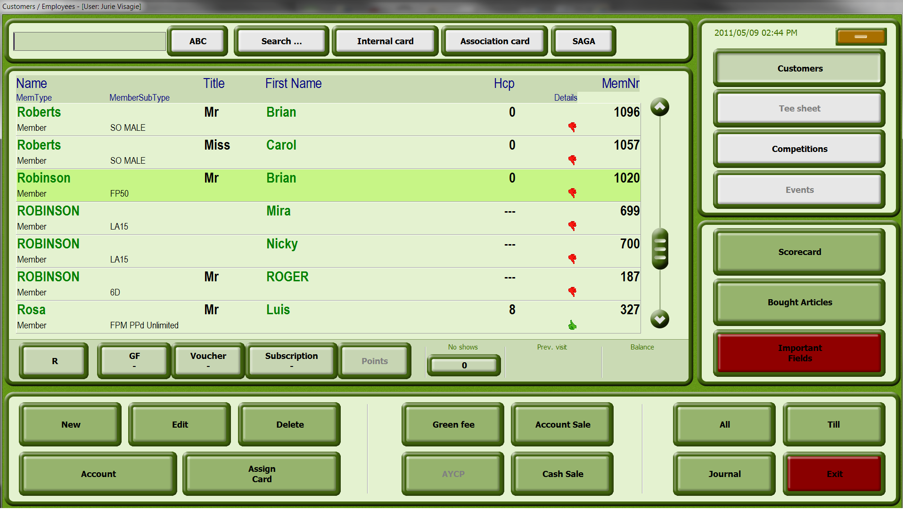

- Next, click on Article and select the article/s you want to ring up – they will be grouped together in “search groups” on the left to make them easier to find. You can edit the amount of any article on the next screen, on the top right hand corner, next to Amount.
- Click on the plus button to add the article/s

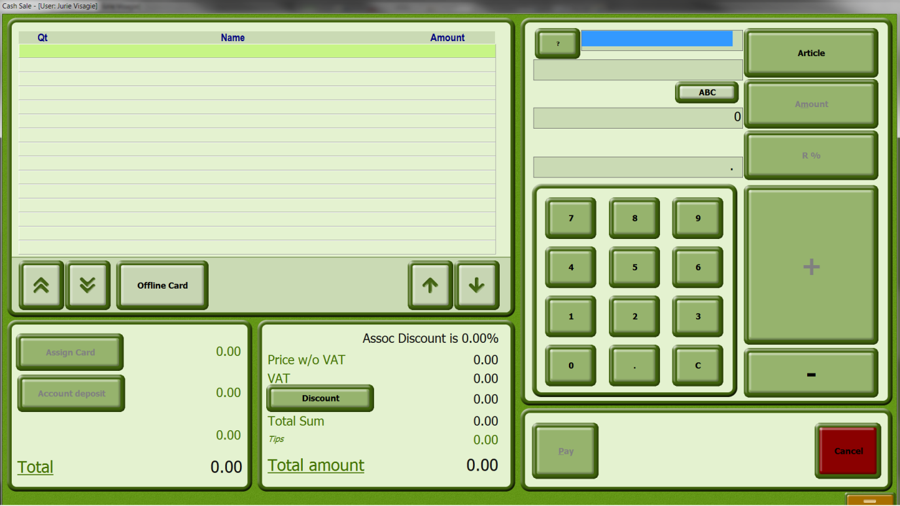

Input Fields

Articles Input field for the article. You can enter the article manually or with the Article button

? (Stock) With the Stock button you can view available stock in selected article
Amount Input field for the amount of the article to be recorded

R % Individual price of the article

Price w/o VAT Nett price of the article

VAT Price of the article with VAT

Discount Discount in Percent

Total Sum Total price

Tips Tip amount where applicable

Total to Pay Total amount including service costs

Buttons

Set With the Set button fields in the list can be displayed or hidden.

Article With the Article button the desired article can be selected.

R % With the Eu% button the selected article can be discounted.

Discount With the discount button the entire invoice can be discounted.

Pay With the Pay button the corresponding article is paid.

When you have finished adding articles, click on Pay to complete the transaction and the following screen will open.

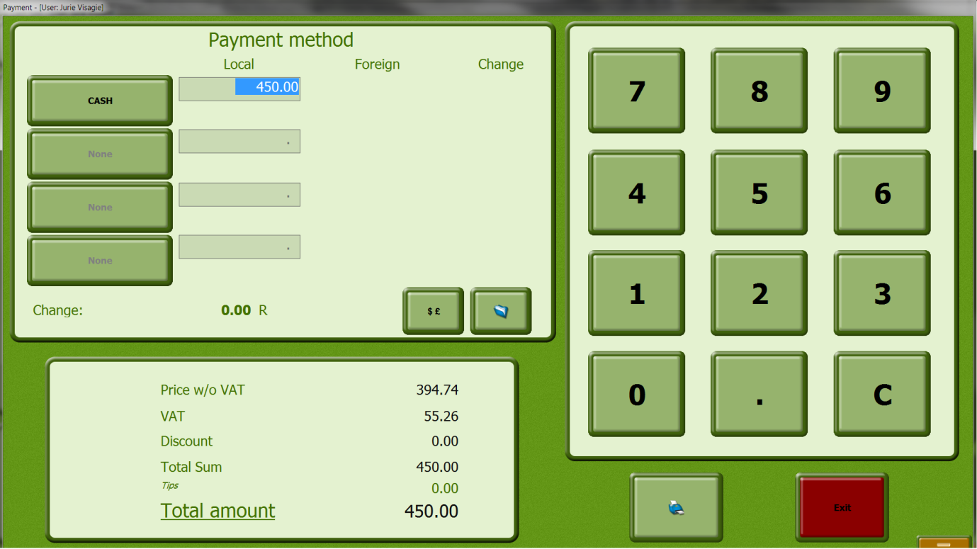

- You can then see all the payment methods by clicking on CASH (all payment methods set up in AlbAdmin will appear as a button list) select the applicable payment method
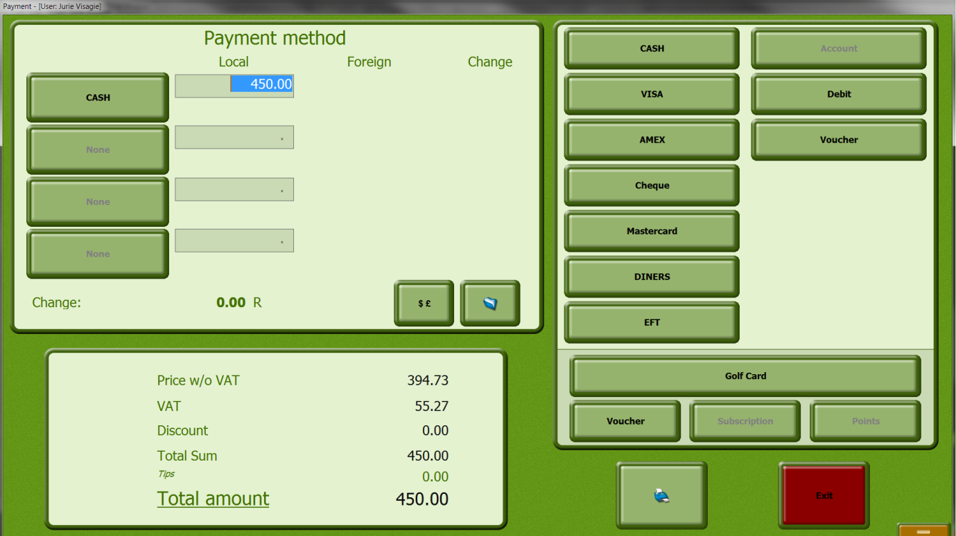

- Then click on the printer icon to capture payment and close the transaction.

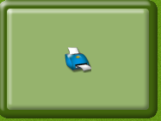

    - Processing of an Account transaction
- Click on Account Sale

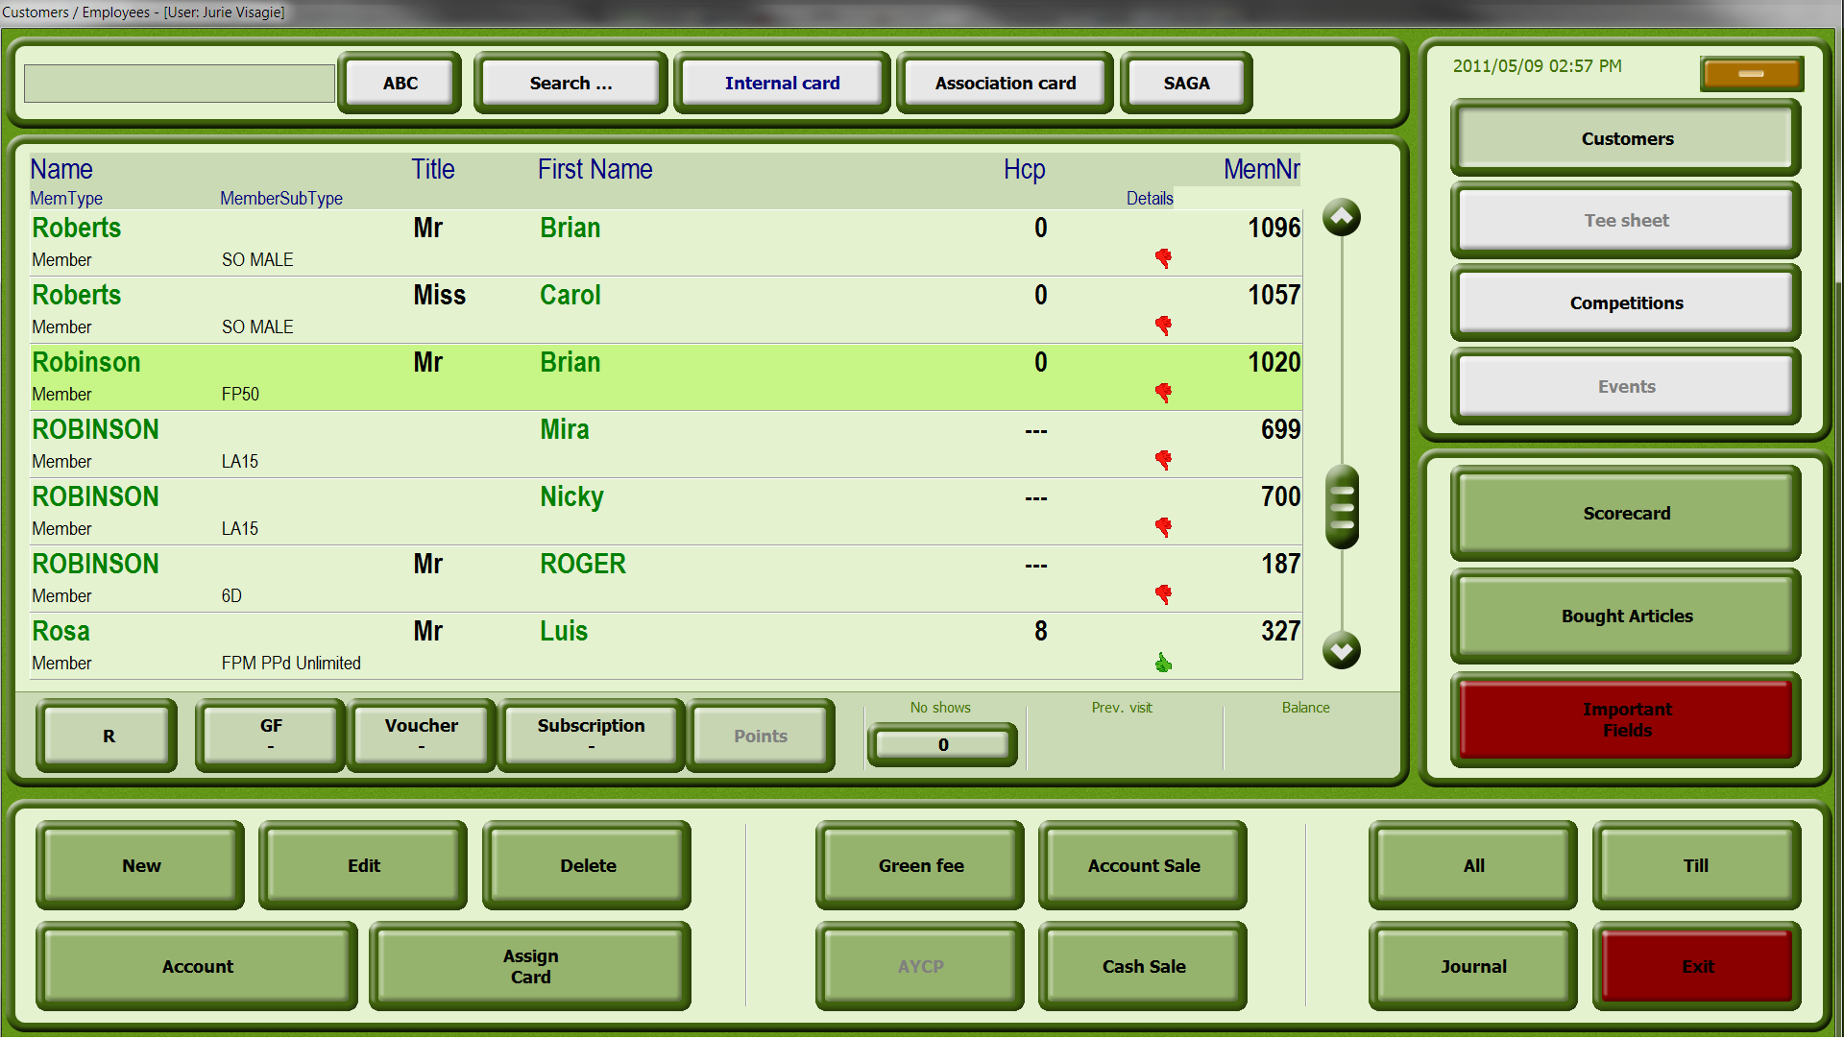

- Next, click on Article and select the article/s you want to ring up – they will be grouped in “search groups” on the left to make them easier to find. You can edit the amount of any article on the next screen, on the top right hand corner, next to number.

Input Fields - See Processing of a Cash Transaction, p29

- Click on the plus button to add the article/s
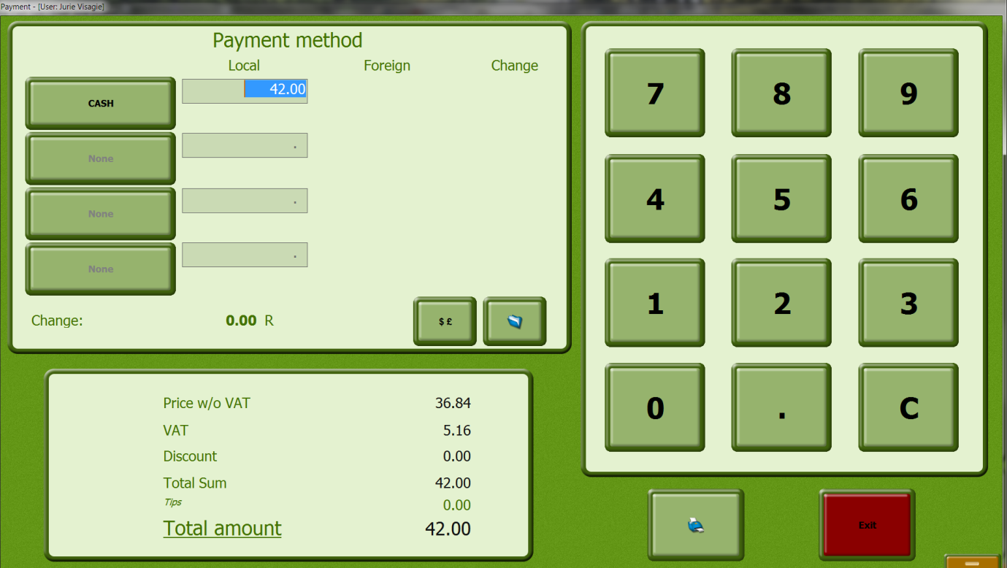

- When you have finished adding articles, the default payment method will display as Account, you simply click on the printer icon to complete the transaction.

  - J
  - ournal of a customer

See the chapter Journal…

  - Creating Invoices

- In the CUSTOMERS window, click the button Account sale.

The following window opens.

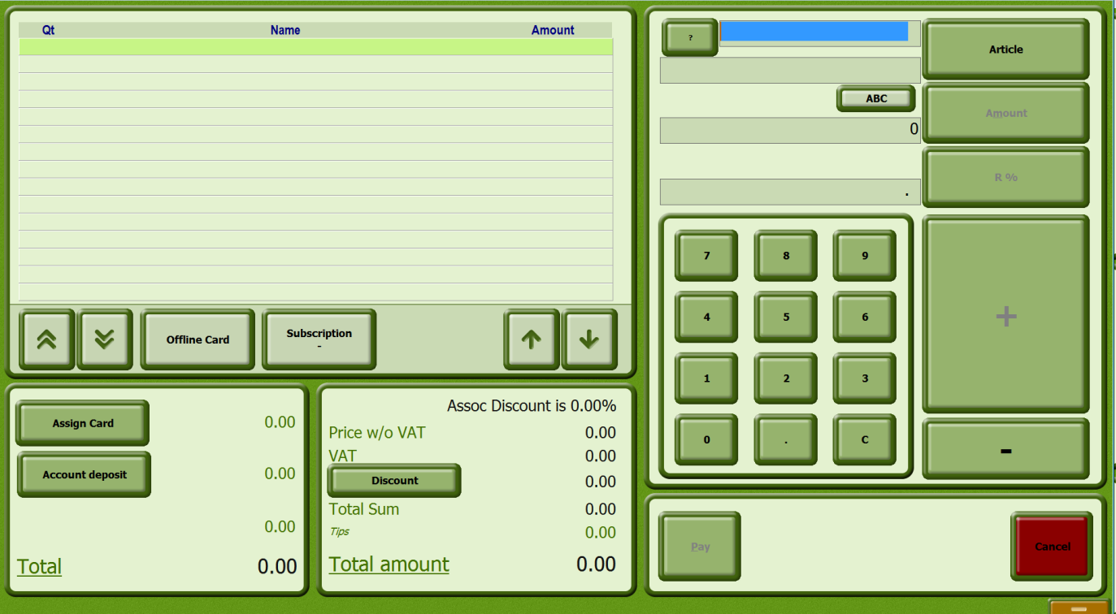

Input Fields – see Processing of a cash transaction, p29

- Click the Article button and select the desired article from the list.

- Enter the quantity of the selected article.

- Click the "Plus Sign" button to add the article to the invoice.

- Grant any discounts with the % button.

- Click the Pay button to pay the article.

  - Making a tee booking

- Click the Tee sheet button. The following window opens.

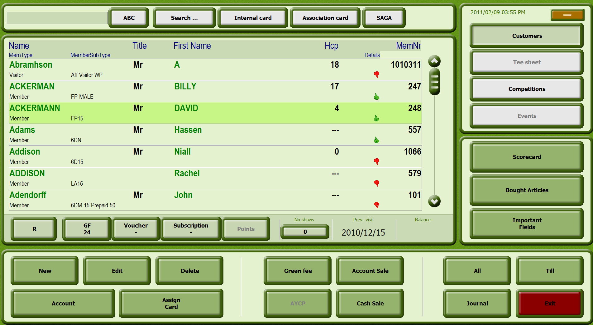

Input Fields

Date The tee sheet for the entered date is displayed. The date can be entered manually or with the arrow or the  button.

Balance Balance of the selected customer

Buttons

Customers Display the customer list

Tee sheet Display the tee sheet

Delete Start Time Delete the tee time selected in the list

New Start Time Book a tee time

Check In Check in the player selected in the list

Courses With the Courses button you can select the course for which the start time is booked.

Journal Invoice Journal of the selected customer. You can reprint invoices, cancel invoice items or change the method of payment.

With customer Article sale with customer assignment

Account Account information of the selected customer

Green fee Direct access to the green fee assigned to the customer subtype or the customer.

Assign Card Opens the ASSIGNED CARDS window. A card can be assigned to an individual manually at this point, the card can be locked and personal conditions for the customer can be stored. If the customer was created with a SAGA card, the data from the card will be displayed in the window.

Without customer Create an invoice without assigning it to a customer

- Select the date for which you wish to display the tee sheet.
  - Booking a new tee time

- Click the Tee sheet button. The following window opens.

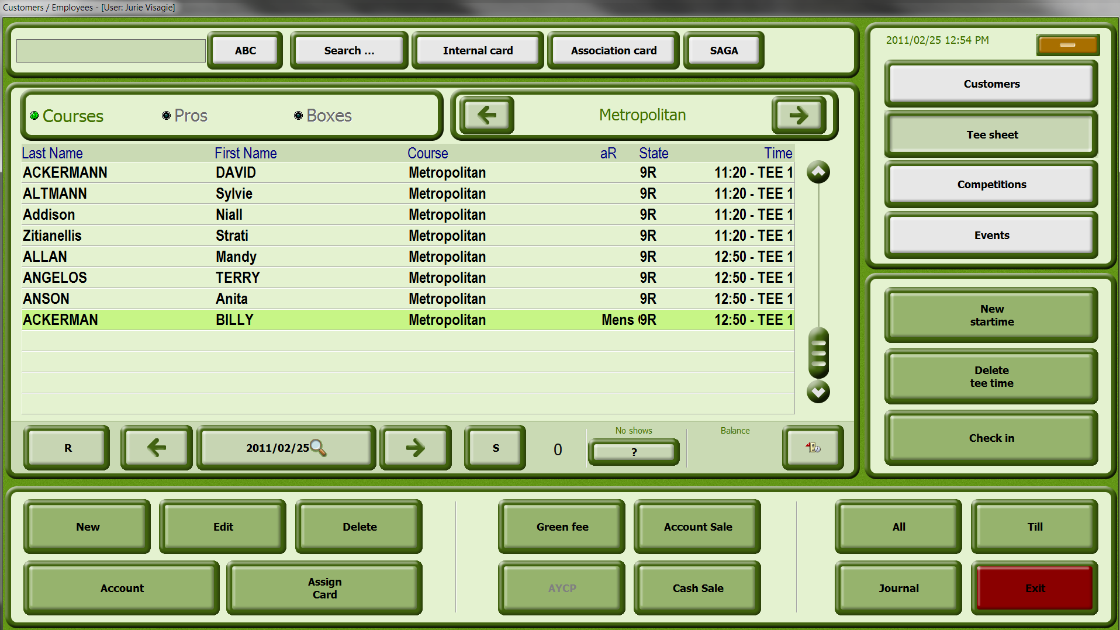

Input Fields

By interval2 The tee sheet for the entered date is displayed. The date can be entered manually, with the arrow or the button.

Balance Balance of the selected customer

Buttons

Customers Display the customer list

Tee sheet Display the tee sheet

Reset The Reset button has no function in this window

Delete Tee Time Delete the start time selected in the list

New Start Time Book a tee time

Check In Check in the player selected in the list

Courses With the Courses button you can select the course for which the tee time is booked.

Journal Invoice Journal of the selected customer. You can reprint invoices, cancel invoice items or change the method of payment.

With customer Article sale with customer assignment

Account Account information of the selected customer

Green fee Direct access to the green fee assigned to the customer subtype or the customer

Assign cards Opens the ASSIGNED CARDS window. A card can be assigned to an individual manually at this point, the card can be locked and personal conditions for the customer can be stored. If the customer was created with a SAGA card, the data from the card will be displayed in the window.

Without customer Create an invoice without assigning it to a customer.

- Select the date for which you wish to display the tee time.

- Select the date for which you wish to create a new tee time.

- Click the New Tee Time button.

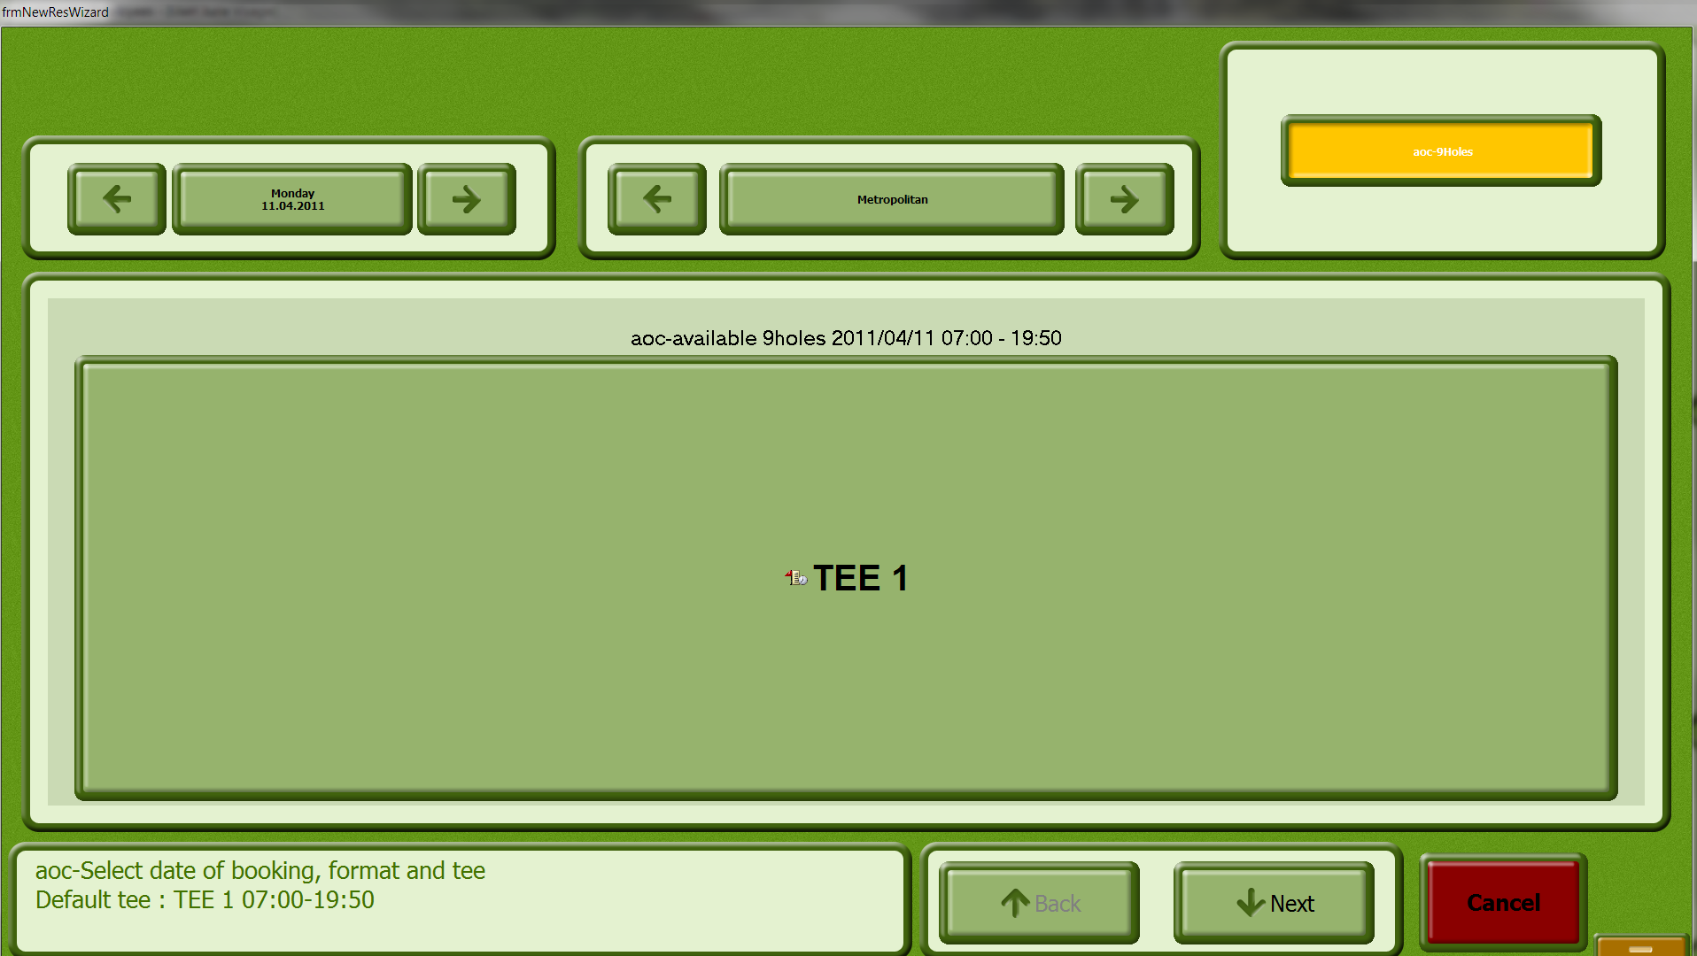
- Select the correct hole count and Tee you wish you start on (in this case, there is only 9 holes and one tee).

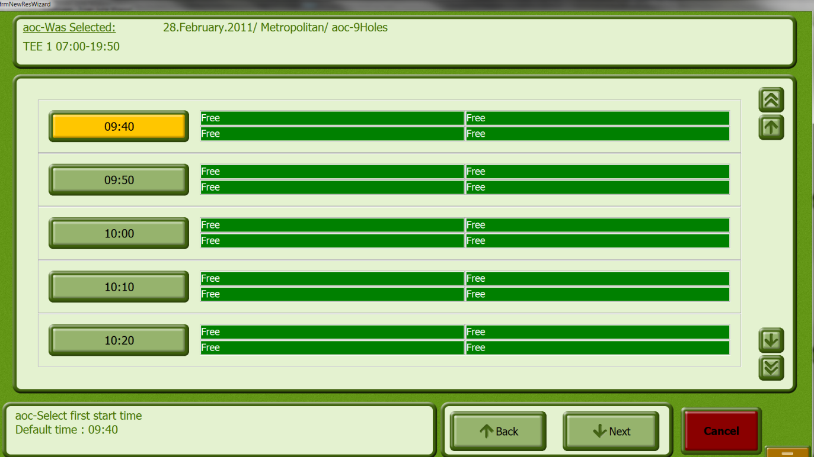

Buttons

Course With the Course button a course can be selected for the tee time.

Date Here you can select the date for which the tee time should be reserved.

Free Times Only time slots which are still free will be listed.

All Times All time slots, including those already reserved, will be displayed.

Time Time for which the tee time should be reserved.

Tee 1 The tee time reservation is valid for Tee 1.

Tee 10 The tee time reservation is valid for Tee 10.

- Enter the course, the date and the tee for which the start time should be reserved.

- Click the button with the desired tee time.

- Select the customer for which the tee time reservation should be made by double-clicking on the name. The customer will be transferred to the list.

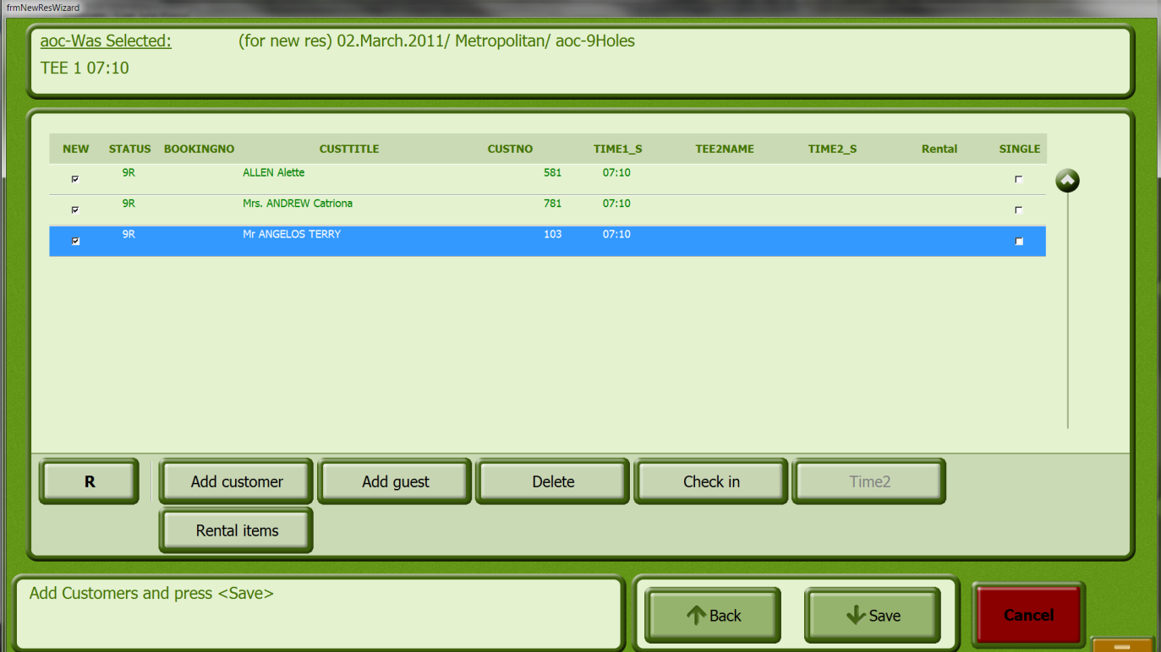

- Click the button Check In.

Buttons

Check In

Only Reservation The start time is only reserved and not confirmed.

Add another reservation Additional reservations can be made.

Cancel Leave the window without making a reservation.

Delete Start Time Deletes a tee booking

- Click the Tee sheet button.

The following window opens.

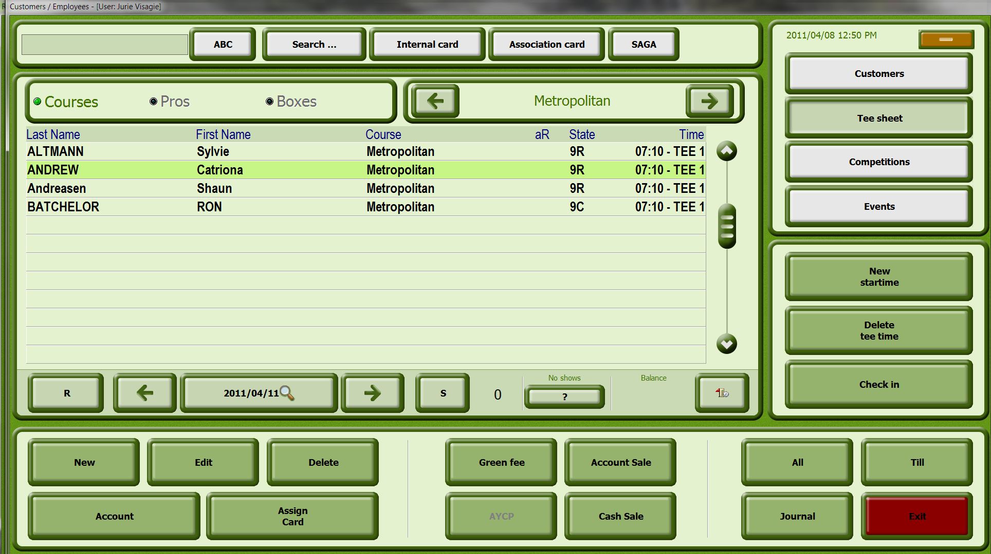

- Select the date for which the tee sheet should be displayed.

- Select the person whose tee time should be deleted.

- Click the Delete Tee Time button.

- Answer the confirmation question.

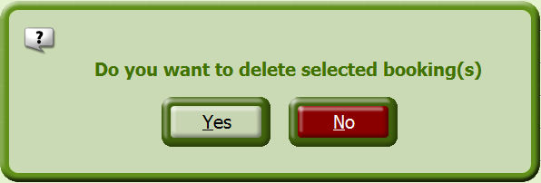

You see the following message:

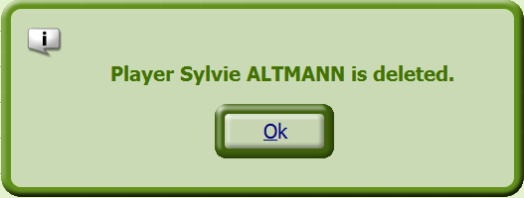

- Confirm the message with "OK"

  - Greenfees
By clicking on the Green fee button, you can process a green fee payment by a customer.

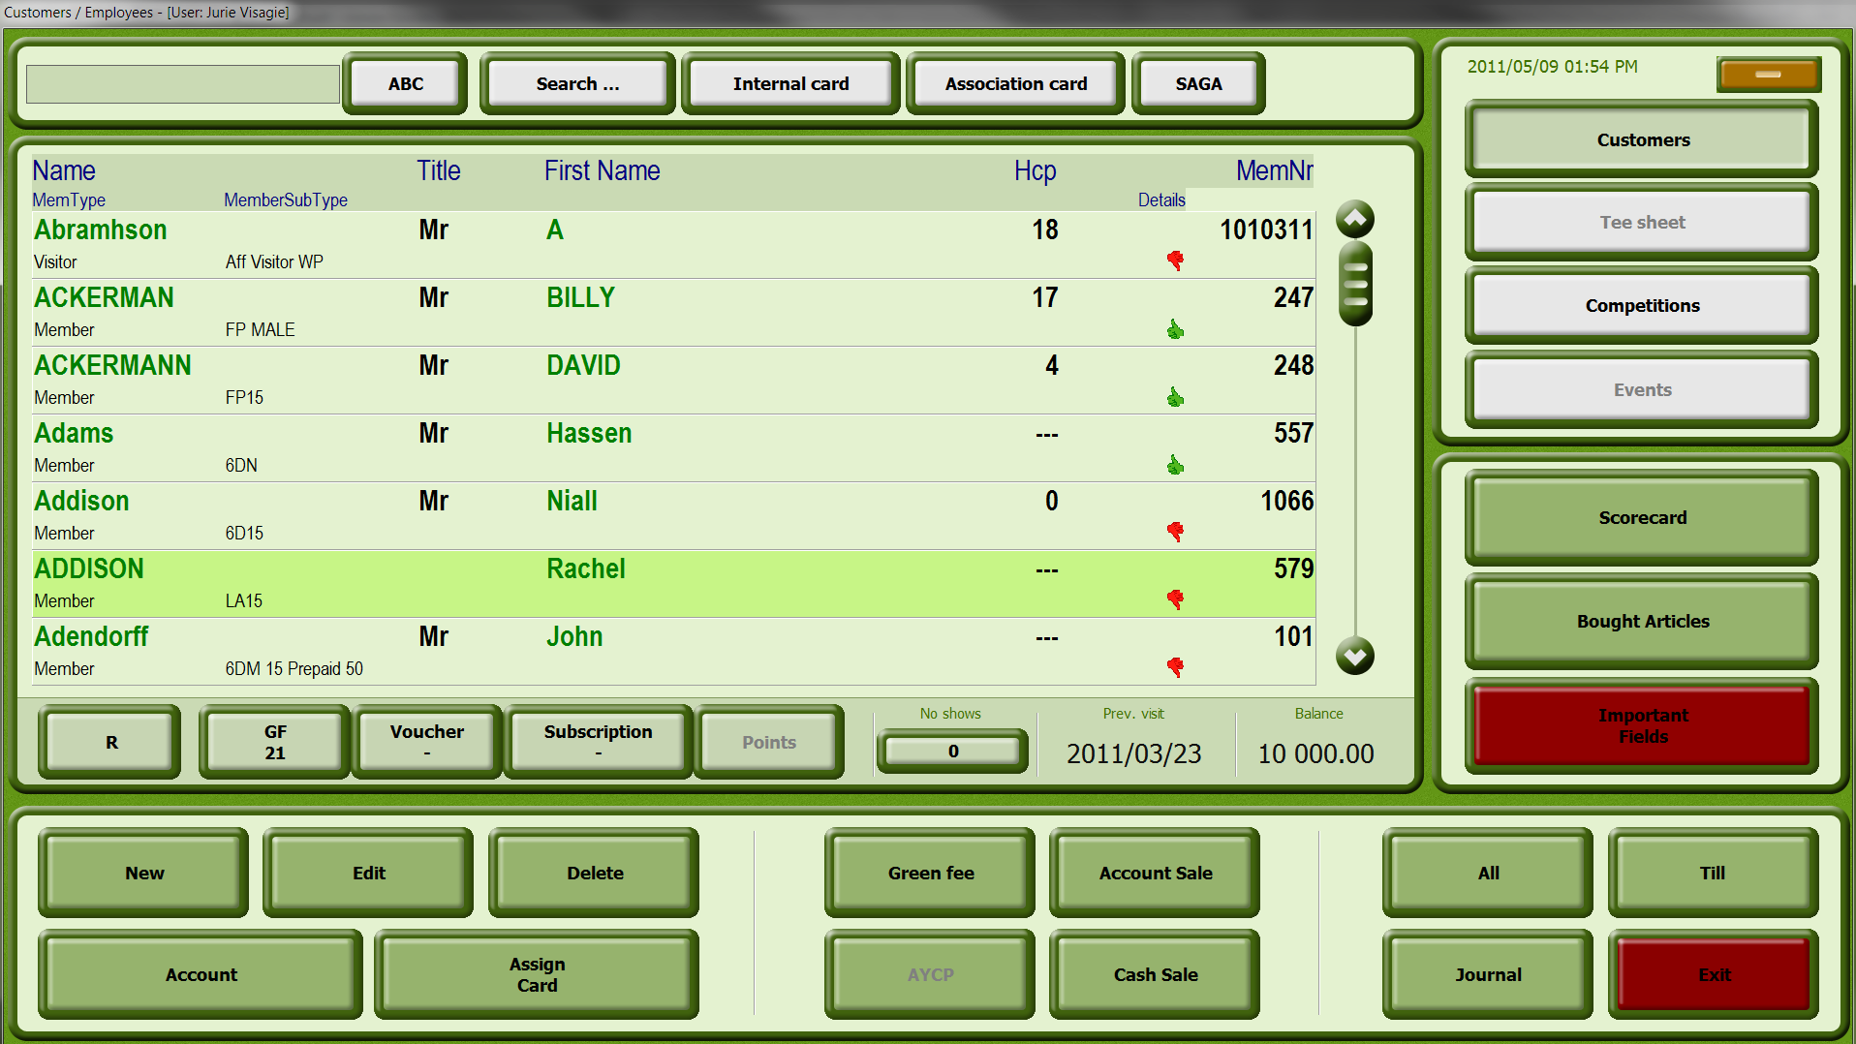

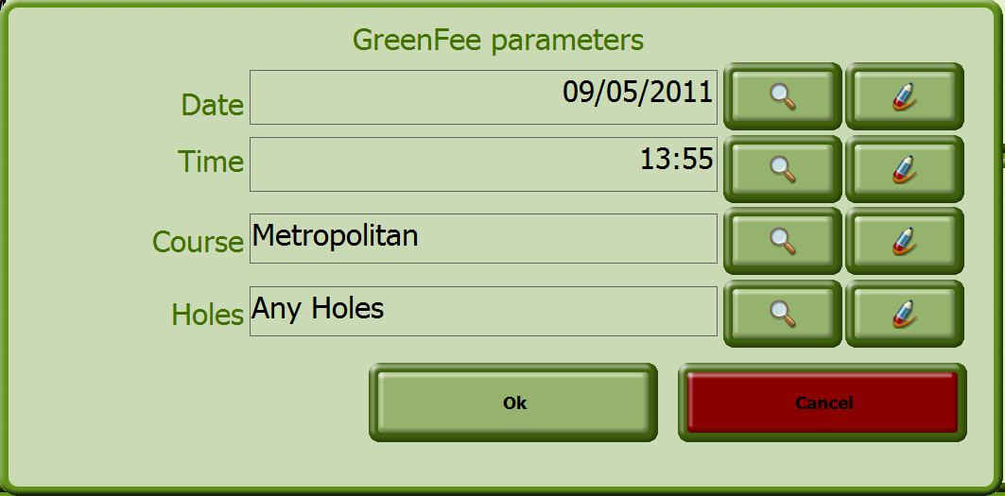

- Select the applicable date and time
- Select the course
- Select the hole count – 9 or 18
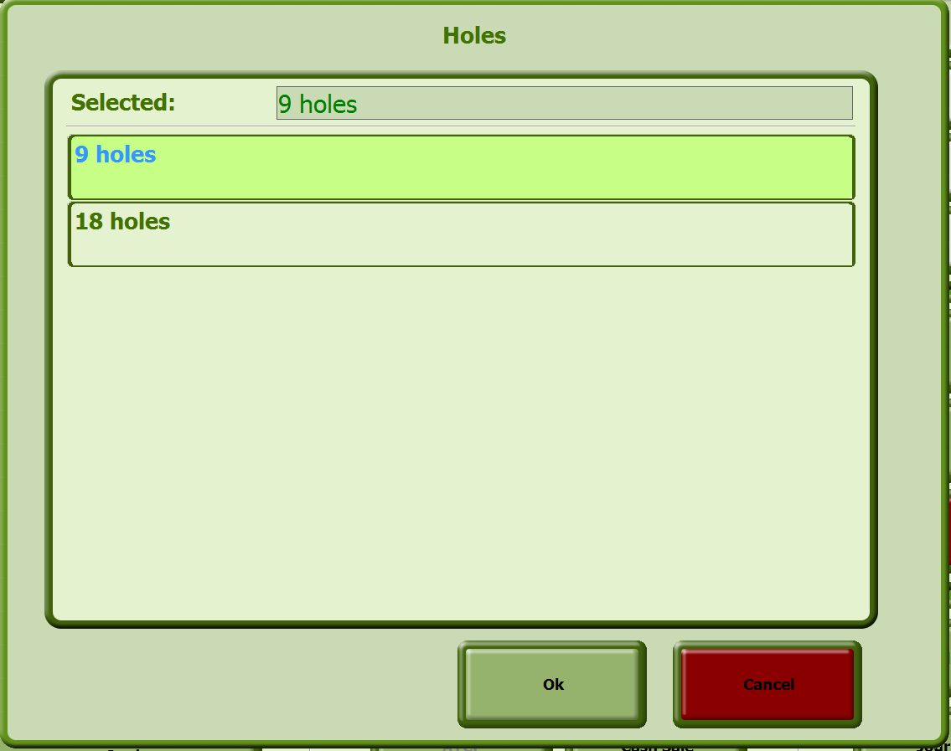

- Next, click on OK and proceed to the payment screen.

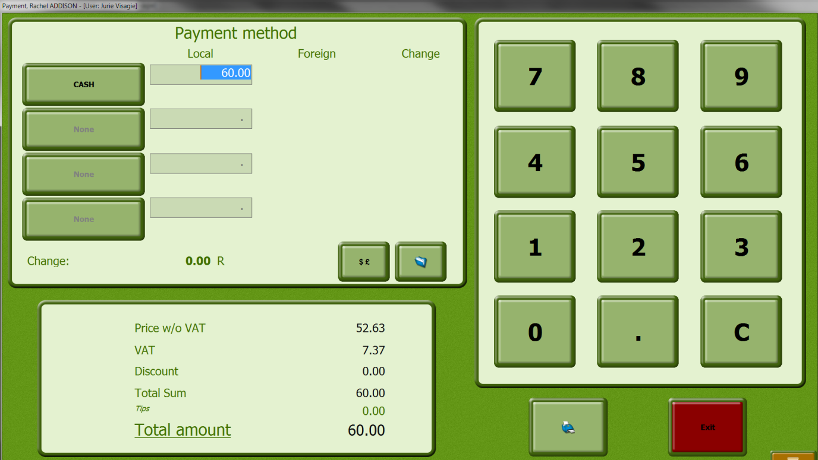
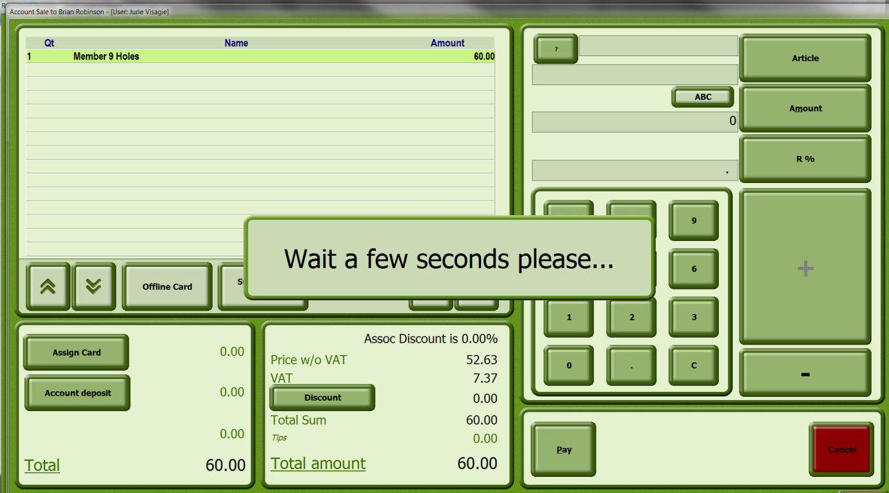

- Account
In the ACCOUNT window you see all information and options for the customer
account.

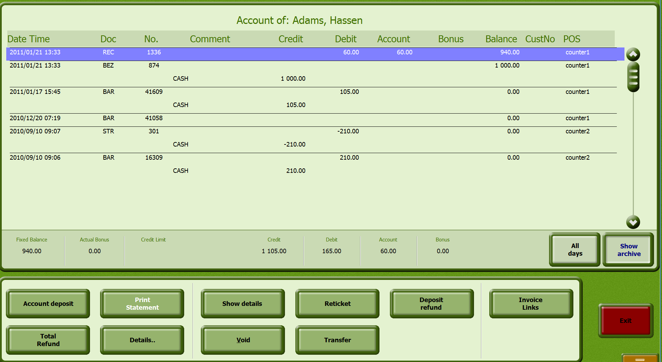

Input Fields

Credit Balance Current account status of the customer

Type Short name of the payment method

Amount Amount which was settled with the above-mentioned payment method

Comments Any comments about the payment method

Buttons

All Days Either all bookings in the List will be displayed or only the bookings which were made in the specified time frame.

Show Archive Either all records in the list will be displayed or only the current ones.

Show Details Here you can change back and forth between the detail view of the currently selected booking and the booking list.

Void With the Void button you can cancel articles from the currently selected booking.

Print Statement Print a report. The following reports are available: Brief Report, Detailed Report or Account Report .

Reticket Reprint the currently selected booking

Credit Payment Payment of a credit

- Journal of a customer

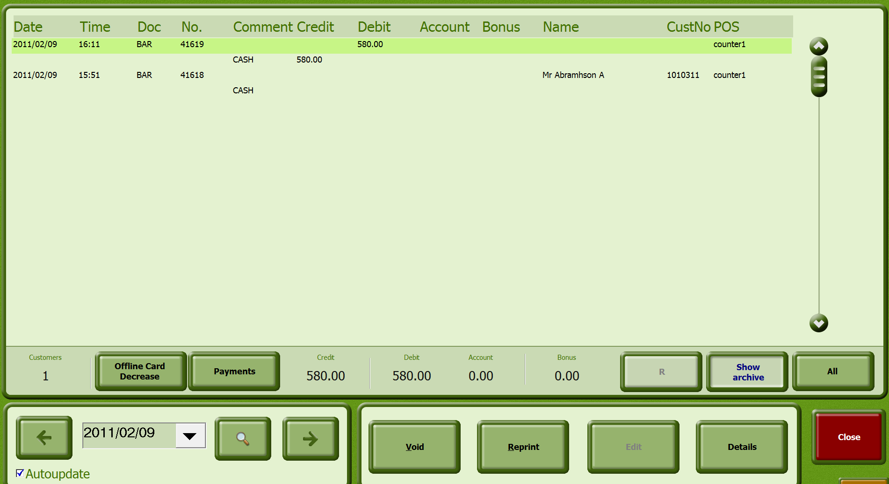

Input Fields

Date Field Input field for the date. The date can be entered manually or by using the calendar sheet.

Auto-update If this box is ticked, the list will automatically be updated after the date is changed. The Update input field is currently active.

Customers Number of invoices in the current customer account

Balance Display of the sum of all invoices for the selected day

Type Short description of the payment method

Amount Amount which was settled with the above-mentioned payment method.

Comments Any comments about the payment method

Buttons

Update Update the list. This button is not active when the Autoupdate box is ticked.

Void Cancel items in the currently selected invoice

RePrint Reprint the selected invoice

- Termination / end of day

In the END OF DAY REPORTS window the daily closing is accomplished and you have the opportunity to reprint previously transacted daily closings.

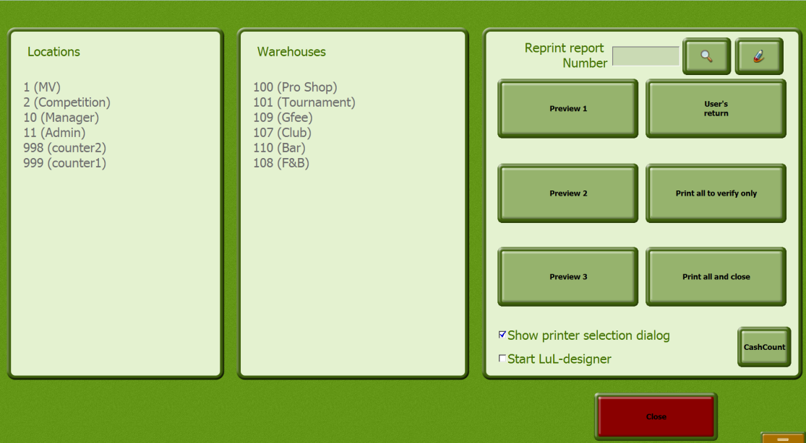

Input Fields

Reprint Report Number Input field for the number of reports that should be reprinted. With the Search button you can search for the report by name or by number.

All Locations If the All Locations box is checked, all locations will be closed out.

All Warehouses If the All Warehouses box is checked, all warehouses will be closed out.

Show Printer Selection
Dialog Checking this box enables you to select the printer.

Buttons

Preview 1 Preview of the booking journal

User’s return Create an employee report

Preview 2 View of the employee report and payment methods.

Print All to verify only Print reports (booking journal, employee report, payment methods report, sales groups report) without performing the end-of-day close.

Preview 3 View of the sales groups volumes

Print All and Close Print reports (booking journal, employee report, payment methods report, sales groups report), performing the end-of-day close.

  - Performing end-of-day close

- In the main menu, click on the Close button.

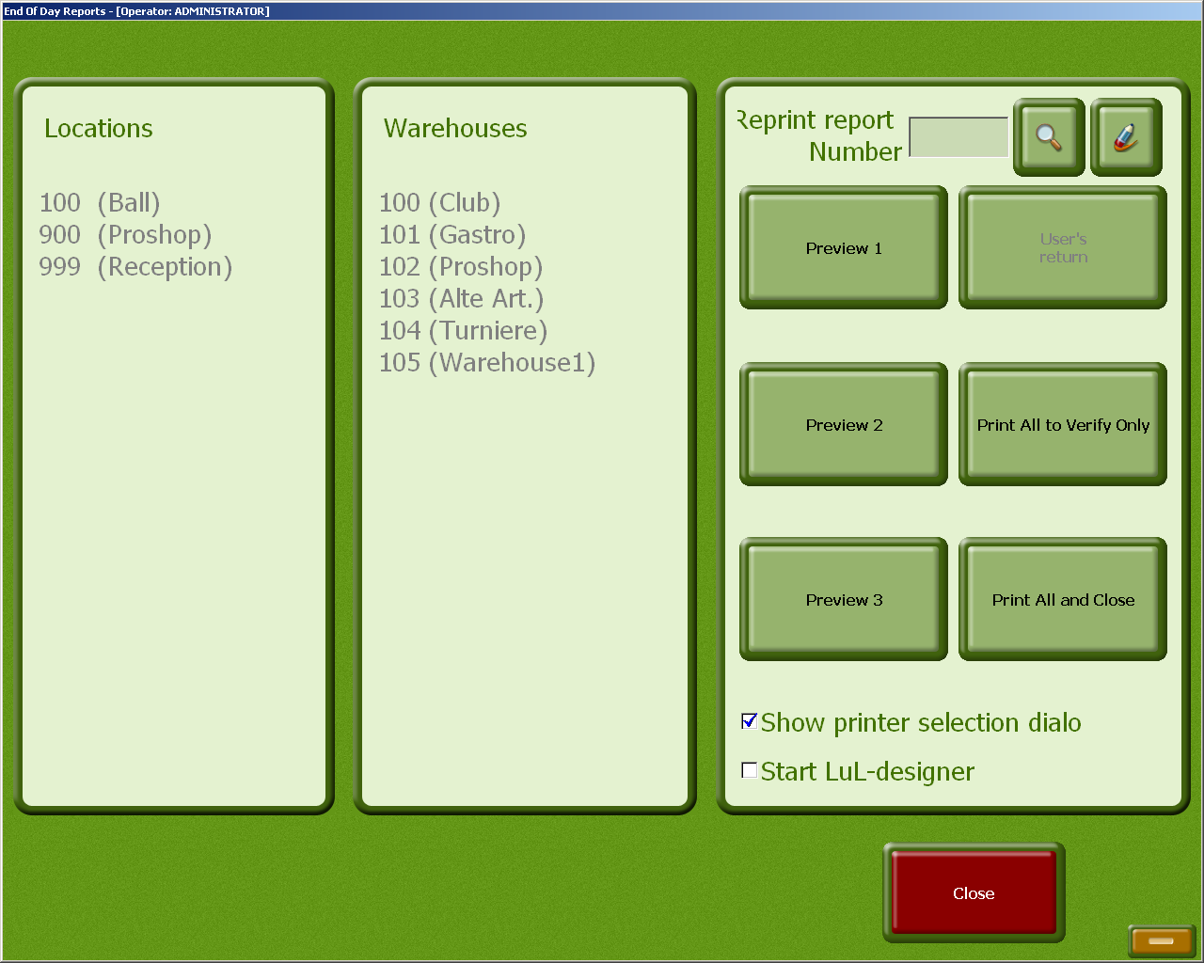

- Click all locations to be considered in the end-of-day close.

- Select all warehouses to be considered in the end-of-day close.

- Click on the "Preview" button or one of the two Print buttons.

If you have not checked either of the boxes for "Show Printer Selection Dialog" or "Start LuL-designer", the daily close will be printed. If the boxes are checked, you can see the entries in the preview and select the desired output medium.

- CashBook

The cashbook is divided into two parts.

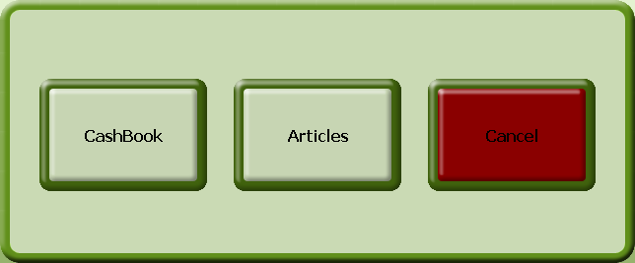

The Cashbook, in which the individual bookings are made, and the Articles area, in which the articles are entered.

  - Cashbook

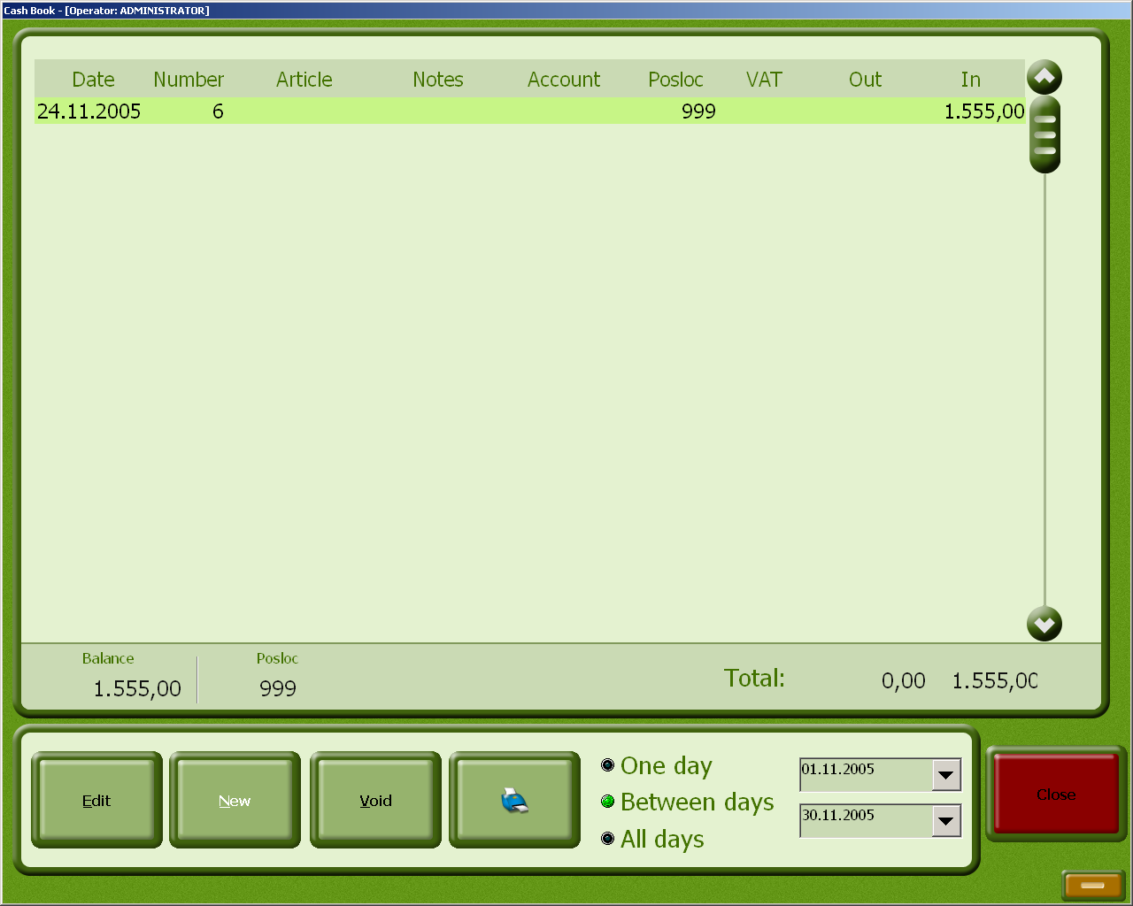

Input Fields

Balance Cashbook balance amount

Total: Total cashbook amount

A Day If the A Day field is selected, only the bookings from the day shown in the field on the right will be displayed.

Between Days If the field Between Days is selected, only the bookings for the period of time shown in the two fields will be displayed.

All Days If the All Days is selected, all bookings will be displayed.

Buttons

Edit Edit the selected booking

New Create a new booking

Void Cancel the selected booking

Print Print the report

  - Inserting a new booking

- Click the button New

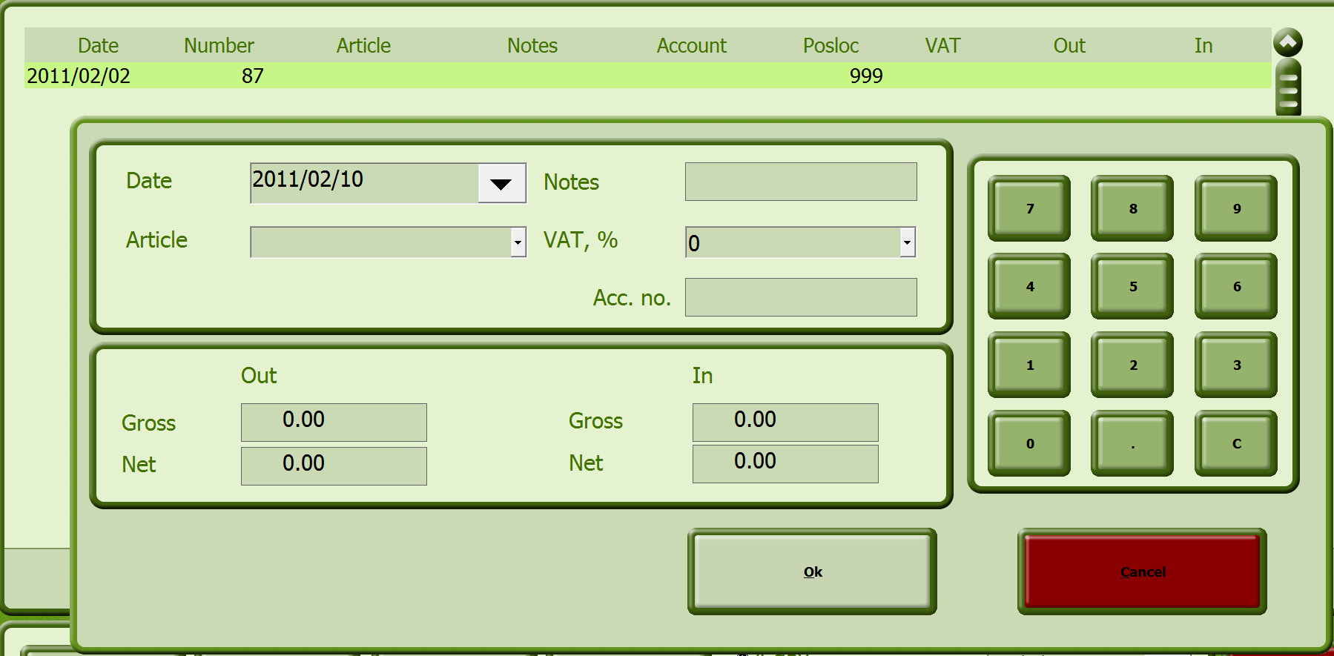

Input Fields

Date Input field for the booking date. The date can be entered manually or by using the calendar sheet. The system automatically enters the current date.

Article Selection list for the article. The articles created in the Articles window are available for selection. If you select the free text item, an article can be entered manually.

Notes Input field for any notes about the article.

VAT, % Selection list for the VAT All VAT rates created in Backoffice are available for selection.

Account Number Number which identifies the corresponding register. It is recommended to use the number of the corresponding location.

Out

Gross Gross amount taken from the register

Net Net amount taken from the register

In

Gross Gross amount present in the register

Net Net amount present in the register

Make the corresponding entries for the booking and confirm with the OK button.

Answer the confirmation question (this only happens in the case of negative balances).

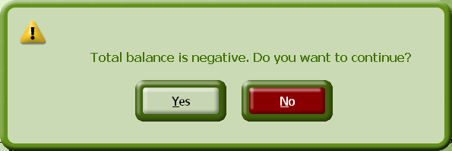

  - Editing a booking

- In the list, select the booking that you would like to edit.

- Click the Edit button and make the changes.

- Click the OK button and answer the confirmation question if needed.

  - Void a booking

- Select the booking to be voided and click the Void button.

- Answer the confirmation question.

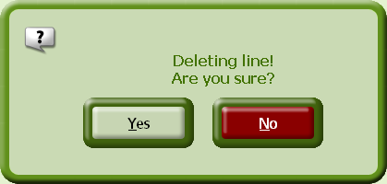

  - Texts / Articles

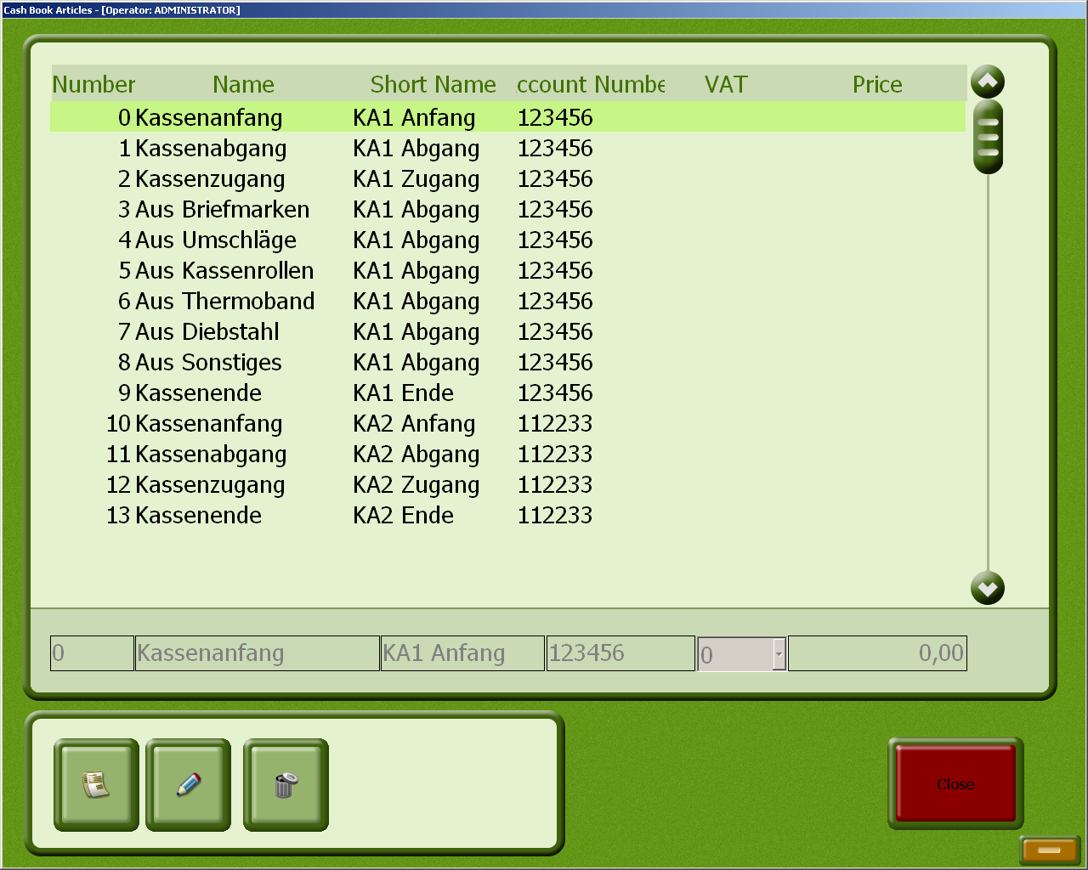

Input Fields

Number Sequential article number

Name Name of the article

Short Name Short name of the article

Account Number Number which identifies the corresponding register. It is recommended to use the number of the corresponding location.

VAT Selection list for the VAT rate. All VAT rates created in Backoffice are available for selection.

Price Individual price of the article

  - Inserting a new article

- Click the button with the paper icon to create a new article and then define the article with the corresponding entries.
- Save the entries with the Save button. 

  - Editing an article

- Select the article to be changed and click the Edit button. 

- Make the changes and save them with the Save button.

  - Deleting an article

- Select the article to be deleted.
- Click the Delete button  and answer the confirmation question.

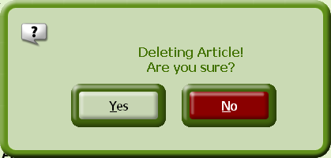
- Remote access by our support team with Netviewer
As part of our installations, we include the Netviewer software, which gives our Support team the opportunity to access your workstation remotely.

This software can be activated in the following ways:

Netviewer icon on your desktop:

- Click on the Netviewer Icon to start a remote management session.

Quick Launch Bar

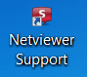

Desktop logo

  - Remote access in the Albatros modules
Click on ‚Help‘ in the top line and then choose ‚Albatros Netviewer Service‘.

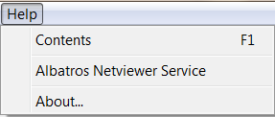

  - Starting the remote access session
- Please call our support number: 086-010 9372 / 079-314 9571. Should our support team member feel that it is necessary to start a Netviewer session, he will ask you to load the software.

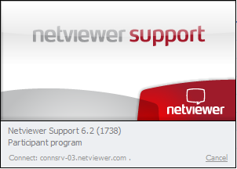

- The session starts with the left screenshot as seen above. The connection is tested and once it has been established successfully, a window pops up, requesting you to enter a code. This code will be given to you by the Support team member and is unique for this session.

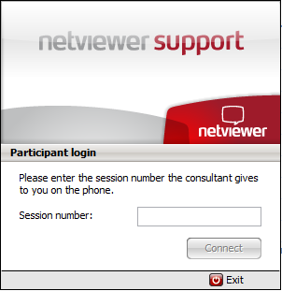

- Once you have entered the number, please click on ‚Connect‘ to confirm and when the secure connection has been established between the two computers, you are requested to allow the transmission of your screen:

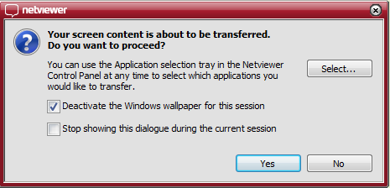

- Click on the button „Yes“, so that the support team member can view your screen. The remote access (Remote control) is now active as shown by the window:

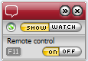

- This menu is visible throughout the whole session. Once the session is completed, a new window opens up to document the end of the remote access. Please click on ‚Close‘ to confirm.

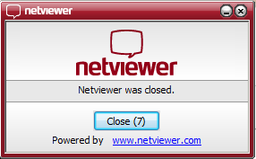

The advantages of Netviewer compare to other remote access software are:

- Quick link via the Internet
- Low costs compared to other softwares on the market
- 128 Bit Encryption
- VeriSign-Certificate

 Support – Hotline

Support inquiry:  Monday – Friday | Operating hours: 08.00 – 17.00
Support-inquiry:  Saturday, Sunday or public holiday | Operating hours: 10.00 -15.00  Included but non-technical only
Remote maintenance  Monday – Friday | Included
Remote maintenance  Saturday, Sunday or public holiday | Included but non-technical only, subject to availability

Publisher of this manual:
iTee Solutions
Old Castle Brewery
Unit 404
6 Beach Road
Woodstock 7925
Office: 086-010 9372
Technical Support: 079-314 9571

Email: info@iteesolutions.co.za
Internet: http://www.iteesolutions.co.za

