
iTee Solutions. Your iTee partner in golf.

Manual:
Members & CRM

Version: March 2011, Ver. 8.7.0.0 - Rev. 1.0.5 FNO

Table of Contents
1. Introduction to Albatros Members 8
1.1 Menu Functions 8
1.2 Find Customer 8
2. Introduction to Customers 8
2.1 Menu Functions 8
2.2 Export Data 8
2.3 Define selection 8
2.4 Change a filter 8
2.5 Delete a filter 8
2.6 Form Letters 8
2.6.1 Create a Form Letter Template (MS Word 2007) 8
2.6.2 Create a Form Letter Template (MS Word 97) 8
2.6.3 Create a Form Letter (MS Word 2000, XP and 2003) 8
2.7 Creating Address Labels 8
2.8 SMS-Messages 8
2.8.1 Sending SMS to a Cell Phone 8
2.9 Write Withdrawal File 8
2.10 Assign standard charges for current selection 8
2.10.1 Tournament Booking Wizard 8
2.11 Print an Exact or Playing Handicap List 8
2.12 Export contacts from Members & read in MS Outlook for sending E-mail 8
2.13 Multiple Handicap Entries 8
2.14 Create Statistics 8
3. Members - Customers 8
4. Details 8
4.1 Create New Customer 8
4.2 Change customer data 8
4.3 Delete customer data 8
5. Contacts 8
5.1 Assigning Persons / Families 8
5.2 Cancel assignment of individuals 8
5.3 Assign the Family Head status 8
5.4 Reset the Family Invoice to an Individual Invoice 8

6. Extras 8
6.1 Enter additional clubs 8
7. Banks 8
7.1 Add a new bank 8
7.2 Change a bank association 8
7.3 Delete a bank association 8
8. Subscriptions 8
8.1 Assignment Options of Charges and Payments 8
8.2 Assignment of Charges and Payments 8
8.3 Load standard charges 8
8.4 Changing a payment 8
8.5 Delete a payment 8
8.6 Sort Articles / Family members 8
9. Reminders 8
10. Accounts 8
10.1 Create Invoices 8
10.2 Delete Items 8
10.3 Print an Invoice 8
11. Memos 8
11.1 Creating a memo 8
11.2 Change a memo 8
11.3 Delete a memo 8
12. Handicap 8
12.1 Making a Handicap Sheet Entry 8
12.2 Changing a handicap sheet entry 8
12.3 Delete a handicap sheet entry 8
13. SAGA Intranet 8
14. Competitions 8
14.1 Registering for a competition 8
14.2 Delete a competition registration 8
15. Clubs 8
15.1 Find a club 8

16. Club data 8
16.1 Create a club 8
16.2 Change club data 8
17. Club Staff 8
17.1 Create a club person 8
17.2 Change a person's data 8
17.3 Delete a club person 8
18. Courses 8
18.1 Create a course 8
18.2 Change Course Data 8
18.3 Delete Course Data 8
19. Auxiliary Tables 8
20. Customer types 8
20.1 Creating a customer type or customer subtype 8
20.2 Changing a customer type or customer subtype 8
20.3 Deleting a customer type or customer subtype 8
21. Counters 8
21.1 Create a counter range 8
21.2 Change counter range 8
21.3 Deleting a counter range 8
22. Age groups 8
22.1 Create an age group 8
22.2 Change an age group 8
22.3 Delete an age group 8
23. Customer groups 8
24. Contact types 8
25. Lockers/Boxes 8
25.1 Locker and Box Management 8
25.2 Additional field "Use Type" 8
26. Address data (Address) 8
26.1 Create a greeting 8
26.2 Changing a greeting 8
26.3 Deleting a greeting 8
27. Title 8
27.1 Create a title 8
27.2 Change a title 8
27.3 Delete a title 8
28. Letter Address 8
28.1 Create a letter address 8
28.2 Change a letter address 8
28.3 Delete a letter address 8
29. Name Suffixes 8
29.1 Create a name suffix 8
29.2 Change a name suffix 8
29.3 Delete a name suffix 8
30. Occupation 8
30.1 Create an occupation description 8
30.2 Change an occupation description 8
30.3 Delete an occupation description 8
31. Countries 8
31.1 Create a country 8
31.2 Change country data 8
31.3 Delete a country 8
32. Postal codes 8
32.1 Create a Postal code 8
32.2 Change a Postal code 8
32.3 32.3 Delete a Postal code 8
33. Banks 8
33.1 Create a bank 8
33.2 Change a bank's data 8
33.3 Delete a bank 8
34. Golf Union 8
34.1 Create a golf association 8
34.2 Change golf association data 8
34.3 Delete a golf association 8
35. VAT 8
35.1 Create a new VAT rate. 8
35.2 Change a VAT rate 8
35.3 Delete a VAT rate 8
36. Clients 8
37. Sale Groups 8
37.1 Create a sale group 8
37.2 Change a sale group 8
37.3 Delete a sale group 8
37.4 Forecast / Budget planning 8
38. Articles/Charges 8
38.1 Create a new article 8
38.2 Change an article 8
38.3 Delete an article 8
38.4 Credit articles 8
38.5 Assign credit 8
39. Membership Contributions (Subs / Fees) 8
39.1 Create a membership contribution 8
39.2 Change a membership contribution 8
39.3 Delete a membership contribution 8
40. Reminder levels 8
41. Documents 8
41.1 Locate an invoice 8
42. Invoice 8
42.1 Pay an invoice item 8
43. Ordering Cards 8
44. Remote access by our support team with Netviewer 8
44.1 Netviewer icon on your desktop: 8
44.2 Remote access in the Albatros modules 8
44.3 Starting the remote access session 8
45. Sample exercises 8
45.1 Exercise 1 "Add Customer" 8
45.2 Exercise 2 "Change Customer" 8
45.2.1 Create a new "External Member" subtype. 8
45.2.2 Assign a subscription to the subtype. 8
45.2.3 Assign the new subtype to the new members. 8
45.2.4 Assign a new home club to the new admission 8
45.2.5 Create an admission invoice for the new member 8
45.3 Exercise 3 "Selection and Communication" 8
45.3.1 Change the selection to include all common members with handicap(...). 8
45.3.2 Generate a serial letter or an E-mail for the resulting selection. 8
45.4 Exercise 4: Subscriptions 8
45.4.1 Create a subscription preview 8
45.4.2 Create a subscription invoice 8

© Frank Nordwig (Albatros, Germany) / Translation done by Sonja Bland (iTee Solutions, South Africa)

- Introduction to Albatros Members
Next to orderly conducting of competitions, an essential task is the reliable management of member data. However, the data managed in ALBATROS FOR WINDOWS is not limited to members.

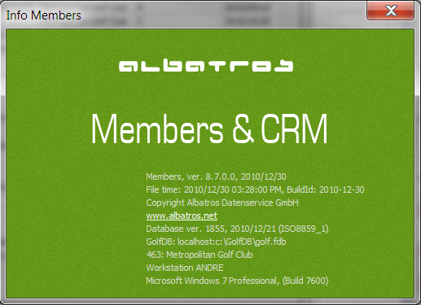

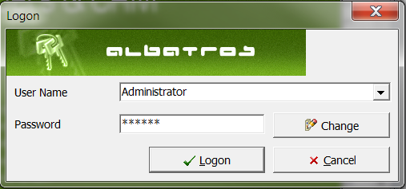

ALBATROS FOR WINDOWS MEMBERS is divided into the following areas:

Register New | 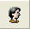 | Find Customer
Members | 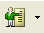 | Club Management | 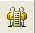
Auxiliary Tables |  | Booking | 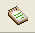
Ordering SAGA Cards |  | SAGA Intranet | 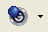
Task Planner | 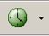 | Start Microsoft Word | 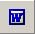

  - Menu Functions
Customer Menu
Find Customer Find a specific customer
Customers The display of the customer list can be restricted to members, non-members or specifically selected customers.
Clubs Open Clubs
Extra Day Scores The Extra Day Scores are entered here (See the chapter Extra Day Scores)
Booking Open the DOCUMENTS window, in which all invoices are listed (See the chapter Documents)
Booking Operations Call up a list with all bookings, a list of bookings only, or a list which contains only debit entries.
Ordering SAGA Cards Opens the wizard for ordering SAGA Cards (see the chapter Ordering SAGA Cards).
Microsoft Word Opens Microsoft Word (external program call)
Log off current user Logs the current user off the system
Task Planner he task planner is integrated into Members and Competitions so that AlbOffice must no longer be started to manage tasks or to process SAGA intranet records.
Exit Exit Members

  - Find Customer
- Click the icon Find Customer.

The FIND CUSTOMER wizard opens

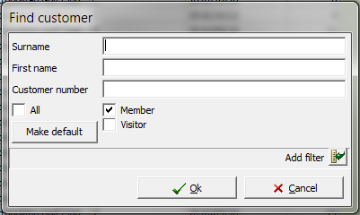

Input Fields
Surname The last name of the customer to search for.
First Name The first name of the customer to search for.
Customer Number The number of the customer to search for.
Tick Boxes Depending on the selection, all members or only particular member types will be searched.
Provides advanced search functions

- Enter the name and, if desired, the customer number of the customer for which you are searching.
- Click the OK button.

Other Menu
Show archived bookings If the option Show Archived Bookings is ticked, the archived DM bookings will be displayed.
Master Data Menu
Service Open Auxiliary Tables

Club Detail Data Open Club Details

NOTE: Additional customer fields see AlbAdmin
- Introduction to Customers
All information relevant to customers is combined in various windows and sorted by content.

The main element in the Customers program section, that is, the customer table, is in the MEMBERS - CUSTOMERS window. The essential data about customers or specific customer groups is collected in this window.

In the DETAILS window, the essential data for each customer is shown, such as name, Entry date, club membership, etc.

In the CONTACTS window, the address and title fields for printing labels, customer mailings or form letters are managed.

Under FAMILY RELATION, persons can be grouped by family.

In LOCKERS, data concerning the rental of clothing lockers or boxes can be provided.

Under EXTRAS you find additional data for each customer, such as team or position.

The windows BANKS, SUBSCRIPTIONS and BOOKING allow for the orderly gathering of all financial activities.

In the MEMOS window, personal notes can be managed.

The classic handicap sheet for a customer is found in the HANDICAP window.

In the SAGA-INTRANET window you find the respective activities for the customer which has taken place over the intranet.

In the COMPETITIONS window you see a list of all competitions in which the customer has already participated or will participate. It is also possible to register for a competition directly from this point.

To navigate between windows, either click on the header of the respective window or use <Ctrl>Tab to move one window to the right.

  - Menu Functions
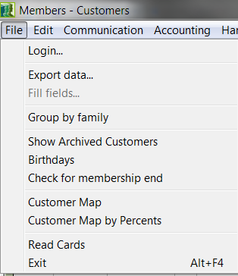
Export Data | With the Export Data function the contents of desired data fields can be transferred to other Windows programs.
Fill Fields | With the help of the Fill Fields function, a given data field can be filled with a unique value for all customer records currently displayed in the customer list.
Group by Family | The customer list is sorted by family.
Show Archived Customers | Displays archived customers
Read Cards | Read the SAGA chip cards
Exit | With the "Exit" function you exit Customers. Key combination "Alt+F4".

  - Export Data
- In the Customer menu, click the Export Data function.

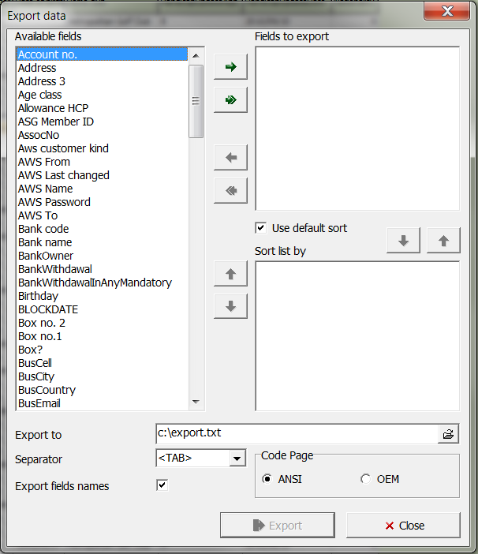

Fill Fields
Export To Select the directory into which the file should be saved.
Separator This list displays the special characters which can be used to separate the individual data fields from one another.
Export Field Names If this box is ticked, the field name will be automatically exported with the data.
ANSI If the file is exported under Windows, check the field ANSI.
OEM If the file is exported under DOS, check the field OEM.

Buttons
Export With the Export button, you export the data to the selected directory.
Close With the Close button, you close the window.

- In the Available Fields column, select the field that you wish to export.
- Drag the marked field with the help of the arrow into the right-hand column. With the double arrow , all the fields can be dragged at once.
- If needed, you can specify an order in which the fields should be arranged in the export file. Mark the relevant field in the right-hand column, and transfer it by using the arrow.
- In the Separator field, select a special character which will be used to separate the data fields from one another.
- Specify the directory into which the file should be exported.
- Click the button Export.

Fill Fields (This function is only for Albatros Administration)
The "Fill Fields" menu pick has been moved from Members to AlbAdmin in order to avoid possible misuse.

- Define a selection so that in the customer table, only records for customers with which a specific field should be filled with exactly the same content will be displayed.
- In the Customer menu, click the Export Data function. 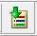

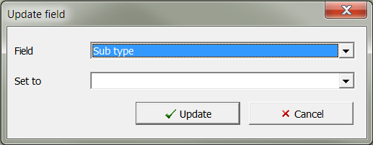

Input Fields
Field Selection list for the field.
Set to Entry field for the value

Buttons
Update With the Update button, the specified field will be filled with the selected content for all customer records.
Cancel Leave the window without performing an action.

- Select the field whose contents should be uniformly filled.
- Enter the value with which the selected field should be filled.
- Click the button Update.

Selection Menu
The Selection menu can be reached from the context menu in the customer table. In order to do this, click the right mouse button on the desired customer to open the context menu. Click on the Filter records... menu item:

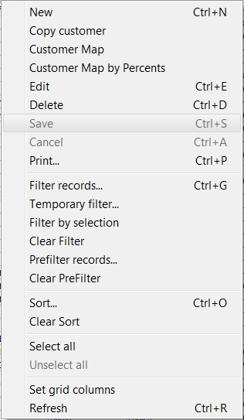

Filter records...
Define a selection

Temporary filter...
Edit the current selection

Clear Filter
Clear the selection

PreFilter records
Define a preliminary selection

Clear PreFilter
Clear the preliminary selection

Filter records
Using a filter or a prefilter, you limit the number of records which are displayed in the customer table to exactly those which fulfil the criteria you have defined. Actions are performed only on this restricted number of records, such as printing the list, export for a form letter, and ordering cards. In addition, cards with detail information can be seen only for these records.

All fields contained in the database - whether available by default or added by you later - can be used as criteria for a selection.

  - Define selection
- Open the Filter function. This can be done in several ways.

- Click the icon Selection.
- Using the <Ctrl>G key combination.
- With the context menu using the right mouse button.
- With the menu option Edit / Selection.
In all cases, the SELECTION wizard opens.

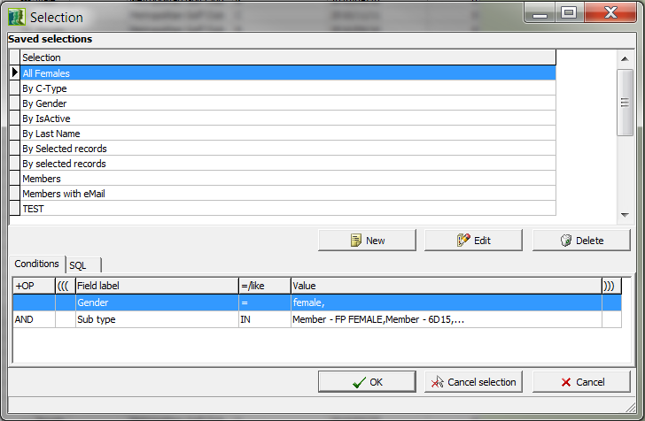

Buttons
New With the New button, a new selection is defined.
Edit With the Edit button you can make changes to the marked selection.
Delete Remove a selection definition.
OK Confirm the marked selection criteria and return to the original window.
Cancel selection With the Cancel selection button, the selection is reset and the complete customer list is again displayed.
Cancel Exit the wizard without performing any actions.
- Click the button New.

The NEW SELECTION wizard opens.

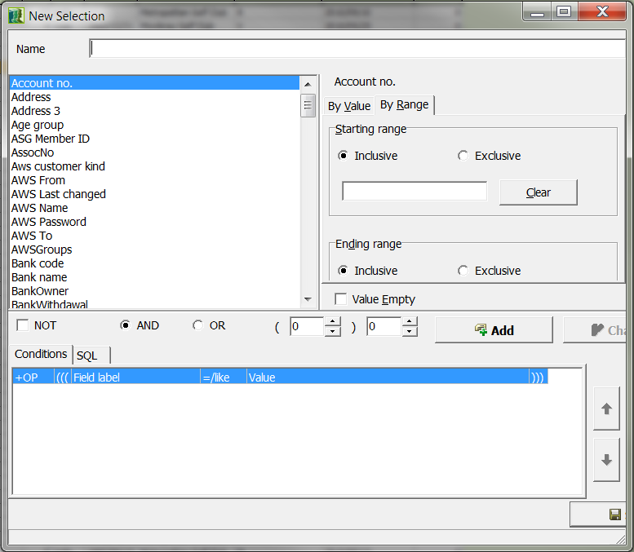

Input Fields
Name Name with which you wish to save this selection.
Value Empty If this box is ticked, persons will be listed who have no data in the given field, i.e. a first name has not been entered.
Not With the Not field, a further limitation of the selection criteria is possible. For example, if you wish to display only female customers with a specific birth date, define the birth date, select the Not field, and define the gender as Male. In this way only female customers with the given birth date will be displayed, and not the male customers.
And With the field And, a further limitation of the selection criteria is possible. For example, you can define a selection to display all clients with the last name of Miller and the last name of Meyer.
Or With the Or field, a further limitation of the selection criteria is possible. For example, you can display all customers with an exact handicap of 16 or a playing handicap of 19.
Parentheses Number of right and left parentheses.

Buttons
Add Add the selected criteria
Change The Change button is not active in this window.
Delete The Delete button is not active in this window.
Save Save the data you have entered.
Cancel Leave the wizard without creating a definition.

- Enter the name under which you wish to save this selection.
- In the left side of the window, make the desired selection criteria. The list contains all the default data fields as well as any you may have added.
- In the right side of the window, enter the exact value for the selection criteria. The following variants are possible here:

For fields with content such as customer type, age group or gender, you can select the desired value from a list of choices. More than one value may be selected in sequence by using the <Ctrl> key.

With Boolean fields, you can choose between "true" (the box is ticked) and "false" (no tick mark).

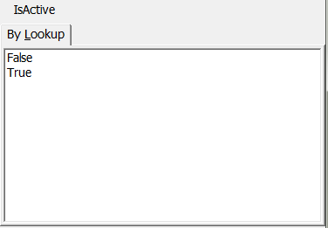

In the case of fields where any text may be entered, you can search for a value or specify a range.

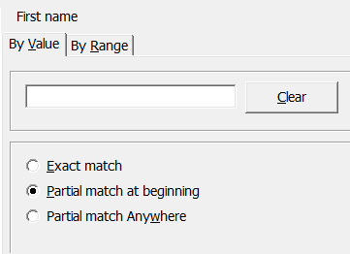

Input Fields
Exact Match Marking this field specifies that the selection will only be valid for people whose first name field contains the exact value "bert".
Partial match at
beginning Marking this field specifies that the selection will only be valid for people whose first name begins with "bert", such as Bertram or Bertha.
Partial match
Anywhere Marking this field specifies that the selection will only be valid for people whose first name contains "bert", such as Herbert or Albertine.
Case-sensitive Ticking this box means that the search will be case-sensitive.

Additional options are available when searching a data field for a particular value.

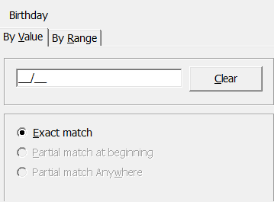

Input Fields
Before Date Marking the Before Date field means that date saved in the Birth Date field must be older than the date specified by you.
After Date Marking the After Date field means that date saved in the Birth Date field must be younger than the date specified by you.
Year minus Age Marking the field Year minus Age means that the entered age value in years will be compared to the difference between the current calendar year and the year which was entered. If the difference is less than the entered value, the record meets the selection criteria, that is, younger persons will be selected.
This Year If the This Year field is marked, the year entered must be equal to the current year.
This Month If the This Month field is marked, the month entered must be equal to the current month.
This Month + Next month Marking this field means that the entered month must be equal to the current month or the next month. In this manner, on August 1 you can select all individuals who have a birthday in August or September. Add an additional sort by birth date, and you can quickly create a birthday list.
Today's Date Marking this field means that the date entered must be equal to today's date.

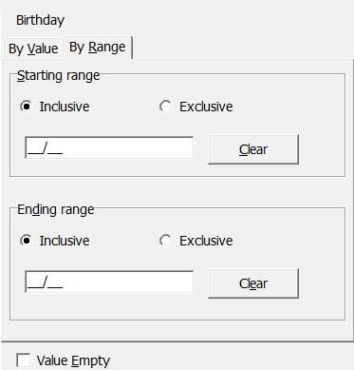

Input Fields
Inclusive If the Inclusive field is marked, all values will be entered including the boundary values.
Exclusive If the Exclusive field is marked, all values will be entered excluding the boundary values.

Buttons
Clear With the Clear button, the entered value is cleared and the field is available again.
Clear With the Clear button, the entered value is cleared and the field is available again.

When a range is entered, the range start and the range end are entered, and you specify whether the boundaries are included (inclusive) or not (exclusive).

For example, if the field Handicap has a range of 15 (inclusive) through 21 (exclusive), all persons with a handicap between 15 and 20 will be displayed. The same range for the Exact Handicap field shows all persons with an exact handicap between 15.0 and 20.9.

If you wish to display individuals whose last name begins only with K, L or M, the Last Name range must be entered as K (inclusive) through N (exclusive), because if you specify Last Name M (inclusive), in addition to persons whose last name begins with K or L, you will only display individuals whose last name is exactly "M".

- Click the Add button when you have specified the field and its associated value. The criteria will be transferred to the bottom window and to the selection.
- If you wish to specify more than one criterion for a selection, define these one after another and click the Add button.
- Click the button Save.
- Click the button OK.
- Only the customers who match the specified criteria will be displayed in the customer list.

In the customer table, in the line below the data records at an entry after the slash, you can see if any active selections as well as the number of customers who match the criterion.

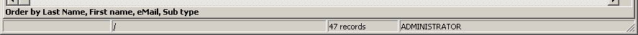

  - Change a filter
- Open the Selection function. This can be done in several ways.

- Click the icon Selection.
- Using the <Ctrl>G key combination.
- Using the context menu with the right mouse button.
- With the menu option Edit / Selection.

- In all cases, the SELECTION wizard opens.
- Mark the saved filter in the list above.
- Click the button Edit.
- Make the changes.
- Click the button Change.
- Save the changes with the button Save.
- Answer the confirmation question.

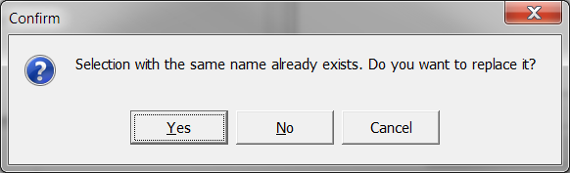

- Click the button Yes.

Only the customers who match the specified filter will be displayed in the customer list.

  - Delete a filter
A filter can be deleted by clicking the Clear Filter item in the context menu with the right button, or also in the wizard window.

- Open the Selection function. This can be done in several ways.

- Click the icon Selection.
- using the <Ctrl>G key combination

In all cases, the SELECTION wizard opens.

- Click the button Clear.

Communication Menu
Print Print a list
Letters With the Letters function you can print form letters, labels and customer correspondence (see Chapter Form Letters).
Send SMS Message Send SMS messages
Send E-mail Sending E-mail
Address Label wizard With this function you open the wizard for printing address labels.

  - Form Letters
Sending the same correspondence to several addresses is called a form letter. These letters differ from one another only in the address and greeting of the recipient.

With the Mail Merge function you can create form letters, labels, and other similar items. The basic procedure consists of creating a main document which contains the text which will always be the same.

In addition the person-specific data is provided for, but only in the form of so-called mail-merge fields which are only filled with concrete data at the time of printing.

A data source is required for this purpose, in which these entries must be saved in a specific format. With ALBATROS FOR WINDOWS you can easily create a data source that meets these requirements.

On the following pages you will find instructions on how to create a main document, how to export the file with the person-specific data (data source) from ALBATROS FOR WINDOWS, and finally how to combine and print both of these as form letters or customer correspondence.

The basic procedure is described in conjunction with two versions of Microsoft Word 1997 and Microsoft Word 2003. If you are using a different program version, there may be small differences.

    - Create a Form Letter Template (MS Word 2007)
- In Members, click Communication, Bulk letters and Bulk letter.

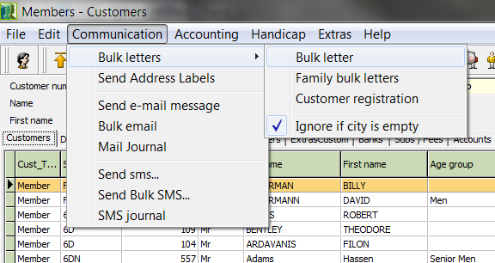

The customers’ values will then be loaded.

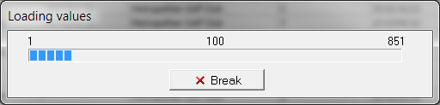

- After this has been done you will be informed of the customers without the necessary details – in this case city information. Here you have the option to view the details of these customers and then close the notification:

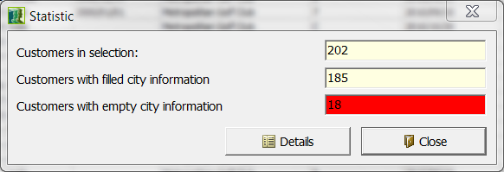

- Clicking on Details will display the following screen:

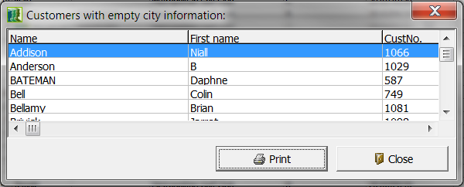

- When clicking on close, a new word document titled “customers’ details” will open.

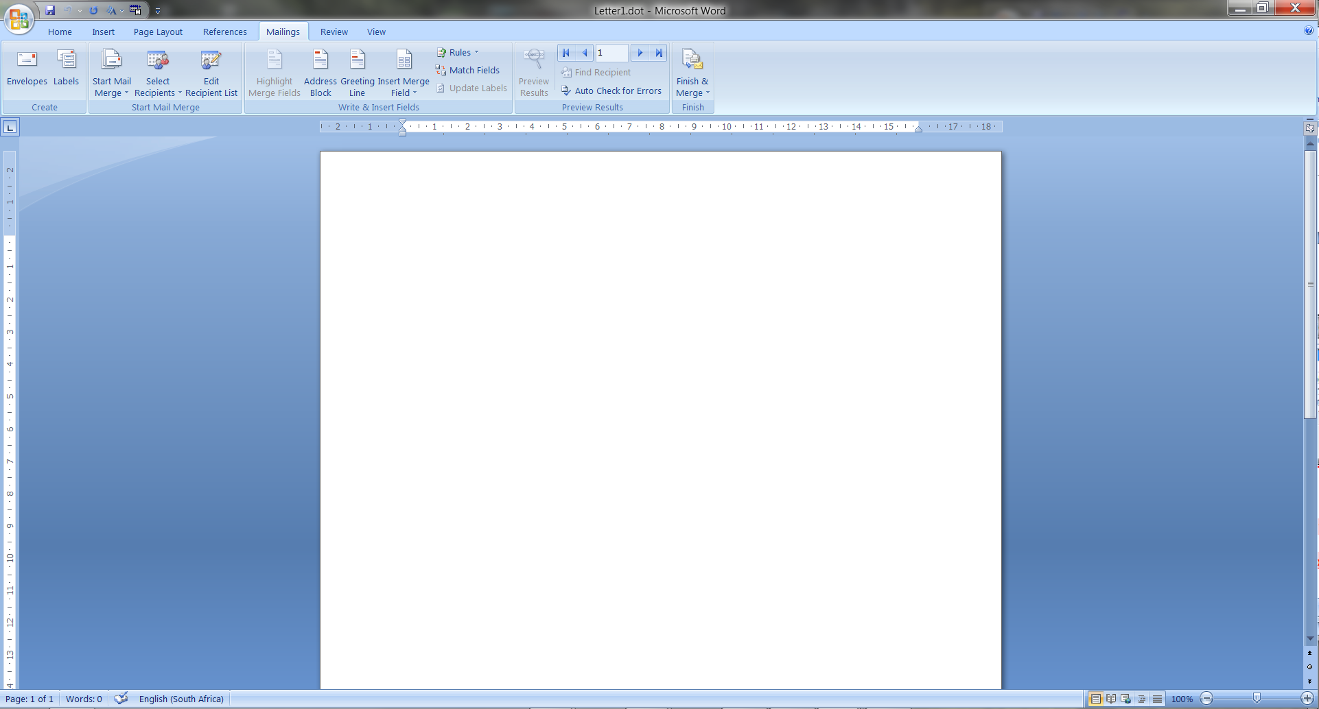

- Then open a new template by clicking on File / New.
- In the Mailings menu, click the Start Mail Merge, then Letters function.
- The Mail Merge manager opens, click on Mail Merge and select Letters.

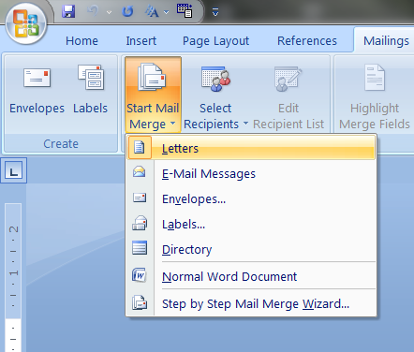

- You can then start typing your letter, inserting the mail merge fields into the main document by clicking the Insert Merge Field button on the toolbar and placing the desired fields into your document.

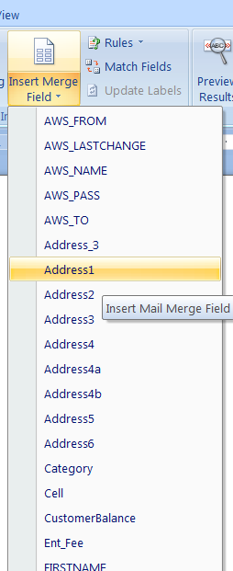

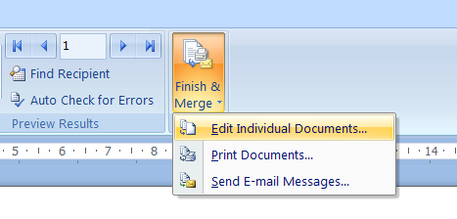

- After completing the letter you click on Finish & Merge, Edit Individual Documents. The information will then be imported and you will see the end result – ready to print.

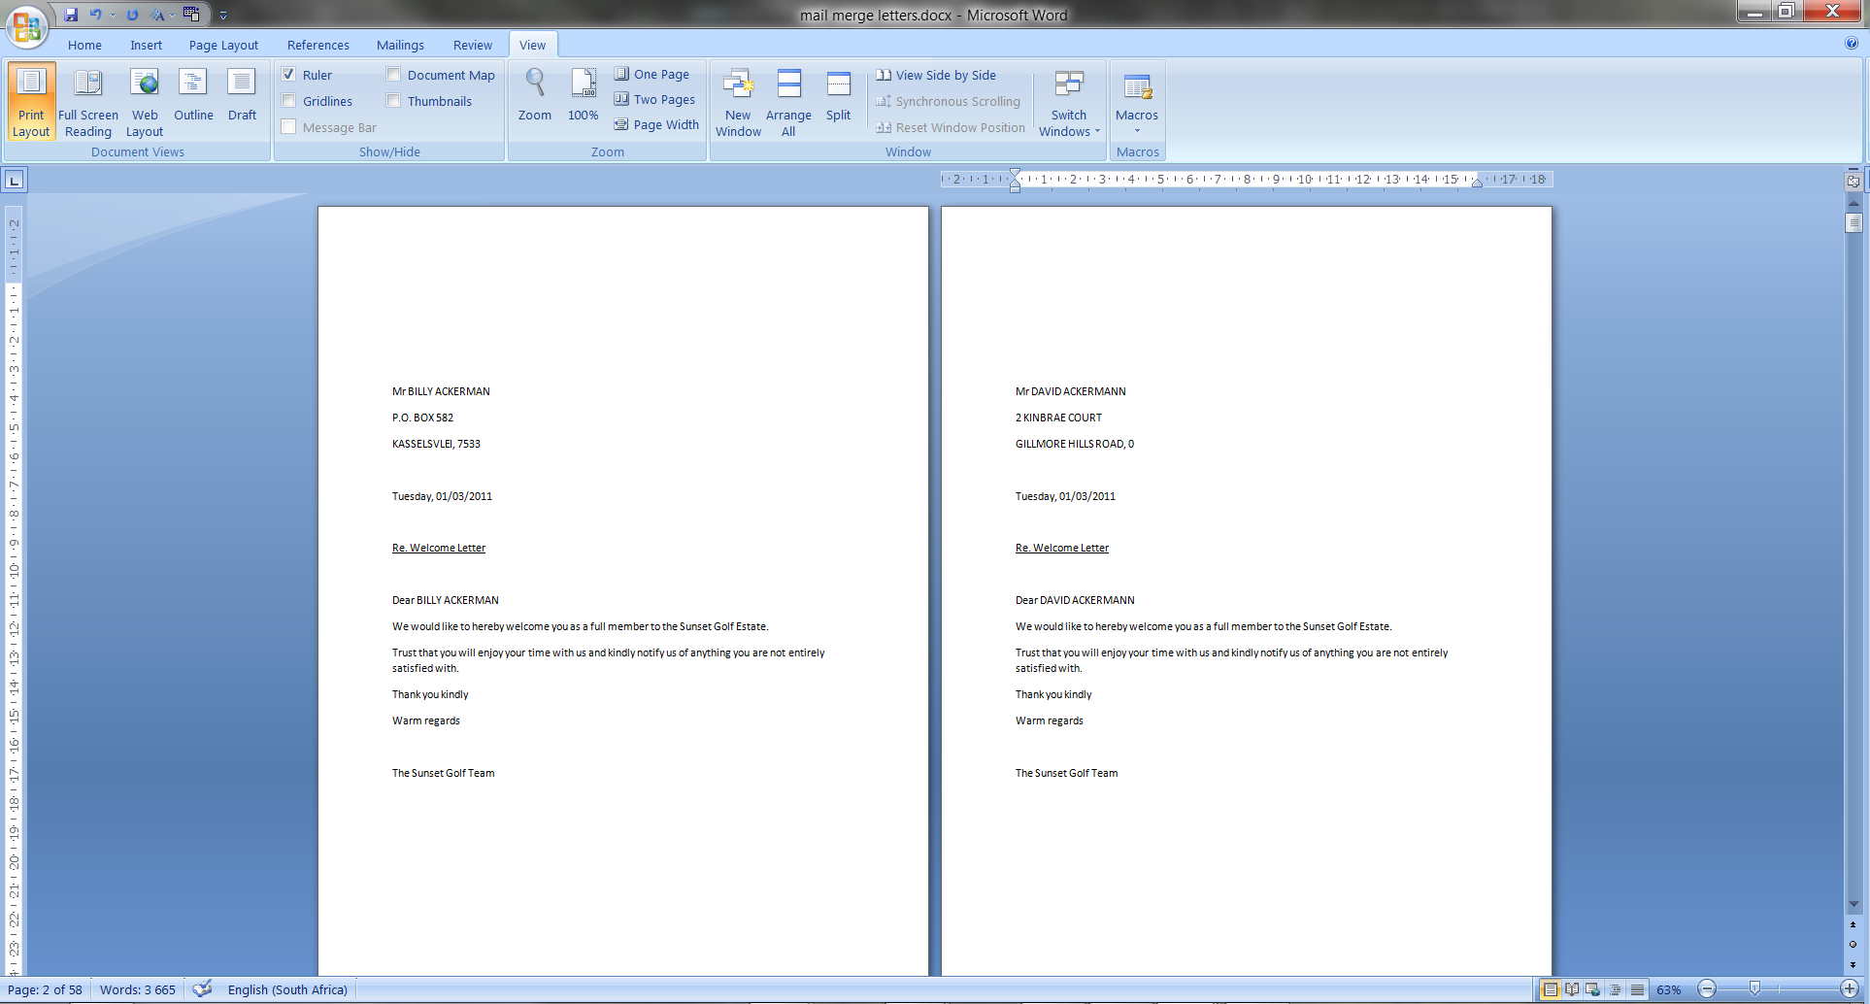

    - Create a Form Letter Template (MS Word 97)
- In Word, open a new template with File / New.
- In the Customer menu, click the Mail Merge function.
- The Mail Merge manager opens:

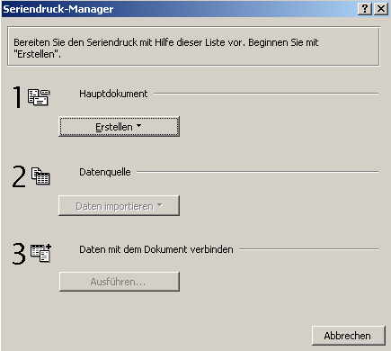

- Click the button Create.
- Click the Form Letters function.

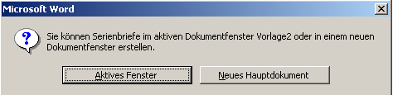

- Click the Active Window button in order to use your own document templates.
- In the Mail Merge manager, click the Import Data button and click the Open Data Source button.

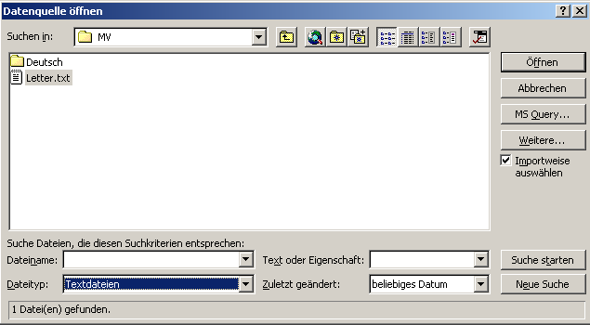
- Using the normal Windows procedure, open the directory in which the ALBATROS FOR WINDOWS program is found on your computer (for example C:/Program Files/Albatros/MV).
- In the File Type field, enter the Text File type, so that in the MV folder the file "letter.txt" is displayed. Select this file, choose the Select Import Method option and click the Open button.
- In the next window, CONFIRM DATA SOURCE, select the Text File type so that special characters such as ä, ö, ü, and ß will be correctly imported into Word, and then click the OK button.

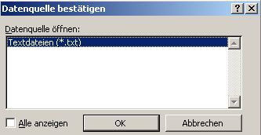

- Confirm the following information.

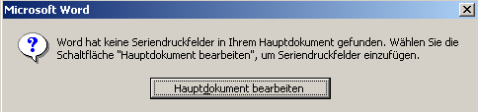

- Insert the mail merge fields into the main document by clicking the Insert Mail Merge Field button on the toolbar and placing the desired fields into your document.
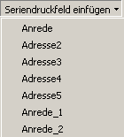

In this case you will be entering the fields in ALBATROS FOR WINDOWS for title, address, and greeting fields.

NOTE! Since the field symbols in Word function as placeholders for actual data, you may not change their name or the special quotation marks they use!

- Create your letter.

- Save the created main document as a document template by entering the Document Template file type in the File Type field.

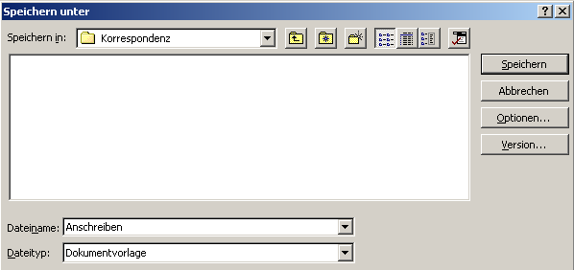

    - Create a Form Letter (MS Word 2000, XP and 2003)
In the new version of Albatros Members several functions have been directly integrated so that you can now start form letters, family form letters and customer correspondence from Members.

- First make a selection of customers to whom you wish to send a form letter. Creating a selection is done by right-clicking in the Members - Customers screen and choosing the Filter/PreFilter option. If you have already saved a filter you can recall it again at this point. Creating a new filter can be done quickly with Customer Type / Customer Subtype. Help on this topic can be found in the Members Manual under the chapter "Create a Filter".
- Now click Communication on the menu bar and choose the menu pick Form Letters / Form Letter from the drop-down menu.

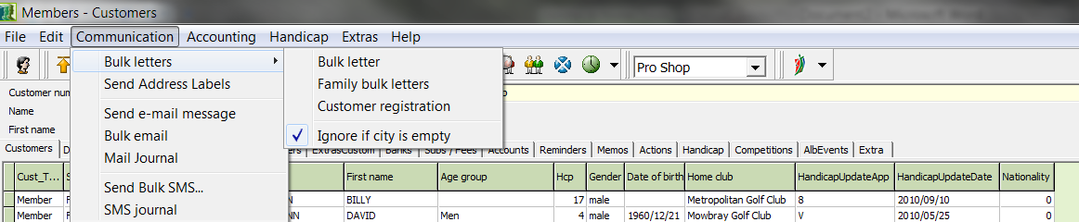

- Please wait until the computer has loaded the values. Depending on the number of records, loading the records can take some time under certain circumstances. In our example, 45 records were selected and the selection was loaded in approximately 15 seconds.

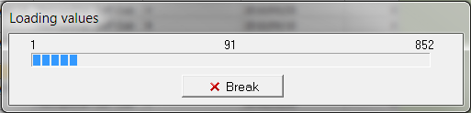

- After the selection has been loaded, the "Open File" window opens. At this point you can either open an existing template or create a new one.

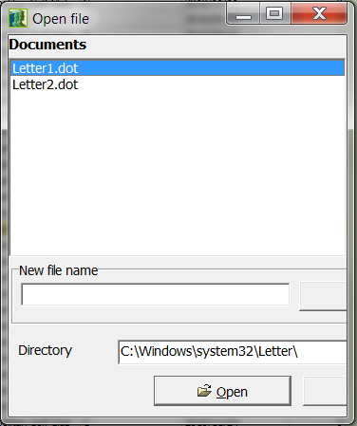

- Select the first entry "Formletter1.dot" and click on the "Open" button.

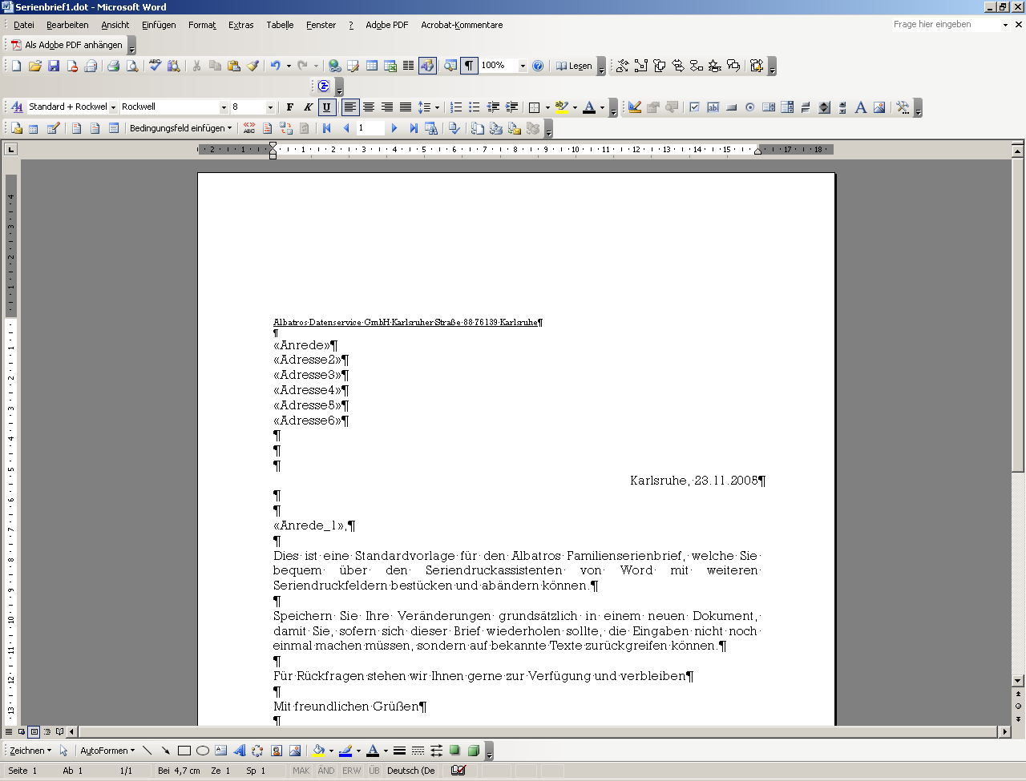

- After the document opens, you see the standard form letter created by Albatros, which you can change as desired. Do not change the address variables; however, as these are part of the mail merge.
- With the Mail Merge navigation bar you can now set all variables, test them, gather them in a new document, save or print them. In the next section we briefly describe the function of the navigation bar.

Main Document Setup: Document typesetting can be changed.
Open data source: Here you can open a separate data source.
Form Letter Recipients: Here you can edit the data source.
Insert Address Block: Here you can insert an address block.
Insert Greeting: Here you can insert a greeting line.
Insert Mail Merge Field: Here you can insert all mail merge fields.

 | 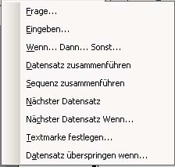 | With condition fields you can control questions, inputs and If...Then... statements; bring together data records and sequences; select records, control records, specify text marks and skip over records. These functions should only be employed by experienced users.
 | Mail Merge Preview: Inserts the data into the Mail Merge fields.
 | Show Mail Merge Fields: Makes the mail merge fields visible.
 | Specify corresponding fields: Set fields to default values.
 | Transfer Labels: Transfer Mail Merge fields to Labels.
 | Jump to First Record
 | One Record Forward
 | Display Current Record
 | One Record Back
 | Jump to Last Record
 | Find Record
 | Perform Error Check in Document
 | Execute Mail Merge in a new document
 | Send Mail Merge to Printer
 | Send Mail Merge result to E-mail
 | Send Mail Merge result to Fax

- Now click in the toolbar on the "ABC-Preview" button. This opens the document preview where you can make sure that all settings and formats are correct.
- If all settings are correct, then click on the "Create Mail Merge in New Document" button.

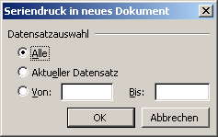 | - In the window which opens, select "All" and click the "OK" button. After this action, the letters will be created in a new document and can be edited individually before printing.

Note: Don't forget to save the new document as well so as to avoid later problems when printing as a result of the document size.

  - Creating Address Labels
This wizard allows you to create address labels directly without using Word. The selection of the labels to be printed refers to the persons marked in the customer list. You can select several persons by clicking them with the right mouse button while holding down the <Ctrl> key, or by creating an individual selection in advance and then selecting in the Selection menu the option Select All.

- In Members, open the address label wizard with Communication / Address Label wizard.

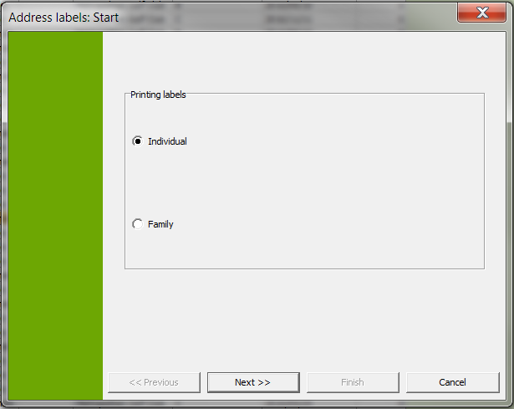

- Select either "Individual" or "Family" and click on the "Next" button.
- In the window that opens, select an address label and click on the Designer button to adjust the size.

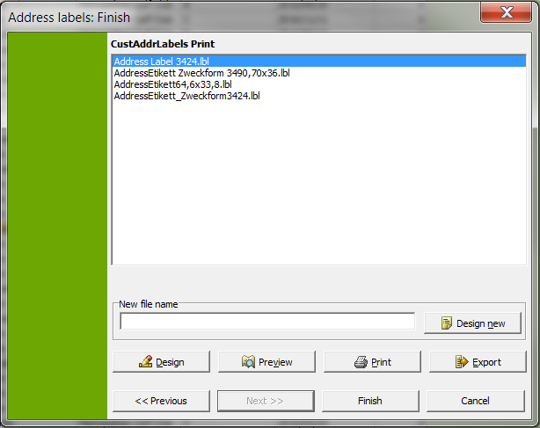

- In the designer that opens, select Project / Page Setup.

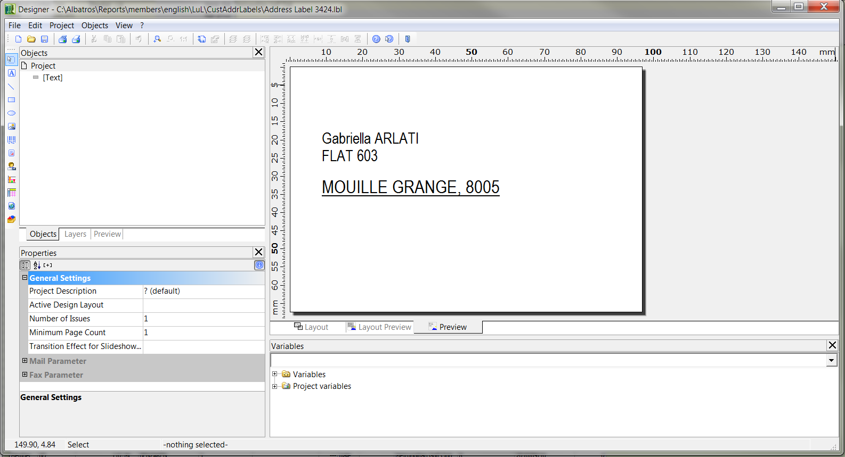

- Now switch to the Templates tab. Here you can select from current address labels from all the well-known manufacturers.

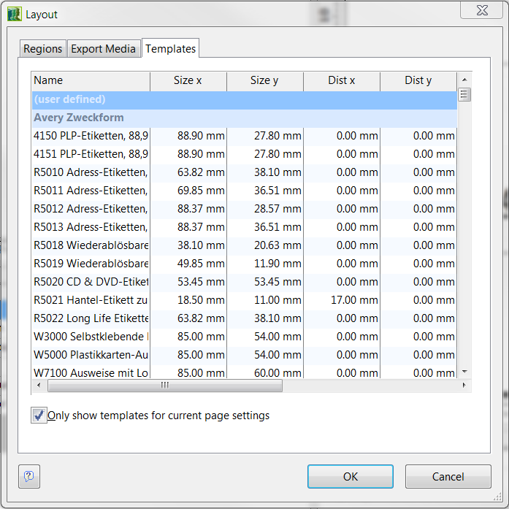

- Select the desired label and confirm your selection by clicking the "OK" button.

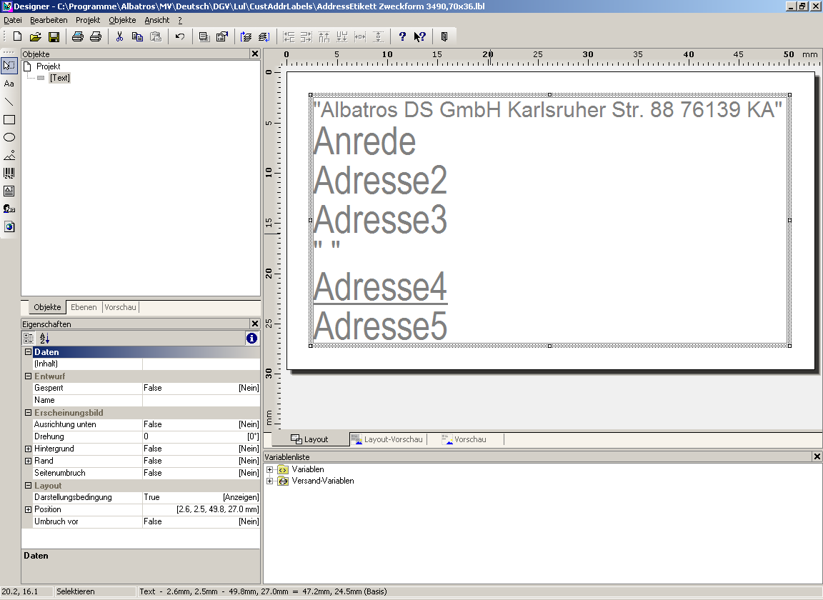

- Center the content of the label as well as possible in the displayed template and confirm your entries with File / Save. You can then exit the program (using the cross in the upper-right corner or with File / Exit) and are taken back to Albatros Members / Merge Labels.
- Now click the "Preview" button and then in the window that opens click on the "Start" button.

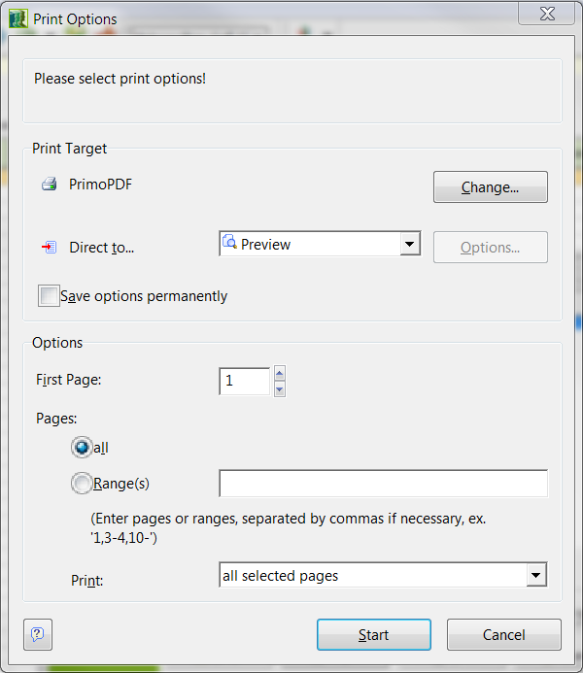

- In the displayed preview you can check the data again.

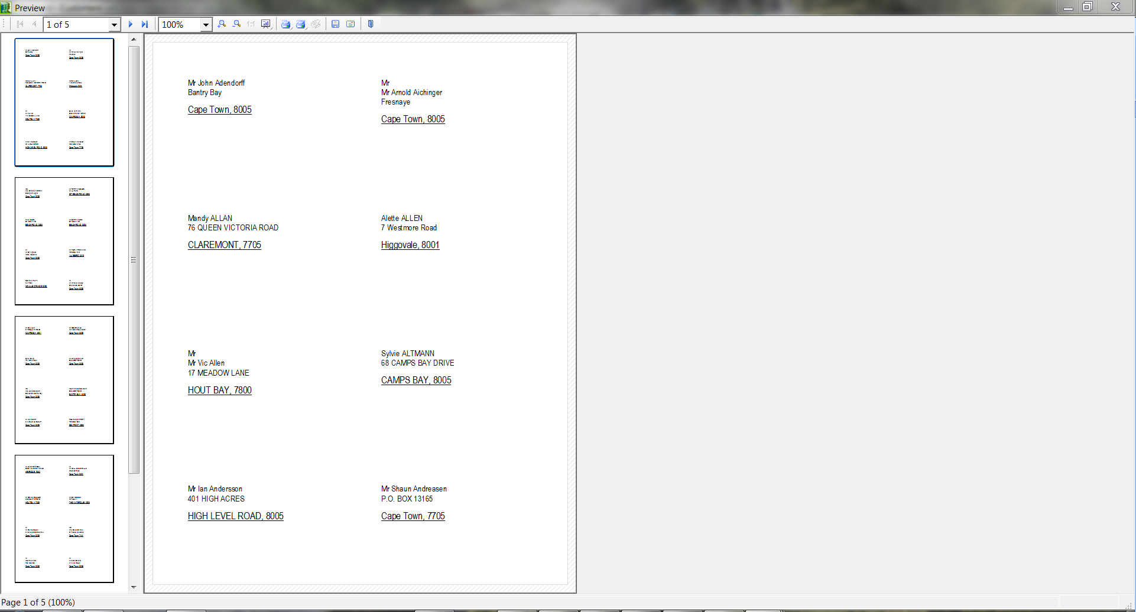

- If the data is correct, you can print the labels directly with the "Print" button. In this case, after the labels have printed successfully you can close the window with the cross in the upper-right corner or with File / Exit, and the Address wizard which is running in the background can also be closed.
- If you are going to use this list often in the future and the data will always be the same, you can take advantage of the Export function. Click the "Export" button and wait until the corresponding output settings have opened.

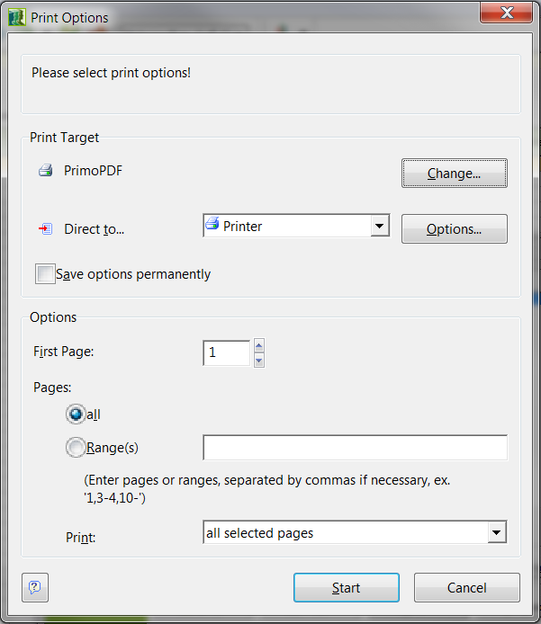

- In the settings select Adobe PDF, for example, and click on the "Start" button. The program will open the "Save As" menu for you.

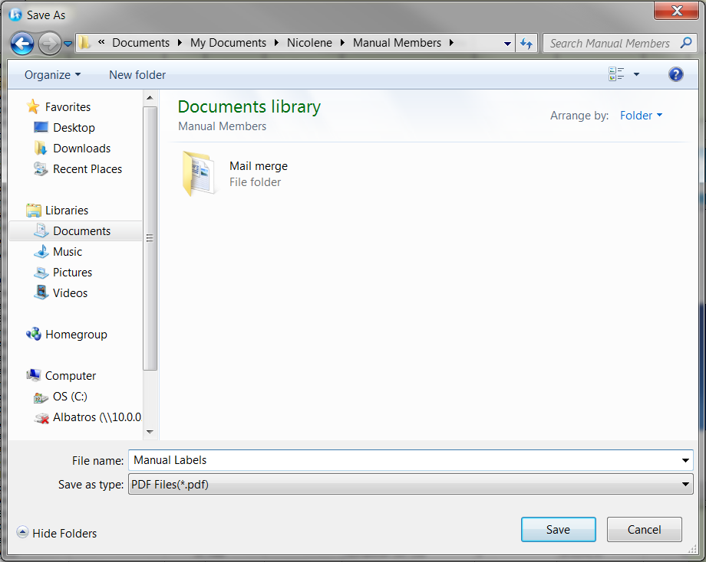

- From this menu, specify the location where the file should be saved, give the file a meaningful name and confirm your entries with the "Save" button.
  - SMS-Messages
An additional means of communication which is supported by ALBATROS FOR WINDOWS is Short Message Service.

With this service, a message of up to 160 characters can be sent to a customer's Cell phone number. The customer can read your message on the screen of his or her cellular phone.

    - Sending SMS to a Cell Phone
- In the Communication menu, click the option Send sms.
- The following window opens.

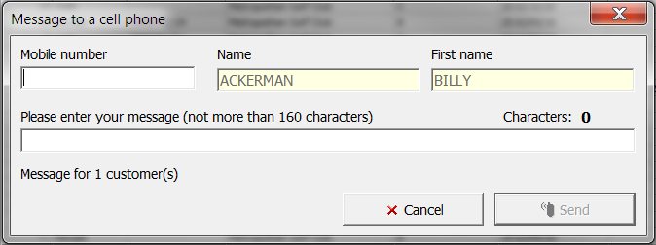

- The system automatically transfers the customer's Cell number which was entered in the DETAILS window into the Mobile number field. If no Cell number was entered in the DETAILS field, you can enter the number by hand. Changes to the Cell number are not possible in this window and must be made directly in the CONTACTS window.
- Enter the message. A maximum of 160 characters are available for this purpose.
- Send the message with the Send button.

Accounting Menu
Subscription Wizard Create invoices with the subscription wizard.
Single Mode If the Single Mode is active, you can create entries for a single person.
Family Mode If Family Mode is active, a total invoice for the entire family is entered. For a family entry, it is necessary for the family invoice function to be assigned to the customer in the LABELS window.
Write withdrawal file for … This function allows you to create a data holder for the marked customers.
Write withdrawal file all... A data holder for all customers found in the filter will be created.
Load default fees for all With this function, default fees will be assigned to the marked individual (see chapter SUBSCRIPTIONS)
Assign default payments
for With this function, default payments will
current selection be assigned for all customers in the selection.

Assign subscription of All customers in the selection will be
current selection assigned a specific subscription article.

Remove subscription for
All Delete the charge assignment.
Invoice Journal (Wizard) With this wizard an open item list of members can be created
Invoice Journal wizard With this wizard an open cumulative list can be created.
Invoice Reports Print all invoices without previewing them first.
Subscription Control List With this function you can create a subscription control list.
Create Letter for Current
Invoice With this function you can create a letter for the invoice recipient selected in the customer list.

Create Letter for Selected
Customers With this function you can create a letter for the customer selected in the customer list.

Tournament fee wizard This wizard is for collecting tournament fees by invoice or by withdrawal.

  - Write Withdrawal File
- Click in the Accounting menu the function Write Withdrawal File or the function Write Withdrawal File for all.

In both cases, the following wizard opens.

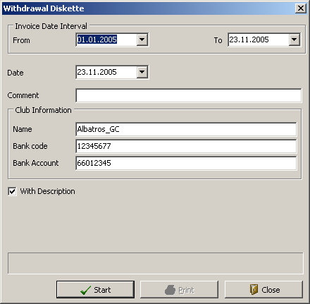

Input Fields
Payment Type Selection list for the payment type
Date Entry field for the date. The date can be entered manually or by using the calendar sheet.
Notes Entry field for any desired notes
Name Name of the club
Bank Code Bank code of the club
Bank Account Account number of the club
With Description If the withdrawal file is provided with a description, this box must be ticked.
Drive Selection list for the drive on which the file is to be saved.

Buttons

Start With the Start button the withdrawal file is created.
Print Print a control list or a withdrawal file companion sheet.
Close Close the window without having created a withdrawal file.

- Make the entries.
- Click the button Start.

  - Assign standard charges for current selection
- In the Accounting menu click the function Subs/Fees, then “Load default fees for all”.

The following wizard opens.

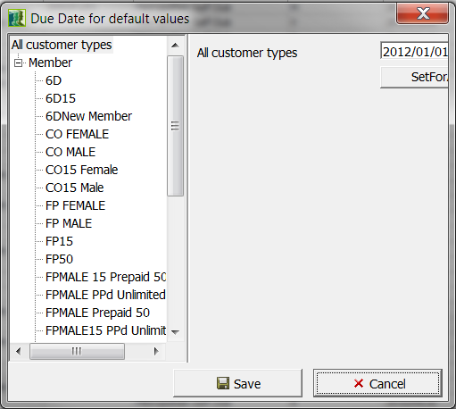

Input Fields
Date Field Due date of the next payment. The date can be entered manually or by using the calendar sheet. The current date is always provided by default.

Buttons
SetForAll The date above will be transferred to all date fields.
Save Save the data you have entered.
Cancel Leave the window without having made any entries.

- Enter the due date of the respective items.
- Save the changes with the button Save.
- If debit articles already exist for any of the customers, the following question will pop up on your screen, click Yes to overwrite only current customer’s debits, Yes for all to overwrite for all customers etc.

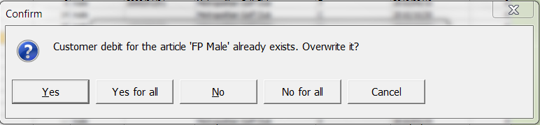

The charge items will be automatically transferred to the SUBSCRIPTIONS window.

    - Tournament Booking Wizard
- Open the Booking Wizard with the menu Articles / Tournament Booking Wizard.

A list of all created competitions is opened.

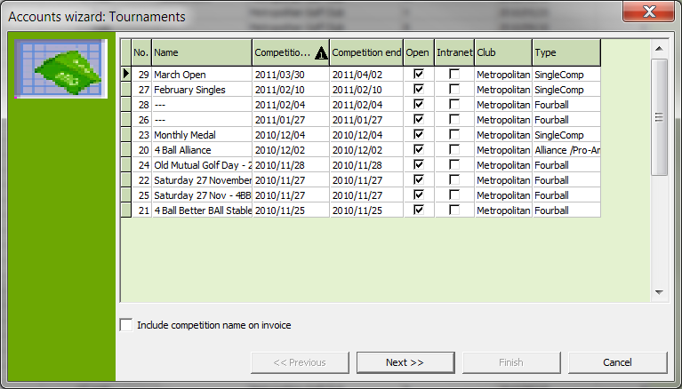

- Select the competition for which the tournament fees should be collected.
- Click the Next button.

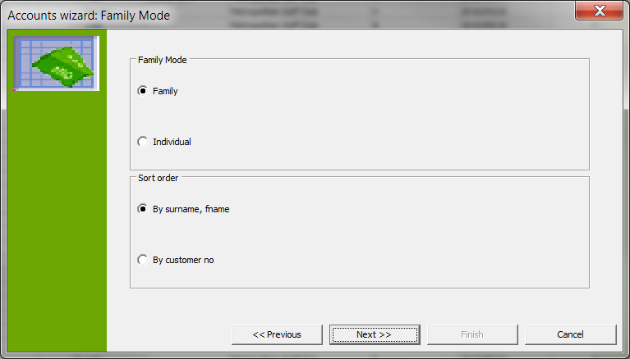

Input Fields

Family If the Family field is marked, the tournament fees will be collected by family.
Individual If the Individual field is marked, the tournament fees will be collected for each individual.
By surname, fname If the field by surname, fname is marked, the list of participants in the next window is sorted by name.
By custno If the field by custno is marked, the list of participants in the next window is sorted by customer number.

- Specify whether tournament fees should be collected by family or by individual by marking the corresponding field.
- Click the Next button.
- Now make a selection of customers with relation to the withdrawal procedure:

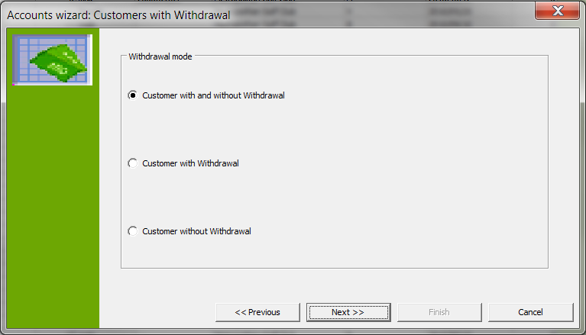

- In the following template you can specify the invoice date.
- Next comes the specification of invoice number according to the range of numbers which you specified in the Albatros administration module. In the following dialog, begin the creation of the invoices with the START button.
- If you have selected "Customer with Withdrawal", the following window opens.

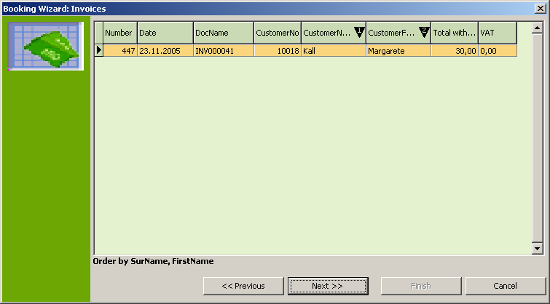
- Click the Next button.

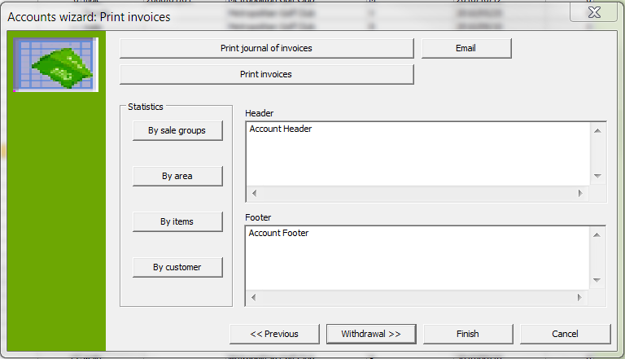

Input Fields
Header Enter here a descriptive text that should be transferred to the invoice. This text will be placed above the invoice items. Copy and paste company stationery’s header so that the invoice has a neat, professional look.
Footer Enter here any text you wish which will be added below the invoice items. Copy and paste company stationery’s footer so that the invoice has a neat, professional look.

Note: The completed input fields are applied as "Invoice form without VAT and with VAT."

You also have the option of creating a booking list sorted by the displayed criteria.

- The invoice journal gives you an overview of the invoices which were created. The invoice journal should be created before printing the invoices and reviewed by using PREVIEW in the report window.
- Next print the invoices by using the Print Invoice button.
- If you wish to create a withdrawal booking, withdrawal diskette and control list, use the Withdrawal button.

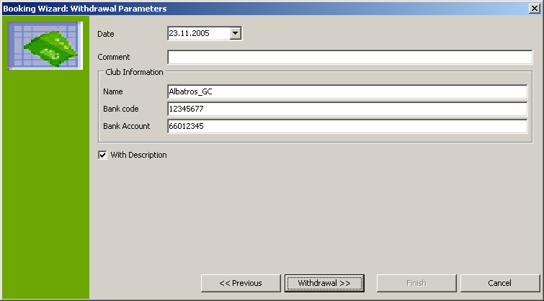

Input Fields
Payment Type Selection list for the payment type.
Date Today's Date. The date can be entered manually or by using the calendar sheet.
Notes Notes text for the Withdrawal entry
Name Name of the club
Bank Code Bank code of the club
Bank Account Club bank account.
With Description If a description was entered, this box must be ticked.
Drive Selection list for the storage drive.

- Click the button Withdrawal.

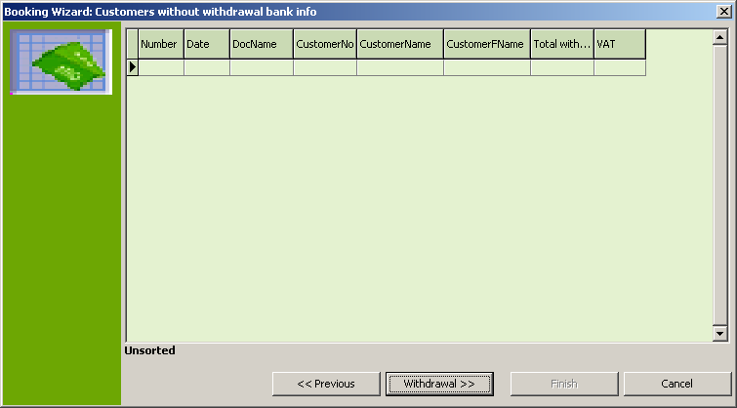
- Click the Withdrawal button again and start the debit entry creation in the following window with the START button. If the procedure completes successfully you see the following message:

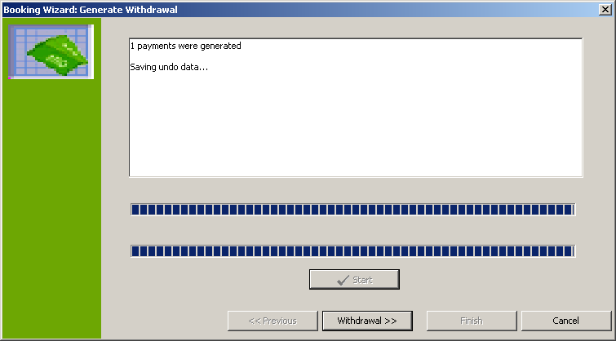

- Click the button Withdrawal.

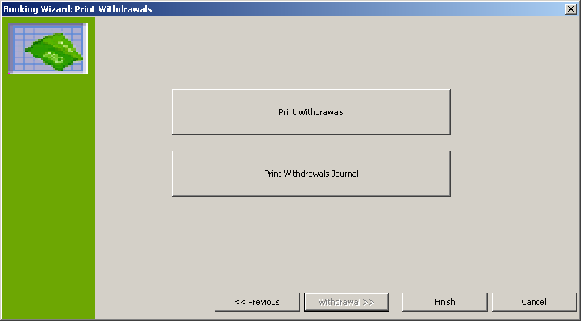

- Print the accompanying sheet for the withdrawal using the Print Withdrawals button and the control list with the Print Withdrawal Journal button.
- Use the Finish button to close the wizard.

Handicap Menu
Exaact Handicap List (3 Column) sorted by exact handicap | Print a three-column exact handicap list of all members in the current selection. This is sorted by exact handicap
Exact handicap List (2 Column) sorted by exact handicap | Print a two-column exact handicap list of all members in the current selection. This is sorted by exact handicap.
Exact Handicap List (2 column) alphabetic | Print a two-column exact handicap list of members in the current selection. This is sorted alphabetically.
Exact Handicap List (3 Columns) alphabetic | Print a three-column exact handicap list of all members in the current selection. This is sorted alphabetically.
Handicap sheet for all selected customers | Print the handicap sheet for all customers, in the selection.
SAGA Exact Handicaps time-specific entries | List of all handicap changes for a specific time period.
Playing Handicap List | Print a playing handicap list.
Send Handicap Sheet as PDF | Send a handicap sheet as PDF file by e-mail.
Multiple Handicap Entries | With the function Multiple Handicap Entries you can edit several record sheets at once.
Archive Handicaps | Allows you to archive up to specified point in time. These handicaps will be removed from the HANDICAP file card.
Display archive data | Re-display archived handicaps in the HANDICAP file card.
  - Print an Exact or Playing Handicap List
- Define a selection of customers to print in an exact or playing handicap list.
- Click the button. 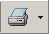 Select the entry "Handicap List" from the list of reports.

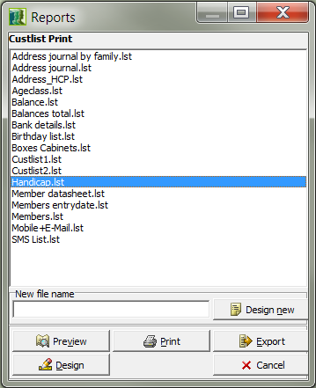

Buttons
Preview With Preview the game handicap list can be viewed once more before printing.
Designer With the Designer you can make individual format changes to the playing handicap list.
Print Print the playing handicap list.
Export With the Export button the playing handicap list can be exported. This can be done as an HTML file for displaying on the internet or also in Rich Text Format for additional editing in Word or Excel.
Cancel With the Cancel button you return to the original window without starting the print operation.

- Click the Preview button if you wish to see the list before you print, or click the Print button.

Send Handicap Sheet as a PDF by E-mail
- In the Handicap menu, click on the function Send Handicap Sheet as PDF.
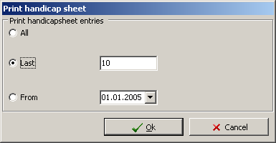

- Now select the handicap sheet type (all entries, only the last 10 entries or all entries after a given date) and click "OK".

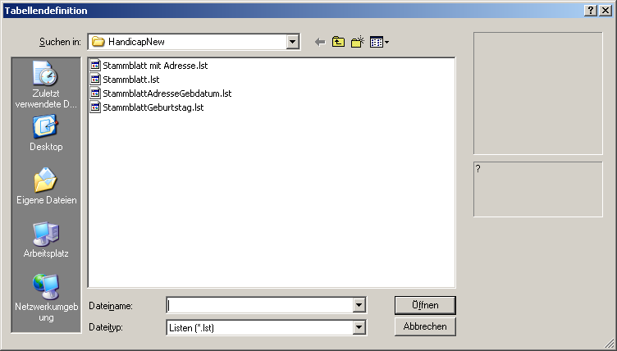

- Select the desired report type from the "Table Definition" window. Confirm your selection with OPEN. Your E-mail program will now be started.

Note: You can change the settings for your E-mail program in Albatros Administration in "Internet Proxy Settings" as well as "GolfManager Print Settings".

- In this window, enter the E-mail address of the recipient in the To line. If this has been entered on the detail page of the customer, it will be automatically entered.
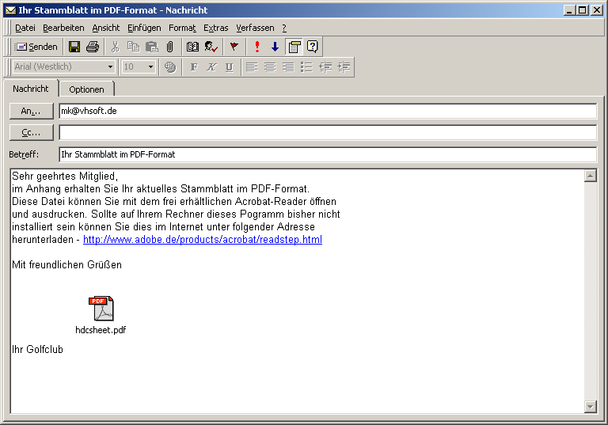

- With the Send button, the E-mail is sent to the customer.

Send E-mail to individual member
- From the member list, select the member to whom you wish to send E-mail. The marking shows you which member is currently selected (See Figure 1).

- On the menu bar, click the "Communication" menu and then "Send E-mail" from the drop-down menu (See Figure 2).

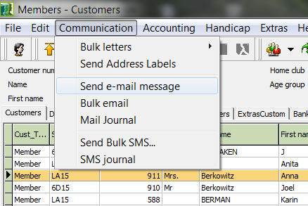

- If installed on your computer, a corresponding E-mail program opens, such as Microsoft Outlook or Microsoft Outlook Express (see Figure below).

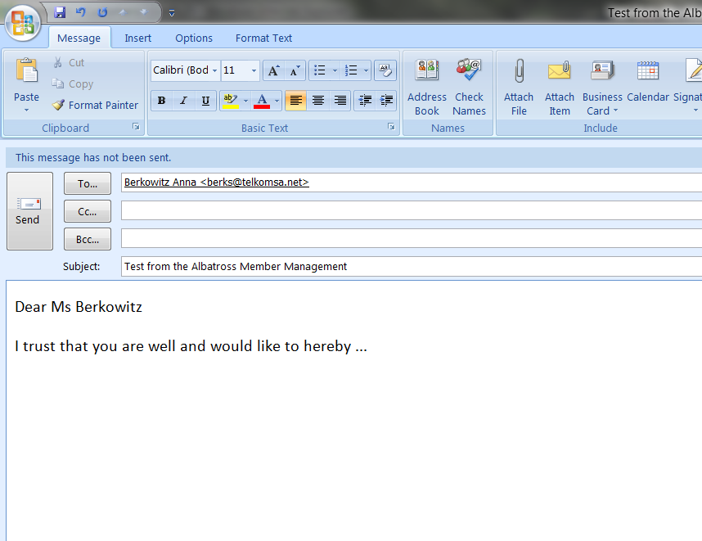

- In the case of an individual member, this is automatically entered in the "To:" field. Write your E-mail and then click on the "Send" button to send it.

Send E-mail to several members
- From the member list, select the member to whom you wish to send E-mail. The marking shows you which members are currently selected. If you wish to select several members at once, click on the first recipient and then hold down the <Shift> key (above the <Ctrl> key) on the keyboard and click on the last recipient.

With this method, all recipients in between are selected as well (see Figure below).

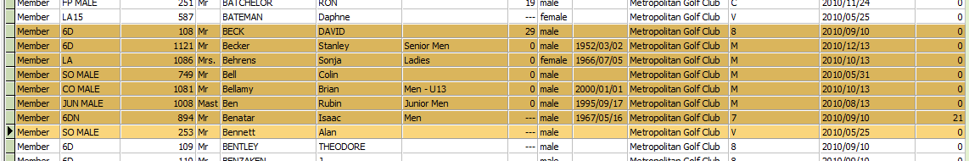

- On the menu bar, click the "Communication" menu and then "Send E-mail" from the drop-down menu (See Figure below).

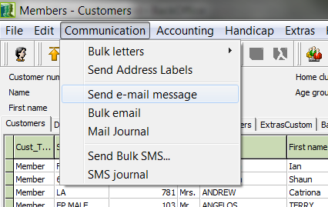

- A field opens which shows you how many customers in your selection have an E-mail address and which customers have no E-mail address (See Figure below). Ideally, every customer selected should have an E-mail address.

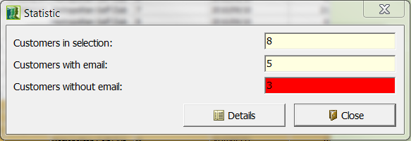

- Now click on the "Close" button. If installed on your computer, a corresponding E-mail program opens, such as Microsoft Outlook or Microsoft Outlook Express (see screen shot below). If you have selected more than one recipient, the recipients are directly copied to the "BCC" field, which means that none of the recipients will see the E-mail addresses of the other recipients (blind copy) This option also prevents gathering of E-mail address by so-called "spam bots".

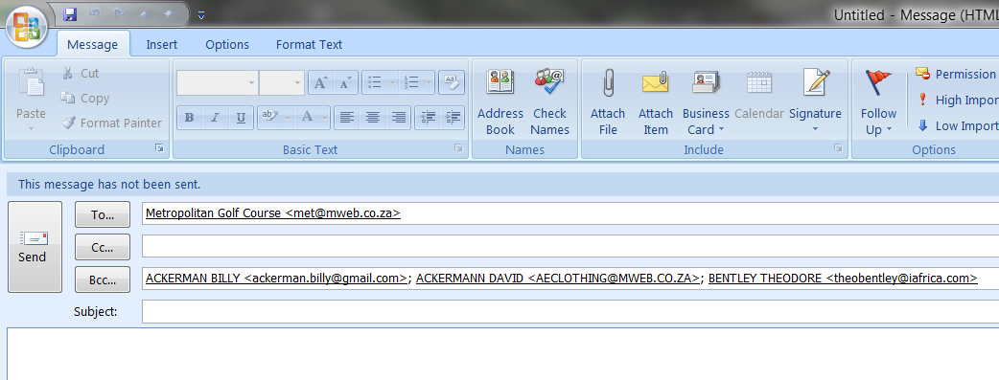

- In the "To:" field an E-mail address which you have already predefined (for example, your own domain) will appear, but the sender is ultimately the account which has been set up on your computer.
- Write your E-mail and then click on the "Send" button to send it.

  - Export contacts from Members & read in MS Outlook for sending E-mail
In order to use the same data you have entered in Members in MS Outlook, you can take advantage of the Import/Export functions of both programs.

Take time while performing this operation so that the data records can be correctly exported, read and assigned.

- First make a selection of customers that you wish to export or click on Edit in the menu bar and then choose "Select All" from the drop-down menu (see Figure below).

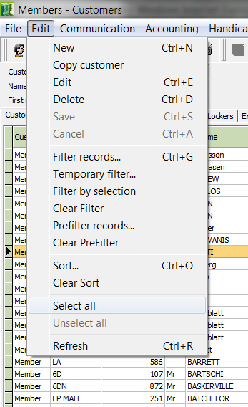

- Now click in the menu bar on "File" and then choose "Export Data" from the drop-down menu (see Figure below).
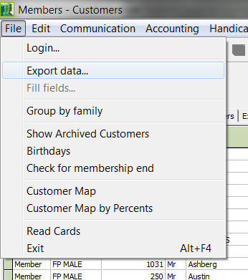

- After you have started the data export, the "Export Data" field opens (See Figure on next page). You must now choose from the available fields the ones which should also be available in Outlook. It makes no sense to export certain fields, so we have created for you a list of fields which should be exported, and on the other side of this list you will find the corresponding fields from Outlook with the correct designations.
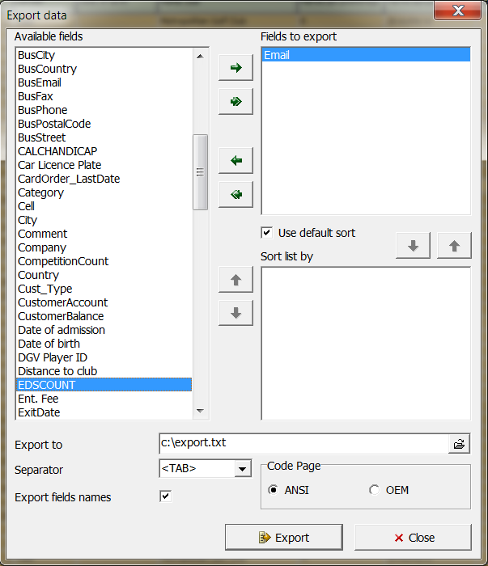

Note the “Separator Character” field

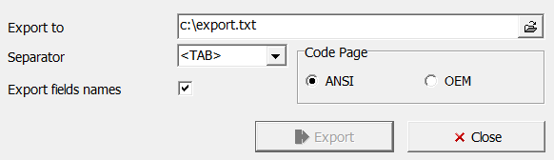

Export Field Designations in Albatros Import Field Designations in MS Outlook
Last Name Name
First Name First Name
Date of Birth Day of Birth
Country Home Country
Street Home Street
City Home City
Postal Code Home Postal Code
Address Greeting
Name Suffix Suffix
Business Phone Business Phone
Telephone (Home) Home Telephone
Home Fax Home Fax
E-mail E-Mail / E-Mail-Address
Business Country Other Address / Business Country
Business Street Other Address / Other Street
Business City Other Address / Other City
Business Postal Code Other Address / Other POSTAL Code
Business Fax Other Address / Business Fax
Business Cell Other Address / Cell 2
Business E-mail E-Mail 2 / E-Mail Address
Private Cell Other Address / Cell 2

Note! also that MS Outlook builds subgroups (+-sign)

- After you have moved terms from the available fields into the export fields by using the single arrow button, change the "Separator Character" from <Tab> to "," and then click on the "Export" button to complete the export.

Albatros Members now creates a file named "export.txt" on your local C: drive. You need this file to import the data into MS Outlook.

- Now start MS Outlook. After the program has started, click "File" on the menu brand then choose "Import and Export" from the drop-down menu (see screen shot below).

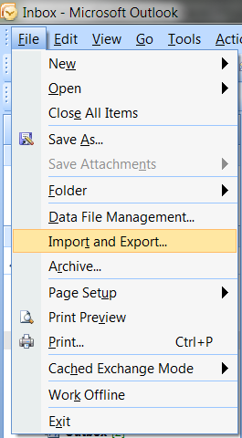

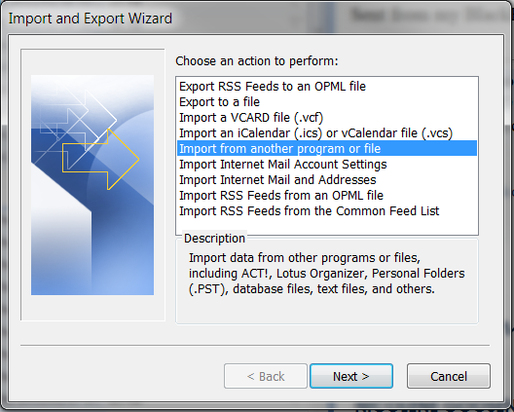

- The Import and Export wizard opens (see Figure above). From the wizard, select "Import from another program or file" and click the "Next" button.

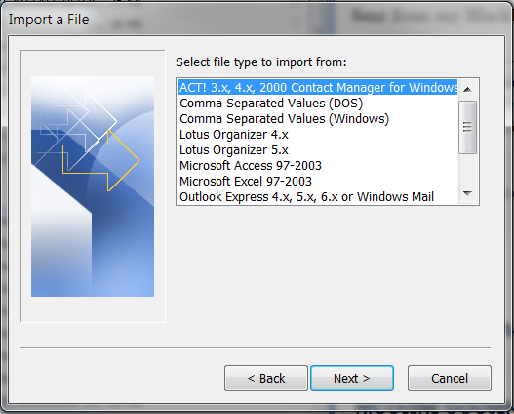

- In the "Select file type to import from" window, choose "Comma-separated values (Windows)" and click the "Next" button (see Figure above).

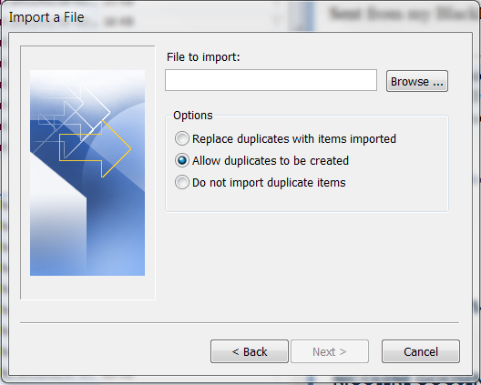

- In the "Import a File" window (see Figure above), click the "Browse..." button. A browse window opens (see Figure below). With the menu in this window, go to the C: drive and click the file "export.txt". Then click on the "OK" button.

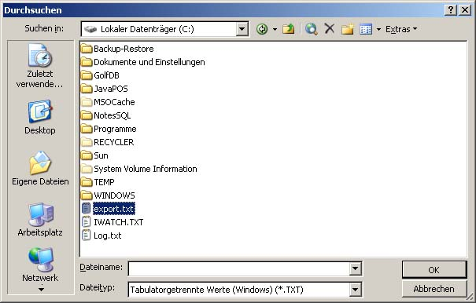

- The previously blank field will be filled with "C:\export.txt". Naturally you can enter this directory path by hand from the keyboard (see Figure below).

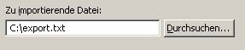

- Now click on the "Next" button. You move to the destination folder window of MS Outlook. In the Select destination folder window, select the folder "Contacts" and then click the "Next" button (see Figure below).

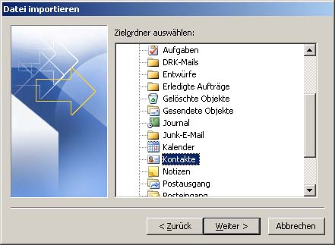

You are taken to the import function in MS Outlook where you must also map the fields by hand, so that the corresponding export data ends up in the right place (see figure below).

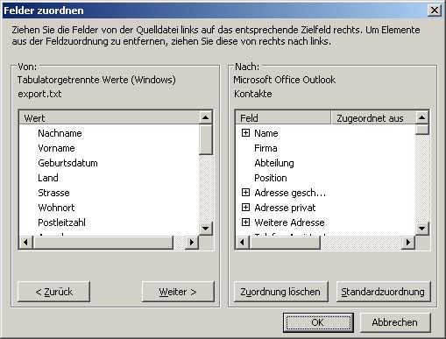

- When you have completed the mapping, click the "OK" button.

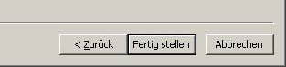

- You are taken to the "Import a File" dialog. Click the "Finish" button. Your data is imported. Depending on the number of records, this can take several minutes.

Note: Depending on your version of MS Outlook or MS Outlook Express (in this example MS Office Professional Pack 2003) the process described can differ in small details.

  - Multiple Handicap Entries
- If you wish to enter new handicaps for several members, then select the Multiple Handicap Entry menu.

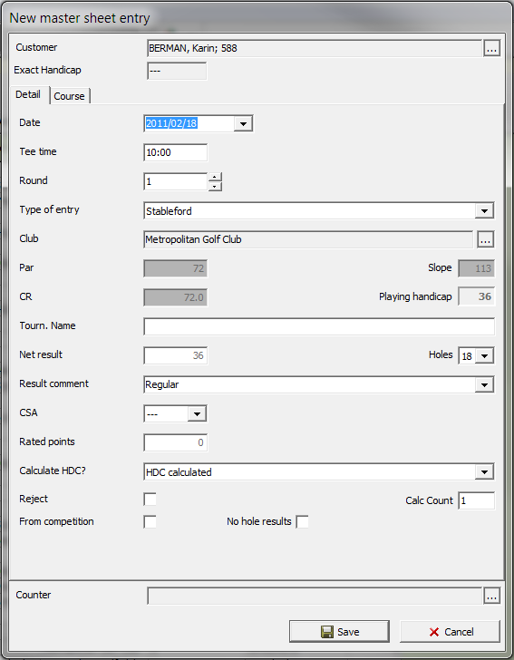

Input Fields

Customer Data Customer Selection List (see chapter Members - Customers, Find Individual Records)
SAGA Exact Handicaps Customer's SAGA Exact Handicap The system automatically enters the current exact handicap of the player.
Date Competition date. The date can be entered manually (without separators) or by using the calendar sheet.
Starting Time Starting time of the round
Round Enter the round
Type of Entry Selection list for the entry type
Club Selection list for the player's home club
Par Par value of the course
Slope Slope value of the course
CR Course Rating (CR) value of the course
SAGA Playing handicap The system automatically calculates the SAGA playing handicap of the player after you enter the course values.
Tourn. Name Name of the Tournament
Net result The player's net result
Result Comment Selection list for the result comment
Rated points Input the net Stableford points
Handicap Effective? Specify whether the competition is handicap effective, non-handicap effective or cancelled.
New Exact HDC The calculator calculates the player's new SAGA Exact Handicap.

Buttons
Save You save your entries with the Save button.
Cancel Exit the wizard without making entries in the handicap sheet.

- Enter your data.
- With the calculator calculate the player’s new exact handicap.
- Click the button Save.
- Select the next player with the button.
- Enter your data.
- Click the button Save.
- Use the Cancel button to end the process.

Other Menu
Statistics Create Statistics.
Prepare Card Ordering Prepare customer data to order cards
Reset Card Ordering In the DETAILS window the tick is removed from the Order Cards field.
SMS Journal SMS list of the recipient.
Birthday List Overview of birthdays

Show changes to the
Archived List of all changes in the backup.
Data

Acquire Association
Number for Acquisition of the Association Number
Selected Members

Recalculate age groups The age group is recalculated for all members.
Extended Booking
Options All invoices or charges of selected customers can be voided.

  - Create Statistics
- In the Extra menu, click the Statistics function.
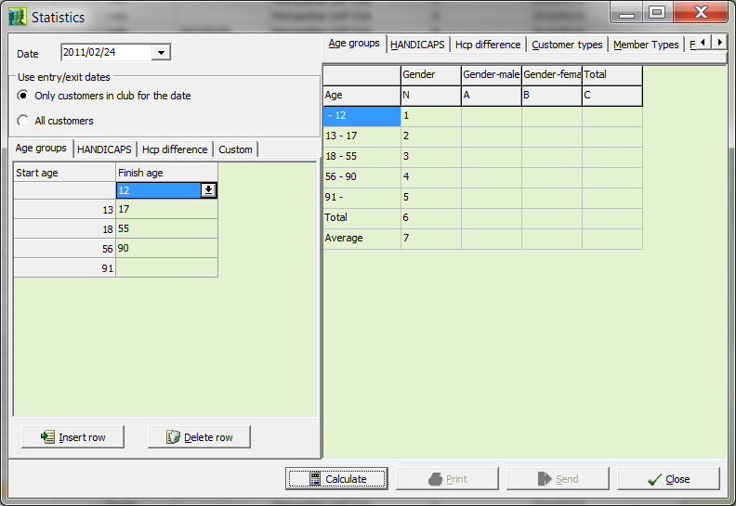

Input Fields
Date Date of validity of the Statistics. The date can be entered manually (without separators) or by using the calendar sheet. The system enters the current date as a default.
If this box is ticked, all customers whose admission
Only customers in club and leave dates match the validity date will be
for the date included in the statistics.

All customers If the All customers field is ticked, the admission or leave date criteria will not be considered and all members will be included in the statistics.

Buttons
Calculate After selecting the criteria, click the Calculate button to compile the statistics.
Print Print the statistics.
Close Close the STATISTICS window

- Enter the validity date for the statistics.
- Specify the criteria “entry/exit dates”.
- Select one of the pre-defined statistics or define one of your own as follows:
- Click the USER DEFINED tab.
- In the right side of the window, select the criteria to use when compiling the statistics and transfer these to the COLUMNS or ROWS windows using the arrow buttons. Then click the Calculate button.
- Print the assembled statistics with the Print button.

- Members - Customers
In the MEMBERS - CUSTOMERS window, all essential information about customers is assembled in table format.

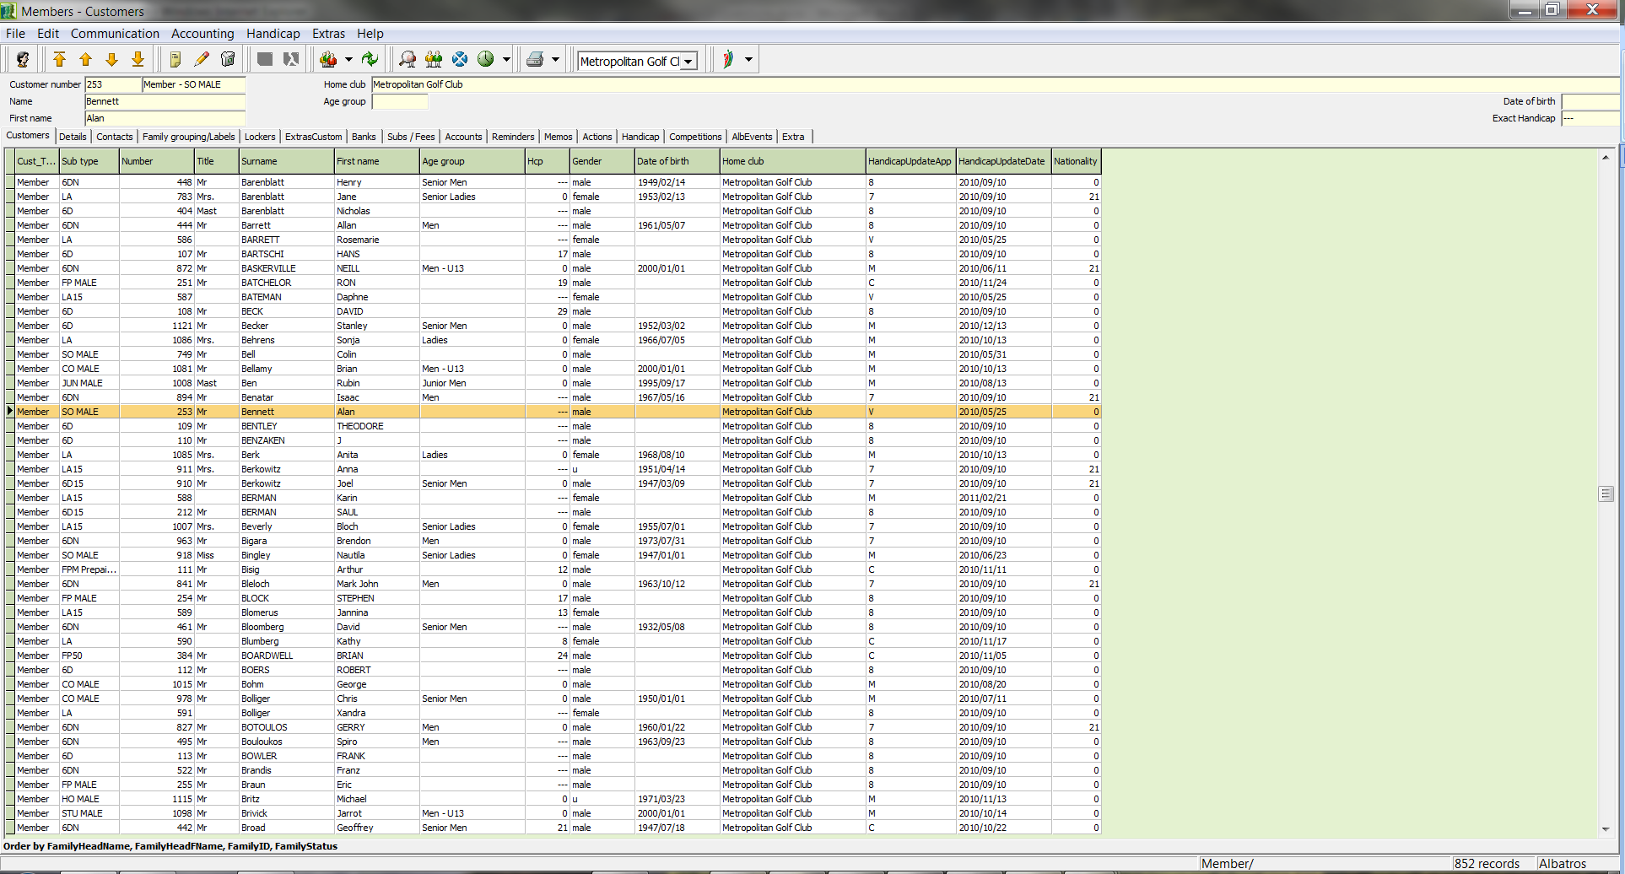

The customer table gives you a rapid overview of the customer data and is the starting point for all subsequent steps.

The currently selected record is indicated by highlighting in color, as well as with the triangle in the left hand column of the window. In addition, certain customer data appear in the fields at the top of the window.

OOO
- Details
In the DETAILS window are displayed club information and age information for the selected customer. The data can be changed with the Edit button.

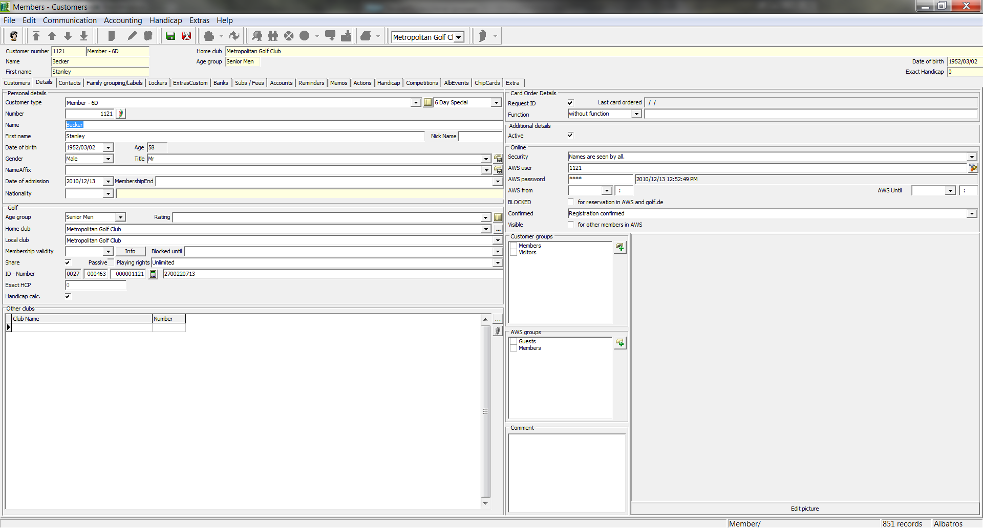

Input Fields
Customer Subtype Selection list for customer subtype. All customer types defined in the auxiliary table are available for selection here. The Customer Subtype field is a mandatory field and must contain an entry for each customer.
Number The system suggests a number for each new customer, based on the values which are set in the COUNTERS’ auxiliary table. The suggestion can be manually overridden. If the number has already been used, the following error message appears:

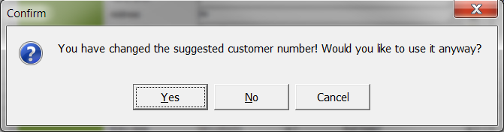

NOTE! Each customer number may only be used once. Customer numbers which have been used before but are now free may not be used, or unique identification of persons in the SAGA would not be possible. If, for example, a new member of your club enters a competition at another club and a check of his handicap against data stored at the SAGA is performed over the internet, the data stored there under this customer number would belong to your "old" member.

Name Last name of the customer without suffixes. The last name is a required field.
First Name First name of the customer
Gender Selection list for the customer's gender
Title Selection list for the customer's title. All titles defined in the TITLE auxiliary table are available for selection.
Address Extras Selection list for name suffixes. All suffixes defined in the ADDRESS EXTRAS auxiliary table are available for selection.
Birth Date Customer's birth date. The date can be entered manually (without separators) or by using the calendar sheet.
Age Group Customer's age group. The age group will be automatically suggested by the system based on the birth date and gender of the customer. The entry can, however, be overridden by hand.
Home club The customer's home club. This field is filled by default with the golf club to whom the installed version is licensed. If a guest's data is being entered, the home club can be selected from the auxiliary table by using the button. (see chapter Club list / Find club)
Date of Admission Date of admission of the customer. The admission date can be entered manually (without separators) or by using the calendar sheet. When registering a new customer, the system provides the current date by default.
MembershipEnd Leave date of the customer. The leave date can be entered manually (without separators) or by using the calendar sheet.
Order Cards When registering a new customer, this box will be automatically checked by the system. All customers for whom this box is ticked will be considered during the preparation for ordering cards (see chapter Order Cards).
Last Card Ordered Date the last card was ordered
ID Number Customer identification number. This is predetermined by the system and consists of the country number of the home club (1st field), the number of the club which the customer belongs to (2nd field) and the member number (3rd field) together.
Function Selection list for a function of the customer.
Exact HCP Customer's SAGA Exact Handicap. The SAGA exact handicap may only be entered in this field when creating a new customer. If the Handicap Calc. box is ticked, the exact handicap is entered into the handicap sheet as an initial entry when saving for the first time. After the initial entry this field is no longer active but is used only for information. Changes may only be made in the handicap sheet.
Handicap calc. If the box is ticked, the entries for handicap and exact handicap will be transferred to the handicap sheet as initial entries, and competition results will lead to a new calculation of the handicap.
Blocked until Management of the time-limited blocking of the handicap. The field is an information field only and has no effect whatsoever on the handicap calculation. The date can be entered manually (without separators) or by using the calendar sheet.
Playing rights Recognition of the contract between member and club.
  - Create New Customer
- Use the icon New.
- Make all entries.
- Save the customer with the icon Save.

  - Change customer data
- Select the customer in the customer table and click the icon Edit.
- Make the changes.
- Save the customer with the icon Save.

  - Delete customer data
- Select the customer in the customer table and click the icon Delete.
- Answer the confirmation question.

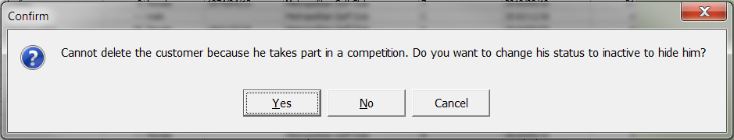

NOTE: After deletion, the record is no longer present in the database. It is advisable to assign the customer to a different customer subtype. Customers who have already participated in competitions or who were assigned to bookings are given the status "inactive".

Checklist for creating a new customer
- In the DETAILS window, click the New icon to create a new customer.
- Entry of the general customer data and the SAGA exact handicap in the DETAILS window. If a required entry is not available in the selection list, it must be created in the corresponding auxiliary table (see chapter Auxiliary Tables).
- Definition of family groups and control of address data for labels in the CONTACTS window (see chapter CONTACTS).
- Entry of other information, such as locker number, birth place or profession in the OTHER window.
- Entry of bank information in the BANKS window.
- Loading of the standard charges and individual charges in the window
- SUBSCRIPTIONS.
- Checking the record sheet in the DEFAULTS window. If, when creating a new customer, the field SAGA Exact Handicap in the DETAILS window has been inadvertently skipped, the initial entry must be made manually in the record sheet.

- Contacts
In the CONTACTS window, all address data is entered which will be used, among others, by the mail merge process.

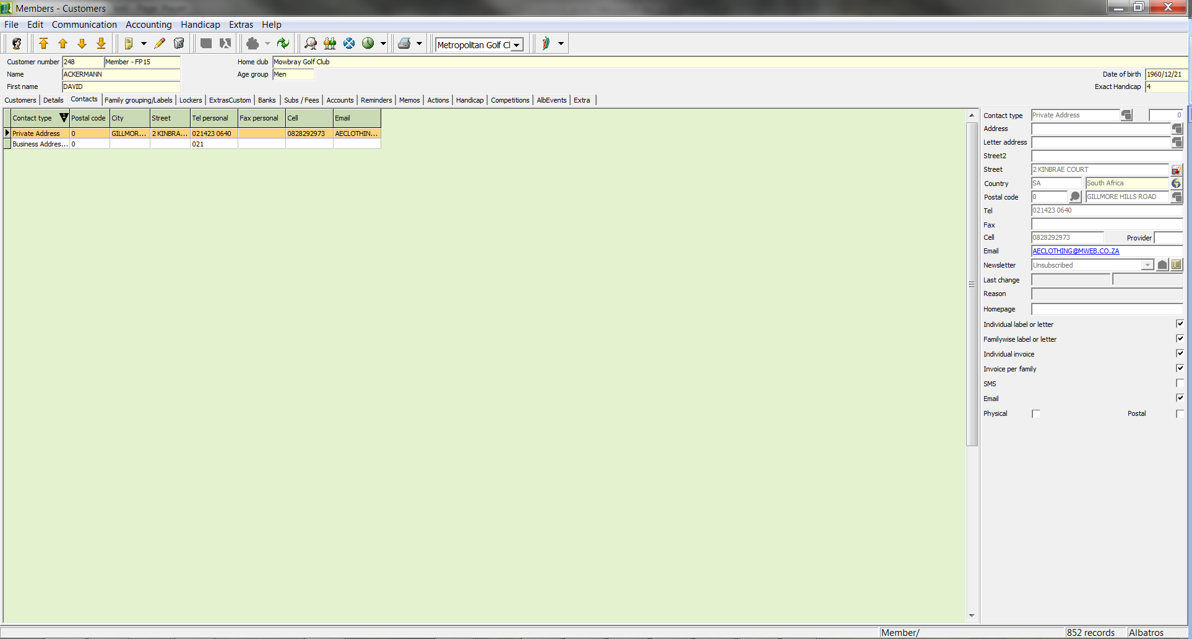

In the lower-left part of the window is the data for the currently selected customer, and in the right-hand side any existing family data is displayed. In the middle part of the window, first select the address type that you wish to change.

Input Fields
Address Selection list for the customer's form of address. All address forms defined in the ADDRESS auxiliary table are available for selection. It is necessary to enter a form of address for the purpose of generating customer correspondence or form letters, since this field is customarily exported in letters.
Letter Address Selection list for the customer's greeting line. All greetings defined in the LETTER ADDRESS auxiliary table are available for selection. It is necessary to enter a letter address for the purpose of generating customer correspondence or form letters, since this field is customarily exported in letters.
Street Input field for the street.
Country Selection list for the country. For this field, the country abbreviations must first be created in the corresponding auxiliary table. When manually entering the country abbreviation, the corresponding country will automatically be entered into the field highlighted in yellow.
Postal code Entry field for the Postal code. For this field, the corresponding auxiliary table has already been filled with the postal code directory for South Africa. After the corresponding postal code has been entered, the city name will be automatically retrieved by the system. By using the auxiliary button , the related auxiliary table can be opened and the desired entry selected. Postal codes for other countries can be added to the auxiliary table by manually adding the postal code and city name and then clicking the Learn City button. If the correct country abbreviation was entered, a new entry will be created.
Tel Customer's telephone number
Fax Customer's fax number
E-Mail Customer's E-Mail address
Home Page Customer's home page
SMS This box must be ticked in order to send SMS-messages
Cell Customer's cell phone number
Provider Subscriber's service provider. For cell phone subscribers whose provider has changed but who have kept their telephone number.

Individual Label
Standard Greeting If this box is ticked, the standard greeting used in the Greeting field will be used. If the box is not ticked, the system will use an appropriate greeting found in the auxiliary tables. In either case the greeting can be manually entered.
Address (1) – (5) The system will automatically enter data in the five address fields. All entries can be changed manually.
Greeting (1) – (2) If the Standard greeting field is ticked, the Greeting field will be filled with the entered greeting. If the box is not ticked, the system will use an appropriate greeting found in the auxiliary tables. In either case the greeting can be manually entered.
Family Labels
Standard Greeting If this box is ticked, the standard greeting used in the Greeting field will be used. If the box is not ticked, the system will use an appropriate greeting found in the auxiliary tables. In either case the greeting can be manually entered. In the case of more than one person, the greeting reads "Dear Family" and the last name of the family will be added.
Address (1) – (5) The system will automatically enter data in the five address fields. If two people are listed together in FAMILY RELATION, both persons will be addressed by name. In the case of a family, the address of the family head is used.
Greeting (1) – (2) If the Standard greeting field is ticked, the Greeting field will be filled with the entered greeting. If the box is not ticked, the system will use an appropriate greeting found in the auxiliary tables. In either case the greeting can be manually entered. If two people are listed together in LABELS, both persons will be addressed by name. In the case of a family, both the family and the family head will be addressed.

  - Assigning Persons / Families
- In the MEMBERS - CUSTOMERS window, select the customer to whom one or more persons should be assigned and change to the Family grouping/Labels window.

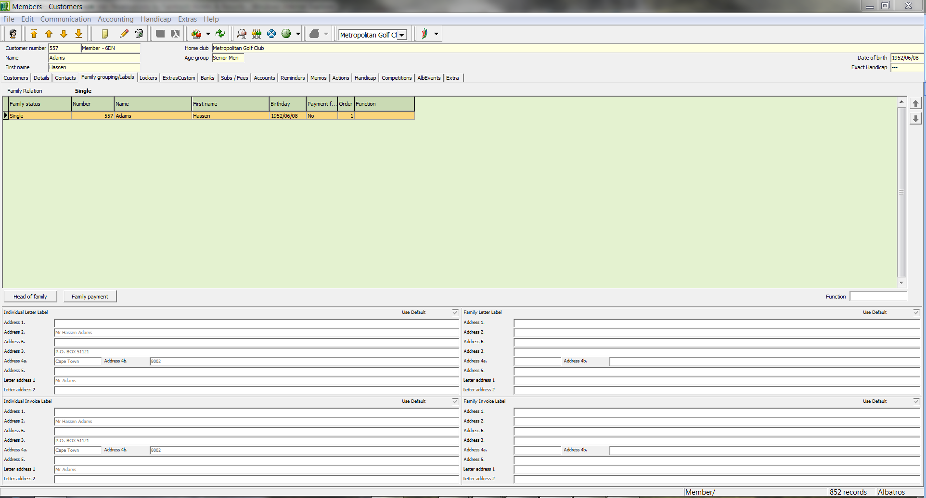

- Use the icon New. Select the corresponding names from the list by double-clicking.

The persons will be assigned automatically.

Buttons
Family Head The status of family head is assigned to the selected person with the Family Head button.
Family Invoice By using the Family Invoice button the selected person is assigned to the family invoice.

NOTE: If you include a person from another family, you can bring both families together.

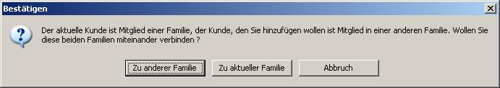

  - Cancel assignment of individuals
- In the MEMBERS - CUSTOMERS window, select the customers whose assignment is to be cancelled and change to the FAMILY RELATION window.
- Select the persons whose assignment is to be cancelled.
- Use the Delete button.

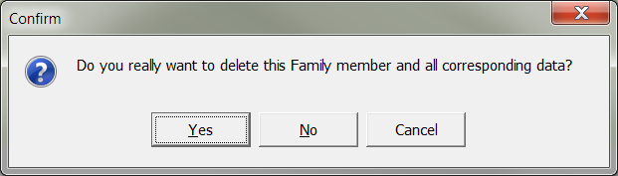

  - Assign the Family Head status
- In the MEMBERS - CUSTOMERS window, select the customer and change to the FAMILY RELATION window.
- Select the persons to be assigned as family head.
- Click the button Save.

NOTE: Only one person can be assigned the status of Family Head within a family.

  - Reset the Family Invoice to an Individual Invoice
- In the MEMBERS - CUSTOMERS window, select the customers for whom the change is to be made and change to the FAMILY RELATION window.
- In the FAMILY RELATION window, select the customers for whom the change is to be made.
- Click the button Save. If the selected person has the status of Family Head, the following confirmation question appears.

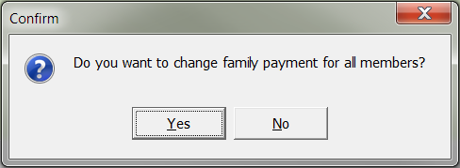

- Answer the confirmation question.
- For the selected person, "No" now appears in the Family Invoice column.

- Extras
In the EXTRAS window, additional data for your club is entered. You are not restricted to the available fields here, but can define additional fields and windows.

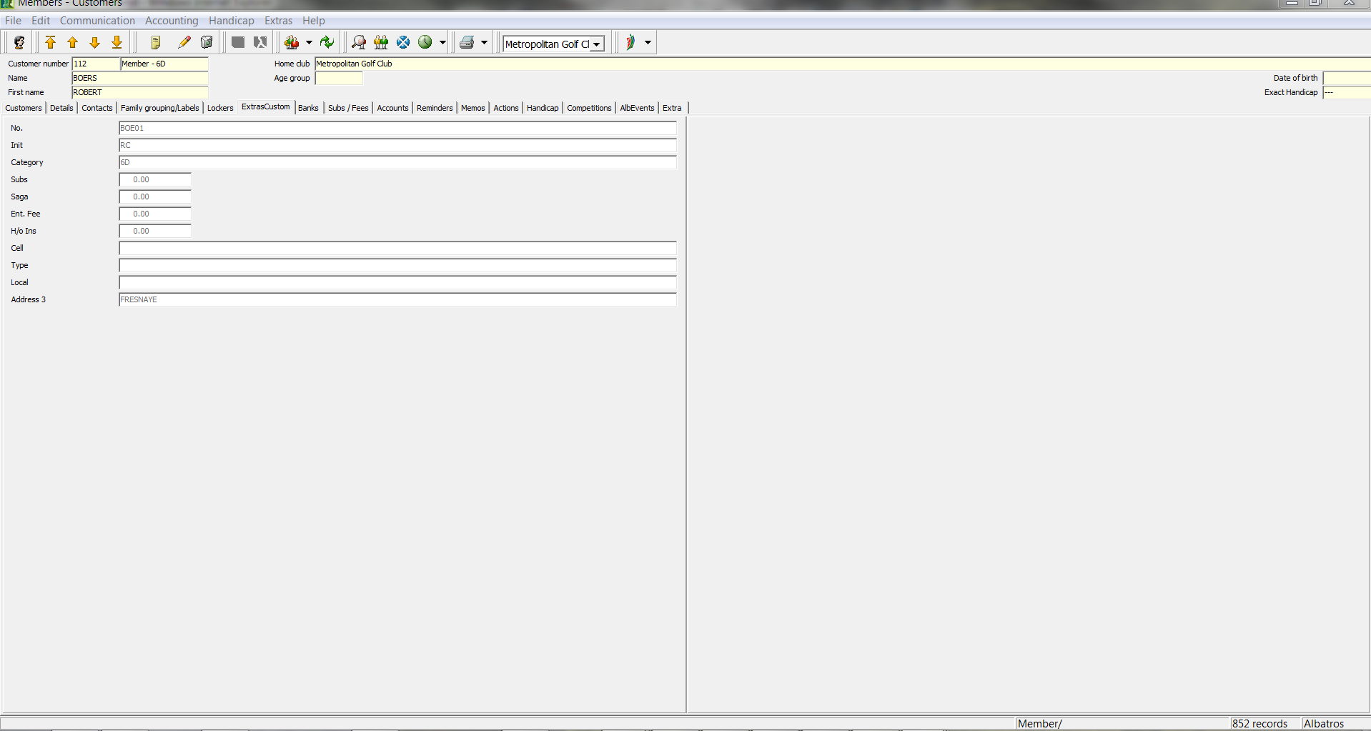

Input Fields
Parking Checking this box shows that the customer has rented a parking place (Golf Cart parking and Auto Parking).
Place Number The place number can be entered here if needed.
Teams Team assignment with check boxes

  - Enter additional clubs
- Select the customer in the MEMBERS - CUSTOMERS window and change to the DETAILS window. Use the Edit icon.
- On the left and below you see the list of additional clubs. Click the button to the side.

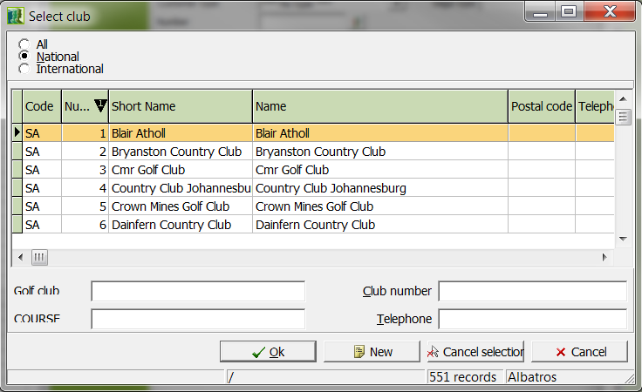

Input Fields
Club Name of the club.
Cust. / Member Number Customer or member number of the customer.

- Click the Edit icon.
- With the button select the club and enter the customer or member number.
- Save the customer with the icon Save.
- Leave the wizard by clicking the cross in the upper-right corner of the window.
- The club will automatically be entered in the Additional Clubs field.

- Banks
You manage the bank associations and related information In the BANKS window.

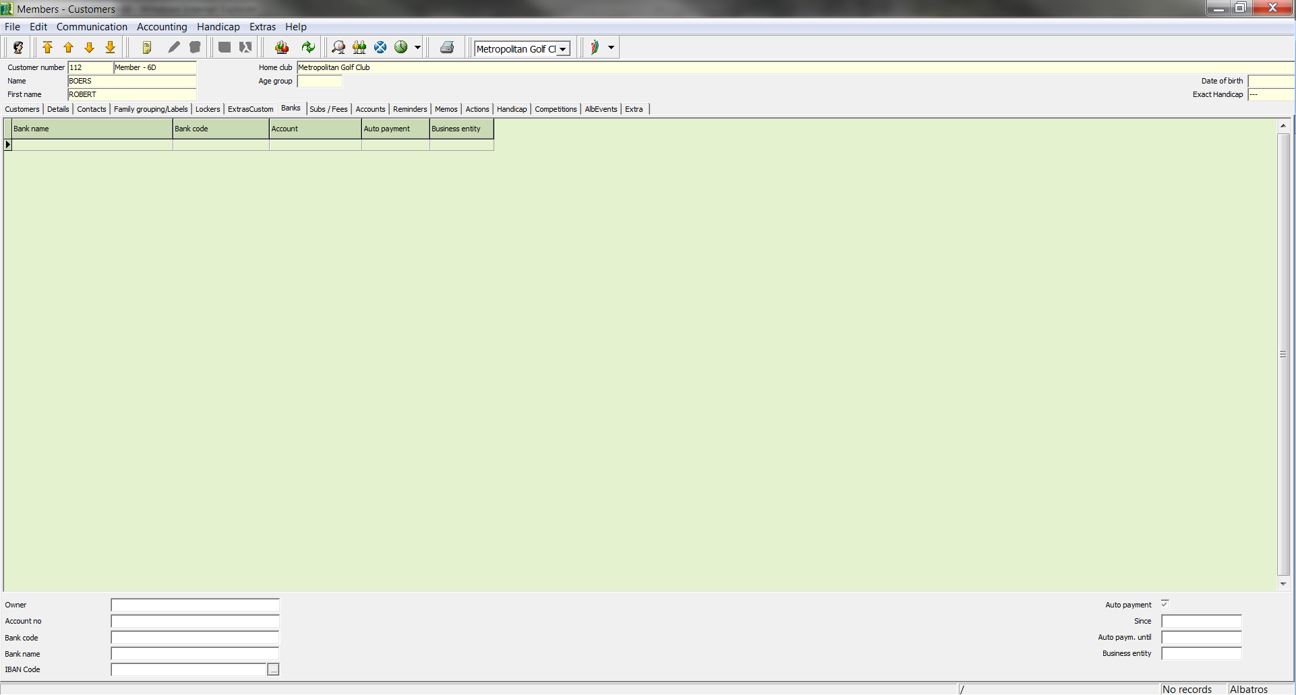

In the list you can see an overview of saved associations. In the bottom portion of the window you find the related details for the association you have selected in the list.

Input Fields
Owner Customer name.
AcctNo Customer's account number.
Bank Code Entry field for the bank's code For this field, the corresponding auxiliary table has already been filled with the bank code directory for South Africa. After you have entered the corresponding bank code, the name of the bank will be automatically supplied by the system. By using the button , the related auxiliary table can be opened and the desired entry selected. Foreign banks can be added in the auxiliary table. You can enter the bank code and bank name manually. By clicking the Learn City button , the bank data will be entered into the system and can then be selected from the list in future.
Bank After you have entered the corresponding bank code, the name of the bank will be automatically supplied by the system.
Auto payment Checking this box means that the club has direct debit authorization.
Since Entry field for the date of direct debit authorization
The date can be entered manually (without separators) or by using the calendar sheet.
Auto paym. until. Entry field for the expiration date of the direct debit authorization. The date can be entered manually (without separators) or by using the calendar sheet.

  - Add a new bank
- Click the New icon.
- Make all entries.
- Save the data with the icon Save.

  - Change a bank association
- Select the bank association that should be changed.
- Click the Edit icon.
- Make the changes.
- Save the changes with the Save icon.
  - Delete a bank association
- Select the bank association that should be deleted. Click on.
- Answer the confirmation question.

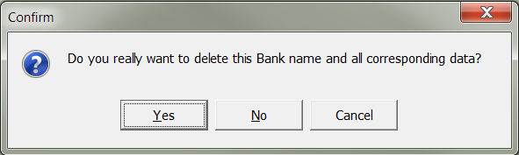

- Subscriptions
A customer's subscription articles are managed in the SUBSCRIPTIONS window.

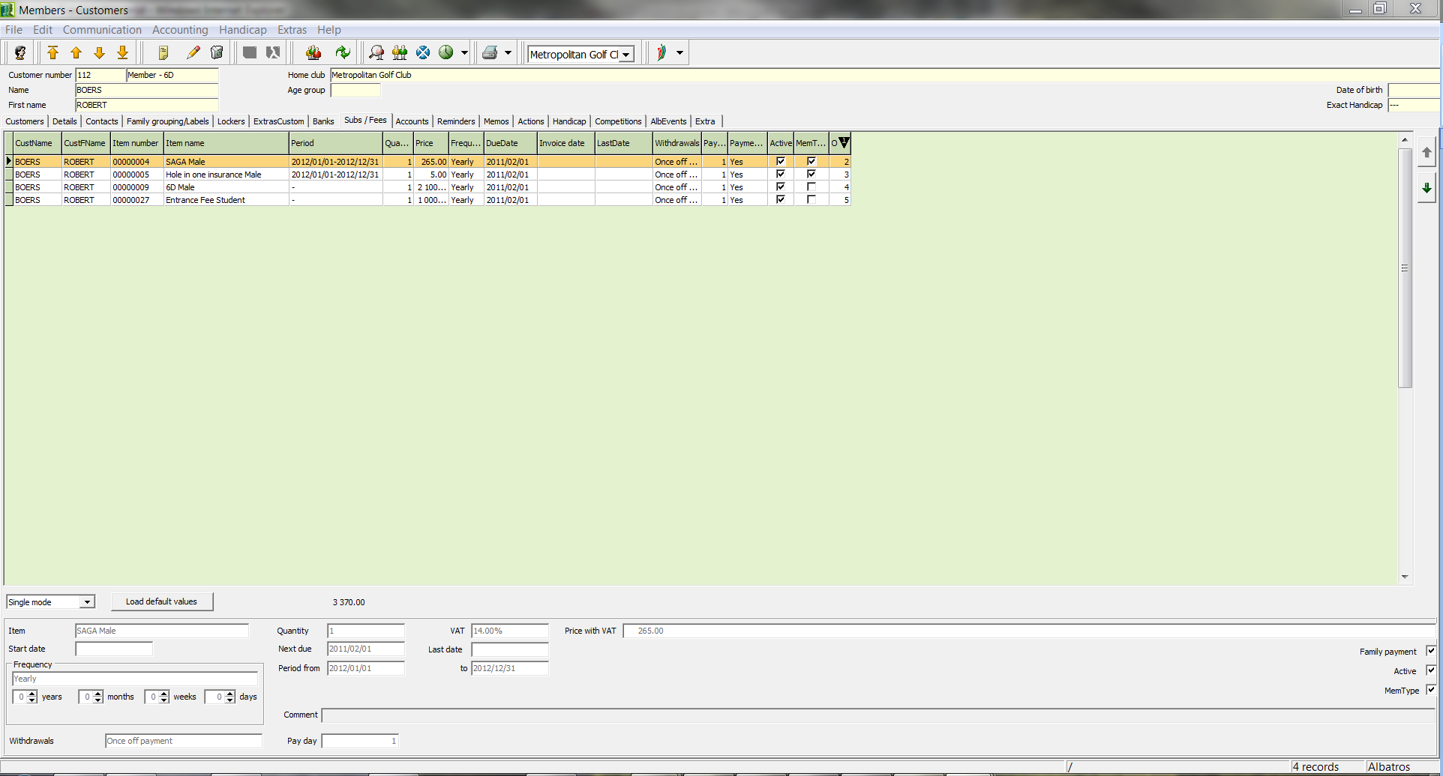

Input Fields
Article Selection list for the article. All created sale groups are available in the SUBSCRIPTION auxiliary table.
Next Due Due date of the next payment. The date can be entered manually or by using the calendar sheet.
Frequency Selection list for the payment schedule.
Comment The description field is not active in this window.
Quantity Number of articles that will be added to the customer invoice.
VAT Enter the VAT
Family paying Ticking this box shows that the items for this customer will be calculated in a family invoice.
Price with VAT Gross item price
Active If this box is ticked, the charges will be considered during the booking process.
Member Type If this function is activated, the charges will be assigned based on membership.
Buttons
Load Standard Charges Once the corresponding charges assignments for various customer (sub) types have been made in the auxiliary tables, these can be loaded with the Standard Charges button.

  - Assignment Options of Charges and Payments
Two options are available for the assignment of charges and payments.

- Assignment of Charges and Payments
- Load Standard Charges

  - Assignment of Charges and Payments
- Select the customer in the customer table and change to the SUBSCRIPTIONS window.
- Click the New icon.
- Select the desired charge and enter the corresponding dates.
- Save the data with the icon Save.

  - Load standard charges
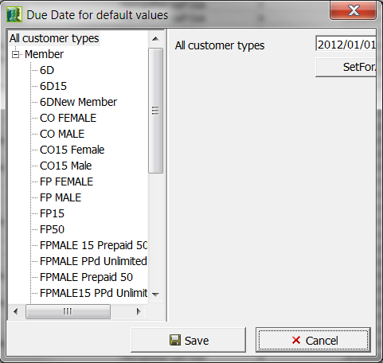

- Select the customer in the customer table and change to the SUBSCRIPTIONS window.
- Use the Load Standard Charges button or the Assign standard charges for current customer in the menu Booking.
- The following window opens.

Input Fields
Date Field Due date of the next payment. The date can be entered manually or by using the calendar sheet. If you load the standard charges, the current date will always be the default.

Buttons
The date in the date field above can be set for all date
SetForAll fields in the dialog by using the SetForAll button.

Save Save the data you have entered
Cancel Leave the window without having made any entries.

- Enter the due date of the respective positions and save your data by using the button Save.
- The charge items will be automatically transferred to the SUBSCRIPTIONS window.

NOTE: With Assign standard charges for current selection in the menu Booking you can assign standard charges for a selection of customers at the same time.

  - Changing a payment
- Select the payment to change in the table.
- Click the Edit icon.
- Make the changes.
- Save the data with the icon Save.

  - Delete a payment
- In the table, select the payment to delete.
- Click the Delete icon.
- Answer the confirmation question.

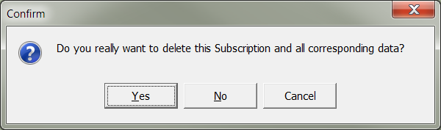

  - Sort Articles / Family members
An unrestricted filter for the family members and items is inserted. This is used when the invoice is printed. You can move the selected records with the arrow button.

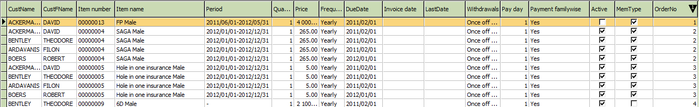

- Reminders
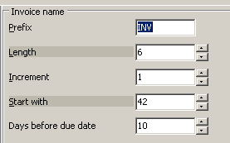
The Albatros software includes a reminder process. The required settings include the due date for the invoice created, as well as the corresponding reminder levels.

The due date is set with the Club Settings/Booking menu, but can also be changed when generating the invoice.

The required settings for the reminder levels are made in Members with the menu item Service/Auxiliary Tables/Subscriptions/Reminder Intervals. The reminder fees must be assigned to a sale group. Reminder fees can be freely defined. You can set as many reminder levels as you desire.

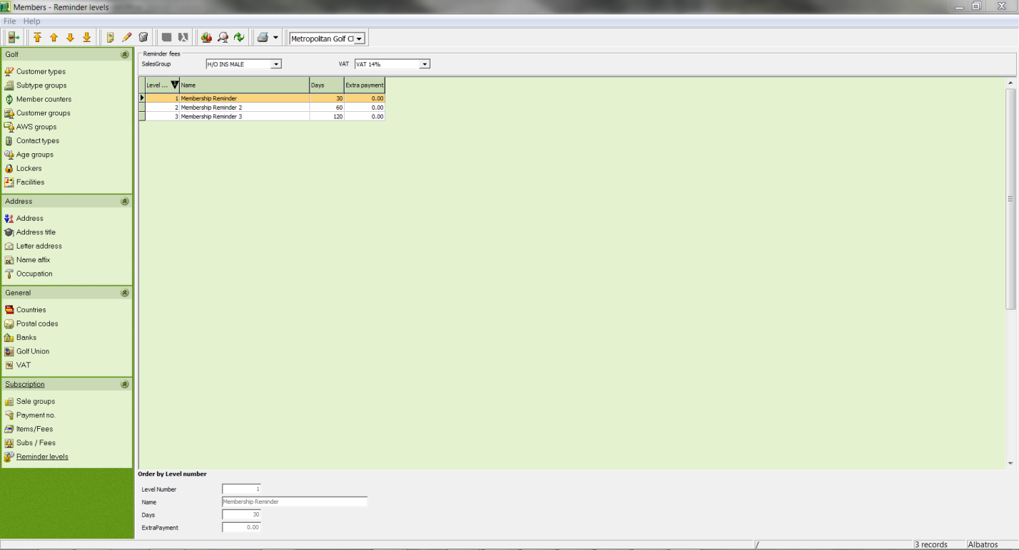
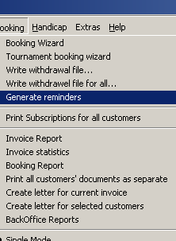

As with reminder levels, automatic reminders can be generated later in Members from the menu item "Booking/Create Reminders". The basis for the automatic creation of a reminder consists of the invoice date and the various payment dates. For example:

Invoice date | + Payment date | +Payment date  Reminder Level 1 | +Payment date  Reminder Level 2 | +Payment date  Reminder Level 3
1/1/2011 | 1/11/2011 | 1/31/2011 | 2/20/2011 | 3/12/2011
 | 10 Days | 20 Days after target | 20 Days after Reminder 1 | 20 Days after Reminder 2

The wizard generates the reminders automatically based on the preset parameters. Reminders and journals can be printed with the respective buttons. In the event of finance charges an accounting record will be created in the "Accounts" tab.

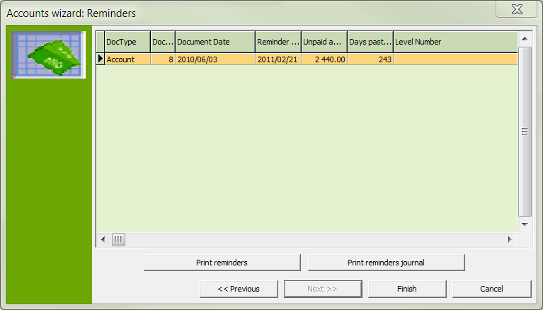

Individual reminders for the respective customer will be listed in the Reminders tab. If the "Create Reminders" box is unticked, no reminders will be created for this customer. The "Create Reminders" button creates reminders for the selected customers.

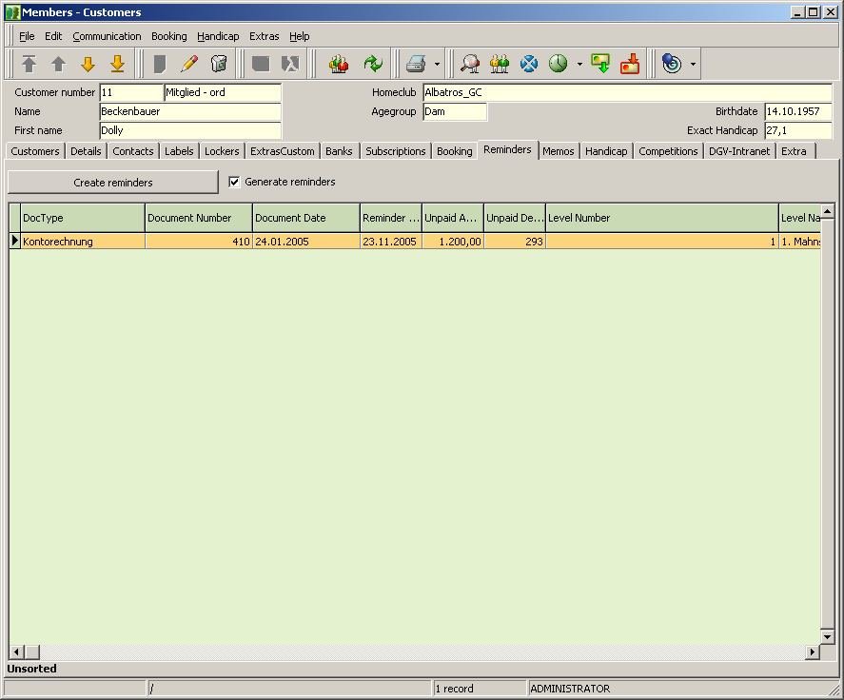
- Accounts
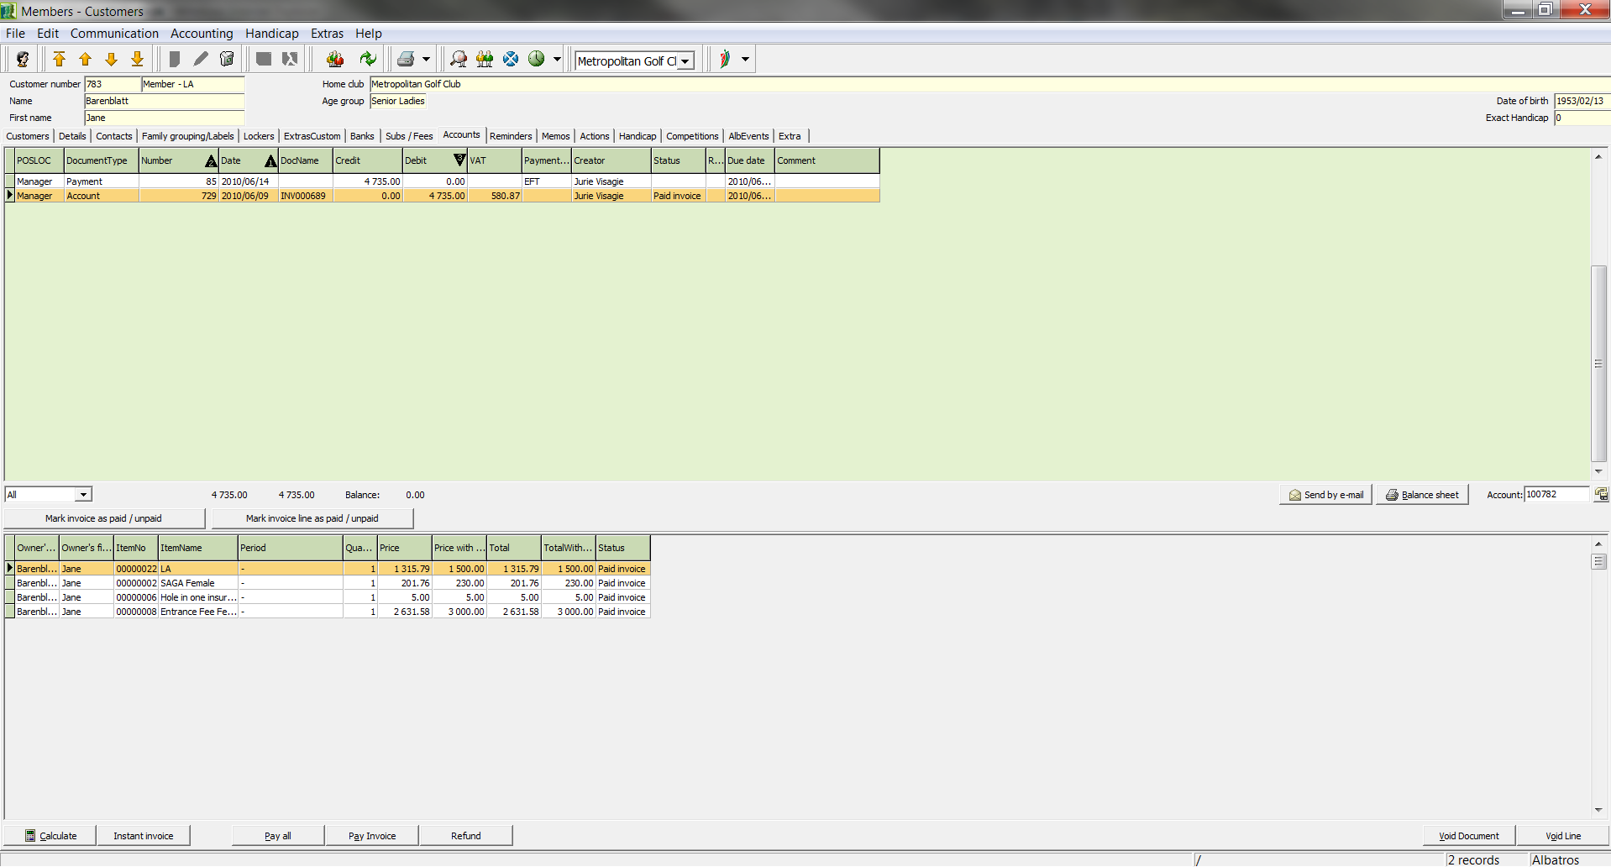 | In the ACCOUNTS window, overdue payments or charges can be assembled into invoices.  In addition you can manage from this point:  … which invoices were created and  …whether these are still open or have been paid.
Buttons
Calculate With the Calculate button the entries to be paid from the SUBSCRIPTIONS window will be assembled in an invoice.
Pay all With the Pay all button, all open invoices for the customer will be assigned the status "paid".
Pay Invoice With the Pay Invoice button, the invoice selected in the list will be assigned the status "paid". At this point you have the opportunity to enter partial payments and payment type.
Void Document With the Void Document button the invoice selected in the list will be cancelled.
Mark Invoice Line as
Paid/Unpaid With the Mark Invoice Line as Paid/Unpaid button, individual invoice items can be marked "paid".
Void Line With the Void Line button, individual invoice items can be cancelled.

  - Create Invoices
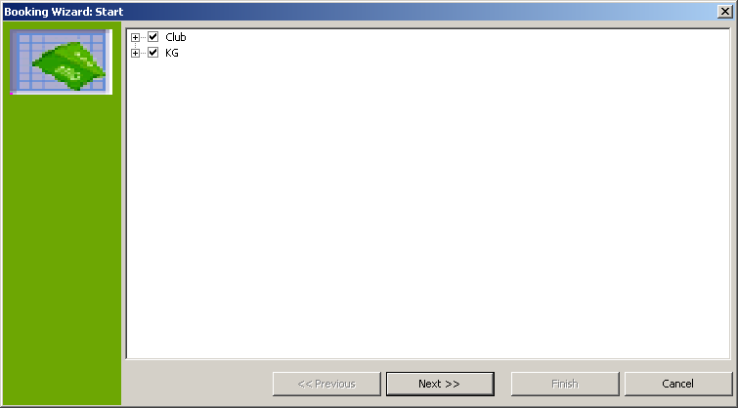

- In the customer table, select the customer for which to make entries and change to the ACCOUNTS window.
- Click the button Calculate.
- The Accounts Wizard opens.
- Check the boxes for the clients for which invoice items are to be called up. With the "+" sign or the "-" sign you can show or hide subordinate levels. By selecting the relevant clients, payment groups or items you can specify which items will be considered for the invoices.
- Click the button Next.
- In the following dialog, specify whether the invoices should be generated for individuals or families, and specify the sort schema.
- Click the button Next.
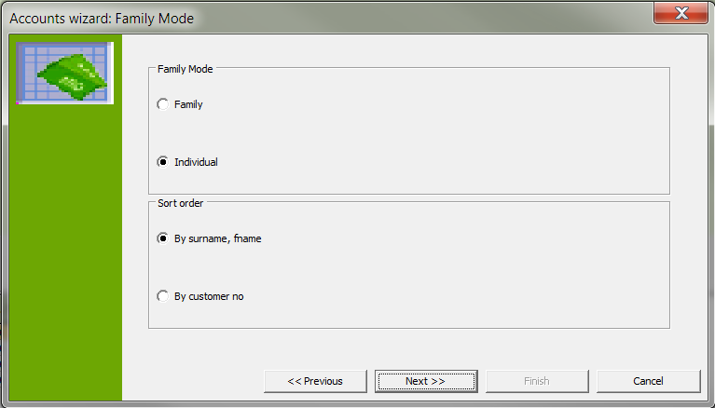
- Enter the due date for the invoice and the invoice date. In either case, the system enters the current date. The value of the due date will be used for the selection of the assigned payments. This means that only assigned payments which are overdue will be considered when the invoice is generated.

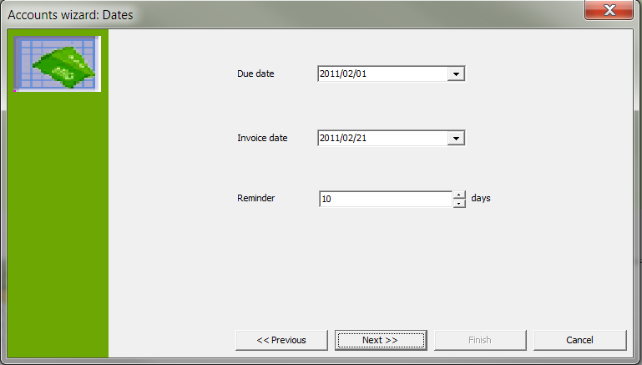

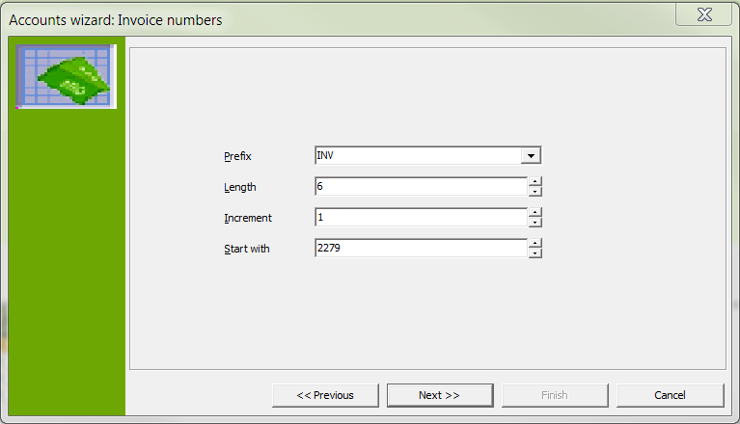 | - Click the Next button.
- Click the Next button.

Input Fields
Prefix A fixed value with which every internal invoice number begins (For example 2013)
Length Length to use for subsequent numbering (Example: 5 – all numbers will be added to the left with zeros so that a 5-digit number always results.
Increment Specifies by which amount the successive number increases (usually 1)
Start with Specify the first successive number

- Create an internal numeration according to your needs.
- Click the Next button.
- Click the Start button to begin the creation of the invoices. When the process has completed, the lower part of the window will display the number of invoices created and the invoice items.

NOTE! If the message "No invoices generated" appears, this means that no invoices could be created for the selected items and members with the given due date. If you feel that invoices should have been created, use the Back button to check the due date.

- Click the Next button.
- A list of the created invoices is displayed. At this point you have the option of canceling the invoice generation, or in other words, resetting the procedure, by using the Cancel button.
- Click the Next button.

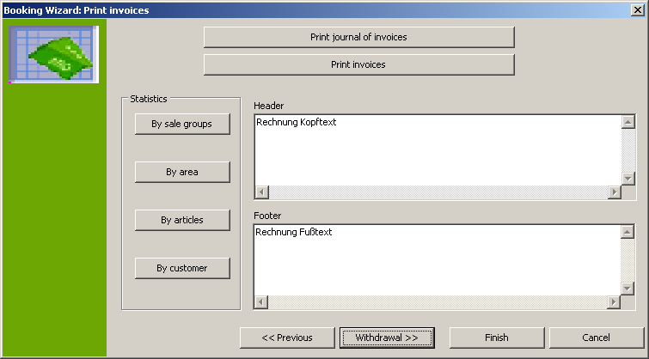

- Print the Invoice Journal The invoice journal contains invoice number, internal invoice number, name, member number and invoice amount, and can serve as an overview of the invoices which were created. The invoice journal should be created and reviewed before the invoices are printed.
- Next print the invoices by using the Print Invoice button.

NOTE! The printing process must be performed after selecting the desired invoice form by using the Print button. It is not possible to print all invoices via the preview, since every member invoice is a separate print object.

- If you have performed the invoice procedure without a bank direct debit authorization, leave the wizard with the Finish button. If you wish to create a withdrawal booking, withdrawal diskette and control list, use the Withdrawal button.

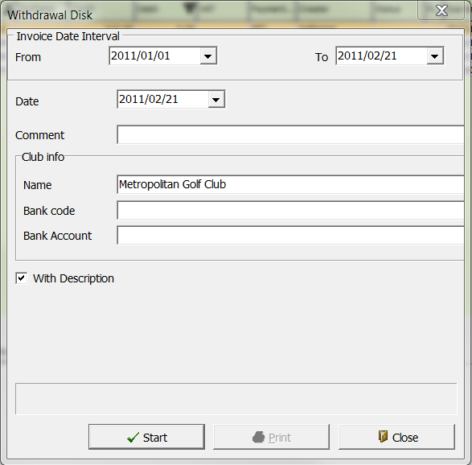

Input Fields
Payment Type Selection list for the payment type
Date Today's Date. The date can be entered manually or by using the calendar sheet.
Note Notes text for the Withdrawal entry
Name Name of the club
Bank Code Bank code of the club
Bank Account Club bank account
With Description If a description was entered, this box must be ticked.
Drive Selection list for the disk drive

- Enter the data in the input fields.
- Click the button Withdrawal.
- Click the button Withdrawal.
- Click the Start button to begin the creation of the invoices.

- Print the accompanying sheet for the withdrawal using the Print Withdrawals button and the control list with the Print Withdrawals Journal button.
- Use the Finish button to close the wizard.

  - Delete Items
- Select the invoice, the payment entry or the individual invoice items that are to be deleted.
- Use the Void Document button to delete an invoice or a payment item, or use the Void Line button in the case that an individual invoice item should be deleted. In both cases the buttons can be replaced by the Delete icon.
- Answer the confirmation question.

NOTE! Only invoices with the status "open" can be cancelled.

  - Print an Invoice
- In the item list, select the invoice to print.
- Click the Print icon.

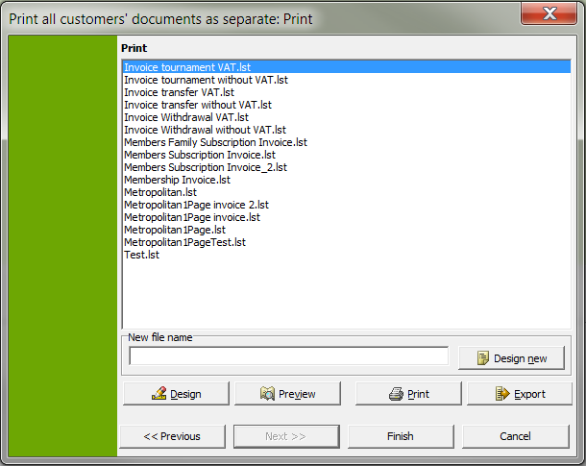

Invoice Templates
InvoiceWithdrawalWithVAT Listing of the invoice items with VAT and information, that amount is deducted.
InvoiceWithdrawalWithoutVAT Listing of the invoice items with VAT and information, that amount is deducted.
Tournament_WithdrawalWithVAT List of the competition items with VAT and information, that amount is deducted by way of debit entry.
InvoiceWithdrawalWithVAT Listing of the invoice items with VAT with the request for transfer.
InvoiceWithdrawalWithoutVAT Listing of the invoice items without VAT with the request for transfer.

Buttons
Preview With Preview the invoice can be viewed once more before printing.
Design With the Designer you can make individual format changes to the invoice. More information about using the designer can be found in the Designer Manual.
Print Print the invoice.
Export The Export button is used to export the invoice. This can be done as a file, in HTML format (enables posting on the internet), as a bitmap, metafile or JPEG graphic, or also in Rich Text Format (enables additional processing in Word or Excel).
Cancel With the Cancel button you return to the original window without starting the print operation.

- Select an invoice template
- Click the button Print.

NOTE! You can also directly select an invoice template with the arrow next to the print icon.

Booking / Invoice Generation Control Sheet
- Create a selection for the group of individuals for whom invoice generation should be performed. Be sure to differentiate between individuals participating in the withdrawal process and those who will not, since a separate billing run must be performed for these invoices.
- Check family group status for all records. If the Family invoice status was selected, a family head must be entered in the table
- If a new item has been added to the standard charges since the last invoice run, a new assignment of standard charges must be made. This is done in the Accounting menu using the option Subs/Fees and “Load default fees for all…”
- If you wish to assign additional payments to a selection of people later, such as a consumption credit note, for example, you must make a selection for this subgroup first.
- Assigning an individual charge. This is done in the Accounting menu with the option Assign payment / charge to the current selection.

NOTE! Make sure the correct payment frequency for the payment has been selected and verify the due date, since the system always provides the current date by default.

- If the individual charges were already assigned to a particular subgroup, the selection of the subgroup for the invoice run must be made again.
- Printing a charges control list with the Accounting / Charge Control List menu. Reviewing the list and correcting any errors.
- Generating Invoices. This is done with the Subscription Wizard in the Accounting menu (see the chapter Booking, Book Entries.)

ATTENTION! Be careful to select the correct due date and invoice date since the system always provides the current date by default.

NOTE! If you are working with direct debit authorizations to any degree, you must make a separate invoice run for each choice (Auto paym. = yes, Auto paym. = no).

ATTENTION! The following criteria must be chosen for the selection so that persons who have not provided bank information will also appear in the selection, and not just the individuals who have a check mark in the Collection box.

Bank name = Is Null (The empty field box must be ticked)

Or not (The Not field must be ticked and the Or field marked)
Auto Payment = yes

- Memos
Notes can be entered n the MEMOS window.

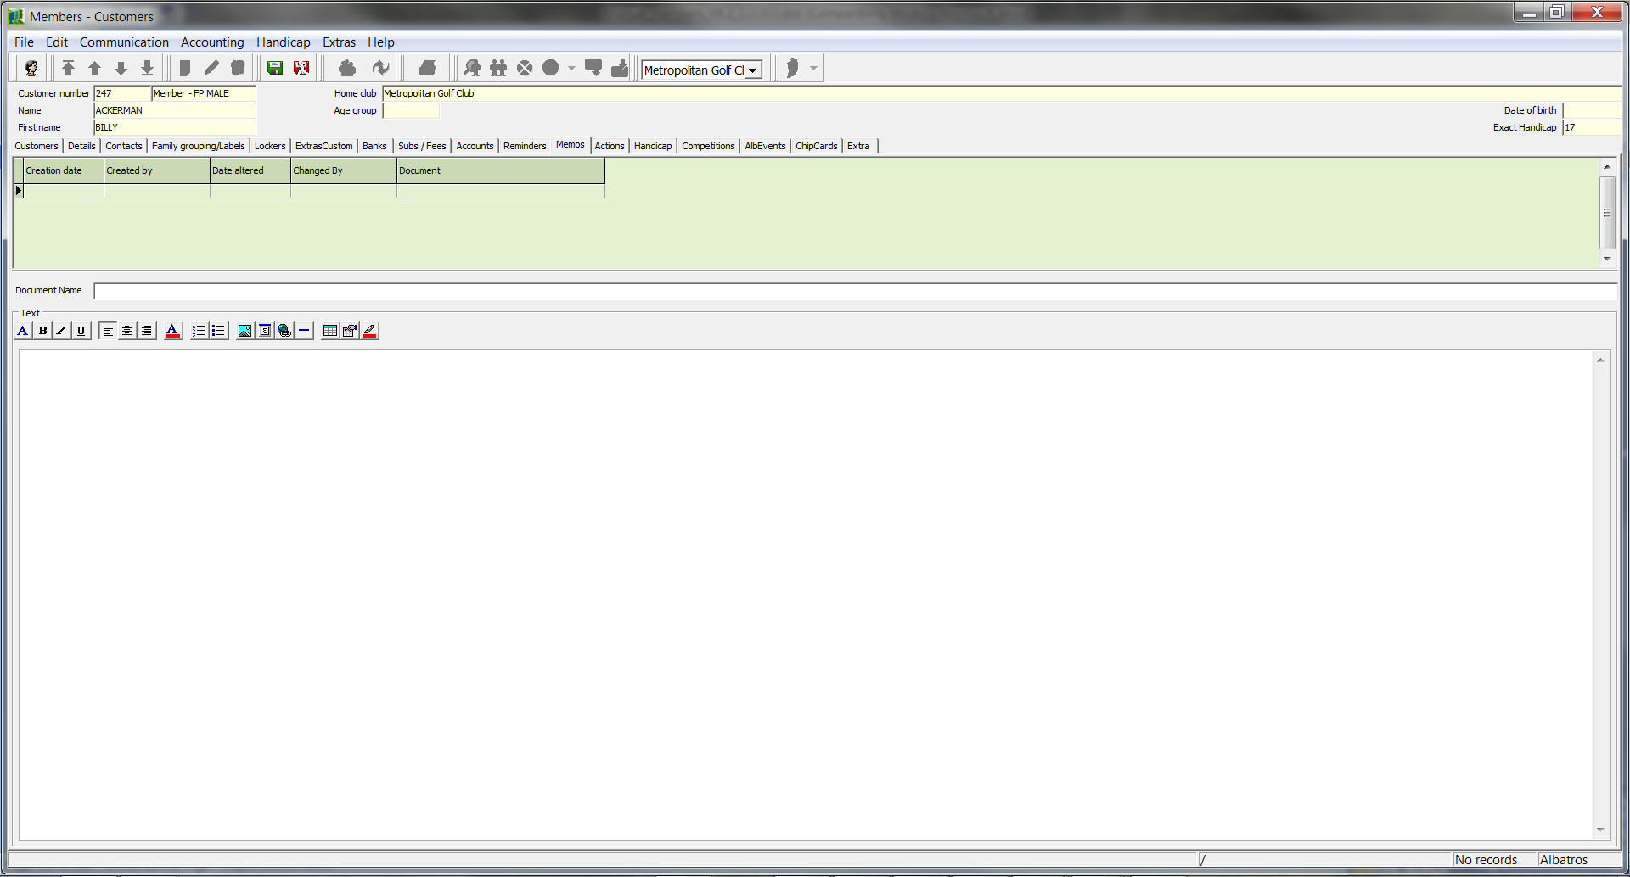

In the memo list you can see who has created a memo, when this was done, as well as who has made changes and on what date. You can see the text relating to the selected note in the lower part of the window.

Input Fields
Document Name Name of the note

  - Creating a memo
- Click the New icon.
- In the Document name filed, enter the name of the note.
- Write your text in the gray part of the window.
- Save the memo with the icon Save.

  - Change a memo
- Select the memo to be changed from the list.
- Click the Edit icon.
- Make the changes.
- Save the changes with the Save icon.

  - Delete a memo
- Select the memo to be deleted from the list.
- Click the Delete icon.
- Answer the confirmation question.

- Handicap
In the handicap window have a view of the record sheet for the customer selected in the customer list.

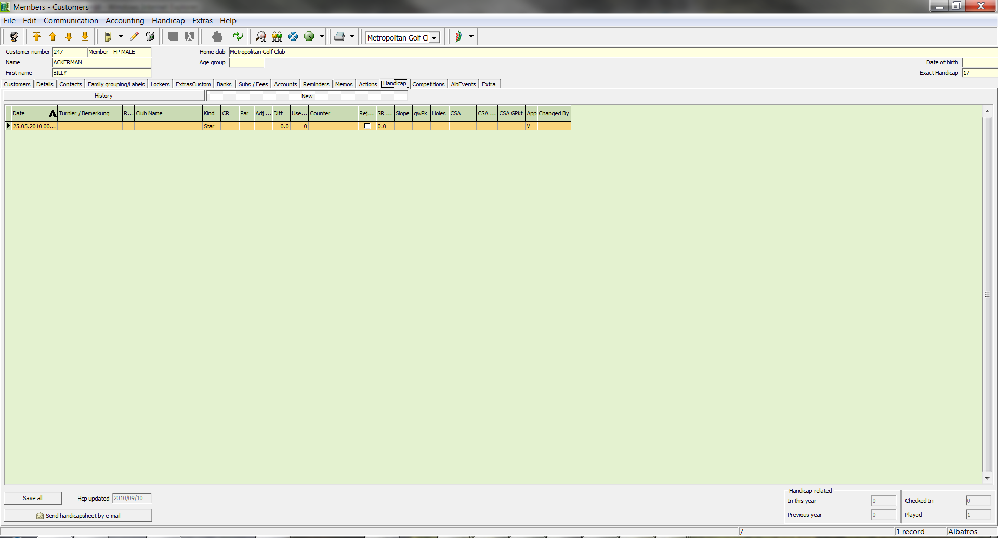

An initial entry is essential for proper handicap management. For this reason, an automatic entry is made in the HANDICAP window when you create a new customer with handicap management. To create a preliminary record sheet for a guest, the Handicap Management box must be ticked and the standard handicap entered in the DETAILS window.

Columns
Date Date and time of the competition
Tournament / Comment Name of the Tournament
Club name Name of the Club
Kind Kind of competition. The entry type is specified by the following abbreviations:
        - Strt: Initial Entry
        - Strk: Stroke Play
        - Stb: Stableford
        - AP: against par

CR CR value of the golf course
Par Par of the golf course
Slope Slope value of the golf course
Res. Result. The result will be calculated based on the completed competition in net (Stb and AP) or gross points (Strk.). In the case of a disqualification (without result evaluation) or No Return a bar is entered; in all other cases a zero.
RT Result type In the case of a normal result, there is no result in the result type column. The abbreviations DQ or DQE stand for disqualification with or without result evaluation. No Return is indicated by NR. NRd indicates a definite disqualification and not a round which was interrupted by illness.
he The column he indicates whether the competition was handicap-effective (he) or non handicap-effective (nh) or was cancelled (cn).
NStbPts Entry of the net Stableford points
NU In the column NU is found the net underplay.
TBV In the column TBV is found the table value resulting from the net underplay.
SAGA Hdcp The player's exact handicap
Prg. In the Prg. column you can see whether the entry was made in Competitions (C) or in Members (M).
  - Making a Handicap Sheet Entry
- Click the New icon.

The following wizard opens:

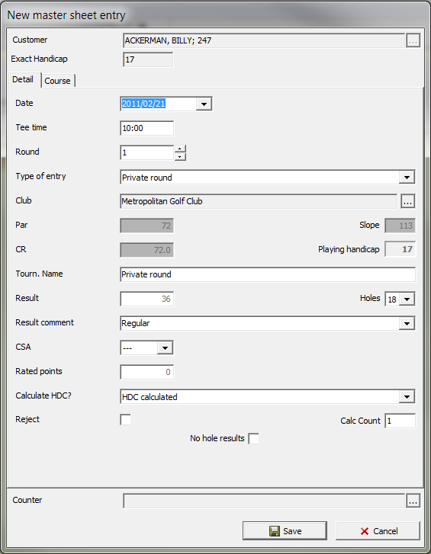

Input Fields
Customer Data Customer Selection List (see chapter Members - Customers, Find Individual Records).
Exact Handicap Customer's SAGA Exact Handicap The system automatically enters the current exact handicap of the player.
Date Competition date. The date can be entered manually (without separators) or by using the calendar sheet.
Starting Time Starting time of the round
Round Enter the round
Type of Entry Selection list for the entry type
Club Selection list for the player's home club
Par Par value of the course
Slope Slope value of the course
CR Course Rating (CR) value of the course
SAGA Playing handicap The system automatically calculates the SAGA playing handicap of the player after you enter the course values.
Tourn. Name Name of the Tournament
Net result The player's net result
Result Comment Selection list for the result comment
Rated points Input the net Stableford points
Handicap Effective ? Specify whether the competition is handicap effective, non-handicap effective or cancelled.
New Exact Handicap With the calculator the new exact handicap can be calculated.

Buttons
Save You save your entries with the Save button.
Cancel Exit the wizard without making entries in the handicap sheet.

- Enter your data.
- Click the button Save.

  - Changing a handicap sheet entry
- Select the handicap entry to be changed.
- Click the Edit icon.
- Answer the confirmation question.

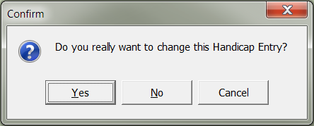

- Make the changes.
- Save the changes with the button Save.

  - Delete a handicap sheet entry
- Select the handicap entry to be deleted.
- Click the Delete icon.
- Use the Delete button.
- SAGA Intranet
In order to receive data from the SAGA intranet or to transmit data to the SAGA intranet, click on the arrow to the right of the SAGA button.
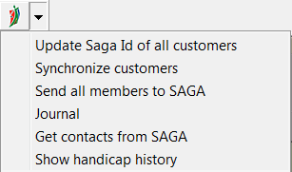

A brief description of the function of the individual menu items is given below. Detailed information is available in the SAGA-intranet manual.
SAGA Intranet Journal

In the SAGA Intranet journal you can view incoming and outgoing records.

Send customer data for selected customers

Transmit data of the customers in the selection. The data can be seen on the SAGA Intranet tab.

Send customer

Transmit data of all customers in the selection.

Send customer's handicap sheets

Transmit the handicap sheet data for the selected customer.

Send All Customers

Transmit the record sheet data for all customers in the selection.

- Competitions
In the COMPETITIONS window you see a list of all competitions in which the customer has already participated or will participate. It is also possible to register the selected customer for a competition directly from this point.

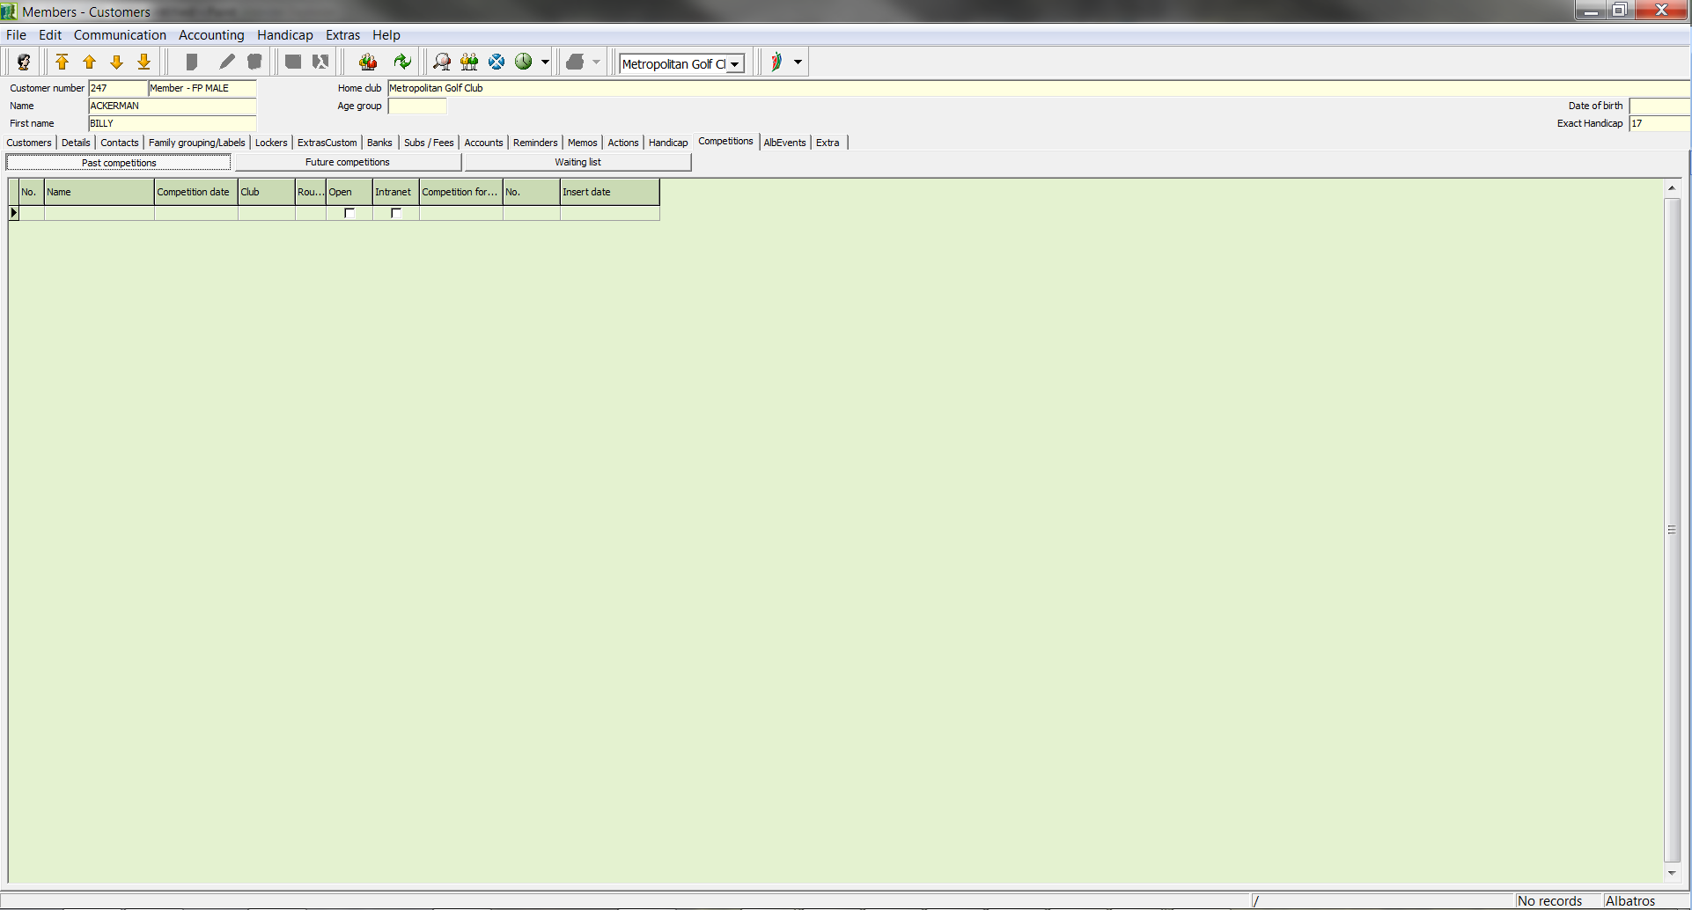

Columns
Past competitions A list of all competitions in which the selected customer has participated.
Future competitions A list of all future competitions for which the selected customer is registered.
Waiting list A list of all competitions for which the customer is registered but for which, due to lack of space, he or she is on a waiting list.
  - Registering for a competition
- Click the New icon.

The following wizard opens:

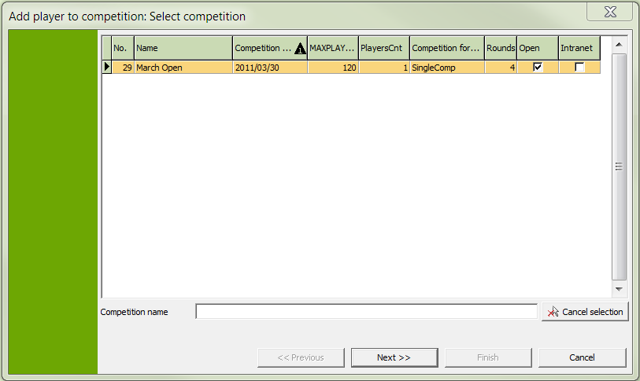

Here you are given a list of all competitions which have already been created.

Input Fields
Name Input field for the competition name to search for in the list. The list is automatically restricted to the competition that corresponds to this name.

- Enter the name of the competition you wish to search for. The list is automatically restricted to the competition that corresponds to this name.
- Mark the desired competition in the list.
- Click the Next button.

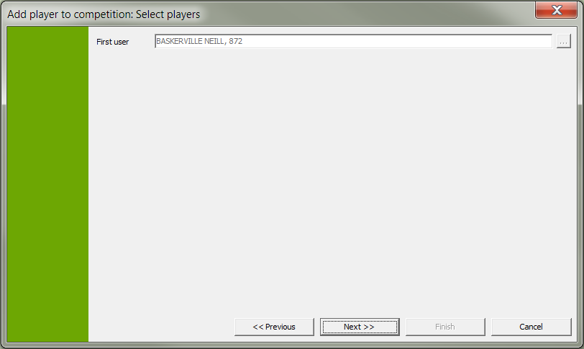

- Confirm the player's entries by clicking the Next button.

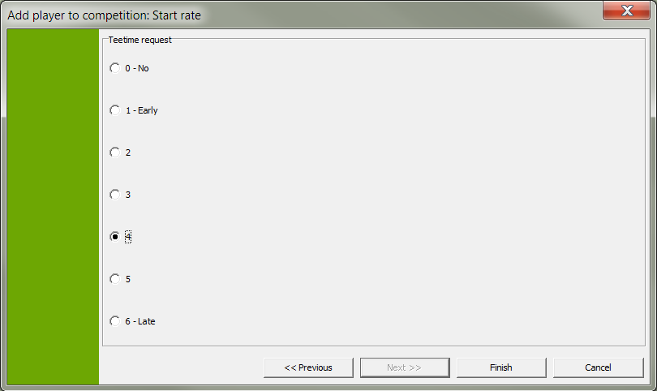

- Enter the player's desired start time, if any.
- Click the Finish button to complete the registration.
- Answer the confirmation question with OK.

  - Delete a competition registration
- Select the competition for which the registration should be cancelled.
- Click the Delete icon.
- Answer the confirmation question.
- Clubs
In the CLUBS window you find a tabular view of all golf clubs.

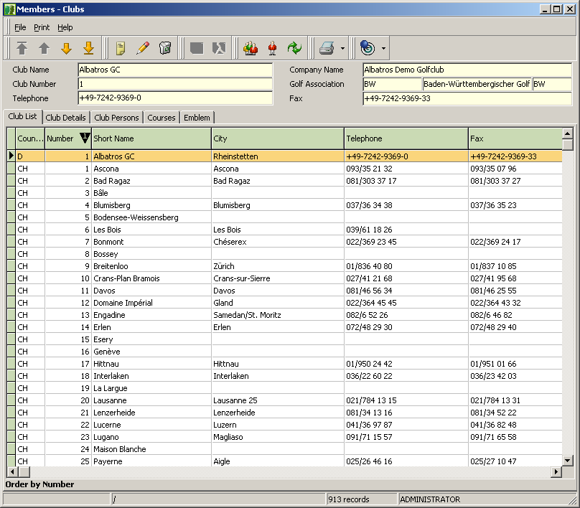

  - Find a club
- Click the icon Find Customer.

The FIND CLUB wizard opens.
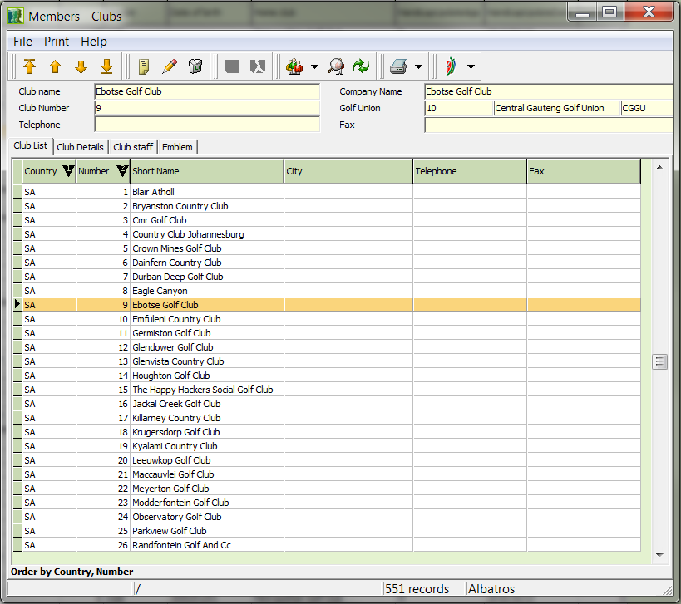

Input Fields
All If the All field is selected, all clubs will be displayed in the list.
National Marking the National field will display only in-country clubs.
International If the International field is marked, only foreign clubs will be displayed in the list.
Golf club Name of the golf club to search for
Postal code Postal code of the golf club
Club number Club number of the golf club
Telephone Telephone number of the golf club

Buttons
OK Clicking the OK button starts the search for the selected club in the customer table.
NEW Allows a new club to be created
Sel. Cancel By clicking the Sel. Cancel button the search criteria will be cleared and the fields are again available for input.
Cancel The Cancel button returns you to the previous window without starting a search.

- Select the criteria to be used in searching for the club. Check the corresponding boxes.
- Enter the name, the postal code, the club number or the telephone number of the club you are searching for. This will perform an extended search. This means that as soon as a letter is entered, the fields Name, Abbreviation and City in the list with the club data will be searched. This must not occur at the beginning of the field. The telephone number is also searched in extended mode. The postal code or club number, however, are not subject to extended search but rather the numbers entered must be at the beginning of the field. Naturally, different fields can be combined according to your needs.
- The search results will automatically be displayed in the current window.
- By double-clicking on the desired club you return to the club list where the selected club remains highlighted.

- Club data
In the CLUB DATA window is displayed the data for the selected club.

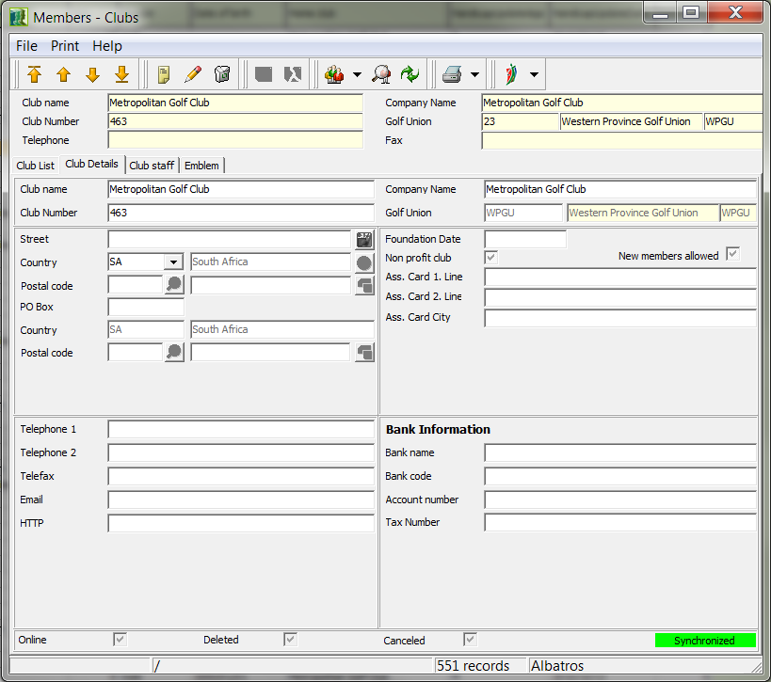

Input Fields
Short Name Short name of the golf club
Number Club number of the golf club
Street Street of the golf club
Country Selection list for the country. For this field, the country abbreviations must first be created in the corresponding auxiliary table. When manually entering the country abbreviation, the corresponding country will automatically be entered into the field highlighted in yellow.
Postal code Entry field for the postal code. For this field, the corresponding auxiliary table has already been filled with the postal code directory for South Africa. After the corresponding postal code has been entered, the city name will be automatically retrieved by the system. By using the button, the related auxiliary table can be opened and the desired entry selected. Postal codes for foreign locations can be added in the auxiliary table. Enter the postal code and city name manually and then click the Learn City button button. If the correct country abbreviation was entered, a new entry will be created.
P.O. Box P.O. Box number of the club
Country Selection list for the country based on the P.O. Box For this field, the country abbreviations must first be created in the corresponding auxiliary table. When manually entering the country abbreviation, the corresponding country will automatically be entered into the field highlighted in yellow.
Postal Code Input field for the postal code based on the P.O. Box. For this field, the corresponding auxiliary table has already been filled with the postal code directory for South Africa. After the corresponding postal code has been entered, the city name will be automatically retrieved by the system. By using the button, the related auxiliary table can be opened and the desired entry selected. Postal codes for international locations can be added in the auxiliary table. Enter the postal code and city name manually and then click the Learn City button. If the correct country abbreviation was entered, a new entry will be created.
Telephone 1-2 Telephone number of the golf club
Telefax Fax number of the golf club
E-mail E-mail address of the golf club
HTTP Internet address of the golf club
Company Name Official name of the golf club
Golf Association Selection list for the golf association responsible for this club.
Foundation date Date the golf club was established
Non Profit Club Checking this box indicates that the golf club is a non-profit organization.
New Members Allowed Checking this box indicates that members can be added.
Ass. Card 1-2 Information on the member identification cards
Ass. Card City Line Information on the member identification cards
Bank Name of the bank
Bank code Bank code of the golf club
Account number Account number of the golf club

  - Create a club
- Use the icon New.
- Make all entries.
- Save the club with the icon Save.

  - Change club data
- Select the club in the club list and click the icon Edit.
- Make the changes.
- Save the data with the icon Save.

NOTE! As a rule you obtain the current valid data from the intranet and do not need to create new clubs or make changes. You should only make changes to the data for your own club!

- Club Staff
Listed in the CLUB STAFF window are all persons active for the club.

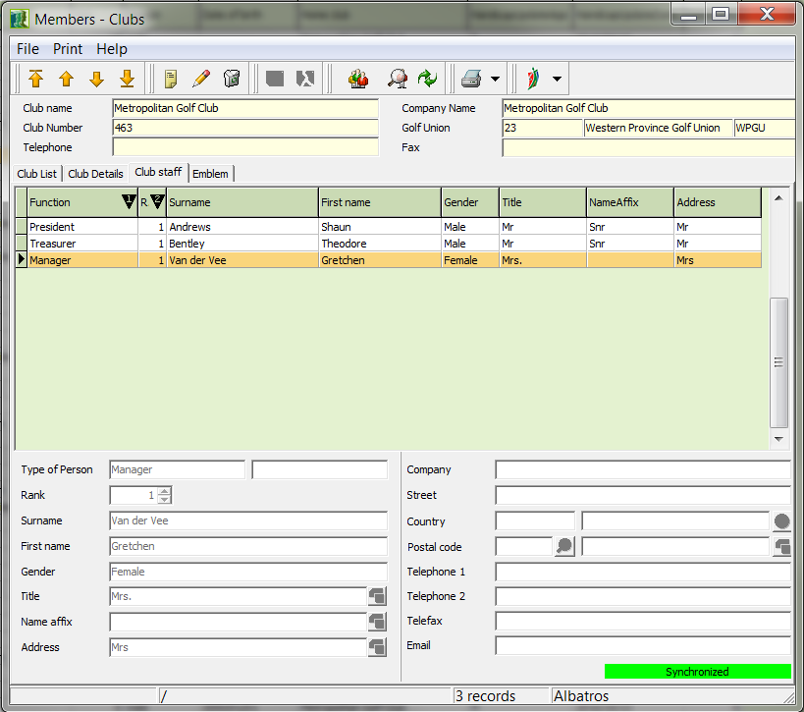

Input Fields
Function Selection list for the function of the person. All greetings defined in the FUNCTION auxiliary table are available for selection.
First Name First name of the person
Gender Selection list for the gender of the person
Title Selection list for the title. All address forms defined in the TITLE auxiliary table are available for selection.
Name Suffix Selection list for the name suffix. All suffixes defined in the ADDRESS EXTRAS auxiliary table are available for selection.
Company Name of the company in which the person is employed.
Street Company street
Country Selection list for the country. For this field, the country abbreviations must first be created in the corresponding auxiliary table. When manually entering the country abbreviation, the corresponding country will automatically be entered into the field highlighted in yellow.
Postal code Entry field for the postal code. For this field, the corresponding auxiliary table has already been filled with the postal code directory for South Africa. After the corresponding postal code has been entered, the city name will be automatically retrieved by the system. By using the button, the related auxiliary table can be opened and the desired entry selected. Postal codes for international locations can be added in the auxiliary table. Enter the postal code and city name manually and then click the Learn City button. If the correct country abbreviation was entered, a new entry will be created.
Last Name Last name of the person
Title Selection list for the title. All titles defined in the TITLE auxiliary table are available for selection.
Telephone1-2 Telephone number of the person
Telefax Fax number of the person
E-mail E-mail address of the person

  - Create a club person
- In the club list, select the club for which you wish to create person and return to the CLUB PERSONS window.
- Click the New icon.
- Make all entries.
- Save the entries with the icon Save.

  - Change a person's data
- In the club list, select the club for which a person is to be changed and return to the CLUB PERSONS window, or search for the club directly in the CLUB PERSONS window with the icon.
- Select the person in the list whose data is to be changed.
- Click the Edit icon.
- Make the changes.
- Save the changes with the icon Save.

  - Delete a club person
- In the club list, select the club for which you wish to delete person and return to the CLUB PERSONS window.
- Select the person to be deleted from the list.
- Click the Delete icon.
- Answer the confirmation question.

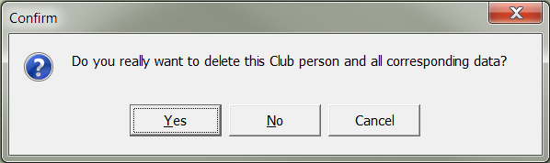

NOTE! The data will be maintained in its current state for the particular club and made available to the other clubs through the intranet. This means, however, that anything entered on this sheet will be available for public access. In order to afford official representatives of your club a certain measure of data security, we recommend that you fill the address fields in this sheet with the address of your golf club.

- Courses
In the COURSES window you find the course data of the respective clubs.

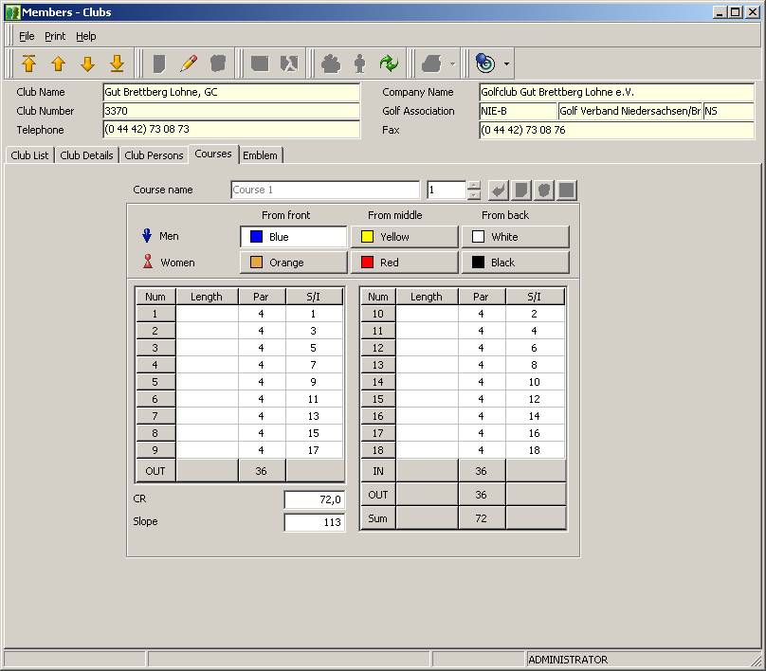

Input Fields
Course Name Description of the course for all 6 tee-off colours, there should be no colour in the course name.
Length Length of the individual holes in meters
Par Par of the individual holes and the selected colour
CR CR value of the course and the currently selected colour

  - Create a course
- Click the Change Entry icon.
- Use the New icon on the right side of the window.
- Click one of the tee-off colors available for men (blue, yellow, white) and enter the corresponding course data. Repeat this process if necessary for all three tee-off colors.
- Click one of the tee-off colors available for women (orange, red, black) and enter the corresponding course data. Repeat this process if necessary for all three tee-off colors.
- Save the course data with Save Data.

NOTE! It is important that you understand the following when defining a course: You need more than a single course definition when you actually have more than one course (for example, 2 x 18 holes or 3 x 9 holes which can be combined in different ways during play). Within the various club courses up to six tee-off colors can be defined.

  - Change Course Data
- Click the icon Change Entry.
- Using the arrows, select the course whose data should be changed.
- Select the tee-off color for which you wish to make changes.
- Make the changes.
- Save the course data with Save Entry.

  - Delete Course Data
- Click the icon Change Entry.
- With the arrow, select the course to be deleted.
- Click the delete icon.
- Auxiliary Tables
To make your work easier and to avoid saving duplicate data in the database, a full complement of auxiliary tables are available to you in ALBATROS FOR WINDOWS.

The values of all fields that may only contain specific values are entered in a auxiliary table. Values do not need to be entered each time in these fields, but may be selected from a list. Since only values in the auxiliary table may be selected, the field is protected from incorrect entries, making the task easier.

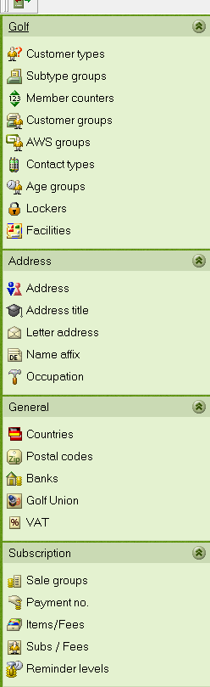 | The auxiliary tables are divided into several tables. subcategories.  These are found on the left side of the window.  You can access the respective tables by clicking the individual categories.  The auxiliary table currently being described in the manual can be recognized by the border around the auxiliary table icon.

- Customer types
Customer types and customer subtypes are managed in the CUSTOMER TYPES window.

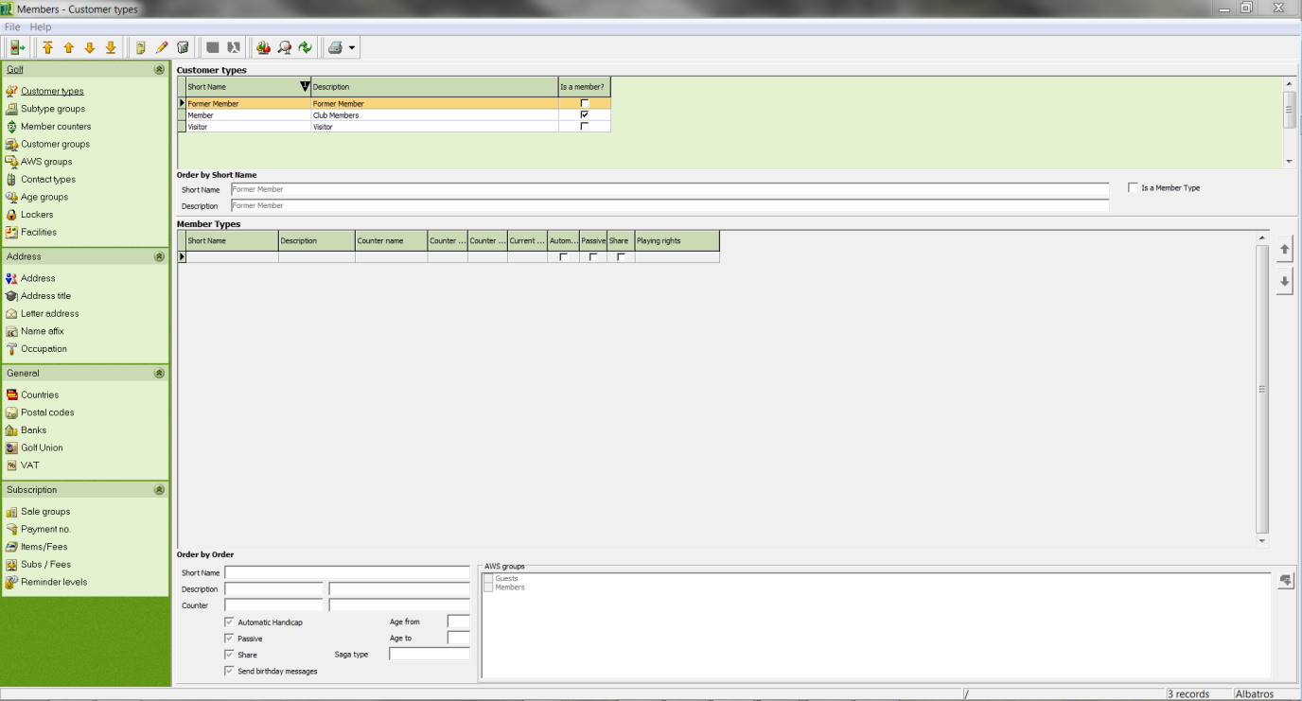

Input Fields
Customer types
Short Name Short name of the customer type
Description Description of the customer type
Customer class Selection list for the customer class
Is Member Checking this box indicates that the customer type has member status.

Customer Subtypes
Short Name Short name of the customer subtype
Description Description of the customer subtype
Counter Selection list for the counter description (see chapter Counters).
Automat. Handicap If this box is ticked, handicap calculation will be activated when a new customer type of this category is created.

  - Creating a customer type or customer subtype
- In order to create a customer type, select a line in the customer table; in order to create a customer subtype, select a line in the customer subtype table. The active table is highlighted in white.
- Click the New icon.
- Make the entries.
- Save the entries with the icon Save.

  - Changing a customer type or customer subtype
- Select the customer type or customer subtype to be changed in the corresponding table.
- Click the Edit icon.
- Make the changes.
- Save the changes with the icon Save.

  - Deleting a customer type or customer subtype
- Select the customer type or customer subtype to be changed in the corresponding table.
- Click the Delete icon.
- Answer the confirmation question.

NOTE! To avoid inadvertently deleting a customer (sub)type to which at least one customer has been assigned, the system checks to see if this has actually been used with any customers and if so, gives you a warning. Deletion of a customer (sub)type is only possible when no such customers are found.

- Counters
In the COUNTERS window you can manage the numerical ranges of the customer and member numbers assigned by your club.

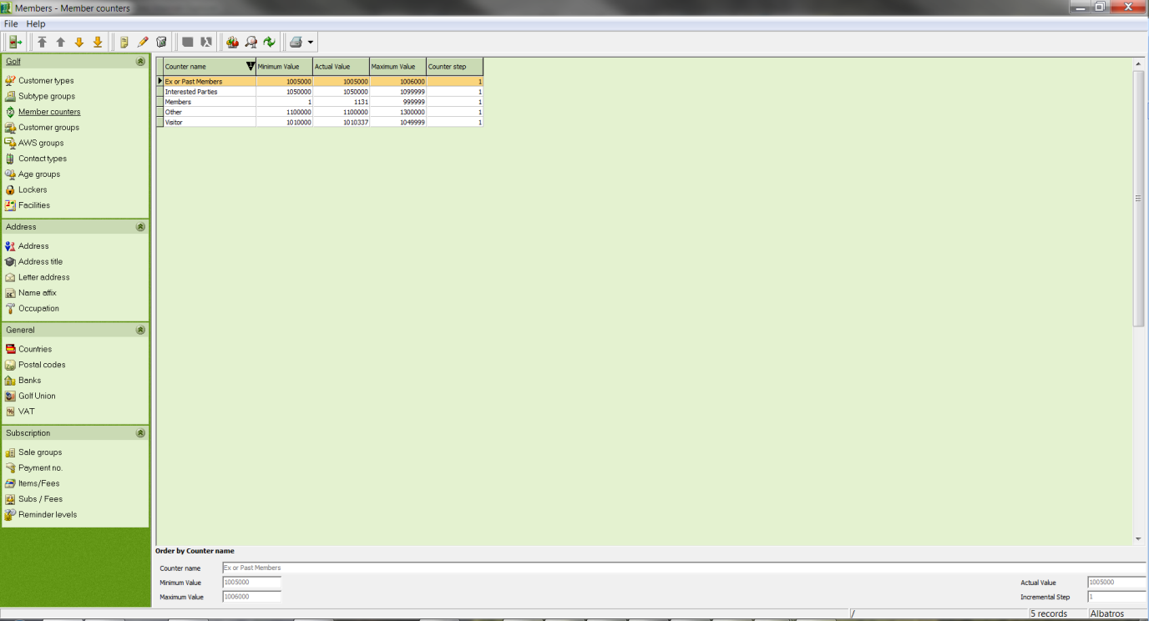

Input Fields
Counter Name Specification of the customer type for which this counter is to be used.
Minimum Value Input field for the minimum value of the range of the counter.
Maximum Value Input field for the maximum value of the range of the counter.
Actual Value The system assigns the next available number for a customer which is created with this counter value.
Counter Step Gives the interval value for customer numbers. To avoid leaving out any customer numbers in the sequence, it is recommended that you enter the value 1 here.

  - Create a counter range
- Click the New icon.
- Enter your data.
- Save the entries with the icon Save.

  - Change counter range
- Select the country whose data is to be changed.
- Click the Edit icon.
- Make the changes.
- Save the changes with the icon Save.

  - Deleting a counter range
- Select the country in the table that you wish to delete.
- Click the Delete icon.
- Answer the confirmation question.

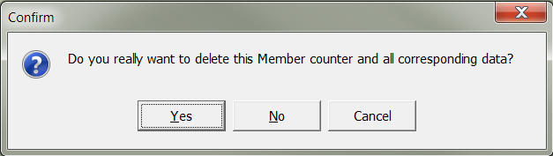

ATTENTION! Errors can occur when customers in your database already have a customer number assigned and you later change the numbering range, especially if customers suddenly belong to another customer type based on their old customer number.

- Age groups
In the AGE GROUPS window all of the SAGA-standard age groups are displayed in table format.

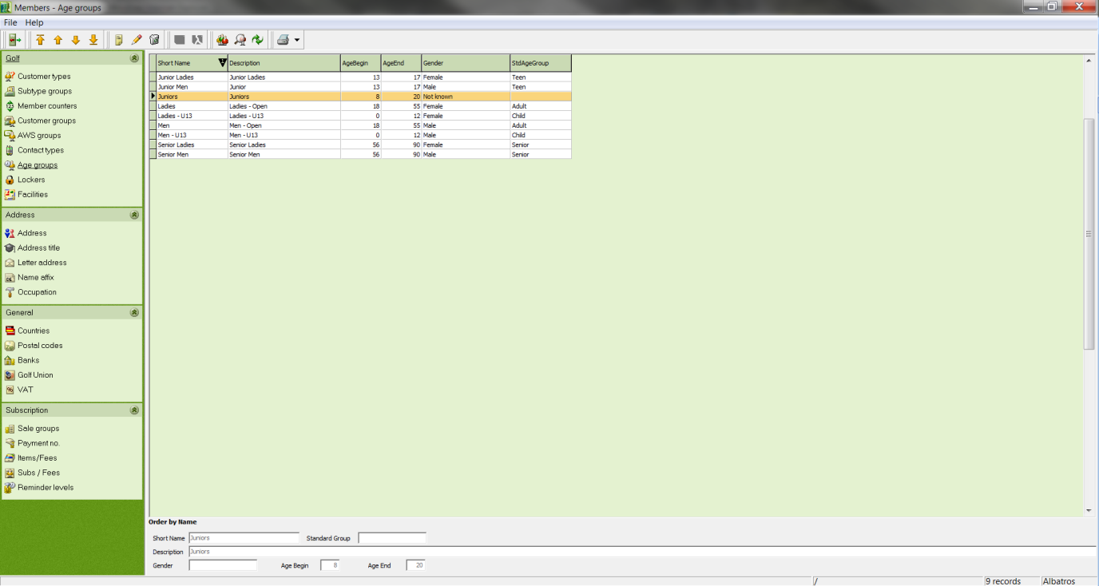

Input Fields
Short name Short name of the age group
Description Detailed description of the age group
Gender Selection list for gender
Age Begin Input the minimum age for the range of the age group.
Age End Input the minimum age for the range of the age group.

  - Create an age group
- Click the New icon.
- Define the age group.
- Save the entries with the icon Save.

  - Change an age group
- Select the age group that should be changed.
- Click the Edit icon.
- Make the changes.
- Save the changes with the icon Save.

  - Delete an age group
- Select the age group that should be deleted.
- Click the Delete icon.
- Answer the confirmation question.

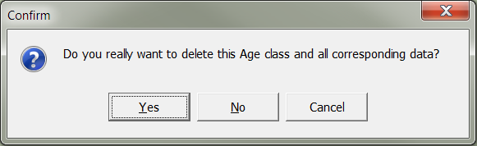

NOTE! An age group can only be deleted if it has not been assigned to any individuals.

- Customer groups
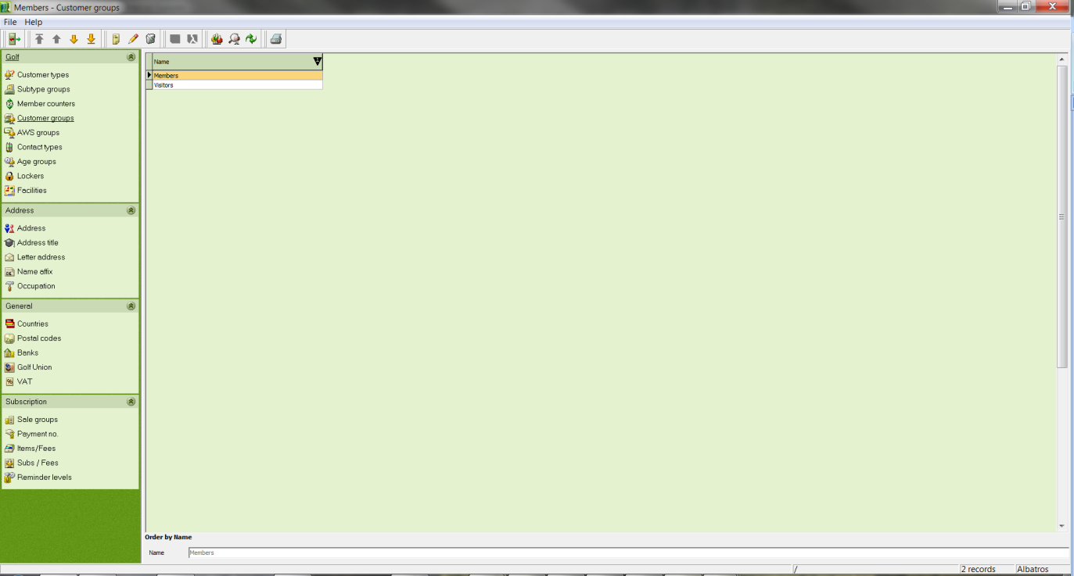

Creating customer groups gives you an additional selection criterion in Members and in addition to creating a selection in the normal way allows for the rapid and easy preparation of special customer lists.

- Create a new customer group by clicking the "New" button, defining the name of the group, and clicking on the green diskette icon to save your entries.
- Make changes to an existing customer group with the "Edit" button. First click the entry to be changed, click the edit pencil icon and save your entries with the green diskette icon.
- To delete an existing customer group, just click the "Wastebasket" icon. If you wish to delete the customer group, answer the security question with "Yes". If an entry is present which has already been assigned to one or more customers, this can only be deleted after the assignments have been removed.

In principle, several entries for any given member are possible, since a customer can belong to more than one customer group or interest group.

You can see the effects of the corresponding entries in Members with the "Details" tab in the "Customers/Members" menu.

Sample entries:
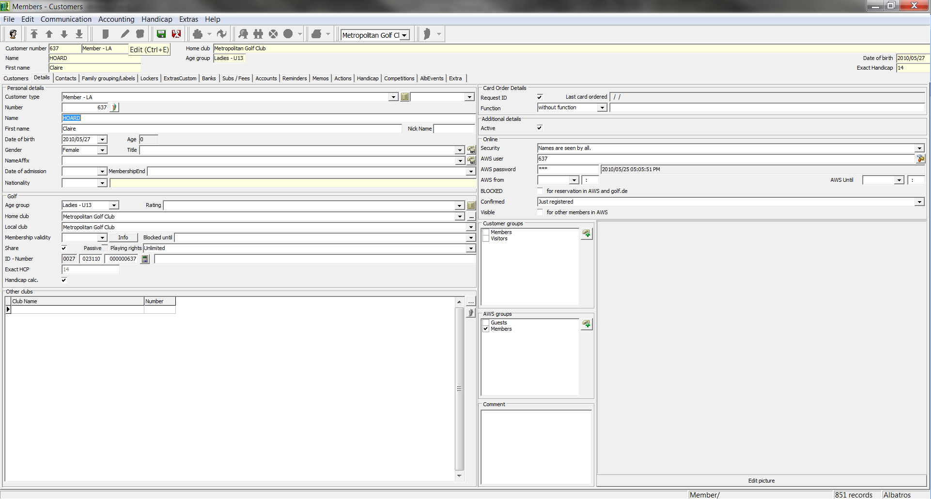

By clicking the "Edit pencil" you can open the edit mode in the "Details" tab, check the desired customer group and save your entries with the green diskette.

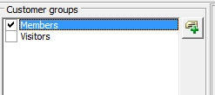

- Contact types
Additional address contact types are entered in "Contact Types".

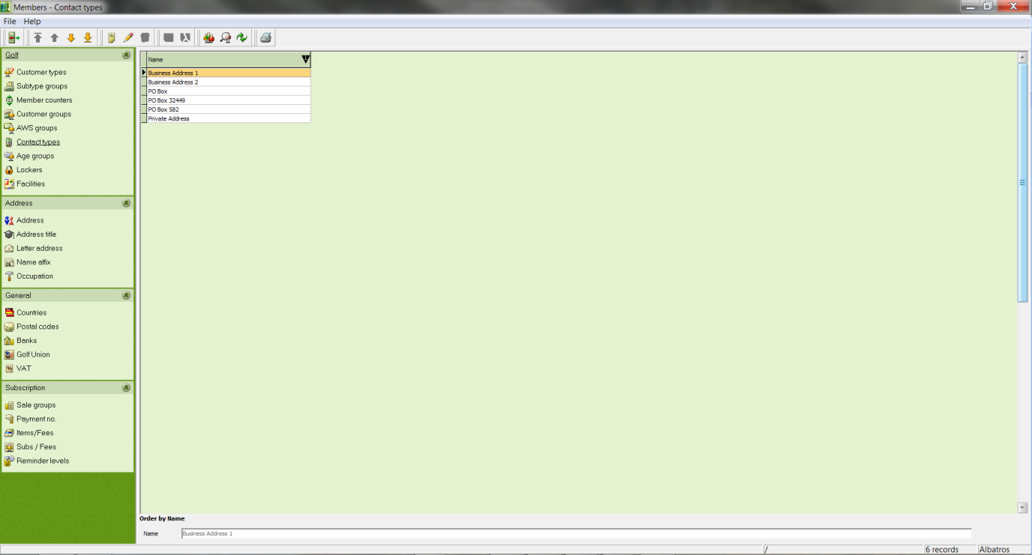

New contact types are created and maintained on this screen.

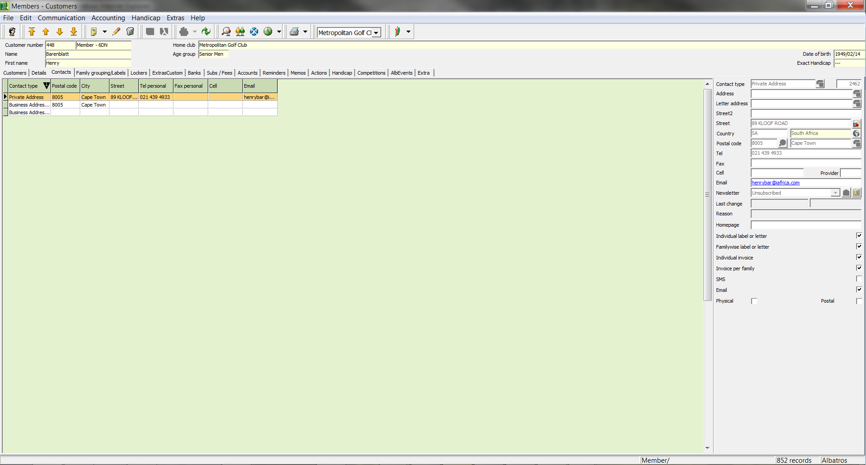

Note: Too many contact types are not necessarily useful and increase the size of the database. It is recommended that you only create meaningful address fields so that the overview remains useful.

- Lockers/Boxes
  - Locker and Box Management
Lockers and boxes are managed from the "Service/Auxiliary Tables" menu pick. The data from the fields "Locker No. 1, Locker No. 2, Box No. 1, Box No. 2" will be taken from the previous version of Albatros.

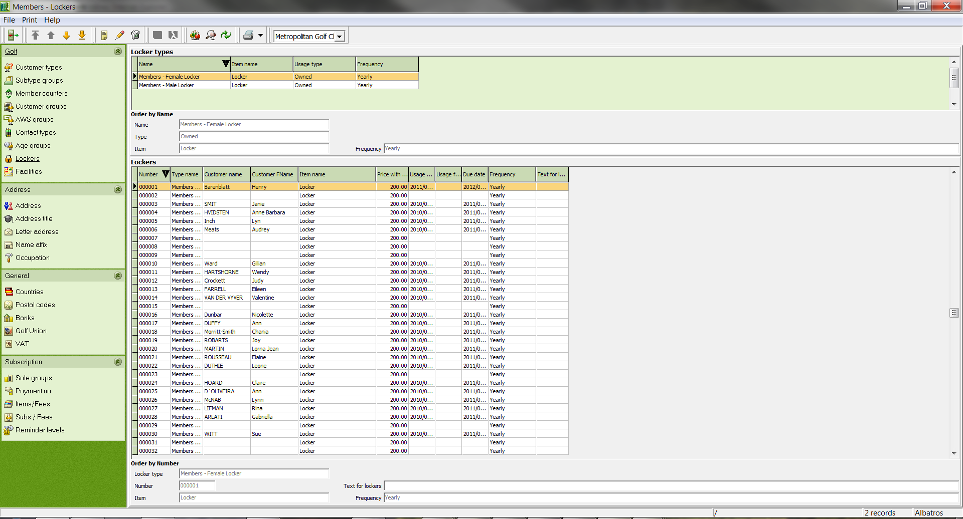

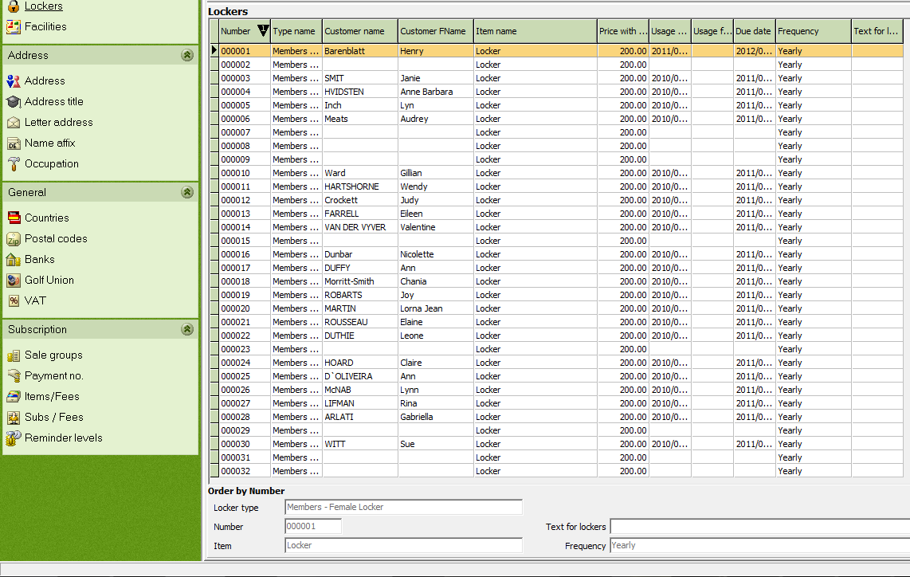

The data will be transferred as text fields which means that the data must be entered accordingly (for example 001, 010, 101 etc.) in order to obtain an accurate sort. The

Types and the lockers and/or boxes belonging to the respective types are managed in the auxiliary table. Every type (or locker/box) can be linked with a charge (article) so that the appropriate charge can be automatically assigned.

The locker and/or box type is managed in the upper window. It is also possible to automatically assign the corresponding fee to all customers who have a locker/box of a particular type.
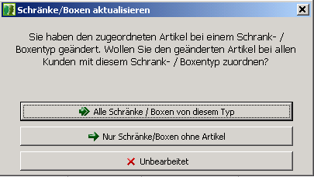
Either all customers who have an assigned locker/box of the selected type will be assigned the corresponding article (all lockers/boxes), or only those who still have no corresponding fee allocation.

The menu item "unedited" makes no article allocations.

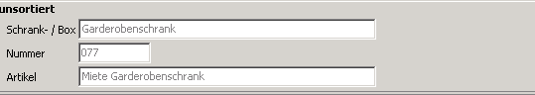
After clicking the "New" or "Edit" icons, the Locker and/or Box management dialog opens in the lower window. You can edit lockers/boxes, numbers and article allocation.

  - Additional field "Use Type"
An additional text field has been added to In locker/box administration which can be used for supplementary information (for example, key number) This field is not displayed in the Albatros standard installation. In order to use this field, bring up the "Change table definition" context menu with the right mouse button and change the view.

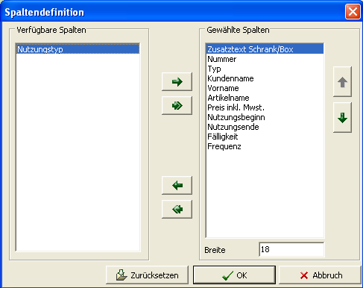

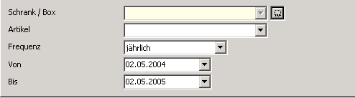
The assignment of lockers/boxes takes place in Members on the "Lockers/Boxes" tab. The "New" and/or "Edit" icons show the frame data for lockers/boxes.

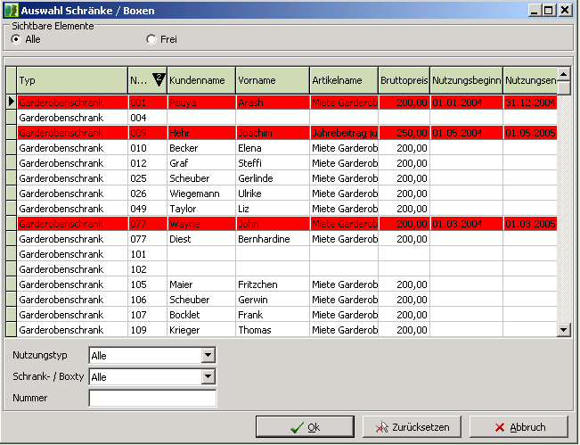
By using the selection icon you can display the list of lockers/boxes. You can display either all lockers/boxes or only the unassigned ones.

Lockers/boxes that have already been assigned are displayed in color.

The Use type, Locker/box type and Number create a selection within the displayed data.

The highlighted Locker/Box is assigned to the customer by
using the "OK" button.

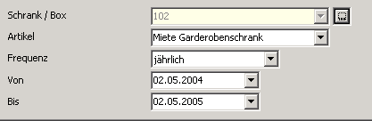
Next you can also define the item assignment and term of use. When you save the new allocation you will be
asked if you would like to update an existing item or whether you would like to create a new item in the payments/payments allocation.

- Address data (Address)
Addresses are managed in the ADDRESS window.

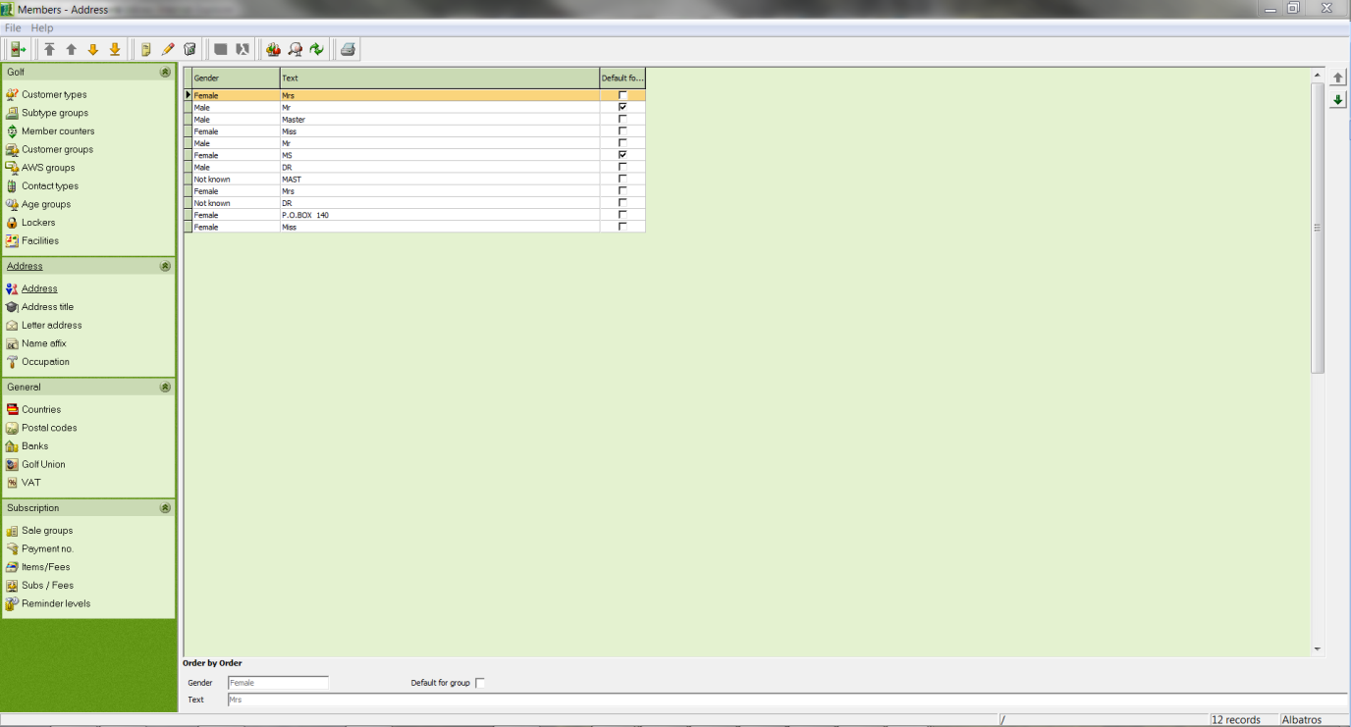

Input Fields
Gender Selection list for gender
Text Greeting text

  - Create a greeting
- Click on the New icon
- Enter your data
- Save the entries with the Save icon

  - Changing a greeting
- Select the country whose data is to be changed
- Click on the Edit icon
- Make the changes
- Save the changes with the Save icon

  - Deleting a greeting
- Select the country in the table that you wish to delete
- Click the Delete icon
- Answer the confirmation question

- Title
In the TITLE window all titles are managed.

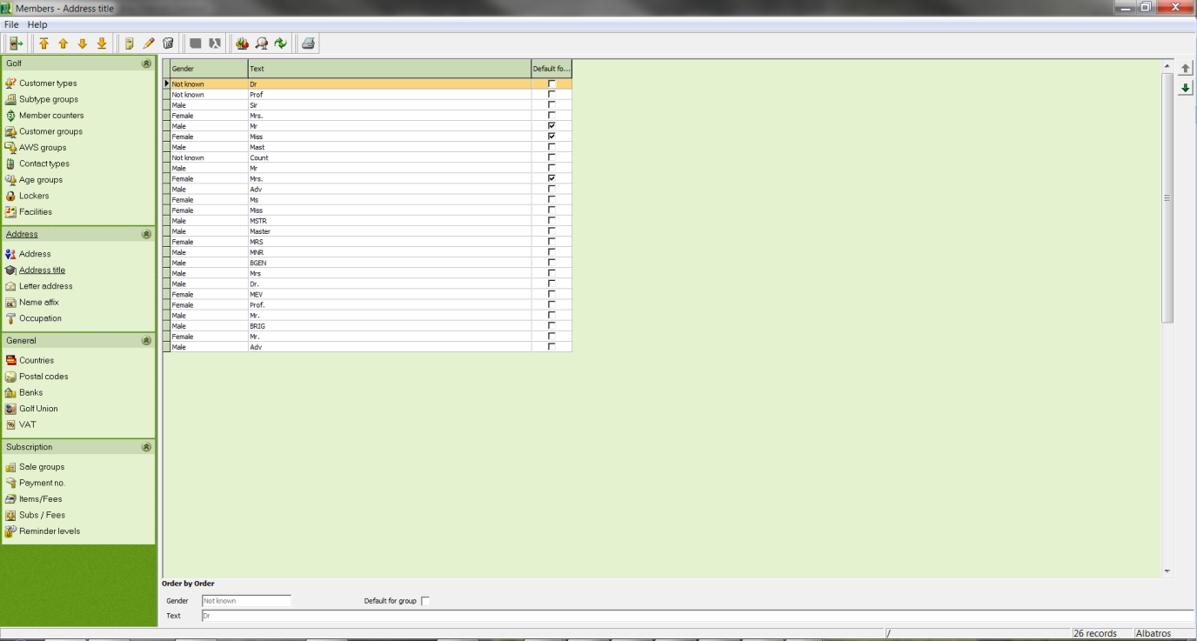

Input Fields

Gender Selection list for the customer's gender
Text Title

  - Create a title
- Click the New icon.
- Enter your data.
- Save the entries with the icon Save.

  - Change a title
- In the table, select the title to be changed
- Click the Edit icon
- Make the changes
- Save the changes with the Save icon

  - Delete a title
- In the table, select the title to be changed
- Click the Delete icon
- Answer the confirmation question

- Letter Address
Letter addresses are managed the ADDRESS LETTER window.

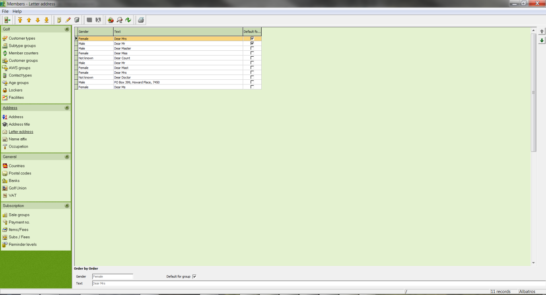

Input Fields
Gender Selection list for the customer's gender
Text Text of the letter address

  - Create a letter address
- Click the New icon
- Enter your data
- Save the entries with the Save icon

  - Change a letter address
- In the table, select the letter address to be changed.
- Click the Edit icon.
- Make the changes.
- Save the changes with the Save icon.

  - Delete a letter address
- In the table, select the letter address to be changed.
- Click the Delete icon.
- Answer the confirmation question.

- Name Suffixes
Name suffixes are managed in the NAME SUFFIXES window.

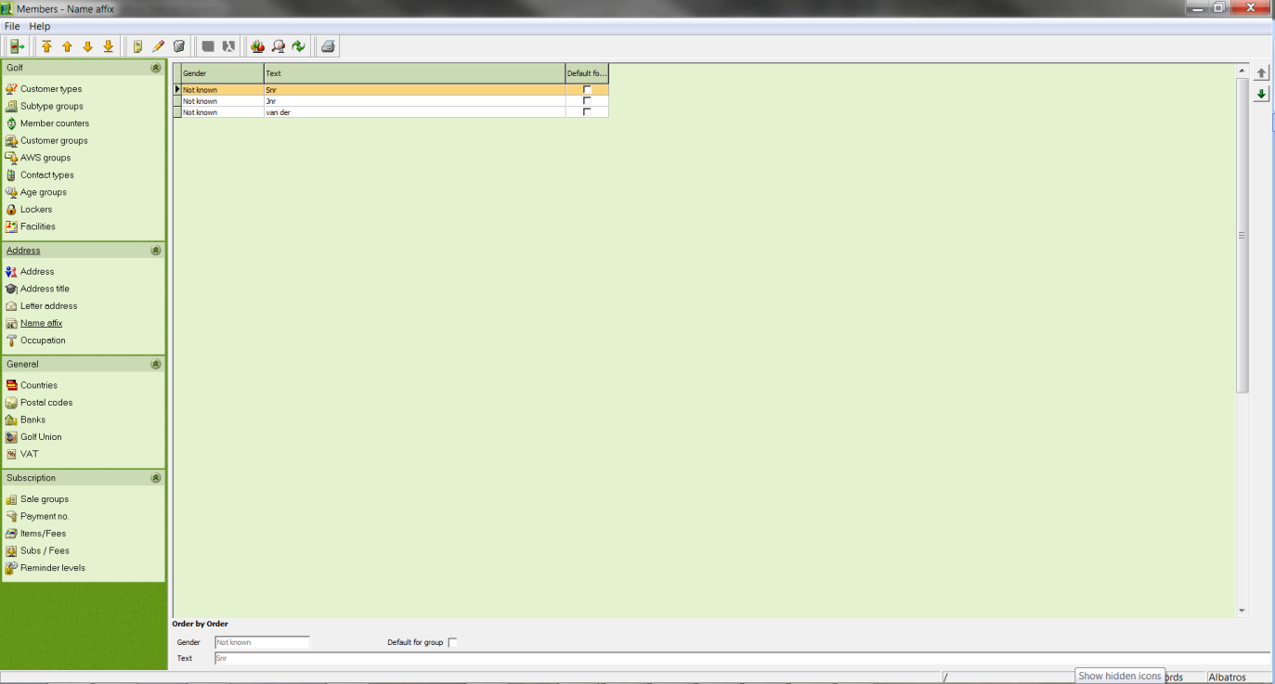

Input Fields
Gender Selection list for the customer's gender
Text Text of the name suffix

  - Create a name suffix
- Click the New icon.
- Enter your data.
- Save the entries with the icon Save.

  - Change a name suffix
- In the table, select the name suffix to change.
- Click the Edit icon.
- Make the changes.
- Save the changes with the Save icon.

  - Delete a name suffix
- In the table, select the name suffix to delete.
- Click the Delete icon.
- Answer the confirmation question.

- Occupation
Occupation descriptions are managed in the OCCUPATION window.

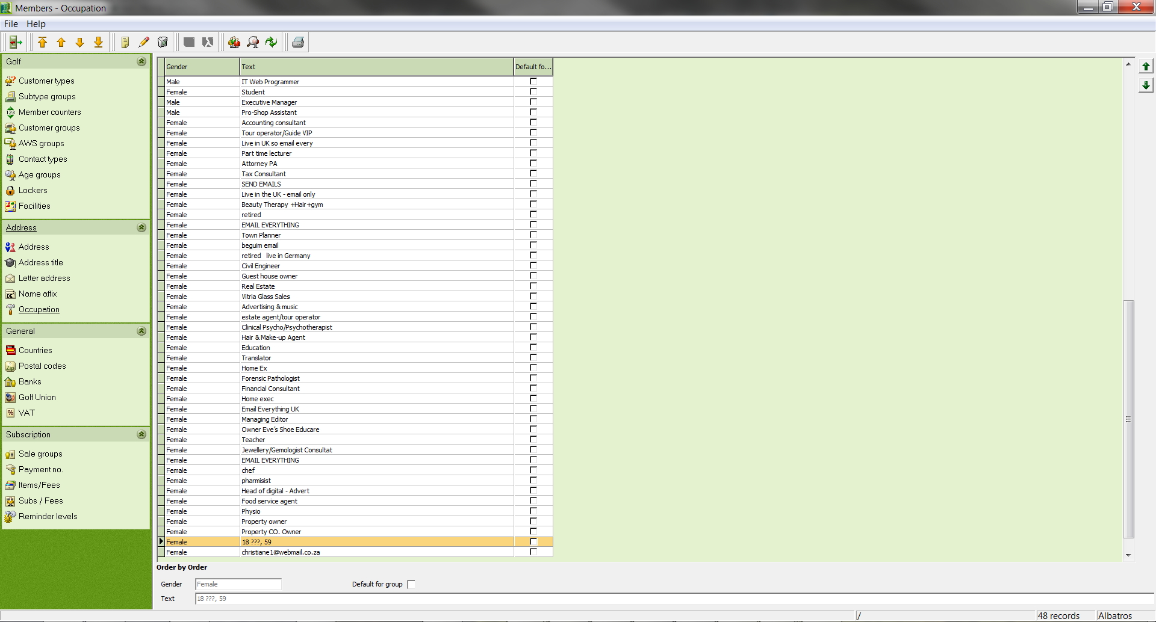

Input Fields
Gender Selection list for the customer's gender
Text Occupation description

  - Create an occupation description
- Click the New icon.
- Enter your data.
- Save the entries with the icon Save.

  - Change an occupation description
- In the table, select the occupation description to be changed.
- Click the Edit icon.
- Make the changes.
- Save the changes with the icon Save.

  - Delete an occupation description
- In the table, select the occupation description to be deleted.
- Click the Delete icon.
- Answer the confirmation question.

- Countries
Country designations are managed in the COUNTRY window with their associated country abbreviations.

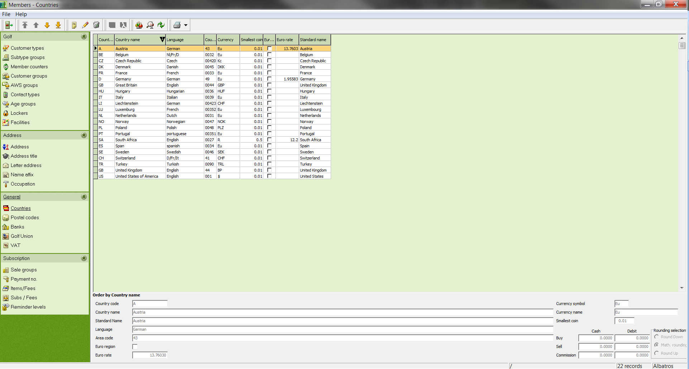

Input Fields
Country Abbreviation Country Abbreviation
Country Country name
Abbrev. Currency Currency abbreviation
Currency Name of the country's currency
Smallest unit Smallest unit of the currency
Language Language of the country
Euro Region If this box is ticked, the entered country belongs to the Euro region.
Country Code Country Code
Euro exchange Current Euro exchange rate

  - Create a country
- Click the New icon.
- Enter your data.
- Save the entries with the icon Save.

  - Change country data
- Select the country whose data is to be changed.
- Click the Edit icon.
- Make the changes.
- Save the changes with the icon Save.

  - Delete a country
- Select the country in the table that you wish to delete.
- Click the Delete icon.
- Answer the confirmation question.

- Postal codes
In the POSTAL CODES window you find the default Postal code directory for South Africa, but you also have the option of entering foreign ZIP codes.

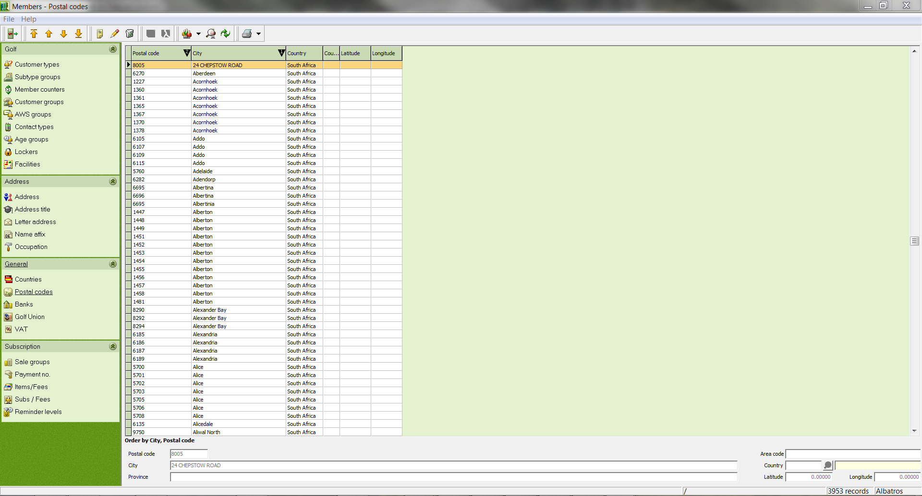

Input Fields
Postal Code Postal code
City Name of the city
City Code City code for the corresponding city
Country Selection list for the country. For this field, the country abbreviations must first be created in the corresponding auxiliary table. When manually entering the country abbreviation, the corresponding country will automatically be entered into the field highlighted in yellow.

  - Create a Postal code
- Click the New icon.
- Enter your data.
- Save the entries with the icon Save.

  - Change a Postal code
- In the table, select the Postal code to be changed.
- Click the Edit icon.
- Make the changes.
- Save the changes with the icon Save.

  - 32.3 Delete a Postal code
- In the table, select the Postal code to be deleted.
- Click the Delete icon.
- Answer the confirmation question.

- Banks
In the BANKS window you find the default list of South African financial institutions with their corresponding bank codes.

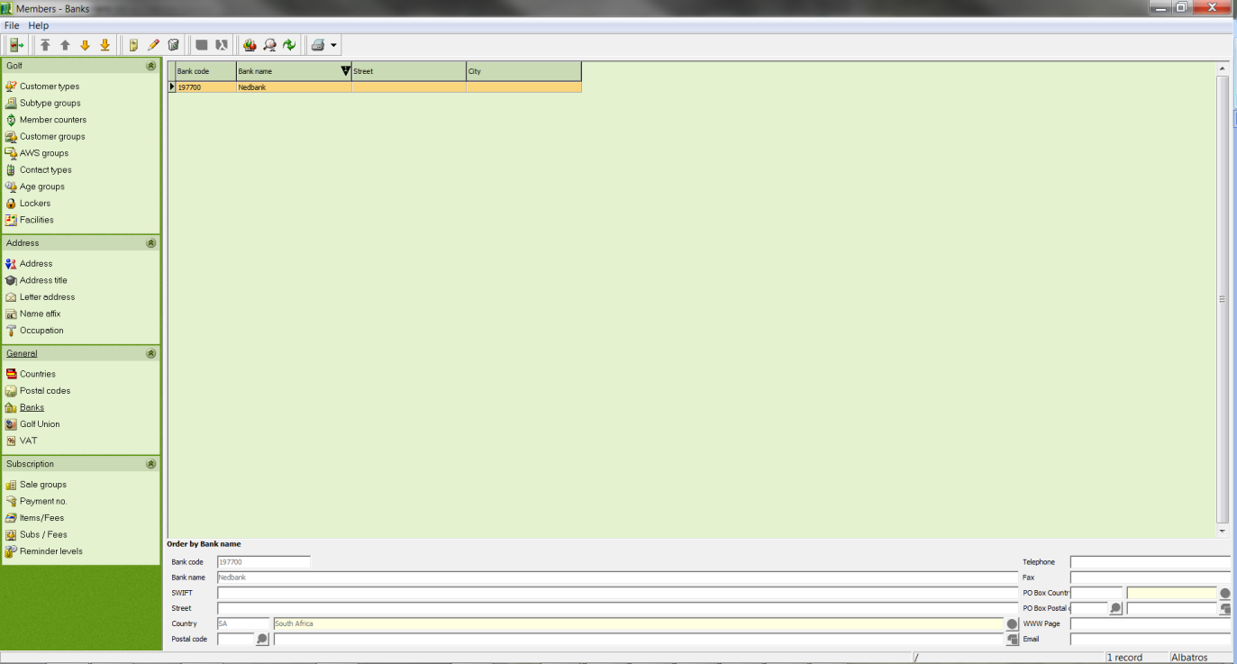

Input Fields
Bank Code Code of the corresponding bank
Bank Name Name of the bank
Street Street address of the bank
Country Selection list for the country. For this field, the country abbreviations must first be created in the corresponding auxiliary table. When manually entering the country abbreviation, the corresponding country will automatically be entered into the field highlighted in yellow.
Postal code Entry field for the postal code. For this field, the corresponding auxiliary table has already been filled with the postal code directory for South Africa. After the corresponding postal code has been entered, the city name will be automatically retrieved by the system. By using the button, the related auxiliary table can be opened and the desired entry selected. Postal codes for international locations can be added in the auxiliary table. Enter the Postal code and city name manually and then click the Learn City button. If the correct country abbreviation was entered, a new entry will be created.
Telephone Telephone number of the bank
Fax Telefax number of the bank
Country PO Box Selection list for the country based on the P.O. Box For this field, the country abbreviations must first be created in the corresponding auxiliary table. When manually entering the country abbreviation, the corresponding country will automatically be entered into the field highlighted in yellow.
Postal code Input field for the postal code based on the P.O. Box. For this field, the corresponding auxiliary table has already been filled with the postal code directory for South Africa. After the corresponding postal code has been entered, the city name will be automatically retrieved by the system. By using the button , the related auxiliary table can be opened and the desired entry selected. Postal codes for international locations can be added in the auxiliary table. Enter the postal code and city name manually and then click the Learn City button. If the correct country abbreviation was entered, a new entry will be created.
Home Page The bank's internet address
E-mail The bank's E-mail address

  - Create a bank
- Click the New icon.
- Enter your data.
- Save the entries with the icon Save.

  - Change a bank's data
- Select the bank whose data is to be changed.
- Click the Edit icon.
- Make the changes.
- Save the changes with the icon Save.

  - Delete a bank
- In the table, select the bank to be deleted.
- Click the Delete icon.
- Answer the confirmation question.

- Golf Union
In the GOLF UNION window you find the official golf associations in South Africa and Austria. These are supplied by default.

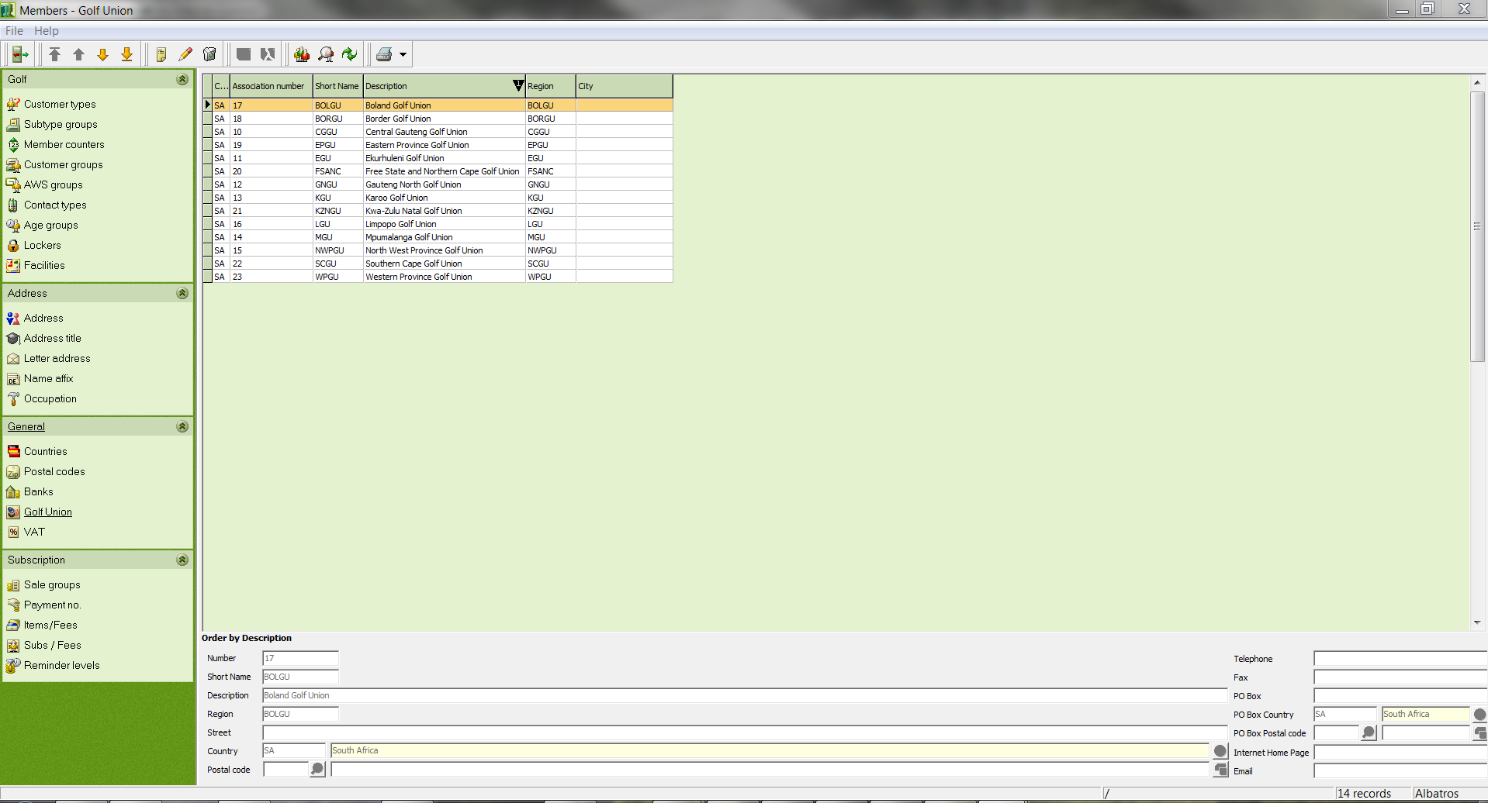

Input Fields
Number Abbreviation of the region name
Description Official name of the golf association
Abbreviation Short name of the golf association
Region Abbreviation of the region name
Street Street
Country Selection list for the country. For this field, the country abbreviations must first be created in the corresponding auxiliary table. When manually entering the country abbreviation, the corresponding country will automatically be entered into the field highlighted in yellow.

Postal code Entry field for the Postal code or Postal code. For this field, the corresponding auxiliary table has already been filled with the Postal code directory for South Africa. After the corresponding Postal code has been entered, the city name will be automatically retrieved by the system. By using the button, the related auxiliary table can be opened and the desired entry selected. Postal codes for other countries can be added to the auxiliary table by manually adding the Postal code and city name and then clicking the Learn City button. If the correct country abbreviation was entered, a new entry will be created.
Telephone Telephone number of the golf association
Fax Telefax number of the golf association
Post Office Box Post office box number of the golf association
PO Box Country Country Selection list for the country based on the P.O. Box For this field, the country abbreviations must first be created in the corresponding auxiliary table. When manually entering the country abbreviation, the corresponding country will automatically be entered into the field highlighted in yellow.
PO Box Postal Code Input field for the Postal code based on the P.O. Box. For this field, the corresponding auxiliary table has already been filled with the Postal code directory for South Africa. After the corresponding Postal code has been entered, the city name will be automatically retrieved by the system. By using the button, the related auxiliary table can be opened and the desired entry selected. Postal codes for other countries can be added to the auxiliary table by manually adding the Postal code and city name and then clicking the Learn City button. If the correct country abbreviation was entered, a new entry will be created.
Internet site Address of the golf association's internet site
E-mail address E-mail address of the golf association

  - Create a golf association
- Click the New icon.
- Enter your data.
- Save the entries with the icon Save.

  - Change golf association data
- Select the golf association to change in the table.
- Click the Edit icon.
- Make the changes.
- Save the changes with the icon Save.

  - Delete a golf association
- Select the golf association to be deleted.
- Click the Delete icon.
- Answer the confirmation question.

- VAT
In the VAT window you input the percentages required to calculate the VAT.

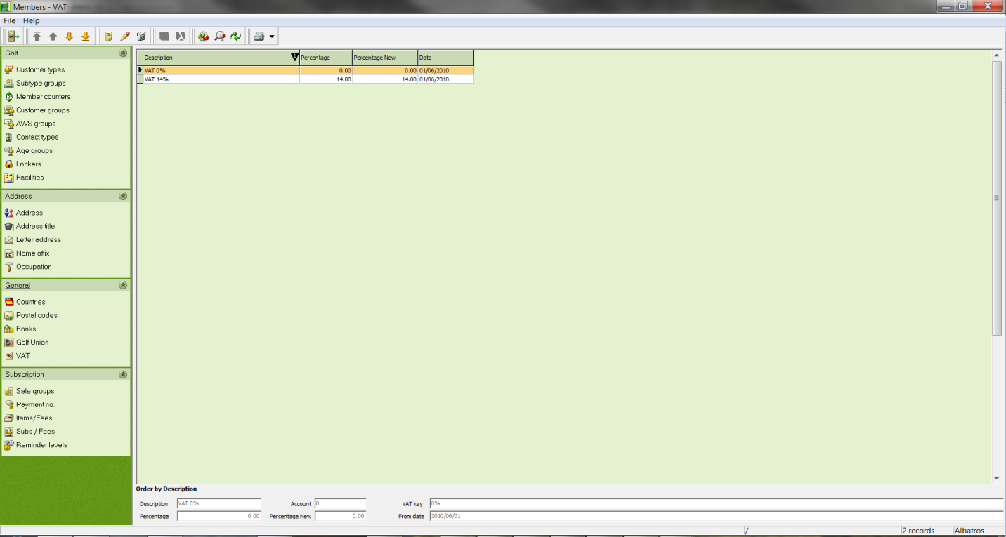

Input Fields
Description Description of the VAT rate
Percentage Input field for the percentage rate. This is necessary to calculate the VAT.
Percentage New Enter a new percentage rate
Date Date after which the current percentage is valid. The date can be entered manually or by using the calendar sheet.

  - Create a new VAT rate.
- Click the New icon.
- Enter your data.
- Save the entries with the icon Save.

  - Change a VAT rate
- Select the VAT rate to be changed.
- Click the Edit icon.
- Make the changes.
- Save the changes with the icon Save.

  - Delete a VAT rate
- Select the VAT rate to be deleted.
- Click the Delete icon.
- Answer the confirmation question.

- Clients
Note: Clients are now managed in Back Office. See the section "Item Data" in Shops/Warehouse.

- Sale Groups
The various income types to which the individual items will be assigned are specified in the SALE GROUPS window.

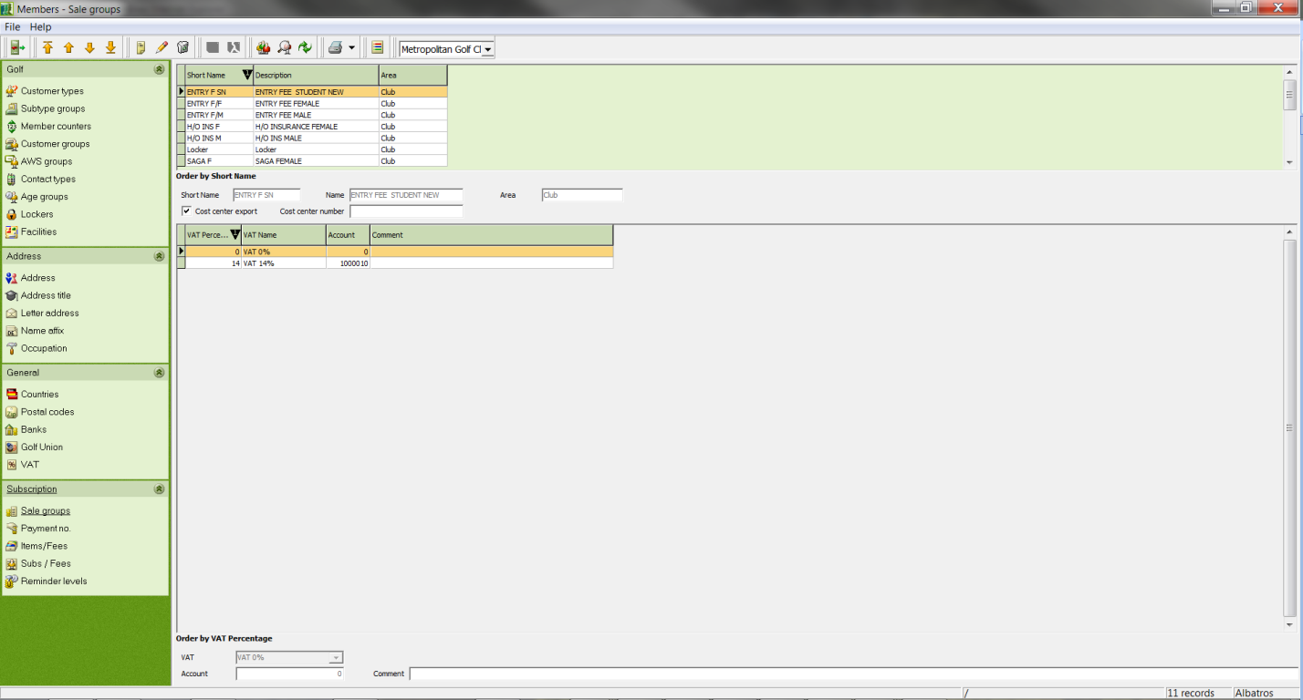

Input Fields
Short Name Short name of the sale group
Description Description of the sale group
VAT Percentage Input the VAT rate
Account Enter the booking account for the tax advisor
Comment Enter a comment

  - Create a sale group
- Click the New icon.
- Enter the short name and the name
- Specify the VAT rate with the drop down field.
- Enter the booking account for the tax advisor.
- Save the entries with the icon Save.

  - Change a sale group
- Select the sale group that should be changed.
- Click the Edit icon.
- Make the changes in the respective fields.
- Save the changes with the icon Save.

  - Delete a sale group
- Select the sale group that should be deleted.
- Click the Delete icon.
- Answer the confirmation question.

  - Forecast / Budget planning
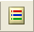
It is now possible to create a budget plan in Members. Using the "Budget values" icon in the menu item Service/Auxiliary Tables/Dues-Fees/Sale Groups you can enter statistics for the year's revenue and a budget for the selected sale group of the respective client.

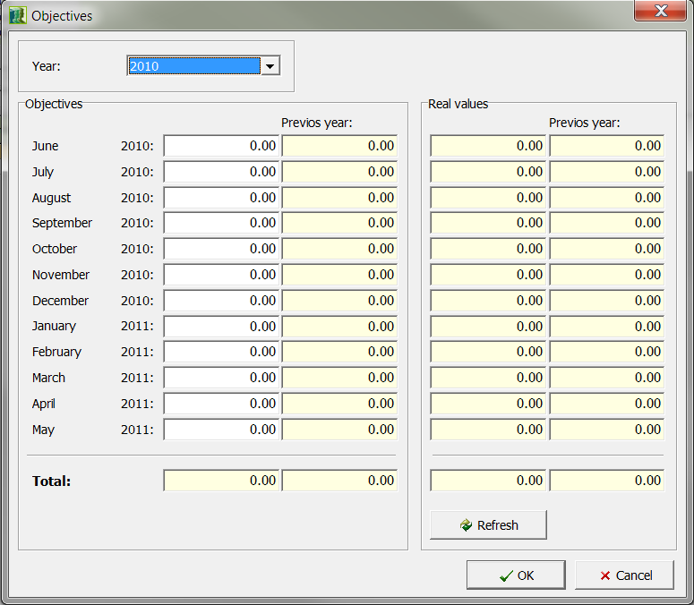

- Articles/Charges
In the ARTICLES window the income types are subdivided into individual items and in each case provided with an item number, a price and the accompanying turnover tax.

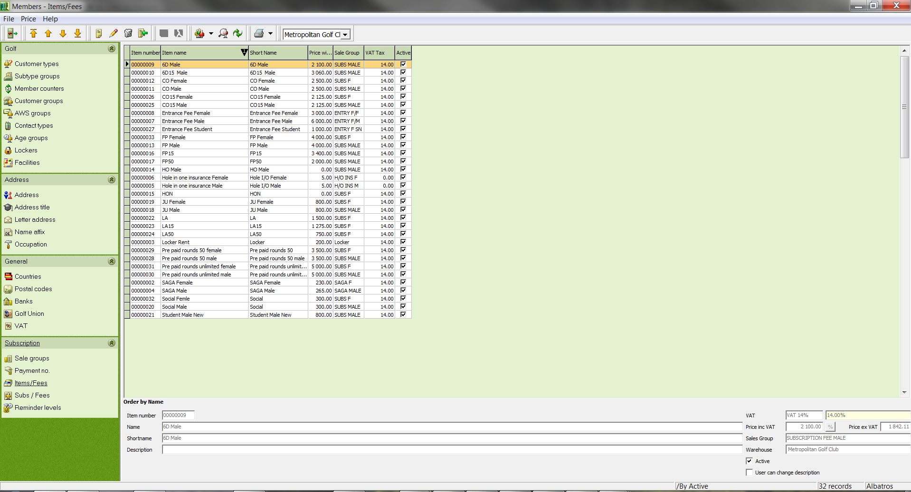

Input Fields
Article Number Article Number
Article Name Article name
Short Name Short name of the item
Description Description of the item
VAT Tax Selection list for the VAT All VAT definitions created in the VAT auxiliary table are available for selection.
Price with VAT Gross price of the item
Price without VAT Net price of the item. This is automatically calculated by the system after the gross price VAT rate has been entered.
Revenues Selection list for the revenue description. All revenues described in the REVENUES auxiliary table are available.
Client Selection list for clients. All clients created in the CLIENTS auxiliary table are available for selection.

  - Create a new article
- Click the New icon.
- Enter your data.
- Save the entries with the icon Save.

  - Change an article
- Select the article to be changed.
- Click the Edit icon.
- Make the changes.
- Save the changes with the icon Save.

  - Delete an article
- Select the article to be deleted.
- Click the Delete icon.
- Answer the confirmation question.

  - Credit articles
Credit articles are created in the auxiliary tables under the menu option "Payment/Charge and Article/Charges".

The credit article must be entered as a negative number. Tax and sale groups must be defined.

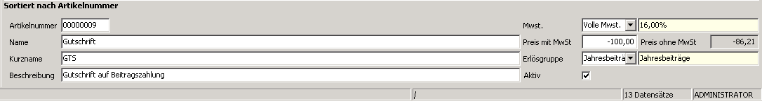
  - Assign credit
The credits can be assigned on the "Payments/Charges" tab in the same way as normal articles.
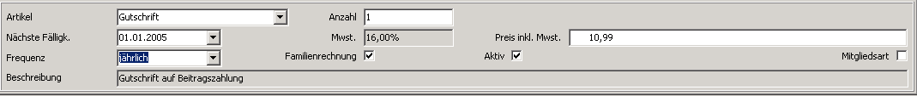

- Membership Contributions (Subs / Fees)
In the Subs / Fees window, various customer types, and particularly the various member types, are assigned certain articles as standard payments.

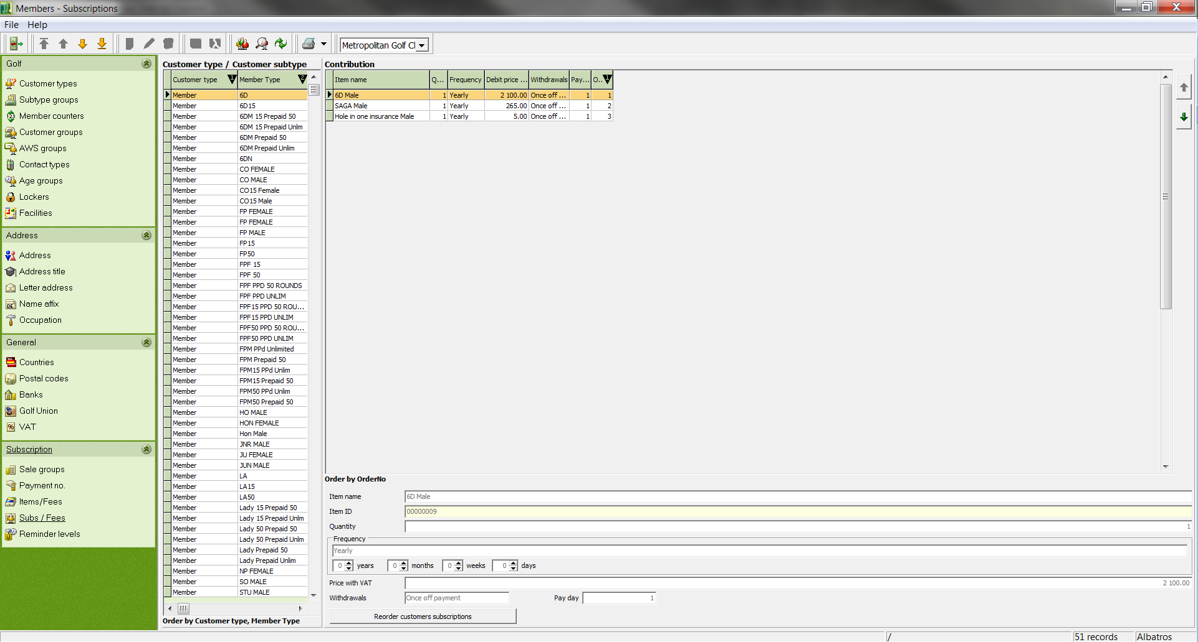

Input Fields
Article Name Selection list for the article name. All articles created in the ARTICLES auxiliary table are available for selection.
Article ID The article number of the entered article is automatically supplied by the system.
Quantity Number of articles that will be added to the customer invoice
Frequency Frequency - Selection list for the payment schedule.
Price with VAT Gross price of the article. The gross price of the entered article is automatically supplied by the system.

  - Create a membership contribution
- In the customer (sub)type list, select the customer type for which a membership contribution should be created.
- Click in the free field of the standard payment list to enable the entry of a payment.
- Click the New icon.
- Make the entries.
- Save the entries with the icon Save.

  - Change a membership contribution
- In the customer (sub)type list, select the customer type for which a membership contribution should be changed.
- In the payment list, select the membership contribution to be changed.
- Click the Edit icon.
- Make the changes.
- Save the changes with the icon Save.

  - Delete a membership contribution
- In the customer (sub)type list, select the customer type for which a membership contribution should be changed.
- In the payment list, select the membership contribution to be changed.
- Click the Delete icon.
- Answer the confirmation question.

- Reminder levels
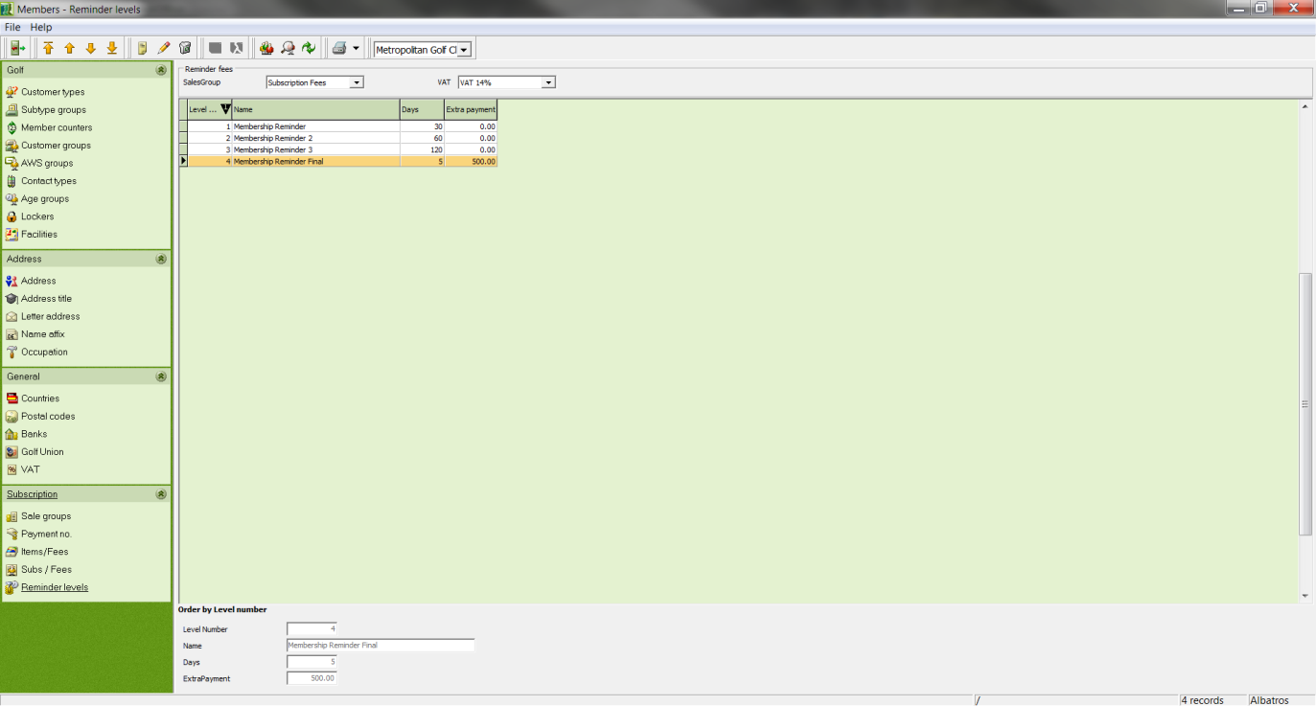

Here you have the opportunity to freely define reminder levels, to assign these levels to a sale group and to assign a VAT rate. If the sale group is not yet available, please create it first and then modify it as needed.

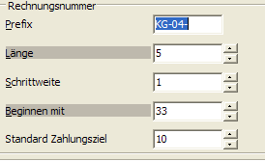
The Albatros software includes a reminder process. The required settings include the due date for the invoice created, as well as the corresponding reminder levels.

The due date is set with the Club Settings/Booking menu, but can also be changed when generating the invoice.

The required settings for the reminder levels are made in Members with the menu item Service/Auxiliary Tables/Subscriptions/Reminder Levels. The reminder fees must be assigned to a sale group. Reminder fees can be freely defined. You can set as many reminder levels as you desire.

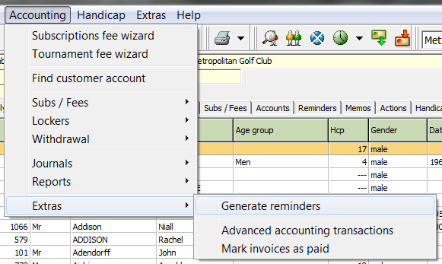

As with reminder levels, automatic reminders can be generated later in Members from the menu item "Accounting/Extras/Generate reminders".

The wizard generates the reminders automatically based on the preset parameters. Reminders and journals can be printed with the respective buttons. In the event of finance charges an accounting record will be created in the "Accounting" tab.

Individual reminders for the respective customer will be listed in the Reminders tab. If the "Create Reminders" box is unticked, no reminders will be created for this customer. The "Create Reminders" button creates reminders for the selected customers.

- Documents
A list of all invoices can be found in the DOCUMENTS window – found under Accounting/Journals/Accounting Journal

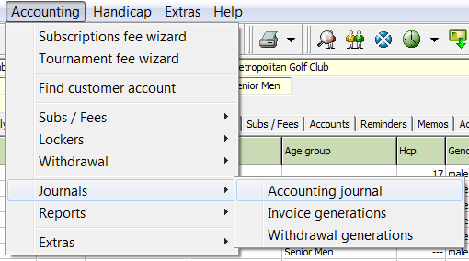

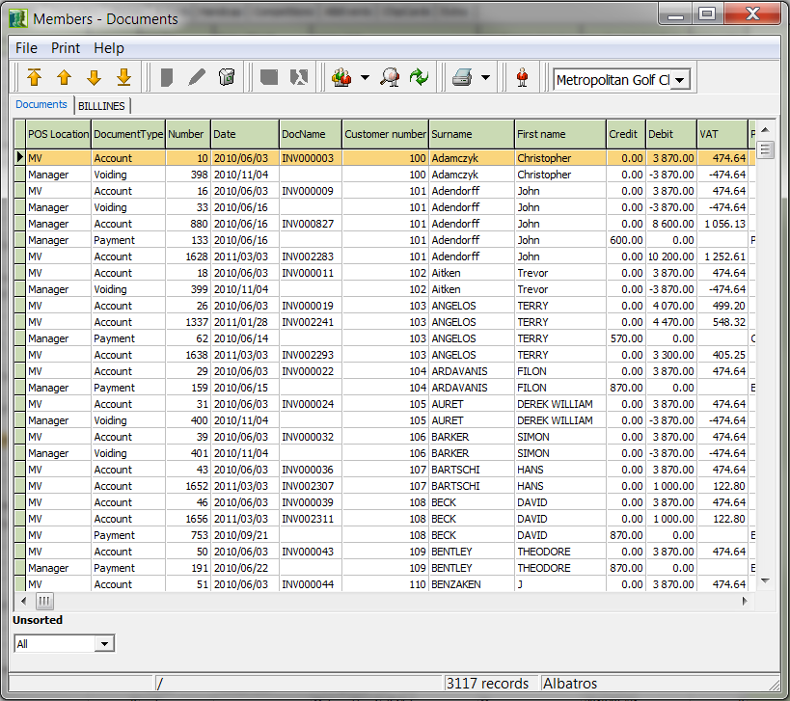

Double-clicking on an invoice takes you to a detailed invoice report. You can pay or cancel these invoices by accessing the context menu with the right mouse button. To perform additional booking operations, select the "access relevant customers" command.

  - Locate an invoice
- Use the right mouse button and the Locate function to open the LOCATE wizard.

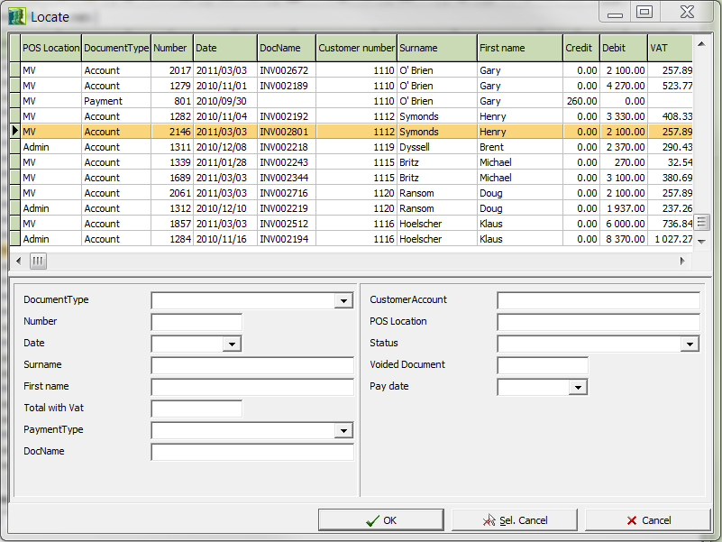

Input Fields

Document Type Selection list for the document type. The display in the document list is restricted to the invoice corresponding to the entered record number.
Number Record number. The display in the document list is restricted to the invoice corresponding to the entered record number.
Date Record date. The date can be entered manually (without separators) or by using the calendar sheet. The display in the document list is restricted to the invoices corresponding to the entered date.
Int. Inv. No. Internal invoice number

Status Selection list for the record status. The display in the document list is restricted to the invoices corresponding to the entered status
Created by Name of the person who created the record
Payment type Selection list for the payment type
Total Enter the invoice total
Total with VAT Enter the invoice total including VAT
Pay date Date at which invoice requires payment

Buttons

OK Clicking the OK button starts the search for the selected record in the record list.
Sel. Cancel By clicking the Sel. Cancel button the search criteria will be cleared and the fields are again available for input.
Cancel The Cancel button returns you to the previous window without starting a search.

- Enter the corresponding search criteria for the invoice you are looking for. These criteria are not case-sensitive.
- If the display of the record list has been limited to the invoice you are looking for, click the OK button. If several invoices are still visible in the list, you must select the desired record before clicking the OK button.
- You are automatically returned to the DOCUMENTS window. The invoice you were looking for is now highlighted in blue in the record list.

- Invoice
In the INVOICE window you will find a list of the invoice items for the invoice selected in the DOCUMENTS window.

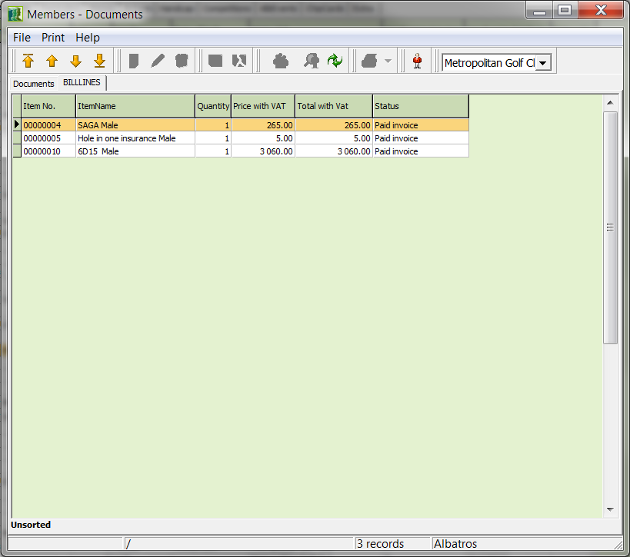
  - Pay an invoice item
- Select the invoice item that was paid by the customer.
- Use the button. 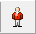
- You are taken directly to the customer in the "Booking" area.
- Click the "Pay Invoice" button.

- Ordering Cards
- Open the Order Cards wizard by clicking on Extras, then Card order, CardOrderWizard.

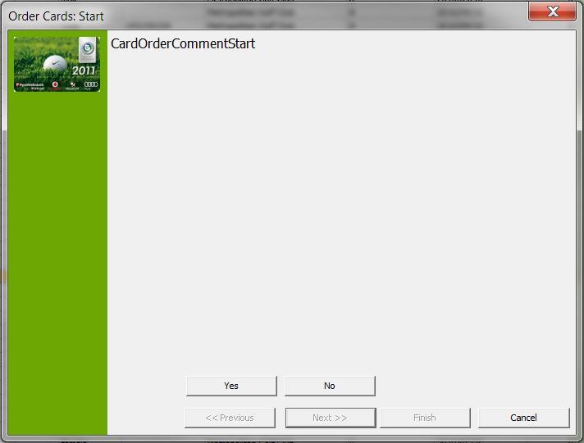

- By clicking the Yes button you agree to the conditions regarding the SAGA and move to the next window. If you click No, you do not agree and exit the Order Cards wizard.

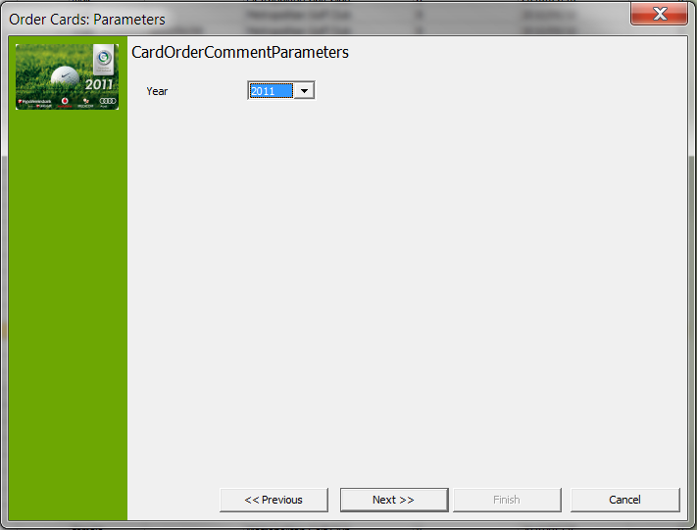

Input Fields
Year Enter the year for which the card is to be ordered. The year can be entered manually or selected by using the arrow.

- Enter the year for which the identification should be ordered and enter the handicap information for the secondary members.
- Click the button Next.

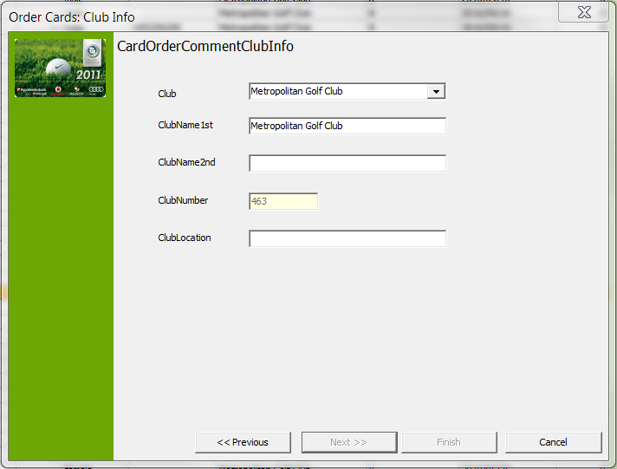

- Make any changes to the data which are required here and then click the "Next" button.

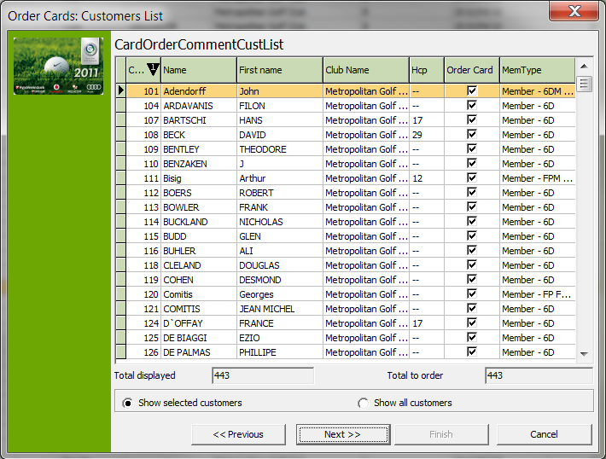

Input Fields
Show selected customers If this box is ticked, only the members in the list will be shown whose data was prepared for ordering identification (in the DETAILS window, the Request ID? box was ticked).
Show all customers If this box is ticked, all members in the list will be displayed.

NOTE! Below the list you will see the count of customers in the list as well as the number of cards to order.

If you forgot to check the Request ID box in the DETAILS window, you can do so in this wizard. Select the Show all customers field and for each appropriate person tick the box Order Card.

- Click the Next button.

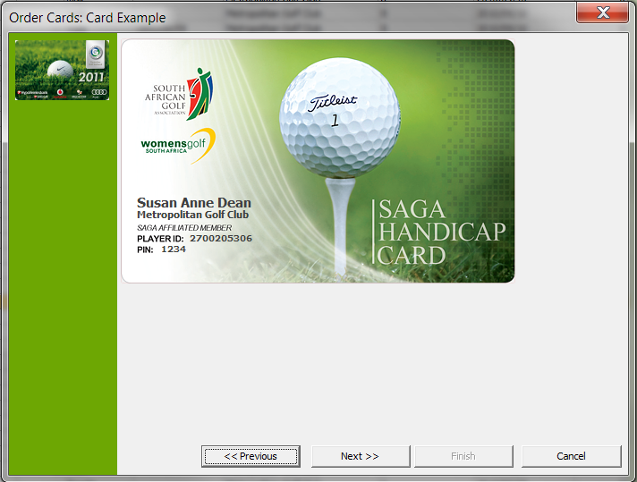

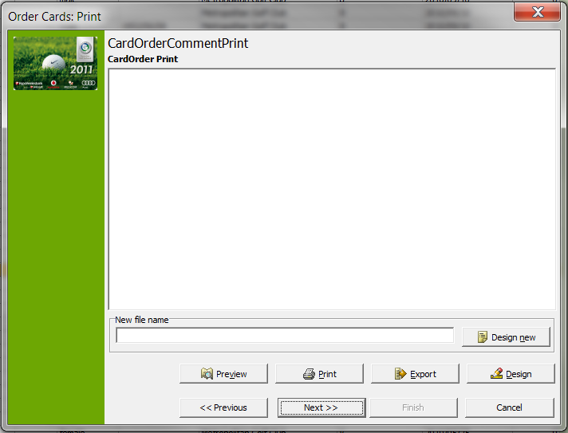

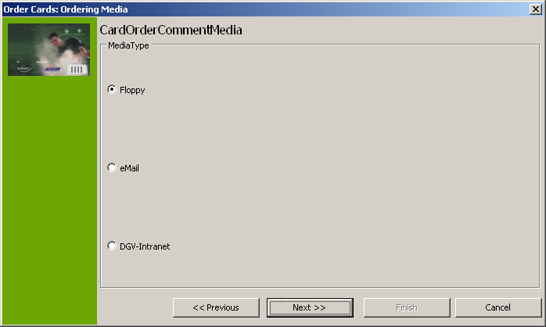

Input Fields

Floppy If the Floppy field is selected, the cards are ordered via diskette.
E-Mail If this field is selected, the cards will be ordered by E-mail.
SAGA-Intranet If the SAGA Intranet field is selected, the identifications will be ordered over the intranet.

- Select the ordering method.
- Click the Next button.

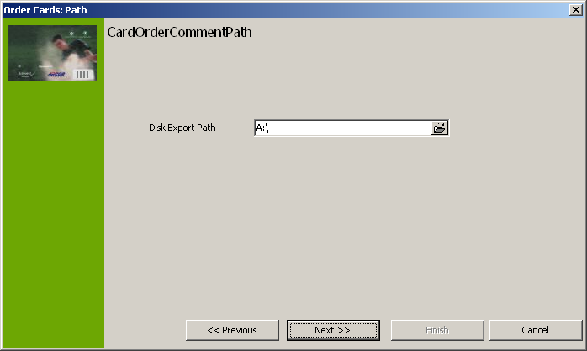
Input Fields
Disk export path If the order is to be done with a diskette or by E-mail, the corresponding data path must be entered here.

- Select the desired path.
- Click the button Next.

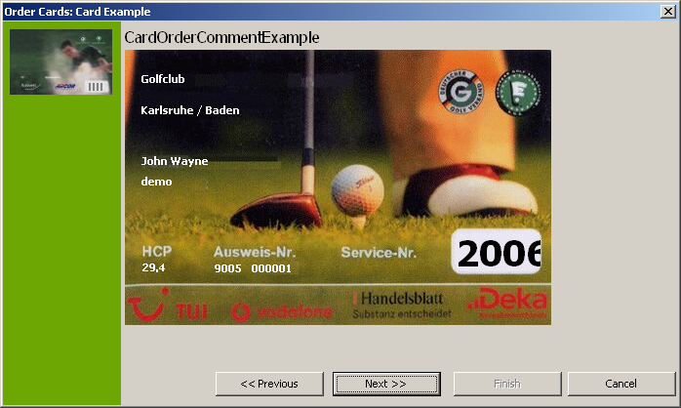

- Review the entries on the sample card.
- Click the Next button

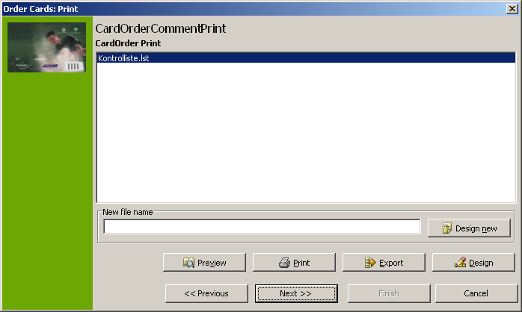

Buttons
Preview With preview the control list can be viewed once more before printing.
Design With the Designer you can make individual format changes to the control list. More information about using the designer can be found in the Designer Manual.
Print Print the control list.
Export The Export button is used to export the control list. This can be done as an HTML file for displaying on the internet or also in Rich Text Format for additional editing in Word or Excel.

- Click the Next button.

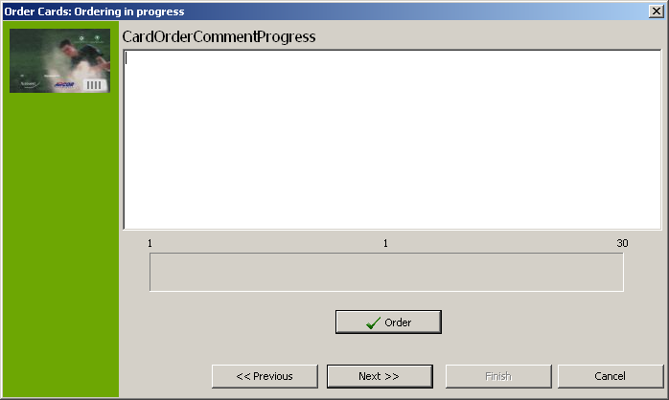

- Click the Order button to prepare the order.
- Click the Next button.

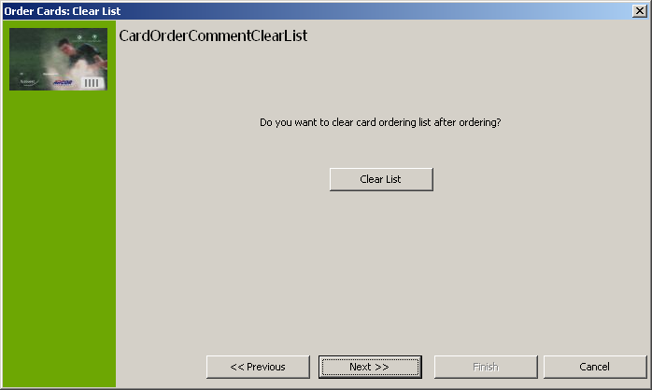

Buttons
Clear List If you click the Clear List button, the check mark in the Request ID field in the DETAILS window will be cleared after the ordering process has completed. This ensures that duplicate cards will not be ordered.

- Click the Next button.
- You see a confirmation message that tells you the cards have been ordered.
- Click the Finish button.

- Remote access by our support team with Netviewer
As part of our installations, we include the Netviewer software, which gives our Support team the opportunity to access your workstation remotely.

This software can be activated in the following ways:

  - Netviewer icon on your desktop:
- Click on the Netviewer Icon to start a remote management session.

Quick Launch Bar

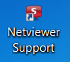

Desktop logo

  - Remote access in the Albatros modules
- Click on ‚Help‘ in the top line and then choose ‚Albatros Netviewer Service‘.

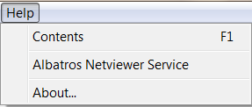

  - Starting the remote access session
- Please call our support number: 086-010 9372 / 079-314 9571. Should our support team member feel that it is necessary to start a Netviewer session, he will ask you to load the software.

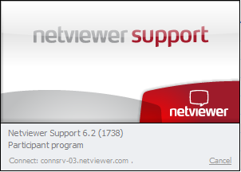

- The session starts with the left screenshot as seen above. The connection is tested and once it has been established successfully, a window pops up, requesting you to enter a code. This code will be given to you by the Support team member and is unique for this session.

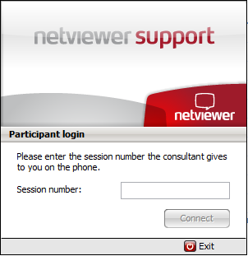

- Once you have entered the number, please click on ‚Connect‘ to confirm and when the secure connection has been established between the two computers, you are requested to allow the transmission of your screen:

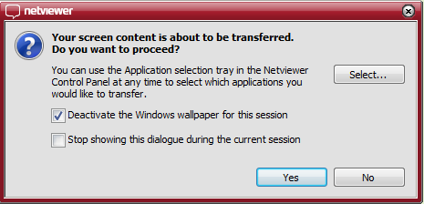

- Click on the button „Yes“, so that the support team member can view your screen. The remote access (Remote control) is now active as shown by the window:

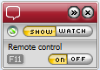

- This menu is visible throughout the whole session. Once the session is completed, a new window opens up to document the end of the remote access. Please click on ‚Close‘ to confirm.

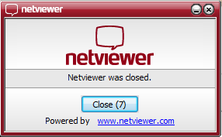

The advantages of Netviewer compare to other remote access software are:

- Quick link via the Internet
- Low costs compared to other softwares on the market
- 128 Bit Encryption
- VeriSign-Certificate

- Sample exercises
This chapter contains sample exercises and answers which lead you to your goal with easy steps.

  - Exercise 1 "Add Customer"
- Create a new common customer.
- Create the spouse of the customer with the same name.
- Assign the family.

The customer would like invoices sent to his company address.

- First sign in to Albatros Members To do this, double-click on the Member icon on the desktop or start the program with Start - All Programs – Albatros. | 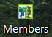

While the program is starting, the following screen appears:

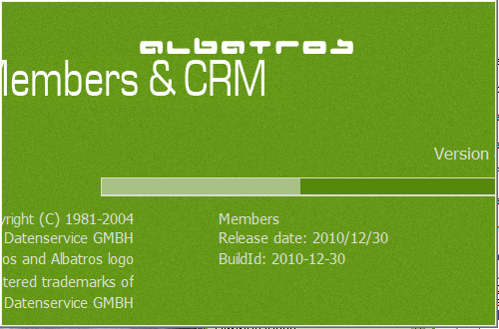

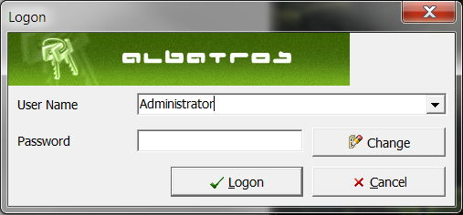

- Enter your username and password. You can log in as an administrator with the password 1234.
- If you wish to change the password at this point, click the "Change" button.
- The password change screen opens. First enter the old password followed by the new password and then re-type the new password.

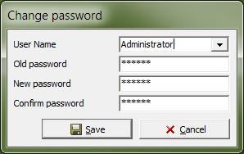

- When you have filled in all the fields and are sure that you wish to save your entries, click on the "Save" button.
- If you are not sure you wish to save your entries, click on the "Cancel" button to cancel the process.

After logging in, you are taken to the start screen of the Member main program.

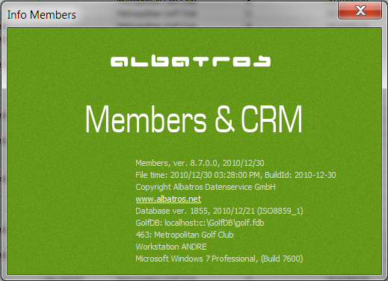

In the main screen you see the version and version date, the creation date, the database version, the version of your operating system, your club number and the name of your workstation.

At the top of the program next to the status line you find the toolbar with the primary functions. These are arranged as follows:

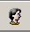      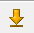  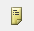  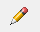  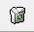  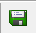  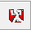  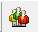  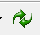 | By clicking on this button you can log a new user in. As soon as you click this button, the current user is logged off and the login screen appears.  By clicking on this button you can move up to the top of the customers’ list screen  By clicking on this button you move up one entry on the customers’ list screen  By clicking on this button you move down up entry on the customers’ list screen  By clicking this button you move down to the bottom of the customers’ list screen  By clicking this button you will be taken to a screen that allows you to add a new customer to the list  By clicking this button you have the option to edit the information of any tab you are working on  By clicking on this button you are able to delete the entry you have selected  By clicking on this button you are able to save the information you have entered  By clicking on this button you can exit from your current screen without saving the information you have entered  By clicking on this button you can filter the customers on display – this can be done by a whole list of variables, e.g. age, gender, last name, membership type etc. These filters can be saved as well.  By clicking on this button you are refreshing the screen, so that any changes that were recently made, will become visible  By clicking on this button you are able to access a list of reports available for printing – e.g. balance sheet, birthdays, customer list, sms list, handicaps etc.

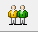  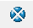  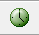  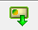 | By clicking this button you can display the customer search screen and search for a customer directly by entering specific information.  By clicking on this button you can switch back to multiple customer mode when you have been viewing a filtered display  This button will display a list of changes made in backup records – it will detail date, person who made the change, object, field that was changed, old value and new value.  By clicking on this button you can schedule reminders, membership changes and other relevant information to be visible to users that operate Members  This button will allow you to read internal cards  This button allows you to assign internal cards  This is where you select the mandatory you want to work in  By clicking this button you make contact with the SAGA server and can update all SAGA ID’s, synchronize customers, etc

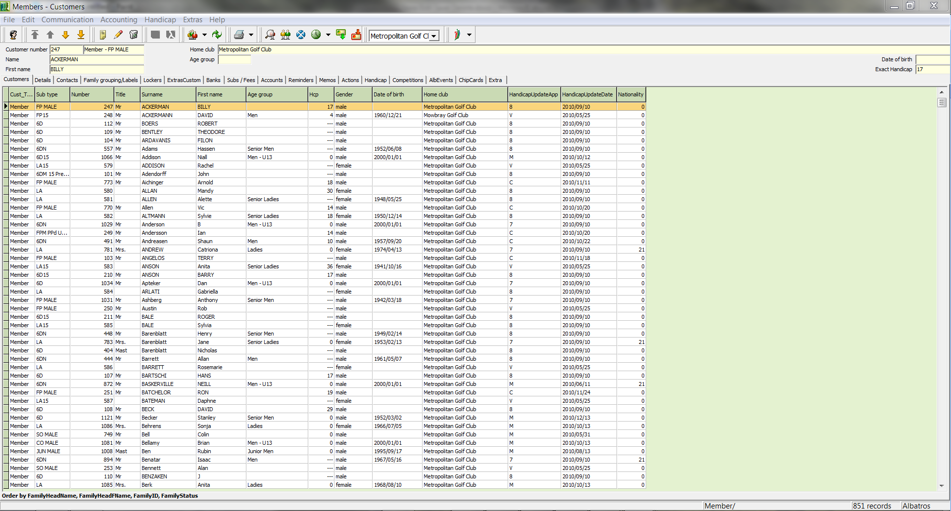

In the main program, you can access all the important functions with the toolbar in the usual manner.

- To create a new customer, use the icon. Click on the icon, and the Add New Customer wizard opens.

- Fill out all fields in this screen for which you already know the information.

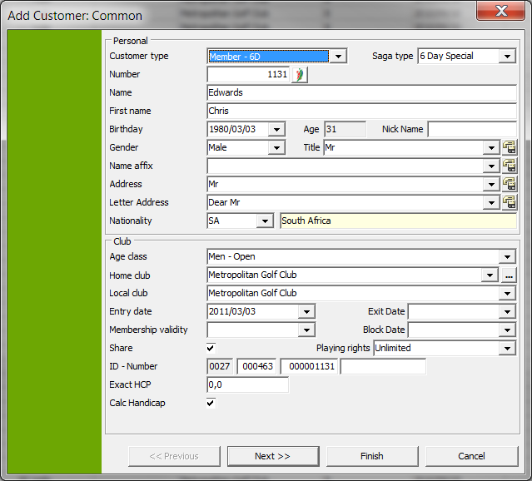

- Don't forget to fill out the exact handicap - it will take you much more time to do this later.

In fields with the selection icon you will find several pre-defined options to choose from. Fields with the Learn icon can be augmented with new data by clicking the learn field.

- When your screen has been completely filled out, click the "Next” button.

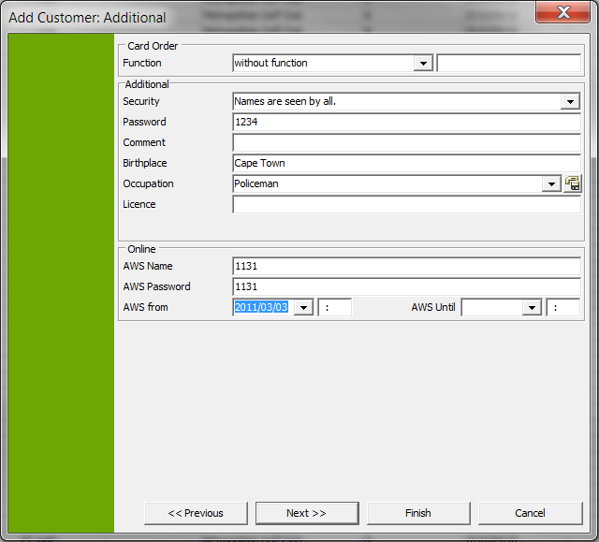

- The Function field already has numerous entries. If none of the entries is applicable, you can add your own description in the associated free-text field which will then be printed on the ID card.
- If you check the SMS box, the new member is assigned to Send SMS. If you select Display on the Internet you can choose which information will be displayed on the internet and assign a password. In addition a comments field is available where you can enter the birthplace, profession, and license information.
- When you have entered all the data in the dialog box you can move to the next dialog by clicking on the ”Next” button.
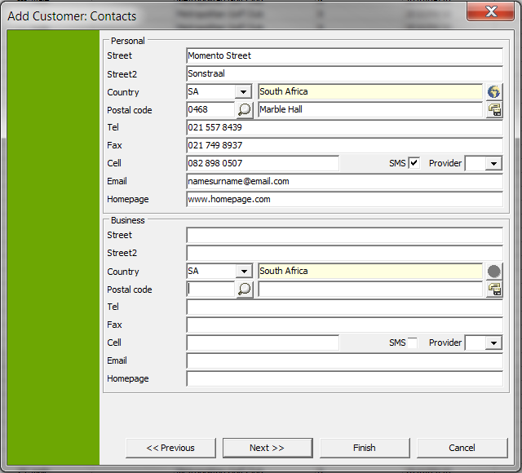

- When filling out the address fields, be careful not to use incorrect characters in the Cell phone number since these are used for Send SMS. Also be sure to enter the correct provider here.

The address data can be provided with home and business addresses, and other addresses can be added after creation.

- When you have filled out the address fields and are sure that everything is correct, you can move to the next entry dialog with the "Next" button.

If you are not certain, you can return to the previous entry dialog

…with the "Previous” button,

… end the wizard now with the "Finish” button

or if you have entered incorrect data

… with the "Cancel” button terminate the process completely without saving.
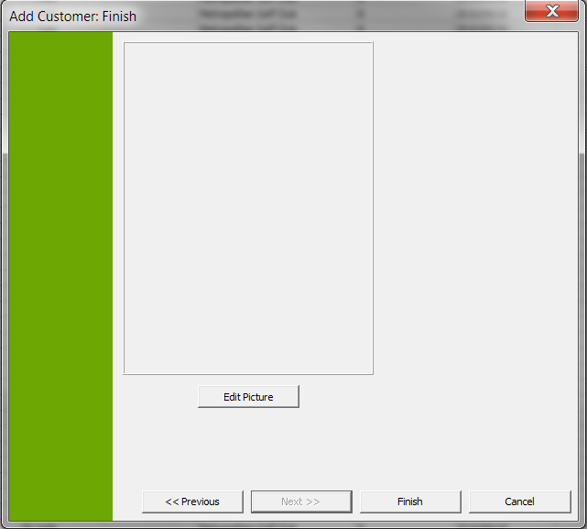

- You can assign a picture to a customer in this dialog. Click on the button "Edit Picture”. Now the "Add Graphic" field opens.

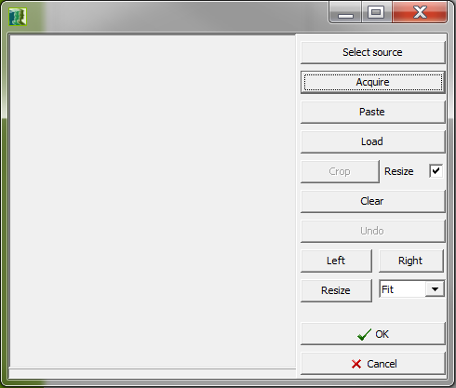

- By clicking on the ”Load” button, select the appropriate directory on your computer where the photo of the customer or the member is found. The picture must be saved in .bmp format.

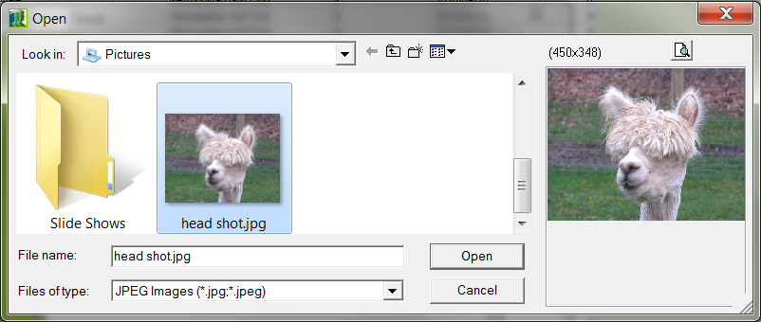

- After selecting the correct picture, click on the "Open” button. The picture will be displayed in the "Add Graphic" dialog again.

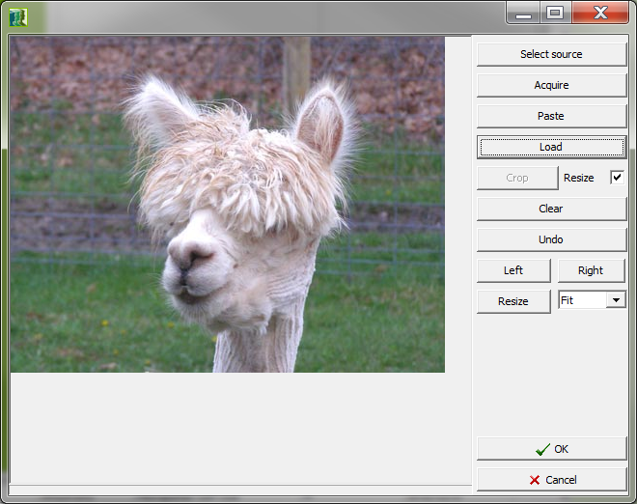

- Click on the button "OK”. You are now returned to the Customer wizard. Click on the button "Finish”.

You are taken to the standard dialog "Due Date for Default Values".
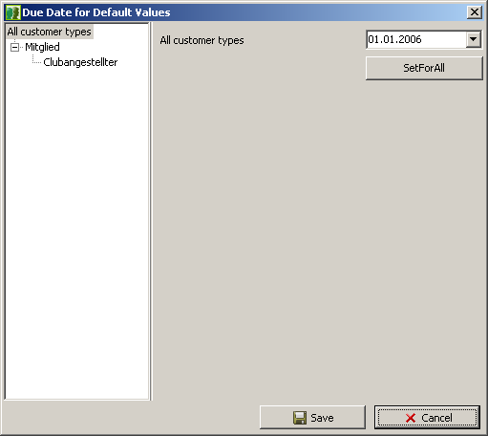

- In this dialog you can specify the due date for each customer type. If the suggested date is suitable then keep it as is, otherwise change the date to a suitable value and click the "Set for all” button and then the "Save” button.
- The customer record will be created and you are automatically taken to the dialog for the newly created customer.

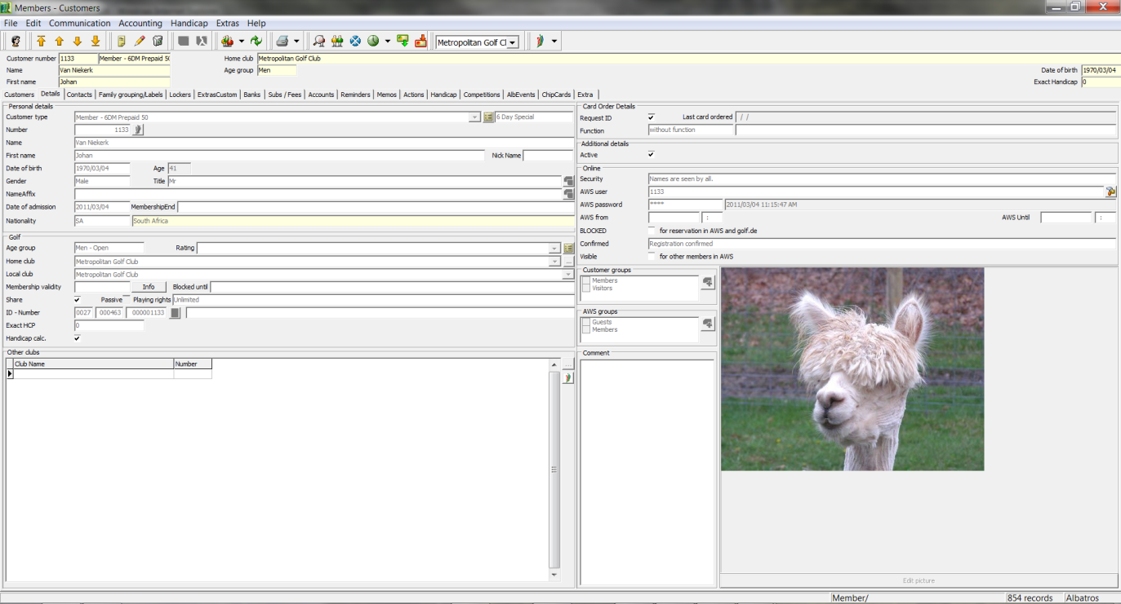

- To create the new customer's spouse, proceed as outlined above.

- After you have created both spouses, assign the family. To do this, change to the Family Head tab and open the record by double-clicking on it.
- Then click on the Family Head tab, followed by the button. 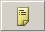
- The Select Customer field opens. Be sure that the selection is only marked with the "All" check mark, otherwise you might not see all members because of other selection criteria.

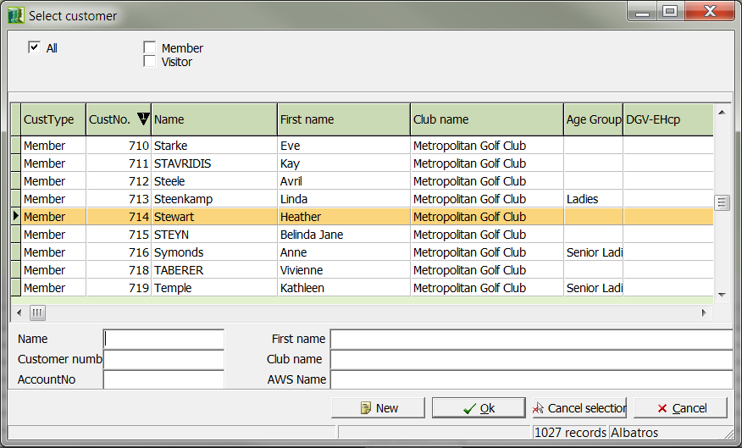

- From the window that opens, find the corresponding spouse and click the "OK" button.
- In the main selection the husband is now the family head and his spouse is identified as a family member.
- In order to create an invoice at this point, a bank connection must be entered. To do this, change to the "Banks" tab. Click on the button from the toolbar.
- Enter the bank connection in the empty fields.

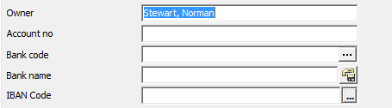
- After you have entered your data, click the button. The data will be transferred to the main screen.

- You have now assigned the corresponding bank connection. Now an invoice should be sent to the company address. To do this, click on the "Contacts" tab.

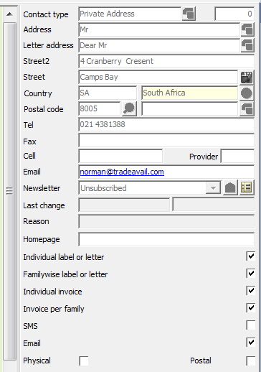 | - Click the home address and then click the button.  - Remove the invoice check box from the field displayed on the right side.  - To save your entries, click on the button.  - Now click on the business address.

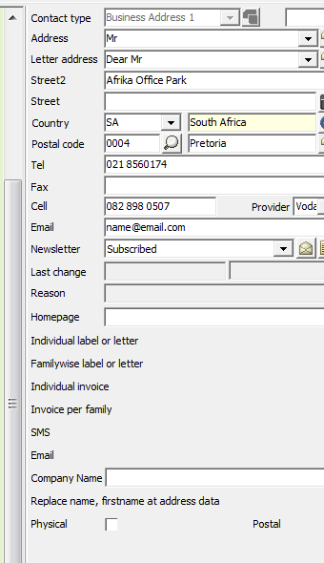 | - To edit your entries, click on the button.  - Add the invoice check box from the field displayed on the right side.  - To save your entries, click on the button.  - Remember that you can still assign lockers/boxes and send an instant invoice to your new member.

  - Exercise 2 "Change Customer"
- Create a new "External Member" subtype.
- Assign a member payment to the subtype.
- Assign the new subtype to the new members.
- Assign the new admission a new home club.
- Create an admission invoice for the new member.

- First sign in to Albatros Members To do this, double-click on the Member icon on the desktop or start the program with Start - All Programs - Albatros

    - Create a new "External Member" subtype.
While the program is starting, the following screen appears:

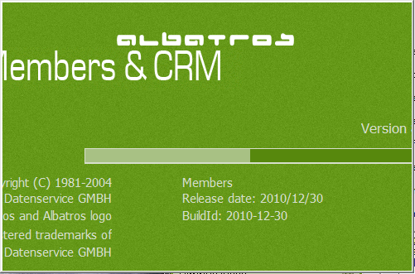

This start screen displays the program version as well as the program release date. Next you see the login screen:

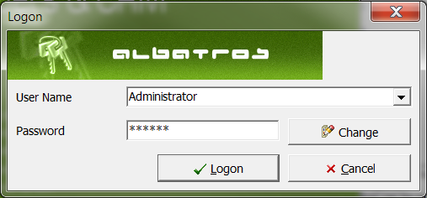

- Enter your username and password. You can log in as an administrator with the password 1234.
- If you wish to change the password at this point, click the "Change" button.
- The password change screen opens. First enter the old password followed by the new password and then re-type the new password.

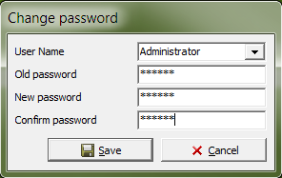

- When you have filled in all the fields and are sure that you wish to save your entries, click on the "Save" button.
- If you are not sure you wish to save your entries, click on the "Cancel" button to cancel the process.
- After logging in, you are taken to the start screen of the Member main program.

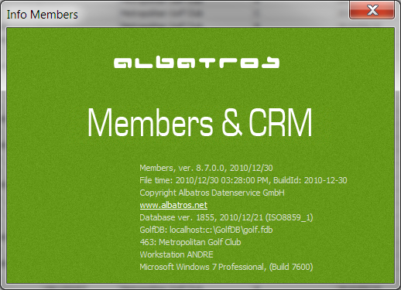

- In the main screen you see the version and version date, the creation date, the database version, the version of your operating system, your club number and the name of your workstation.

At the top of the program next to the status line you find the toolbar with the primary functions. These are arranged as follows:

By clicking on this button you can log a new user in. As soon as you click this button, the current user is logged off and the login screen appears.

By clicking on this button you can move up to the top of the customers’ list screen

By clicking on this button you move up one entry on the customers’ list screen

By clicking on this button you move down up entry on the customers’ list screen

By clicking this button you move down to the bottom of the customers’ list screen

By clicking this button you will be taken to a screen that allows you to add a new customer to the list

By clicking this button you have the option to edit the information of any tab you are working on

By clicking on this button you are able to delete the entry you have selected

By clicking on this button you are able to save the information you have entered

By clicking on this button you can exit from your current screen without saving the information you have entered

By clicking on this button you can filter the customers on display – this can be done by a whole list of variables, e.g. age, gender, last name, membership type etc. These filters can be saved as well.

By clicking on this button you are refreshing the screen, so that any changes that were recently made, will become visible

By clicking on this button you are able to access a list of reports available for printing – e.g. balance sheet, birthdays, customer list, sms list, handicaps etc.
By clicking this button you can display the customer search screen and search for a customer directly by entering specific information.

By clicking on this button you can switch back to multiple customer mode when you have been viewing a filtered display

This button will display a list of changes made in backup records – it will detail date, person who made the change, object, field that was changed, old value and new value.

By clicking on this button you can schedule reminders, membership changes and other relevant information to be visible to users that operate Members

This button will allow you to read internal cards

This button allows you to assign internal cards

This is where you select the mandatory you want to work in

By clicking this button you make contact with the SAGA server and can update all SAGA ID’s, synchronize customers, etc

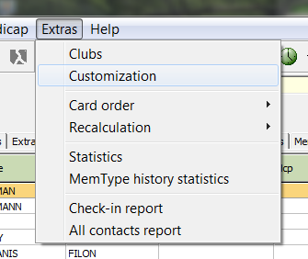
- You are now in the main screen of the auxiliary table in the Member - Customer Type tab:

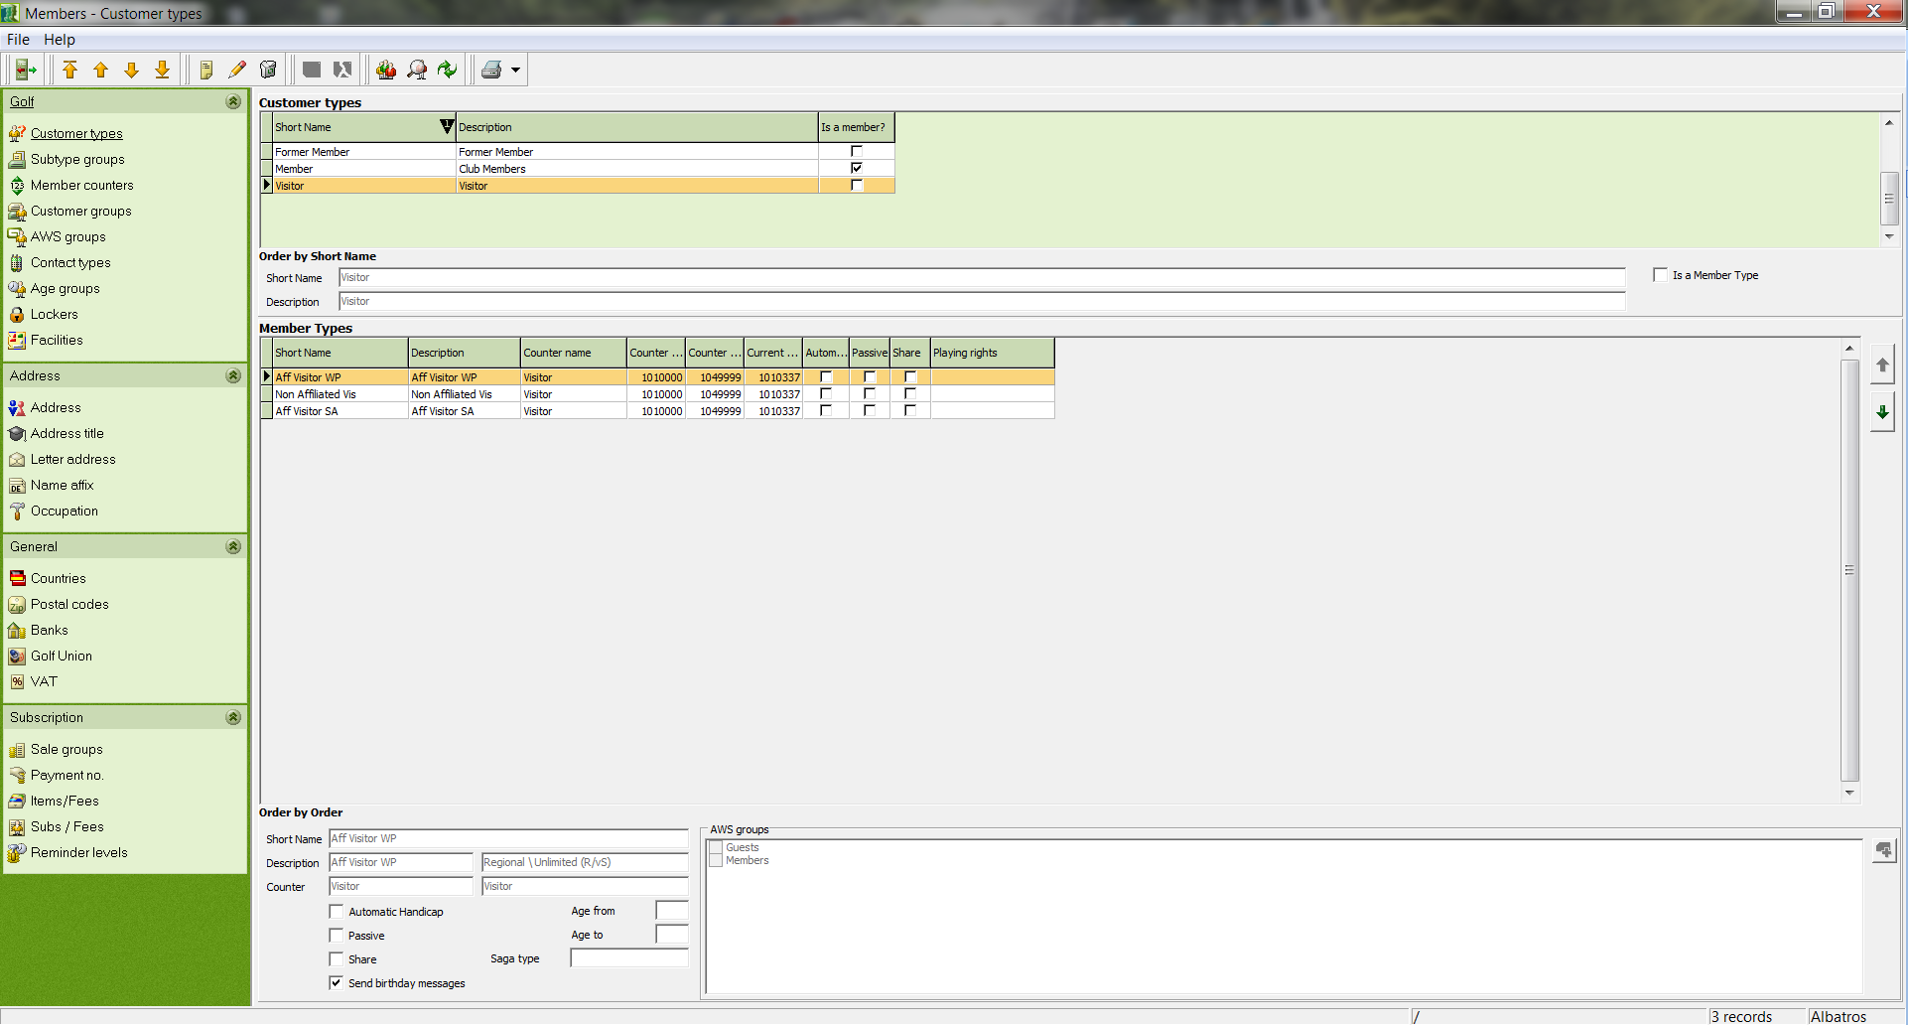

- Now click the button and move to the entry fields.

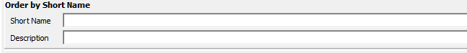

- Make meaningful entries in the fields. In the short name we have entered "Ext. Memb.", and the description contains the full text "External Member". As a counter we have selected Member from 1.

Note: Please be sure to assign a counter value or the value "unknown" will be assigned which can lead to considerable problems in the database.

- Now click on the button. You have now created a customer subtype and the screen appears as follows:

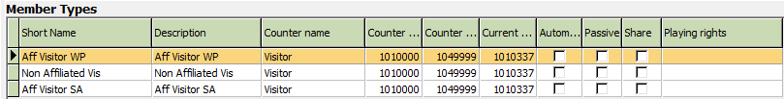

You have now completed the first part of the exercise.
    - Assign a subscription to the subtype.
We now come to the assignment of a subscription to the subtype. In order to do this, a new article must be created in the auxiliary table.

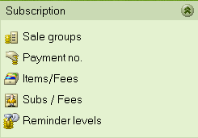

- In the Subscription menu, choose the option Items/Fees.
- Now click on the button.

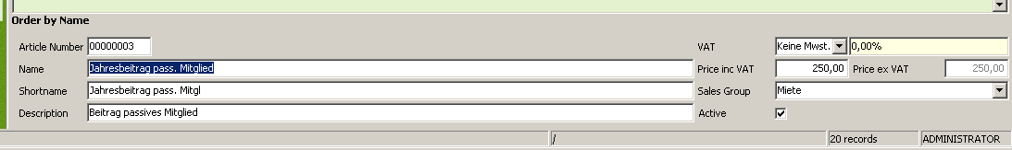

- Make meaningful entries in the fields as shown here in the example. The article number is supplied automatically here, the name and the description may be identical, and be sure to enter something meaningful for the short name.
- In the VAT field for the yearly charges enter the full VAT amount and then specify the price for external members. Here in the menu, Euro 500.00 was selected.
- Be sure to assign the payment to a sale group so that you can find it later for evaluations.
- Now save your entries with the button. In the overview you can now see the newly created article:

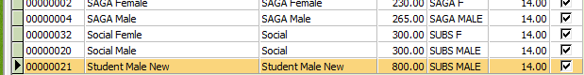

- Change to the Membership Contribution submenu.

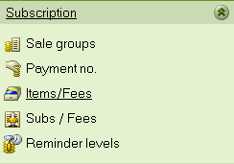

- Now click in "Customer Type/Subtype" on "Ext. Member" and then in the "Standard Payment" field, and this field is then created.
- Click on the button and then arrange the articles in the individual fields.

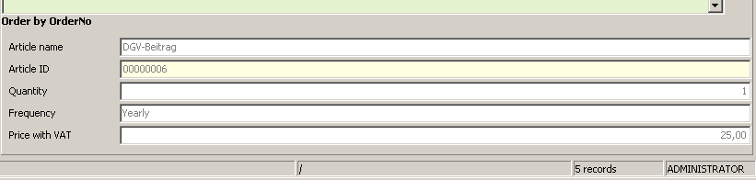

- For the article name select the article you created previously, "External member yearly charges".
- The article number in the next field is automatically entered and should not be changed.
- The count is "1" by default and in this case also correct, so do not change it.
- As with the other member payments for the same time period, the invoice frequency should be "Yearly".
- The Price Including VAT is also provided automatically and comes from the price you previously entered.
- To finish and save your data, click the button.

You have now finished the second part of the exercise, assigned a member payment to the subtype. You can now assign this subtype to a new member.

    - Assign the new subtype to the new members.
- To do this, exit the auxiliary table and click the button 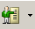 to move to Members.
- Find the two newly created members and open the first member with a double-click.
- Change to the tab ”Items/Fees”. The correct procedure is to first delete the yearly payment for a regular member and then to enter a new yearly payment for an external member.
- To delete the record click on it and then click the button.

The confirmation question appears:

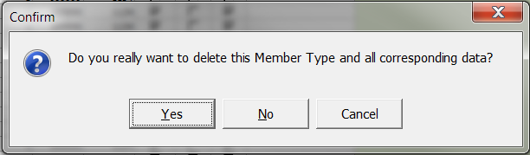

- Click on the button "Yes".
- To make the new assignment, click on the button.

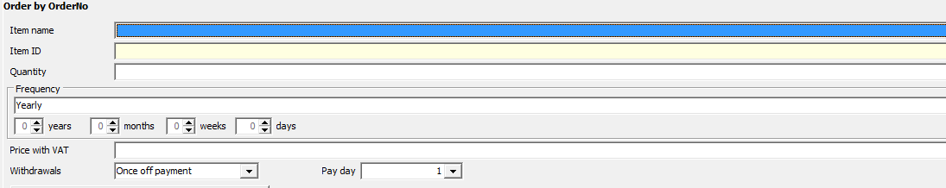

- From the list that appears, select the new external member yearly payment and save your selection with the button.

You have now completed the third part of the exercise.

    - Assign a new home club to the new admission
- Launch Members and go to Customer with the button.
- Select the family members which were previously set as external members and then double-click on the family head. You are now by default on the "Details" tab.
- To edit the record, click the edit button on the toolbar.

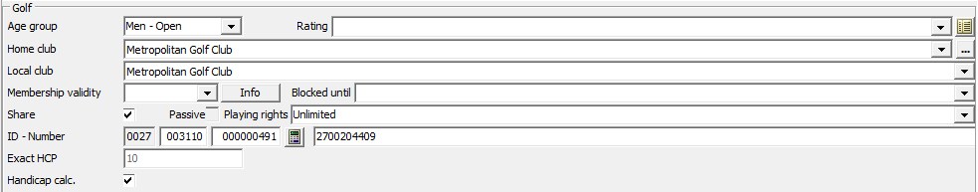

- In the "Golf" field, click on the button and select the new home club.
- Then click on the button to end and save your work.

If you see no error message, then you have successfully completed the fourth exercise.

    - Create an admission invoice for the new member
An additional feature that is new in Version 8.1 is the creation of an immediate invoice which can be found on the bookings tab.

- If you are still in the changed family head you can select this tab directly, otherwise change to the family head and then go on to the accounts tab.
- Next click on the button "Instant Invoice".

The booking wizard for Articles opens:

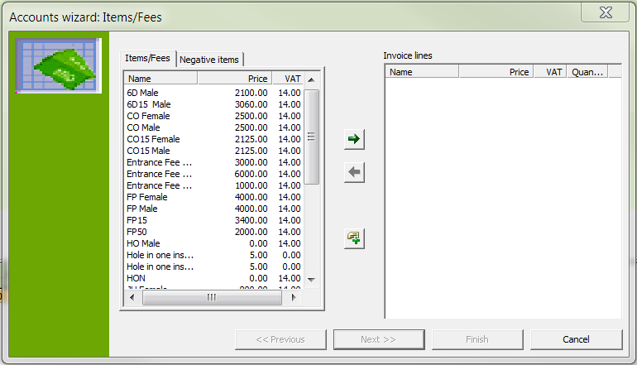

In the booking wizard you can create the admission invoice and provide discounts based on admission date without impacting your standard payments which are calculated from 01 January.

- Select the corresponding invoice items and transfer them to the invoice item list with.

- The transfer window opens in which you can enter and adjust the payment amount and the corresponding number of invoice items.

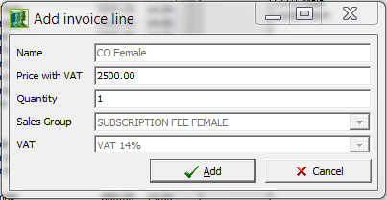

- To confirm, click the "OK" button. Your booking screen will look like this:

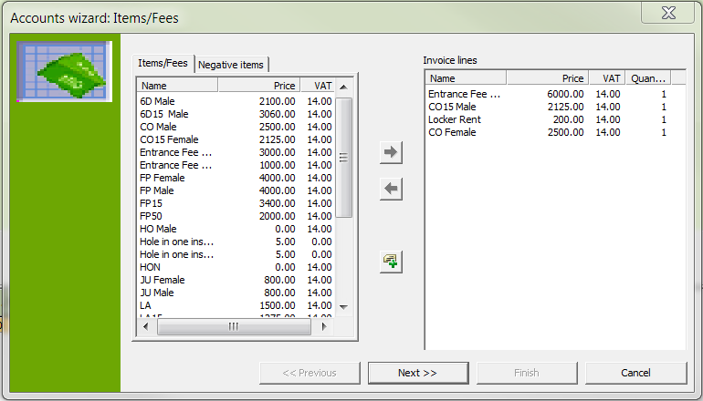

- Now click on the button "Next". You now enter family mode.

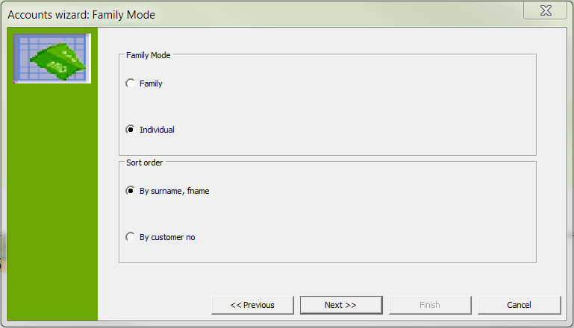
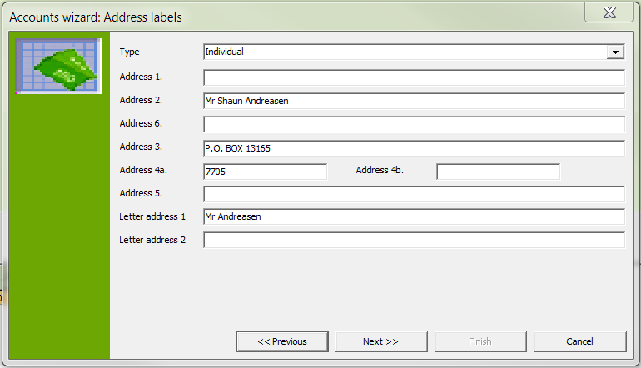

- Now click on the button "Next". You are taken to the Booking wizard for dates.

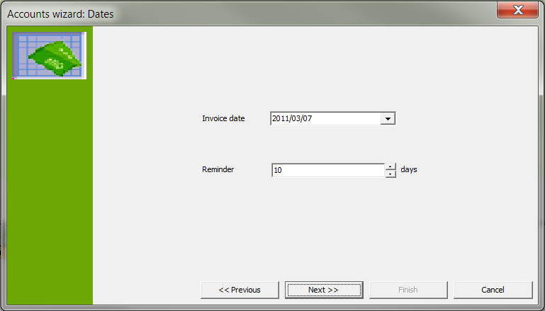

- Here you can adjust the invoice data as needed. You can do this from the keyboard or with the calendar sheet.

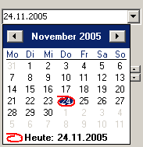

- Now click on the button "Next". The invoice wizard for invoice numbers opens.

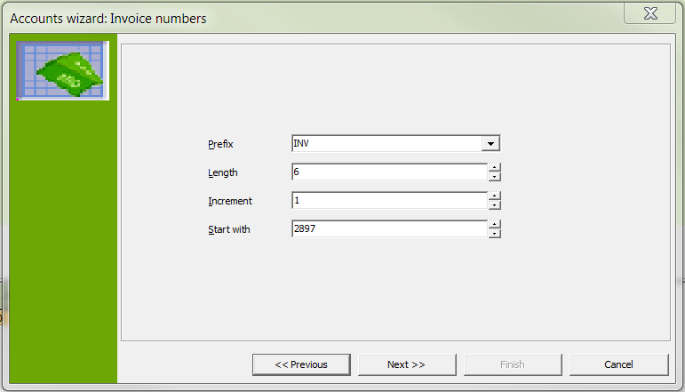

- At this point you have a final opportunity to adjust prefix, length, increment and starting invoice number.
- Now click on the button "Next". You come to the generate invoice wizard.

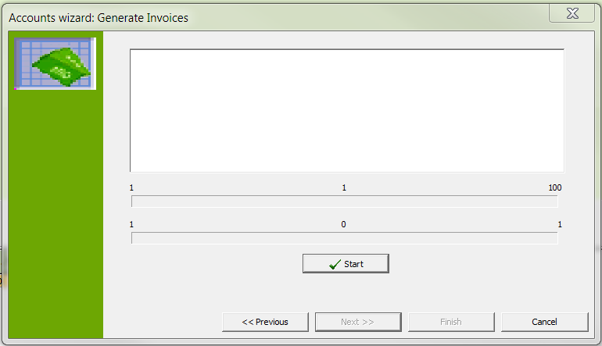

- Now click on the button "Start". The invoice is calculated and the progress is shown in the invoice window.

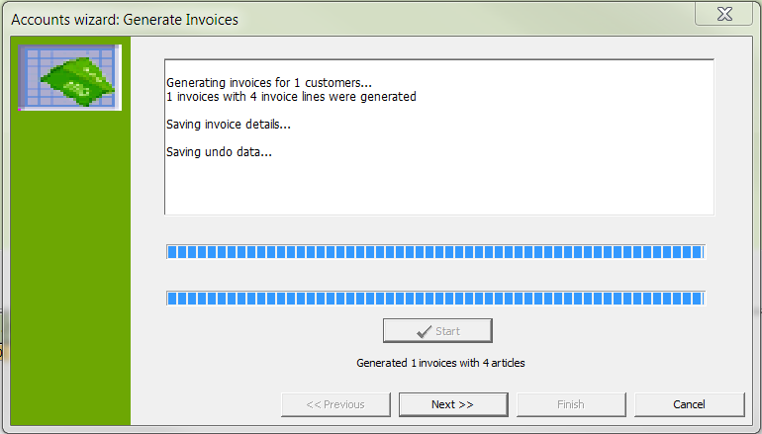

- Now click on the button "Next".

You jump to the booking invoice wizard. If you had created several instant invoices, you would see here an overview of the created invoices. In this example, however, there is only one instant invoice.

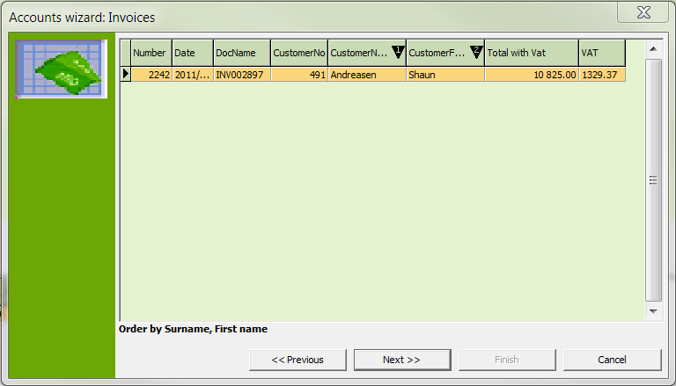

- Now click on the button "Next". This brings you to the print invoice wizard.

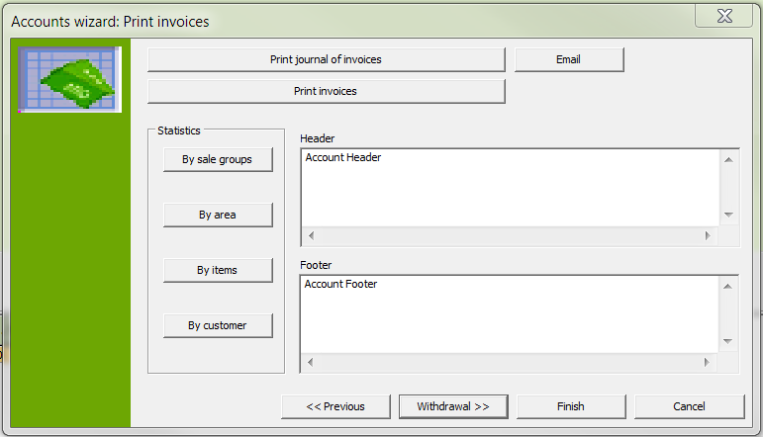

- With the "Print journal of invoices" button you can print the corresponding invoice journal which you will need for the account. Click this button and you see the following overview:

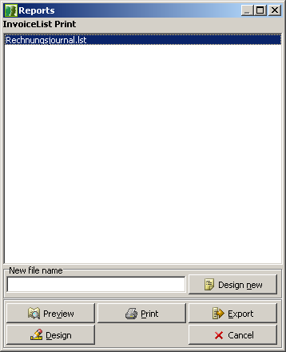 | As with all print options, you have the following possibilities:  - Preview  - Direct print with printer selection  - Export function  - Change to the Designer to adjust the forms  - Cancel

- From these options, select Preview by clicking on the corresponding button "Preview". The print preview is displayed:

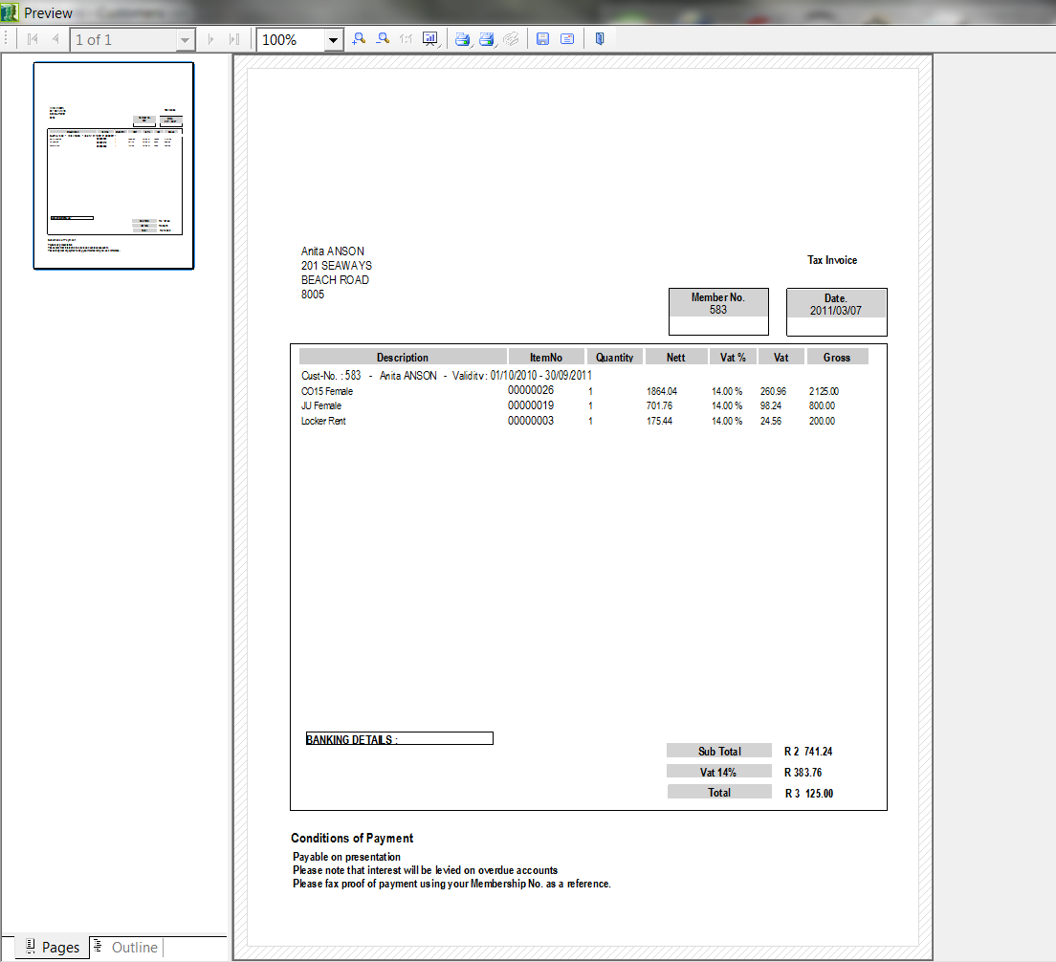

- With the print button you can print the invoice journal. Close the window with the cross in the upper-right corner.
- With the "Print Invoices" button you can print the invoices for the selected customer. Now click on the button. You see the following selection options:

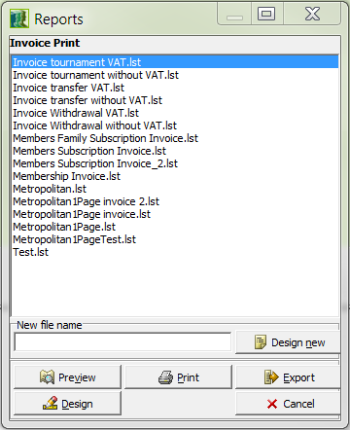

Here you can choose between:
- Withdrawal invoice with VAT.
- Withdrawal invoice without VAT
- Invoice form with VAT
- Invoice form without VAT
- Invoice transmittal with VAT
- Invoice transmittal without VAT
- Competition debit entry with VAT
- Competition withdrawal without VAT
- Select the option "Invoice Form with VAT" and click the Preview button.

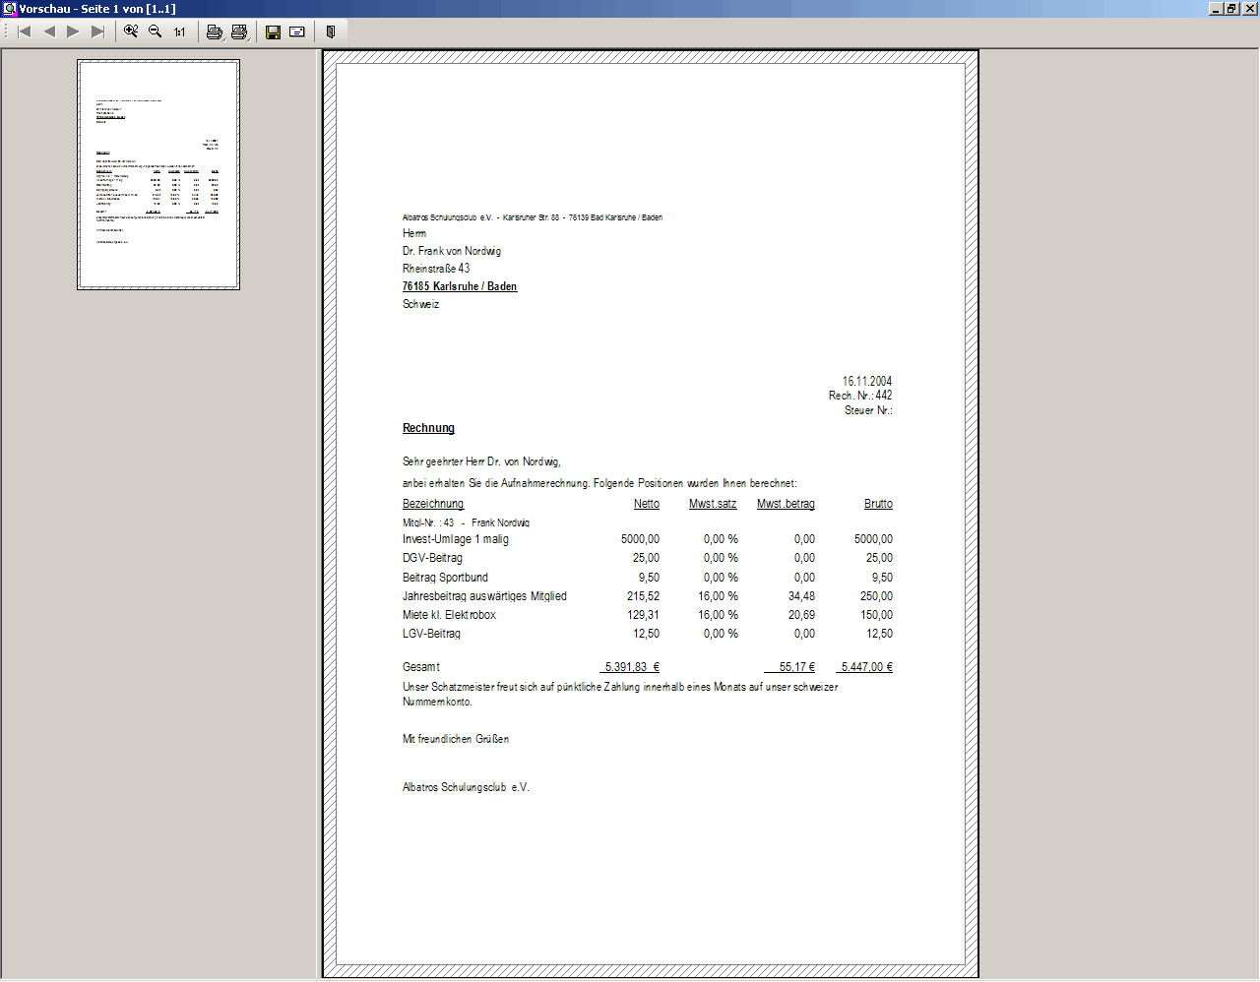

- With the button you can print the invoice journal. Close the window with the cross in the upper-right corner.
- Since we have chosen a normal invoice in this instance, you can now click on the "Finish" button.
- When the customer pays his admission invoice, you can click on the paid button in the main screen. The payment window then appears:

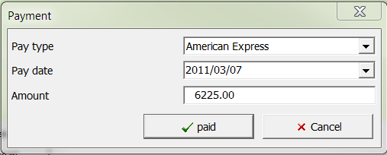
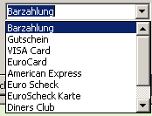

- In the Pay type field you can specify the type of payment, followed by the pay date, and if there is an overpayment or underpayment, adjust the new payment amount. To save your entries, click on the button "paid".

Now the both invoice and the payment is shown, and the customer balance is once again cleared.

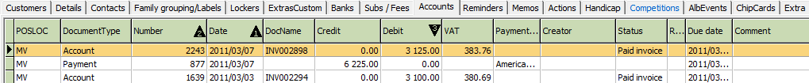

Naturally you have the option of paying individual invoice items in the overview shown on the lower left if the customer makes a partial payment.

This form is connected with more expenditure, however, since a balance reconciliation is possible only after payment of all items.

You have now successfully completed the fourth exercise.

At the end of this exercise we have included another small memo sheet for you which should make your daily work with Albatros easier:

- Have the necessary subtypes, articles and payment assignments been created?
- Have the required fields been filled in?
- Have family relations and bank connections been handled?
- Who is the home club and does it keep handicap records?
- Are due dates and frequency of payments correct?
- Have the transmission to the intranet and the card orders been performed?

  - Exercise 3 "Selection and Communication"
- Generate a new selection with all common members.
- Change the selection to include all regular members with handicap of 16.0 or better.
- Generate labels for the resulting selection.
- Generate a form letter or an E-mail for the resulting selection.

Exercise Part 1: Generate a new selection with all common members.
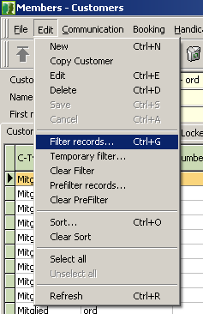

- In Members click on the toolbar on "Edit", then on "Select All", and then again on "Edit", and finally on the "Filter records" in the drop-down that is opened.

You are now in the Selection field. In this field you can create new filters, edit old filters, delete filters and alter the selection parameters.

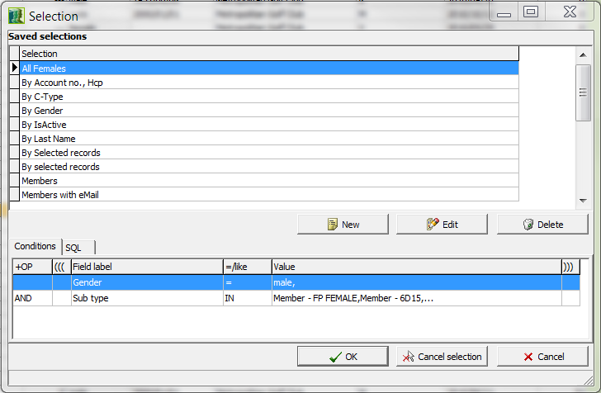

- Since this filter has not been saved, it must be created again. Now click on the button "New".
- You move to the "New Selection" field. Here you can make the assignment for the desired selection.

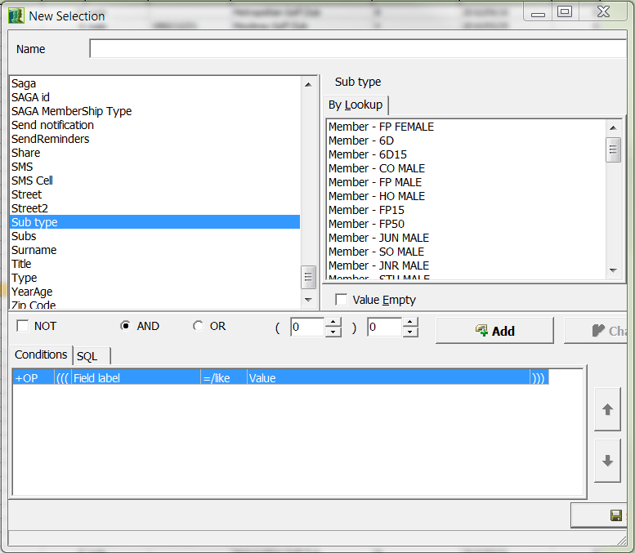

- To quickly find this in the list again, fill in the field name with a meaningful description, here in the example "Select Common Members Only". Next click on "Subtype" and in the Search term field click on "Member - Com". Be sure that the "And" condition is ticked and click on the "Save" button for the final selection.

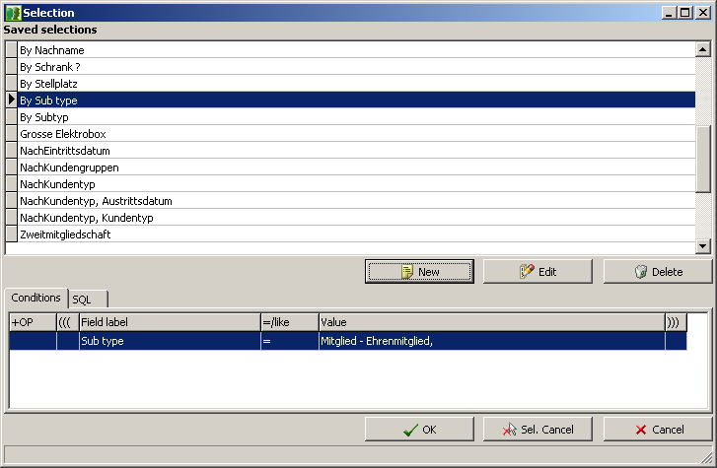

The selection you have specified will be displayed:

- Now click on the button "OK". The selection appears:

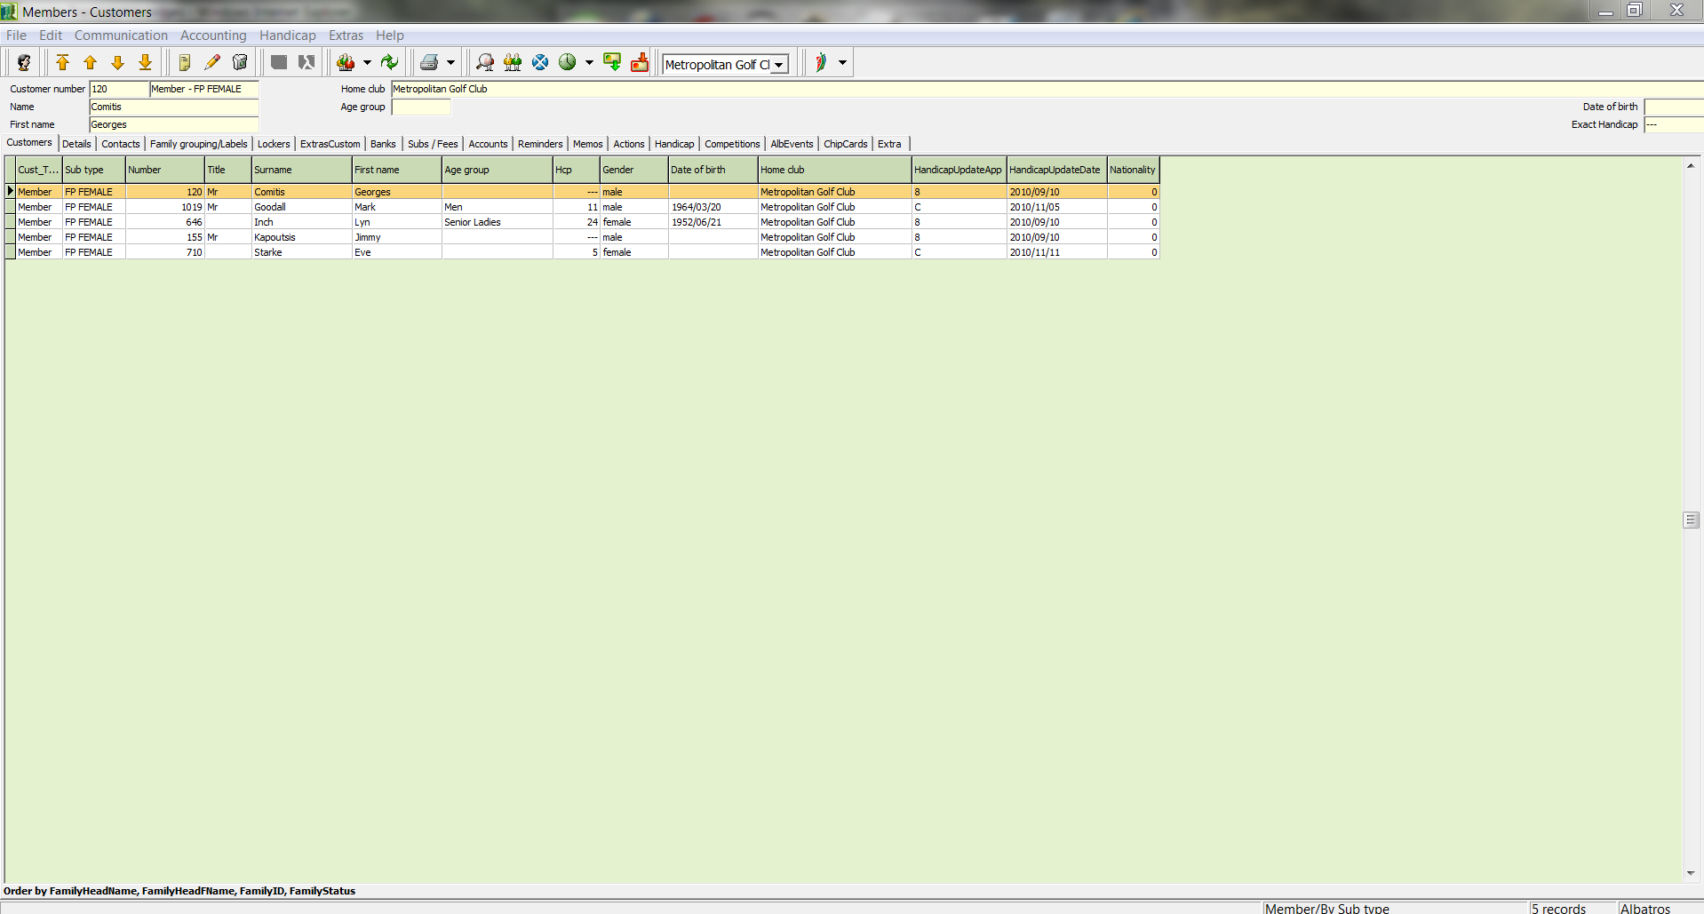

You have now successfully completed the first part of the exercise.

    - Change the selection to include all common members with handicap of 16.0 or better.
With the selection of all common members that you have just made, you can change the selection with just a few steps.

- First click on "Edit" in the toolbar, and then on "Select All".
- Now you can click "Edit" in the menu bar to change to "Selection".

The saved selections are displayed.

- To make the new assignment, click on the button "Edit".

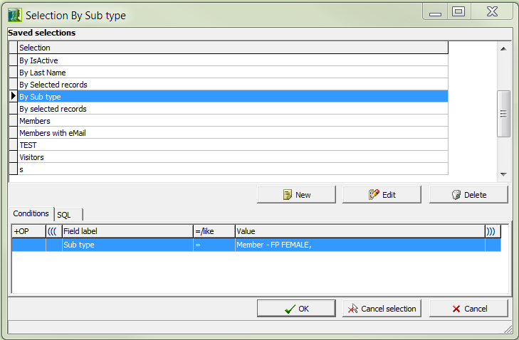

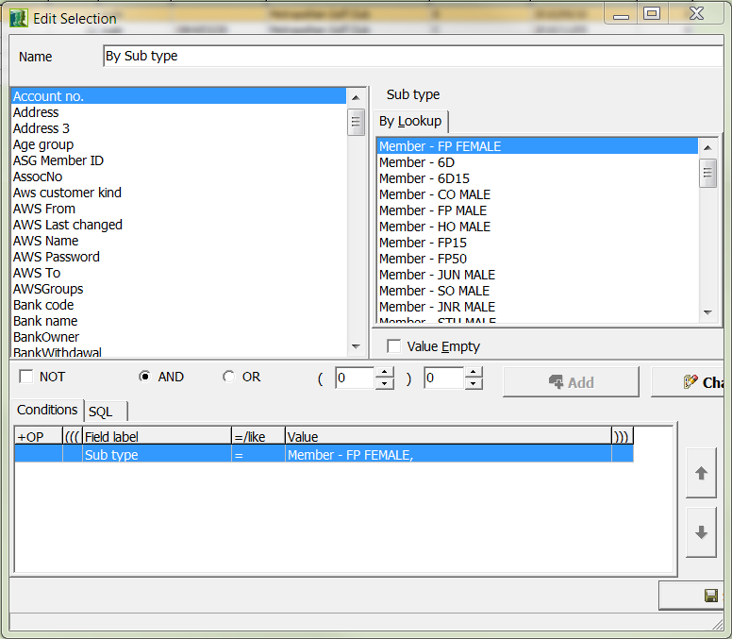

- From the selection list, choose SAGA-Std., click in the right field on "By Range". In the "Starting Value" enter "0", in the "Ending Value" enter "16", and then click on the "Add" button.
- So that you can find this list again later with all attributes, add it to the resulting selection. At this point you have made the desired selection and can complete the action by clicking the "Save" button.
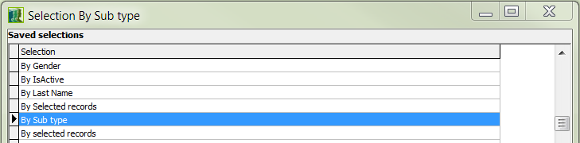

- To finish, click the "OK" button. The selection is made (see illustration):

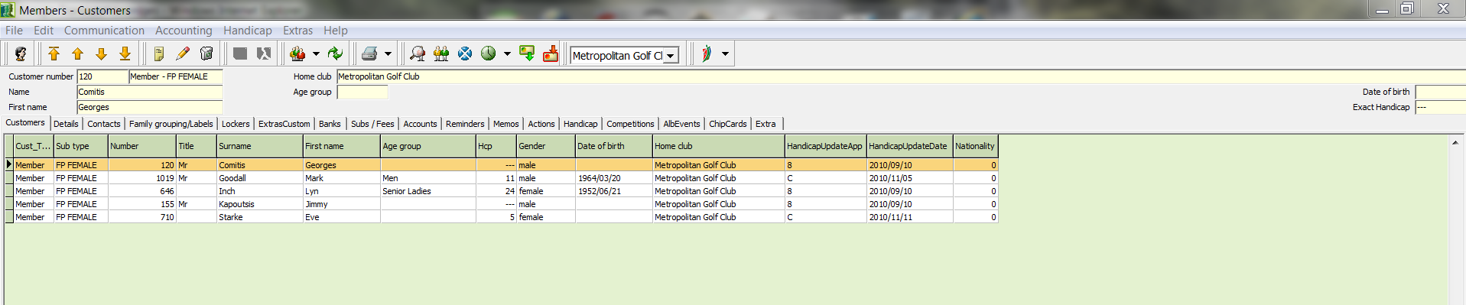

You have now successfully completed the second part of the exercise.

Generate labels for the resulting selection.
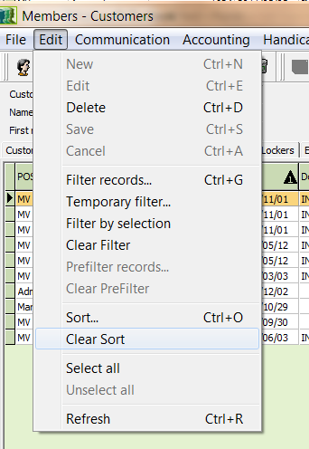 | - Select all entries in your selection with the "Edit" option on the menu bar, and choose "Select all" from the drop-down list.

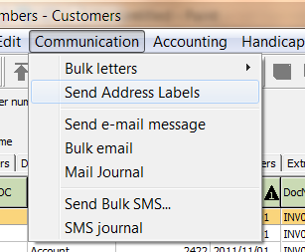 | - Start the Address Label wizard with the "Communication" menu by choosing "Send Address Labels" from the drop-down menu.

- The following choice appears. Keep "individual" selected.

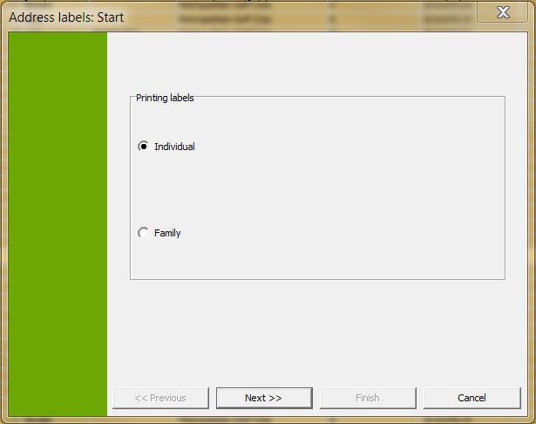

- Now click on the button "Next". You move to the selection dialog for pre-defined address labels. It is also possible to use the Designer here to create additional labels or to export if needed.

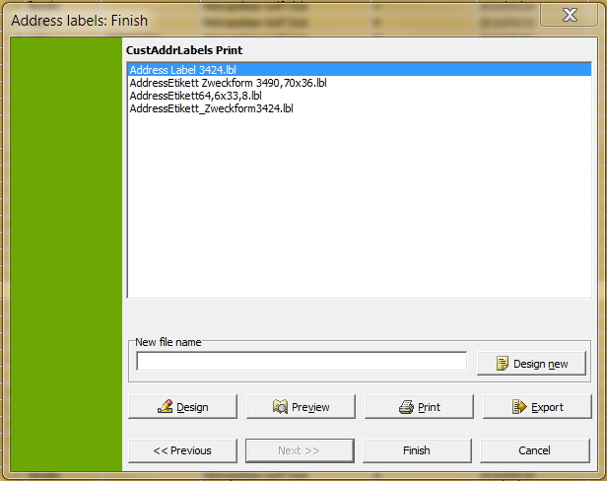

- Select the sample label Zweckform 3424.lbl by double-clicking and you are taken to the address label preview.

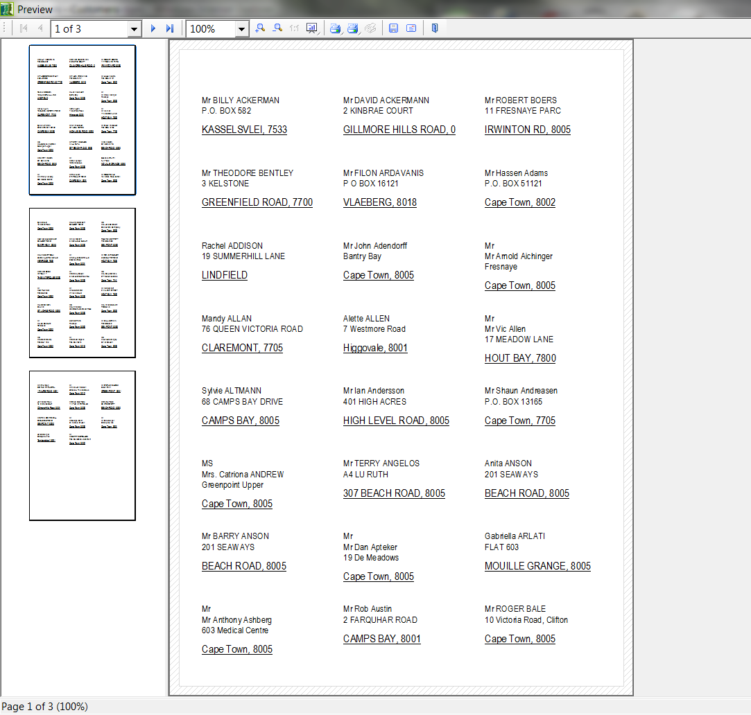

- From here you can verify whether all address data has been correctly entered before printing and make corrections, repeating the procedure if needed. If all entries are correct, then insert the appropriate labels into the printer and print from the menu bar with the "Print" button.
- If the windows-standard printer selection window is needed, click on the "Print" button with the right mouse button and the required dialog will be automatically opened.

- Naturally you have the option of choosing the desired label type from a list, or create user-defined ones. You can do this from the Designer.

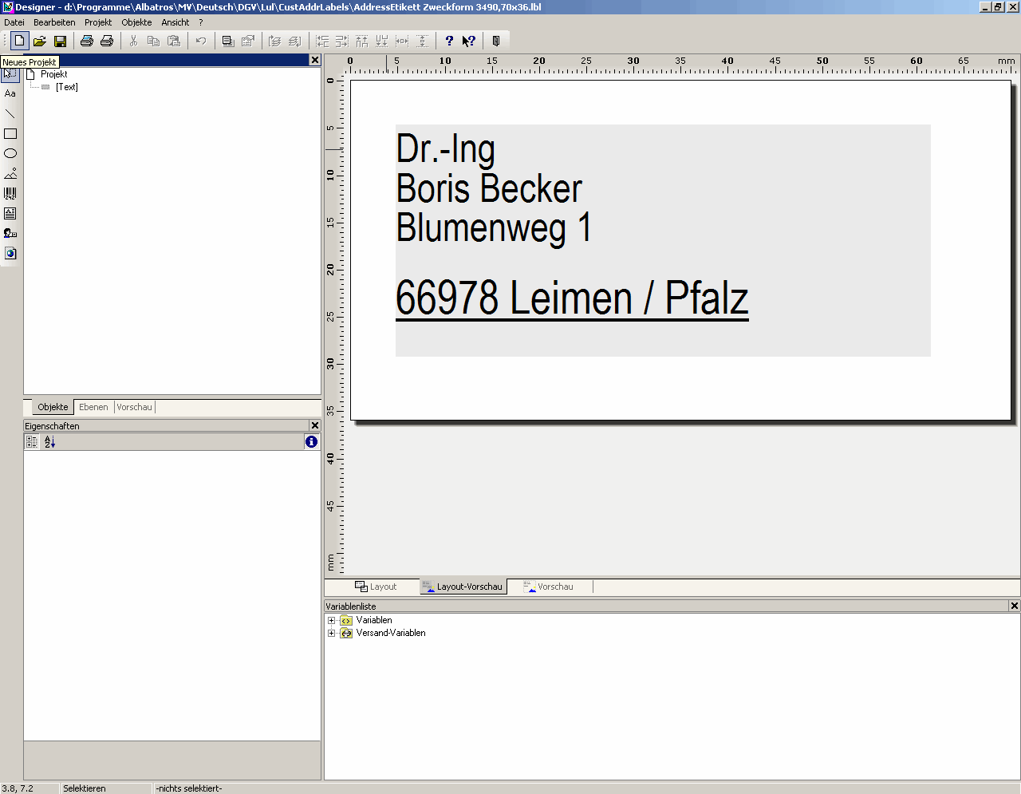 | - Now in the "Address Labels: Finish" screen, click the Designer button.  The program screen is displayed as follows:

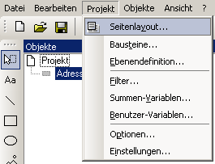 | - Select Projects from the menu bar and in the window that opens select Page Layout.  - In the window that opens select the definition tab.  You are now in the Designer template directory.

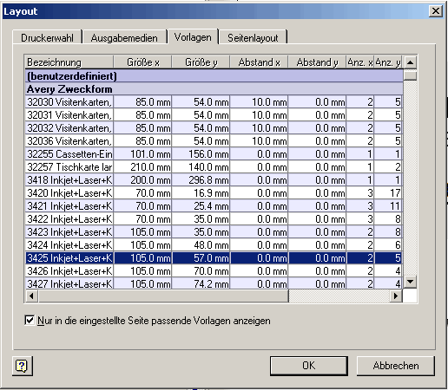

- Select the template for the desired address label.

In our example we are using Zweckform label 3425

- First confirm the selection by double-clicking.

The program switches automatically to the Page Layout tab.

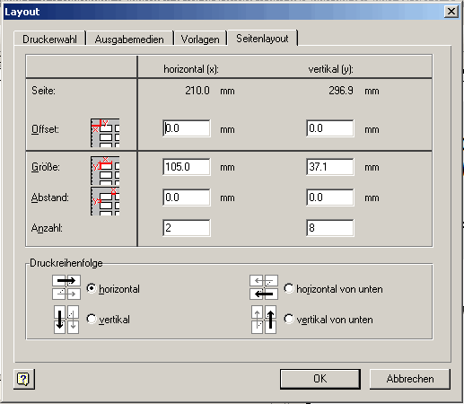 | In page layout you see the values for the address labels in horizontal and vertical arrangement.  The values you selected have been accepted in their entirety  Additional settings are usually not needed.  - After making your selection, click on the OK button.

In the Designer main screen you now see the new layout, along with rulers that correspond to the new label size.

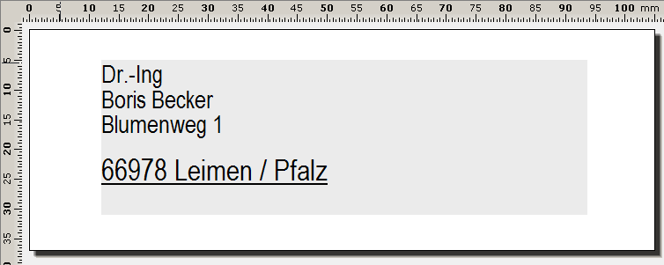

- When changing address labels, it is possible under certain circumstances that the label is printed off-center. If this is the case, simply click in the label you have created and while holding down the left mouse button, drag the label to the desired position.

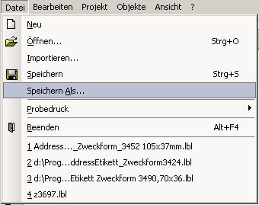 | - When all settings are correct, save the finished layout with a new name. To do this, go to the "File" menu and select "Save as..." from the drop-down menu.  - You can then leave the program with the button.

Note: If you save your personally-created label with the same name as the Albatros default, it is possible that this list will be reset to its original state at the time of the next program update. For this reason, it is recommended that you always choose a different file name.

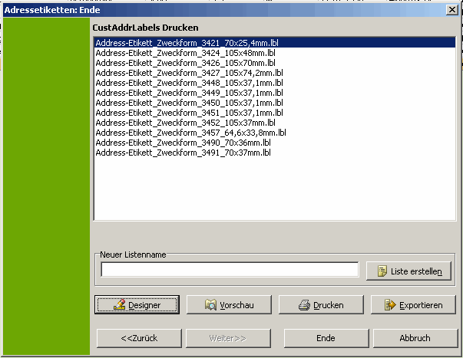

- In the overview you then see the labels that you have defined. We have made a small selection for you here from three default labels.

You have now successfully completed the third exercise, creating individual labels.

Note: When starting the Address Label wizard you can also choose the "By Family" option.

This choice creates labels for families. Always use this option when you wish to send special communications to families, or when you send advertisements and wish to send these flyers to families and not to each individual member. This can result in a reduction of your postage costs.

    - Generate a serial letter or an E-mail for the resulting selection.
- In order to create a form letter for the selection, click on the "Communication" menu, followed by "Serial Letters" and then "Serial Letter" in the menus that open.
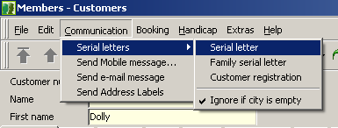

From the structure you can see that it is also possible to send a family serial letter as well as a customer communication. The option "Ignore if Address Empty" is ticked by default. Naturally you can uncheck this option first, if desired.

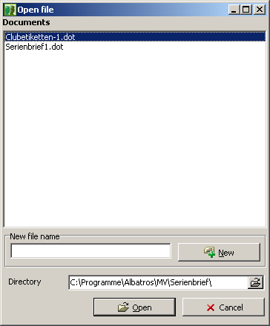 | The first time you use this option, only the standard template "Formletter.dot" is available.  - You can load this standard template by clicking the “Open” button or create a new template by entering a new list name and clicking the “New” button  In our example, we have prepared a template for verifying bank connections and have opened this one.

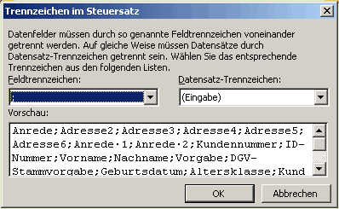 | - When opening Microsoft Word 2003 (used here), the "separators in control file" window opens.  - Semicolons have been selected as the separators. This is correct. Click on the "OK" button to confirm. The form letter is now started.

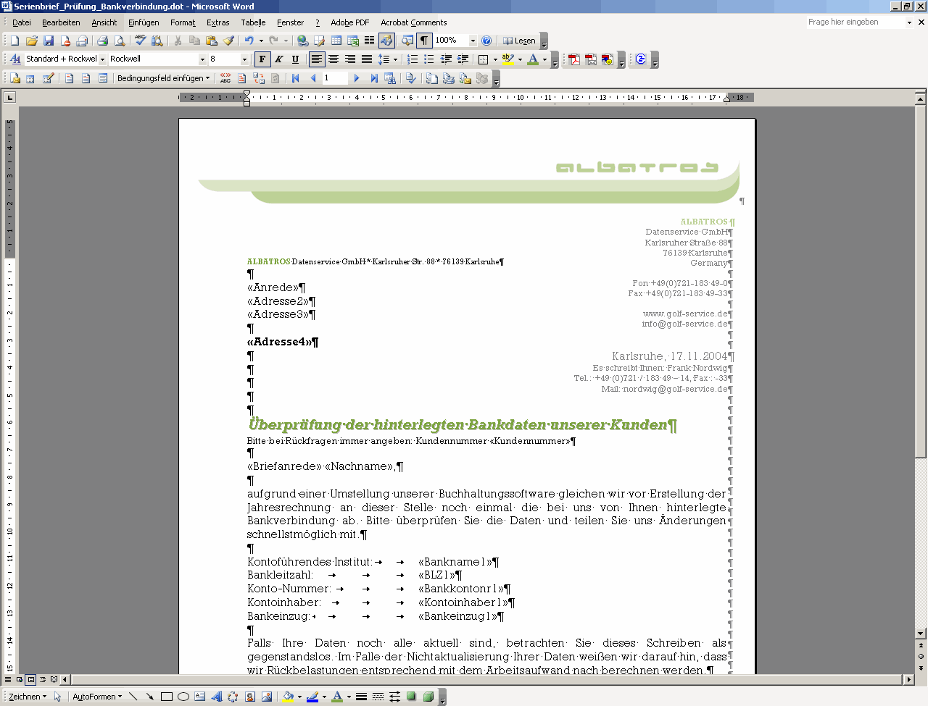

- You can see the form letter that you have begun in the overview screen. Now click on the "Extras" menu, and then on "Letters and Mailings" and "Create Serial Letter" in the following menus.

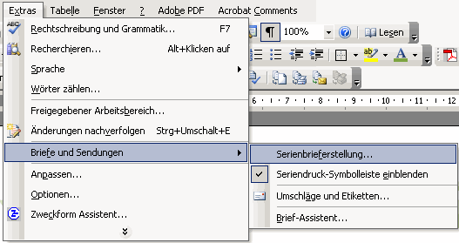

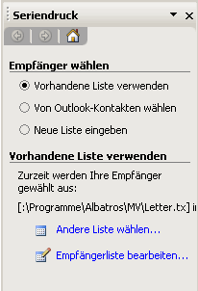 | - The Serial Letter wizard opens in Word. Under the first choice "Select recipients", in addition to the suggested list you can also select other lists or edit the present one  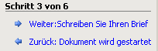  - If the present list is complete and contains addresses and data, you can skip this step and jump to the next one. Click on "Next".

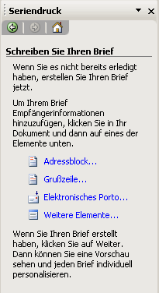 | - In the next option you can use the "Additional Items" link to position and format all the mail merge fields in the document. The feature "Electronic Postage" only works if it has been installed first.  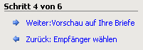  - When you have filled in the variables in the mail merge you can finish this step and move to the next one with the control list Click on "Next: Preview your Letters".

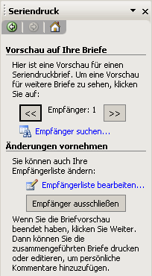 | - In the "Preview your Letters" option you can look at each letter individually and, if needed, make a note to yourself regarding recipients that have errors, or exclude that recipient.  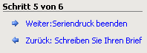  - When you have finished previewing your letters, you can move to the next step with the control list. Click on "Next: Finish Mail Merge".

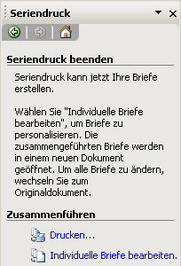 | - In the "Finish Mail Merge" option you can generate the letters. If you wish to print without further editing, click directly on the "Print" option.  - WE recommend, however, that you select the "Edit Individual Letters" option, so that you can personalize and modify the individual letters if needed. Now click on this option.

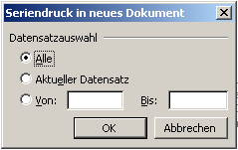 | - Keep the "Mail Merge in New Document - All" and in this dialog box click the OK button.

- The database and merge template will be combined into a new letter. Before you print, save the merged file.

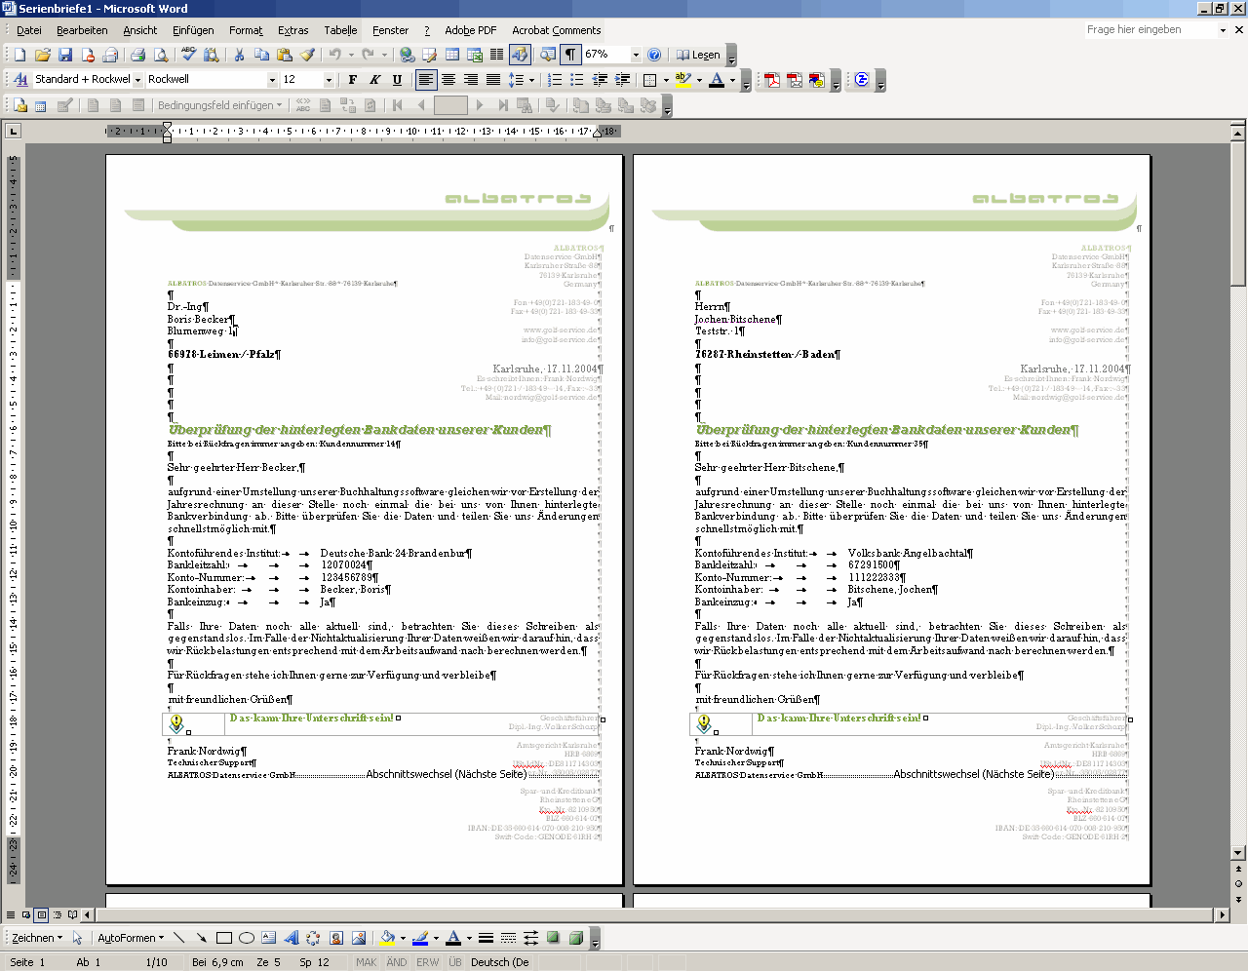

- Edit individual letters to personalize them. After personalizing the letters, you can print them in Microsoft Word in the usual way.

- Click on the printer in the Word toolbar. The print process will start automatically on the active printer.

  - Exercise 4: Subscriptions
    - Create a subscription preview
    - Create a subscription invoice

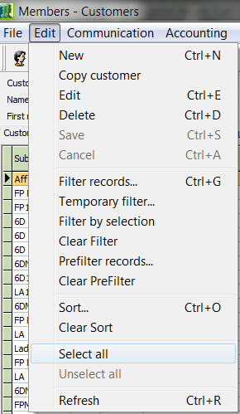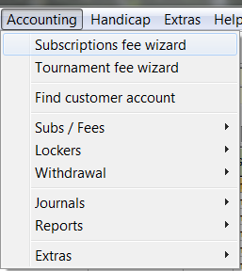

- To begin, click in the Edit menu and then on "Select All". All customers are now selected. Now click in the Accounting menu and then on Subscription fee wizard. The following dialog opens:

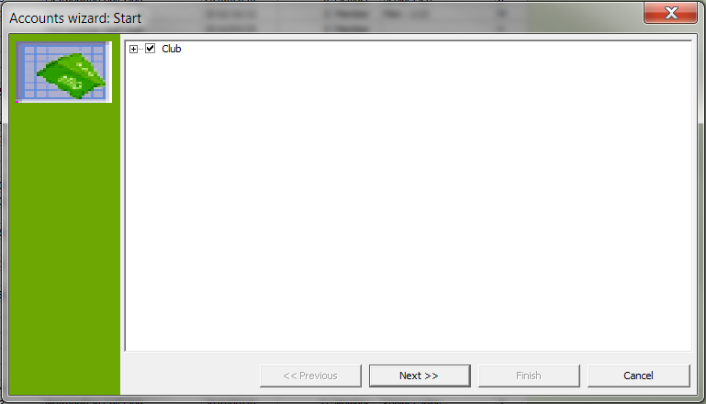

- In the start menu, the choice "Club" is selected - keep this choice. To start, click the button "Next".

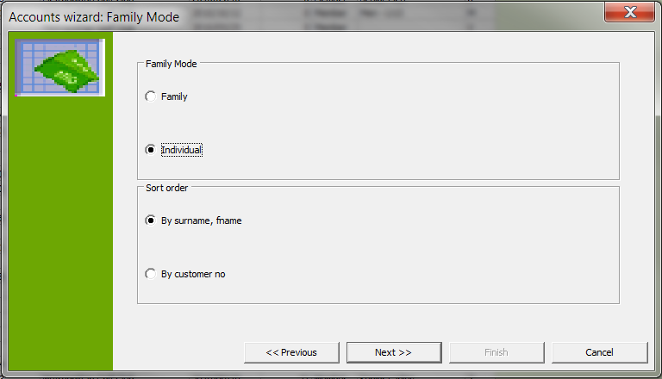

- You are now in Family Mode. In the first row you can select "Family" or "Individual", as well as select the sort orders "By surname, fname" or "By custno". When you have made your selection, click on the button "Next".

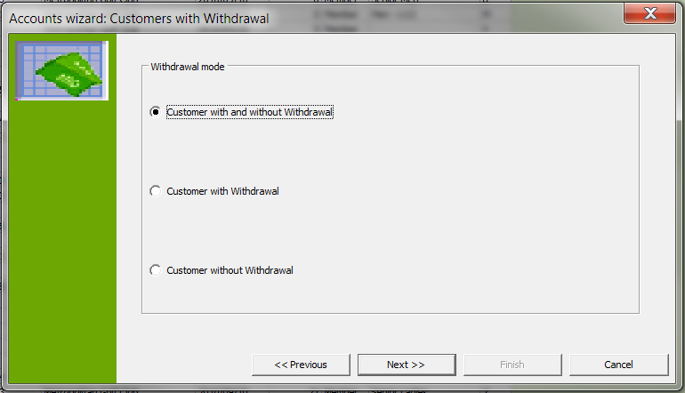

- Now the "Customers with Withdrawal" window opens. In our example we have selected "Customer with and without Withdrawal". When you have made your selection, click on the button "Next".

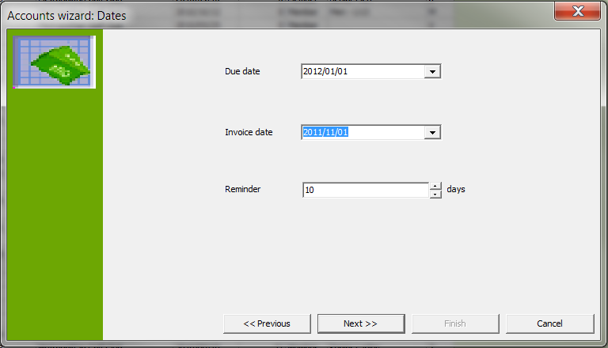

- You now come to the "Dates" screen. In the Due Date field, enter the due date, and in the Invoice Date field enter the date for which the invoice should be generated. When you have made your selection, click on the button "Next".

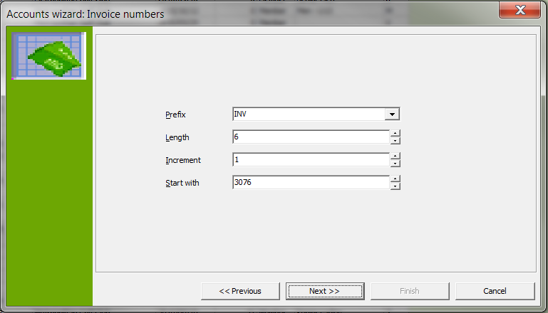

- In the next window you can specify the invoice prefix, the length of the invoice number, the increment and the beginning invoice number. When you have made your selection, click on the button "Next".

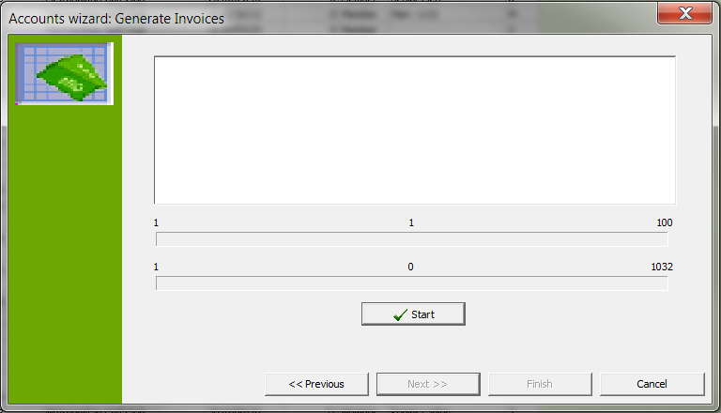

- You now come to the Generate Invoices screen. To start, click the button "Start" in the invoice wizard.

This screen shot shows you how the invoice generation process looks:

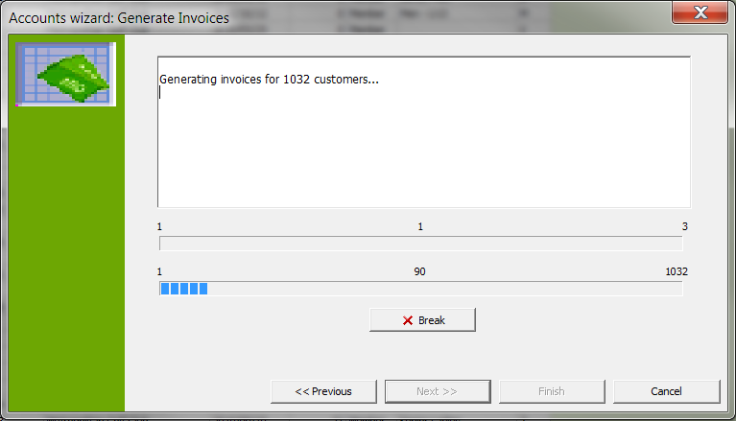

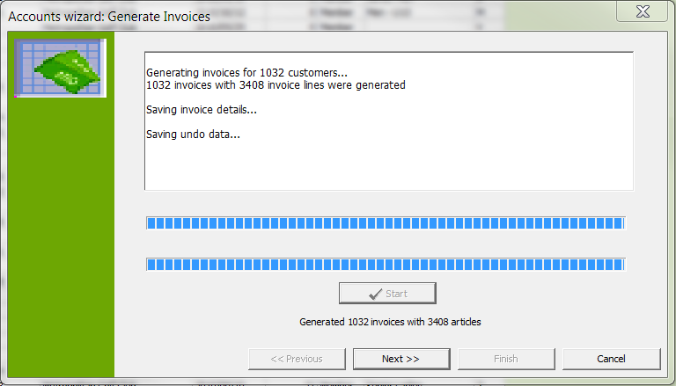

- Then the process has finished, you see that in our case 1032 invoices with 3408 items were generated. Click on the button "Next".

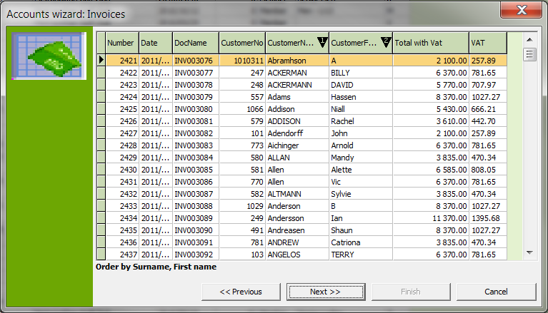

- Now the next window shows the generated invoices with the corresponding charges which have been assigned. You now have the opportunity to check the invoices. When you have finished, click on the button "Next".

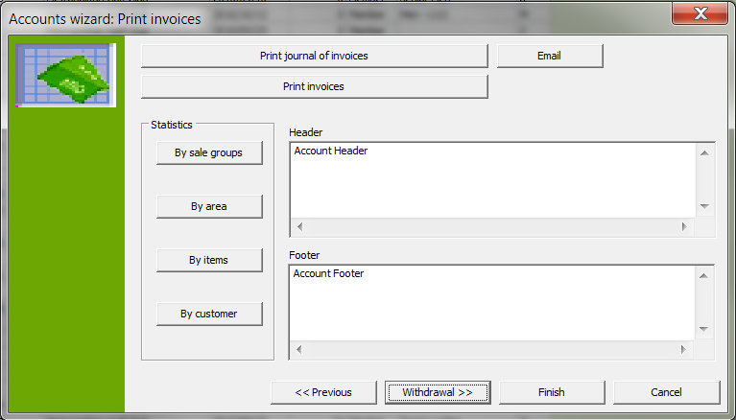

- You are now in the Print Invoices screen. First click the button Print journal of invoices. The following window opens.

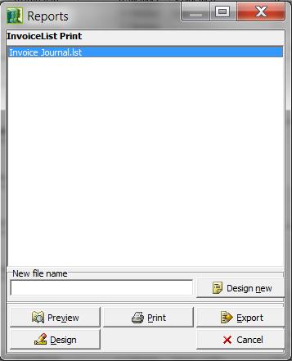

- In the "Reports" window, select the default "Invoice Journal.lst" as long as this has not already been created and click the "Preview" button.

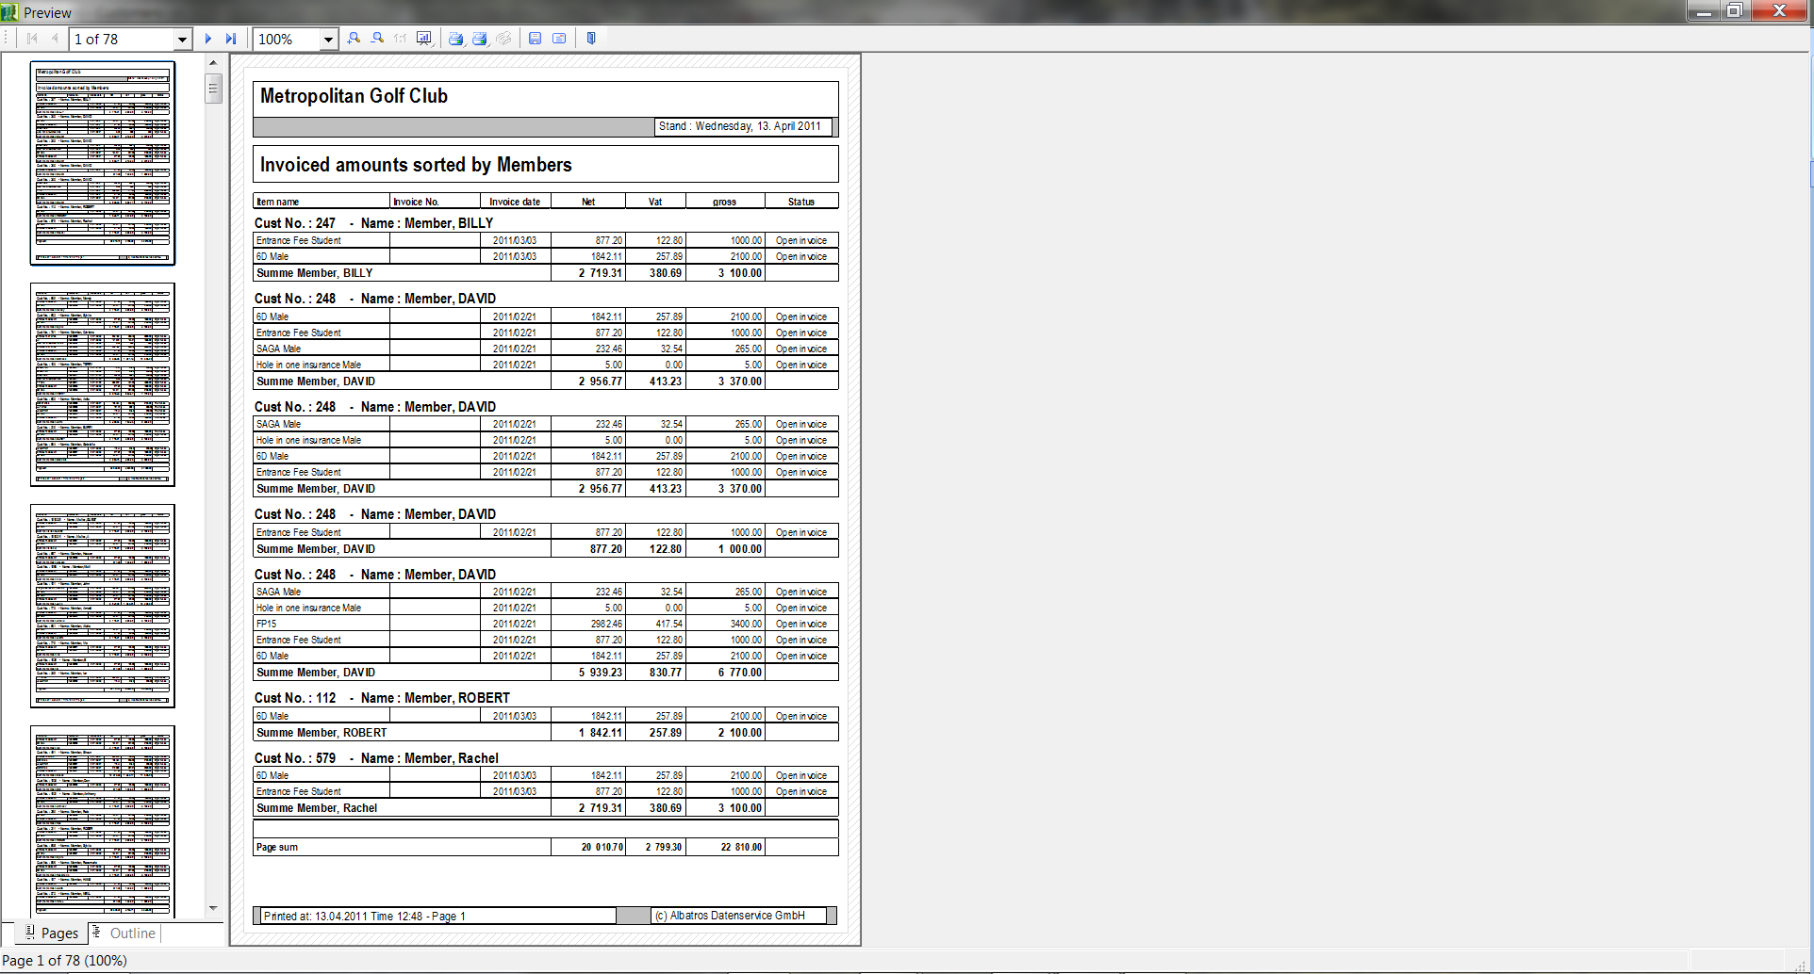

- In the preview you see the invoices in the journal. Click the left Print button to print the invoice journal directly and the right Print button if there are several invoices. If you need to select your printer first, do this by clicking with the right mouse button.
- Now click on the button "Print Invoices". This will print out your invoices.

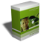 Support – Hotline

Support inquiry:  Monday – Friday | Operating hours: 08.00 – 17.00
Support-inquiry:  Saturday, Sunday or public holiday | Operating hours: 10.00 -15.00  Included but non-technical only
Remote maintenance  Monday – Friday | Included
Remote maintenance  Saturday, Sunday or public holiday | Included but non-technical only, subject to availability

Publisher of this manual:

iTee Solutions
Old Castle Brewery
Unit 404
6 Beach Road
Woodstock
7925
Office: 086-010 9372
Technical Support: 079-314 9571

Email: info@iteesolutions.co.za
Internet: http://www.iteesolutions.co.za

