iTee Solutions. Your iTee partner in golf.


Albatros Quick Guide

Step by step instructions on the most common
tools & functions in Albatros

Release: April 2012 - Ver. 8.8.0.0
Table of Contents

1. Backoffice 3
1.1 How to create, edit or delete a warehouse 3
1.2 How to create, edit or delete a sales group 3
1.3 How to create, edit or delete a search group 3
1.4 How to Add, Edit or Delete an Article 3
1.5 How to find an article 4
1.6 How to add a Combined article 4
1.7 How to create, edit / delete a supplier 5
1.8 How to create a supplier’s invoice 5
1.9 How to log / manage returns to suppliers 5
1.10 Stock Take Procedure 6
1.11 Print Article List 6
1.12 Do inventory maintenance 5
1.13 How to create and assign member standard conditions 7
1.14 How to set up and assign discounts 7
1.15 How to print a report – step by step 8
1.16 How to set up comments to help with food ordering 8

- Backoffice
  - How to create, edit or delete a warehouse
- Go to Articles info, click on Warehouses.
- Click on New, then capture only the relevant information – Code, Short name and Name – and click OK.
- You can edit and delete a warehouse by selecting the warehouse and using the edit and delete icons at the top of the page, saving any changes. You can only delete a warehouse if there are no articles associated with the warehouse.

  - How to create, edit or delete a sales group
- Go to Articles info, click on Sales groups.
- Click on New, then capture only the relevant information – Short name and Name – and click OK.
- You can edit and delete a sales group by selecting the sales group and using the edit and delete icons at the top of the page, saving any changes. You can only delete a sales group is there are no articles associated with the sales group.

  - How to create, edit or delete a search group
- Go to Articles info, click on Search groups.
- Click on New, then capture only the relevant information – Short name and Name – and click OK.
- You can edit and delete a search group by selecting the search group and using the edit and delete icons at the top of the page, saving any changes. You can only delete a search group if there are no articles associated with the search group.

  - How to Add, Edit or Delete an Article
- Click on New, then capture only the relevant information – Name, Short name, Warehouse, Unit, VAT Tax, Search group, Sales group, Price With VAT and tick or untick the following boxes: Article Allow Discount, Art. w/Stock Control, Active and Available.
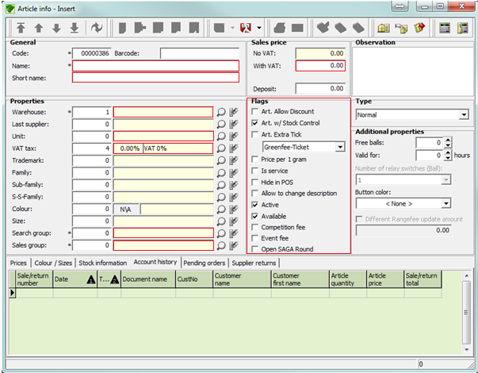

- When all the relevant information has been captured, you click on the Save button.
- To edit / delete an article, simply select the article and use the edit / delete icon at the top of the screen, saving any changes. You will not be able to delete an article if there are any sales associated with the article.
- For unused articles that cannot be deleted, you can untick the Active and Available boxes to remove the article from the Point of Sale.
  - How to find an article
- Simply click anywhere on the screen and start typing the name of the article, if it is listed it will be highlighted.

  - How to add a Combined article
- Go to Articles info and click on Combined articles and click on New.
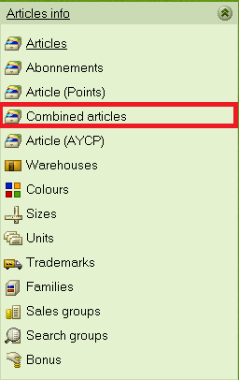
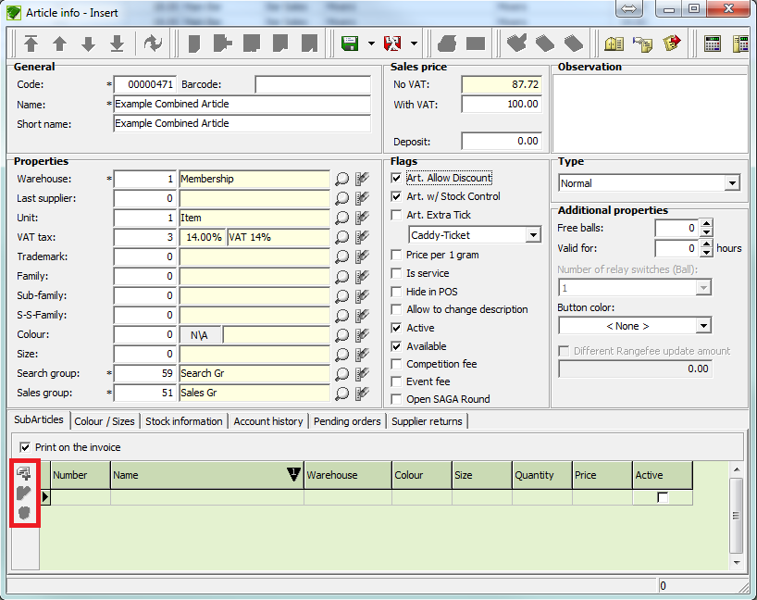
- Then capture only the relevant information – Name, Short name, Warehouse, Unit, VAT Tax, Search group, Sales group, Price With VAT and tick or untick the following boxes: Article Allow Discount, Art. w/Stock Control, Active and Available.

ADD
EDIT
DELETE

- Then click on the bottom of the screen – SubArticles – Add – and add the ingredients from the article list.
- Please note the cost of the individual articles will automatically add up and change the sales price at the top right of the window so you have to ensure you check it before saving the combined article.
- Click Save to complete.

  - How to create, edit / delete a supplier
- Go to Movements, click on Suppliers, then New
- Next capture all the necessary information – name, address, contact numbers and email address - and click OK
- To edit / delete, select supplier and click the edit / delete icon at the top of the page and Save. You can only remove a supplier if there are no articles associated with the supplier.

  - How to create a supplier’s invoice
- Make sure that all relevant articles are created before you capture the supplier invoice.
- Go to Movements, click on Suppliers invoices, and then click on New.
- In the Insert window, select the supplier from the list next to Supplier number (if Supplier is not listed, click New and create a new Supplier)
- You then add the invoice number and date.
- To add the articles, click on the main screen to activate and click New
- You then have the option to view Only last supplier articles or All suppliers’ articles, if this is your first invoice capture, ensure you have All Suppliers ticked.
- You then select the articles from the list by clicking on them and capturing quantity, price with VAT as well as discount %.
- When you are satisfied all articles have been added and the total amount is correct, simply click Accept.

  - How to log / manage returns to suppliers
- Click on Movements, Suppliers remittance guides, then click New
- On the Insert screen capture the information requested by selecting the supplier from the existing list.
- Capture the invoice number and date at the top right hand side of the screen.
- Then click New again to start adding the articles you want to return – please note the selection on the right hand side where you can select to view only articles you have ordered from this supplier or All suppliers
- Insert quantity, the price will be displayed already, you can edit this if you choose, then click Save (Top Right).

  - Stock Take Procedure

- Print Article List
- Count your stock
- Do inventory Maintenance

  - Print Article List
- Go to Articles info and click on Articles.
- Ensure that you select the correct Warehouse, Family, Search group and Sales group so that you are viewing the articles you want to do inventory of.
- Right click anywhere on the article list and select Print article list...
- Select any of the report options and click Preview so you can view the list before printing it.
- If you are happy with the list click on the Print icon and your list will be printed.

  - Do inventory maintenance
- Go to movements, Inventory Maintenance
- Select the warehouse you want to take inventory of
- Click Open at the top of the page – you will now have a list of all your articles and a column where you can capture new stock quantities third from right, you can also insert new average price and reason for any indiscrepencies.
- When you are done, click on the Close Inventory icon at the top of the screen.
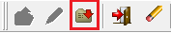

- A message will appear to confirm that you want to update your stock and cost Price. Click on yes.
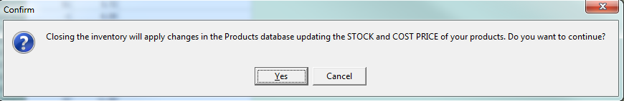

Please note you cannot make any changes to articles when you have inventories open so be sure to close inventories properly when you are done.
  - How to create and assign member standard conditions
You will do this after you have created (a) new member type/s.

- Go to POS and click on Standard conditions. Check to see if the correct conditions are already there. If not, create a new standard condition that applies to the new membership type.
- Give the condition a name and set the dates when the condition is applicable.
- For a green fee click on the small add new button. Select the green fee article, 9 or 18 holes and the age groups and save the condition when done.
- Click on Assign member standard condition, select the new member type, tick all the standard conditions that apply to this new member type and Save – PLEASE NOTE you have to ensure that all standard conditions that apply to this membership type – including ALL the bar discounts and happy hours - are selected.

  - How to set up and assign discounts
- Go to POS, click on Standard condition, click New
- Name the discount – e.g. Bar Discount
- Apply Day of month, Day of week, Time intervals, Date Periods
- Then go to the Discount section at the bottom of the page and specify the discount percentage that applies to each search group.
- There are two columns Pro, % that gives discount in reception and F+B, % that applies to discount in Gastro / Food & Beverage.
- When discounts have been assigned click on Save.
- Then click on Assign member standard conditions, and then ensure that the discount condition you just created is assigned (ticked) to all the relevant member types.
  - How to print a report – step by step
- Under Maintenance Reports you will find reports related to suppliers, inventories, stock levels and supplier orders.
- Under POS (Point of Sale) reports you find Weekly and Monthly payments, financials, green fees, discounts, balance reports, articles sold by sales and search group reports etc.
- BEFORE selecting the report you want to print, first select the correct warehouse, then start and end date, POS Locs (Point of Sale locations), sales and search groups.
- You then select your chosen report, select where further prompting and then click Preview. If you are happy with the information on the report, click Print.
- For supplier reports and inventory reports, a window with the relevant data is displayed and the print icon is active. For the Inventory, Current Stock, Purchases and Open purchase orders reports, a wizard enables you to print the report.

  - How to set up comments to help with food ordering
- Click Food + Beverage, Article comments
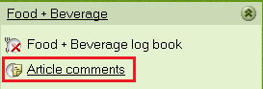
- Click new and add your text – e.g. White bread, Brown bread, Eggs overeasy, Eggs Sunny side up (to add with breakfast orders), Rare, Medium, Well done (to add with a steak order)

These comments will be available on Food + Beverage for the staff to add to order when they are ringing up the meals to help kitchen staff with preparation and presentation.

