
iTee Solutions. Your iTee partner in golf.

Manual:
Backoffice
(Stock control)

Release: March 2011 Ver. 8.7.0.0 - Rev. 1.0.2 FNO

Table of Contents
1. Maintenance Reports 8
1.1 Print a Report 8
1.1.1 Direct printing 8
1.1.2 Printing with the Wizard 8
1.2 Print barcode labels 8
1.3 Customer Conditions 8
2. POS Reports 8
2.1 Print a report 8
2. Booking (add-on module to Reception) 8
3. Articles 8
3.1 Create a new article 8
3.2 Change an item 8
3.3 Delete an item 8
3.4 Print barcode labels 8
4. Warehouse 8
4.1 Create a new warehouse 8
4.2 Edit a warehouse 8
4.3 Delete a warehouse 8
5. Colours 8
5.1 Add a new colour 8
5.2 Edit colours 8
5.3 Delete a colour 8
6. Sizes 8
6.1 Add a new size 8
6.2 Edit size 8
6.3 Delete a size 8
7. Units 8
7.1 Add a new unit 8
7.2 Edit unit 8
7.3 Delete a unit 8
8. Families 8
8.1 Add a new family 8
8.2 Edit family 8
8.3 Delete a family 8
9. Sales groups 8
9.1 Add a new sales group 8
9.2 Edit a sales group 8
9.3 Delete a sales group 8
10. Search groups 8
10.1 Add a new search group 8
10.2 Edit a search group 8
10.3 Delete a search group 8
11. Age groups 8
11.1 Add a new age group 8
11.2 Edit an age group 8
11.3 Delete an age group 8
12. Address 8
12.1 Add a new address 8
12.2 Edit an address 8
12.3 Delete an address 8
13. Address Title 8
13.1 Create a new address title 8
13.2 Edit an address title 8
13.3 Delete an address title 8
14. Name Affix 8
14.1 Create a name affix 8
14.2 Edit extra name affix 8
14.3 Delete extra name affix 8
15. Address letter 8
15.1 Add a new address letter 8
15.2 Edit the address letter 8
15.3 Delete an address letter 8
16. Occupation 8
16.1 Create a new occupation 8
16.2 Edit an occupation 8
16.3 Delete an occupation 8
17. Customer types 8
17.1 Create a new customer type 8
17.2 Edit a customer type 8
17.3 Delete a customer type 8
18. Member types 8
18.1 Create a new member type 8
18.2 Edit a member type 8
18.3 Delete a member type 8
19. Suppliers 8
19.1 Create a new supplier 8
19.2 Edit a supplier's details 8
19.3 Delete a supplier 8
20. Suppliers invoices 8
20.1 Create an invoice 8
20.2 Direct entry of an article 8
20.3 Article from a Purchase Order 8
20.4 Edit an invoice 8
20.5 Delete an invoice 8
20.6 Print an Invoice 8
21. Suppliers remittance guides 8
21.1 Create a remittance 8
21.2 Direct entry of an article 8
21.3 Edit a remittance 8
21.4 Print a remittance entry 8
22. Suppliers orders 8
22.1 Create an Order 8
22.2 Edit an order 8
22.3 Delete an order 8
22.4 Print an order 8
23. Inventory maintenance 8
23.1 Create a new inventory 8
23.2 Edit an inventory 8
24. Warehouse updates (transfers) 8
25. Holidays 8
25.1 Create a Holiday 8
25.2 Edit a holiday 8
25.3 Delete a holiday 8
26. Weekends 8
27. Doors 8
27.1 Create a door 8
27.2 Edit an entry 8
27.3 Delete a door 8
28. Countries 8
28.1 Create a country 8
28.2 Edit a country 8
28.3 Delete a country 8
29. Document Type 8
29.1 Create a document type 8
29.2 Edit a document type 8
29.3 Delete a document type 8
30. Methods of Payment 8
30.1 Create a method of payment 8
30.2 Edit a payment method 8
30.3 Delete a payment method 8
31. VAT 8
31.1 Create a VAT 8
31.2 Edit a VAT 8
31.3 Delete a VAT 8
32. Daily Comments 8
32.1 Make entries 8
32.2 Evaluation of the entered data 8
33. Standard Conditions 8
33.1 Create a condition 8
33.2 Change a condition 8
33.3 Delete a condition 8
34. Assign member standard condition 8
34.1 Assign a standard condition 8
35. Member doors Permission 8
35.1 Assigning doors permissions 8
35.2 Edit doors permissions 8
36. Employee doors permission 8
36.1 Assigning doors permissions 8
36.2 Edit doors permissions 8
37. Food & Beverage logbook 8
38. Article comments 8
38.1 Create a new article comment 8
39. Remote access by our support team with Netviewer 8
39.1 Netviewer icon on your desktop 8
39.2 Remote access in the Albatros modules 8
39.3 Starting the remote access session 8

REPORTS

- Maintenance Reports
These reports are helpful for managing your suppliers, doing inventories and general stock control.

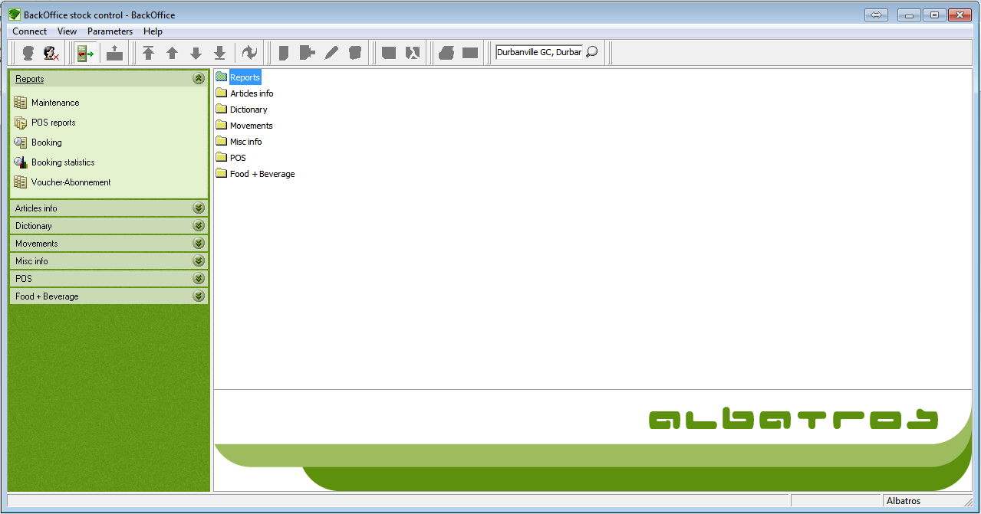

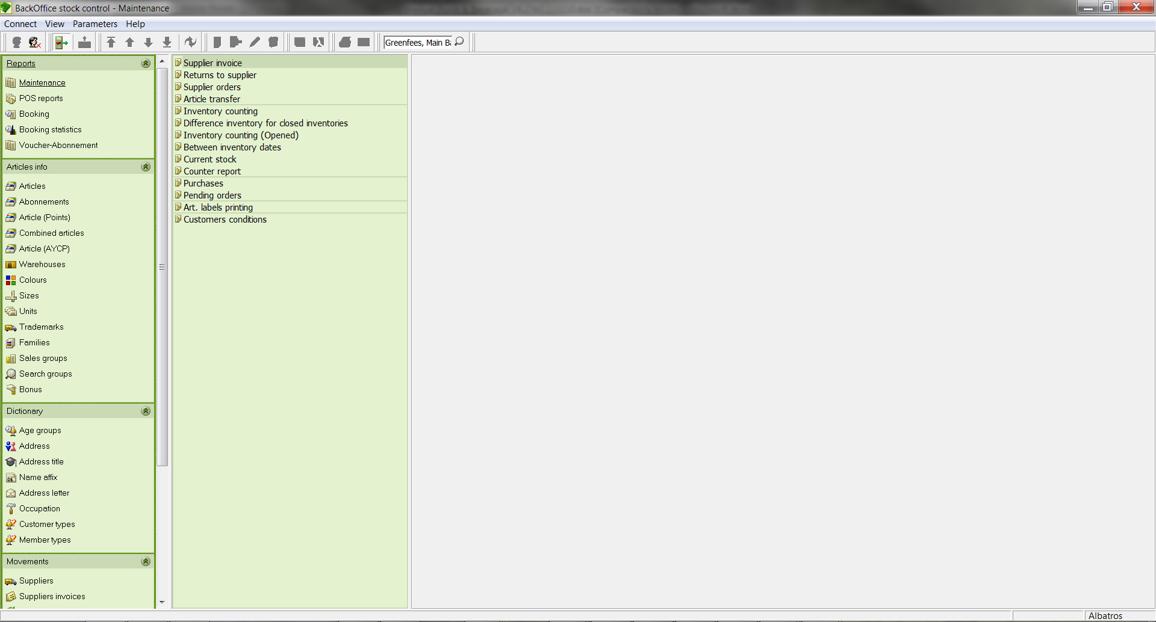
  - Print a Report
- Click the report you wish to print.
- Under the master data reports you find reports concerning merchandise management and customer conditions. For supplier reports and inventory reports, a window with the relevant data is displayed and the print icon is active. For the Inventory, Current Stock, Purchases and Open purchase orders reports, a wizard enables you to print the report.

    - Direct printing
- If needed, refresh the data with the icon.
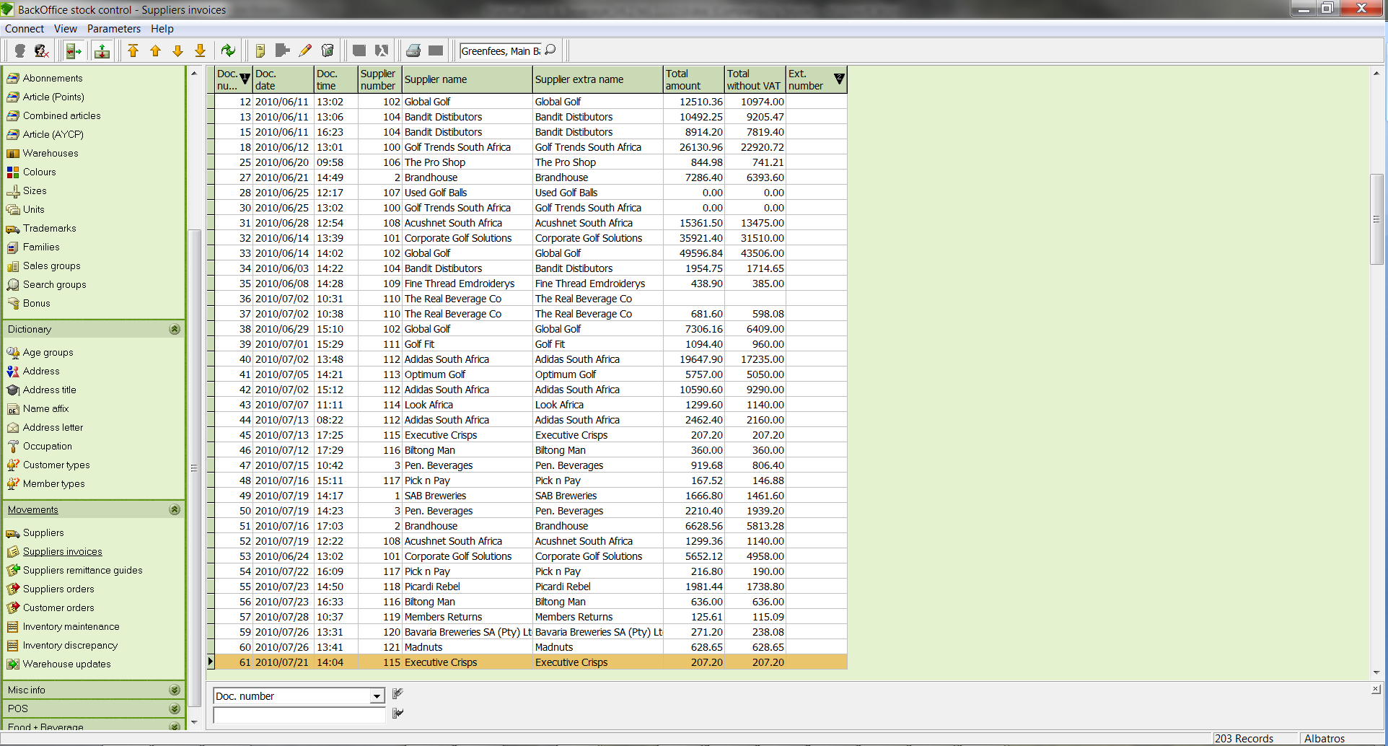
- Click the Print button. 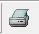
- The Reports window opens.
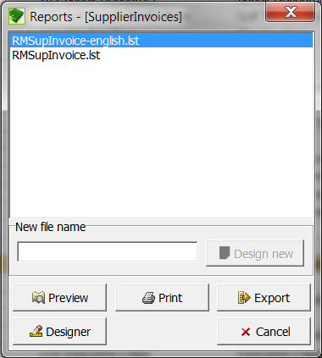

- Now click on the Preview button.
"Order by" selection window
Article Number The report is sorted by article number.
Name The report is sorted by article name.
Article Colour The report is sorted by article colour.
Article size The report is sorted by article size.
Warehouse The report is printed according to warehouse.
Descending If this box is ticked, the report will be sorted in descending order according to the selected criteria.

- Select the criteria to be used in sorting the report.
- Click the button OK.

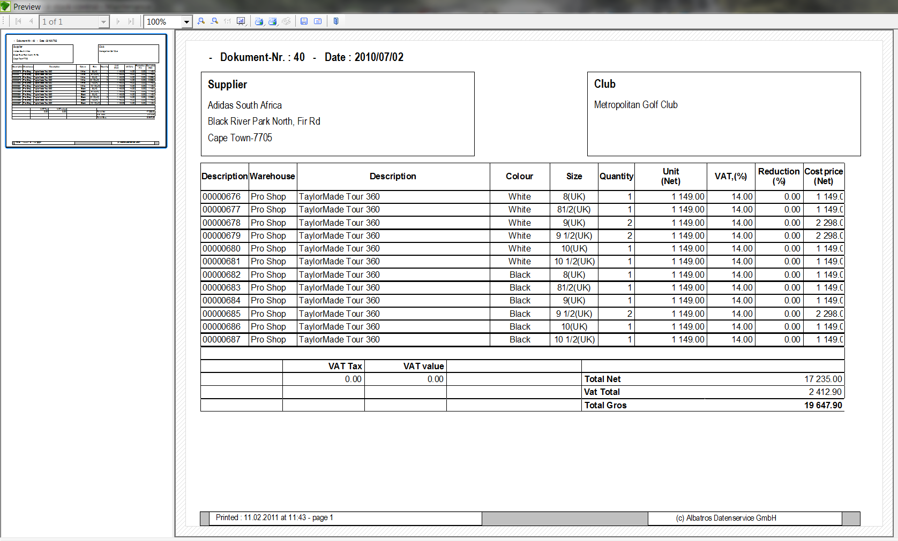

You are now in the List&Label preview. By using the Print button on the menu bar,

.

You can print the displayed page or all pages. You can select the printer to be used by right-clicking on the printer icon. By rolling your cursor over the additional functions you will see popup tool tips.

Here you have the windows-standard printer selection dialog along with the choice of pages to print.

- In the first field you see the printer selection, in the second field the current printer selection which can be changed with the button “selection”, and in the third field the optional page settings.

- Start printing the report with the button “OK”.

    - Printing with the Wizard
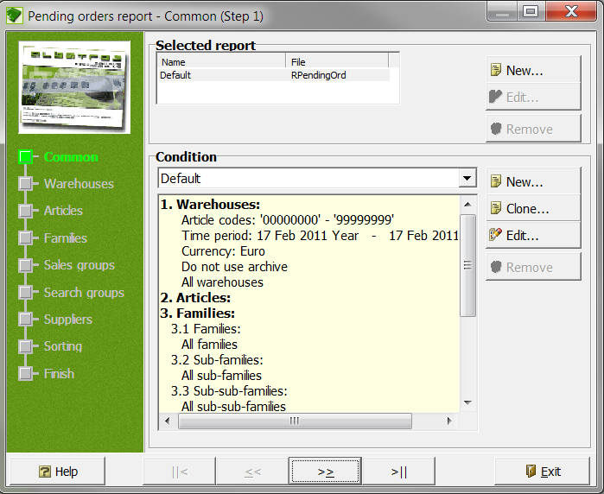

Input Fields
Selected Report With the "New", "Edit" and "Remove" buttons reports can be created, changed and deleted.
Condition With the buttons "New", "Clone", "Edit" and "Remove" you can save and edit standards (conditions).
Buttons
New Create a new report/condition.
Edit Edit a report/condition.
Remove Delete a report/condition.
Clone Copy a condition.
Exit Leave the wizard without entering or transferring any data.

- Select the report and any corresponding conditions.
- Click the button Next.

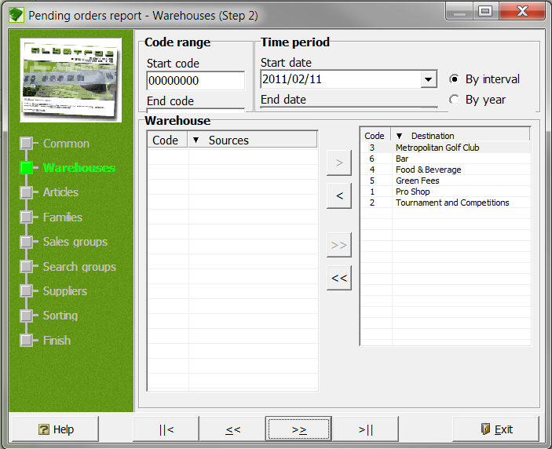

Input Fields
Start code Input field for the lowest article number that should appear in the report.
End code Input field for the highest article number that should appear in the report.
Start date All dates after this date will be included in the report. The date can be entered manually or by using the calendar sheet.
End date All dates before this date will be included in the report. The date can be entered manually or by using the calendar sheet.
By Interval If the By interval field is selected, the report can be limited to a time period after the given date.
By year If this field is selected, the report can be limited to a specific year.
By month If the By month field is selected, the report can be limited to a specific month.

- Enter a time period for the report.
- Select the corresponding warehouse by moving it with the arrow button into the window on the right.
- Click the button Next.

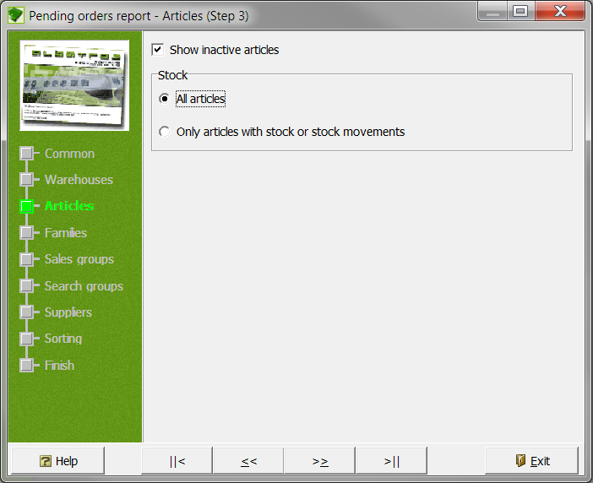

Input Fields
Stock
All Articles If this field is selected, all articles will be considered in the report.
Only articles with stock If this field is selected, only
or stock movements articles with stock or stock movements will be considered for the report.

- Select the corresponding criteria for the report and then click the Next button.

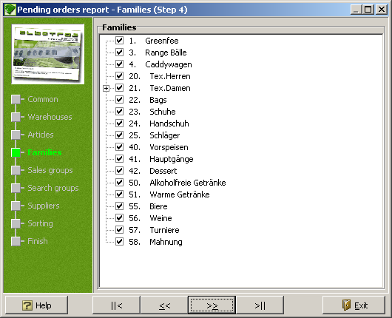

- Select the article families to be used for the report
- Click the Next button. .

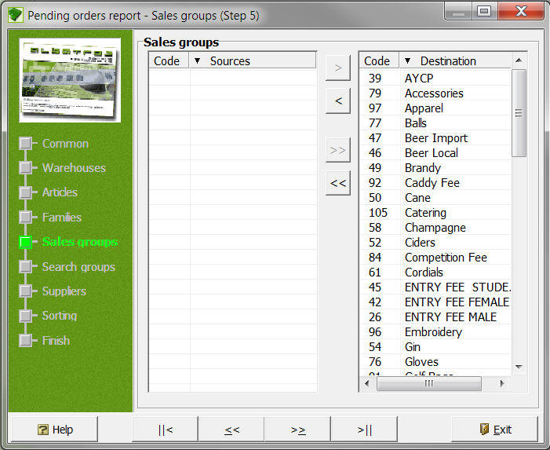

- Select the corresponding sale groups for your report by moving them with the right arrow button into the right-hand window.
- Click the Next button.

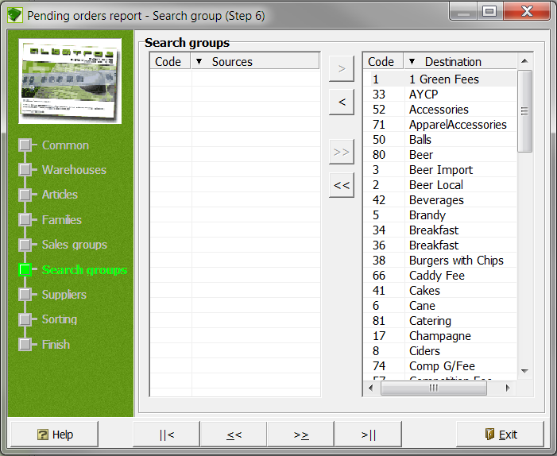

- Select the corresponding search groups for your report by moving them with the arrow button into the right-hand window and then click on the button.

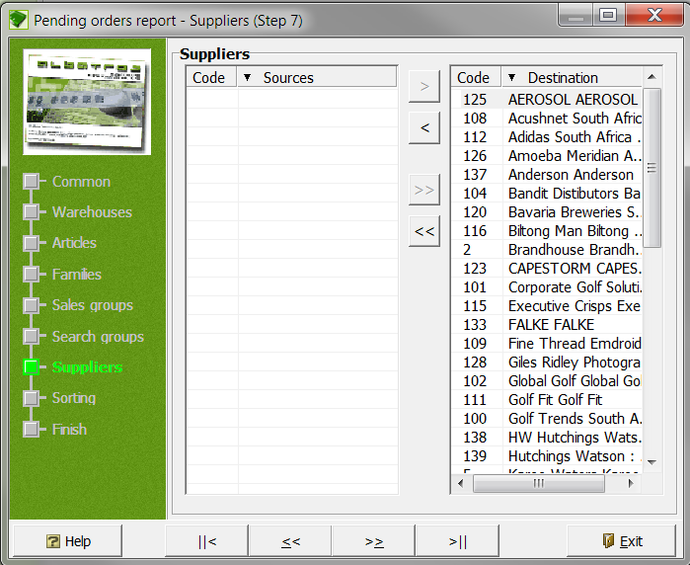

- Select the corresponding suppliers for your report by moving them with the arrow button into the right-hand window and then click on the Next button. .

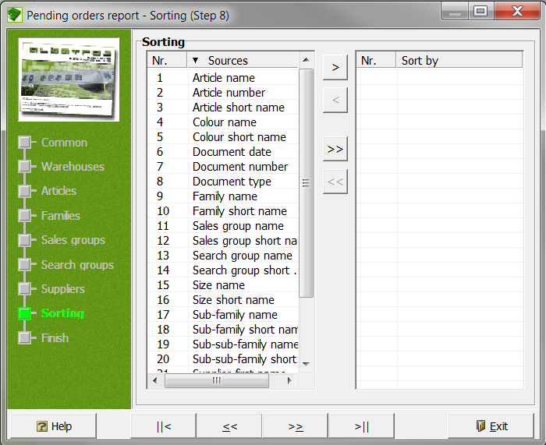

- Select the corresponding sort criteria for your report by moving them with the arrow button into the right-hand window.
- Click the Next button .

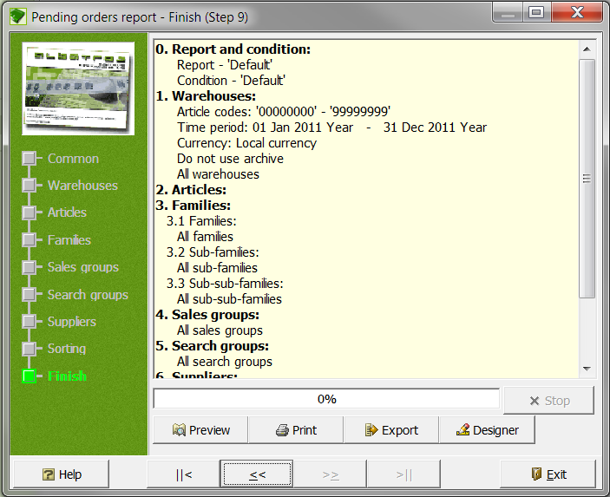

All data relevant to the report will be consolidated.

Buttons
Stop Stop the print preparation process.
Preview With the preview button you can see the report before printing it.
Print Print the report.
Export Export the report.
Designer Open the Designer.

- Click the”Export” button.

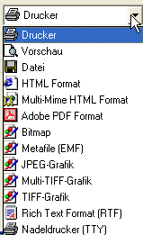

- Here you are give the Albatros-standard option of exporting the data in another format. Select the desired format and export the report with the "Start" button.

  - Print barcode labels
- Articles must be selected before they are visible in this window!
- Click the icon to print barcode labels.
In the next window the articles selected for barcode printing will be displayed. The articles can be filtered with the drop-down menus "Warehouse" and "Family".

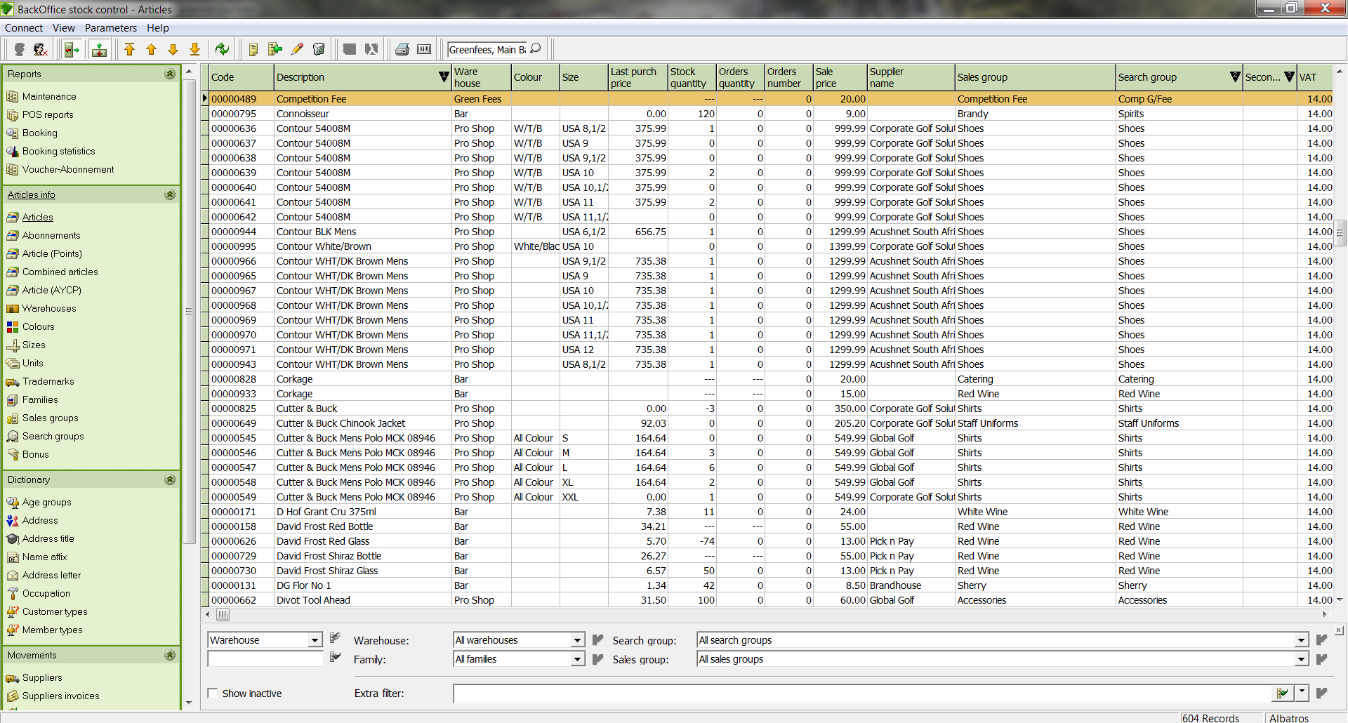

- Select the articles for which you wish to print barcode labels. You can select all articles by holding in the shift key and using the right mouse button or select individual articles by using <Ctrl> left-click.
- The printer icon opens the dialog for printing barcodes based on List&Label (laser or ink-jet printers with sheet-fed labels).
- The "Barcode" icon prints the barcode labels on a simple label printer.
- With the print icon you are taken to the "Print' menu. For each article, as many labels will be printed as there is inventory in the warehouse.
- You can define whether only one label will be printed (when you are not labeling all articles but rather a code sheet for the cash register) or according to quantities on hand (See comment 1).
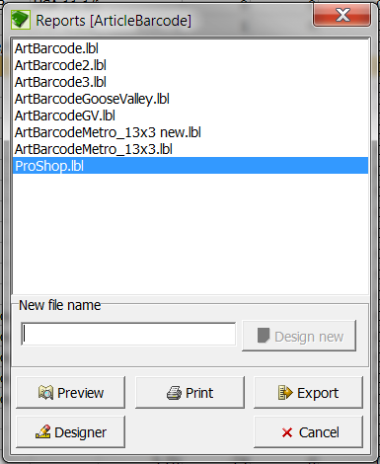

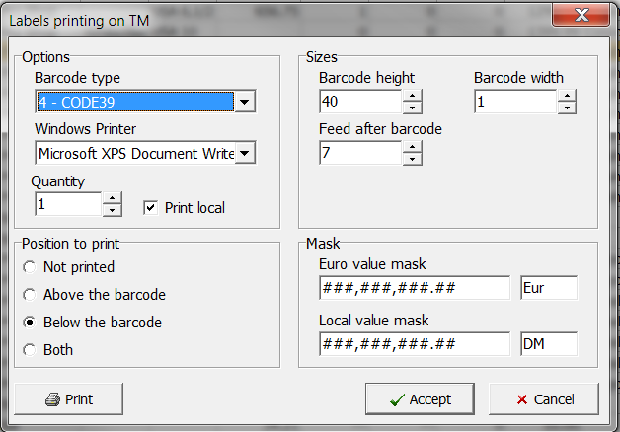

- With the "New Entry" icon new articles for the barcode print can be selected.

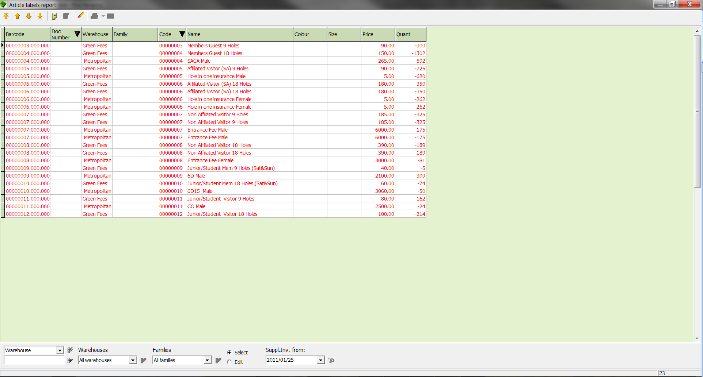

- The articles can be marked with multi-select.
- Save the selected articles with the Save icon. Next you are returned to the main dialog.

  - Customer Conditions
This is a report that displays all customers’ conditions and can include greenfees, rangefees, balls allowed, days of the week and month allowed to play etc.

- When clicking on this option you will have the following filtering and sorting options:

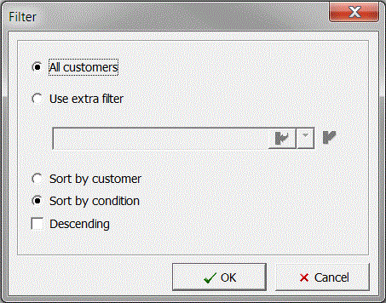
Display all customers The report displays all customers.
Use extra filter You will be given other variables to filter by
Sort by customer The report is sorted by customer.
Sort by condition The report is sorted by condition.
Descending The report is descending by condition levels.

- When you click use extra filter and you click on the search button next to the option, this screen will appear, giving you numerous other fields to filter the results.

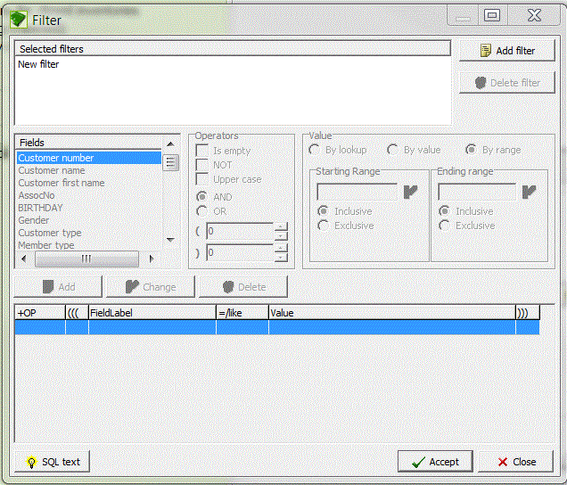

- When you have selected OK to get a preview of this report, this is what you will see:

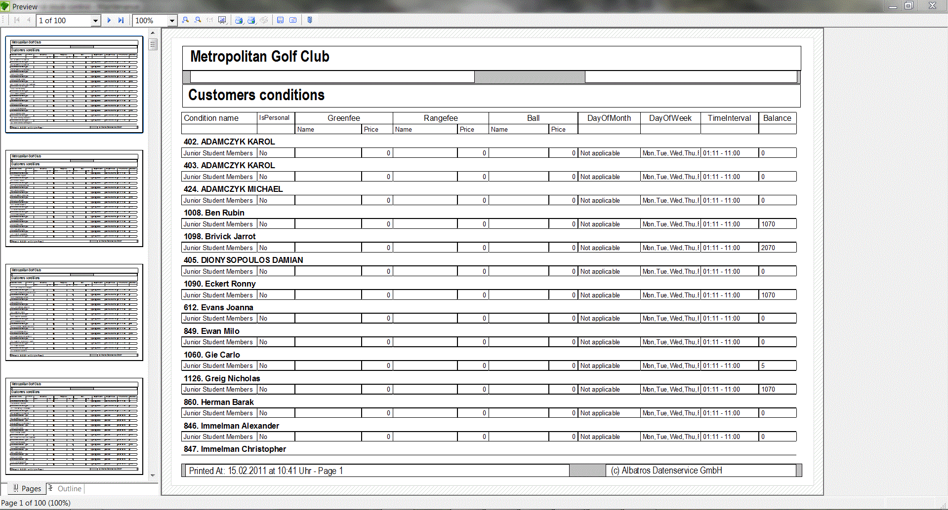

2. POS Reports
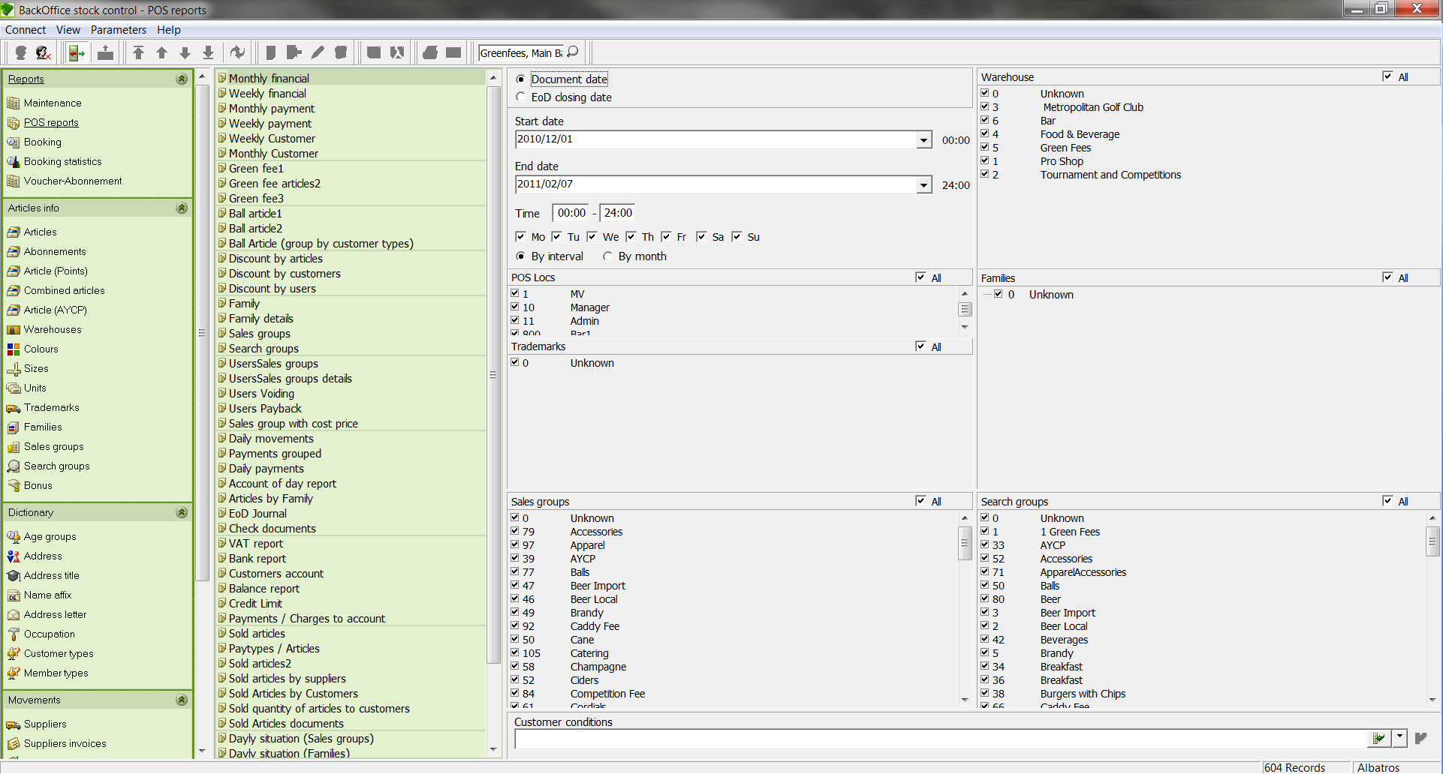

Filter Options
Document Date If this tick box is active, the entered date range is used as a filtering criterion.
EoD Closing Date If this tick box is active; the entered End of Day is used as filter criterion.
Start date Input field for the relevant start date for the report.
End date Input field for the relevant end date for the report.
All If this box is ticked, all sale groups, search groups and families will be evaluated. If this box is unticked, individual areas can be selected.
Buttons
Preview With the preview button you can see a report before it is printed.
Print Print the report.
Designer With the Designer, individual format changes can be made to the report. More information about using the Designer can be found in the Designer User Manual.
Export With Export, you can export data in various formats.
Cancel With the Cancel button you can cancel your selection and jump to the previous List.

Reports
Monthly Financial Monthly overview of sales sorted by sales groups.
Weekly Financial Weekly overview of sales divided into time periods and sorted by sales groups.
Monthly Payment Monthly overview of receipts and payments to customer accounts.
Weekly Payment Weekly overview of receipts and payments to customer accounts.
Green fee1 List of green fee / range fee sales sorted by club with customer data.
Green fee articles2 List of green fee / range fee sales sorted by customer.
Green fee3: List of green fee / range fee sales sorted by club without customer data.
Ball article1 Report of ball automat bookings sorted by club. This report is only available when the PORTMAN program is being used.
Ball article2 Report of ball automat bookings sorted by Customer. This report is only available when the PORTMAN program is being used.
Ball article Report of ball automat bookings sorted by customer
(group by customer subtypes. This report is only available when the PORTMAN
type) program is being used

Discount reports List of the discounts given by Articles, Customers & Users
Family Sales report for a selected time period sorted by family.
Family details Sales report for a selected time period sorted by families.
Sales group Sales report for a selected time period sorted by sale groups with profit data by grouped in percentages.
Search group Sales report for a selected time period sorted by search group.
Users Sales groups Sales group income sorted by employees.
Users Sales groups details Sales groups income with articles sorted by employees.
Sales groups with cost
price Article sales by sale group with profit data

Daily movements Daily bookings sorted by booking type.
Payments grouped List of payments by payment time with total.
Daily Payments List of daily payments with employee data, sorted by document type.
Account of Day report Article sales sorted by sales group with purchase/sales price and profit.
VAT report Bookings sorted by VAT rates and sales groups.
Bank report Totals by payment type and taxable portion.
Customers account You can print the following reports with these options:
Account statement Statement of the booking records for the corresponding time period
Bookings with payments
from
Direct / Account Customer list with booking record and total

Customer account
detail report Customer's account summary

Balance report List of customer account balances
Credit Limit List of customer credit limits
Payments / Charges Lists all payments and charges to an account
to account sorted by day

Sold Articles Income report by payment type per sales group.
Paytypes / Articles Income report by payment type per payment method
Sold Articles2 Lists all article sales by customer.

Sold articles by List of sold articles per supplier.
Suppliers

Sold articles by Lists all sold articles with customer
Customers information – detailed report

Sold quantity of articles Lists green fee and driving range
to customers: sales to customers.

Sold articles documents Lists all sold articles.
Daily situation
(Sales groups) Daily list of sold articles by sales groups

Daily situation (Families) Daily list of sold articles by family.
Year Yearly evaluation sorted by sales groups.
Sales group

Year Yearly evaluation sorted by family.
Family

2.1 Print a report
- Click on the desired report and in the window that opens click on the button Preview.

You are now in List&Label and can view and edit pages with the option from the toolbar.

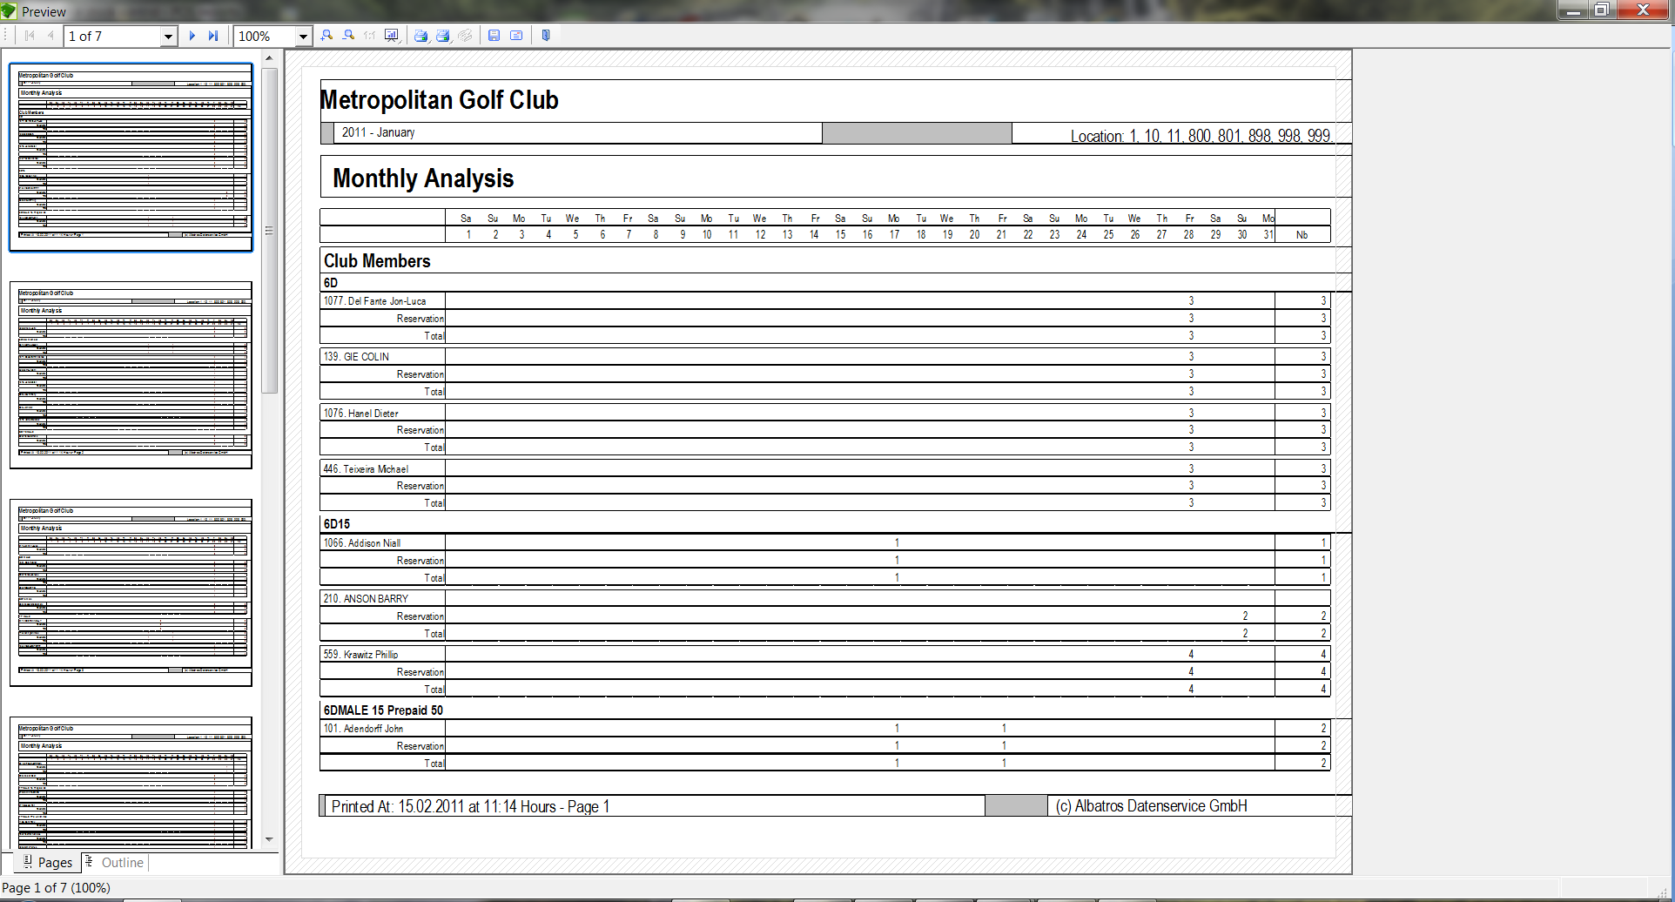

- Start printing the report with one of the buttons - depending on whether you want the current page or all pages.
- By right-clicking on the icon you can bring up the windows-standard printer selection dialog along with the choice of pages to print.
- To start the print job, click the button OK.

NOTE: If you made an incorrect choice, click the Cancel button.

- Booking (add-on module to Reception)
In the RESERVATIONS menu you find various tee sheets.

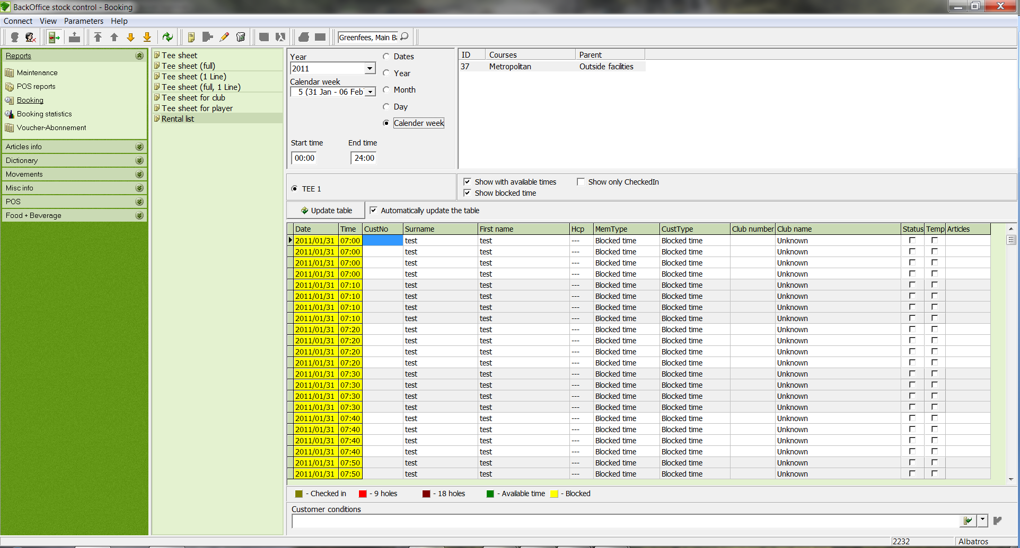

Filter Options
By interval (“dates”) If this button is selected, a date range can be entered in the input fields.
By year If this button is selected, the start list is filtered for an entire year.
By month Filtered for a month, where month and year must be entered.
By day Filtered for a particular day, where year and month must be entered.
By calender week Filtered for a particular calendar week, where the year must be entered.

The corresponding tees can be selected with the appropriate tick boxes. If the "Show with free time" box is ticked, the unbooked tee times will also be displayed. The "Update table" button reloads the assigned reservations.

Automatically update If this box is ticked, the tee sheet will be
the table automatically updated.

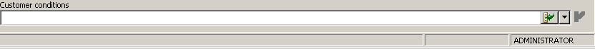

With "Customer conditions" right at the bottom of the page the tee sheet can be filtered according to various customer types and sub-types, similar to the way as you create a selection in Members.

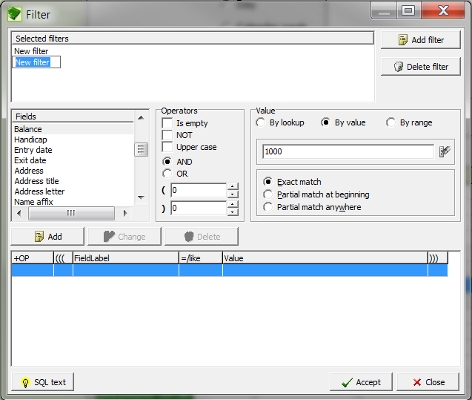

Lists
Tee sheet Listing of all reservations by time with customer information.
Tee sheet (full) Complete start list with customer information and free times.
Tee sheet (1 Line) Listing of all reservations. One line per flight is created.
Tee Sheet (full, 1 Line) List of all reservations with free times. One line per start time is created.
Tee sheet for club Start times grouped by club. The clubs can be selected in the following window.

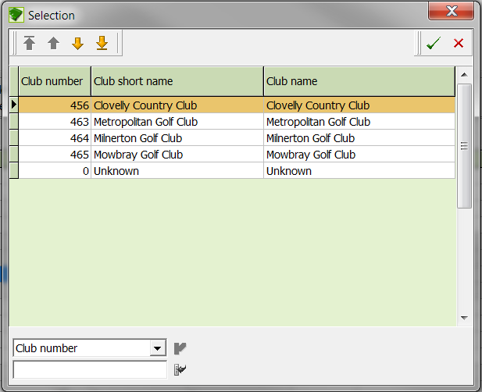

Tee sheet for player Prints a confirmation of the reserved tee times for the selected player. The players can be selected in the following window.

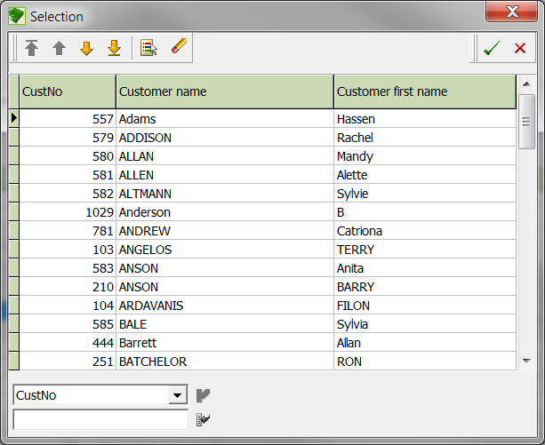

Rental list manage all rental items here

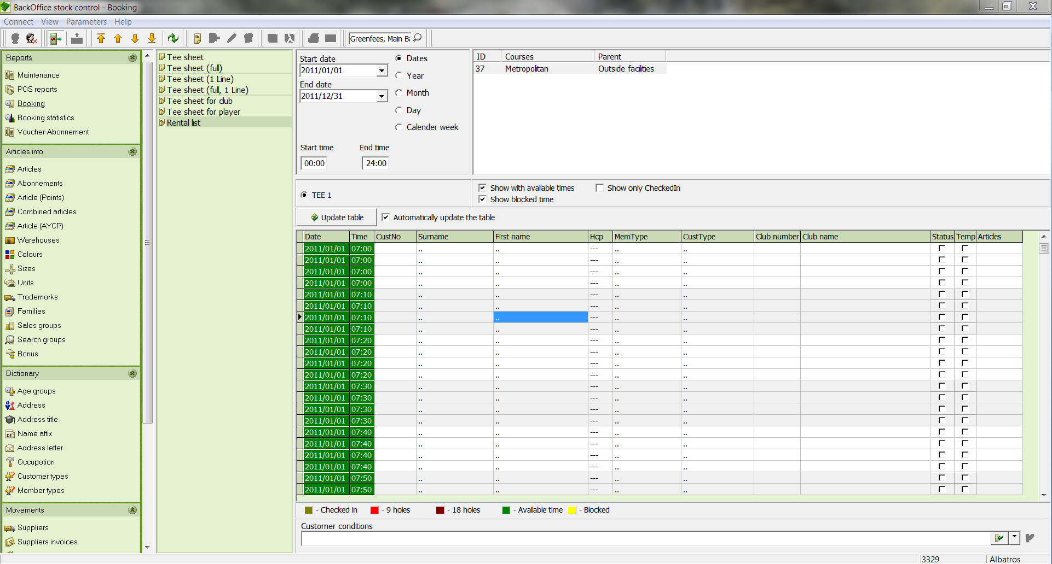

You create a new rental item by clicking on new, you will then see the following screen to be completed:

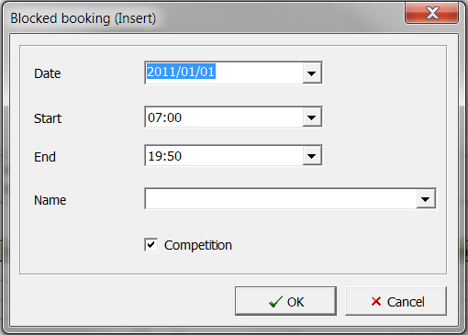

Article info
- Articles
New articles are created and managed in the ARTICLES window.

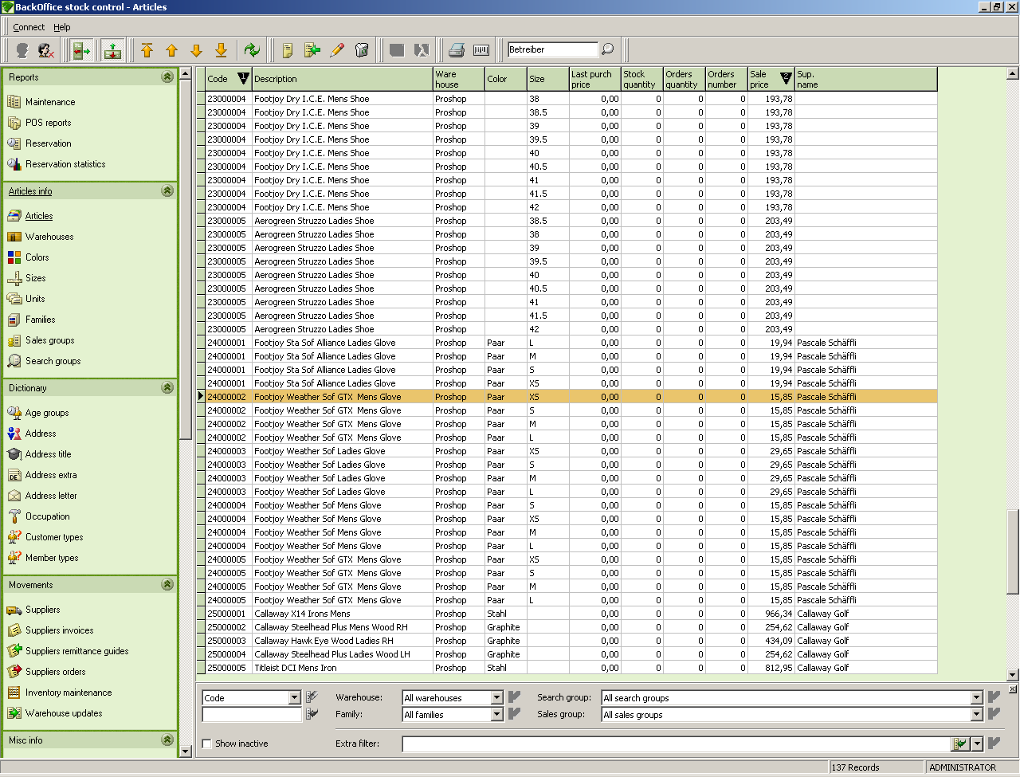

Input Fields
Selection field Selection field for the category used to filter the list.
Input field Input field for the topic used to filter the list.
Save filter If this box is ticked, the filter will be saved.
Show inactive If this box is ticked, articles not currently used in Reception will also be listed.
Warehouse Selection list for the warehouse used to restrict the item display.
Family Selection list for the family used to restrict the item display.
Search group Selection list for the search group. The search group is the main topic used to find an article in Reception.
Sales group Selection list for the sales group. The sales group is relevant to the finance office for the breakdown of articles.

  - Create a new article
- Click the icon Add new record.
- The Article Info window opens.

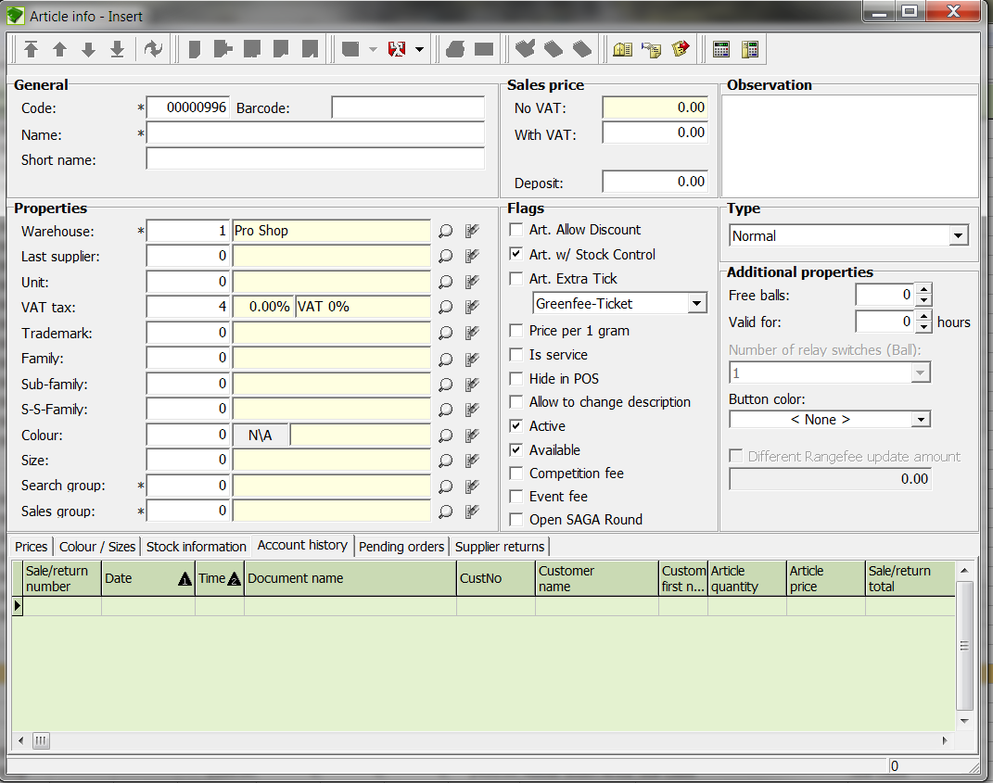

Input Fields
Code Input field for the article number. The system automatically supplies the next available number.
Barcode Input field for the 2nd barcode. It is possible to enter a freely-selected PLU number for the article, which will be used to find the article in Reception. By default the field is empty.
Name Input field for the article name.
Short name Input field for the short name of the article.
Note - text used in Reception will be added!
No VAT Net price of the item. The net price is calculated automatically from the gross price and the corresponding VAT rate, and cannot be entered manually.
With VAT Gross price of the item.
Observation Input field for any comments on the article.
Warehouse Selection list for the warehouse that should be assigned to the article. All warehouses are available that were entered in the WAREHOUSES window.
Last supplier Selection list for the suppliers. All suppliers are available that were entered in the SUPPLIERS window.
Unit Selection list for the article unit. All units are available that were entered in the UNITS window.
VAT Tax Selection list for the VAT rate. All VAT rates are available that were entered in the VAT window.
Family Selection list for the family in which the article should be categorized. All families are available that were entered in the FAMILIES window.
Sub-family The sub-family represents a subgroup (refinement) of the main article family. For example, the term "Men's Outerwear" could be the sub-family for the "Men's Clothing" family.
Sub-sub-family The sub-sub-family represents a subgroup (refinement) of the sub-family. For example, the term "Polo shirts" could be the sub-sub-family for the sub-family "Men's Outerwear".
Colour Selection list for the article colour.
Size Selection list for the article size. All sizes are available that were entered in the SIZES window.
Search group Selection list for the search group. All search groups are available that were entered in the SEARCH GROUPS window. The search group is the main topic used to find an article in Reception.
Sales group Selection list for the sales group. All sales groups are available that were entered in the SALES GROUPS window. The sales group is relevant to the finance office for the breakdown of articles.
Art. Allow Discount If this box is ticked, this means the article can be discounted when sold in Reception.
Art. w/ Stock Control If the article is to be subject to stock control, this box must be ticked.
Art. Extra Tick This box must be ticked to enable green fee and range fee ticket printing.
Is service If this box is ticked, the article is considered as a service article. A service article does not appear in the sales volume display.
Hide in POS If this box is ticked, the article is not visible in the POS-location assigned sales station (Reception).
Allow to change If the article description should be changeable at the time of sale, this box must be checked description
Available If the article is available in stock, this box must be ticked.
Competition fee If the article falls in the competition fee category, this box must be ticked.
Event fee If the article falls in the event fee category, this box must be ticked.
Open SAGA This button opens an SAGA Round automatically
Round

Selection Fields
GF or RF Article This selection means that the article belongs to the Green Fee / Range Fee article group. This is relevant for the reports.
Ball article This selection means that the article is a ball article. A ball article means the range balls dispensed from the automat.
Active You can completely deactivate an article with this tick box. Caution: If you remove the check mark from this box, the article will no longer be visible, even in Backoffice.

- Define the article with the necessary data.

Note 1: Article groups, search groups and sales groups must ALWAYS be entered; otherwise the article will not appear in Reception (search group) and cannot be evaluated in reports.

Note 2: You now have the option to enter the number through the input field or make the selection with the magnifying glass.

Note 3: When creating an article it is also important how a starting purchase and an initial inventory is entered. (Either creation of all articles and initial inventory or supplier quick entry)

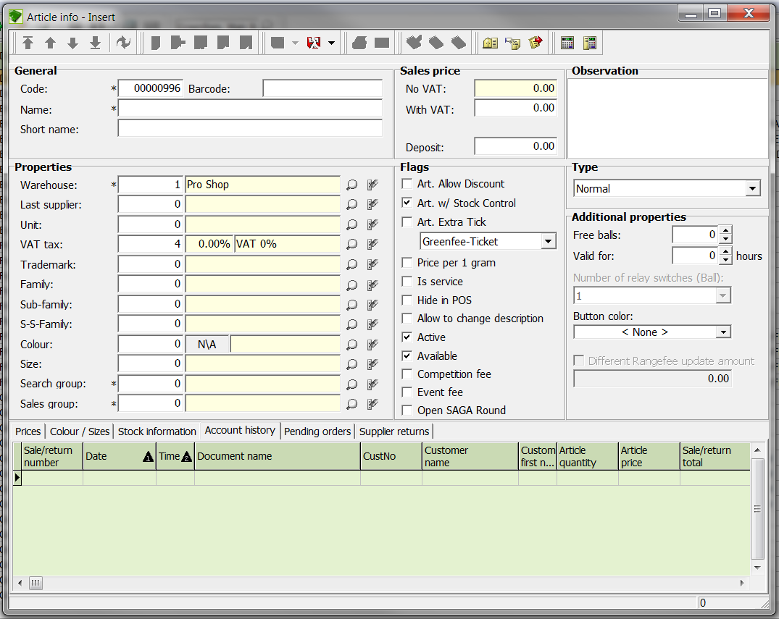

- Save the entries with the icon Save Entry.
NOTE! To facilitate article creation, the information for an existing article can be transferred to a new article with the Copy new info to new article button. Only individual changes such as price need to be made.

  - Change an item
- In the table, select the article to change.
- Click the icon Edit current record and make the changes, save the changes with Save Entries after your changes.

  - Delete an item
- In the table, select the article to delete.
- Click on the icon Delete current record.

The CONFIRM window opens.

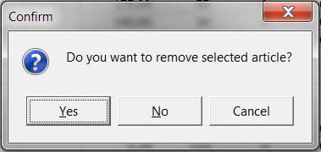

Verify that this is the article you wish to delete and confirm the deletion with the Yes button, or if you do not wish to delete, click the No button. If you are not sure, abort the procedure with the Cancel button.

NOTE! Only articles without inward or outward movement assigned can be deleted.

  - Print barcode labels
- Select the article in the list for which the labels should be printed.
- Click the icon Print on label printer.

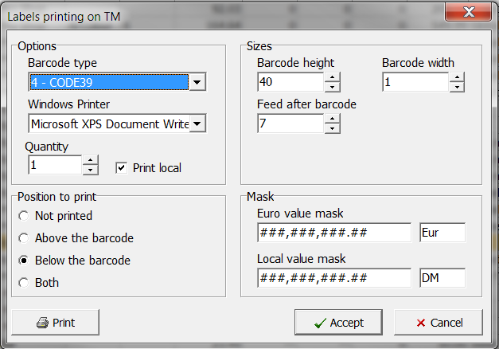

- Enter the number of labels desired. Here you have the windows-standard printer selection dialog along with the choice of pages to print and click the Print button.

- Warehouse
In some cases it is necessary to enter different warehouses so that separate merchandise management for the corresponding areas can be effected.

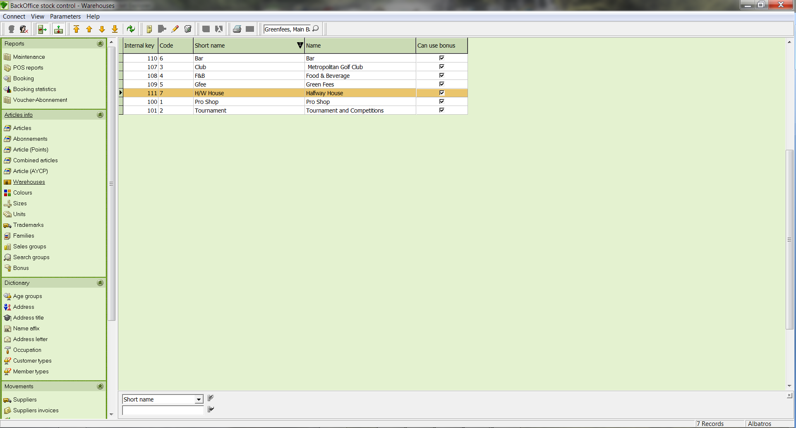

Input Fields
Selection field Selection field for the category used to filter the list
Input field Input field for the topic used to filter the list

  - Create a new warehouse
- Click the icon Add new record.
- The ADD NEW WAREHOUSE RECORD wizard opens.

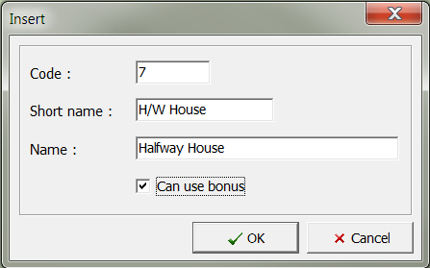

Input Fields
Code: Input field for the number
Short Name: Input field for the short name
Name: Input field for the name
Can use bonus: If this box is ticked, …

- Define the warehouse with the necessary data.
- Save the data by clicking the Add button.

  - Edit a warehouse
- From the list, select the warehouse to be edited.
- Click the icon Edit current record.
- Make the changes.
- Save the changes with the OK button.

  - Delete a warehouse
- From the list, select the warehouse to be deleted.
- Click on the icon Delete current record.

The DELETE CURRENT RECORD window opens.

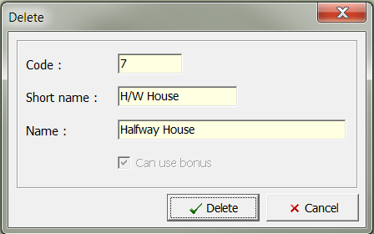

- Be sure that this is the warehouse that you wish to delete and click the button Delete.
- Colours
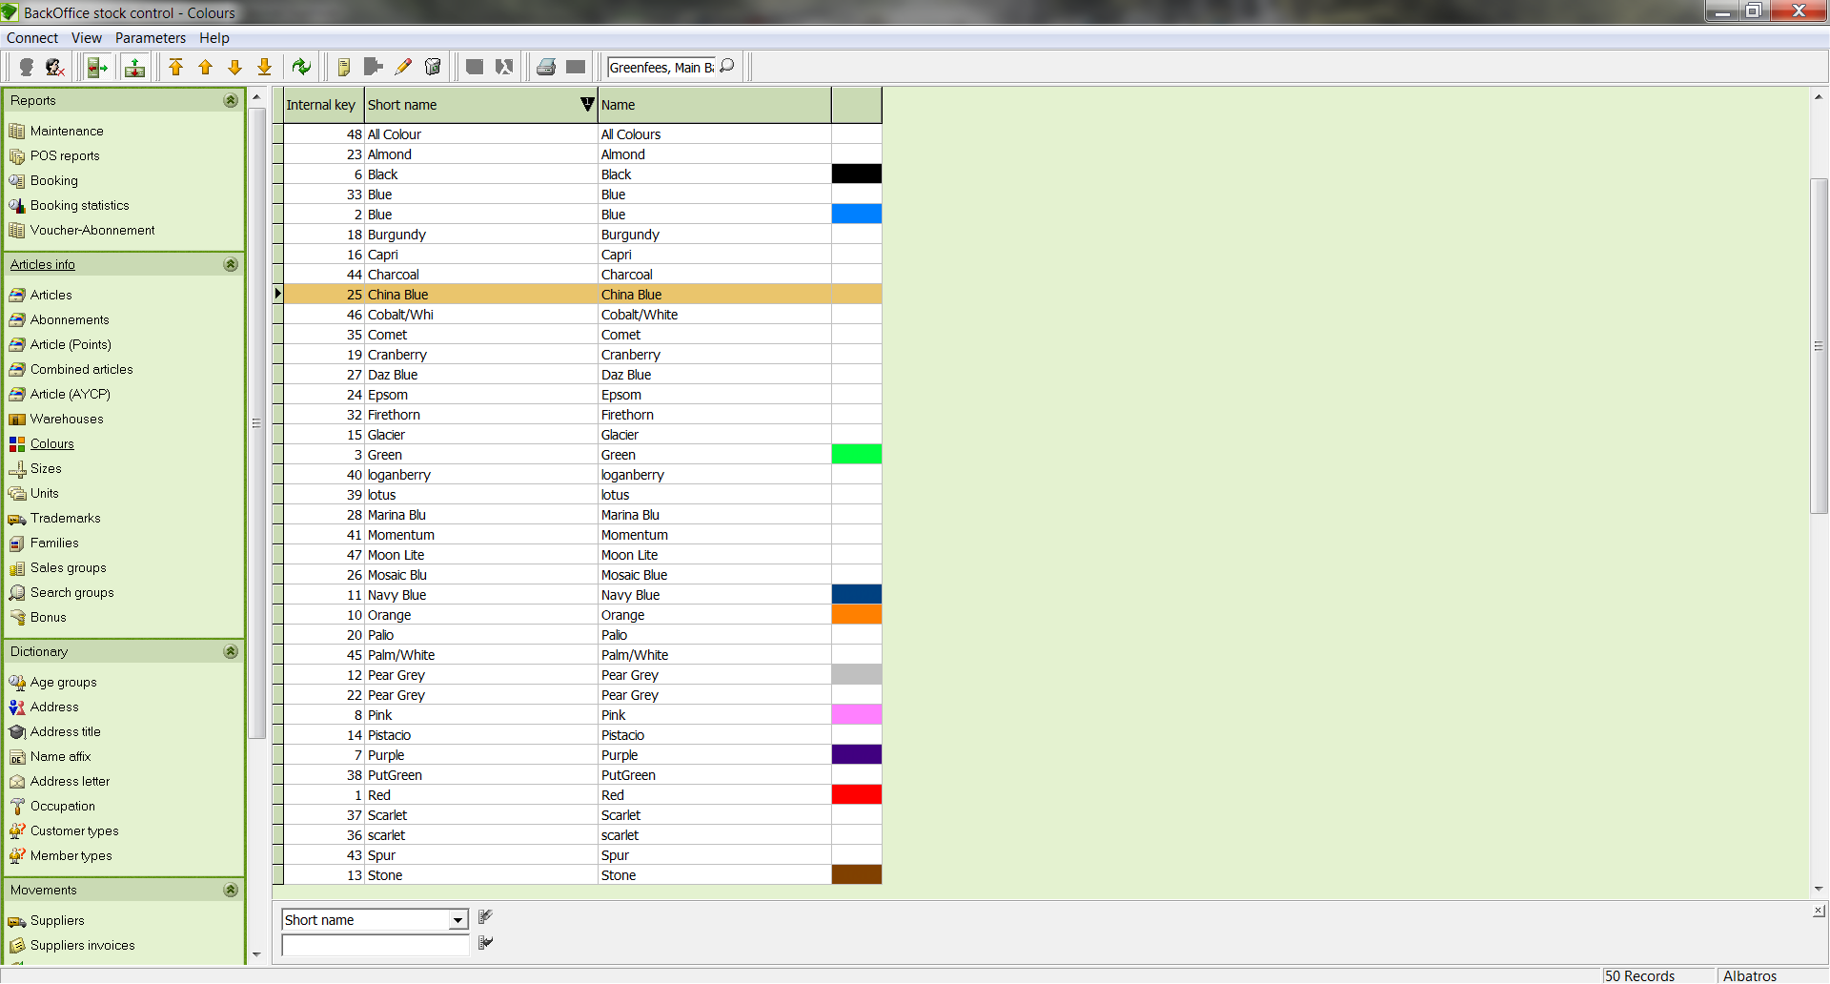

Input Fields
Selection field Selection field for the category used to filter the list
Input field Input field for the topic used to filter the list

  - Add a new colour
- Click the icon Add new record.
- The ADD NEW COLOUR RECORD wizard opens.

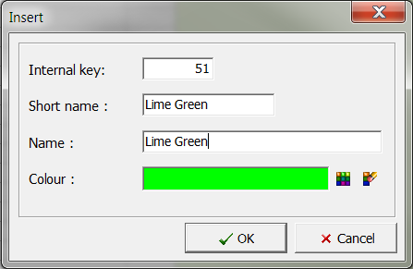

Input Fields
Internal Key: Input field for the colour code, the system automatically supplies the next available number.
Short name: Input field for the short name of the colour
Name: Input field for the full name of the colour
Colour: Selection of the colour

- Define the colour with the necessary data.
- Save the data by clicking the OK button.

  - Edit colours
- In the table, select the colour to be edited.
- Click the icon Edit current record.
- Save the changes with the OK button.

  - Delete a colour
- In the table, select the colour to be deleted.
- Click the icon Delete current record, and the DELETE COLOUR RECORD? window opens.

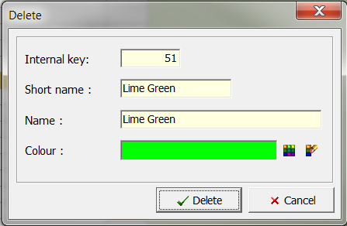

- Be sure that this is the colour that you wish to delete and click the Delete button. If you do not wish to delete the colour, close the window with the Cancel button.

- . Sizes
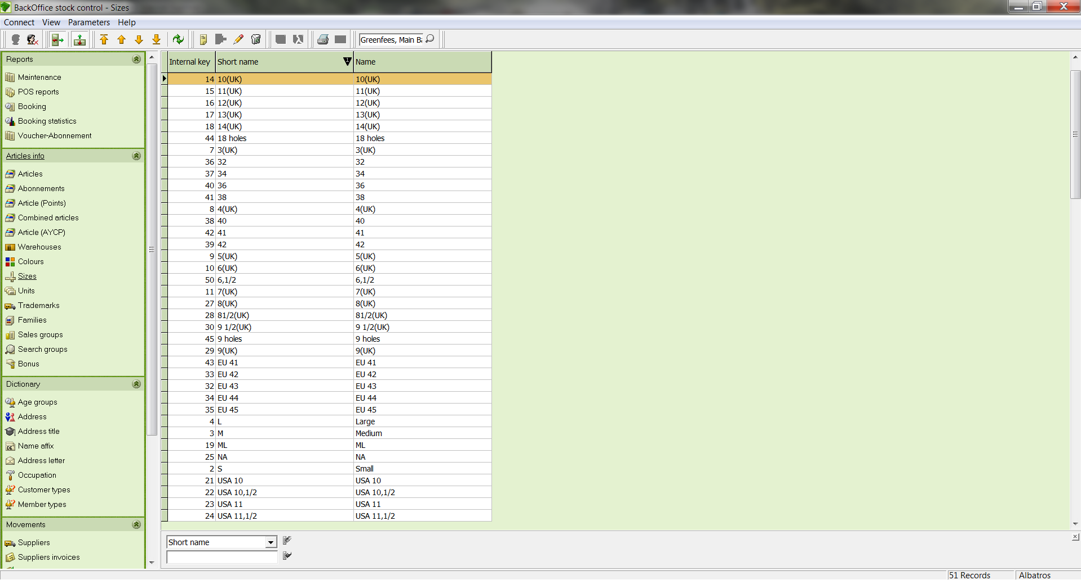

Input Fields
Selection field Selection field for the category used to filter the list
Input field Input field for the topic used to filter the list

  - Add a new size
- Click the icon Add new record.
- The ADD NEW SIZE RECORD wizard opens.

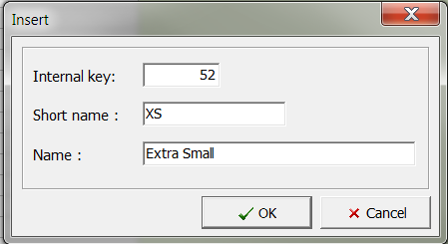

Input Fields
Internal Key: Input field for the number. The system automatically supplies the next available number.
Short name: Input field for the short name of the search group
Name: Input field for the name of the search group

- Define the size with the necessary data.
- Save the data by clicking the OK button.

  - Edit size
- In the table, select the size to be edited
- Click the icons Edit current record.
- Make the changes
- Save the changes with the OK button.

  - Delete a size
- In the table, select the size to be deleted.
- Click on the icon Delete current record.
- The DELETE SIZE RECORD window opens.

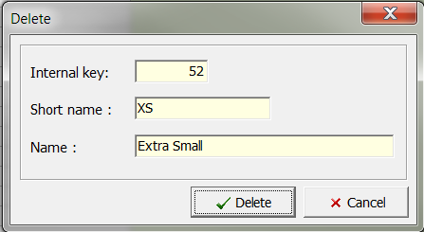

- Be sure that this is the size that you wish to delete and click the button Delete. If you do not wish to delete the size, close the window with the Cancel button.

- Units
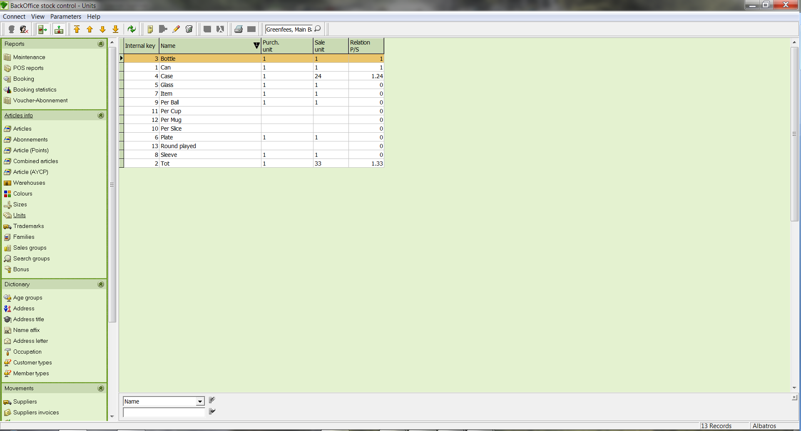

Input Fields
Selection field Selection field for the category used to filter the list
Input field Input field for the topic used to filter the list

  - Add a new unit
- Click the icon Add new record.
- The ADD NEW UNIT RECORD wizard opens.

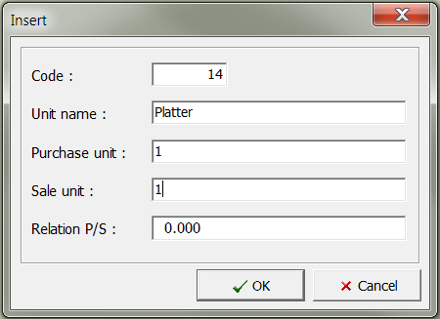
Input Fields
Code: Input field for the number. The system automatically supplies the next available number.
Unit Name: Input field for the name of the unit
Purchase unit: Input field for the purchase unit
Sale unit: Input field for the sales unit
Relation P/S: Input field for the Purchase/Sale relationship

- Define the unit with the necessary data.
- Save the data by clicking the OK button.

  - Edit unit
- In the table, select the unit to be edited.
- Click the icon Edit current record.
- Make the changes.
- Save the changes with the OK button.

  - Delete a unit
- In the table, select the unit to be deleted.
- Click on the icon Delete current record.

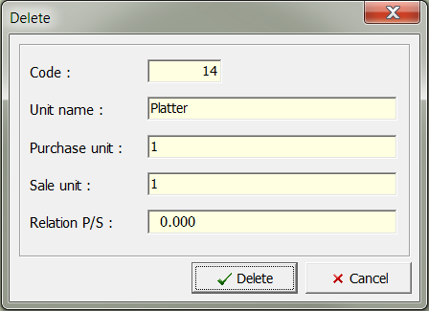

- The DELETE window opens (to the side).
- Be sure that this is the unit that you wish to delete and click the button Delete. If you do not wish to delete the unit, close the window with the Cancel button.

- Families
The family is a logical sub-categorization which is specially utilized in the Pro Shop in order to provide a multi-level sub categorization.

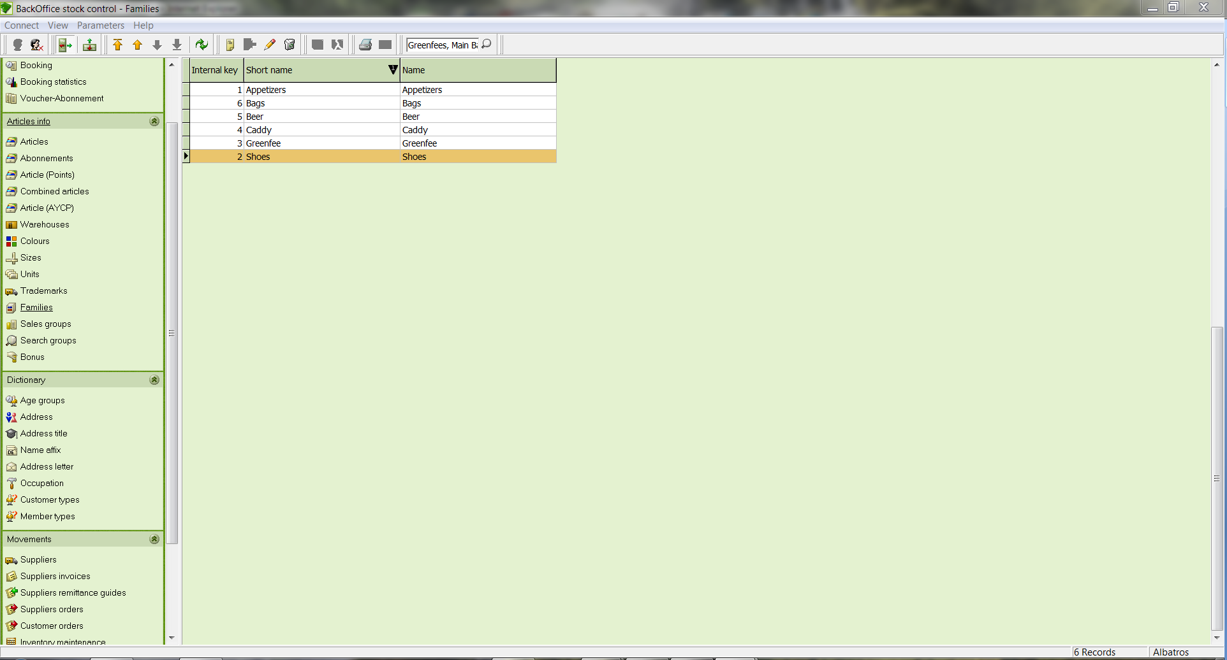

Input Fields
Selection field Selection field for the category used to filter the list
Input field Input field for the topic used to filter the list

  - Add a new family
- Click the icon Add new record.
- The ADD NEW FAMILY RECORD wizard opens.

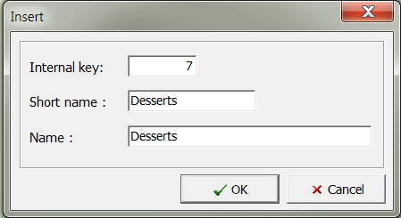

Input Fields
Internal Key: Input field for the number. The system automatically supplies the next available number.
Short name: Input field for the short name of the family
Name: Input field for the name of the family

- Define the family with the necessary data and save your entries by clicking the button OK.

  - Edit family
- In the list, select the family to edit and click on the Edit current record icon.
- Make the changes and save them with the OK button.

  - Delete a family
- In the table, select the family to be deleted.
- Click on the icon Delete current record.

The DELETE window opens.

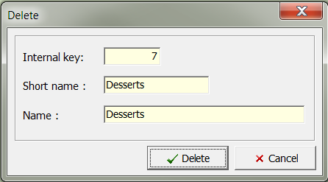

- Be sure that this is the family that you wish to delete. Then click on the Delete button. If you do not wish to delete the family, close the window with the Cancel button.

NOTE! A family can only be deleted if it is not used in the article database and does not have a sub-family.

- Sales groups
The sales group is an income-oriented subdivision of the article. This should be arranged with your tax advisor.

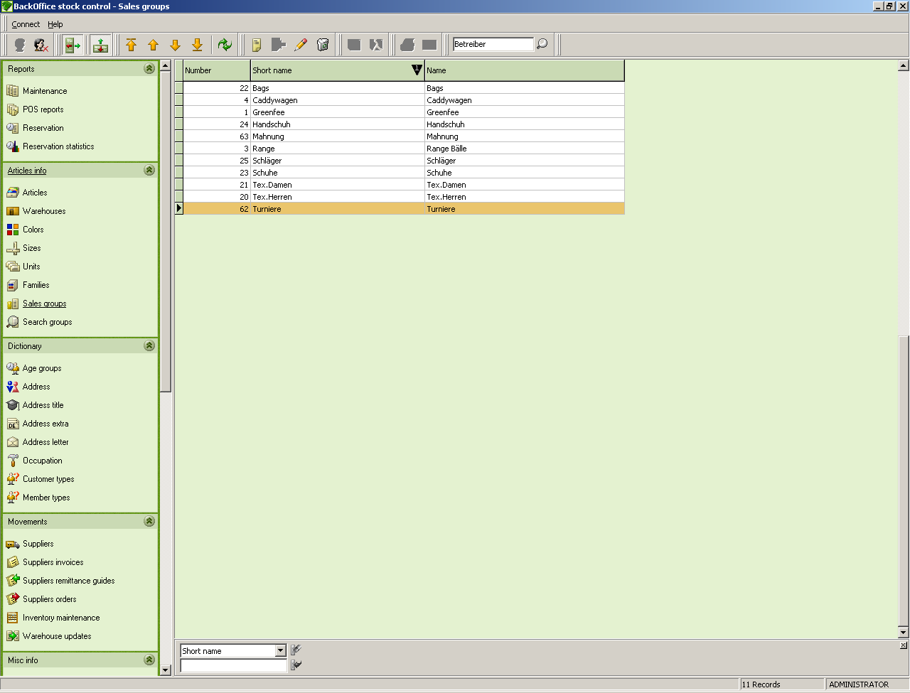

Input Fields
Selection Field Selection field for the category used to filter the list
Input field Input field for the topic used to filter the list

  - Add a new sales group
- Click the icon Add new record.
- The ADD NEW SALES GROUP wizard opens.

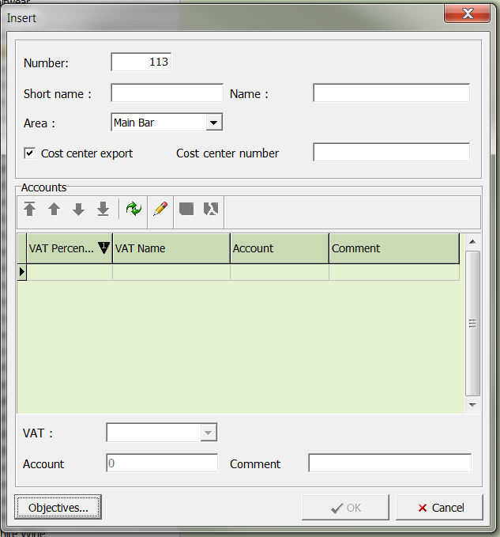

Input Fields
Number: Input field for the number. The system automatically supplies the next available number.
Short name: Input field for the short name of the sales group
Name: Input field for the name of the sales group

- Define the sales group with the necessary data and save your entries by clicking the button OK.

  - Edit a sales group
- In the table, select the sales group to be edited
- Click the icon Edit current record
- Make the changes and save them with the OK button.

  - Delete a sales group
- In the list, select the sales group to edit and click on the Delete current record icon.
- The DELETE SALES GROUP window opens.
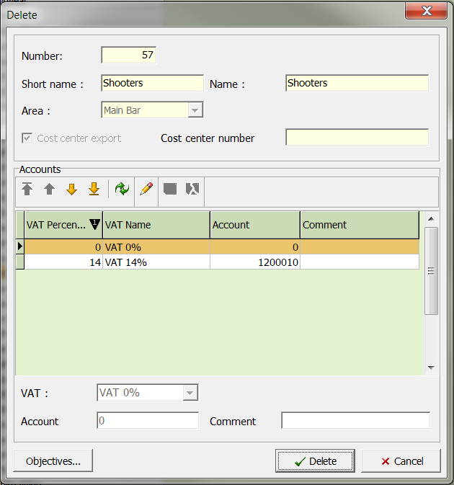

- Be sure that this is the sales group that you wish to delete.
- Close the window and delete the sales group by clicking the Delete button. If you do not wish to delete the sales group, close the window with the button Cancel.

NOTE! A sales group may only be deleted if it is not used in the article database.

- Search groups
The search group is a sales-oriented sub categorization of articles. This is used for sub categorization on the basis of factors pertinent to sales, and is needed particularly for articles which are sold without cash purchase.

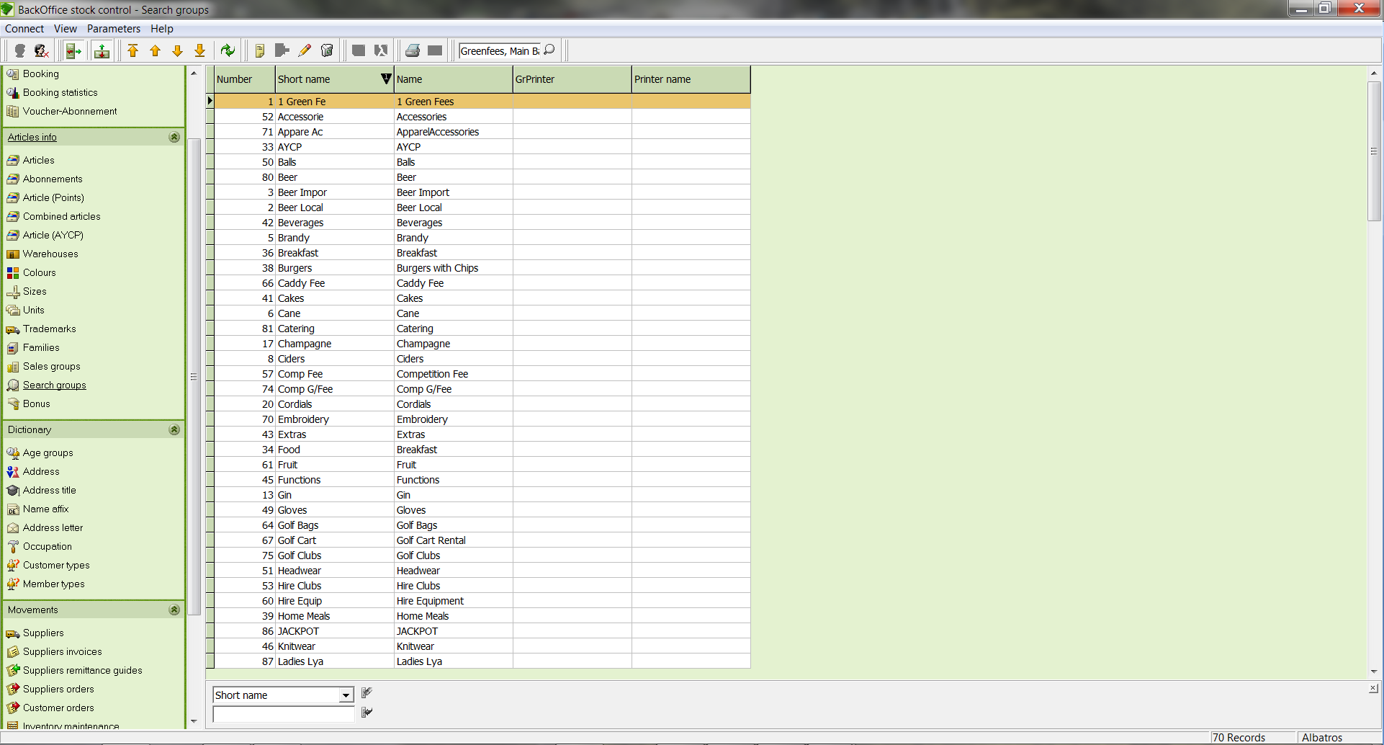

Input Fields
Selection field Selection field for the category used to filter the list
Input field Input field for the topic used to filter the list

  - Add a new search group
- Click the icon Add new record.
- The NEW SEARCH GROUP Wizard opens.

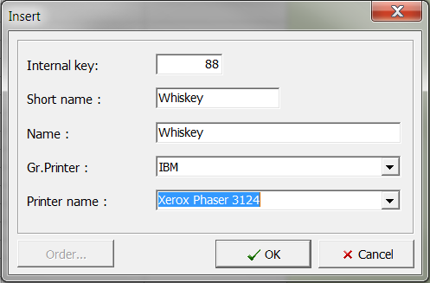

Input Fields
Internal Key: Input field for the number. The system automatically supplies the next available number.
Short name: Input field for the short name of the search group
Name: Input field for the name of the search group
Gr. Printer: Selection list for gastronomy printer. This setting is used only for sales slips in Gastro.
Printer name: Selection list for the printer name

- Define the search group with the necessary data and save your entries by clicking the button OK.

  - Edit a search group
- In the list, select the search group to edit and click on the Edit current record icon.
- Make the changes and save them with the OK button.

  - Delete a search group
- In the list, select the search group to delete and click on the Delete current record icon.
- The DELETE SEARCH GROUP window opens.

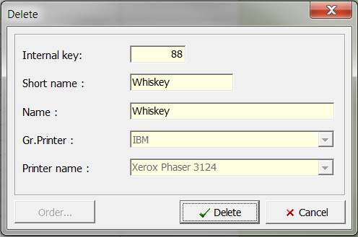

- Be sure that this is the search group that you wish to delete and click the Delete button. If you do not wish to delete the search group, close the window with the Cancel button.

- Age groups
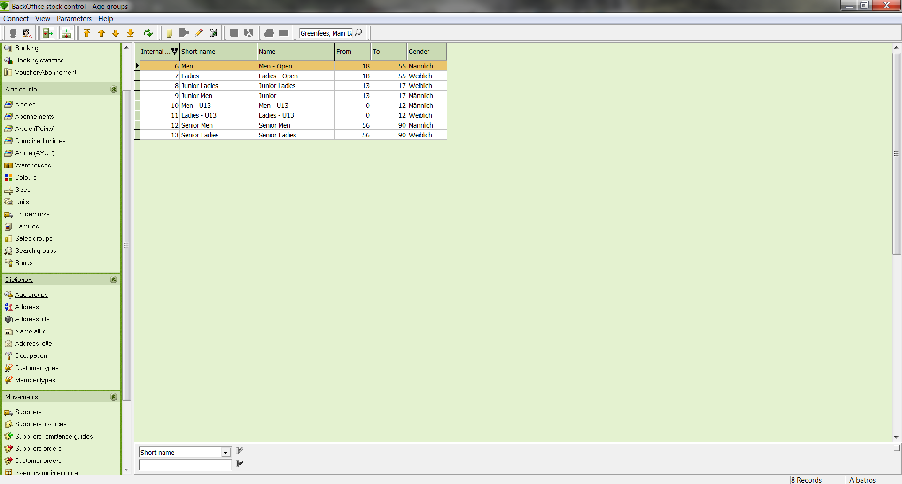

Input Fields
Selection field Selection field for the category used to filter the list
Input field Input field for the topic used to filter the list

  - Add a new age group
- Click the icon Add new record.

The ADD NEW GROUP wizard opens.

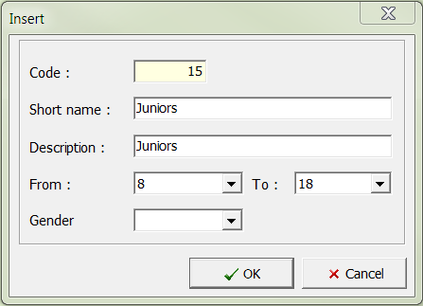

Input Fields
Code Input field for the number. The system automatically supplies the next available number.
Short Name Input field for the name of the age group
Description Description of the age group
From Selection list for the beginning age of the age group
To Selection list for the ending age of the age group
Gender Selection list for the gender that applies to this age group

- Define the age group with the necessary data and save your entries by clicking the button OK.

  - Edit an age group
- In the table, select the age group to be edited.
- Click the icon Edit current record.
- Make the changes and save them with the OK button.

  - Delete an age group
- In the table, select the age group to be edited.
- Click the icon Delete current record, and the DELETE AGE GROUP RECORD window opens.

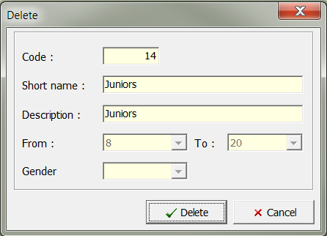

- Be sure that this is the age group that you wish to delete and click the Delete button. If you do not wish to delete the age group, close the window with the Cancel button.

NOTE! An age group can only be deleted if it has not yet been assigned to a customer.

- Address
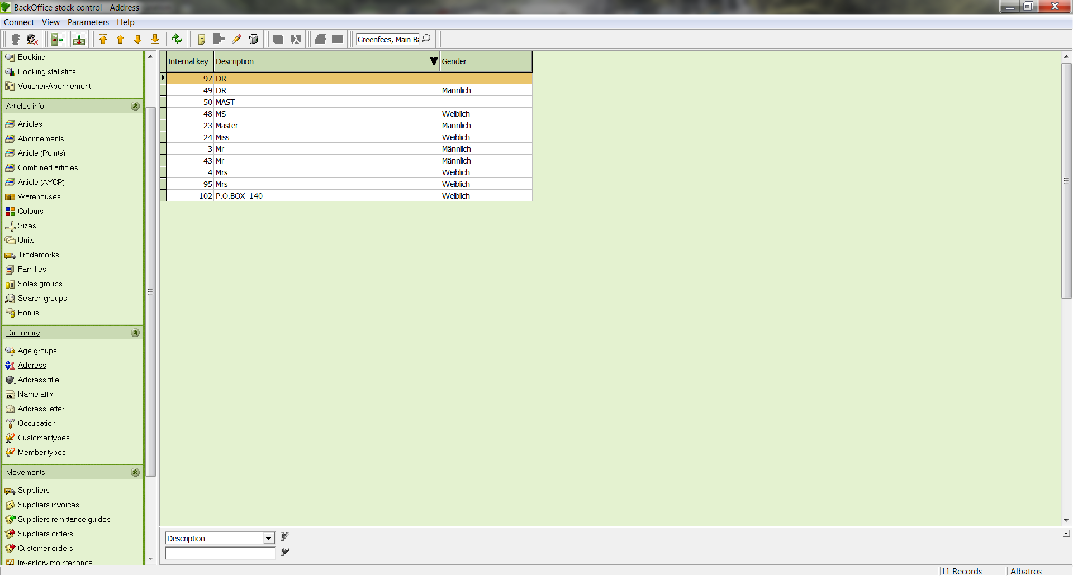

Input Fields
Selection field Selection field for the category used to filter the list
Input field Input field for the topic used to filter the list

  - Add a new address
- Click the icon Add new record.
- The ADD NEW ADDRESS wizard opens.

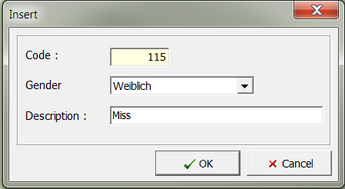

Input Fields
Code Input field for the number. The system automatically supplies the next available number.
Gender Selection list for the gender that applies to this address
Description Title of the address

- Define the address with the necessary data.
- Save the data by clicking the OK button.

  - Edit an address
- In the table, select the address to be edited.
- Click the icon Edit current record.
- Make the changes and save them with the OK button.

  - Delete an address
- In the list, select the address to delete and click on the Delete current record icon.
- The DELETE ADDRESS window opens.

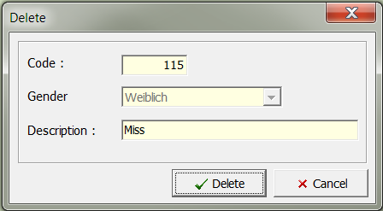

- Be sure that this is the address that you wish to delete.

- Confirm the deletion of the address by clicking the Delete button. If you do not wish to delete the address, close the window with the Cancel button.

NOTE! An age group can only be deleted if it has not yet been assigned to a customer.

- Address Title
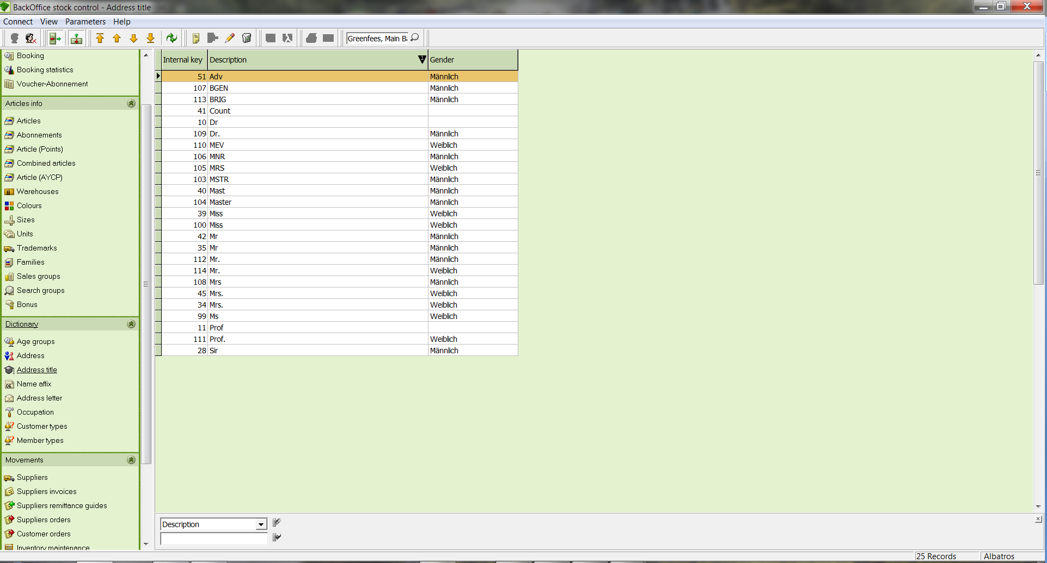

Input Fields
Selection field Selection field for the category used to filter the list.
Input field Input field for the topic used to filter the list.

  - Create a new address title
- Click the icon Add new record
- The ADD NEW ADDRESS TITLE wizard opens.

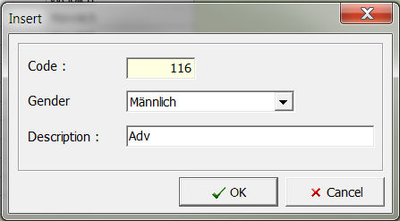

Input Fields
Code Input field for the number. The system automatically supplies the next available number.
Gender Selection list for the gender that applies to this address title
Description Description of the address title

- Define the address title with the necessary data and save your entries by clicking the OK button.

  - Edit an address title
- In the list, select the address title to edit and click on the Edit current record icon.
- Make the changes and save them with the OK button.

  - Delete an address title
- In the table, select the address title to delete.
- Click on the icon Delete current record.
- The DELETE ADDRESS TITLE window opens.

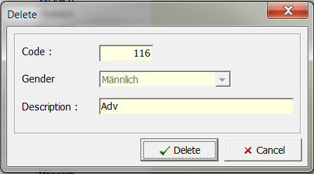

- Be sure this is the address title you wish to delete and click the Delete button. If you do not wish to delete the address title, close the window with the Cancel button.

NOTE! The address title can only be deleted if it is not assigned to any customer.

- Name Affix
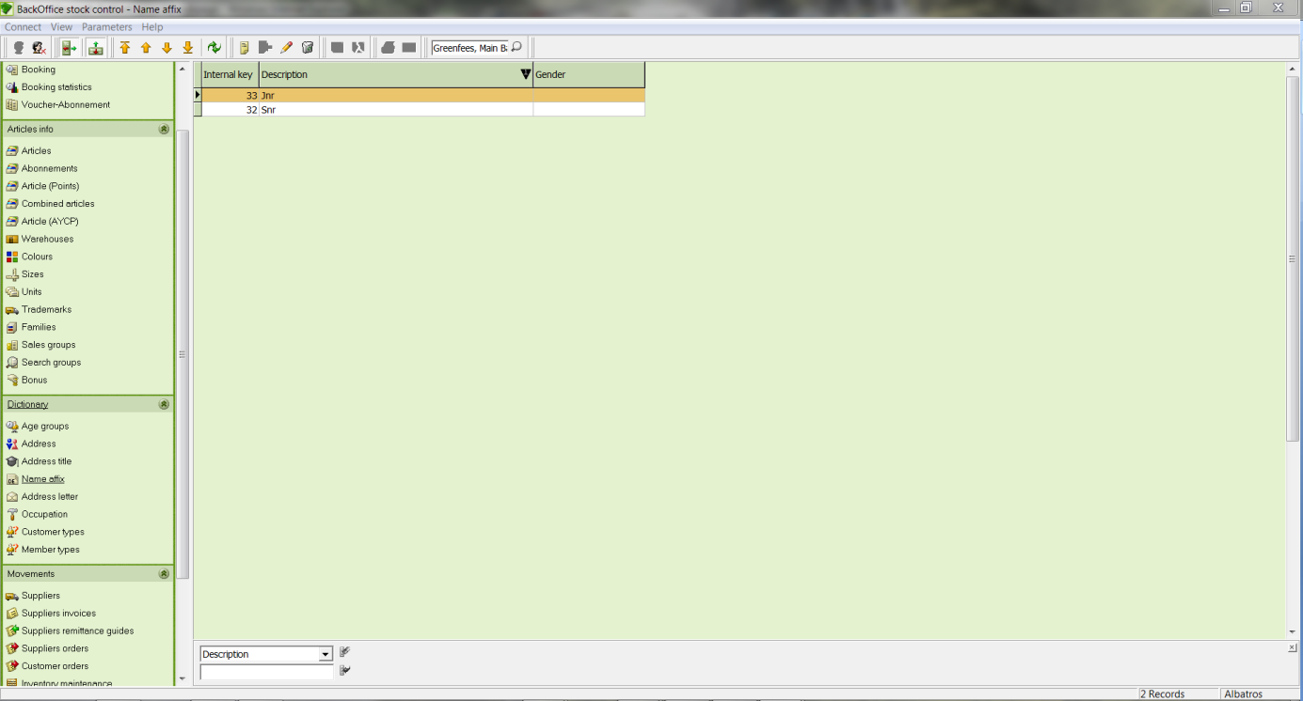

Input Fields
Selection field Selection field for the category used to filter the list
Input field Input field for the topic used to filter the list

  - Create a name affix
- Click the icon Add new record and the ADD NEW NAME AFFIX wizard opens.

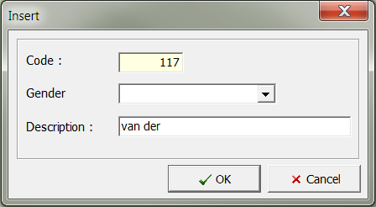

Input Fields
Code: Input field for the number. The system automatically supplies the next available number.
Gender: Selection list for the gender that applies to this address extra
Description: Title of the address extra

- Define the address extra with the necessary data and save your entries by clicking the OK button.

  - Edit extra name affix
- In the table, select the address extra to delete.
- Click the icon Edit current record.
- Make the changes and save them with the OK button.

  - Delete extra name affix
- In the table, select the address extra to delete
- Click on the icon Delete current record.
- The DELETE NAME AFFIX window opens.

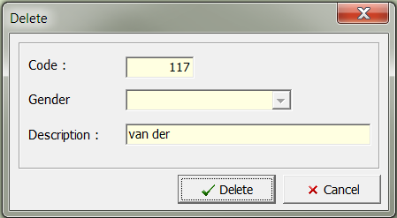

- Be sure that this is the address extra that you wish to delete and click the Delete button. If you do not wish to delete the address extra, close the window with the Cancel button.

NOTE! The address extra can only be deleted if it is not assigned to any customer.

- Address letter
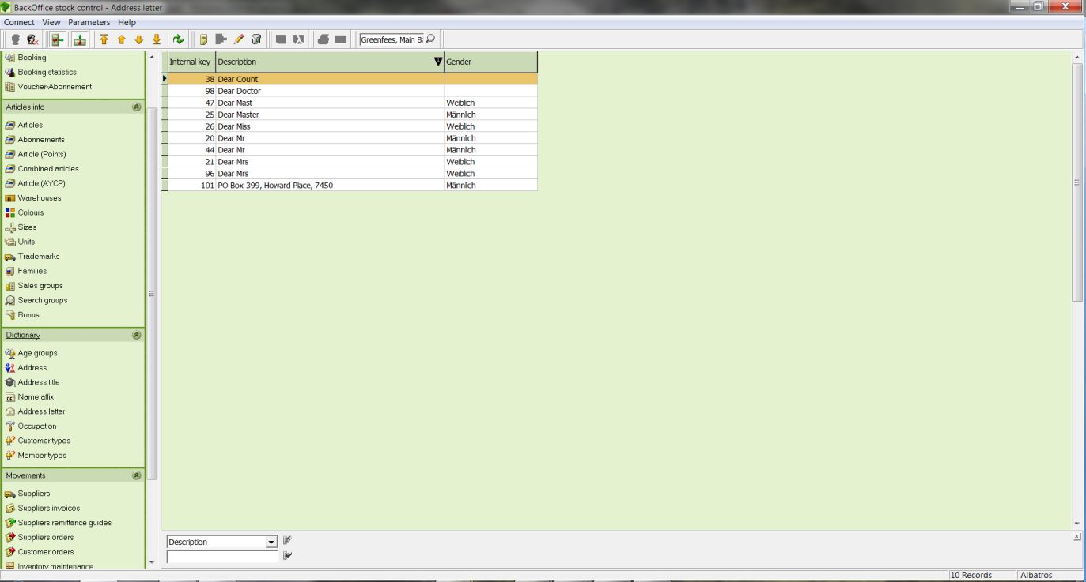

Input Fields
Selection field Selection field for the category used to filter the list
Input field Input field for the topic used to filter the list

  - Add a new address letter
- Click the icon Ad new record.
- The ADD NEW ADDRESS LETTER wizard opens.

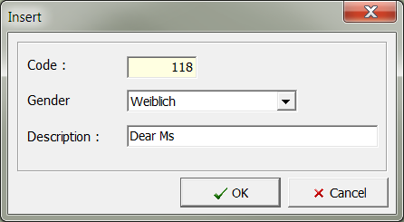

Input Fields
Code: Input field for the number. The system automatically supplies the next available number.
Gender: Selection list for the gender that applies to this address letter.
Description: Title of the address letter.

Define the address letter with the necessary data. Save the data by clicking the OK button.

  - Edit the address letter
- In the table, select the address letter to be edited.
- Click the icon Edit current record.
- Make the changes and save them with the OK button.

  - Delete an address letter
- In the table, select the address letter to be edited.
- Click on the icon Delete current record.
- The DELETE ADDRESS LETTER window opens.

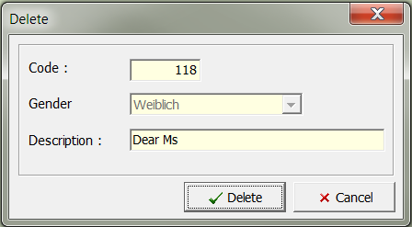

- Be sure that this is the address letter that you wish to delete and click the Delete button. If you do not wish to delete the address letter, close the window with the Cancel button.

NOTE! An age group can only be deleted if it has not yet been assigned to a customer.

- Occupation
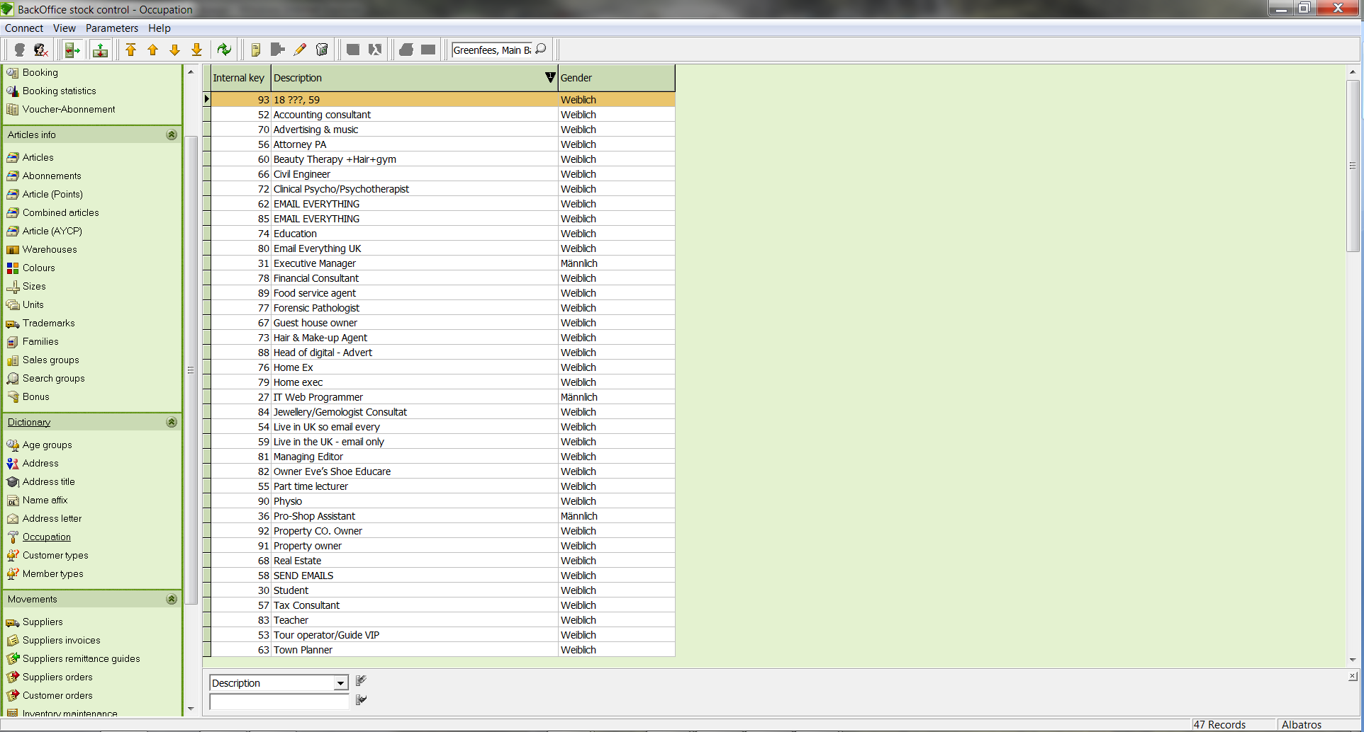

Input Fields
Selection field Selection field for the category used to filter the list.
Input field Input field for the topic used to filter the list.

  - Create a new occupation
- Click the icon Add new record.
- The ADD NEW OCCUPATION wizard opens.

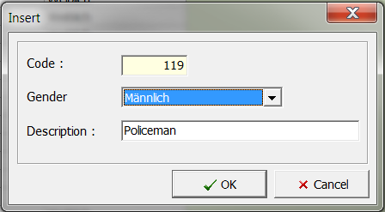

Input Fields
Code: Input field for the number. The system automatically supplies the next available number.
Gender: Selection list for the gender that applies to this profession.
Description: Title of the occupation.

- Define the occupation with the necessary data.
- Save the data by clicking the Add button.

  - Edit an occupation
- In the table, select the occupation to edit.
- Click the icon Edit current record.
- Make the changes and save them with the OK button.

  - Delete an occupation
- In the table, select the occupation to delete.
- Click on the icon Delete current record.
- The DELETE OCCUPATION window opens.

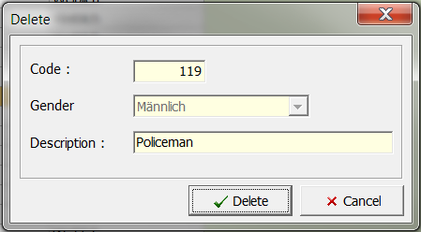

- Be sure that this is the occupation that you wish to delete and click the Delete button. If you do not wish to delete the occupation, close the window with the Cancel button.

NOTE! The occupation can only be deleted if it is not assigned to any customer.

- Customer types

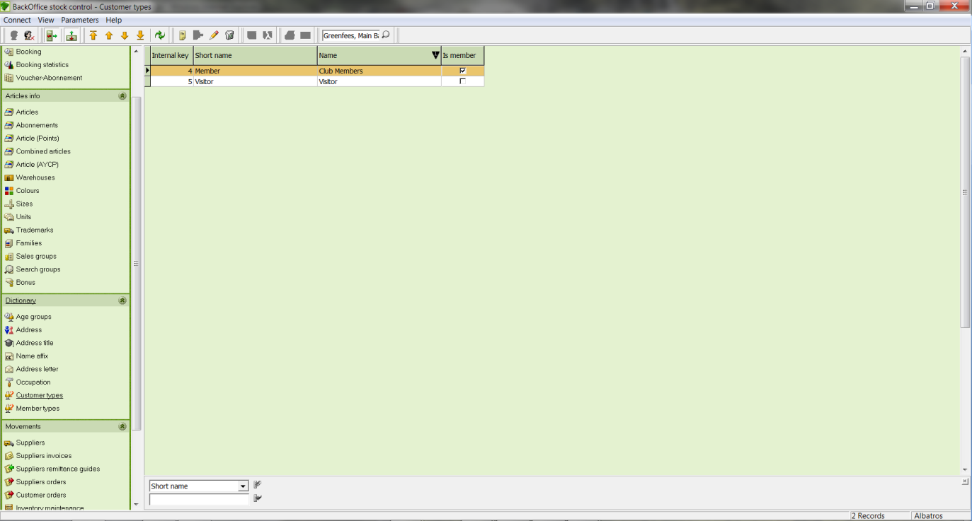

Input Fields
Selection field Selection field for the category used to filter the list
Input field Input field for the topic used to filter the list

  - Create a new customer type
- Click the icon Add new record.
- The ADD NEW CUSTOMER TYPE RECORD wizard opens.

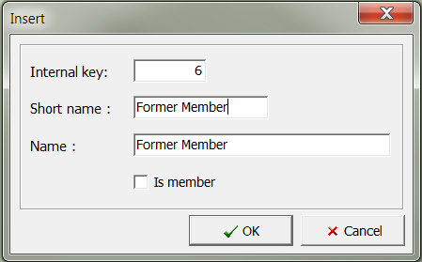

Input Fields
Internal Key Input field for the number. The system automatically supplies the next available number.
Short Name Short name of the customer type
Name Full name of the customer type

- Define the customer type with the necessary data.
- Save the data by clicking the OK button.

  - Edit a customer type
- In the table, select the customer type to edit.
- Click the icon Edit current record.
- Make the changes and save them with the OK button.

  - Delete a customer type
- In the table, select the member type to delete.
- Click on the icons Delete current record.

The DELETE CUSTOMER TYPE RECORD window opens.

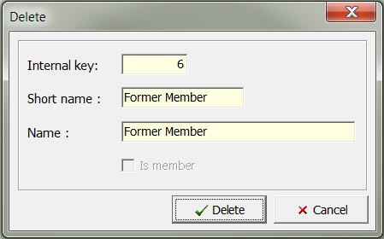

- Be sure that this is the customer type that you wish to delete and click the Delete button. If you do not wish to delete the customer type, close the window with the Cancel button.

NOTE! The customer type can only be deleted if it is not assigned to any customer.

- Member types
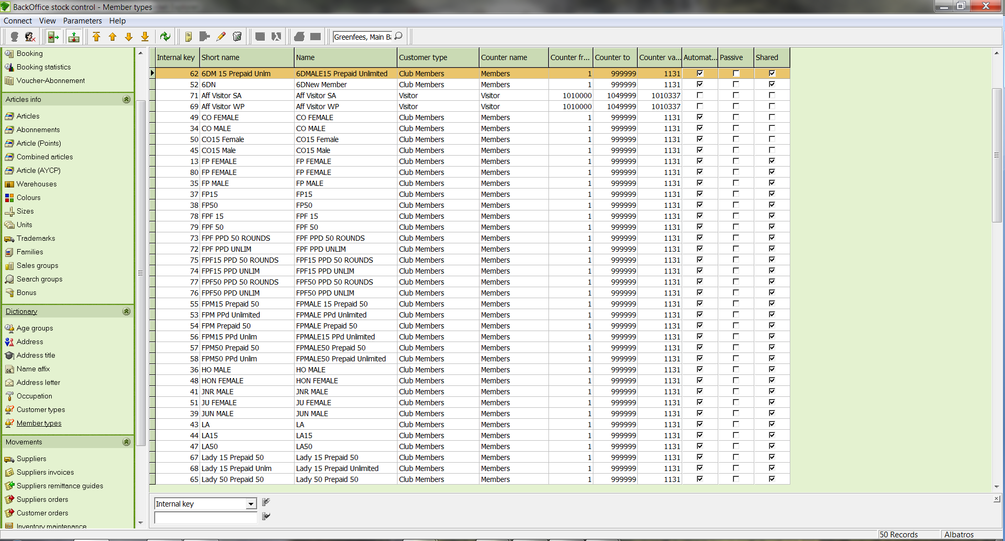

Input Fields
Selection field Selection field for the category used to filter the list
Input field Input field for the topic used to filter the list

  - Create a new member type
- Click the icon Add new record
- The ADD NEW MEMBER TYPE RECORD wizard opens

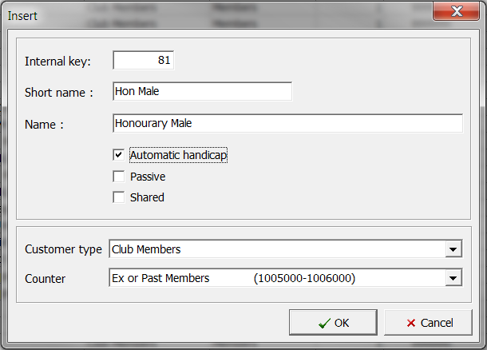

Input Fields
Internal Key Input field for the number. The system automatically supplies the next available number.
Short Name Short name of the customer type
Name Full name of the customer type
Key Selection of member type – all other fields will be filled automatically.
Counter Selection of the counter (customer numbers) – all other fields will be filled automatically.

- Define the member type with the necessary data
- Save the data by clicking the OK button

  - Edit a member type
- In the table, select the member type to edit
- Click the icon Edit current record
- Make the changes and save them with the OK button

  - Delete a member type
- In the table, select the member type to delete.
- Click on the icon Delete current record.

The DELETE MEMBER TYPE RECORD window opens.

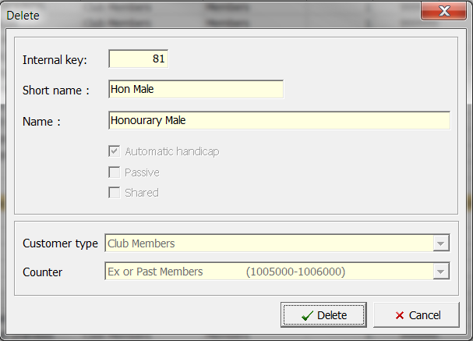

- Be sure that this is the member type that you wish to delete and click the Delete button. If you do not wish to delete the member type, close the window with the Cancel button.

NOTE! The member type can only be deleted if it is not assigned to any customer.

- Suppliers
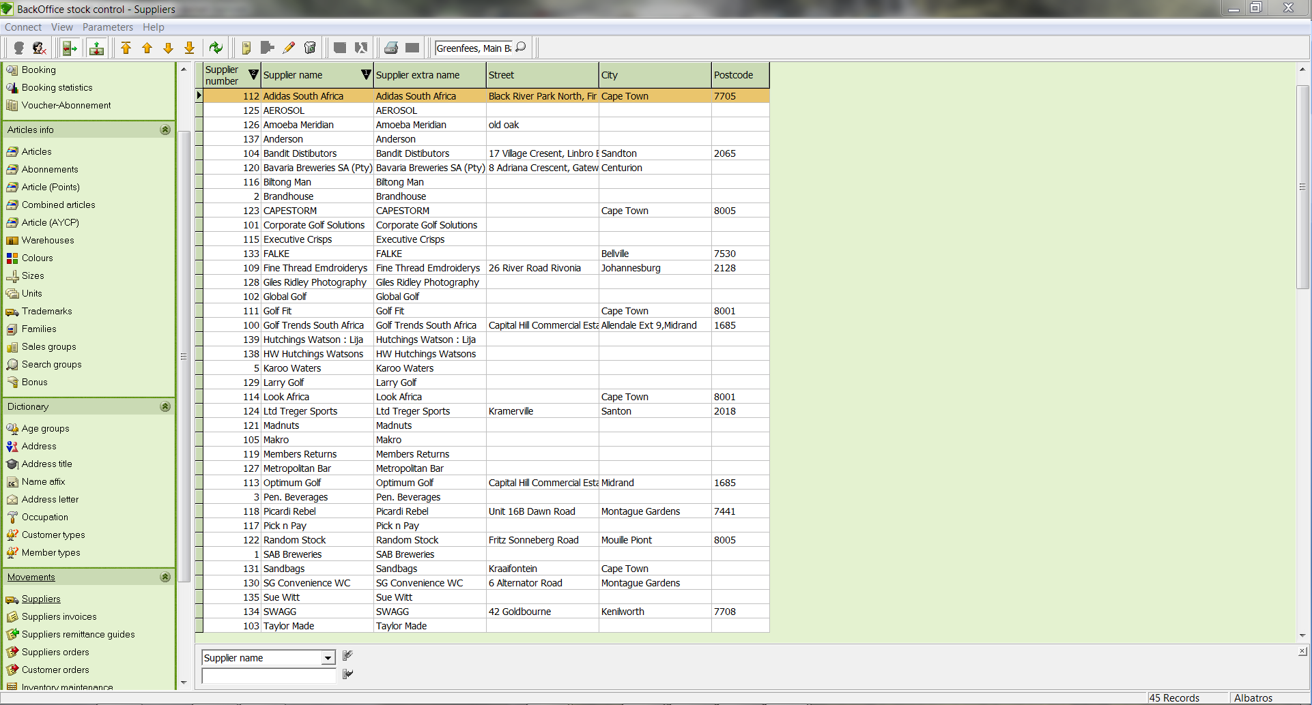

Input Fields
Selection field Selection field for the category used to filter the list
Input field Input field for the topic used to filter the list

  - Create a new supplier
- Click the icon Add new record
- The ADD NEW SUPPLIER wizard opens

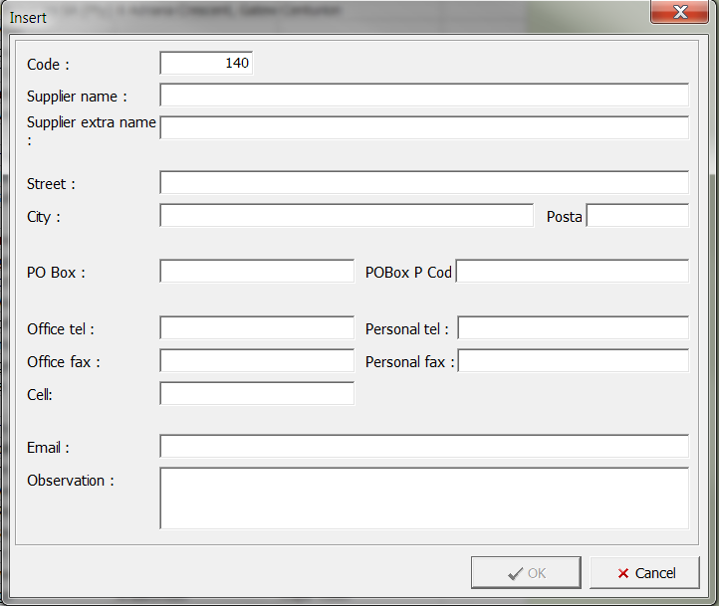

Input Fields
Code Input field for the number. The system automatically supplies the next available number
Supplier name Name of the supplier
Supplier extra name Input field for the supplier's extra name
Street Input field for the supplier's street
City Supplier's City
POSTAL/PO Box Input field for the supplier's Postal/PO box code
Office Tel & Fax Business telephone number of the supplier
Personal Tel & Fax Input field for the supplier's business fax
Cell Supplier's cell phone number
E-mail Supplier's E-mail address
Observation Input field for any comments about the supplier
P.O. Box Address of the PO Box
PO Box postal Input field for the PO Box postal
Private tel Supplier's private phone number
Private fax Input field for the supplier's private fax

- Enter the necessary details for the supplier
- Save the data by clicking the OK button

  - Edit a supplier's details
- In the table, select the supplier to edit
- Click the icon Edit current record
- Make the changes and save them with the OK button

  - Delete a supplier
- In the table, select the supplier to delete.
- Click on the icon Delete current record.

The DELETE SUPPLIER RECORD window opens.

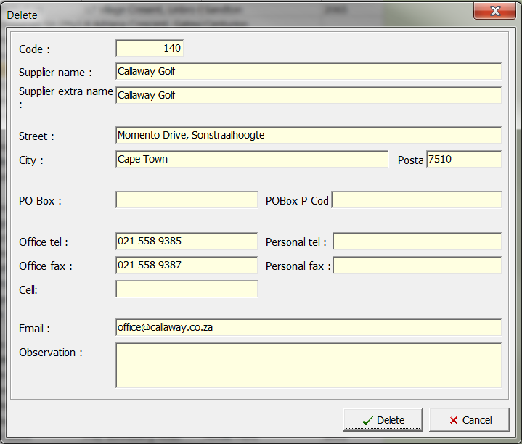

- Be sure that this is the supplier that you wish to delete and click the Delete button. If you do not wish to delete the supplier, close the window with the Cancel button.

NOTE! The supplier can only be deleted if it is not assigned to any customer.

- Suppliers invoices
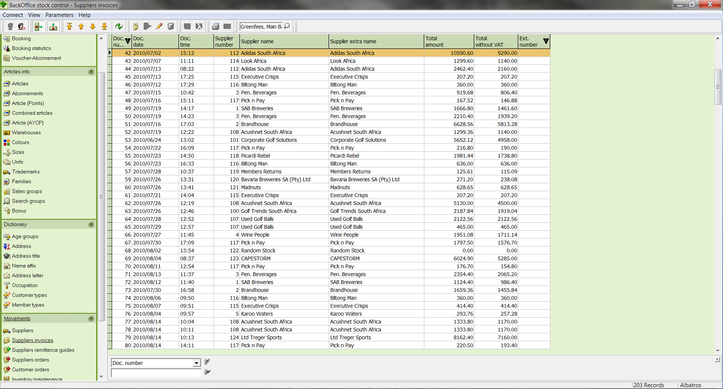

Input Fields
Selection field Selection field for the category used to filter the list
Input field Input field for the topic used to filter the list

  - Create an invoice
- Click the icon Add new record.
- The SUPPLIER INVOICE MAINTENANCE window opens.

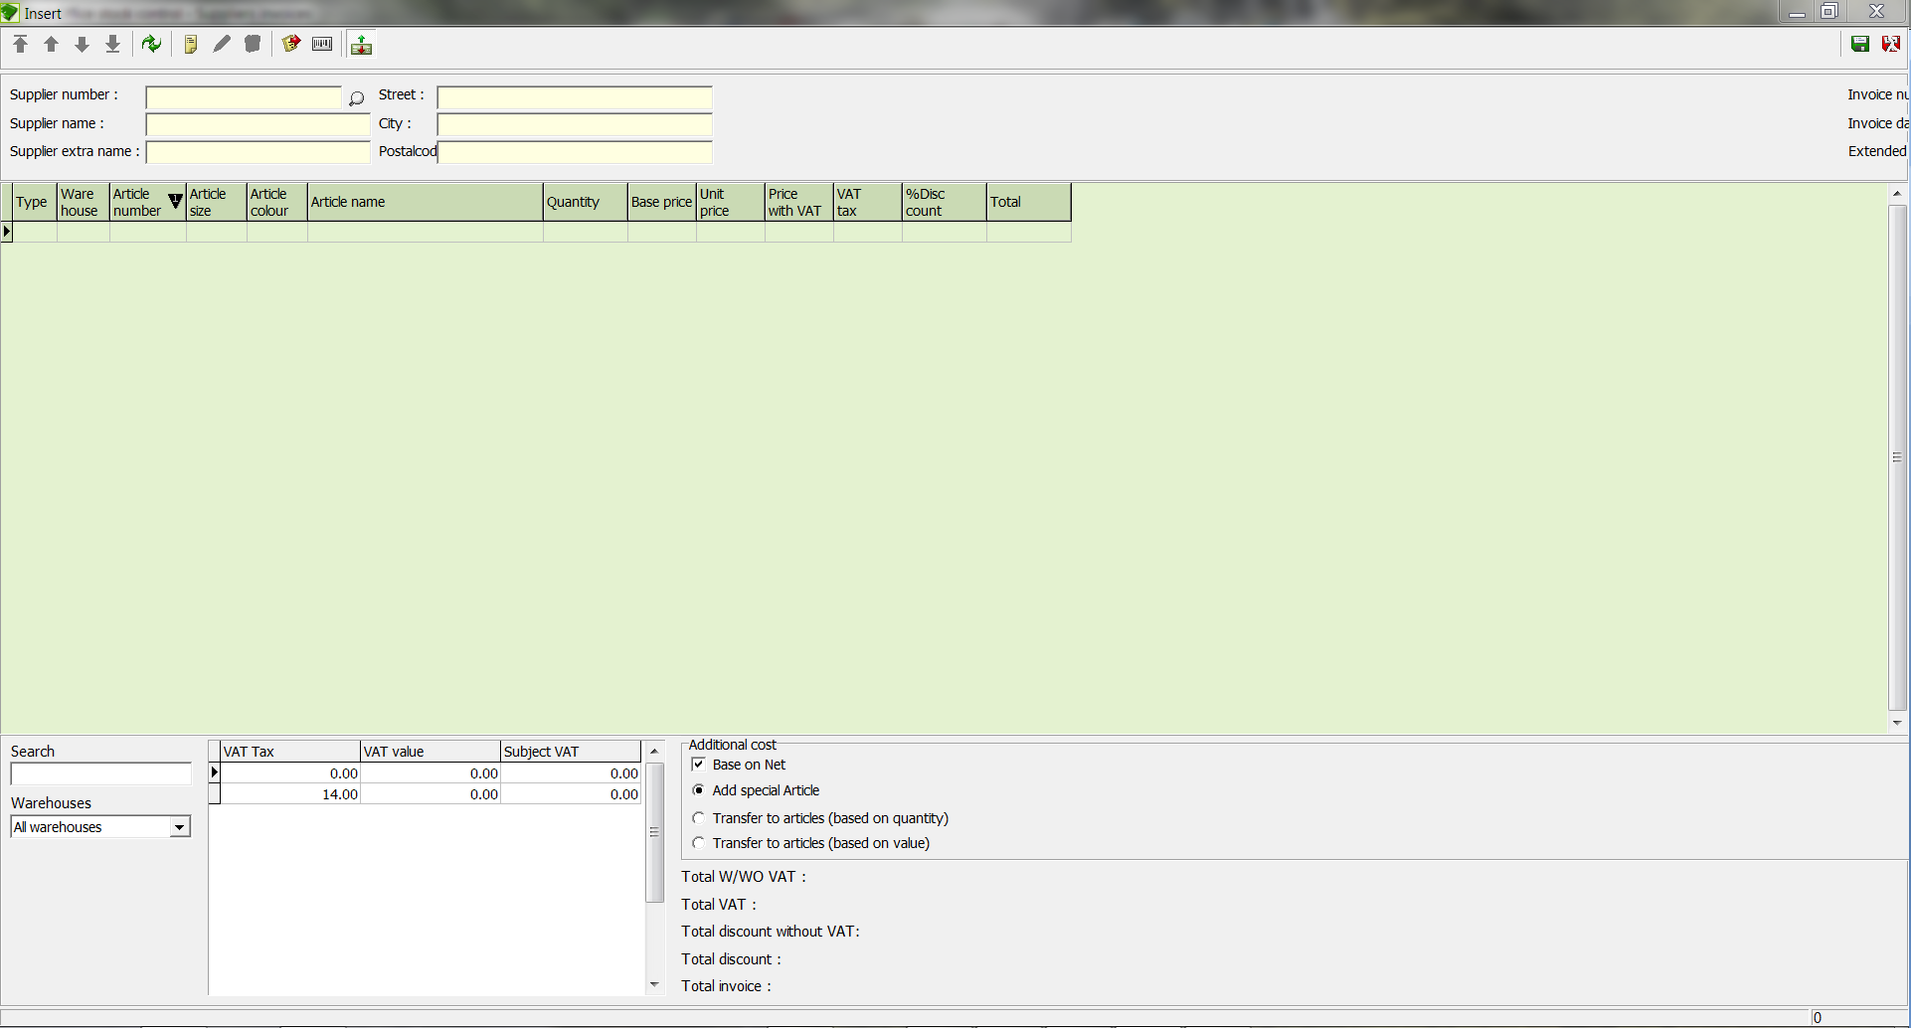

Input Fields
Supplier number Supplier's internal number. The number will be automatically supplied by the system after selecting the supplier with the Search button.
Supplier name Name of the supplier. The name will be automatically supplied by the system after selecting the supplier with the Search button.
Supplier extra name Supplier's Extra Name. The name will be automatically supplied by the system after selecting the supplier with the Search button.
Street Supplier's street. The street will be automatically supplied by the system after selecting the supplier with the Search button.
City Supplier's City. The city will be automatically supplied by the system after selecting the supplier with the Search button.
POSTAL code Supplier's Postal Code. The postal code will be automatically supplied by the system after selecting the supplier with the Search button.
Invoice number Input field for the invoice number. This will be supplied by the system automatically.
Invoice date Input field for the date. The date can be entered manually or by using the calendar sheet. The system automatically enters the current date.
Search: Article number Input field for the article number to search for
Warehouses Selection list for the warehouse to search for
Total W/WO VAT Input field for the net amount. The net amount will automatically be supplied by the system after an article has been entered.
Total VAT Input field for the VAT. The VAT will automatically be supplied by the system after an article has been entered.
Total orders Input field for the total order amount. The invoice amount will automatically be supplied by the system after an article has been entered.

There are two ways to create an invoice. The articles can be entered into the invoice directly or they can be read from an open purchase order or delivery receipt.

  - Direct entry of an article
- With the Search button, select the supplier.
- Click the icon Add new record.
- The ARTICLE wizard opens.

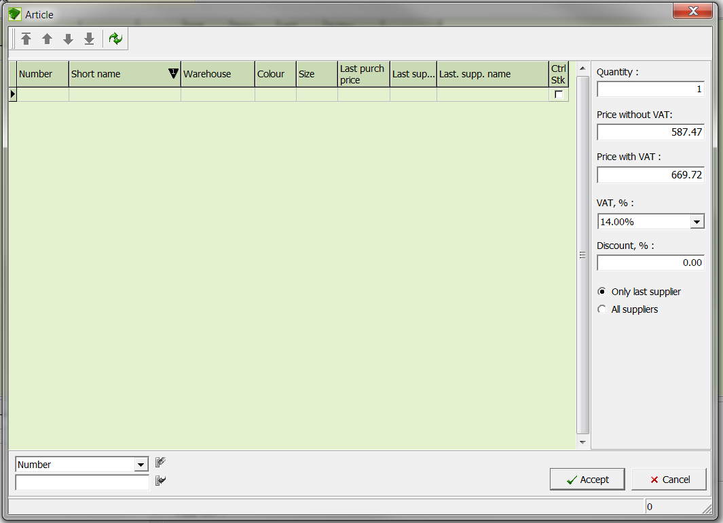

Input Fields
Quantity Input field for the article quantity
Price without VAT Input field for the individual price per unit
Discount, % Input field for the discount in percent
Only last supplier If this field is marked, only the articles of the last searched supplier will be listed.
All suppliers If this field is marked, the articles of all suppliers will be displayed.
Selection field Selection field for the category used to filter the list.
Input field Input field for the topic used to filter the list.

- Select the desired article in the list and enter the desired quantity.
- Confirm your entry with the button. 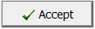
- Save your invoice entries with the Save button and return to the SUPPLIER INVOICES window.

  - Article from a Purchase Order
- With the Search button, select the supplier.
- Click the Order button to capture the article from a purchase order. In both cases, the following window opens.

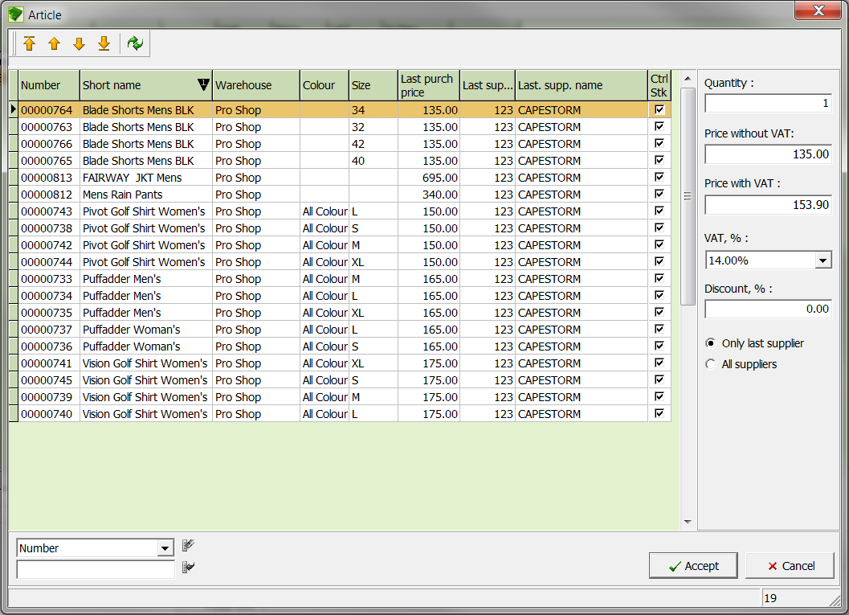

- Enter the quantity of each article that you wish to capture and confirm the entries with the Accept button.
- The article is now inserted into the invoice. Save your invoice entries with the Accept button and return to the SUPPLIER INVOICES window.

  - Edit an invoice
- In the list, select the invoice to edit and click on the Edit current record icon.
- The SUPPLIER INVOICES window opens with the details of the selected current invoice.
- Make the changes and save them with the Accept button.

  - Delete an invoice
In the list, select the invoice to be deleted and click the Remove icon, and then answer the confirmation question.

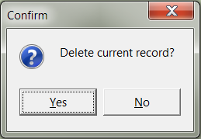

  - Print an Invoice
- In the table, select the invoice to be printed.
- Click the icon, and then in the window that opens, click the “print” icon and select a sort sequence for your invoice. 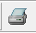

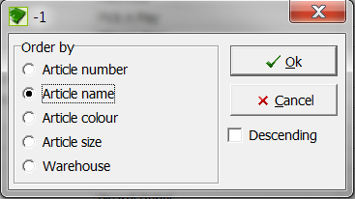

- Confirm the sort sequence with the button OK.
- The List&Label window opens.

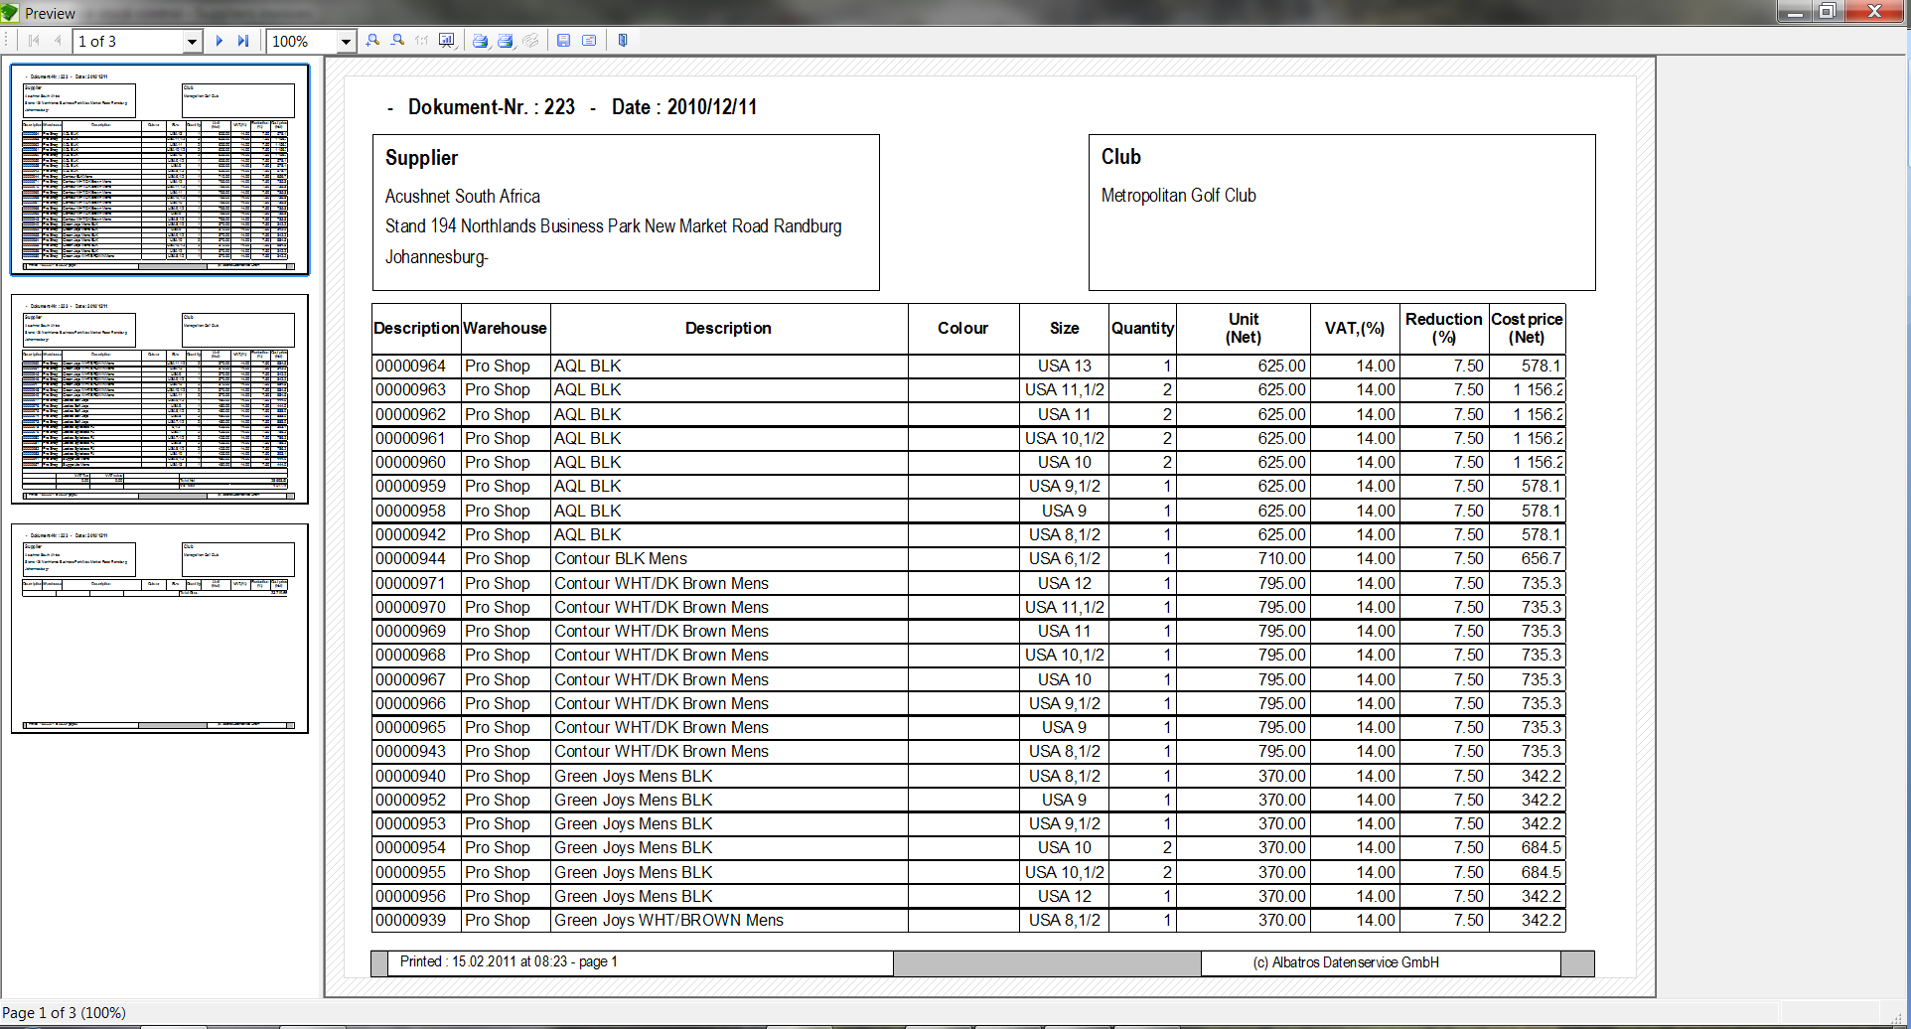

- Start printing the invoice with the button.

- Suppliers remittance guides
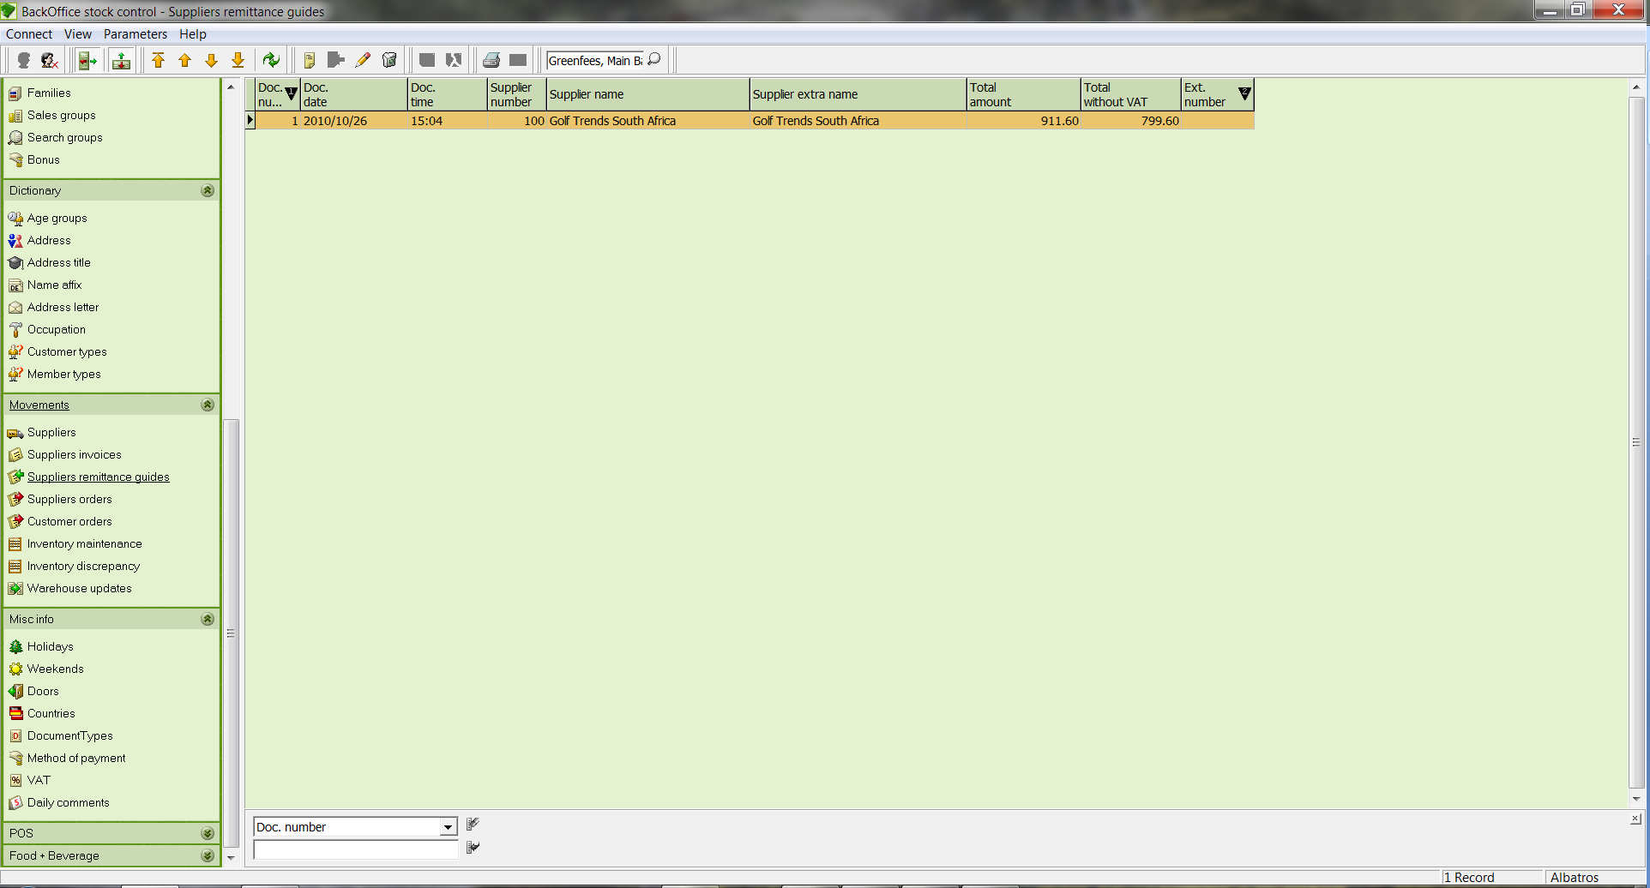

Input Fields
Selection field Selection field for the category used to filter the list
Input field Input field for the topic used to filter the list

  - Create a remittance
- Click the icon Create New Data Record and the SUPPLIER REMITTANCE MAINTENANCE window opens.

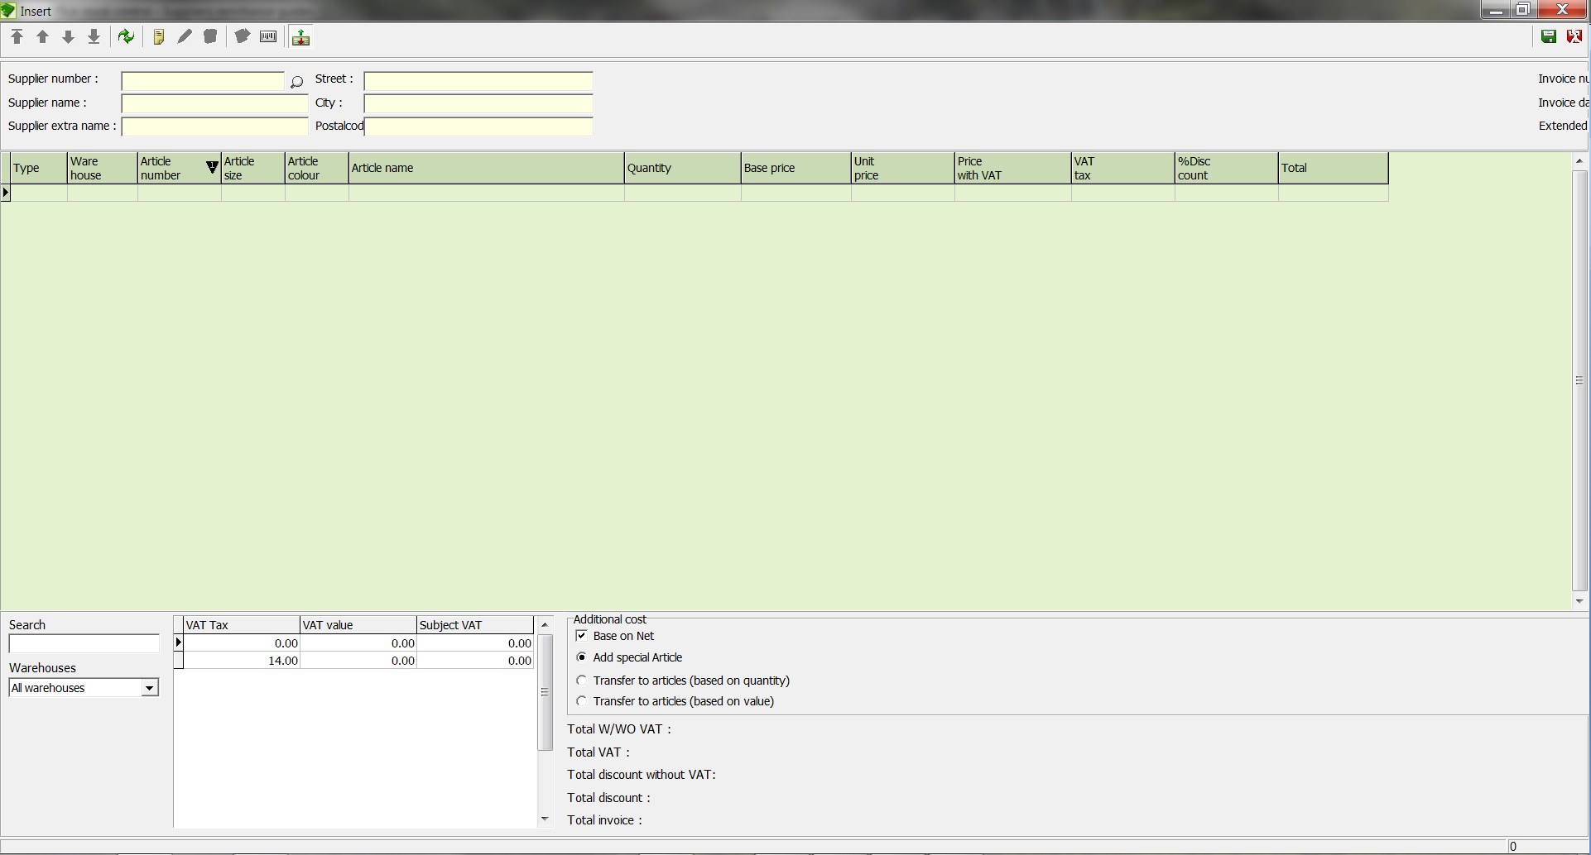

Input Fields
Supplier number Supplier's internal number. The number will be automatically supplied by the system after selecting the supplier with the Search button.
Supplier name Name of the supplier. The name will be automatically supplied by the system after selecting the supplier with the Search button.
Supplier extra name Supplier's Extra Name. The name will be automatically supplied by the system after selecting the supplier with the Search button.
Street Supplier's street. The street will be automatically supplied by the system after selecting the supplier with the Search button.
City Supplier's City. The city will be automatically supplied by the system after selecting the supplier with the Search button.
Postal code Supplier's postal Code. The postal code will be automatically supplied by the system after selecting the supplier with the Search button.
Remittance number Input field for the entry number of the remittance. This will be supplied by the system automatically.
Remittance date: Input field for the date. The date can be entered manually or by using the calendar sheet. The system automatically enters the current date.
Search: Article number Input field for the article number to search for
Warehouses Selection list for the warehouse to search for
Total W/WO VAT Input field for the net amount. The net amount will automatically be supplied by the system after an article has been entered.
Total VAT Input field for the VAT. The VAT will automatically be supplied by the system after an article has been entered.
Total orders Input field for the total order amount. The invoice amount will automatically be supplied by the system after an article has been entered.

  - Direct entry of an article
- With the Search button, select the supplier.
- Click the icon Add new record and the ARTICLE wizard opens.

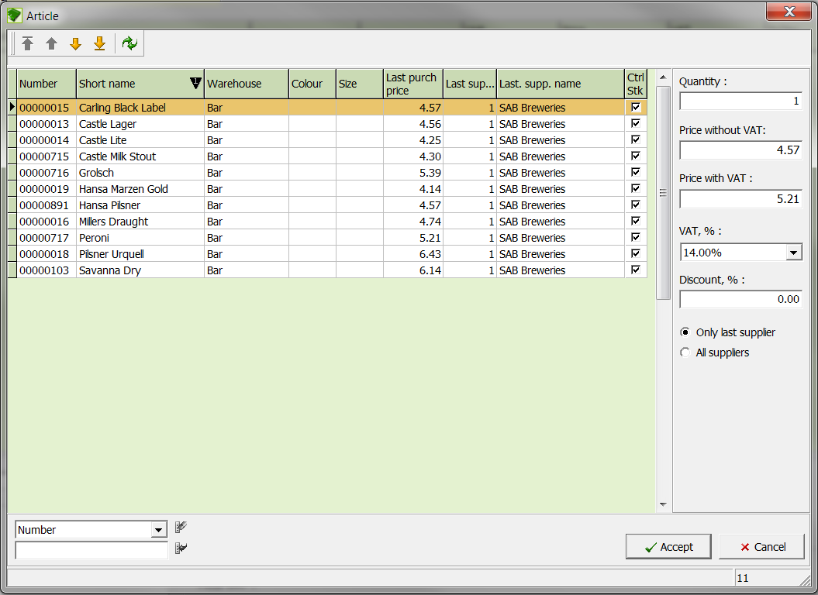

Input Fields
Quantity: Input field for the article quantity
Price with and without
VAT Input field for the individual price per unit

Discount, % Input field for the discount in percent
Only last supplier If this field is marked, only the articles of the last searched supplier will be listed.
All suppliers If this field is marked, the articles of all suppliers will be displayed.
Selection field Selection field for the category used to filter the list
Input field Input field for the topic used to filter the list

- Select the desired article in the list and enter the desired quantity.
- Confirm your entries with the Accept button and save the entries with the icon Save.
- Article from a Purchase Order
- With the Search button, select the supplier.
- Click the Order button to capture the article from a purchase order.
- The following window opens.

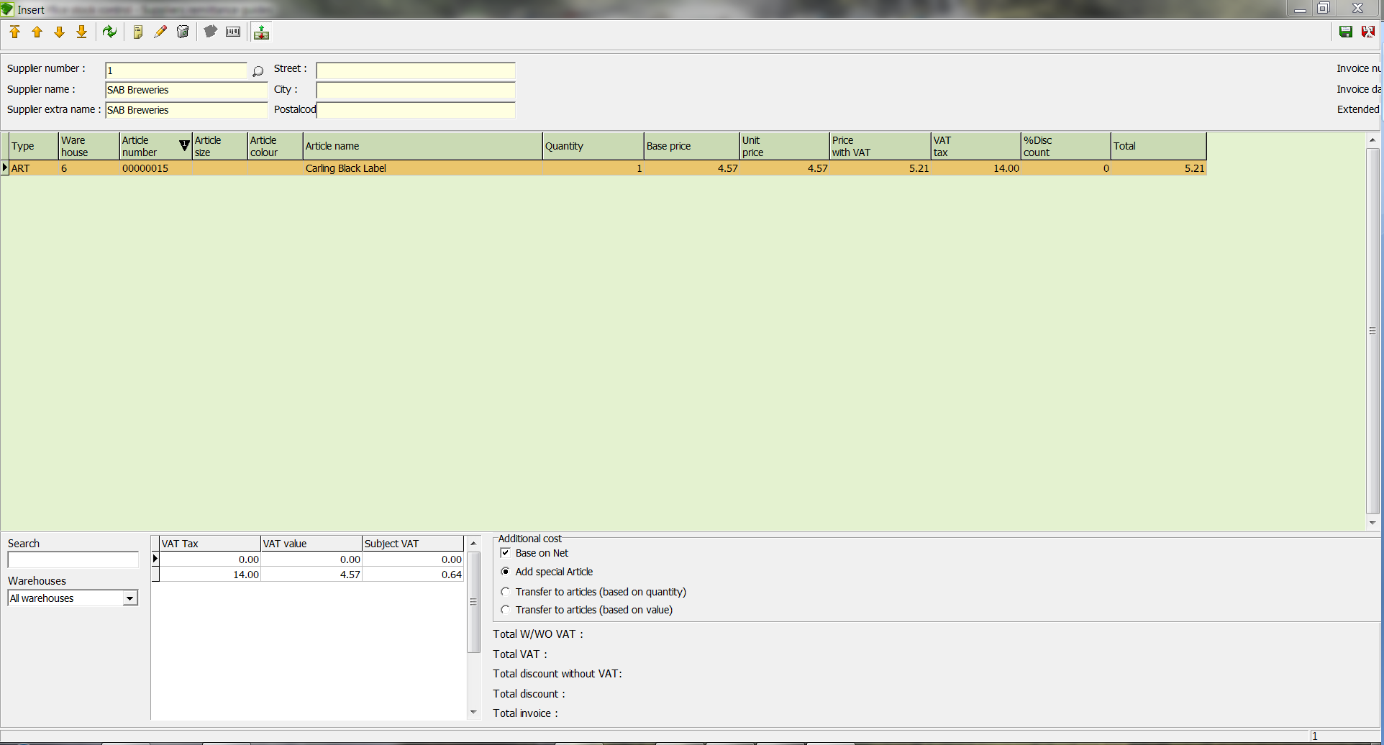

- Enter the quantity of each article that you wish to capture.
- Save the changes with the icon Save.
- The articles are transferred to the entry.
- Save the entry data with the Save button and return to the SUPPLIER INVOICES window.

  - Edit a remittance
- In the list, select the remittance to edit and click on the Edit current record icon.
- A window with the details of the corresponding remittance opens.
- Make the changes and save them with the icon Save.
- Delete a remittance entry

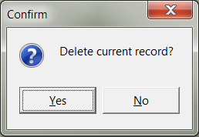

- In the table, select the remittance entry to delete.
- Click the Delete icon.
- Answer the confirmation question

  - Print a remittance entry
- In the table, select the remittance entry to print.
- Click the icon Export report and in the window that opens click the icon Print.
- Select a sort sequence for your remittance entry.

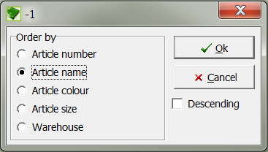

- Confirm the sort sequence with the button OK, and the item is printed.
NOTE: With the Preview button you can see the sort in List & Label, and by clicking with a right-click on the printer button you can select the printer with the standard Windows dialog.

- Suppliers orders
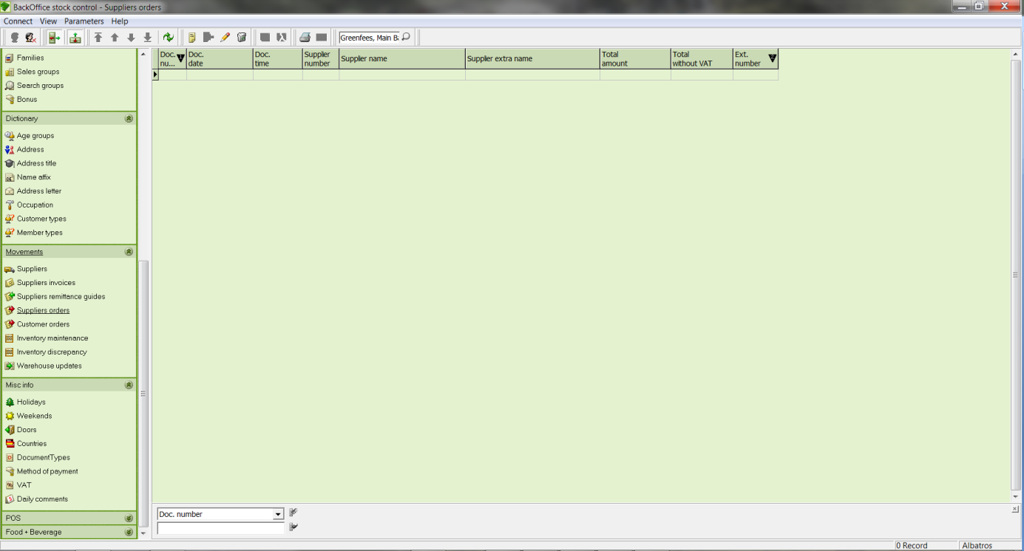

Input Fields
Selection field Selection field for the category used to filter the list
Input field Input field for the topic used to filter the list

  - Create an Order
- Click the icon Create New Data Record and the SUPPLIER ORDERS MAINTENANCE window opens.

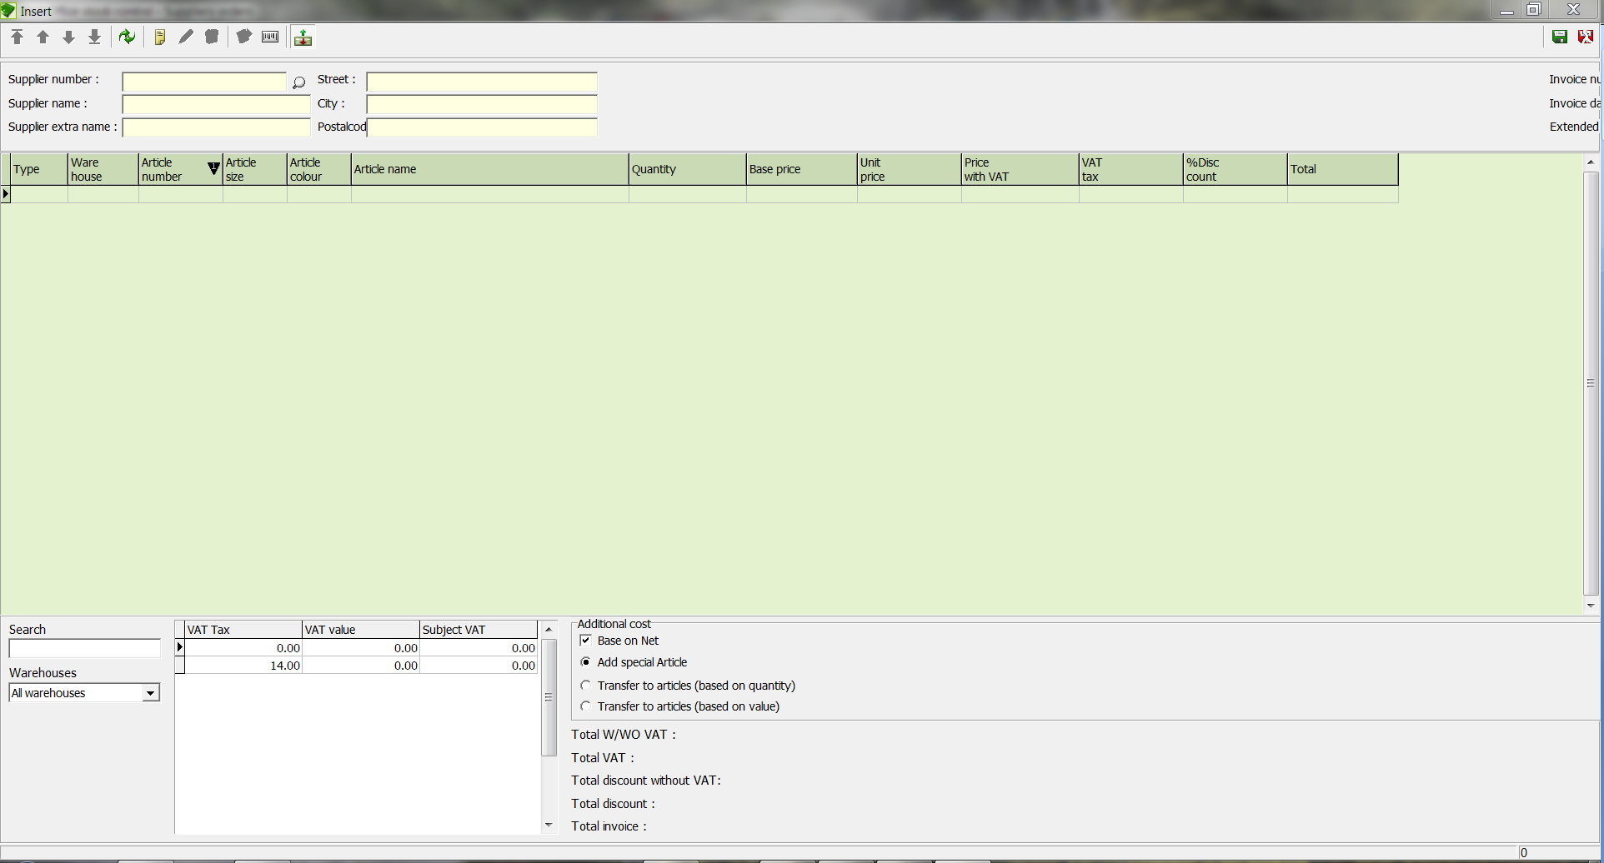

Input Fields
Supplier number Supplier's internal number. The number will be automatically supplied by the system after selecting the supplier with the Search button.
Supplier name Name of the supplier. The name will be automatically supplied by the system after selecting the supplier with the Search button.
Supplier extra name Supplier's Extra Name. The name will be automatically supplied by the system after selecting the supplier with the Search button.
Street Supplier's street. The street will be automatically supplied by the system after selecting the supplier with the Search button.
City Supplier's City. The city will be automatically supplied by the system after selecting the supplier with the Search button.
Post code Supplier's postal Code. The postal code will be automatically supplied by the system after selecting the supplier with the Search button.
Order number Input field for the order number. This will be supplied by the system automatically.
Order date Input field for the date. The date can be entered manually or by using the calendar sheet. The system automatically enters the current date.
Search: Article number Input field for the article number to search for
Warehouses Selection list for the warehouse to search for
Total W/WO VAT Input field for the net amount. The net amount will automatically be supplied by the system after an article has been entered.
Total VAT Input field for the VAT. The VAT will automatically be supplied by the system after an article has been entered.
Total order Input field for the total order amount. The invoice amount will automatically be supplied by the system after an article has been entered.

- With the Search button, select the supplier.
- Click the icon Add new record.
- The ARTICLE wizard opens.

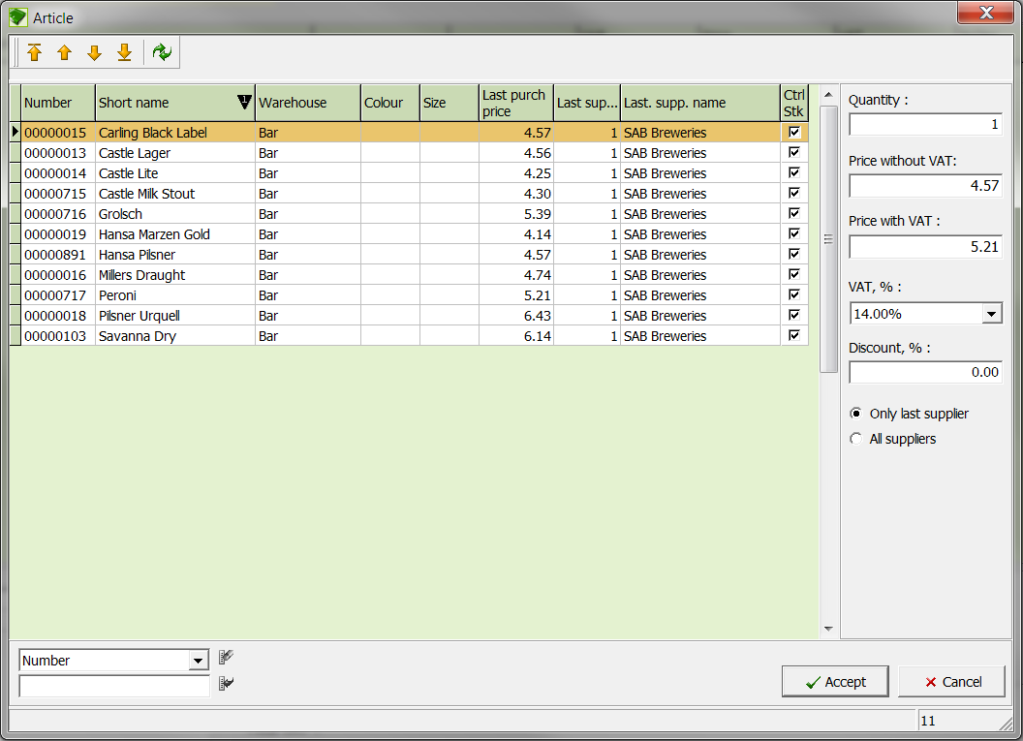

Input Fields
Quantity Input field for the article quantity
Price with and without VAT Input field for the individual price per unit
Discount, % Input field for the discount in percent
Only last supplier If this field is marked, only the articles of the last searched supplier will be listed.
All suppliers If this field is marked, the articles of all suppliers will be displayed.
Selection field Selection field for the category used to filter the list
Input field Input field for the topic used to filter the list

- Select the desired article in the list.
- Enter the desired quantity of the article.
- Confirm your entry with the button Accept.

- Save the entry data with the Save button and return to the SUPPLIER ORDERS MAINTENANCE window.

  - Edit an order
- In the table, select the order to be edited.
- Click the icon Edit current record.
- The SUPPLIER ORDERS MAINTENANCE window opens with the details of the corresponding entry.

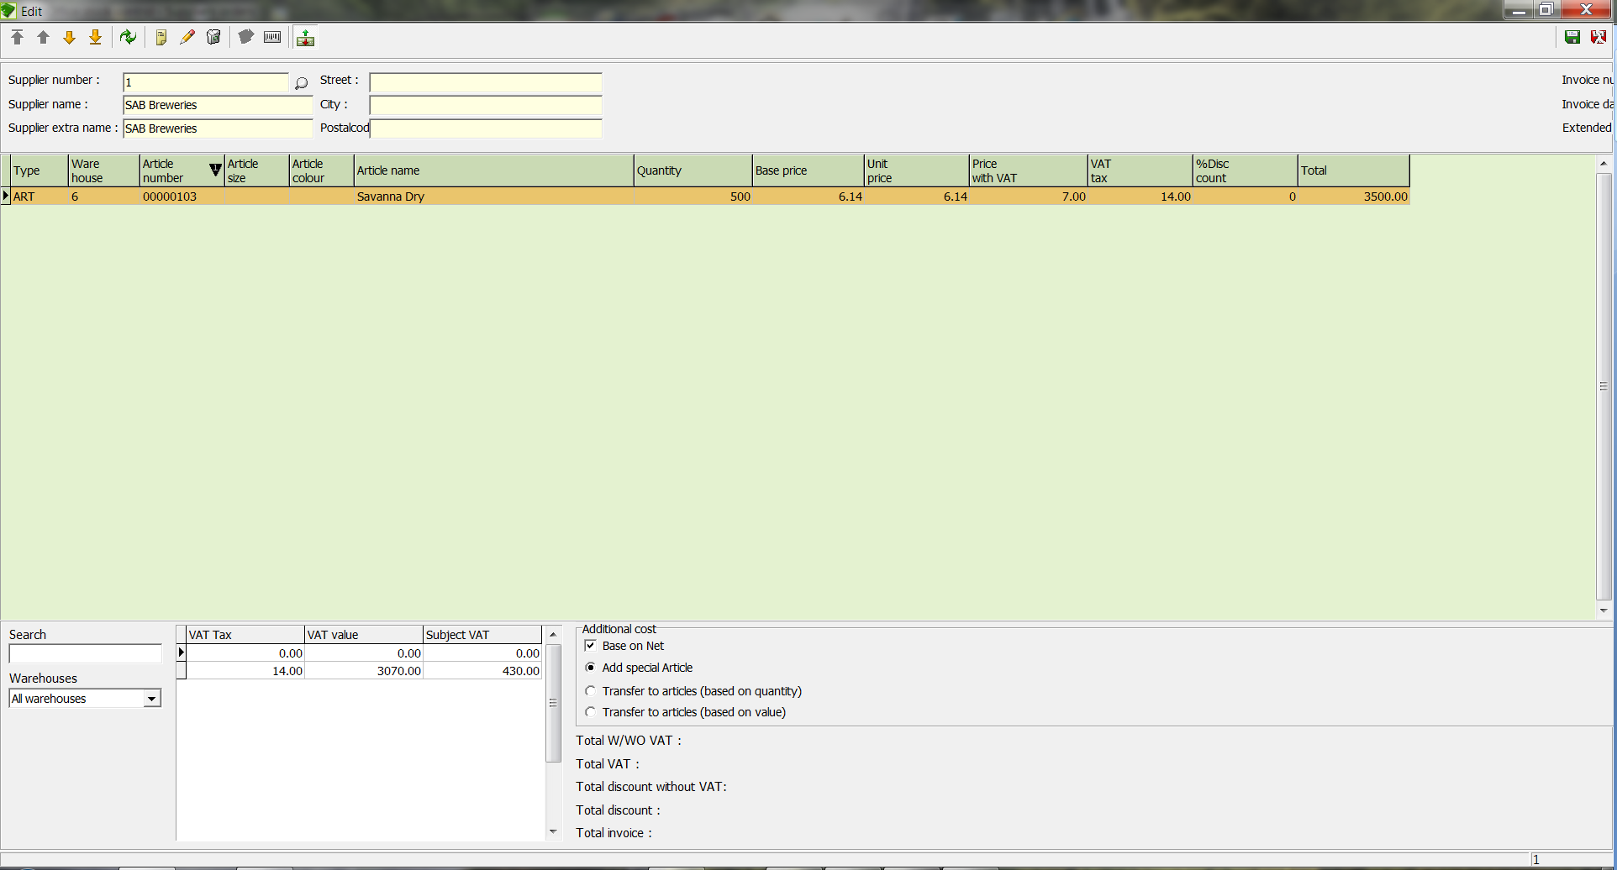

- Make the changes and save them with the icon Save.

  - Delete an order
- In the table, select the order to be deleted.
- Click the icon Delete and answer the confirmation question.

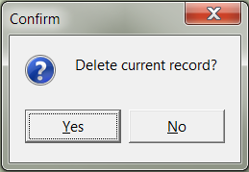

  - Print an order
- In the table, select the order to be deleted.
- Click the icon and then the icon Preview.
- Select a sort sequence for your order.

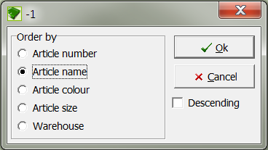

- Confirm the sort sequence with the button OK.
- The List & Label window opens. Here you have the windows-standard option to select a printer by right clicking on the button, as well as the choice of pages to print.

Order Control List
- Open the SUPPLIER ORDERS window in the category Stock Movements.
- Enter the suppliers and the desired articles of the order. (See the chapter Articles).
- Print the order and fax this to the suppliers.
- When the merchandise arrives from the supplier, check the shipment with the printed order sheet.
- Open the SUPPLIER INVOICE... window in the category Stock Movements.
- Enter the suppliers for the order.
- Select the order with the Orders button.
- Enter the actual quantity delivered here. If only a partial delivery was made, the system automatically saves the undelivered quantity. As soon as the remaining merchandise is delivered, this can be read into the invoice in the same way.
- Print the invoice and file it.
- If for any reason a part of the order is returned to the supplier, open the SUPPLIER REMITTANCES window in the category Stock Movements.
- Enter the suppliers for the order.
- Select the order with the Orders button.
- Enter the quantity of the article that is to be returned.
- Print the return order and put it with the merchandise to be returned.

- Inventory maintenance
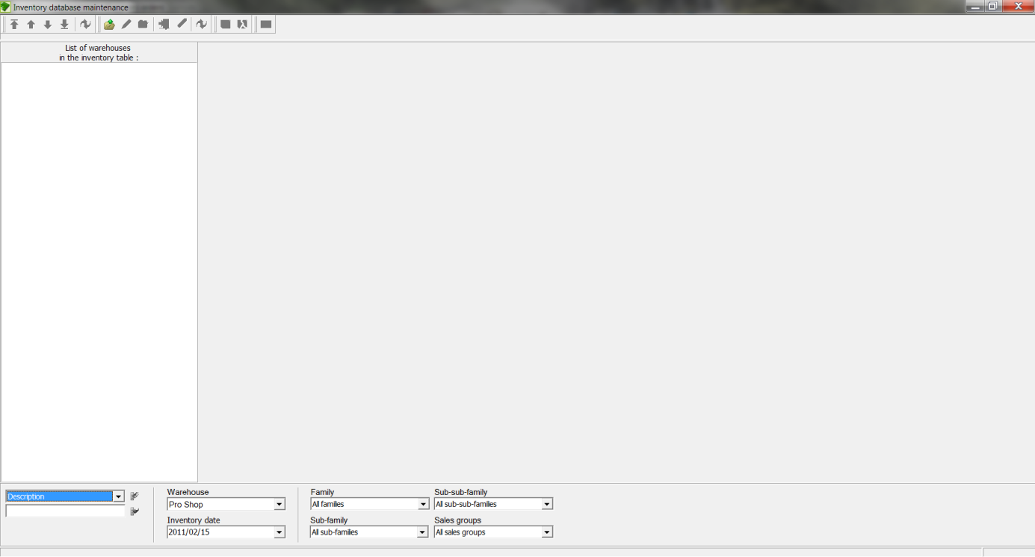

Input Fields
Description Selection list for the search criteria
Warehouse Selection list for the warehouse. All warehouses are available that were entered in the WAREHOUSES window.
Inventory date Date of the inventory. The date can be entered manually or by using the calendar sheet.
Family Selection list for the family. All families are available that were entered in the FAMILIES window.
Sub-family Selection list for the sub-family
Sub-sub-family Selection list for the sub-sub-family
Sales group Selection list for the sales group. All sales groups are available that were entered in the SALES GROUPS window.
Buttons
Open inventory Create a new inventory
Close inventory Closing the inventory does not mean closing the window but rather finalising the inventory.
Edit inventories Edit an inventory that has not been finalised
Update article If a new article was created during the inventory, the article must be updated with the button Update article.
Make changes Confirm a change
Cancel changes Cancel a change
Reset inventory Resetting an inventory means that all entries and changes will be deleted. The inventory will be returned to its original state.
Close Closing the inventory means closing the window so that the inventory can be continued at a later date.

  - Create a new inventory
- In the bottom part of the window, select the corresponding warehose.
- Click the button OPEN Inventory.

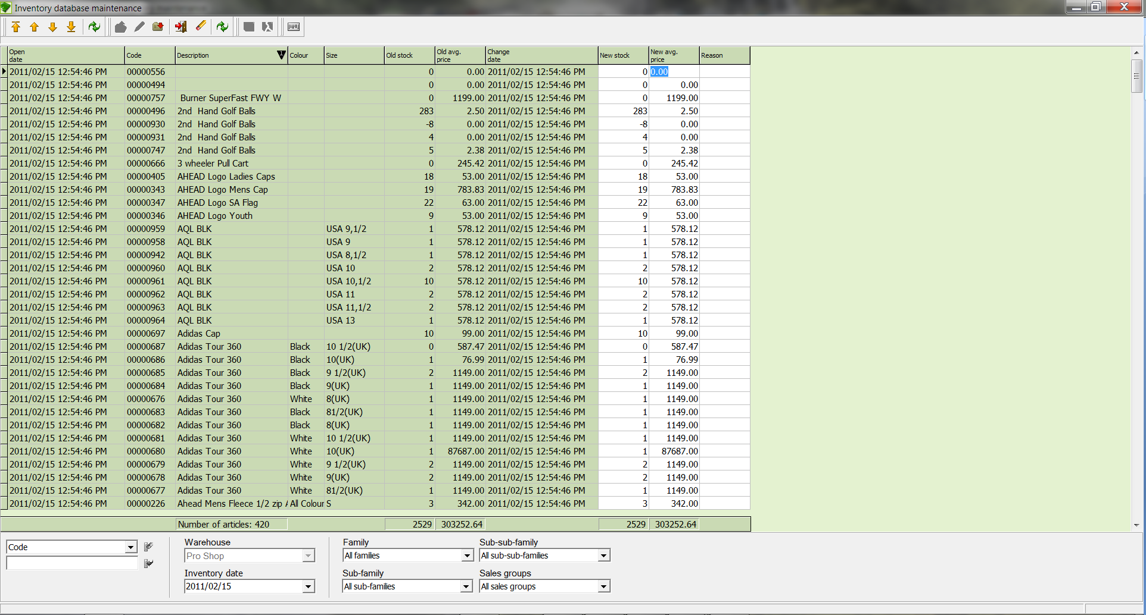

- Enter the corresponding quantities.
- Confirm the entries with the button Make Changes.

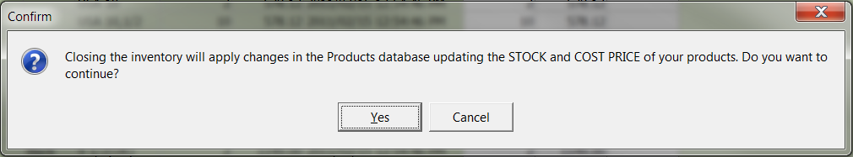

- Close the inventory with the Close inventory button.

NOTE! If the inventory has not been finished and you wish to continue with it at a later time, you must leave the inventory with the Close button. Note! No sales can be confirmed until the inventory is completed, as the stock on hand would change.

  - Edit an inventory
- Click the button Edit Inventory.
- Enter your data.
- Close the inventory with the Close inventory button.

Inventory Control Sheet
- In the category Reports / Maintenance Reports, print an inventory counting sheet.
- Count every individual item in the warehouse and enter the quantities in the count sheet.
- Open the INVENTORY window in the Stock Movements area.
- In the bottom part of the window select the corresponding warehouse.
- Click the button Open Inventory.
- In the New Stock column enter the quantity for each article. Any changes in price are made in the New Avg. Price column.
- When all quantities have been entered, confirm your entries with the Save button.
- Close the inventory with the Close inventory button.

NOTE! If the inventory has not been finished and you wish to continue with it at a later time, you must leave the inventory with the Close button.

NOTE! If the inventory was interrupted, open the inventory with the Edit Inventory button.

NOTE! If changes to the stock have been made during an inventory, such as the addition of a new article, you can reflect these changes in the inventory with the Update products button.

- Warehouse updates (transfers)
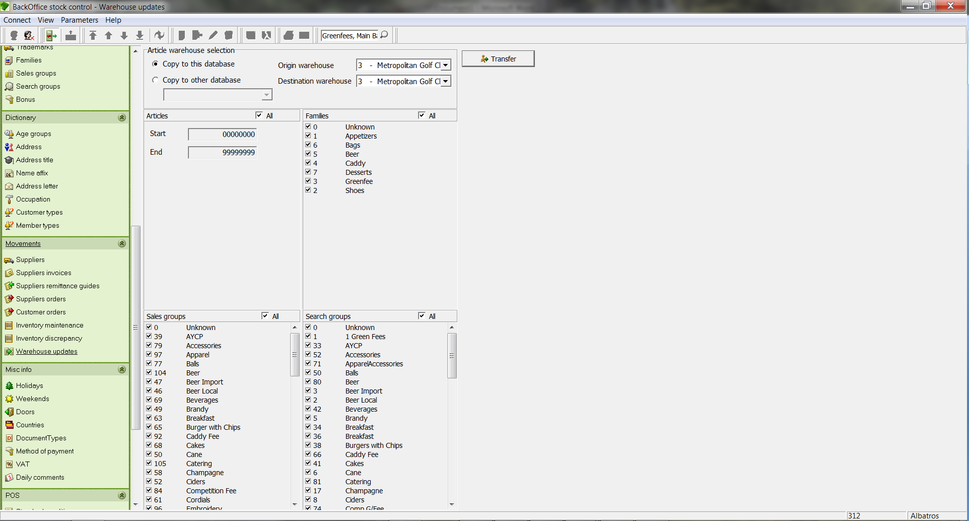

Procedure
- Select origin warehouse.
- Select destination warehouse.
- Select another database (if necessary).
- Select the groups or positions.

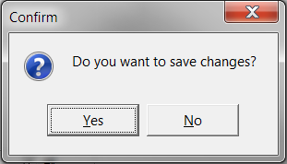

- Click on the button "Transfer".
- To finish, click the button "Yes".

Miscellaneous info

- Holidays
Holidays are used in Albatros, for example, for Green Fee evaluation, that is, in reservations made in Reception.

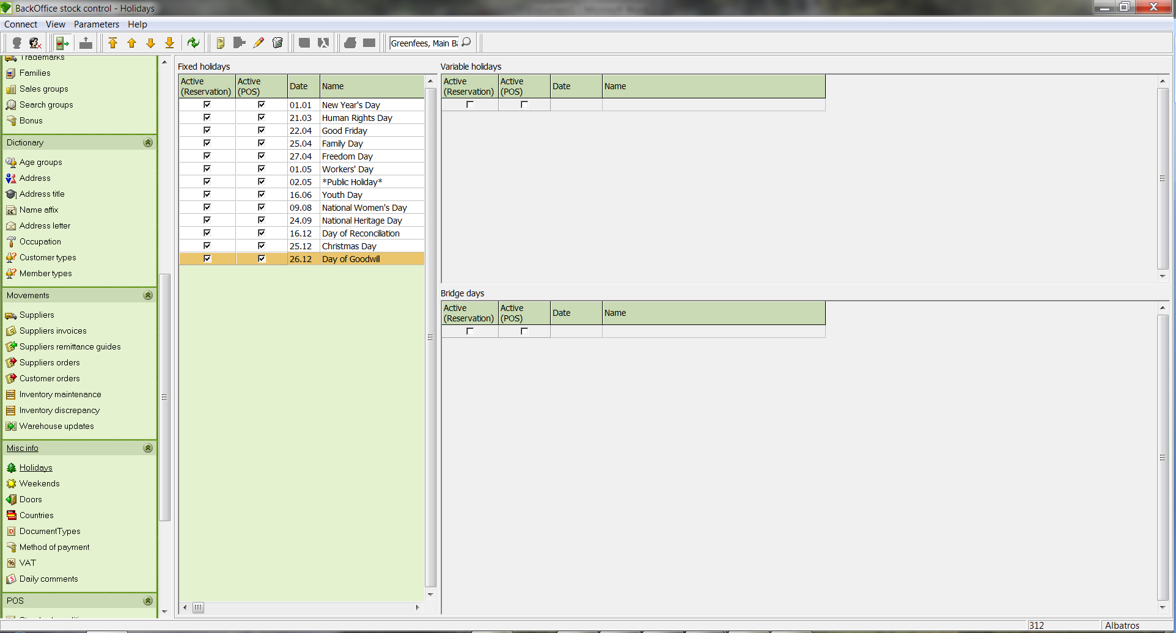

Input Fields
Selection field Selection field for the category used to filter the list
Input field Input field for the topic used to filter the list

  - Create a Holiday
- Click the icon Add new record.
- The ADD NEW HOLIDAY RECORD wizard opens.

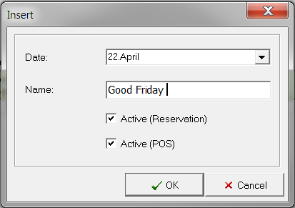

Input Fields
Internal key Input field for the number. The system automatically supplies the next available number.
Date Input field for the date. The date can be entered manually or by using the calendar sheet.
Name Name of the holiday

- Define the holiday with the necessary data.
- Save the data by clicking the OK button.

  - Edit a holiday
- In the table, select the holiday to edit.
- Click the icon Edit current record.
- Make the changes.
- Save the changes with the OK button.

  - Delete a holiday
- In the table, select the holiday to delete.
- Click on the icon Delete current record.
- The DELETE HOLIDAY window opens.
- Verify that this is the holiday you wish to delete.
- Close the window and delete the holiday by clicking the Remove button. If you do not wish to delete the holiday, close the window with the Cancel button.

- Weekends
Here you can specify the weekend days.

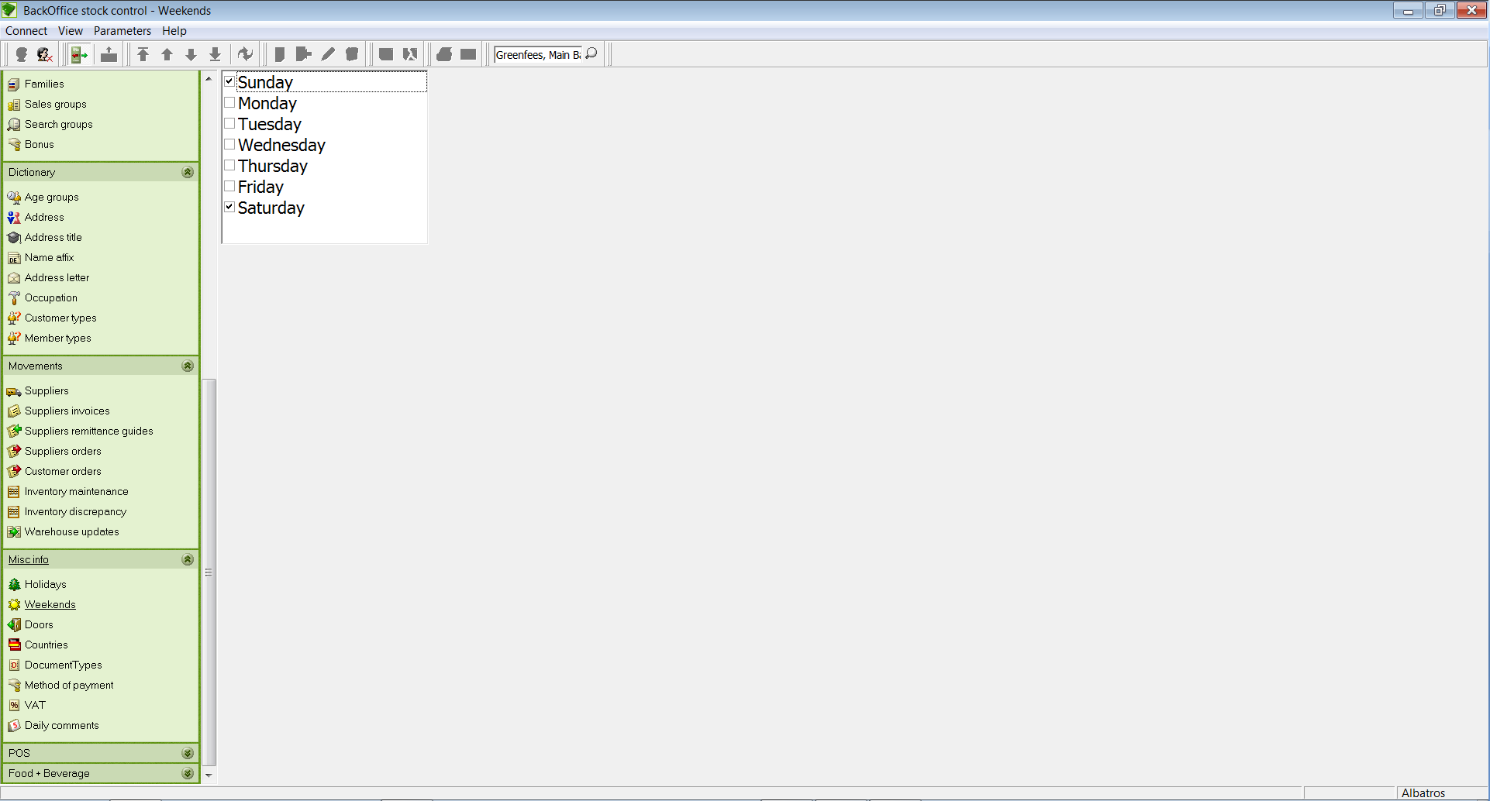

Set the correct day you want to mark as a weekend or public holiday and click on the "green disk" icon to save your selected choice. If you don't want to change the input, click the "red disk" icon to cancel.

Input Fields
Sunday If this box is ticked, Sunday is counted as a weekend day.
Monday If this box is ticked, Monday is counted as a weekend day.
Tuesday If this box is ticked, Tuesday is counted as a weekend day.
Wednesday If this box is ticked, Wednesday is counted as a weekend day.
Thursday If this box is ticked, Thursday is counted as a weekend day.
Friday If this box is ticked, Friday is counted as a weekend day.
Saturday If this box is ticked, Saturday is counted as a weekend day.

- Doors
Data in this window may only be edited if access has been granted by the Albatros software.

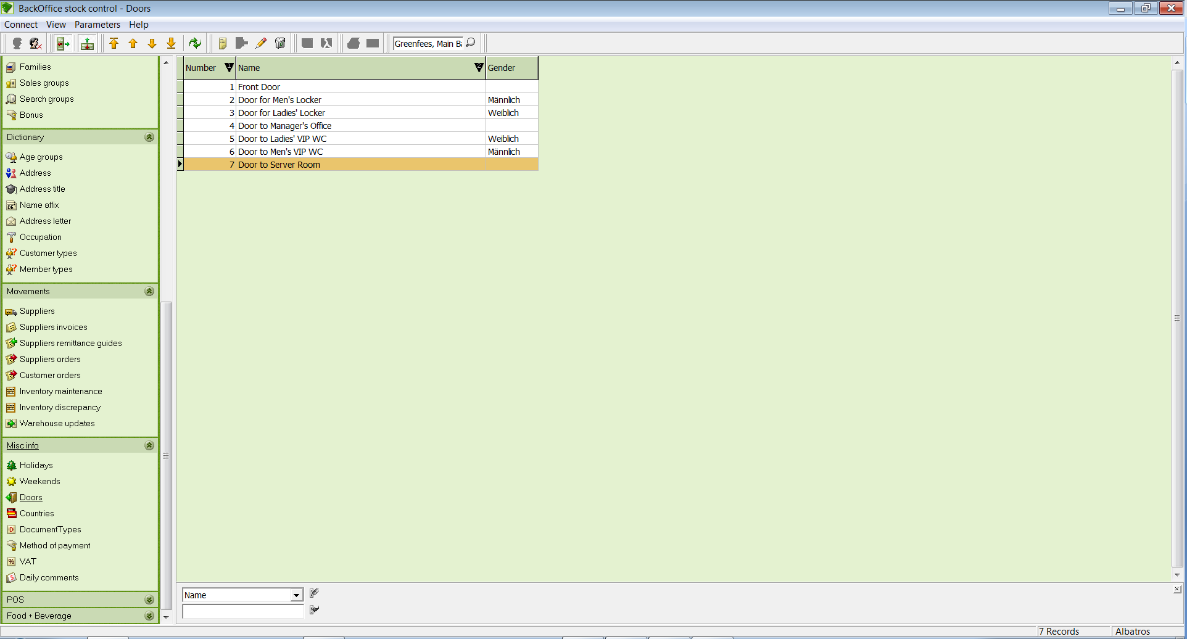

Input Fields
Selection field Selection field for the category used to filter the list
Input field Input field for the topic used to filter the list

  - Create a door
- Click the icon Add new record.

The Insert wizard opens.

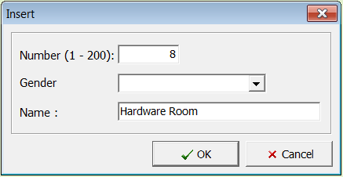

Input Fields
Number (1-200) Input field for the number. The system automatically supplies the next available number.
Gender Gender if applicable
Name Description of the door

- Define the door with the necessary data.
- Save the data by clicking the OK button.

  - Edit an entry
- In the table, select the door to be edited.
- Click the icon Edit current record.
- Make the changes.
- Save the changes with the OK button.

  - Delete a door
- In the table, select the door to be deleted.
- Click on the icon Delete current record.

The DELETE DOOR RECORD? window opens.

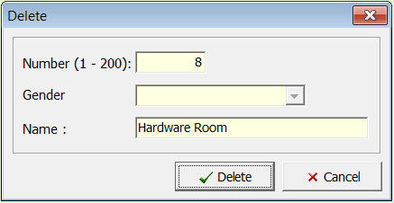

- Be sure that this is the door that you wish to delete.
- Close the window and delete the door by clicking the Delete button. If you do not wish to delete the door, close the window with the Cancel button.

- Countries
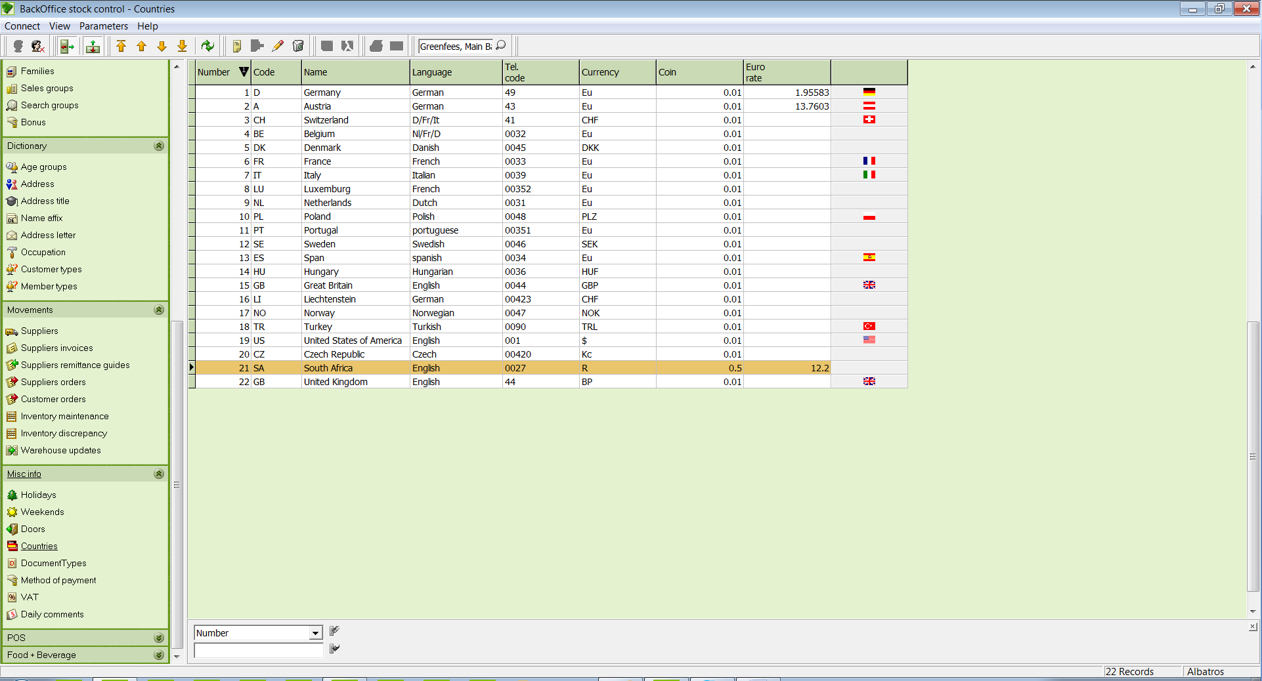

Input Fields
Selection field Selection field for the category used to filter the list
Input field Input field for the topic used to filter the list

  - Create a country
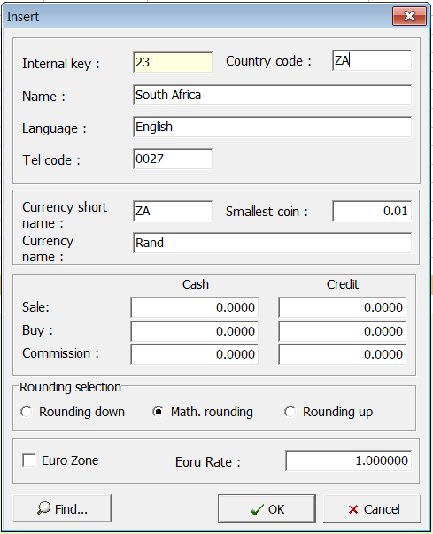

- Click the icon Add new record.

The EDIT COUNTRY RECORD wizard opens.

Input Fields
Internal key: Input field for the number. The system automatically supplies the next available number.
Country Code: Input field for the country code
Name: Name of the country
Language: Input field for the language
Tel Code: Input field for the telephone country code
Currency Short Name: Input field for the short name of the currency
Smallest Coin: Entry field for the smallest unit of the currency
Currency Name: Name of the currency
Euro Zone: If this box is checked, the country falls within the Euro zone.
Exchange Rate: Entry field for the exchange rate

- Define the country with the necessary data.
- Save the data by clicking the OK button.

  - Edit a country
- Select the country in the table you with to edit.
- Click the icon Edit current record and make the changes.
- Save the changes with the OK button.

  - Delete a country
- Select the country in the table that you wish to delete.
- Click the icon Delete current record, and the DELETE COUNTRY? Window opens.
- Be sure that this is the country you wish to delete and delete the country by clicking the Remove button.

- Document Type
With the Document Types menu pick you can manage the various document types. Every booking procedure is identified with the corresponding document type. You can assign a debit or credit status to each type, as well as assigning a counter range and see for each variable used the corresponding counter interval. Changes to existing document types should only be made after consultation with iTee Solutions.

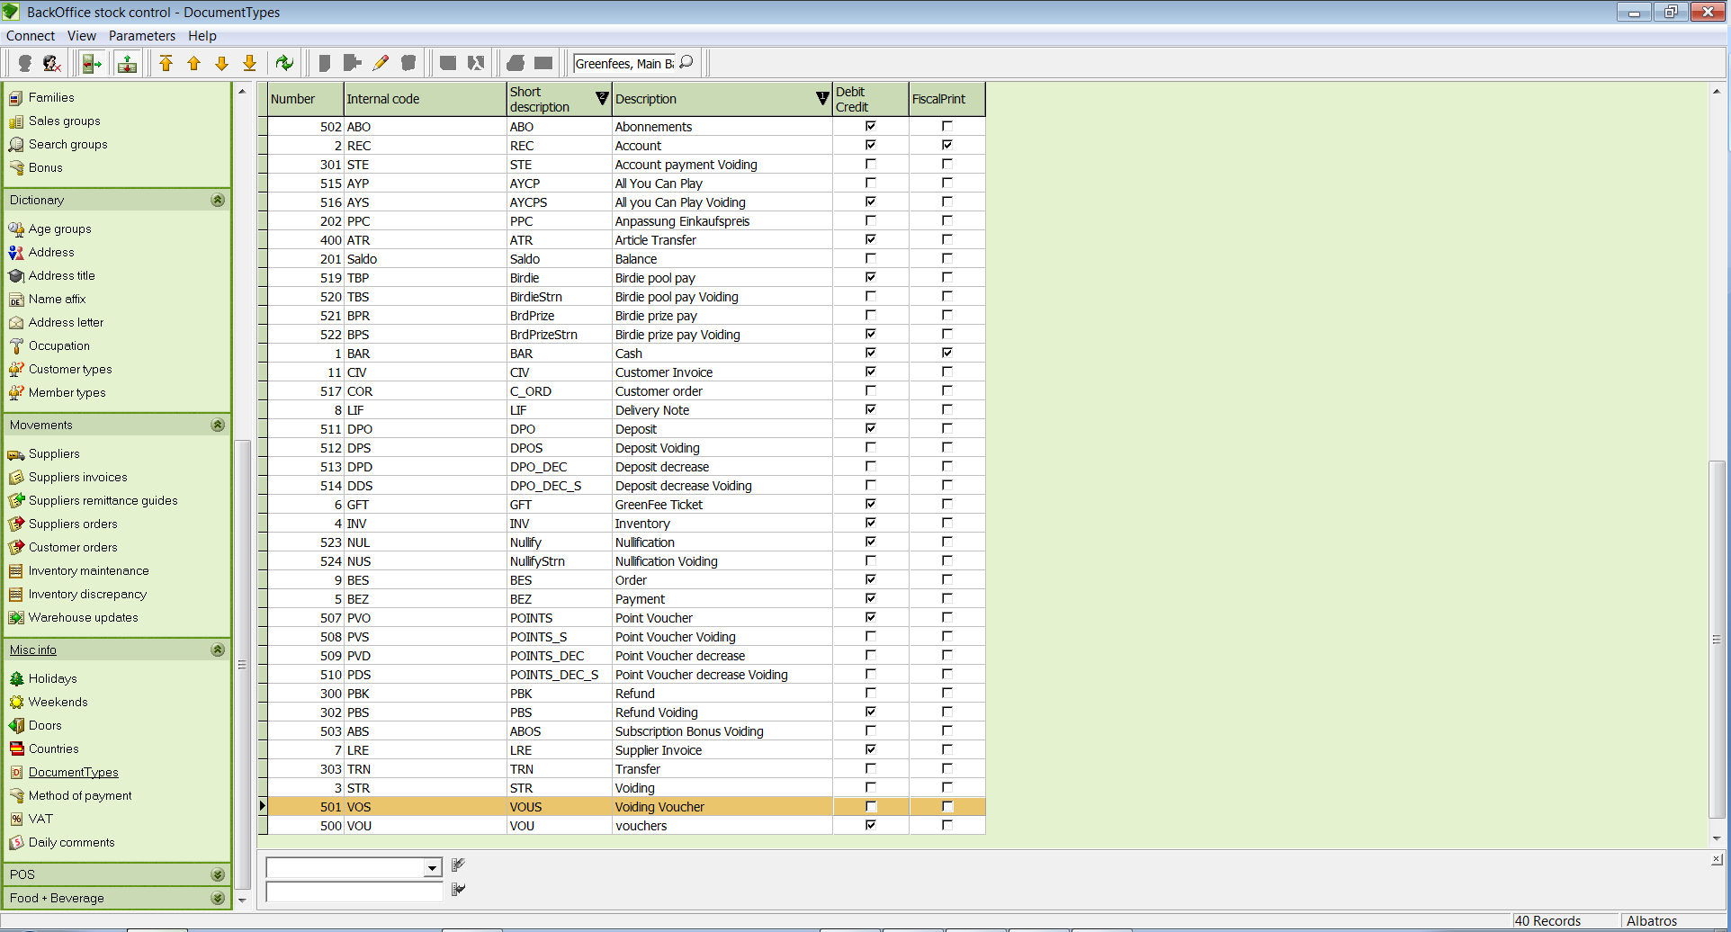

Input Fields
Selection field Selection field for the category used to filter the list
Input field Input field for the topic used to filter the list

  - Create a document type
- Click the icon Add new record and the ADD NEW DOCUMENT TYPE wizard opens.

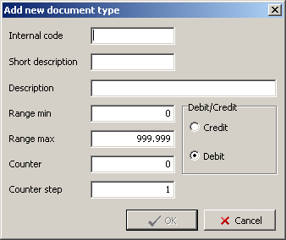

Input Fields
Internal Code Input field for the short description of the document type.
Short Description Name of the document type
Range Min Input field for the minimum value
Range Max Input field for the maximum value
Counter Input field for the counter value, with which the counting of the document type should begin.
Counter step Input field for the counter increment value
Credit If this field is selected, the bookings for this document type are credit entries.
Debit If this field is selected, the bookings for this document type are debit entries.

- Define the document type with the necessary data.
- Save the data by clicking the OK button.

  - Edit a document type
- In the table, select the document type to edit.
- Click the icon Edit current record and make the changes.
- Save the changes with the OK button.

  - Delete a document type
- In the table, select the document type to delete.
- Click the icon Delete current record, and the DELETE DOCUMENT TYPE window opens.
- Be sure that this is the document type you wish to delete and delete the document type by clicking the Remove button.

- Methods of Payment
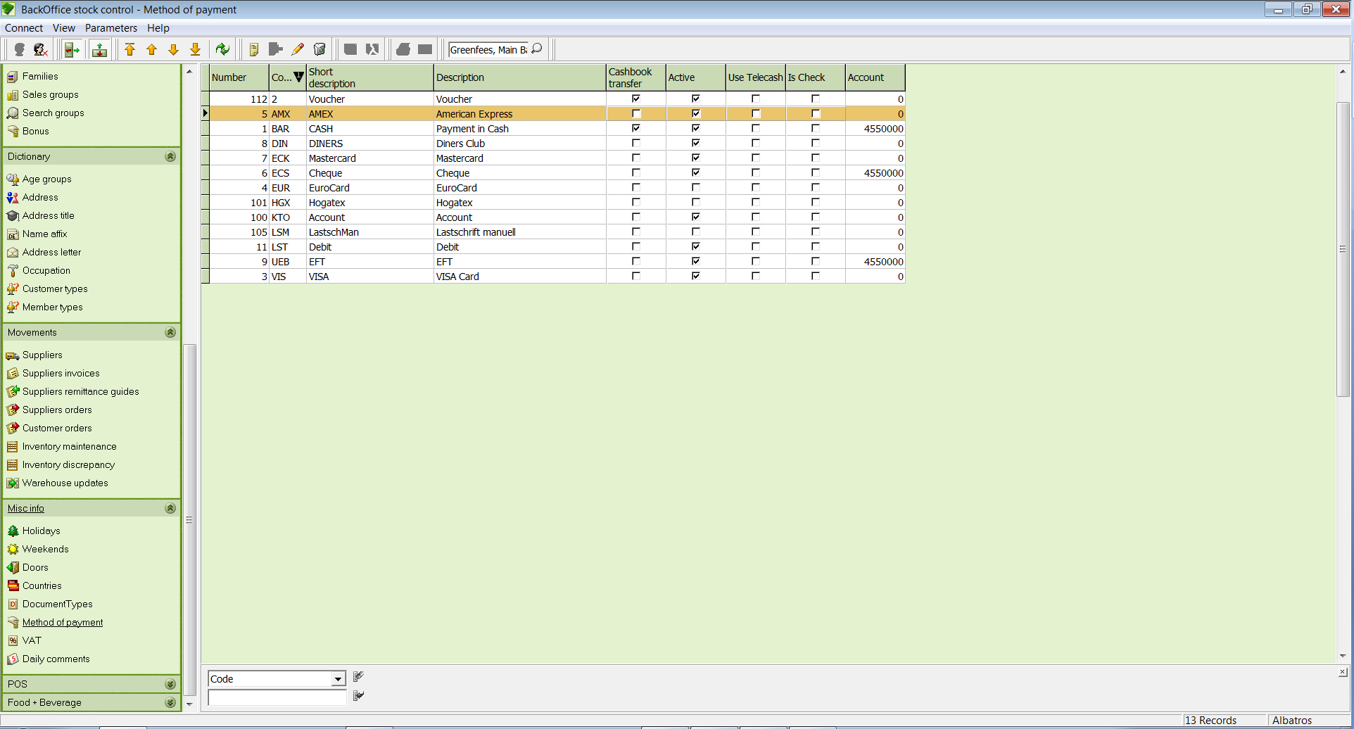

Input Fields
Selection field Selection field for the category used to filter the list
Input field Input field for the topic used to filter the list

  - Create a method of payment
- Click the icon Add new record.
- The ADD NEW PAYMENT METHOD RECORD wizard opens.
- The field descriptions are explained in detail on the next page. Before creating a new payment method, please read these descriptions.

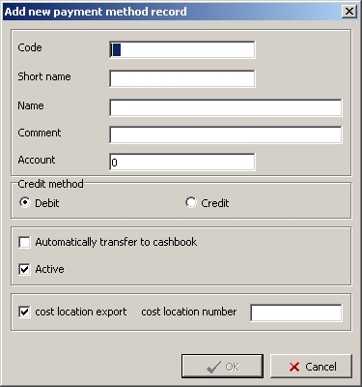
Input Fields
Code Input field for the number. The system automatically supplies the next available number.
Short name Input field for the short name of the payment method. Select a meaningful short name for the payment method you are creating.
Name Name of the payment method. Enter a meaningful name with the essential information so that you can find the payment method again.
Comment Enter any comments about this payment method
Account Enter the account number to which the payment method should be credited/debited.
Credit method
Debit / Credit Enter the "Credit" type here, using Debit for charges and Credit for payments.

Automatically transfer If this box is ticked, the entry will
to cashbook automatically be transferred to the cashbook. ATTENTION! This is only possible for cash payments.

Active If the Active box is ticked, the payment method will be displayed as well. If the check mark is absent, the payment method will be hidden.
Cost Centre Export Automatic export function if this box is ticked.
Cost Centre Number Input field for assignment or input of the cost centre number for bookkeeping.

- Define the payment method with the necessary data.
- Save the data by clicking the OK button.

  - Edit a payment method
- In the table, select the payment method to be edited.
- Click the icon Edit current record.
- Make the changes.
- Save the changes with the OK button.

  - Delete a payment method
- In the table, select the payment method to be deleted.
- Click the icon Delete current record, and the DELETE PAYMENT METHOD window opens.
- Be sure that this is the payment method that you wish to delete.
- Close the window and delete the payment method by clicking the Delete button. If you do not wish to delete the payment method, close the window with the Cancel button.

- VAT
Albatros provides the VAT rates assigned to the corresponding country here. If these should be changed, the changes can be made from here. Before changing this data, please contact iTee Solutions.

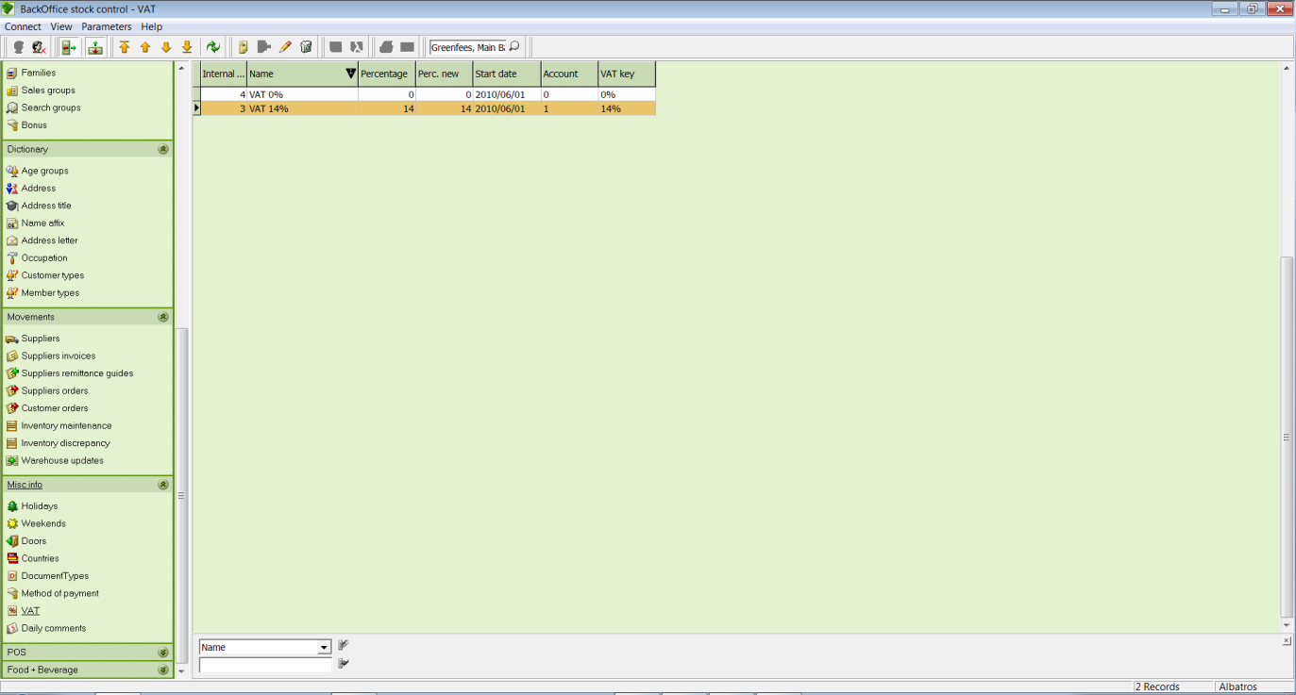

Input Fields
Selection field Selection field for the category used to filter the list
Input field Input field for the topic used to filter the list

  - Create a VAT
- Click the icon Add new record.

The ADD NEW VAT RECORD wizard opens.
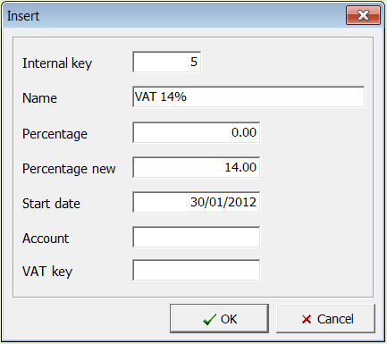

Input Fields
Internal Key Input field for the number. The system automatically supplies the next available number.
Name Input field for the name of the VAT
Percentage Percentage rate of the VAT
Percentage new Input field for the new percentage of the VAT
Start date Input field for the date when the new VAT rate is effective. The system automatically enters the current date.
Account
VAT key

- Define the VAT rate with the necessary data.
- Save the data by clicking the OK button.

  - Edit a VAT
- In the table, select the VAT rate to edit.
- Click the icon Edit current record.
- Make the changes.
- Save the changes with the OK button.

  - Delete a VAT
- In the table, select the VAT rate to delete.
- Click the icon Delete current record, and the DELETE PAYMENT METHOD window opens.
- Be sure this is the VAT rate you wish to delete, and delete the VAT rate by clicking the Remove button. If you do not wish to delete the VAT rate, close the window with the Cancel button.
- Daily Comments
In the Daily Comments menu pick you can make comments in the Weather and Additional Comments fields which can be used for evaluation purposes in Reports / Sales Reports - Daily Report. This enables you to compare turnovers on the basis of specified data during particular periods.

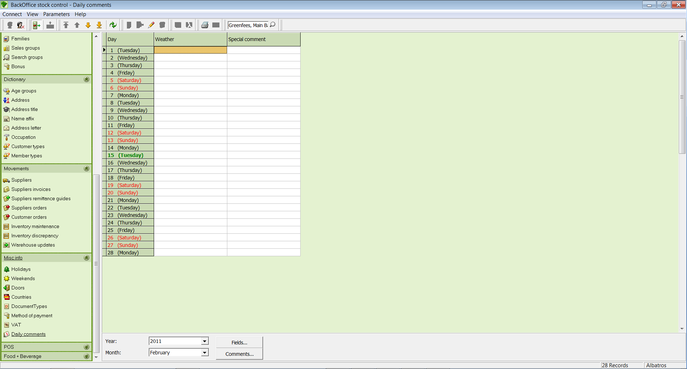

Fields
Day The date and weekday are displayed here, typically the current day.
Weather In the Weather field you can make comments about the daily weather conditions. As a default no weather information is entered, and it is recommended that you create the weather conditions in advance.
Additional Comment In the Additional Comment field you can make entries which are useful for evaluation, such as Limited Play Operations, Full Play Operations, Driving Range Only, etc.
Year You can select the appropriate year with the Year field. This is done with a drop-down menu.
Month You can select the appropriate month with the Month field. This is done with a drop-down menu.
Buttons
Fields By clicking on the Fields button you can insert additional selection fields. Please consult with iTee Solutions before doing this.
Comments By clicking on the Comments button you can insert predefined comments. The entries appear in both the Weather and Additional Comments fields.

  - Make entries
- Double-click in the Weather field on the corresponding day to be filled out.
- Enter either the weather conditions or select a value from the suggested defaults.
- Now click in the Additional Comments field and select a value from the suggested defaults or enter the desired information with the keyboard.
- Now click on the Save button.

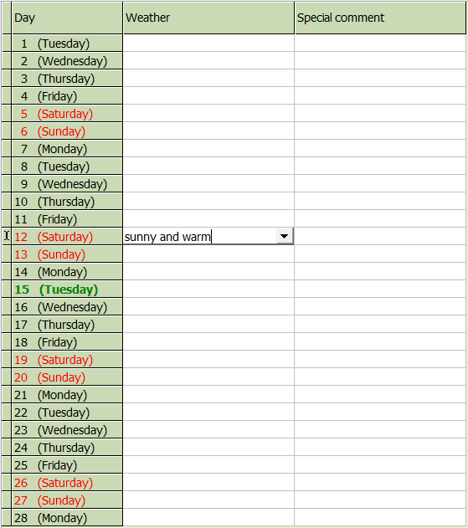

The entries made in this dialog can also be seen in Backoffice under Reports / Sales Reports - Daily Report. The display of these field values is only done if the table has been previously filled in.

  - Evaluation of the entered data
- Change to the main group Reports, and then select the submenu Sales Reports.
- Enter the desired evaluation period using "From Date" and "To Date".
- Double-click on the corresponding Daily Report (Sales Groups) from the selection list on the right.
- From the selection field that opens, select the item "Sales Group Number" and click on the OK button.
- The report window opens, and from there you select Daily Report and click on the Preview button.

You can see the following printed report in the preview screen, and in the lower area you see the displayed values.

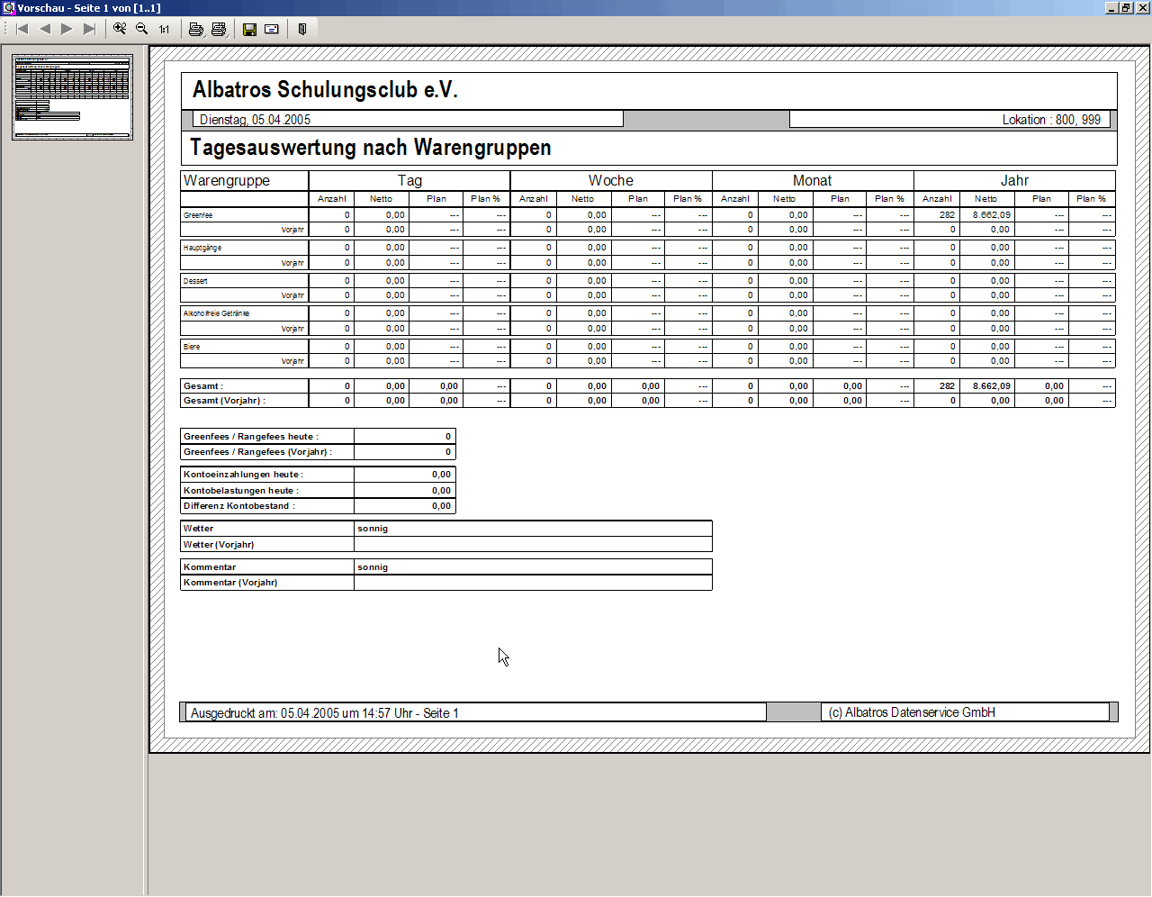

POS

- Standard Conditions
In the STANDARD CONDITIONS window the standard conditions are created and managed. The condition assigned to the customer will be automatically considered during a sale in Reception, provided that the requirements are met. (Time, Weekday) it is advisable to add an appropriate condition, for example in the case of green fee agreements with partner clubs.

A more detailed explanation is necessary here. Apart from the green fee condition, the free balls function is nevertheless entirely different. In addition the range fee and ball condition are connected with automatic deductions at the ball automat.

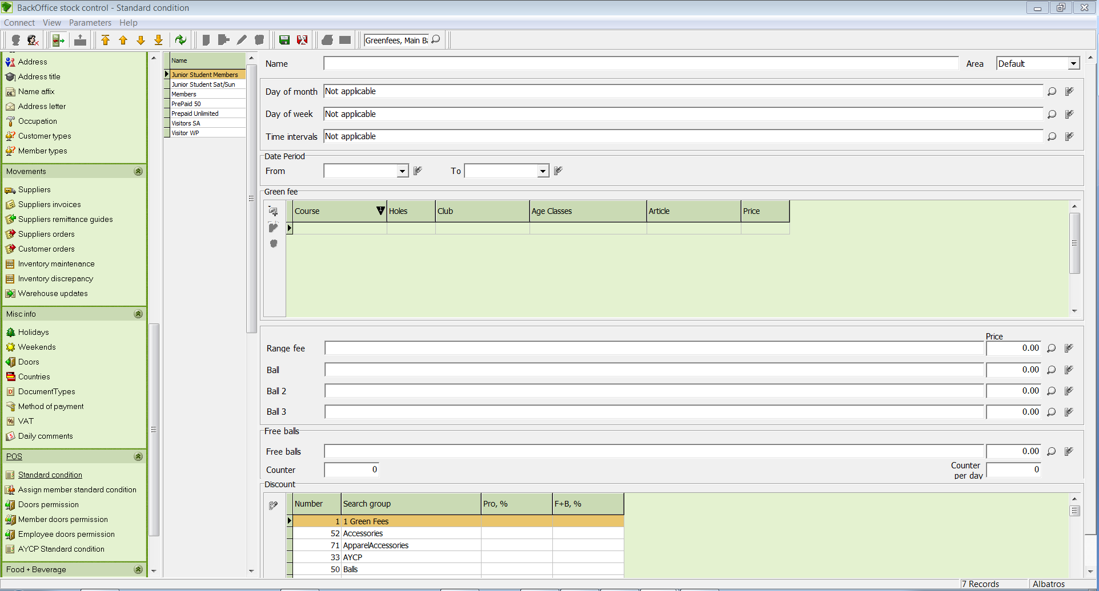

Input Fields
Name Input field for the name of the condition.
Day of Month Input field for the specific day of the month on which the condition is valid.
Day of Week Input field for the specific day of the week on which the condition is valid.
Time intervals Input field for the time intervals in which the condition is valid.
Date Period Input field for the date intervals
Green fee Input field for the green fee article.
Range fee Input field for range fee/s where applicable

Ball, Ball 1, 2 & 3
Ball article Input field for the ball article
Free Balls Input field for the article description
Counter Quantity of free balls per day
Discount % Input field for any discount percentage in Gastro and Proshop

The sequence does not match the screen in Backoffice. The field functions (particularly counters) should be described.

  - Create a condition
- Click the icon Add new record.
- Enter the details of the condition.
- Save the data with the icon Save.

  - Change a condition
- In the left side of the window select the condition to be changed.
- Click the icon Edit current record.
- Make the changes.
- Save the changes with the icon Save.

  - Delete a condition
- In the left side of the window select the condition to be deleted.
- Click on the icon Delete current record.
- Answer the confirmation question by clicking on the Yes button.

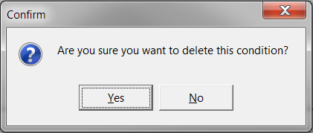

- Assign member standard condition
In the STANDARD CONDITIONS window you can assign standard conditions to individual customer types. At the time of sale, the condition which is most beneficial to the customer at this point in time will automatically be selected. Attention: There are further implications to the ball automat!

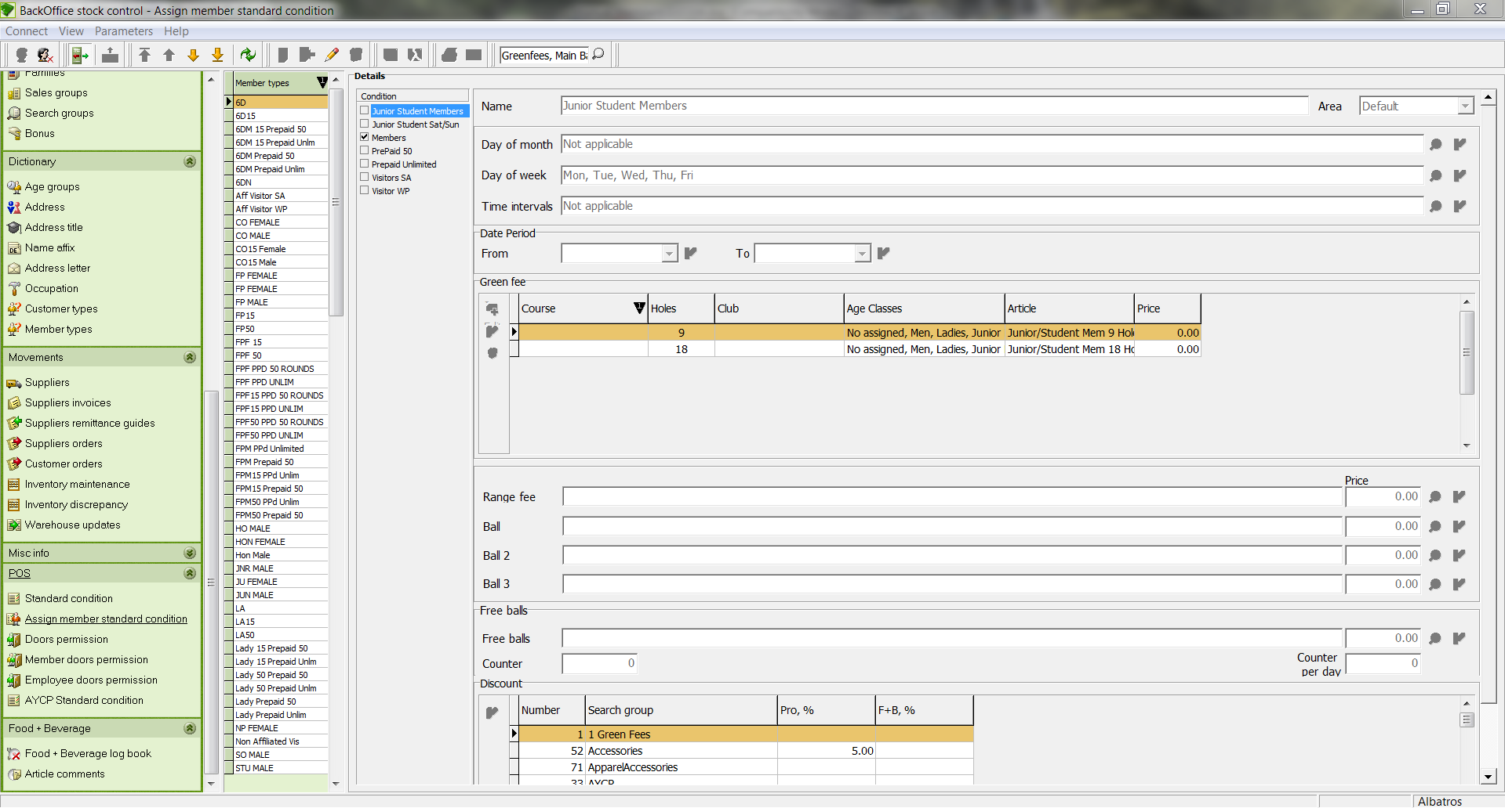

Input Fields
Day of Month Input field for the specific day of the month on which the condition is valid.
Day of Week Input field for the specific day of the week on which the condition is valid.
Time interval Input field for the time intervals in which the condition is valid
Ball article Input field for the ball article
Green fee Input field for the green fee article
Range Fee Input field for the range fee article

Price Price of the corresponding article

Discount
Gastro % Input field for any discount percentage in Gastronomy
Pro-Shop % Input field for any discount percentage in the Pro Shop

Free Balls
Counters Input field for the quantity of free balls
Price Input field for the price
Counter per day Input field for the quantity of free balls per day

  - Assign a standard condition
- In the left part of the window, select the customer subtype to which the standard condition is to be assigned.
- Click the icon Edit current record.
- Check the box of the condition that should be assigned to the customer subtype.
- Save the data with the icon Save.

- Member doors Permission
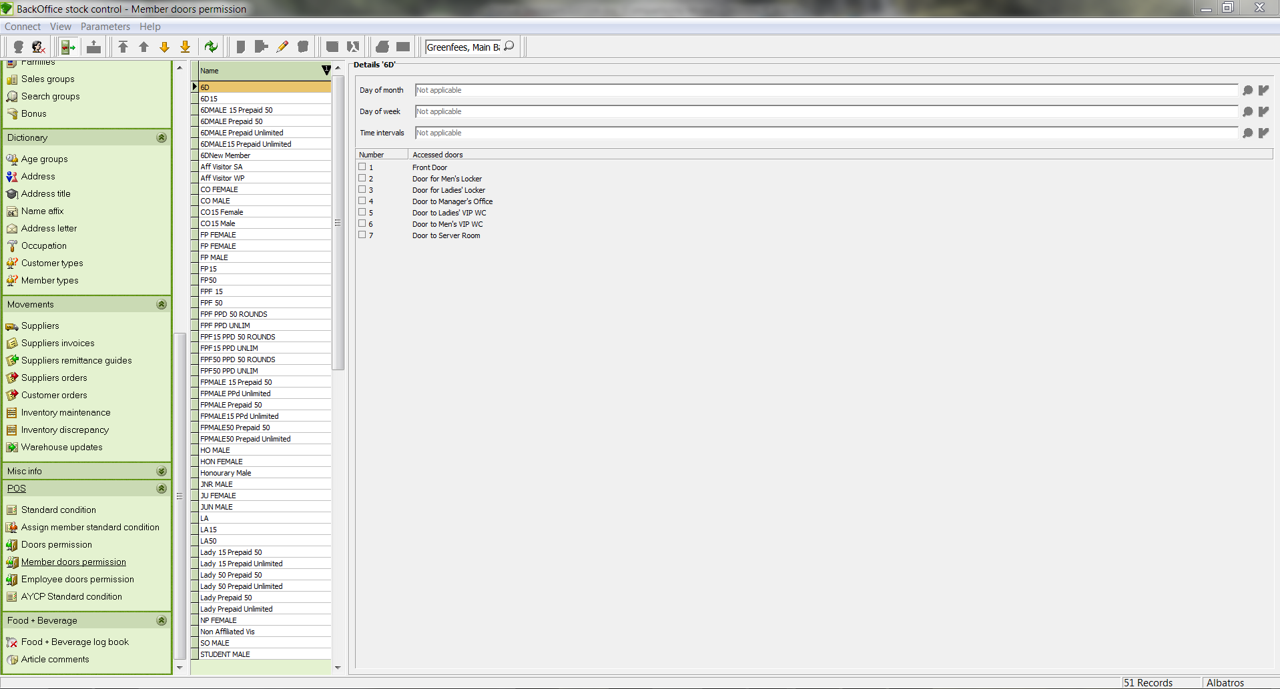

Input Fields
Day of Month The doors permissions can be limited to certain days of the month.
Day of Week The doors permissions can be limited to certain days of the week.
Time interval The doors permissions can be limited to certain time intervals.
Men's Lockers If this box is checked, the selected customer type has access to the men's locker room.
Women's Lockers If this box is checked, the selected customer type has access to the women's locker room.
Caddy Shack If this box is ticked, the selected customer type has access to the caddy shack.
Office If this box is ticked, the selected customer type has access to the office.
Pro Shop If this box is ticked, the selected customer type has access to the Pro Shop.
Course workers If this box is ticked, the selected customer type has access to the course workers' rooms.
Gastronomy Service
Entrance If this box is ticked, the selected customer type has access to the men's locker room.

Employee Locker Room If this box is ticked, the selected customer type has access to the employees' locker room.

  - Assigning doors permissions
- In the left side of the window, select the customer type for which the doors permission should be assigned.
- If needed, restrict the access to a given time period.
- Grant access to the individual rooms by checking the appropriate boxes.
- Save the data with the icon Save.

  - Edit doors permissions
- In the left side of the window, select the customer type for which the doors permission should be changed.
- Click the icon Edit current record.
- Make the changes.
- Save the changes with the icon Save.

- Employee doors permission
Data in this window may only be edited if access has been granted by the Albatros software.

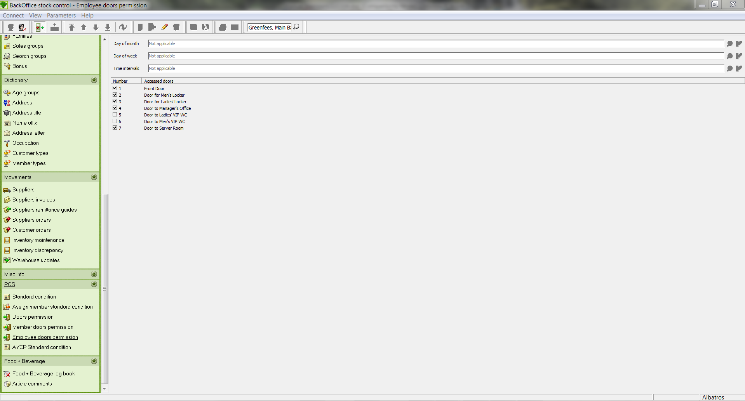

Input Fields
Day of Month The doors permissions can be limited to certain days of the month.
Day of Week The doors permissions can be limited to certain days of the week.
Time interval The doors permissions can be limited to certain time intervals.
Men's Locker Rooms If this box is checked, the employees have access to the men's locker rooms.
Women's Locker Rooms If this box is checked, the employees have access to the women's locker rooms.
Caddy Shack If this box is checked, the employees have access to the caddy shack.
Office If this box is checked, the employees have access to the office.
Pro Shop If this box is checked, the employees have access to the Pro Shop.
Course workers Caddy Shack If this box is checked, the employees have access to the course workers' rooms.
Gastronomy Service
Entrance If this box is checked, the employees have access to the men's locker rooms.
Employee Locker
Rooms If this box is checked, the employees have access to the employee locker rooms.

  - Assigning doors permissions
- If needed, restrict the access to a given time period.
- Grant access to the individual rooms by checking the appropriate boxes.
- Save the data with the icon Save.

  - Edit doors permissions
- Click the icon Edit current record.
- Make the changes.
- Save the changes with the icon Save.

Food & Beverage

- Food & Beverage logbook
In the GASTRO LOGBOOK window you find a list of all cancellation bookings in Gastronomy.

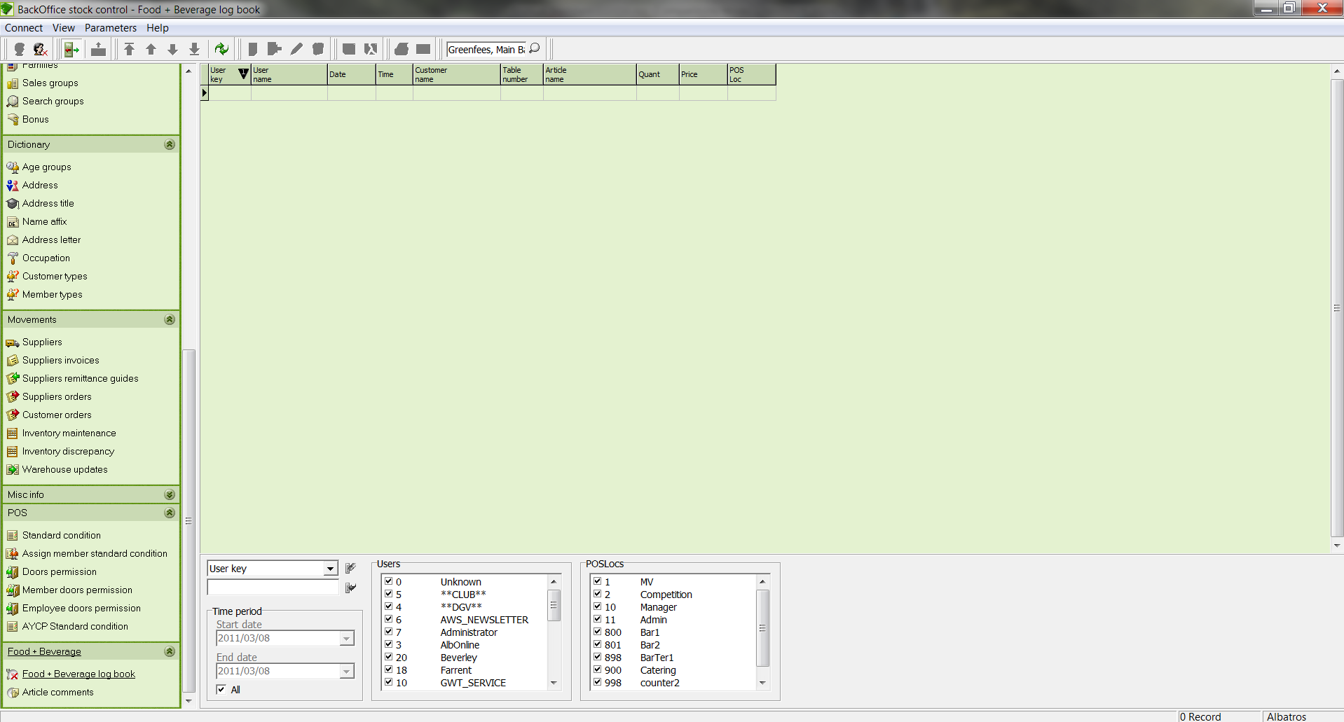

Input Fields
Selection field Selection field for the category used to filter the list.
Input field Input field for the topic used to filter the list.

Time period
Start date Input field for the date after which the cancellation bookings should be displayed
End date Input field for the date until which the cancellation bookings should be displayed
All If this box is checked, all bookings will be displayed.
Users The check box specifies the user who has access to the cancellation log book.
POSLoc The check box indicates the POS location which has access to the cancellation log book.

Article data control list
- Create a warehouse.
- Create the corresponding sales group. Where possible, these should be discussed with your tax advisor since they are aligned according to turnover and are used for financial accounting
- Create the corresponding sales group.
- Create the supplier. At least one internal supplier must be created.
- Create the family. In addition these can be subdivided into subfamilies and sub-sub-families.
- Create any colours (red, blue, green).
- Create any sizes (S, M, L, XL, 36, 38, 40).
- Create any units (piece, pair, box).
- Create the article.
- Enter the current quantity on hand. You can enter this through a supplier invoice or directly in Inventory.
- Print the barcodes to label the articles.

- Article comments
In this area you´ll define the comments for miscellaneous articles.

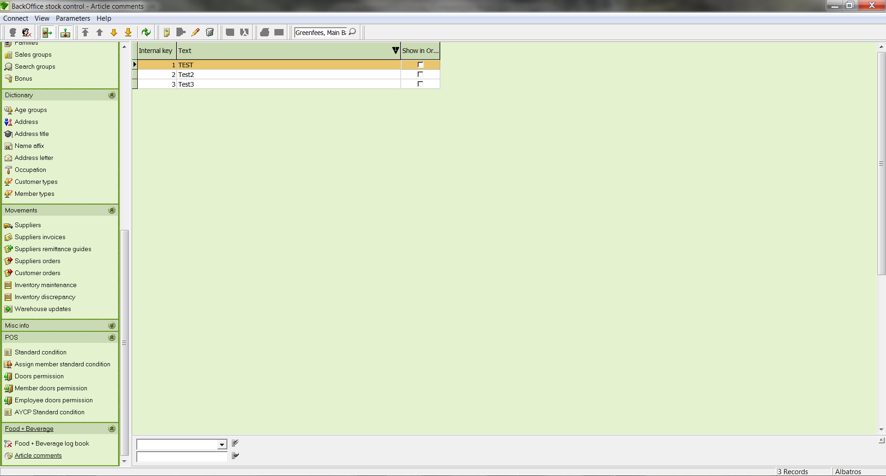

  - Create a new article comment
- Click on the button "New".
- Enter your text in the Comments field.

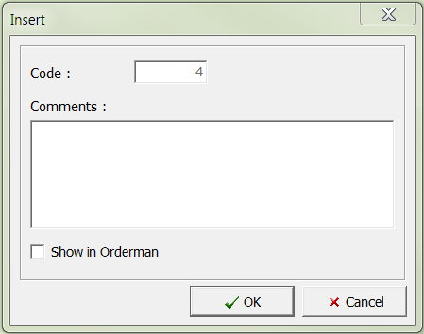

- Click on the button "OK".

- Remote access by our support team with Netviewer
As part of our installations, we include the Netviewer software, which gives our Support team the opportunity to access your workstation remotely.

This software can be activated in the following ways:

  - Netviewer icon on your desktop

- Click on the Netviewer Icon to start a remote management session.

Quick Launch Bar

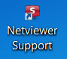

Desktop logo

39.2 Remote access in the Albatros modules
- Click on ‚Help‘ in the top line and then choose ‚Albatros Netviewer Service‘.

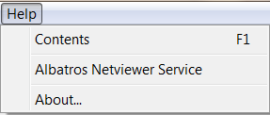

  - Starting the remote access session
- Please call our support number: 086-010 9372 / 079-314 9571. Should our support team member feel that it is necessary to start a Netviewer session, he will ask you to load the software.

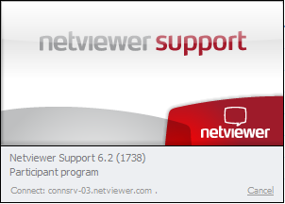

- The session starts with the left screenshot as seen above. The connection is tested and once it has been established successfully, a window pops up, requesting you to enter a code. This code will be given to you by the Support team member and is unique for this session.

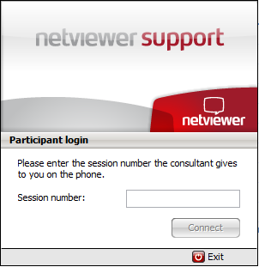

- Once you have entered the number, please click on ‚Connect‘ to confirm and when the secure connection has been established between the two computers, you are requested to allow the transmission of your screen.

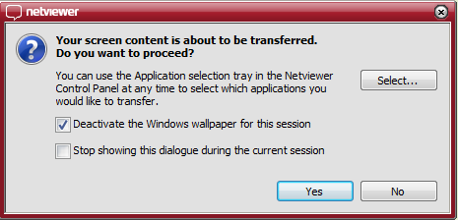

- Click on the button „Yes“, so that the support team member can view your screen. The remote access (Remote control) is now active as shown by the window:

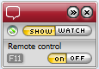

- This menu is visible throughout the whole session. Once the session is completed, a new window opens up to document the end of the remote access. Please click on ‚Close‘ to confirm.

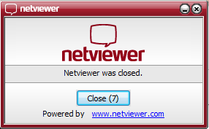

The advantages of Netviewer compare to other remote access software are:

- Quick link via the Internet
- Low costs compared to other software on the market
- 128 Bit Encryption
- VeriSign-Certificate

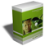 Support – Hotline

Support inquiry:  Monday – Friday | Operating hours: 08.00 – 17.00
Support-inquiry:  Saturday, Sunday or public holiday | Operating hours: 10.00 -15.00  Included but non-technical only
Remote maintenance  Monday – Friday | Included
Remote maintenance  Saturday, Sunday or public holiday | Included but non-technical only, subject to availability

Publisher of this manual:

iTee Solutions
Old Castle Brewery
Unit 404
6 Beach Road
Woodstock
7925
Office: 086-010 9372
Technical Support: 079-314 9571

Email: info@iteesolutions.co.za
Internet: http://www.iteesolutions.co.za

